AL-FARABI KAZAKH NATIONAL UNIVERSITY

R. S. Iminova

PRACTICAL WORKS ON IDENTIFICATION
OF ORGANIC SUBSTANCES

Methodical manual

Almaty
«Qazaq university»
2017
UDC
LBC
І
Recommended for publication by the decision of
the Faculty of Chemistry and Chemical
Technology Academic Council, RISO of the Kazakh National University named after Al-Farabi
(Protocol №3 dated 17.03.2017)

Reviewers:

Doctor of Chemistry sciences, Professor Burasheva G.Sh.

Iminova R.S.
І Practical works on identification of organic substances: methodical manual / R.S. Iminova. – Almaty: Qazaq university, 2017. – 133 p.
ISBN 978-601-04-2330-5

In this guidance manual are qiven qualitative reactions for different classes of organic compounds, methods for determining the most important functional groups that allow to identify unknown organic substance, some techniques of purification and recovery of organic substances, methods for determining certain physical constants of organic compounds, and brief description of the physical methods of organic compounds identification and laboratory works to them. The manual contains tables, pictures and applications, summarizing the presented material.
The manual is intended for students of Al-Farabi Kazakh National University studying in the speciality 5B060600 – "Chemistry" and 5B072100 – "Chemical technology of organic substances" which are passing practical course "Organic Compounds Identification".

В настоящем учебно-методическом пособии рассмотрены качественные реакции различных классов органических соединений, описаны методики определения важнейших функциональных групп, позволяющие идентифицировать неизвестное органическое вещество, описаны некоторые методики очистки и выделения органических веществ, представлены методики определения некоторых физических консткант органических соединений, приведено краткое описание физическим методам идентификации органических соединений и лабораторные работы к ним. Пособие содержит таблицы, рисунки и приложения, обобщающие представленный материал.
Учебное пособие предназначено для студентов КазНУ им. аль фараби, обучающихся по направлению подготовки по специальностям 5В060600 – «Химия» и 5В072100 – «Химическая технология органических веществ», изучающих практический курс «Идентификация органических веществ».

UDC
LBC

ISBN 978-601-04-2330-5 © Iminova R.S., 2017
© Al-Farabi KazNU, 2017
CONTENTS

Introduction .5

SAFETY INSTRUCTIONS IN LABORATORY
OF ORGANIC CHEMISTRY .8

I. QUALITATIVE ELEMENTAL ANALYSIS
(IDENTIFICATION OF ELEMENTS) 12
Laboratory work №1.
Preliminary Tests (Appearance, behavior to heating and
solubility of unknown substance) 12
Laboratory work №2.
Identification of Functional Groups: saturated, unsaturated
aromatic hydrocarbons and Halogencarbohydrates. 15
Laboratory work №3. Identification of Functional Groups:
Hydroxyl compounds (alcohols, phenols, naphthols). 17
Laboratory work №4.
Identification of Functional Groups: Carbonyl compounds
(aldehydes and ketones). 21
Laboratory work №5. Identification of Functional Groups:
Carboxylcontaining compounds. 25
Laboratory work №6. Identification of Functional Groups:
Nitrocompounds, Amines, Carbohydrates. 27

ІІ. METHODS OF PURIFICATION AND SEPARATION
OF ORGANIC SUBSTANCES 32
Laboratory work № 7. Distillation. 32
Laboratory work № 8. Crystallization. 43

ІІІ. DETERMINATION OF PHYSICAL CONSTANTS. 50
Laboratory work № 9. Melting point 50
Laboratory work № 10. Boiling point 54
Laboratory work № 11. Determination of the density 57
Laboratory work № 12. Determination of the refraction index 60

ІV. PHYSICAL METHODS OF ORGANIC COMPOUNDS
IDENTIFICATION 65
Laboratory work №13. Preparative chromatographic
Separation on columns (of dyes, pigments, green leaf) 67
Laboratory work №14. Separation of amino acids by method
of partition chromatography on paper. 71
Laboratory work №15. Separation and identification
of dicarboxylic acids by TLC in an aqueous-organic mobile phases 73
Laboratory work №16. Determination of impurities
in medicines by TLC 76
Laboratory work №17. Qualitative and quantitative determination
of flavonoids by TLC 79

V. SEVERAL SPECTROSCOPIC METHODS 85
Laboratory work №18. Checking by standart solution.
A comparison of the data with the values obtained
in the new instruments. Identification and curve fit of the present
solutions in the UV-spectrum. 99
Laboratory work № 19. Spectrophotometric determination
of nicotinic acid 101
Laboratory work № 20. Spectrophotometric determination
of injection cyanocobalamin (vitamin B12) 103
Laboratory work № 21. Quantitative analysis of xylene
isomers mixtures by the IR spectra 107
Laboratory work № 22. Determination of substances authenticity
in IR spectra of the samples dispersed in potassium bromide 110
Laboratory work № 23. Identification of the substance
by IR spectrum of a sample suspended in liquid paraffin 116

Reference 120

Appendix 121

INTRODUCTION

Identification is the establishment of a correspondence between the test compound and the already known one. Separation of individual compounds from mixtures, the release of the impurities from them (purification), identification or determination of the previously unknown compound structure are general operation steps required in organic chemistry as for synthesized or natural substances. The main methods for the separation and purification of organic compounds are based on various properties of organic sustances in a mixture.
For the separation of mixtures of substances differing in density or particles size, the following methods are used:
- Filtering
- Separation using membranes or molecular sieves
- Centrifugation
- Precipitation
- Decantation.
The ability of components mixture distribution in various ways between two immiscible phases used in such separation and purification methods:
- Distillation (liquid - gas)
- Recrystallization (solid matter - liquid)
- Distillation and sublimation (gas - solid substance)
- Extraction (liquid - liquid or solid - liquid)
- Chromatography (gas - liquid, liquid - liquid, liquid - solid, gas - solid).
On the difference in the rate of particles motion in an electric field based method of electrophoresis (for example, amino acids separation). They are also used complex methods (in particular, crystallization extraction).
Chemical reactions often used for separation of mixtures: ion exchange on the cationate or anionate; synthesis of easily separable derivatives (for example, oximes, hydrazones or phenylhydrazones of aldehydes, 2,4-dinitrophenyl derivatives of amino acids, etc.)
Cleaning operations are carried out repeatedly before organic compounds achieve constant values ​​of physical constants (boiling point and melting point, refraction index, density, constant chromatographic R_{f}, IR - spectrum, etc.). These constants allow us to identify known compounds using literature data.
Firstly obtained compounds tested for biological activity.
Each organic compound characterized by constant physical properties under certain conditions (temperature and pressure). Easy determined and usually contained in the chemical literature in the description of the individual compounds these physical properties: melting point, boiling point, density, refraction index, and in some cases the rotation of the light polarization plane, values of R_{f}, IR, UV, NMR (nuclear magnetic resonance), and mass spectra.
One of the organic chemistry important parts is identification and characterization of the unknown substance structure. It is often possible to establish the structure of a compound on the spectra basis alone (IR, NMR, etc.), and the spectra typically must be supplemented with other information about the compound: its physical state and properties (melting point, boiling point, solubility, odor, color, etc.), elemental analysis, and confirmatory tests for functional groups.
The structure of unknown or newly synthesized compound can be determined by following scheme:

Individual compound
Qualitative elemental analysis (Identification of elements)
Quantitative elemental analysis (The simplest formula of the substance)
Determination of molecular weight (Molecular or gross-formula)
Determination of substance structure (Chemical, dimentional and electronic structure)
Chemical
methods:
- Functional Analysis;
- Synthesis of known derivative;
- Destruction.

Physical methods of research:
- Absorption Spectroscopy: UV and visible region of the spectrum. Infrared spectroscopy, microwave spectroscopy, electron paramagnetic resonance (EPR), nuclear magnetic resonance (NMR);
- diffraction techniques: X-ray, electron, gamma spectroscopy;
- Mass Spectrometry;
- Dielkmetry, polarimetry, and others;
- Quanto-chemical methods.

The most simple is to establish the identity of the unknown compound to the known (identification), as well as to prove its purity by determining its physical constants and compare them with the available literature data. The substance can be considered pure only when the physical constants did not change after repeated purification. Absolutely pure substance can be imagined only in theory. In the practice pure substance is called substance that contains known, very small amount of impurities. The interest in the pure substances is caused by the needs of modern science and technology in materials with special physical and chemical properties.
So, by using these guidelines for laboratory work student can learn the basic rules of safety at work and training laboratory methods for identification of organic compounds various classes and know how to use reference books.
Plan of Chemical Identification of Unknown Substance
1. Preliminary tests:
1.1. Appearance (aggregate state, color, smell)
1.2. Behavior on heating
1.3. Solubility (in water, ether, the diluted solution of soda and alkali)
2. Identification of functional groups.
3. Definition of physical constants (melting temperature, boiling temperature, refraction index).
4. UV- and IR-spectra analysys.

SAFETY INSTRUCTIONS IN LABORATORY
OF ORGANIC CHEMISTRY

I. State of workplace

1. The laboratory should be clean, on desktops should be nothing superfluous or unnecessary in the work.
2. Unacceptable to keep on the table bottles of reagents, solvents, strong acids, and alkalis.
3. Marks have to be in all flasks with reagents.
4. Unacceptable to conduct experiments in a dirty bowl. All used dishes have to be washed after the experiment.

II. Working with glass

1. To avoid injury caused by broken glass it is necessary to keep safety precautions when working with glass and chemical glassware.
2. Thin-wall dishes must be heated on asbestos grid rather than on an open flame. And it is necessary to make sure that the burner flame is not beaten out from the grid as a result of the uneven heating of the vessel.
3. Large beakers with liquids should be lifted only with both hands by keeping the bottom with one hand.
4. When breaking capillars you need to stretch it but not to bend, because of bend can be cuts to the hand.
5. When inserting a glass tube in a rubber tube, the tube should be kept as close as possible to the end of the inserts. The tube does not need to push, and screwed, moistened with water, petroleum jelly or glycerine. The end of the tube must be weld first.

III. Rules for working with corrosive and toxic substances

1. All substances in the laboratory should be treated as more or less poisonous, as ¾ used substances are poisonous.
2. It is unacceptable to gain corrosive and poisonous liquid in the pipette by mouth, as this may be chronic burns of the mouth and poisoning. For this purpose, use a rubber bulb.
3. All work associated with the release of vapors or gases should be carried out under the hood!
4. Do not store the concentrated acid in a thin-walled container.
5. Do not pour down the sink strong smelled, volatile organic compounds, as well as acid and alkaline solutions without dilution or neutralization.
6. Do not try to taste substances in a laboratory. Smell substance carefully, not inhaling deeply by easily directing wrist.
7. Mixing and dilution of organic substances, accompanied by release of heat, carried out in a heat-resistant container. When dilution of sulfuric acid prohibited to pour there water, since in this case the acid can release from the vessel.
8. Do not boil in the workplace substances that form harmful gases.
9. When weighing bulk materials do not pour them directly into the pan.
10. When you move the vessels with hot liquids you need to keep them with both hands, holding one hand on the bottom, and the other hand on the neck.
11. You have not to lean above a vessel with boiling liquid.
12. If acid or alkali is spilled it is necessary to neutralize them by filling with sand. Wet the sand to remove the remnants of rinse water.
13. Remains of flammable, corrosive, explosive materials should be keep in the special sink.

IV. Working with some of the reagents and solvents

1. Operation with metallic sodium
When working with metallic sodium is necessary to make sure that on the table wasn’t even small amounts of water. Work with metallic sodium has to be kept away from squirting hoses refrigerators, outdoor faucets. Cut sodium can be dry on a white paper; also you have to put goggles on and don’t touch it with bare hands. Affter completions of the work you have to carefully collect all remained unreacted sodium in a dish with kerosene and deliver it to laboratory assistant. Before washing dishes carefully check whether remains even the smallest amount of metallic sodium.
2. Work with bromine
You have to be very careful when working with bromine because that it is a very toxic substance; it has dangerous effect on the mucous membranes and leaves very strong burns which are hard to heal. All work with bromine is carried out in a fume hood.
In the case of burns from bromine treat burned area with alcohol.

3. Work with acids
When you transfer concentrated acids it is necessary to use rubber gloves, apron and goggles. Upon dilution of concentrated sulfuric acid by mixing a sulfuric acid and nitric acid, and by mixing accompanied by any acids heat use porcelain or glass glassware.
It is strictly forbidden to pour into the sink waste caustic liquid. Previously they have to be neutralized in special bottles. When acid is contacted with skin it leaves burns. Burned area should be washed under running water for 20-30 minutes, and then treated with a weak solution of baking soda.

4. Work with phenol and alkalis
Alkali and phenol in dry form and in the form of concentrated solutions can cause skin burns. Burned area has to be wash long with warm water, and then the affected area is treated with a weak solution of acetic acid; phenol burns are washed with alcohol.
5. Work with organic solvents
Distillation of the organic substance and other works related with heating under atmospheric pressure are not allowed in hermetically sealed vessels. The internal space of any device that is not designed to work under pressure to prevent the explosion always has to have a connection to the atmosphere.
When dealing with inflammable liquids, such as ether, petroleum ether, benzene, etc., should not be included and fire adjacent tiles. It is strictly prohibited to heat them over an open fire or on the tile. The heating may be performed only on a pre-heated water bath in a flask fitted with a water condenser.

Vapours of ether are heavier than air and spread over the table which can cause a fire or explosion in the presence of an open flame.
Vapours of alcohols (methyl, ethyl, propyl) form explosive mixtures with air, therefore can not be distilled off to dryness. Methanol vapors are poisonous, especially by inhalation, in contact with the wound and ingestion.
Benzene, toluene, flammable and explosive, poisonous in pairs, by inhalation and skin contact.
Chloroform and ether are narcotic.
Carbon tetrachloride causes headaches, loss of consciousness, seizures. Not flammable.
Acetone, formalin, aniline are toxic in swallowing. If they inhaled their vapors cause dizziness, nausea, vomiting.
When you work with organic solvents you should take precautions and use personal protective equipment.

- QUALITATIVE ELEMENTAL ANALYSIS
(IDENTIFICATION OF ELEMENTS)

In this experiment you will carry out several qualitative tests that will allow you to identify the solubility behavior of unknown organic compounds and examine of their functional groups - including amines, alcohols, carboxylic acids, alkanes, alkenes, and alkyl halides. Each functional group has a particular set of chemical properties that allow it to be identified. So some of these properties can be demonstrated by observing solubility behavior, while others can be seen in chemical reactions that are accompanied by color changes, precipitate formation, or other visible effects.

Laboratory work №1

Preliminary Tests
(Appearance, behavior to heating and solubility
of unknown substance)

1.1. Appearance. Before starting definition of the functional groups which are a part of the studied compound it is necessary to define an aggregate state of substance, its color and a smell. These data will help to do preliminary conclusions on structure of the analyzed substance and will facilitate further researches.
1.2. Behaviour to heating. The following stage in the analysis of organic compound consists in burning of substance in a torch flame. The smoking flame is observed at combustion of high-molecular or aromatic hydrocarbon. If the substance burns without the rest, it means that in it doesn't contain metal. When burning carbohydrates the smell of burnt sugar is caught.
Experience: On a tip of the pallet bring some crystals or 1-2 drops of substance in a torch flame.
1.3. Solubility. Determination of solubility of substance in water and various nonaqueous solvents will help us to make the conclusion to what class of organic compounds belongs this substance. On various solubility of substance in water and ether organic compounds can be divided into 4 main groups:
a) soluble in water and ether: the lowest aliphatic alcohols, aldehydes and ketones, the lowest and average carbonic acids, aliphatic amines, polyatomic phenols, aminophenol.
b) insoluble in water, in ether: aliphatic and aromatic hydrocarbons, the highest amines and sulphamides, sulfanylic
acid.
c) soluble in water, but insoluble in ether: polyatomic alcohols, polybasic acids, carbonic oxyacids, aliphatic amino acids, sulfonic acids, salts, carbohydrates.
d) insoluble in water, but soluble in ether: hydrocarbons, alcohols (C₅ and more), the highest aldehydes and ketones, the highest and average carbonic acids, anhydrides of acids, halogen derivatives hydrocarbons, simple and esters, phenols, the highest amines, nitrocompounds.
The solubility of an organic compound in water, dilute acid, or dilute base can provide useful information about the presence or absence of certain functional groups.
Solubility in water: Most organic compounds are not soluble in water, except for low molecular-weight amines and oxygen-containing compounds. Low molecular-weight compounds are generally limited to those with fewer than five carbon
atoms.
Carboxylic acids with fewer than five carbon atoms are soluble in water and form solutions that give an acidic response (pH < 7) when tested with litmus paper.
Amines with fewer than five carbons are also soluble in water, and their solutions give a basic response (pH > 7) when tested with litmus paper.
Ketones, aldehydes, and alcohols with fewer than five carbon atoms are soluble in water and form neutral solutions (pH = 7).
Solubility in NaOH: Solubility in 6M NaOH is a positive identification test for acids. A carboxylic acid that is insoluble in pure water will be soluble in base due to the formation of the sodium salt of the acid as the acid is neutralized by the base.
Solubility in HCl: Solubility in 6M HCl is a positive identification test for bases. Amines that are insoluble in pure water will be soluble in acid due to the formation of an ammonium chloride salt.
Scheme 1. The Solubility Test Flowchart

Experience: For determining of solubility take 0.01-0.10 of substance, 3 ml of solvent, and well mix test tube contents. It is necessary to carry out test of solution on pH environment. Water solutions of carbonic acids and phenols will have sour reaction, and aliphatic amines – alkaline. Thus it is necessary to consider that aromatic acids (benzene, salicylic, phthalic) and phenols are well dissolved only in hot water.
In reference of substance to any class of organic compounds test of solubility in the diluted NaOH solution (5%) or NaHCO₃ (5%) gives the good help:
1) carbonic acids and some sour phenols (nitrophenols) are soluble in both specified solutions. Besides, at effect of the diluted sodium bicarbonate solution on carbonic acids allocation of CO₂ is observed.
2) phenols, primary and secondary aliphatic nitrocompounds are dissolved only in NaOH solution (but not NaHCO₃). Phenols are dissolved in the diluted solution of a caustic natr owing to formation of soluble phenolates in water. At acidulation phenols are emitted again.
3) alcohols with alkali don't react and therefore insoluble alcohols in water aren't dissolved and in alkali.
When heating water solution of the analyzed substance from
10-20% yellow coloring appears NaOH solution in case of aldehydes, alcohols and the restoring sugars, and polyatomic phenols give brown-black solutions.

Laboratory work №2

Identification of Functional Groups: saturated, unsaturated aromatic hydrocarbons and Halogencarbohydrates

Reference of substance to a certain class of compounds is carried out by means of the functional analysis, i.e. definition of groups of the atoms possessing characteristic reactionary ability – so-called functional groups.
Saturated hydrocarbons can be distinguished from other classes of organic compounds on their small reactionary ability in relation to the majority of the reactants used in laboratory. Their identification is carried out on the basis of physical constants (melting temperature, boiling temperature, refraction index).
Unsaturated hydrocarbons of ethylene series have multiple C=C bond which is found on the following reactions:
1) Bromine accession reaction. The compounds containing double bond attach bromine. In process of addition of bromine there is a fast decolouration of solution. However, some aliphatic hydrocarbons having tertiary atom of carbon at the increased temperature easily react replacements with bromine. At effect of bromine on aromatic amines and phenols also there is a replacement reaction. Replacement reaction, as well as accession reaction, proceeds with bromine decolouration.
Experience: To CCl₄ or CH₃COOH add to substance solution on drops bromine solution in the specified solvent when hashing. If substance soluble in water, bromination it is possible to conduct "bromic water" (saturated solution of bromine in water). Observe bromine coloring disappearance.
2) Reaction with potassium permanganate (Wagner's reaction). High-quality reaction to existence of multiple bond is reaction with potassium permanganate solution. Fast disappearance of violet coloring of KMnO₄ with simultaneous loss of a brown flaked deposit of MnO₂ indicates presence of compound with double bond.
Experience: The testing substance (0.1 g) is dissolved in acetone or pyridine or acetic acid, add some drops of solution of alkali or soda and flow 0.1% KMnO₄ solution. Observe disappearance of violet coloring of permanganate and emergence of a flaked deposit of brown color.
Unsaturated hydrocarbons of acetylene series have multiple C≡C bond and on properties are close to compounds with double bond. Therefore the same reactions of accession of bromine and oxidation of permanganate of potassium which, proceed with a smaller speed are suitable for their detection. However atoms of hydrogen at acetylene and its monoalkyl replaced derivatives, unlike ethylene hydrocarbons, can easily be replaced on metals with formation of the painted atsetilenid.
Experience: Stip of filter paper is wetted with an ammonia solution of copper (I) chloride, in contact with acetylene hydrocarbons it gives a red dyeing (color).
Aromatic hydrocarbons.
- Alkylation with chloroform in the presence of aluminum chloride.
To distinguish aromatic hydrocarbons from aliphatic we can use alkylation reaction of arenes with chloroform in the presence of AlCl₃. This reaction is accompanied by the formation of colored products. During the interaction of benzene and chloroform in the presence of AlCl₃ besides the basic colorless reaction product is triphenylmethane, also is formed colored complex salt of triphenylchlormethane:

3 C₆H₆ + CHCl₃ → (C₆H₅)₃CH + 3 HCl
5 C₆H₆ + 2 CHCl₃ → (C₆H₅)₃CCl + (C₆H₅)₂CH₂ + 5 HCl
(C₆H₅)₃CCl + AlCl₃ → [(C₆H₅)₃C]⁺ AlCl⁴⁻
(colored complex salt of triphenylchlormethane)

2) Nitration Experiment
Caution! Sometimes the reaction takes place very rapidly. To 0.1 g of the compound (preferably in solution CCl₄) with continuous shaking, 3 ml of 8 nitrating acid (a mixture of concentrated nitric and sulfuric acids in the ratio 1: 2). Then, under the thrust heated for 5 minutes in a water bath at 45 to 50 ° C and poured onto ~ 10 g of crushed ice. If the solid precipitated or forms a water-insoluble oil, it is possible to judge the presence of an aromatic system.
Halogencarbohydrates
Beilstein Sample. The presence of halogen compounds are easily detected by the formation of volatile copper halide which change color of flame to green or blue-green color. But we must remember that many of the nitrogen-containing substances (quinoline, pyridine, and urea) give a positive sample in the absence of halogen.
Experience: The copper wire was calcined in the burner flame until the termination of the flame coloration and the formation of black plaque on the surface of oxide of the copper (II). The cooled wire moistened with several drops of liquid to be analyzed or placed at her crystal material and applied to a colorless flame burner. First, the flame becomes luminous due to the combustion of carbon and then painted in a bright green color.

Laboratory work №3

Identification of Functional Groups: Hydroxyl compound (alcohols, phenols, naphthols)

Hydroxyl compound. Hydroxyl compounds include aliphatic alcohols, phenols, naphthols, and other compounds.
- Determination of alcoholates and phenolates. Alcohols and phenols quite easily react with metallic sodium with hydrogen evolution and formation of alkoxides and phenoxides.
Experience: To the test substance dissolved in ether, add a piece of sodium metal. There is a release of hydrogen.

ROH + Na → RONa + H₂

- Preparation of the ester
_{H +}
CH₃COOH + ROH → CH₃C (O) OR + H₂O
Experience: Equimolar amounts of the test alcohol (not more than 1-2 ml) and glacial acetic acid with 0.5 ml of conc. H₂SO₄ was heated slightly with shaking and then diluted with water - ester emerges in the upper layer.
- The sample Lucas distinguish primary, secondary and tertiary alcohols of different mobility on the hydroxy groups with alcohols in the reaction solution of ZnCl₂ in conc. hydrochloric acid. Concentrated hydrochloric acid during the reaction with alcohols have ability to replace a hydroxyl group with the formation of water-insoluble chlorinated alkyls:

However, depending on the structure of the alcohol, this reaction proceeds at different rates. Tertiary alcohols react with this reagent at a high velocity, giving insoluble haloalkyl; primary alcohols react only after prolonged standing or heating, secondary occupy an intermediate position.
Experience: To 1 ml of the sample alcohol was added 6 ml of Lukas reagent (16 g of anhydrous ZnCl₂ in 10 ml of conc. HCl), the mixture was shaken and left for 1-2 minutes. If the primary alcohol, the solution remains clear but may darken, if secondary - turbidity occurs, and if a tertiary – at the bottom formed oily layer of haloalkyl. Sometimes the reaction mixture must be warm in a water bath!
- Denizhe Reaction (for tertiary alcohols). Tertiary alcohols are dehydrated easily with concentrated sulfuric acid. Thus, formed olefins give yellow or red sediments with mercury ions.
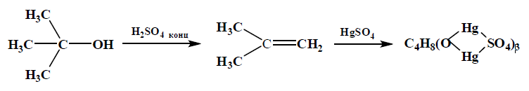
Experience: To 3 ml of the Denizhe reagent (HgSO₄ 5 g in
100 ml of water and 20 mL of conc. H₂SO₄) was added a few drops of test substance and boiled for 1-3 minutes. In the case of tertiary alcohols we can observe falling of yellow or red sediment. Primary and secondary alcohols to form a hazy solution, which after some time form crystals.
Reaction with chromate solution used for detection of primary, secondary and tertiary alcohols. Primary alcohols are oxidized with chromic acid to aldehydes, secondary to ketones , wherein the mixture changed color from orange to green. Tertiary alcohols are not oxidized by chromic acid, but chromic acid esters give colored in yellow or red wine.
- The reaction with the chromate solution is used for recognition of the primary, secondary and tertiary alcohols. Primary alcohols are oxidized with chromic acid to aldehydes, secondary to ketones, wherein the mixture changed color from orange to green. Tertiary alcohols are not oxidized by chromic acid, but gives chromic acid esters colored in yellow or red wine.
Experiment: 1-2 ml of the alcohol was treated with gentle heating 5 ml of Beckman - chromate solution (50 g K₂Cr₂O₇ in 300 ml of water, 28 g of conc. H₂SO₄). If the solution is colored in red wine, it means that the tertiary alcohol. In the case of easily oxidized primary and secondary alcohols appears green.
- Reaction to polyatomic alcohols hydroxide of copper (II). A freshly prepared solution of copper hydroxide (II) by reaction with polyols to form complex salts dark blue:

Experience: 5-6 drops of the substance is dissolved in dilute alkali and add a few drops of a dilute solution of copper sulfate. If the copper hydroxide precipitate is formed and the solution turns blue, the likely presence of a polyhydric alcohol.

Reactions characteristic of phenols
- Reaction with a solution of ferric chloride(III). Most of the phenols with ferric chloride (III) form an intensely colored complex salts. For monohydric phenols usually appears violet color; diatomic phenols appears green, black and purple and yellow color in the case of catechol, resorcinol and hydroquinone, respectively.

Experience: To 1-2 ml water (preferably chloroform) solution of the test substance was added a few drops of 3% solution of FeCl₃. Observe the appearance of color.
- The addition reaction of bromine. The addition of "bromine water" to the aqueous solution of phenol the disappearance of color due to bromine substitution reaction:

Under the action of an excess of bromine water tribromophenol oxidized further to a yellow colored product – 2,4,4,6-tetrabromcyclohexadienon:

Experience: To 1 ml of aqueous phenol solution was gradually added 1 ml bromine water. Painting of bromine disappear and fall yellow crystals.
- Reaction with nitrous acid. Most of the phenols that do not have substituents in the para position, reacted with nitrous acid to form the p-nitrozophenols that in the presence of concentrated sulfuric acid is condensed with excess phenol to form intensely colored reaction products. The phenol is condensed with nitrozophenol and gives colored compound -indophenol:

Experience: In the test tube is poured 0.5 ml of concentrated sulfuric acid was added under stirring a few (2-3) drops of phenol. The mixture was cooled in an ice-water beaker. To this solution was added a drop of sodium nitrite. An intense pink color, which, when added alkali (up to an alkaline reaction) becomes the blue-green.

Reactions characteristic of naphthol
Naphthols are poisonous! Caution Avoid contact with the skin!
- Forming naphtholate. Naphthols poorly soluble in water, but soluble in alkaline solution, showing acidic properties.
Experience: For a few crystals naphthol 1 ml of water, and after thorough mixing, significant dissolution occurs. A solution of sodium hydroxide and naphthol observed dissolution in alkali.
- Reaction with a solution of ferric chloride (III)
Experience: The tube is placed a few crystals of the test substance and 0.5 ml of ethanol was added. To the alcohol solution is poured 0.5 ml of 5% sodium carbonate solution and stirred. The test tube was gradually added a solution of potassium permanganate. The purple color disappeared and a precipitate of manganese oxide (IV).

Laboratory work №4

Identification of Functional Groups:
Carbonyl compounds (aldehydes and ketones)

Qualitative reactions of carbonyl compounds are related to their ability to engage in various reactions replacement and addition. Aldehydes and ketones behavior in these reactions are almost the
same. In some cases there is, however, a difference in the reaction
rate.
Reactions common to aldehydes and ketones
- Reaction with 2,4-dinitrophenylhydrazine used for identifying aldehydes and ketones and their quantification. The appearance of yellow or red precipitate indicates the presence of a carbonyl group.

R, R' – H, alkyl and aryl

Experience: Analyzing substance or its alcohol solution taken in the small quantity, stir up with several milliliters of reagent (0.4 g the dinitrophenylhydrazine is dissolved in 21 ml conc. HCl also dilute with water to 100 ml). Necessarily solution is cooled or, on the contrary, heated. Observe allocation of a yellow or red deposit. The deposit is filtered, wash out water, dry up at the room temperature, define m.p also compare it with table data.
2. Reaction with nitroprussid of sodium. With nitroprussid of sodium react all aldehydes and ketones, having CH or CH₂ group near a carbonyl. Thus solution it is painted in red color. Colouring isn't observed, if at a carbonyl has Ar, and also in case of formaldehyde.
Experience: To solution of carbonyl connection in water, alcohol or air add some drops of 0.5% freshly cooked solution of sodium nitroprussida Na₂[Fe(CN)₅(NO)] and solution poorly alkalinize.
Observe red coloring the most intensive at ketones. Coloring disappears at acidulation, and also when standing. In radio solution carbonyl connection only the water layer is painted.
- Reaction with hydroxylamine. At action of a hydrochloride of hydroxylamine on the carbonyl connection is formed oxy and HCl is allocated:

R₂C=O + HCl NH₂OH → R₂C=NOH + H₂O + HCl

Change of pH of the environment can be found on coloring change indicator, for example, the methyl orange.
Experience: In a test tube pour in 1-2 ml 0.5n spirit NH₂OH solution · HCl, add some drops of a methylorange, neutralize in a case need 0.1n alkali solution also flows dissolved in alcohol analyzing substance. Emergence of pink coloring on cold or at heating points to presence of carbonyl connection. But it is necessary to remember that reaction between carbonyl connection and hydroxylamine it is reversible and therefore it is necessary to care of that oxy whenever possible didn't come to contact with acidic solutions, differently to the oxy can back pass into an initial state.
Reactions, characteristic only for aldehydes
- Reaction with fuksinsulfuric acid. Water solution of fuksin sulfur - (Schiff's reactant) serves for you high-quality detection of aldehydes. At addition to solution of steam-fuchsin of water solution of oxide of sulfur (IV) or a transmission of the gaseous SO₂ the fuksinsulfuric acid which doesn't have coloring is formed. This acid with RCHO aldehydes forms hinoidic dye of crimson color.

Experience: To 2 ml of solution of fuksin sulfuric acid flow 2 drops of substance or its solution. Emergence of crimson coloring indicates presence aldehyde. Some ketones and nonsaturated connections cause the partial restoration of initial coloring of fuchsin, therefore emergence it isn't considered weak pink coloring positive reaction. Don't give colourings of some aromatic oxyaldehyde and glyoxal.
- Reaction with Feling liquid Aldehydes – strong reducers, restore compounds of copper (II) to copper (I), thus are oxidized to the corresponding carbonic acids. As the reactant containing Cu²⁺ ions, the reactant is applied Feling.
Experience: The reactant of Feling consists of two parts:
I –CuSO₄ solution in water and II – alkaline solution of salt of wine acid KO(O)C(CHOH)₂C(O)ONa (segnetov salt). Before the use mix equal volumes of both solutions approximately on 2 ml. Heat 0.05 g of substance from 2-3 ml of Feling liquids within 5 minutes on the boiling water bath. Change of color solution of feling liquid and loss of a yellow or red deposit oxide of copper (I) serves as positive reaction. Change of color solution of Feling liquid and loss of a yellow or red deposit oxide of copper (I) serves as positive reaction.

Aromatic aldehydes of this reaction usually don't give.

6. Reaction with Tollens's reactant (reaction of «a silver mirror») All aldehydes restore ammoniac solution of an oxide of silver. Ag₂O silver oxide in the presence of excess of ammonia passes into solution in type of an ammoniac complex:

Ag₂O + 4NH₃ + H₂O → 2[Ag(NH₃)₂]+OH

– Aldehydes, easily oxidized, restore compounds of silver in to the alkaline environment to metal silver:

2[Ag(NH₃)₂]OH + RC(O)H → RC(O)ONH₄ + 2Ag + 3NH₃ + H₂O

Experience: Mix in a pure test tube 0.05 g of substance from 2-3 ml "the ammoniac silver solution" (to 0.1n to AgNO₃ solution add on drops ammonia to dissolution of originally formed deposit). If silver mirror it isn't formed on cold, reactionary mix, without shaking up, not for long heat on to water bath at 60-70 °C. In case of benzole aldehyde, aromatic aldehyde it is possible to add to reactionary mix a drop of the diluted alkali for reaction accelerations. Carefully! The solution remains immediately pour out, since at standing the extremely explosive rattling Ag₃N silver – nitride is formed silver.

Laboratory work №5

Identification of Functional Groups:
Carboxylcontainig compounds

Carboxylcontainig compounds. It is easy to determine carbonic acids by their solubility in alkalis, carbonates and bicarbonates and on their acidity (test on litmus). However, sour also some other organic compounds, for example, give reaction phenols.
Reaction with salts of coal acid. Acids react on cold with NaHCO₃ with allocation of CO₂:

RC(O)OH + NaHCO₃→ RC(O)ONa + 2H₂O + CO₂

Experience: 1 ml of acid dissolved in 1 ml of 50% ethanol and addedAn equal volume of 5% NaHCO₃ solution, shaken well, but not heated. There bubbling carbon dioxide.
Preparation of the ester (see. «Hydroxylcompound»). As the alcohol in this reaction, itrecommended to use isoamyl alcohol.

Identification of some individual acid.
Formic acid, the first member of the homologous series acids, has special properties. Formic acid and its salts, likealdehydes readily undergo oxidation reaction. Discover formic acid may be by reactions typical for aldehyde, in particularthe reaction of the "silver mirror". Formic acid recovered from ammonia solution of silver oxide; silver metal itself is oxidized to carbonic acid, which breaks down into water and carbon dioxide.

HC(O)OH+ 2[Ag(NH₃)₂]OH → CO₂ +2Ag + 4NH₃ + 2H₂O

Formic acid is also discoloring KMnO₄ solution and when heating with conc. H₂SO₄ and CO₂ forms.

Acetic acid. To a solution of acetic acid add 2 drops of FeCl₃ and 1 ml of isoamyl alcohol. The tube shaken vigorously, the mixture allowed exfoliating. Layer of isoamyl alcohol should remain colorless; it is painted in a reddish-brown colorpresence of other acids such as propionic.
Oxalic acid. To the aqueous solution added a little acetate solution and then a solution of CaCl₂ - A white finely crystalline precipitate of calcium oxalate. Oxalic acid is oxidized with potassium permanganate in an acidic medium with CO₂ release (sample with barite water).
Tartaric acid. To a solution of the acid solution was added 0.5N KOH – when rubbing the wand of a white precipitate of the acid salt of tartaric acid; at adding 10% NaOH pellet disappearing - the average is formed salt, which is highly soluble in water:
Adding CuSO₄ solution to the average potassium-sodium salt (Rochelle salt) obtained Felingov’s liquid - blue coloration.
Benzoic acid is dissolved in hot water sublimes.
Salicylic acid with a solution of FeCl₃ gives the violet staining oxidized with potassium permanganate, decolorized bromine dissolved in CCl₄ in the thermal decomposition is observed the formation of phenol and CO₂.

HOC₆H₄C(O)OH → C6H₅OH + CO₂

Sulfanilic acid is diazotized by reaction with nitrous acid to give a diazonium salt which in solution is combined with β-naphthol to give a red-orange dye (to dissolve the sulfanilic acid in water should do make a few drops of soda solution or alkaline). the addition of bromine to a solution of sulfanilic acid in hot water, a precipitate formed tribromoaniline.

Ethers.
Ethers – compounds having fruity smell, usually liquid sparingly soluble in water. In the analysis of the esters used them the ability to hydrolysis and substitution of alkoxy other residues.
Formation of hydroxyl acids. With hydroxylamine in strongly alkaline media esters give hydroxamic acids that exist in tautomeric form and form salts of Fe (III) in acidic medium a colored complex:
RC(O)OR’ + H₂NOH → RC(O)NHOH + R’OH
RC(O)NHOH ↔ R(OH)C=NOH
3RC(O)NHOH + FeCl₃→ (RC(O)NHO) ₃⁺Fe³⁺ + 3HCl

Experience: 1 drop or a crystal of an analyte is mixed with 1 ml of 0.5n NH2OH*HCl alcohol solution and 0.2 ml of 6N aqueous mixture NaOH was heated to boiling and after cooling 2 ml of 1N hydrochloric acid. Adding 1 drop of 10% FeCl₃ solution appears magenta or red (not yellow) color after 5 minutes of standing.
Use this qualitative reaction is limited, as it is also provided halide anhydrides and acids and certain other compounds.

Laboratory work №6

Identification of Functional Groups:
Nitrocompounds, Amines, Carbohydrates

1. Nitrocompounds. Quality reaction on the of nitro compounds based against various primary, secondary and tertiary nitro compounds to nitrous acid or the ability of primary and secondary nitro compounds to form the aci-form.
- The action of nitrous acid is a typical reaction to the quality primary and secondary nitro compounds. Primary aliphatic nitro compound with nitrous acid give nitric acid salts, which are painted in blood red:
RCH₂NO₂ + HONO →R(NO₂)C=NOH

Secondary aliphatic nitro compound forms with HNO2 nitro compounds, painted in blue color:

R₂CHNO₂ + HONO→R₂C(NO₂)NO + H₂O

Tertiary aliphatic nitro compound with nitrous acid did not react.

Experience: A few drops of the nitro compound dissolved in concentrated NaOH, added NaNO₂ and the mixture gently acidified with dilute H2SO4. In the case of a primary nitro formed red color, which disappears in an excess of acid, and at the alkalization reappears. If it turns blue color, this indicates the secondary nitro group.
- Reaction of aci-nitro compounds with FeCl₃ (III). Primary and secondary aliphatic nitro compounds under shaking with concentrated sodium hydroxide solution under cooling converted to sodium salt form aci-nitro compounds.

Experience: Substance shaken with concentrated NaOH solution. The resulting salts are dissolved in a little water, ether is added and drop wise add the solution of diluted FeCl₃. When shaking the ether layer becomes red or brown-red. The tertiary nitro compounds do not give this reaction; therefore, aci-form is not possible.
- Reduction of nitro compounds.
The reduction reaction take part all nitro compounds. Aliphatic nitro compounds exhibit the basic properties, which can detected by a change in color of litmus paper. Opening of aromatic nitro compounds performed after restoring them into amines by reactions inherent in the latter.
Experience: A few drops of testing substance were added to
1-2 ml of 30% sodium hydroxide, add zinc piece and was heated in a water bath (reaction is carried out in the thrust!). A piece of wet litmus paper tray to the opening of the tube, resulting aliphatic amine causes blue color of indicator paper.
- Detection of aromatic nitro compounds.
Experience: 2 drops of phenol is heated until boiling, also 3 drops of water and a piece of KOH size of a pea; after the addition of aromatic nitro compounds appear brownish-red color.
- Amines.
Amines – organic bases, fatty amines have a basic reaction on litmus. Almost all the amines form salts with acids, particularly recommended obtaining them in the case of tertiary amines. Different include primary, secondary and tertiary aliphatic and aromatic amines to nitrous acid. With acylation reagents, the amines form crystalline products.
- Formation of salts. The test sample treated with dilute HCl. If the substance is not soluble in water, it goes into a solution, so the test sample contain amine.
- The reaction of nitrous acid. Primary aliphatic amines by the action of nitrous acid are isolate nitrogen (the sample is not completely reliable because HNO₂ decomposes to form NO and NO₂).

Primary aromatic amines by the action of HNO₂ give a diazonium salt, which in solution combined with ß-naphthol. The appearance of orange or orange-red staining shows the presence of aromatic amine:

Secondary aliphatic and aromatic amines reacting with nitrous acid gives nitrozoamines:

Tertiary fatty-aromatic amines by the reaction with nitrous acid produces C-nitrozo compounds:

Experience: Previous 0.2-0.4 g of test substance dissolved in 3 ml of conc. HCl. This solution was cooled to 0 ° C (ice-water) and poured dropwise thereto 10% solution of KNO₂ until the reaction with starch-iodine piece of paper does not show the presence of free HNO2. The reaction carried out under the hood!
Primary aliphatic amines – the gas released.
Aromatic primary amines – 1-2 drops obtained diazo solution was placed on a piece of filter paper and put beside several drops liquor ß-naphthol or phenol. At the site of contact between the two drops the orange color appears. Secondary aliphatic and aromatic amines – releases nitrosamines as a dark oil in the upper layer. Caution! Nitrosamines are highly toxic; they do not have to get on your skin!
Tertiary fatty aromatic amines – staining solution in a yellow-brown color. To the tube was added 5% solution of sodiumcarbonate untilappearance of a green color, and then poured in ether and shaken. The ether layer painted in emerald green color.
Fully aliphatic and wholly aromatic tertiary amines do not react with nitrous acid.
- Isonitrile reaction (on primary amines). Primary amines by reaction with chloroform and alkali formizonitriles:

Experience: A few drops of amine or a few crystals of solid dissolved in 1 mL of ethanol, add 2 mL of dilute alkali and a few drops of chloroform. The mixture heated briefly to boiling. The appearance of the characteristic odor indicates the formation of the isonitrile. The reaction is extremely sensitive! Caution! Isonitriles are very poisonous! The reaction conducted under the hood! At the end of the work, the remains must decomposed with concentrated hydrochloric acid.
- The reaction to tertiary amines
Experience: drop wise with a solution of citric acid (2 g citric acid in 100 mL of acetic anhydride) mixed with straw or crystal of the substance. Heat the mixture in a boiling water bath. In the presence of a tertiary amine appears purplish-red color.
- Carbohydrates – multifunctional derivatives
І. Interaction with concentrated H₂SO₄
Experience: A few grains of sugar dissolved in 1-2 ml of water. To a cold solution gently along the walls of the tube, add an equal volume of sulfuric acid, being careful not to stir the mixture. Sulphuric acid forms the heavy bottom layer under a sugar solution. At the boundary of these layers, gradually appear dark brown ring – is the cleavage products of sugar under the influence of H2SO4.
ІІ. Evidence of OH-group presence.
Experience: Placed into tubes 0.5 mL of 0.5% aqueous solution of sugar and 3 mL of 2N NaOH. To this mixture was added 0.5 mL of 0.2N solution of CuSO₄.
For a more accurate analysis of results qualitative reactions on the content of the different functional groups in the study of organic compounds by student in Annex 1 is presented a table for registration of the results of the qualitative analysis of functional groups of organic compounds.

ІІ. METHODS OF PURIFICATION AND SEPARATION OF ORGANIC SUBSTANCES

Laboratory work № 7

Distillation

The distillation (distillation) – a process in which the distilled substance is heated to boiling, the resulting vapor is condensed and discharged as a distillate. Separation by distillation of a mixture based on differences in the composition of liquid and vapor.
This method is applicable, provided the thermal stability of the substance being distilled, ie material should not decompose during the distillation.
By means of distillation can be:
  - Divide the mixture of liquids with different boiling points,
Separate liquid substance dissolved therein by solid or resinous impurities.
  - To drive off the volatile solvent from the material to be cleaned.
Depending on the properties of substances separated by distillation is carried out under different conditions:
  - At atmospheric pressure,
  - In vacuum
  - Steam.
Based on the differences in the boiling points of the mixture components used simple (direct flow) or fractionation (countercurrent) distillation at atmospheric pressure and under vacuum.

A simple distillation at atmospheric pressure
Simple distillation is widely used for distilling off the organic solvent from the non-volatile impurity or separating a mixture of liquids greatly differ from each other in their boiling points. Satisfactory separation is possible, provided that the difference in boiling point is distilled liquid is at least 80 ° C.
Fig. 1. provides for simple distillation device, consisting of a distillation flask, Wurtz nozzle fitted with a thermometer, a cooler, alonzha and receiver.

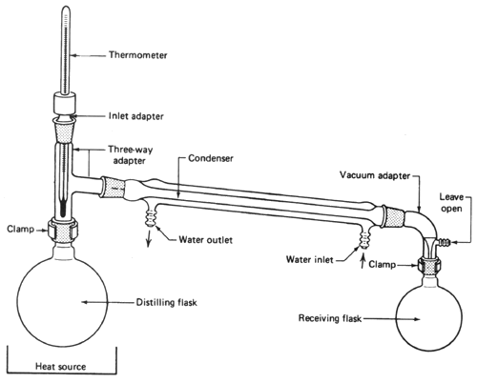

Fig. 1. Installation for simple distillation

By simple distillation vapors of boiling liquid from coming into the distillation flask cooler where the condensate is converted. In this process, vapor and condensate move in the same direction, so called a co-current distillation. Separation of mixtures of liquids can occur only at the stage of evaporation.

Simple distillation in vacuum
Some organic substances may not be distilled at atmospheric pressure, since they decompose partly or completely. Others have very high boiling points that make it difficult distillation. In such cases, the distillation should be performed under reduced pressure as vacuum vapor pressure becomes lower when the outside temperature.
To create a water jet vacuum is applied, and oil pumps. Water pump is attached to the tap by means of a piece of thick-walled rubber hose and secured with clamps. The inside of the water jet pump (Fig. 2) consists of two inserted one into other glass tubes of different diameter. The top tube is narrowed at the bottom, the water passes through it very thin stream at a high speed, dragging the molecules of the air and creating a vacuum in the outer chamber. With good pressure water jet pumps create a vacuum of 10-20 mm Hg. Art. Water jet pumps made of glass, stainless steel or Teflon.

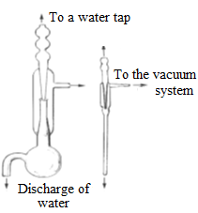

Fig. 2. Water jet pumps
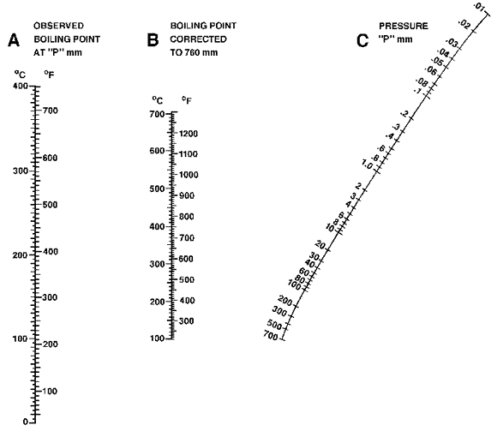
Fig. 3. The nomogram pressure – fluid boiling point.
For a rough estimate of the boiling point under reduced pressure, you can use the following rule of thumb: the reduction of the external pressure by half, the boiling temperature is lowered by about 15 ° C. Thus, a substance with a boiling point of 200 ° C at a pressure of
760 mm Hg. at 380 mm Hg. It will boil about 185 ° C.
To get an idea of ​​the observed under the boiling point is distilled at a residual pressure of any substance to the literature, you can use the nomogram shown in Fig. 3. To this must be imposed on a short line pattern so that it crossed the right scale to the point corresponding to that observed in the distillation pressure and average scale - in a point corresponding to the boiling temperature of the liquid was distilled at atmospheric pressure. Then the point of intersection of this line with the left scale will correspond approximately to the boiling temperature of the liquid when the device made in a vacuum.
Apparatus for vacuum distillation has several significant differences from the plant for distillation at atmospheric pressure
(Fig. 4).

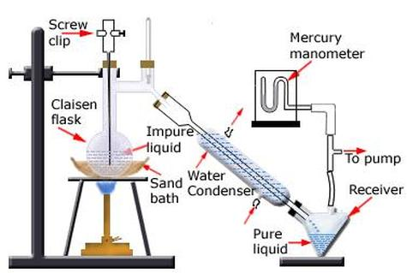

Fig. 4. Installation for vacuum distillation

Two neck distillation flask provided with Claisen attachment, one of which is designed for the throat of the thermometer, and the other for a capillary, through which the air or inert gas, when the system is under vacuum. The capillary is required to achieve uniform boiling liquid, without shocks and bounce. The amount of air flowing into the flask through a capillary, can be adjusted using the clamp on the hose piece is fitted on the upper end of the capillary. The hose must be inserted into a piece of thin wire, which prevents it from sticking under vacuum system and thus ensures the smooth flow of air into the flask.
When choosing a refrigerator governed by the same considerations as for distillation at atmospheric pressure. In order to make the process of vacuum distillation it was possible to select the individual fractions using different modifications rider. The most simple, so-called "spiders". Instead of "spider" is also used forshtos Anshyutts-Thiele, which allows you to change receivers, without breaking the vacuum in the device and without interrupting the distillation. This nozzle is used in large volume distillation fractions. Two neck distillation flask provided with Claisen attachment, one of which is designed for the throat of the thermometer, and the other for a capillary, through which the air or inert gas, when the system is under vacuum. The capillary is required to achieve uniform boiling liquid, without shocks and bounce. The amount of air flowing into the flask through a capillary, can be adjusted using the clamp on the hose piece is fitted on the upper end of the capillary. The hose must be inserted into a piece of thin wire, which prevents it from sticking under vacuum system and thus ensures the smooth flow of air into the flask.

Steam distillation
In organic chemistry, steam distillation is used for separation, purification, or separation of substances which are not miscible or little miscible. This process, which is co-distillation with water, consists of passing a jet of steam through the hot mixture was distilled substances and water. The method is based on the fact that the high boiling point substance having a volatility, and is transferred from the steam is condensed together with it in the refrigerator. The collected distillate in the receiver in the form of two immiscible liquid layers then separated in a separatory funnel.
Immiscible substances vapor pressure independent of each other, in contrast to what is observed for the soluble substances in each other. The total vapor pressure P equal to the sum of the mixture of the vapor pressures of the two components. P_{A} and P_{B} is not dependent on the ratio of the components:
P = P_{A} + P_{B}.

The boiling point of a heterogeneous mixture is achieved when the total pressure becomes equal to atmospheric vapors.
When steam distillation a mixture of water and high boiling point substances boil at temperatures below the boiling point of water. It allows you to clean high-boiling substances are sensitive to heat, do not withstand conventional distillation. Steam distillation is of great importance in the separation of volatile products from the tarry impurities. Often this method is used in the allocation of organic matter from natural objects, especially those that are part of the essential oils.
In order to determine whether the steam volatile substance, a small amount must be heated in a tube with two milliliters of water. Above this second test tube holding the bottom of the tube, which put ice. If condensing on the cold bottom of the second tube turbid drop, the volatiles steam.
Instead of water vapor and vapors can be used other substances with the following properties: low mutual solubility with the secreted substance vapor pressure close to the water vapor, and a low molecular weight. Apparatus for steam distillation is shown in Fig. 5. It consists of a steam generator, a tube through which the steam enters the distillation flask and the refrigerator. As the steam generator can be round or flat-bottomed flask.

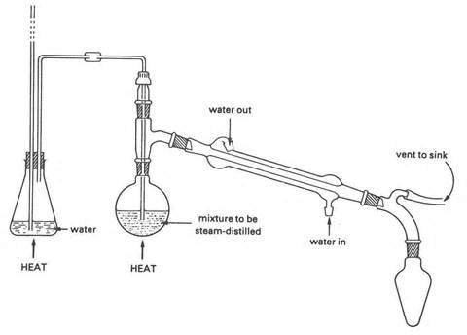
Fig. 5. Apparatus for steam distillation

Fractional distillation (rectification)
Simple distillation method is not effective for the separation of liquids with a difference in boiling points of less than 80 ° C. In this case use by fractional distillation (rectification), based on the multiple repetition of the evaporation and partial condensation of the vapor mixture of liquids, which results in their separation. Distinguish distillation at atmospheric pressure and under vacuum (applied to separate high boiling and thermally unstable liquids).
Similarly, the behavior of a pure liquid, a binary mixture of two completely miscible with each other liquids starts to boil at a temperature at which the total vapor pressure of both components is equal to the external pressure. The total vapor pressure of the mixture equals the sum of the partial vapor pressures of each component. According to Raoult's law the partial pressure of one of the mixture components depends on the mole fraction of the substance in the mixture.
When the total vapor pressure of the mixture reaches 760 mm Hg. Art., it starts to boil. Since the partial pressure of volatile components makes up most of the total pressure, the original condensable
vapor consists mainly of a volatile component and contains only a small amount of high boiling material which accumulates in the residue. However, this leads to the fact that according to Raoult's
law the partial pressure of a high boiling component was increased. As the concentration of the residue of the substance increases the boiling point, and its share in the vapor increases. Progress in this distillation by the example of ethanol, butanol is depicted in
Figure 6.
An equimolar mixture of ethanol, butanol and boils at about
93 ° C at atmospheric pressure (pure ethanol boils at 78 ° C, pure butanol at 117.5 ° C). The lower curve shows the temperature dependence of the boiling mixture of ethanol and butanol from their composition (in mole percent). The upper curve expresses the appropriate vapor composition defined by Raoult's law. Distillation takes place with a gradual increase in the boiling temperature according to curve towards the lower point 1. Separation of this mixture can only be achieved by repeating multiple distillation fractions collected.
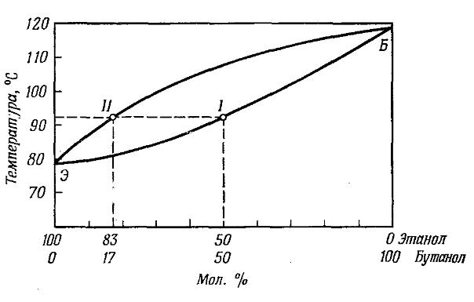

Fig. 6. Diagram of ethanol – butanol boiling

Separation efficiency can be markedly improved by using a fractional distillation (rectification) method. Distillation was carried out using a special speaker – reflux condensers (dephlegmators).

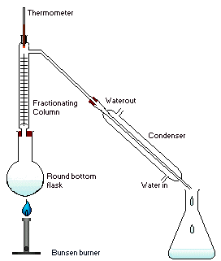

Fig. 7. Installation for rectification

To a mixture of two liquids distillation apparatus was collected, shown in Fig. 7 («quicklime» placed at the bottom of the flask to the apparatus assembly).
Dephlegmator consists of a set of vertical tubes bulb distillation (column) filled with a material with a large surface area on which the partial condensation of the vapor. The dephlegmator and steam condensate (reflux) move in opposite directions that is based on the action column countercurrent principle couples rising upwards is removed from the reflux flowing down low-boiling components and vapor reflux extracts high boiling component. The process is repeated several times throughout the column height. This type is called countercurrent distillation. It is necessary to establish the closest contact between rising vapor and descending condensate, which flows into the distillation flask. Under these conditions, an equilibrium is established in a dephlegmator, wherein the vapor in the upper part composed mainly of the more volatile component. The process efficiency depends on the surface area of ​​the falling reflux. In the best cases it is possible to divide the liquid boiling temperature which differs by only a few degrees.

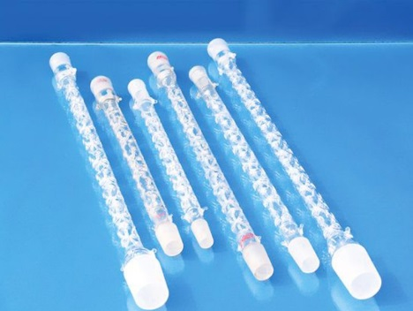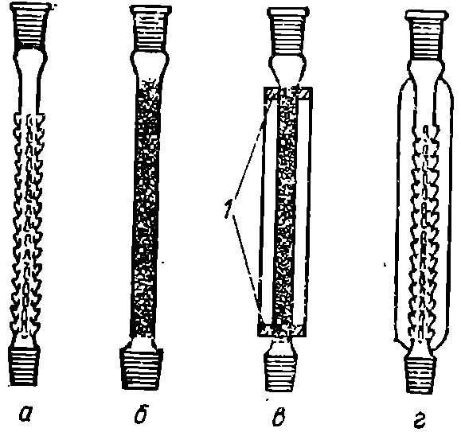

a – Vigreux column, b – with a nozzle, c – with a revolving belt, g – tree shape

Fig. 8. Reflux condenser (dephlegmators)
There are several types dephlegmator (Figure 8). The first type includes those columns in which a high surface area is achieved by filling a loose material of the cylindrical tube, which is called "nozzle" (Fig. 8b). As the nozzles used glass beads, glass or porcelain rings (Raschig rings), glass and metal spiral, cutting short glass tubes.
The columns of the second type are liners made of pre-cast stainless steel meshes.
The third type is represented by open columns with respect to the internal space. These include Vigreux column representing tselnopayanuyu glass tube with projections pointing downwards (Fig. 8a), «Christmas tree» reflux condenser (Fig. 8d). The most effective of these are the columns of concentric tubes, in such columns vapor rises through the narrow annular space between the two walls through which the condensate flows.
There is also a column with a rotating belt, where in the condensate and vapor is mixed by means of rapidly rotating the twisted tape.
The distillation column should be insulated to processes occurring in it proceeded in the conditions maximally approximate to adiabatic. With significant external cooling and overheating of the walls speakers correct her work is impossible. When the distillation of substances with a boiling point up to 80 ° C as the insulation can wrap the cord column asbestos, glass wool, put on her "shirt" or foam placed in a glass tube, to thereby create an air shirt.
Column type is selected based on the difficulty of separation of the mixture. The closer the boiling point separated liquids, the more effective shall be the column, i.e. have a greater internal surface area. In addition, it is necessary to take into account the amount of product being distilled, and the value of the pressure at which distillation should be carried out. The amount of each component being recovered in pure form from a feed mixture shall be at least 10 times the column operating capacity. For the distillation of small quantities of substances used column with the least possible labor capacity (hollow tube, Vigreux column).
However, not all liquid mixtures can be separated into individual components, even when using the most efficient distillation columns. There azeotropic mixtures boiling at a constant temperature. They can not be separated by distillation, since the resulting vapor has the same composition as the liquid. In this case we speak about the positive or negative deviation from Raoult's law. In practice one often encounters azeotrope formed by water and an organic liquid such as ethanol (96%) - water (4%). Water separation is performed in such cases by means of drying agents such as anhydrous calcium chloride or oxide, sodium sulfate, sodium or potassium hydroxide, phosphorus oxide (V) and others. Ethanol for dehydration, for example using refluxing over calcium oxide svezheprokalennym for 6-8 hours, after which the alcohol is distilled, preventing moisture from air drying calcium chloride tube attached to a alonzh tube.
Experimental technique. The flask was filled with a mixture of 2/3 shared heated on a hot plate (or bath, depending on the nature of the components of the mixture) to boiling and set the rate of distillation 1-2 drops per second (Fig. 7). Too rapid distillation of steam enters the refrigerator, without having to enrich low-boiling component, and therefore the separation of the mixture becomes impossible. During the distillation, several fractions were collected and their number depends on the number of the substances in the mixture. The temperature range of the collection of each fraction is selected empirically.
Laboratory work № 8

Crystallization

Crystallization – is the process of formation and growth of crystals from a solution, melt or gas phase.
Crystallization and recrystallization from a solution or substance melt and crystallization from the gaseous phase (sublimation, volatilization) are widely used in laboratories and in the industry to be effective methods of cleaning contaminants from solid compounds. The process generated organic synthesis «raw» (crude) products can be released in a more or less pure form by cooling the reaction mixture, or after evaporation of the solution, but require further purification, so subjected to recrystallization. Often the «raw» product manages to clear only by repeated recrystallization, leading to large losses of substance. It is therefore desirable pre-treatment of the substance or the use of another method of treatment.
Recrystallization from a solution
Recrystallization from a solution is based on the fact that the solubility of compounds in solid hot solvents is much higher than in the cold, as well as on the difference in the solubility of substances in the same solvent. Recrystallization from a solution in two sluchashyah applied when the crude material contains a readily soluble or, alternatively, the insoluble impurities.
If the impurity solubility greater solubility of the basic substance, after recrystallization, the primary material will be in the solid phase and impurity – in the mother liquor.
When the solubility of impurities is less solubility of the basic substance by heating the crude product of the saturated solution is prepared in a suitable solvent, the solution was filtered hot to remove insoluble impurities and the filtrate was then cooled. As a result, drop crystals whose impurity content is less than in the starting material.
Sometimes the crude material contains impurities, which are soluble in the solvent to a very small degree and thus partially precipitated together with a basic substance. Then quite a pure substance can be obtained only by repeated recrystallization (fractional crystallization).

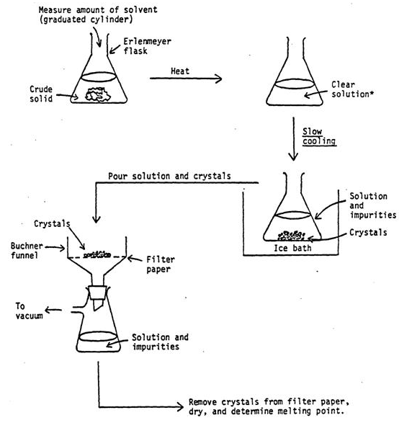

Fig. 9. Recrystallization procces

Dissolution – a physicochemical interaction process gas, liquid or solid matter from the liquid (the solvent), whereby a solution is formed as a transparent homogeneous liquid. At the same time under the influence of liquid molecules is the distribution of solute throughout the volume of the solvent. This process is known to the saturation limit. The solution which is in equilibrium with a solute and contains the maximum possible amount of material at a given temperature, called a saturated solution. The saturated solution of a dynamic equilibrium in which at a time so the molecules pass into solution as separated from the solution. The saturated solution at this temperature contains the maximum possible amount of material. The concentration of a saturated solution of a substance is a measure of the solubility under these conditions. Reserve solubility of the substance at a given temperature coefficient is characterized by a solubility that shows the number of grams of a substance that is soluble in 100 g of solvent at a given temperature. The unsaturated solution contains less material and in a supersaturated – more than saturated.
For the first time received supersaturated solutions T.E. Lovitz (1794). This solution having a high concentration of solute than a saturated solution under the same conditions. They can be prepared by slow cooling of saturated solutions. Supersaturated solution is thermodynamically unstable. Introducing these crystal mixing solute or promote the precipitation of excess substance from the solution. On the dissolution rate affects the degree of grinding of the solute. With increasing fineness increases the contact surface between the liquid and solid phases, which speeds up the process.
The choice of solvent. Crystallization success largely depends on the correct choice of solvent. The solvent used for crystallization, should have the following properties:
a) be chemically inert with respect to the cleaning substance at room temperature and the boiling temperature of the solution;
b) the solubility of the substance in the chosen solvent should increase significantly during heating and cooling at – decrease;
c) dissolving the impurity well even at a lower temperature, or to dissolve them virtually at boiling;
g) the solvent must be easily removed from the surface of crystals by washing or by drying.
To select the solvent used reference data on the solubility of the substance being purified, or carried out by the selection of an experienced. The tube is placed, and a few grains of substance added 2-3 drops of solvent. If a substance is easily soluble at room temperature, the solvent is not suitable for purification from soluble impurities, but can be used for removal of insolubles. In the case where dissolution at room temperature is bad, the tube was gently heated until complete dissolution of the sample. If, after cooling, the crystals fall, the suitable solvent for recrystallization. It is desirable that the solvent boiling temperature was 10-15°C below the melting temperature of the substance. Otherwise, the agent may be allocated as an oil (melt). The substance in the result is dirtier than before recrystallization. This can be explained by the formation of two-phase system with a large contact surface, as a result of removing the substance from the solution is an impurity as dopant distribution ratio between the solvent and the molten material tends to be in favor of the molten material. If the substance is recrystallized very low melting point and is not possible to select an appropriate solvent, the dissolution should be conducted at a lower temperature and to provide a strong solution of cooling agent.
When unable to pick up an individual solvent, crystallization is carried out from a solvent mixture. For compounding, usually choose two solvents: «good» (good dissolving substance) and «bad» (non-solvent). Cleansing agent is dissolved under heating in a «good» solvent, then reduce its solubility, adding dropwise a hot solution of «poor» solvent nonvanishing until turbidity. The solvents used in the mixture must be mixed well with each other. The following solvent mixtures are typically used: water-alcohol; alcohol-benzene; alcohol, glacial acetic acid; acetone-water; ether-acetone-benzene; chloroform-petroleum ether and the like.
When choosing the solvent guided empirical rule «like dissolves like» (hydrocarbons - hydrocarbon, carbonyl compounds – in acetone, etc.). In other words, for dissolving substances used solvents with similar or the same chemical properties, also recorded their polarity, characterized by the value of the dielectric constant ε (value ε given in reference literature), which for different solvents varies in a fairly wide range (for ε hexane = 1, 9 for ε = 25, ethanol, etc.). Polar substances are readily soluble in polar solvents (high value of ε), and the non-polar – nonpolar (low value of ε).
When choosing the solvent should be considered its freezing point, the possibility of regeneration after recrystallization, toxicity and availability.
Most used solvents - water, alcohols, acetone, diethyl ether, dioxane, ethyl acetate, chlorinated (chloroform, carbon tetrachloride, dichloroethane, chlorobenzene), carbon disulfide. Often, solvents are aliphatic and aromatic hydrocarbons, petroleum ether (mixture of liquid alkanes, mainly C₅ and C₆ branched chain), gasoline (a mixture of liquid hydrocarbons containing in the molecule an average of from 5 to 9 carbon atoms), cyclohexane, benzene, toluene, xylenes. Other commonly used solvents should be noted nitrobenzene, acetonitrile, formamide and solvents possessing the basic amine properties – pyridine and quinoline. Similar properties are to diethyl ether, tetrahydrofuran (THF) and dioxane. All solvents are characterized by certain physical constants (boiling point, distillation range, density, refractive index). Purified solvents containing no water are referred to as absolute.
There are various methods of purifying organic solvents. Thus, for example, diethyl ether absolutises repeated shaking with a concentrated solution of calcium chloride and subsequent distillation over sodium metal. Ether is very dangerous to use - highly flammable, it forms explosive mixtures with air.
Dehydration of ethanol – boiling calcium okisidom rectified with in a few hours. Ethanol is easily ignited, forms explosive mixtures with air.
Stimulation of crystallization. Often the crystalline substance is not out of solution, even on prolonged cooling. In order to accelerate the crystallization process creates artificial crystallization centers. It is often used two passes.
1. Introduction «seed». This technique consists in the fact that a solution is made of the same substance crystals (seed), i.e. artificially create the crystallization centers. If a pure substance there can be moistened with a glass rod and abruptly cool it by placing an empty tube cooled externally. The thin films of liquid crystals are formed on the surface of the glass rod. It is also possible to leave the solution for several days at low temperature.
2. Rubbing a glass rod to the vessel wall. This technique consists in the fact that taking neoplavlennuyu glass rod, making it into the solution and gently rubbing against the vessel wall. This creates a fine glass dust, some dust particles may be suitable crystallization centers. The same crystallization centers and may be dust particles contained in the air. Crystallization always starts from the walls and from the surface to the center, on hard surfaces or at the interface. The electric and magnetic fields, ultrasound, and sometimes strong cooling (e.g. with liquid nitrogen) – all contribute to the process of crystallization.
Experimental technique. Recrystallization from a solution includes the following main steps:
a) dissolving the substance with heating;
b) hot filtering to separate insoluble impurities;
c) crystallization upon cooling of the mother liquor;
g) filtering under vacuum.
When choosing a solvent for an unknown substance should always be first to experience its solubility in water. For this small amount of material to be placed in a test tube, add 1 ml of water (solvent) and observe the dissolution at room temperature. If the substance is not dissolved at room temperature, the tube with the material must be heated to boiling.
If a solvent suitable for crystallization on cooling tubes under cold running water must fall crystals.
In the presence of activated carbon to be added in the material colored impurities. It should be borne in mind that the addition of coal causes a sharp boiling, therefore it can not be added to the superheated liquid. It should be somewhat cool the solution, and then adding carbon.
After selecting the solvent for the crystallization agent is weighed and placed in a conical flask, adding small portions of pre-heated water (solvent). If the substance is not dissolved, then add a little water and the solution was again brought to boiling and etc (Fig.9.).
When the substance is completely dissolved, saturated hot solution rapidly filtered, making sure that during the filtration did not drop crystals. To crystallisation does not start on the funnel, it is necessary to heat and to avoid saturation of the solution. If the solution is cooled slowly, large crystals were formed. For a more complete separation of crystals flask must be cooled under running cold water. The crystallization may be accelerated by friction of the glass rod sides of the flask.

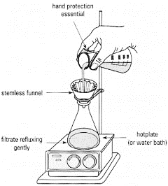

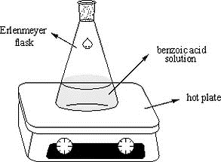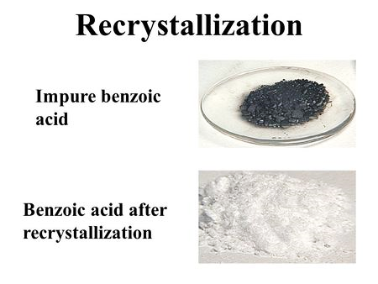

Fig. 10. Scheme of Experimental technique of recrystallization

The crystals were filtered off from the mother liquor under water pump vacuum on a Buchner funnel, using a Bunsen receiver flask (stock solution if many) or a small tube of sidearm. After separation of the crystals they were dried in air, weighed and the yield of pure substance in percent by weight taken for crystallization.
ІІІ. DETERMINATION
OF PHYSICAL CONSTANTS

After purification and chemical analysis we need to determine physical constants of analyzing substance (melting point, boiling point, refraction index). Using handbook you can answer to question what compound given for analysis easier than all are defined and are, as a rule, given in chemical literature at the description of separate connections the following: melting point, boiling point, density, index of refraction, and in certain cases also optical rotation, size R_{f}, IR, UV, nuclear magnetic resonance and mass spectrums.
It is simplest to establish identity of unknown compound with known (identification), and also to prove its purity, having defined its physical constants and having compared them to the available literary data. It is possible to recognize substance clear only when its physical constants do not change after repeated cleaning.

Laboratory work № 9

Melting point

Melting point (m.p) is the major constant characterizing solid matter.
Melting point of compound call temperature at which its crystal phase is in equilibrium with characteristic melt. Melting point corresponds to temperature at which steam tension over solid matter is equal to steam tension over liquid.
It is possible to define melting point in the course of melting or in the course of a crystallization of a melt as if overcooling is excluded, crystallization temperature coincides with melting temperature. Usually mean an interval of temperatures between emergence of the first drops of liquid and the complete transition of solid matter of liquid state by melting point. For pure individual substances this interval is measured by degree shares. It is possible to define a temperature band of melting by repeated melting of an exemplar after its hardening more precisely.
In the presence of impurity melting point of substances always goes down according to a Raoul's law.
Thus, mixtures of substances have to melt at lower temperature, than the individual substances making them. Absence of a depression of melting point of mix of the studied substance with the standard is considered as the proof of their identity (or their complete relative insolubility). Use it for identification of chemical combinations. For this purpose mix in equal quantities (on 0,05 or 0,1 g) the studied substance and chemically pure standard substance (reference substance) and define melting point of mix. If test of mixture melts at the same temperature, as each component separately, identity of the studied substance with standard is considered proved. If test of mixture melts at lower temperature, than each component separately, it means that the studied substance not to the identically standard.
Determination of melting point of mixture is the most widely used and easily applicable criterion of identity which, however, should use with caution. Existence of a depression indicates distinction of substances, but absence of a depression is observed sometimes in case of two rather difficult compounds having slight structural distinctions.
Technology of experiment. The most widespread of all methods of determination of melting point of organic matters is determination of melting point by a capillary method. For this purpose a small amount is thin the pounded and well dried up preparation place the thin-walled capillary soldered since one end which attach to the thermometer and place in the heating block. Use a capillary 45-50 mm in length, with a diameter of 1.0-1.2 mm for colorless substances and 0.8-1.0 mm for the painted. For waxy and fibrous substances it is possible to use capillary tubes of a few larger sizes. When filling a capillary its open end is pressed several times into the powdery substance placed on a clock glass. After that the capillary is struck several times with the filled end about a table surface. The filled capillary is thrown the soldered end down by 10-15 times through a glass tube 800 mm high and with a diameter of 15-20 mm, put upright on a glass or tiled plate, before consolidation of substance into a layer of 2-3 mm. Melting point of hygroscopic substances is defined in the capillaries soldered since both ends; thus the capillary has to be shipped entirely in a heating bath (the heating block).
The capillary is fixed on the thermometer a rubber ringlet (a ring cut off from the rubber hose suitable by the sizes), a copper wire or paste top end a drop of sulfuric acid. Test of substance has to be at the level of the mercury tank of the thermometer.
Upon transition from solidity in fluid in routine conditions of heating in a capillary it is possible to observe the following phenomena: contraction of substance (the column of substance changes the form, contracting and lagging behind capillary walls, without visible transition to liquid state); a steam (on an internal surface of a capillary there are liquid droplets, the substance bakes, without losing the compendency); partial melting (in a capillary along with solids the liquid meniscus on all section of a capillary is formed). After that at a little more high temperature there comes the condition of the complete fusion.
To avoid a rather large and sometimes not enough reliable amendments on extending the mercury, thermometers are recommended for shorter set of TL-6.
Some organic substance melts with decomposition (color appearance, gas evolution). The decomposition temperature is usually not clearly expressed, and often not able to accurately reproduced.
Melting point determination in a capillary can be performed very precisely, if at the preliminary experiment to determine the approximate melting point material, and then the capillary with the substance placed in the device, heated a few degrees below this approximate value.
The simplest of these is the DDMP instrument (Fig. 10). This device consists of a round bottom flask with 100-150 ml of throat 90 mm long and 30 mm in diameter. The flask was poured on 2/3 of its volume of coolant, which is used as the concentrated sulfuric acid, paraffin or silicone oil.
The neck of the flask is inserted into a special tube length of 150 mm and a diameter of about 15 mm, which is fixed in the neck of the bulb ring with a special slot (to avoid an explosion, possibly by heating a sealed container); moreover, the tube has an opening for communication with the atmosphere.

1 – Flask 2 – coolant 3 – test-tube 4 – thermometer 5 – capillary substance 6 – ring for fixing the capillary 7 – ring for fixing the tubes 8 – Hole in vitro

Fig. 11. The device for determining the melting point of the DDMP

The tube was sealed with a cork stopper inserted into it a shorter thermometer, a lower end of which must be a few millimeters above the bottom of the tube. The flask contents were heated to about
10-15 °C below the anticipated melting point of the drug, the instrument measuring the temperature with a thermometer, and then placed in a test tube with a capillary thermometer shortened so that no thermometer or capillary not touch the bottom and walls of the tube. Then continue to heat apparatus, raising the temperature at a rate of 0.5 °C per minute. If the substance decomposes during melting, the heating rate is increased to 2-3 °C in the mine, or the capillary is placed in the drug unit, preheated to a temperature of approximately 5 °C below the anticipated melting point. The beginning of melting is the appearance of the first drops of molten material, or the appearance of the meniscus in the capillary, and the end - moment of complete melting of the substance. Both temperatures note and consider melting range of the substance.
In determining the melting point of substances that melt below 170 °C is used without the rinsed vial flask. Sulfuric acid, the use of which requires great care, it can be used in the determination of the melting temperature of 250 °C. If concentrated sulfuric acid in the process becomes brownish tint, the bleach is added thereto a few crystals of potassium nitrate or sodium nitrate. A mixture of concentrated sulfuric acid (7 parts) and potassium sulfate (3 parts) after 5 minutes boiling under vigorous stirring, became a clear liquid which can be used as a heating medium to 320 °C (a mixture of hygroscopic, and it must be protected from moisture).

Laboratory work № 10

Boiling point

In the process of evaporation of liquids equilibrium between liquid and vapor. The vapor pressure above a liquid is determined by the temperature and the nature of the liquid. At the moment when the vapor pressure becomes equal to the external pressure, the liquid begins to boil.
The temperature at which the vapor pressure of the liquid becomes equal to the outside is called boiling point.
Boiling point unlike the melting temperature is strongly dependent on external pressure, so it is necessary to indicate the pressure at which measurements were made. If the pressure is not specified, it means that the boiling point is measured under a pressure of 760 mm Hg. Moreover, at its value significantly affected by the presence of even small amounts of impurities. Therefore, the boiling point is rarely used to identify characteristics of the fluid and its purity, more reliable performance pure liquid substance is the index of refraction. Table 1 shows the boiling point and refractive index of certain organic liquids.
With low vapor pressure deviation from the normal rule is executed:

ΔТ= С₀ (760–р) Т,

where ΔT – a deviation from the normal boiling point, K;
C₀ – empirical coefficient; p – pressure at which the measured temperature T.
The coefficient C₀ has the following meanings:
  - Substances with very low boiling points 0.00014.
  - The majority of substances 0.00012.
  - Substances associated by hydrogen bonds.

Table 1
Boiling point and refractive indices

Some organic substances  Substance | Т. boil., °С | n_{D}²⁰
Acetone | 56 | 1,3580
Benzene | 80 | 1,5010
Butanol-1 | 117 | 1,3985
Dimethylformamide | 153 | 1,4303
Diethyl ether | 34,6 | 1,3520
2-propanol | 82 | 1,3774
Petroleum ether | 40 – 65 | 1,3660 – 1,3700
Toluene | 110 | 1,4960
Chloroform | 61 | 1,4460
Carbon tetrachloride | 76 | 1,4600
Ethyl acetate | 77 | 1,3725

In most cases, a boiling point is determined by a thermometer immersed in the vapor phase. Boiling point defined in pairs, always lower than the true, as several pairs of sub-cooled and it takes time to reach thermal equilibrium and phase liquid – vapor. Therefore any liquid is distilled, first drops of distillate distills at lower temperatures. Conversely, the end of the distillation flask when there is little liquid as a result of overheating, the distillate is distilled at a high temperature.
In this regard, according to the existing standard boiling point is defined as the interval between initial and final boiling points at atmospheric pressure (760 mmHg, or 1013 kPa). Wherein initial boiling point is the temperature at which the receiver is distilled in the first five drops of fluid, and the ultimate – the temperature at which a receiver moves 95% of the liquid. But, strictly speaking, the boiling point of the liquid is such a temperature that the thermometer in contact with both the liquid and vapor phases – in this case the temperature is measured at equilibrium conditions.
The value of boiling point of substance largely depends on its molecular size and intermolecular interactions contribution. So, for normal alkanes (C4-C12) is characterized by an increase in boiling temperature to 20-30 ° C for each subsequent member of the homologous series. Strengthening of intermolecular interactions (with the same number of carbon atoms) in the series:

ethers <aldehydes <alcohols.

Fig. 12. Device for determining of boiling point
according to Sivolobova

It leads to an increase in the boiling points in the same sequence. Quite significantly increases the boiling point of the substance in the case of formation of intermolecular hydrogen bonds (alcohols, amines, carboxylic acids and so on). Effect of pollutants on the boiling point greatly depends on the nature of the impurities. So, it is strongly influenced by residual amounts of volatile solvent. On the contrary, the impurity compounds with the same boiling point do not change (under ideal behavior) boiling point, in accordance with Raoult's law. Generally, impurities in minor amounts are for the boiling point is much less significant than the melting point.

Determination is repeated several times using every time a new batch of liquid and a new capillary. The final result is considered as the average of all measurements. This value, reduction to normal pressure, take account as the boiling point of the substance. To bring the temperature to normal pressure boiling initially observed pressure lead to 0 ° C. To do this, subtract the correction barometer pressure, taking into account the amendment temperature: at 13-20 °C amendment 2 mm.Hg.clm. 21-28 °C 3mm.Hg.clm. 29-35 °C, 4 mm.Hg.clm. Then, using Table 2, the observed value of the boiling point corrected for each millimeter of mercury to the difference between normal blood pressure (760 mm Hg. clm.) and observed given to 0 °C. At pressures below 760 mm Hg.clm. an amendment was added, otherwise subtract.

Table 2
Amendment to bring the temperature of boiling to normal pressure

Temperature limits of boiling, °С | Amendment, °С for each mm.hg.clm | Temperature limits of boiling, °С | Amendment, °С for each mm.hg.clm.
10-30 | 0,035 | 130-150 | 0,050
30-50 | 0,038 | 150-170 | 0,052
50-70 | 0,040 | 170-190 | 0,054
70-90 | 0,042 | 190-210 | 0,057
90-110 | 0,045 | 210-230 | 0,059
110-130 | 0,047 | 230-250 | 0,062

Laboratory work № 11. Determination of the density

Determination of the density of the gaseous, liquid and solid substances is carried out to determine their degree of purity and identification, studies of the properties, determine the concentration of two-component solutions, alcohols, acids and bases.
The density of pure substance ρ – a physical quantity, equal to ratio from the mass m to the substance occupied volume V:
ρ = m / V

The basic unit of density in the International System of Units (SI) is the kilogram per cubic meter (kg / m³), the other ways of expressing the density – g / cm³, g / ml, kg / l, t / m³ – are derived from the main one.
The relative density of the material – the value equal to the ratio of its density to the density of some other substance under certain physical conditions. Such conventional material is water at 4 °C and normal atmospheric pressure (760 Torr or 1013 kPa) or dry air at
20 °C and atmospheric pressure:

d = ρ / ρ₀

where ρ – density of the material, ρ₀ – density of the standard substance.
Relative density – a dimensionless quantity. The relative density of the fluid can be carried to a temperature of 20 °C and a density of water at 4 °C. In this case, the relative density is denoted by d₄²⁰. If the density of the liquid is determined by the experimental conditions are not at 20 °C and at a different temperature t, its value can be restated d₄^{t} the normal value of the formula:

d₄²⁰ = d₄^{t} + a (t - 20)

where d₄^{t} – is a relative density of the test liquid at the test temperature t °C; A correction for the average temperature of 1 °C. Value-edits and are presented in Table 3.
Experimental technique. To determine the relative density usually use two methods. One of them is compared with the mass of the test body a certain amount of mass equal to the volume of the standard liquid (Pycnometric method); another technique is based on Archimedes' principle and the establishment of so-called «buoyancy», or «pushing force» (determination by hydrometer and hydrostatic weighing).

Table 3
Temperature amendment under determining density

Relative density | Amendment  а | Relative density | Amendment  а
0,810–0,820 | 0,000752 | 0,880–0,890 | 0,000660
0,820–0,830 | 0,000738 | 0,890–0,900 | 0,000647
0,830–0,840 | 0,000725 | 0,900–0,910 | 0,000633
0,840–0,850 | 0,000712 | 0,910–0,920 | 0,000620
0,850–0,860 | 0,000699 | 0,920–0,930 | 0,000607
0,860–0,870 | 0,000686 | 0,930–0,940 | 0,000594
0,870–0,880 | 0,000673 | 0,940–0,950 | 0,000581

Pycnometer can determine the density of gases, liquids and solids (Fig. 12). These glass-walled vessels with a label on the neck are stoppered on the sand. The method allows us to determine the density of the substance to 0.0001 g / cm³. To determine the density of matter pycnometric by trial must be thermostated. In the simplest cases, the density of liquids can be determined approximately using the hydrometer. This method has practical application, e.g., for determining the density of sulfuric and nitric acids. However, hydrometer measures the density requires large amounts of liquid, whereas the pycnometric method dimension sufficiently small and the amount of substance.

a – hydrometer, b – a hydrometer with thermometer soldered,
в – pycnometer
Fig. 13. Devices for determining of density
Laboratory work № 12

Determination of the refraction index

The refractive index – an important constant that is used to determine the purity of the substance, to clarify its chemical nature, as well as to determine the concentration of solutions.
When crossing the light beam interface between two transparent media changes the direction of the beam, the beam refraction occurs. This phenomenon is called refraction, that is, the refraction of light. The angle α, formed by the direction of the incident direction of the refracted ray with the continuation of the normal - light beam with the normal (Fig. 14), is called the angle of incidence and the angle β, formed an angle of refraction. According to the law of refraction of light, for optically homogeneous media attitude sines of the angles of incidence and refraction is a constant, called the refractive index or the refractive index n:

n = sinα / sinβ

Refractive index ratio is also called the propagation speed of light in air to the velocity of light in the substance being tested.
Medium1, α
Medium2, β

Fig. 14. The refraction of light at the interface of two media
The set of methods of physical and chemical analysis of liquids, minerals and solutions based on the measurement of refractive index is called a refractometer. The main advantages are speed refractometry measurements, low consumption of material and high accuracy (about 0.01%). Instruments used to measure the refractive index are called refractometers.
The most widely used method for determining the refractive index of the limiting angle of refraction and total internal reflection. When the light beam passes from the medium 1 with refractive index n1 to medium 2 having a refractive index n₂, between the angles of incidence α and the angle of refraction β relationship exists:

sinα / sinβ = n₁ / n₂ или n₁ sinα = n₂ sinβ

medium1

Medium2

Fig. 15. Total internal reflection of light

If the medium is optically denser medium 1, 2, the angle of incidence and angle of refraction less (Fig. 15). If the angle of incidence approaches its limit value of 90 °, the refractive index and the angle can be 90 °. In this case, the beam does not pass into the second medium, and slides along the interface. With further increase of the angle of incidence beam reflected from the medium 2. This phenomenon is called total internal reflection, and the angle of incidence at which it occurs - limiting the angle of incidence γ. In this case, the last equation becomes:

n₂ sin 90 = n₁ sin γ

However, sin 90 = 1, то n₂ = n₁ sin γ purposes. The refractive index of the binary mixture depends on the concentration of the components that can be calculated, using the formulas:

x = (n - n₀) / F,

where x – mass concentration of the substance in the solution;
n – refraction index of the solution; n₀ – solvent refractive index of standard solution at the same temperature; F – factor equal to the refractive index of the largest gain with an increase in the concentration of 1% (set experimentally).
In case of deviation from linearity for accurate determination of concentrations is necessary to build a calibration curve in the coordinates «concentration – the index of refraction». If the difference in refractive indexes constituting the solution components is equal to 0.1, then the accuracy of determining the concentration by the refractometry method can make a few hundredths of a percent.
The value of the refractive index is used in organic chemistry to find the value of molecular refraction M_{r} of the material which is its constant independent from the temperature.
Knowing the refractive index of the material n_{D} and its density
d₄^{t}, molecular refraction M_{R} calculated by the equation of the
Lorentz:

M_{R} = (n²-1) M / (n² + 2) d = 3/4 π N_{L} α,

where M – molecular weight of substance; α – the electronic polarizability of the molecule.
The molecular refraction leads to a number of assumptions about the structure of the molecule, it is directly proportional to the electron polarizability of the molecule.
Technique of the experiment . Determination of the refractive index is carried out by the refractometer IRF-454 (Fig. 16).

1 – quide , 2 – refractometry block , 3 – socket, 4 – hook, 5 – scale 6 – vernier,
7 – fitting, 8 – the handle, 9 – socket, 10 – the hinge ,11 – mirror 12 – the union,
13 – guiding, 14 – valve, 15 – the mirror , 16, 17 – flywheels

Fig. 16. Refractometer IRF 454

Work on the refractometer is carried out in the following
order:
1. The refractometer is set so that the light shines on the window of lighting prism (with open damper 14). The light source can serve as a light bulb or fluorescent light.
2. On a clean polished surface of measuring prism with a glass rod or a pipette without touching the surface add a few droplets of a liquid
3. Dip the lighting prism and press it with hook 4.
4. Install the eyepiece to clearly see the crosshairs, is the mirror collar 11 to achieve the best illumination of the scale.
5. Rotate the flywheel 16 introduce the border of light and shade in the eyepiece. Rotate the flywheel 17 to the disappearance of a rainbow of color-term boundary line.
6. Flywheel 16 suggest the border of light and shade exactly on the cross-hairs on the scale and remove the countdown. The index serves as a benchmark for fixed vertical bar prism 10. The scale interval 5 ∙ 10⁻⁴. Whole, tens, hundredths and thousandths portion ticking on a scale ten-share estimate by eye.
ІV. PHYSICAL METHODS OF ORGANIC COMPOUNDS IDENTIFICATION

The use of physical phenomena is one of the leading places in the analysis of chemical systems. Today, everyone who is connected with chemistry or studies of the substance is required to navigate the physical and chemical methods of analysis. There are a number of methods used in analytical chemistry. The chromatographic and spectral methods are used in most research laboratories of production quality control. It should be noted a great interest and practical application of these techniques in various fields of human activity and the flow of chromatographic and optical processes in nature. Suffice it to list the applications: analysis of environmental pollution, food analysis, medicine, clinical analysis, toxicological and trial use,
etc.
Chromatography prevails over other separation methods, without replacing them. Chromatographic instruments occupy one of the first places both in terms of use, and growth in demand for them. However, the holding of any chromatographic analysis is often associated with other physical and chemical methods of analysis.
Optical methods allow for qualitative and quantitative determination of substances. For a comprehensive analysis of the substance of the authenticity, the presence of impurities quantitative determination involves the use of various physical and chemical methods. To characterize any chemical compound, it is necessary to know the optical properties, the ability of the distribution and adsorption on different materials, and the possibility of its extraction. It should be emphasized that the chromatographic, optical methods (spectrophotometry (UV, IR spectroscopy, and others) do not compete with each other and complement each other.

- Chromatographic methods of analysis

In 2003, 100 years since the opening of one of the most effective methods to study the composition of complex multi-component mixtures of substances – chromatography. This discovery belongs to the Russian botanist MS Flowers, who first was not limited to the simple observation of phenomena of adsorption plant pigments on the powdery adsorbents, but realized that in these simple experiments before him the curtain of obscurity, beyond which is truly boundless possibilities for studying the structure and properties of a variety of substances.
«Chromatography (from Greek “hromatos” – color) – physical separation method in which the separated components are distributed between two phases, one of which is stationary (stationary phase) while the other (the mobile phase) moves in a particular direction» (the terminology IUPAC 1993).
However, chromatography is not only a «physical method of separation». The chromatography can be defined as the science of separation methods, as well as the qualitative and quantitative determination of components of liquid and gaseous mixtures based on their different sorption (adsorption, distribution, etc.) in dynamic conditions. Dynamic conditions are created in the simplest case the motion of the analyzed mixture components (mobile phase) through a sorbent layer (stationary phase). The stationary phase (SP) chromatography can be in solid and liquid sorbents. Movable second phase (MP), – gas or liquid passing through the chromatography

Classification chromatographic methods
- In the state of aggregation phase.
- Gas chromatography – Mobile phase (MP) is a gas; gas-solid phase (stationary phase (SP) – solid), gas-liquid chromatography (stationary phase – liquid).
- Liquid chromatography – Mobile phase – liquid; liquid – solid-phase chromatography (stationary phase – solid sorbent), liquid – liquid chromatography (stationary phase – liquid).
- The shape of the stationary phase.
- Column chromatography (CCh).
- Planar chromatography – stationary phase is applied to a plane (paper chromium (PC)),
- Chromatography in thin layers (TLC).
- On the mechanism of sorption.
- Adsorption – the absorption of solid sorbent due to the intermolecular interaction forces.
- Distribution – solubility in different stationary and mobile phases.
- Ion exchange – differences in the electrostatic interaction of ions with the ionic groups of the sorbents.
- Sedimentary – difference in solubility of the substances to be separated.
- Ligand-binding – the difference in the ability to form coordination compounds with defined component.
- Exclusion – separation based on the difference in the sizes and shapes of molecules.
- By means of a chromatographic process.
- Front, exclusion, eluent.

Laboratory work №13

Preparative chromatographic separation on columns
(of dyes, pigments, green leaf)

Objective: to divide preparative column dyes, pigments, green leaves, preparatively separate dyes and pigments of green leaves by using column chromatography.
Equipment: green leaves, methyl orange, methyl blue, crystal violet, malachite green, petroleum benzene, benzene, sodium sulfate, methanol, calcium carbonate, sucrose, petroleum ether, alumina, glass columns of diameter 8 - 10 mm and a length of 25-30 cm, burettes, tubes, pipettes, burettes with rubber tube, clamp screw chuck, and a glass end or faucet, glass wool, volumetric flasks, conical flask for 25-30 ml, water bath, a piece of copper mesh.
Usually for chromatographic separation of substances on alumina mixtures used glass columns with diameter 8-10 mm and a length of 25-30 cm also used burettes with rubber tube, clamp screw chuck, and a glass end or faucet. Before installation the column washed thoroughly, dried, placed in the lower part of the glass wool swab and installed to the tripod, so that it could be placed beneath Receiver – conical flask at 25-30 ml (Fig.17).
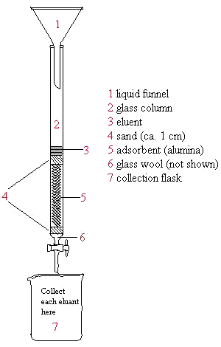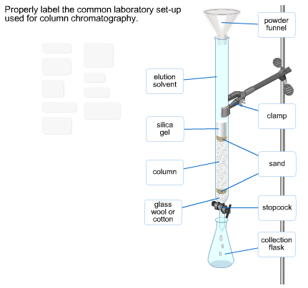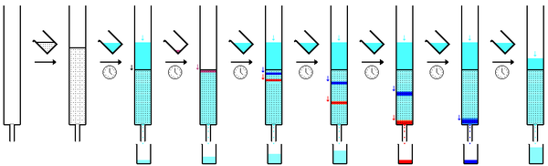

Fig. 17. Chromatographic separation of mixtures of substances
on alumina employed diameter glass columns

Alumina for column packing has a mark "for chromatography". The degree of its activity should not be less than III. It has to be previously sieved through a sieve of 0.25 mm or through folded twice nylon stocking. Next substance is placed in a conical flask and wet in a solvent which is after it used in accordance with the prescription of two subsequent separations of specific substances. The resulting alumina slurry poured by small portions in a fixed tripod column, continuously tapping it with a piece of thick-walled vacuum rubber to ensure settling of the adsorbent. When filling of the column is completed from the upper part of its walls washed remainder of alumina with the same solvent. The top layer of the adsorbent must be sufficiently dense and smooth, or moving layer of substances in the process of separation will be greatly distorted.
When alumina finally precipitates, into the upper part of the column (0.5 cm above the surface on alumina) you have to put second wad from glass-wool. The solvent must flow out from the column at rate of 30-40 drops per minute. If the aluminum oxide layer will be too thick and the desired speed of dripping will not be achieved, then it has to be increases by air pressure on the top of the column. For this purpose, the column top equipped with a rubber stopper with a tube connected to a compressed air system. When the level of the solvent in the column is fall to the upper pad of glass-wool, to the column is poured prepared mixture of substances to be separated. It should be remembered that during operation alumina should always be covered with the solvent.
Separation of methylene blue and fluorescein mixture. In column1 (10-12 mm) filled with 15 g of aluminum oxide in ethanol, at once poured a mixture of 30 mg of fluorescein, and methylene blue (1:1) in 20 mL of ethanol. With the passage of the solution through a column separation observed a blue strip of methylene blue from green-yellow fluorescein strip. Methylene blue is eluted from the column with ethanol in the receiver. Then change the receiver and fluorescein eluted with water. The resulting solutions are evaporated and determined yield for each dye.
Separation of methyl orange and methylene blue mixture. It is carried out as described above (see. Separation of methylene blue and fluorescein mixture). For the separation of the solution take 10 mL of methyl orange, and 30 mg of methylene blue in 15 mL of ethanol. Methylene blue washed with ethanol, and methyl orange with water.
Separation of crystal violet and malachite green mixture. It is carried out by the same procedure (see. Separation of methylene blue and fluorescein mixture). For the separation of the mixture used a solution of crystal violet 50 mg and malachite green 50 mg. As the liquid is used water while filling the column. It is also used for the subsequent washing of both dyes.
Separation of green leaves pigment on column with several adsorbents.
Dry 4-5 fresh leaves or grass for 1 hour at 40 ° ​​C or 20 hours at 0°C. Finely crush and shake for 1 hour with a mixture of 90 mL of petroleum ether, 10 ml of benzene, and 30 ml of methanol. Filter and wash filtrate for 4 times by 50 mL of water. Dry with sodium sulphate and evaporate on a steam bath before a volume of 5 mL.
To the bottom part of the column d = 1 cm put a piece of copper mesh and fix it. Place on that piece and filled with a plug of cotton wet column (as described above for the alumina). In the individual conical flasks shake 8 g alumina with I activity degree, 5.3 g of calcium carbonate and 7 g of sucrose with 15, 30 and 20 mL of petroleum ether at each. After placing of alumina to its surface placed a circle of filter paper. After this you need to place suspension of calcium carbonate, sucrose and circle again. From the dropping funnel are placed pigments extract. Wash with benzene-petroleum ether (1:4). In column appears strips (from bottom to up): bright orange (Al₂O₃) - carotene; yellow (CaCO₃) – xanthophylls; blue-green (sucrose or CaCO₃) – chlorophyll a; bright green (sucrose) – chlorophyll b.
Air sucked through the column for drying. Copper grid is removed and adsorbents pushed onto the filter paper. From each batch of adsorbent pigments eluted with a mixture of ether:methanol (50:1).

Control questions:

- What is the essence of chromatography methods?
- What is the nature of the chromatographic separation according to the method: a) gas adsorption chromatography; b) gas-liquid chromatography; c) distribution of liquid chromatography; g) precipitation chromatography; d) TLC; e) ion-exchange chromatography; g) molecular sieve chromatography?
- What are the areas of use, the advantages and disadvantages of adsorption chromatography methods?
- What are the requirements for adsorbents and solvents? What are the most common solvents and adsorbents in liquid chromatography?

Laboratory work №14

Separation of amino acids by means of partition chromatography on paper

Objective: to divide and identificate amino acids. Their mixture is gived as a solution. The task is designed to glycine, alanine, valine and phenylalanine. By using of partition chromatography divide amino acids on paper.
Equipment: glycine, alanine, valine, phenylalanine, 0.5% ninhydrin solution in methanol or acetone, a graduated cylinder for 1 liter, chromatographic paper, glass slide.
Before the work take from the instructor control task – the solution of two unknown amino acids, from the laboratory assistant – a sheet of chromatography paper which is cutted to the size of the cylinder, draw in it with a pencil as shown in Fig. 18. In the ruler is carried out a distance of 2 cm from the lower horizontal cut off line AB. Draw circles of diameter 3 mm by 2 cm apart from each other. Above each circle put the numbers 1, 2, 3.

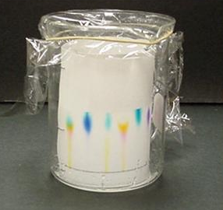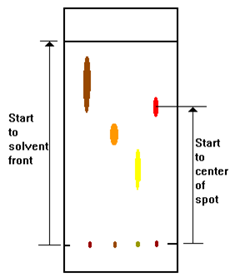

Fig. 18. Chromatography papers

Amino acid solutions placed to paper on separate tables. The paper is placed on thoroughly pre-washed glass. Under the lower edge of the paper put a glass plate or a notebook so that the part of the paper where the circles painted remained suspended and does not touched the surface of the glass. With capillaries specially prepared for each solution on paper mugs are consistently placed drops of tested amino acid mixtures and solutions «witnesses». It must be practiced so that the drop to be placed is not extended beyond the drawn circle. The solution is placed on the circle 5-6 times after drying of the previous drop.
After drying of placed drops thoroughly wash hands with soap and water, roll the paper into a cylinder and stitch over the edge of the sheet so that the edges do not overlap, and that shape was more or less the correct cylinder. Particular attention is given to the fact that when mixed points A and B have to coincide. At the bottom of the glass cylinder (careful with not to wetting walls) is poured a mixture of n-butyl alcohol, acetic acid and water (4:1:5). Solvent layer height has to not exceed 1 cm from the bottom of the cylinder.
Paper cylinder gently inserted vertically in a glass cylinder so that it does not touch the walls, and that caused the drops was on the lower end of the paper cylinder. For better alignment of the paper cylinder in a glass cylinder is often placed crumpled filter paper on top of paper which is between the walls and the glass cylinder.
The glass cylinder tightly capped with a cover with rubber gasket. Leave the cylinder before solvent rised almost to the top. Then carefully take out the paper cylinder, by pencil place border of solvent front, open seam, straighten the paper and hang it to dry under the hood or in the oven (at 70-80 °C).
When the solvent is completely evaporated the chromatogram is sprained. As a revealing reagent for amino acids is used 0.5% ninhydrin solution in methanol or acetone. By this solution chromatogram is sprayed several times from the sprinkler so that the paper became only slightly damp and would not formated streams of this solution. Then it has to be dried in air and heated in an oven at 110 °C until arising of purple spots. Much better is to gradually dry the chromatogram in the dark. Arised spots easily round with pencil and if desired fixed solutions by nickel sulfate, after which chromatogram is dried in the air.
The qualitative composition of the reference mixture of amino acids is determined by the value of R_{f} for each spot, comparing with R_{f} calculated from the chromatogram for «witnesses». R_{f} values ​​of amino acids in this system: glycine 0.13; Alanine 0.18; valine, 0.36; Phenylalanine 0.46.
In thisversion, task can be performed for other amino acids (see Table in Annex 2), as well as for simple carbohydrates (see Table in Annex 3). On carbohydrates chromatography they stain by ammonia solution of silver nitrate (black spot).

Control questions:

- What methods are used to determine the effectiveness of chromatographic separations?
- What are areas of application, advantages and disadvantages of gas chromatography methods?
- Which device is used as a batcher?
- What are the: a) differential detectors; b) integrated detectors?
- What is the operating principle of differential detectors: a) catharometer; b) thermochemical; c) ionization (or flame – ionization); g) selectively (thermionic)?

Laboratory work №15

Separation and identification of dicarboxylic acids by TLC in an aqueous-organic mobile phases

Objective: To determine the effect of molecular structure on the retention parameters and efficiency in relation to the shared system components.

Stages of work
1. Preparation of the chromatographic chamber.
2. Preparation of the chromatographic plates.
3. Analyzation of chromatography standards and samples.
4. Staining of the plate.
5. Calculation of dicarboxylic acids chromatography parameters.
Placed on plate dicarboxylic acids moves on a thin layer of sorbent with different speeds. The higher molecular weight of the acid the greater the speed of its molecules move and in which separation based. The appearance of polar groups (in tartaric acid) also has an impact on the separation of the dicarboxylic acids. Some formulas of dicarboxylic acids are shown in table 4.
Table 4
Test of dicarboxylic acid
Acid | Formula
oxalic | НООС-СООН
Succinic | НООС-(СН₂)₂-СООН
Glutaric | НООС-(СН₂)₃-СООН
Adipic | НООС-(СН₂)₄-СООН
Sebacic acid | НООС-(СН₂)₈-СООН
Tartaric | НООС-СН(ОН)СН(ОН)-СООН

Equipment, facilities, and conditions of chromatography:
1. Chamber from chemically resistant glass for TLC with diameter 150 mm, height 250 mm.
2. Sprayer for spraying the chromatograms.
3. The drying cupboard.
4. Microsyringe Hamilton or МШ-1 on 1.0 microliters.
5. The standard ethanol solutions of dicarboxylic acid with mass fraction of 0.5%.
6. The indicator purple bromocresol (bromphenol blue or bromocresol blue) 0.04% solution in 50% ethanol with 0.1 M NaOH basification to pH 10.
7. Plates «Silufol», covered with a thin layer of silica gel.
8. Mobile phase: ethanol, ammonia, distilled water mixed in a volume ratio of 100:16:12.
9. The source of compressed air

Preparation to the work: To the chamber for carrying out the analysis placed strip of filter paper which width equal to the height of the camera. To the chamber pour 45-50 cm³ of mobile phase, cover with glass and left in this state for 1.0-1.5 hours until complete saturation by vapor of the mobile phase.

In the chromatographic plate by pencil draw the starting line at a distance of 20 mm from the edge. By microsyringe to the line placed 1,0 mcL of standard and sample solutions with an interval of 15 mm. The diameter of the placed droplets should not to exceed 3-5 mm. To this, solution was placed by small portions while removing the solvent in a stream of air.

Performance of the experiment: A plate with placed droplets placed into the prepared chamber so that the spots were higher than in the mobile phase. The plate was kept in a closed chamber until the solvent front rises to a height of 12 cm before the finish line which is drawn with pencil. Then it removed from the chamber; dried in an oven at 110 °C for 60 minutes to completely remove the mobile phase. After cooling, the plate is sprayed from a spray solution of bromocresol purple (or other revealing agent), dried in an oven at a temperature of 80-90 °C for 3-6 min. With pencil mark yellow spots, which correspond to the position of dicarboxylic acids.

Processing of results: For the identification of dicarboxylic acids calculate R values ​​of standard acids solutions and investigated material placed on the same plate by formula:
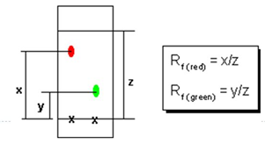
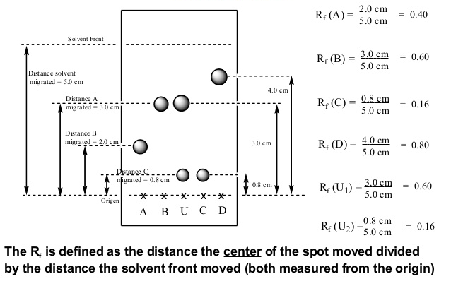
Fig. 19. Thin layer chromatography. Calculation of Rf’s

Laboratory work №16

Determination of impurities in medicines by TLC
Objective: To determine the purity of the substances.
Stages of work
1. Preparation of the chromatographic chamber.
2. Preparation of witness’s substance standard samples.
3. Preparation of the chromatographic plates.
4. Analyzation of chromatography standards and samples.
5. Drying of the plate.
6. Lighting plate under UV light or spot visualization with the indicators (depending on the chromatographic system).
Part 1: Determination of impurities in the nicotinic acid
Equipment, facilities and conditions of chromatography
1. Chamber from chemically resistant glass for TLC with diameter 90 mm, height 150 mm.
2. The drying cupboard.
3. Microsyringe МШ-10.
4. Plates covered with a layer of silica gel F₂₅₄.
5. Pencil.
6. Mobile phase - solvents mixture: 1-propanol - anhydrous formic acid – water (85:10:5).
7. Standard solution of nicotinic acid with mass fraction 0.005%.
8. Chromoscopy with UV radiation at λ =254 nm.
Performance of the experiment: Preparation of the standard sample witness material solution (SSWM)
A nicotinic acid:

Accurately weighed 0.5000 g of nicotinic acid (0.2500 g) dissolved in water in volumetric flask for 50.00 cm³ (25.00 cm³) with light heating, cooled, bring to the mark with water. By pipette 0.50 cm³ of the resulting solution transfer to volumetric flask for 100.0 cm³, the volume is bringing with water to the mark and the solution is mixed. Use freshly prepared solutions.
Chromatography
On the line, covered with silica gel F₂₅₄, where plate starts place on drying by cold air current 10 mcL (100 mcg) of a 1% medicine solution and here close as SSWM poured 10 mcL (0.5 mcg) and 4 mcL (0.2 mcg) of 0.005% nicotinic acid solution in water. The plate with the placed species is dried in the air for 15 minutes. Placed in a chamber with an eluent which is a mixture of solvents: 1-propanol – anhydrous formic acid – water (85:10:5) – and carry out chromatography by ascending method.
When the front of the mobile phase will pass 80% of the plate height, it is removed from the chamber, dried for 10 minutes at a temperature of 100-105 ° C and examined in UV light at λ = 254 nm. Spots substance visible in UV light netly encircle with pencil.
In the chromatogram of the experimental medicine solution may be the only one impurity spot on aggregate size and color intensity not exceeding the spots on the chromatogram of SSWM solution (no more than 0.5%). The magnitude of the spots and their color intensity made conclusion about the presence of the impurity components. If the intensity of the spots impurities comparable to the intensity and the magnitude of one of the spots with quite a known content of the substance in the sample is carried out semi-quantitative determination of the impurities content relative to standard samples of material witness.
Note: The chromatographic system is considered suitable if in the chromatogram visible spot of 0.2 g of nicotinic acid with R_{f} = 0,65.
Part 2: Determination of impurities in the novocaine
Equipment, facilities and conditions of chromatography
1. Chamber from chemically resistant glass for TLC with diameter 90 mm, height 150 mm
2. Chromoscopy with UV radiation at λ =254 nm.
3. The drying cupboard.
4. Microsyringe МШ-10.
5. Standard solution of novocaine with mass fraction of 0.005%.
6. The plates covered with a layer of silica gel F₂₅₄.
7. Mobile phase - a mixture solvents: 1-propanol - anhydrous formic acid – water (85:10:5).
8. Pencil.

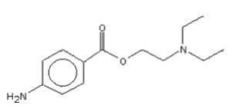

Novocaine

Performance of the experiment:
Preparation of SSWM solution
Accurately weighed novocaine 0.0025 g dissolved in ethanol in volumetric flask for 25.00 cm³.
Chromatography
On the starting line of the plate with a fixed layer of silica gel G60 F₂₅₄ with size 9 × 10 cm (Kieselgel G 60 F₂₅₄) placed on drying by current of compressed air 0.020 cm³ of 0.5% medicine (100 mcg). Nerly as the standard sample witness material solution (SSWM) is applied 0.020 cm³, 0.010 cm³ and 0.002 cm³ (2.0, 1.0, 0.2 mg) 0.01% of n-aminobenzoic acid solution. The plate with placed species is dried in the air for 3 minutes, placed in a chamber with an eluent which is a mixture of solvents: chloroform – heptane – acetone – glacial acetic acid (5:1:1:0.5) – and chromatographed by the ascending method. When the mobile phase front reaches the end of the plate, it is removed from the chamber, dried in air for 10 minutes and examined in UV light at λ = 254 nm.
Spot of an impurity in the chromatogram of the medicine should not be more in size and color intensity than SSWM spot (not more than 2% in the medicine).
Chromatogram of n-aminobenzoate acid (0.2 mg) in 95% alcohol is used to evaluate system suitability.
Impurities: 0,020 cm³ (200 micrograms) of 1% solution of the medicine in a mixture of water and glacial acetic acid in a ratio of 1:1 placed to the starting line of «Silufol» with size 1 cm × 15 or «Sorbfil» with size of 5 × 10 cm.
The plate with the applied sample dried in the air for 10 minutes and then in an oven at a temperature from 100 to 110 °C for 5 min, and chromatographed in the chamber with a mixture solvent of chloroform – methanol – acetic acid in relation 95:10:2. When the solvent front will pass 10 cm (for «Silufol» plates) and 8.7 cm (for a plate «Sorbfil»), the plate is removed from the chamber, dried in air for 15 minutes, then in oven at a temperature of 100-110 °C for 10 min.
The cooled plate sprayed with a 1% solution of n-dimethylaminobenzaldehyde.
In the chromatogram of the test medicine solution spot size and the intensity of their coloration make conclusion about the presence of the impurity components. If the intensity of the spots impurities comparable to the intensity and the magnitude of one of the spots with quite a known content of the substance in the sample is carried out semi-quantitative determination of the impurities content relative to standard samples of material witness.

Laboratory work №17

Qualitative and quantitative determination
of flavonoids by TLC

Objective: To determine the qualitative and quantitative composition of a mixture of flavonoids using internal normalization method and the video-densitometry calibration curve.

Stages of work
1. Preparation of the eluent and preparation the chamber for TLC.
2. Preparation of the flavonoids solutions.
3. Preparation of the plate for TLC.
4. Placing samples on the plate.
5. Analization of chromatography samples.
6. Stain of chromatograms.
7. Scanning of chromatograms.
8. Qualitative analysis of chromatograms.
9. The calculation of chromatographic parameters using video-densitometry:
a) Calculation of the tracks;
b) Qualitative analysis of the analyzed mixture composition, and quantitative determination by internal normalization method;
c) Quantitative determination by calibration graph.
Equipment, facilities and conditions of chromatography
1. Chamber from chemically resistant glass for TLC with diameter 90 mm, height 150 mm.
2. Chromoscope with UV radiation at λ = 254 nm.
3. The drying cupboard.
4. Microsyringe МШ-10 or Hamilton for 1.00 mcL.
5. Quercetin (C₁₅H₁₀O₂₇), rutin (S₂₇N₃₀O₁₆ × 3H₂O), naringin
(S₂₇N₃₂O₁₄) + catechin (S₁₅N₁₄O6 × 2H₂O).
6. Volumetric flasks 2-10-2, with amount 10.00 cm³.
7. The plates are covered with a layer of silica gel F₂₅₄ brand «Sorbfil», «Sulifol» or «Armsorb».
8. Mobile phase – solvent mixture: amyl alcohol – acetic acid
– water (2:1:1).
9.Revealing agents:
  - 25% of ammonia;
  - Diazotized sulfanilic acid (0.5 g of sulfanilic acid dissolved in 12.5 ml of concentrated HCl and 75 mL of water). Before applying mix solution of 4 ml prepared with 1 mL of
0.1 M NaNO₂ and 5 ml of 2M NaOH (all solutions metered by pipette);
10. 5% aqueous solution of ferric chloride.
11. Pencil.
12. Scanner.
13. Sprayer.
Performance of the experiment:
1. Preparation of the eluent and preparation of the chamber for TLC
Chromatography is carried out in special chambers for TLC –glass round or rectangular tanks with a glass lid. At the bottom of the chamber poured mobile phase - eluent.
The eluent in this paper is a mixture solvent of amyl alcohol – acetic acid – water (2:1:1). The mobile phase prepared in separate flask by mixing 10 cm³ of amyl alcohol, 5 cm³ of acetic acid,
5 cm³ of distilled water. Height of eluent layer in the chamber has to be about 0.5 cm.
Chamber with eluent tightly closed with cover has to stand for 20 minutes to saturate its space by vapours of the eluent - it speeds up the process of chromatography.
2. Preparation of the flavonoids solutions.
Flavonoids solutions prepared in volumetric flasks for 10.00 cm³ with concentrations of 0.5; 1.0; 1.5; 2.5; 4.0 mg / cm³ by samples.
3. Preparation of the plate for TLC:
a) for the qualitative analysis and quantitative determination by method of internal normalization plate for TLC of «Sorbfil», «Sulifol» or «Armsorb» brand or similar size are place on the table and with pencil without pressure easily draw a line parallel to the lower edge of the plate at a distance of 1.5 cm from the edge. This line is called the "starting line". On the starting line draw with a pencil points which are separated from each other and from the plate edges. It is desirable that the distance between two points will be not less than 1.5 cm. The layout of the plates is carried out carefully without disturbing the layer of silica gel.
b) quantitative determination by calibration graph. Marking of the plate performed as described above, from calculation for solutions 5 points containing certain substance amount and one point for a sample solution (a total of 6 points).
4. Placing of samples to the plate:
a) for the qualitative analysis and quantitative determination by the method of internal normalization to drawed points by microsyringe with amount 1 mcL place 2 series of prepared solutions by separating the plate into two parts for the subsequent imaging spots by different revealing agents. It is possible to use two plates.
Placing is carried out by light touch of drop squeezed out from needle of microsyringe to plate by several times (spot diameter have to be less than 0.3 cm³) with surface drying with bulb or compressed air. A new portion of solution is placed after drying of the previous one. When all the samples are placed, and the spots are dryed the plate is ready for chromatography.
b) Quantitative determination by calibration curve. Placing of samples is carried out as described above. Calibration solutions are placed in order of increasing flavonoids concentrations in the sample.
5. Analization of chromatography samples.
The plate with the species placed in a chromatography chamber in position that the starting line with a spot was above the level of the eluent level by sorbent at an angle of 45-60° down. The chamber was closed with a cover before the eluent rise to 2/3 of the plate height. The chromatogram removed from the chamber by pencil marked height of lifting eluent front and dried in air.
6. Stain of chromatograms.
To stain components zones separated into two parallel series of analyzed solutions by cutting the plate into two parts. Each series treated with various revealing agents. To visualize the whole of flavonoids as a revealing agent is used diazotised sulfanilic acid. The chromatogram is treated with reagents using a spray bottle. After treatment with a solution plate dried at 100-105 °C in an oven for 1-2 minutes until the yellow-brown areas. The second chromatogram stained in ammonia vapours.
7. Scanning of chromatograms.
Scanning of chromatograms can be performed using any flatbed scanner with the ability to scan in full-color mode with a resolution of 300 dpi. The file must be saved without compression in * .bmp format. It is also possible to direct scanning of chromatograms by program «Sorbfil Videodensitometr». For this read User's Guide for this software. Scanning of chromatogram is carried out in the following order:
  - In File menu, choose Select Scanner item;
  - After clicking on the Scanning of chromatogram on the toolbar on the screen appears scanning window. You must install the full-color scanning mode with a resolution of 300 dpi;
  - After the scan you can save the image for further use in the program «Sorbfil Videodensitometr».
8. Qualitative analysis of chromatograms.
Carry out a qualitative analysis of chromatograms; identification of flavonoids occurs by amount of agents relative velocity transfer over the plate (R_{f}) using different revealing agents with comparing the R_{f} value with the values ​​of R_{f} from table (Table 5).

Table 5
R_{f} value of flavonoids

The amount of flavonoid name | The value of R_{f} standards | R_{f} (manifestation of ammonia vapors) | The value of R_{f} (manifestation of diazotized sulfanilic acid)
Quercetin | 0,82±0,01
Rutin | 0,49±0,01
Naringin | 0,52±0,01
Catechins | 0,79±0,01
other

It concludes that the qualitative composition of the mixture can be analyzed on the basis of the obtained data.
9. The calculation of chromatographic parameters using video-densitometry
Semi-quantitative determination of the flavonoids content. This stage of operation is performed using the «Sorbfil Videodensitometr» software and a flatbed scanner.
Densitometer-based flatbed scanner does not require changes to existing TLC methods and can process any plate with visualized spots. Densitometer "Sorbfil" allows to produce two types of quantitative calculations:
  - Calculation of the content of analytes in the mixture (expressed in percentage); It can be carried out using internal normalization method.
  - Calculation of the substance concentration in the sample. The main stages of the determination:
a) Calculation of the tracks. The calculation starts with the layout of the chromatogram - placement of the starting line, front and track boundaries. To do this, use the user's guide to the program «Sorbfil Videodensitometr». Track results of the calculation are the analog curve, which peaks correspond to the intensity and width of the track spots.
Calculation of the track after setting the sensitivity threshold. The sensitivity threshold is chosen at 10% of the maximum intensity of the chromatographic peaks. When working with the chromatograms it is possible to install 4 image smoothing modes (without smoothing, smoothing by 3, 5, 7 points). Depending on the quality of the chromatogram smoothing carried as directed by the instructor. Then carry out filtration of the baseline noise;
b) qualitative analysis of the analyzed mixture contents, and quantification by internal normalization. Results of track calculation give in Exel format in the program, indicating R_{f} quantities, spot area (S), the percentage of substances in the area of all spots (S%), height (H), the percentage of the material in % by bands height to analog chromatogram.
c) quantifying the routine method of calibration curve. To calculate the amount of analyte in the sample according to this method all chromatography steps were performed similarly to those described previously. Carry out chromatography of 5 standard samples with concentrations 0.5; 1.0; 1.5; 2.5; 4.0 mg / cm³ and build the calibration curve for the S and H values, depending on the content of the substance in the sample. According to the calibration curve determine the content of rutin in the sample.
Results are provided in the summary Table 6.

Table 6
Contents of phospholipids

№ | С, mcg/cm³ | S, rel. un. ar. | H, rel. un.
1
2
3
4
5
х

In conclusion for the work give qualitative and quantitative composition of the analyzed mixture.

V. SEVERAL SPECTROSCOPIC METHODS

Among the physical methods in the study of organic compounds, in addition to chromatographic, the most widely used spectroscopic methods. The most information can be obtained by studying the interaction of matter with electromagnetic radiation in a wide range of frequencies, starting from and ending radiowaves γ-rays. Thus there is a change in the energy of the molecules, which is determined by the ratio
⊗E = E₁ − E₂= hν , (13)
where ⊗E – change in energy of the system; E₁, E₂ – energy system in different states; h – Planck constant; ν – radiation frequency.
When placed in an electromagnetic field molecule absorption occurs only in the case of performing the Bohr condition (13).
In the transition from state E₁ to E₂ molecule absorbs energy when returning from a state in E₁ E₂ – radiates it at the same frequency.
The electromagnetic spectrum covers an enormous range of wavelengths or energies. The main part of the spectrum used in the spectral analysis:

Wavelength interval
10⁻⁴...0.1 nm or 10⁻¹³ ...10⁻¹⁰ m
10⁻² ... 10 nm, or 10⁻¹¹…10⁻⁸ m 10...400 nm or 10⁻⁸ ... 4 ∙ 10⁻⁷ m
400…760 nm or 4·10^{–7}...7.6·10^{–7}

Side of the spectrum
γ-radiation
X-Ray radiation
Ultraviolet
Visible light

The molecular spectral analysis involves the qualitative and quantitative determination of the composition of the sample at the absorption and emission spectra. Energy of the molecule in the first approximation can be divided into three components related to the rotation of the molecules as a whole, forming the molecule vibrations and movement of electrons of atoms in a molecule.
Molecular spectra are very complex, located in different areas of the wavelength (frequency) and divided into electron-vibrational, rotational and vibrational-rotational. They are usually located in the area 105⁻⁸ × 103 cm⁻¹ (0,10-1,25 micrometers); 8 × 10³-2,5-10² cm⁻¹ (1,25-40 microns); 2,5 × 10²-20 cm⁻¹ (40-500 microns), respectively, and characterize electronic transitions in molecules and vibrational transitions with a change in the vibrational rotational states of the molecule.
Methods of molecular absorption spectroscopy are based on measuring the reduction of electromagnetic radiation intensity transmitted through the tested sample. Depending on the wavelength of the incident light in the ultraviolet spectrophotometry distinguish (UV), visible (view) and infrared (IR) region of the electromagnetic radiation.
The study of the structure and properties of the compounds involves the use of complex physical methods. In the study of the organic compounds the most widely used methods of absorption spectroscopy, nuclear magnetic resonance spectroscopy. Along with the spectral method used mass spectrometry based on conversion of substance by electron impact.
The role of physical methods in solving problems of organic chemistry is very high, because these methods allow identifying of a compound by obtaining information about its structure: to establish the presence of functional groups and conjugated bonds, distinguish cis – and trans- isomers, to conclude intra- and intermolecular interactions. To conduct the study requires a small amount of a substance (usually a few milligrams), the analysis can be performed in a short time. Physical Methods also allow studying the kinetics and monitoring the progress of the reaction, to determine the quantitative composition of the mixture.
The most widely used spectral methods, associated with exposure to electromagnetic radiation substance. The most important are the absorption spectra:
- In the ultraviolet (UV) and visible region of the spectrum where the absorption of the energy required to excite the electrons in the molecule (this type of spectroscopy is called electron spectroscopy);
  - In the infrared (IR), which is absorbed by the energy required to change the vibrational states of molecules (also called vibrational spectroscopy);
  - In the field of RF energy, where the energy expended for the reorientation of the spins of the nuclei (nuclear magnetic spectroscopy resonance -NMR).
The mechanism of interaction of electromagnetic radiation with matter in different regions of the electromagnetic spectrum (Table. 6.) is different, but in any case the molecule is absorbed certain quantity energy (absorption spectroscopy). This molecule proceed from one energy state to another.
In general, to obtain the absorption spectrum of a sample of material is placed between the source and receiver of electromagnetic radiation. The receiver measures the intensity of radiation transmitted through the sample compared with the initial intensity at a given wavelength.
The absorption spectrum is recorded in the coordinates where the axis of abscissa the wavelength λ, and the vertical axis – the intensity of the absorption, or transmission.

Table 7.

The area of the electromagnetic spectrum Wavelength, λ | 10 ⁻³ nm | 10 nm | 400 nm | 800 nm | 300 mm | 300 mm
The spectral  region | Soft  X-rays-mechanical radiation | Ultra-violet | Visible | Infrared | Micro-wave | Short wave
Cause of  Absorption of  radiation | Transitions internal electrons in atoms | Transitions of valence electron |  | Vibrational transitions of the molecules, | Rotational transitions of the molecules | Spin transitions of nucleus and electron
The observed spectrum of the absorption | Electronic spectrum |  |  | IR |  | NMR EPR spectrum

UV spectroscopy

Under the influence of electromagnetic radiation on a substance is cause of absortion of radiation. The range of electromagnetic waves is extremely broad – it waves with a length of 10 ⁻¹⁹ -10 ⁻⁸ m (hard X-ray and γ-rays) to hundreds of meters (radio waves). Electromagnetic radiation of different inter-acts with an organic molecule, which thus becomes an excited state. The absorption of radiation occurs when the quantum of radiation corresponds to the difference between the energy levels of the excited and unexcited molecules that is absorbed by the radiation, of a particular wavelength. The absorption in the ultraviolet and visible region associated with the excitation of electrons. It gives electronic absorption spectra.
The absorption spectrum is the distribution of wavelengths by the electromagnetic radiation intensity of how it passes through the test substance. In practice, the absorption spectrum obtained in the following manner: the test substance is placed between the radiation source and detecto, source using special devices sends radiation with a certain wavelength or changings, receiver measures the intensity of radiation transmitted through the sample, and record it on a tape recorder.
The electronic spectrum appears at absorption material ultra-violet (wavelengths 200-400 nm) and visible (400-800 nm) radiation. The principal difference between these sections of the spectrum there, they differ only in that the wave length of 400-800 nm are perceived by the human eye, and we see a colored substance.
UV radiation has enough power. Under the influence of UV light occur exciting of molecule, i.e. the transfer of electrons to a higher energy levels and redistribution of the electron density in the molecule. The hardest excited electrons are formed in σ-communication easier – π-electron bonds and lone pairs of electrons. The most easily transferred excited states of electrons forming the conjugated system. Consequently, electrons are easily excited quantum of light is required at least a high-energy, and the absorption will occur in the longer wavelength region of the spectrum. For example, compounds containing only σ- connection (alkanes, alcohols, ethers), absorb UV radiation at wavelengths shorter than 200 nm, which lies outside the working range of serial devices. The absorption of alkenes, due to double bond C = C, although it is shifted to longer wavelengths region, but also shifted in the region of wavelengths shorter than 200 nm. At the same time, 1,3-butadiene – where there conjugated double bonds absorbing at a wavelength of 217 nm.
Fragments of the molecules, causing selective absorption of electromagnetic radiation, called chromophores. These include many functional groups containing an unshared electron-pair of electrons adjacent to a multiple bond such as the groups COOH, C = O, C = N, C ≡ N, NO_{2.} But for those intense absorption of chromophores, connected with π-electron excitation lies in the wavelength region (200 nm or less); weak absorption caused by the excitation of unshared electron pairs can be registered only for the C = O groups (270-290 nm) and NO₂ (270-280 nm). Chromophore is benzene ring; Benzene itself absorbs strongly at a wavelength of 200 nm and weakly - at 255 nm. Aromatic compounds absorb UV light over a wide range depending on the nature of the substituents on the ring.

Fig. 20. UV spectra of benzene (1) and phenol (2)

In the presence of substituents in conjugation with entering
π-electron aromatic system, the absorption intensity increases and simultaneously the absorption maximum shifts to longer wavelengths as illustrated by the example of the UV absorption spectra of benzene and phenol (Fig. 20 (1)), as well as the absorption spectrum β-carotene (Fig. 20 (2)).
There are four types of electronic transitions with bonding and nonbonding orbital of the ground state to the excited state orbital loosens: σ → σ *, π → σ *, n → π *. For these transitions is characteristic difference of ∆E values.
In general, UV spectroscopy allows surely judge the presence of a coupling system, including aromatic rings. This method is used for the quantitative determination of substances absorbing in the UV region of the spectrum, since the intensity of the absorption is proportional to the concentration of the substance. The advantage of the method lies in the availability of devices (UV spectrophotometer) and ease of operation to them.

Infrared spectroscopy

Some features of molecular spectra. If the molecule absorbs or emits a relatively low energy photons (one to two orders of magnitude smaller than for the excitation of the electron spectrum), the vibrational spectrum of the molecule is observed. The change of the dipole moment of the molecule at the time of excitation of vibrational state is a prerequisite for the absorption or emission of energy. Have changes in the dipole moment of oscillation depends on the symmetry of the system.
In the diatomic molecule is the only possible swing motion of atoms along the bond axis. In such molecules as O₂, C₁₂, etc., The dipole moment is zero, the movement of these molecules are not accompanied by the absorption of infrared radiation. Such vibrations are called inactive in the IR spectrum. These types of molecules are CO, HC1, and others. Positive and negative centers atoms do not always coincide, so the electron distribution in the absorption of infrared radiation varies, which leads to a change in the molecular dipole moment. Such fluctuations are called and act vnymi in the IR region. They can interact with an electromagnetic radiation absorbing energy and giving rise to absorption bands in the spectrum.
Infrared reports molecule in the ground (lowest) electronic state, the energy required for transitions between rotational and vibrational energy levels. Upon absorption of a molecule photon energy absorption of light occurs defined (characteristic) frequencies associated typically with the atoms and functional groups in the molecule. The beam passing through the sample, is weakened in the region of absorption. By recording the intensity of the transmitted radiation, get a curve on which the visible absorption maxima.

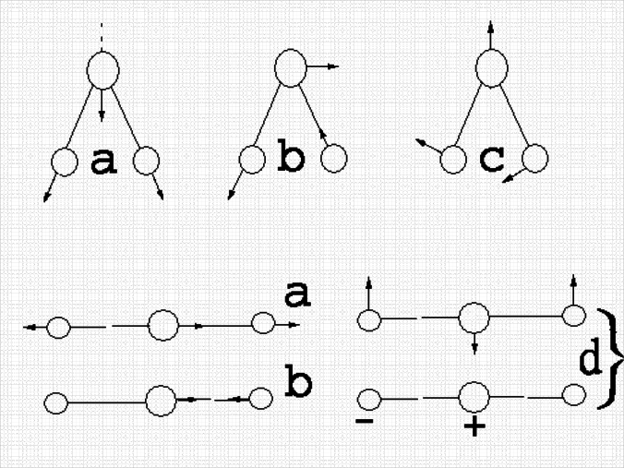
2)
1)

a – symmetric stretching vibrations in the nonlinear (1) and line (2) molecules (νs); b – the non-linear asymmetrical oscillations in (1) and line (2) molecules (νas); c – bending vibrations in a non-linear molecule (δ); d – degenerate vibrations in a linear molecule

Fig. 21. Fluctuations of triatomic molecules:

Vibrational spectra of molecules rich in stripes, each of which corresponds to the excitation of specific vibrational state of the molecule. The number of possible vibrations of the molecule is determined by its structure: for a non-linear molecule consisting of N atoms, the number of possible variations is equal to 3N-6 for linear – 3N-5. Some of these have the same oscillation frequency, so the corresponding absorption bands overlap.
Oscillatory motion of atoms in a molecule can be roughly divided into two types: 1) stretching vibrations when there is a periodic displacement of atoms along the connection axis valence X → Y (Figure 19, fluctuations 1a, 1b, 2a, 2b). 2) Deformation at which the magnitude of change in the angle between two bonds (Fig. 19, vibrations 1c, 2d).
The change of the dipole moment of oscillation depends on the symmetry of the system. If the molecule has symmetry (plane, axis of symmetry center or mirror-rotary axes), all forms of its normal vibrations are characterized by certain symmetry properties. There are three cases the behavior of the normal vibrations in relation to any symmetry operations (see Figure 19.):
1) normal mode remains the same (symmetric);
2) it changes its sign to reverse (asymmetrical);
3) it passes to another form of the normal vibrations (degenerate).
For triatomic groups ended YXY (eg, CH₂ groups) characterized by four types of bending vibrations: scissor (bending), fan (wagging), torsion (twisting) and the Pendulum (rocking) (Figure 20.).

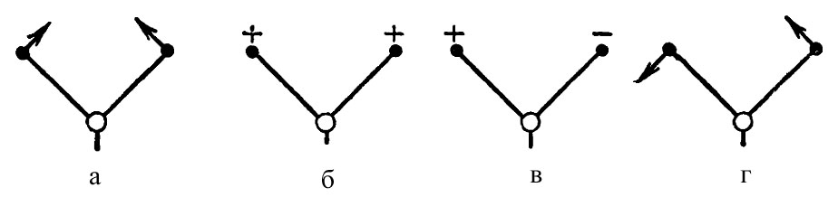

a) scissor; b) rolling; c) twisting (torsion); g) the pendulum

Fig. 22. Expansion fluctuations XYX groups of atoms

Effect of mass and force constant the oscillation frequency. From the formula shows that the oscillation frequency ν is determined by two parameters - the force constant K and the reduced mass M. From Table 8 and 9, it follows that the increase in mass of the atoms while maintaining the order of connection of the absorption band shifts towards lower frequencies, while increasing the values ​​of the force constant, in contrast, leads to an increase in the oscillation frequency. In a polyatomic molecule, the situation is much more complicated, and, nevertheless, this relationship helps to roughly estimate the area in which the individual frequencies and their characteristic nature manifested.

Table 8
The dependence of ν on the reduced mass M at K ≈ const

bonds | М, sp. un. | К, N/cm [9] | ν, сm⁻¹ *
С-H | 0,92 | 5,00 | 3000
С-С | 6,00 | 4,34 | 1060
C-Cl | 9,00 | 3,64 | 700–600

* The values of ν are calculated approximately, since they depend not only on M and K, but also on the structure of the molecule, which is communication.
Table 9
The dependence of v on the force constant K at constant M

bonds | М, sp. un. | К, N/cm [9] | ν, cm⁻¹
С-С | 6,0 | 5 | 1060
С=С | 6,0 | 10 | 1600
С ≡ С | 6,0 | 15 | 2000
С-N | 6,5 | 5 | 730
С=N | 6,5 | 10 | 1650
С ≡ N | 6,5 | 15 | 2100

Fluctuations are those of the characteristic, the more parameters K and M of the oscillating group differ from the parameters of the rest of the molecule. Virtually any substitution, a small change geometry molecule leads to a shift of the absorption bands. But when atoms close in mass and filleted having similar power factors that distinguish oscillations belonging to the individual relations (see Table 10).
Table 10
The values of ν for bonds with similar values of K and M

bonds | М, sp. un. | К, N/сm [2] | ν, сm⁻¹
С-H | 0,92 | 5 | 3100–3000
N-H | 0,93 | 5 | 3400–3300
O-H | 0,94 | 5 | 3500–3400

Group frequency and spectrum interpretation

In the experimental study of vibrational spectra, it was found that the groups have the same absorption in a narrow frequency range, which is called the characteristic (group) frequency. The existence of the characteristic frequency can be represented as follows: individual oscillations or groups of atoms linkages may be weakly coupled to the rest of the molecule vibrations and oscillations of the frequency band or a communication depends on their structure or nature of the considered connection.
The frequency can be regarded as a characteristic if its value is much different from the values ​​of all other frequencies. For example, the frequency of stretching vibrations of C-H bonds in the CH₃ and CH₂ groups are in the range 2800-3000 cm⁻¹, the frequency of bending vibrations associated with the change in the angle of the H-C-H and C-C-H - in the field of about 1450 and 1200 cm⁻¹, respectively, and the frequencies associated with changes in C-C bonds, below 1200 cm⁻¹. Therefore, the frequency of stretching and deformation vibrations of C-H groups should be considered characteristic. They are also the oscillation frequency due to a change in distance between the two differ in their atomic mass. For example, for the group C-H stretching vibrations in the characteristic region 2900 cm⁻¹ to O-H - 3500 cm⁻¹ for N-H - at 3500-3300 cm⁻¹ for Si-H - when 2300-2100 cm⁻¹ to S-N - at 2600-2500 cm⁻¹.
The characteristic frequencies are set for many organic and inorganic substances and are summarized in the table of group frequencies, which are very useful for identifying groups of atoms on the infrared spectra. There are no strict rules of interpretation of the infrared spectra there is not, but some of their basic position may be used during operation.

The typical IR absorption range for covalent bonds in 600 - 4000 cm⁻¹. The graph shows the regions of the spectrum where the following types of bonds normally absorb. For example a sharp band around 2200-2400 cm⁻¹ would indicate the possible presence of a C-N or a C-C triple bond.

Fig. 23. The IR absorption range

First of all, it is necessary to accurately determine the position of the absorption bands in the spectrum by calculating the frequency corresponding to the maximum of each band. This is preceded by pre-calibration of the device by standard samples (e.g., polystyrene), since improper adjustment could be a source of errors. If you are using forms to record the spectrograms spectrometers equipped with recorders, should clearly record the beginning and end of the recording. You can then calculate the position of each peak in this frequency range. In a preliminary study, it is necessary to cover the spectrum of the field stretching and deformation vibrations of the groups and, in addition, the area of ​​"fingerprint" (1350-600 cm⁻¹), which are manifested frequency characteristic of fluctuations of specific groups.
The appearance in the spectrum of the absorption band, expected on the basis of information about the structure of matter, still is not proof of the presence in it of the corresponding group. You need to check in other regions of the spectrum the presence of absorption bands characteristic of this group. In contrast, the absence of a strong absorption band characteristic of a group indicates its absence in the test substance. Thus, for the region 1750-1650 cm⁻¹, characteristic strong absorption of a carbonyl group C = O. The lack of absorption in this region of the spectrum is proof of the absence of this group in the test substance. If absorption occurs in this area, it is possible by absorption in other regions of the spectrum to determine the nature of the carbonyl group. For example, the C = O absorption of vibrations caused by this group -C = O group. Carboxylic acids for the presence of bands at 1720-1750 cm⁻¹ must be duplicated by the presence of bands corresponding valence (v) and deformation (δ) OH vibrations bands and valence v C-O vibrations in the wave number
1100-1200 cm⁻¹.
In other classes of compounds should also expect changes in the position of the absorption bands. Thus, for the aldehydes in the presence of C = O groups, except strong absorption at 1710-1680 cm⁻¹, presence of the band necessarily v C-H at 2800 cm⁻¹. To the ketone group C = O with characteristic absorption arylalkyl groups only at 1700-1670 cm⁻¹.
Classify the strip to any groups much easier when changing the structure of the molecule. For example, when the identification acids in the carbonyl absorption in its translation acid salt leads to the disappearance of the absorption at 3700-2500 cm⁻¹ (ν - vibrations of the OH groups involved in the formation of hydrogen bonds in the R-COOH), 1750-1650 cm⁻¹ (ν - oscillations of C = O groups into COOH), 1200-1100 cm⁻¹ and the appearance of peaks at 1580-1540 cm⁻¹ and 1400-1380 cm⁻¹ due to vibrations ionised COO- group (Fig. 24) .

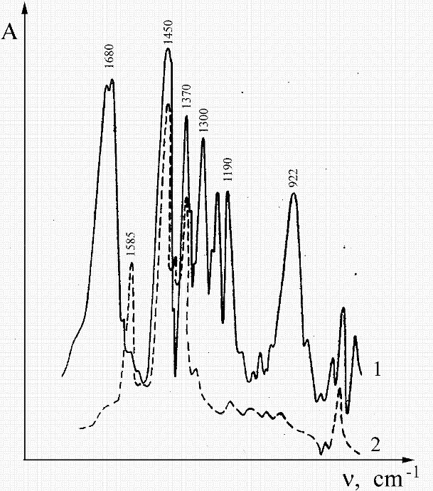

Fig. 24. IR spectra of sebacic acid (1) and its sodium salt (2)

Substitution with deuterium protium H D useful in identifying absorption bands C-H (absorption maximum of C-H at 2900 cm⁻¹ shifted to 2600 cm⁻¹).
Application of UV, IR, and NMR spectroscopy for the identification of organic compounds
In the study of organic compounds the most widely are used infrared spectroscopy in the ultraviolet and visible regions of the spectrum and proton magnetic resonance spectroscopy. Infrared spectroscopy allows to reliably establishing the identity of the compounds of the coincidence of the absorption bands for the entire region of the infrared spectrum (400-4000 cm⁻¹). IR spectroscopy is also used to determine the individual structural elements having a characteristic absorption band. This group consisting of hydrogen groups with multiple bonds. The absorption in the ultraviolet and visible regions of the spectrum enables to determine the compound containing conjugated multiple bonds and groups having a hetero atom at the double bond (C = O, C = S, N = N, NO, NO2, and others.).
Spectroscopy of proton magnetic resonance provides information about the environment of the protons in the compound (on the basis of the chemical shifts of individual protons) and on the number and spatial arrangement of neighboring magnetic cores (based on the nature and magnitude of the spin-spin interaction). The spectral characteristics of some of the structural elements shown below. Saturated hydrocarbons are transparent in the UV and visible regions of the spectrum. Their IR spectra are characterized by the presence of bands of stretching vibrations of CH (ν_{CH} 2800-2990 cm⁻¹) and the deformation vibrations (δ_{CH} ~ 1380 cm⁻¹ and ~ 1460 cm⁻¹) methyl, methylene and methine groups. The NMR spectra of the protons of aliphatic hydrocarbons occur in the 0.8-2 ppm Introduction of functional groups leads to a shift of the proton signals in the NMR spectra in the weaker field (up to 5 ppm) and the appearance in the IR spectra characteristic absorption bands of these groups. Unsaturated compounds can be identified by IR spectra of the band of stretching vibrations of CH = above 3000 cm⁻¹ and the bands of stretching vibrations of multiple bonds (ν _{C=C} 1620 - 1680 cm-1, ν _{C ≡ C} 2000-2100 cm⁻¹). In the PMR spectrum olefinic protons have signals at 4.5-7.5 ppm acetylene protons at 2-3 ppm Pairing multiple bonds leads to the appearance in the UV spectra of intense absorption bands π → π * - transitions lg ε ≥ 4. The aromatic compounds of the benzene series are easily identified on the electronic absorption spectra (absorption band intensity lg ε = 2-3 in the field 250-350 nm, often with a vibrational structure). The IR spectra of aromatic compounds have a band ν_{CH} ~ 3050 cm⁻¹ bands associated with fluctuations in the ring (1450 – 1600cm⁻¹), and strips of non-planar deformation vibrations of CH (650-900 cm⁻¹). The adsorption in 650-900cm⁻¹ is possible to determine the position of the substituents on the benzene ring, if the substituents do not have their own absorption bands in this region. In the PMR spectrum signals of aromatic protons at 6-8 ppm manifest. The hydroxyl group of alcohols and phenols are identified by the absorption band of stretching vibrations in the area 3600-3000 cm⁻¹. Aldehydes and ketones are detected by an intense absorption band of stretching vibrations of carbonyl group in the IR spectrum (ν _{C=O} 1740-1660 cm⁻¹) and low-intensity absorption band of the π → π * - transition (lg ε = 1-2) in the electronic absorption spectra. Aldehydes can be distinguished by the presence of ketone and aldehyde group ν_{CN} bands in the IR spectra (2800-2600 cm⁻¹) and by the appearance of signal, aldehyde proton in NMR (9-10 ppm). Carboxylic acids are defined by the bands of stretching vibrations of the carbonyl group (ν _{C = O} 1720-1680 cm⁻¹) and a hydroxyl group (ν _{OH} = 3000-2500 cm⁻¹) in the infrared spectrum. In the PMR spectrum signal of the proton of the carboxyl group is in weak fields at 8-11 ppm. The carboxylic acids also in the IR spectra have strong absorption bands due to the variation of the carbonyl group. At esters ν _{C = O} band is located in the region 1750-1715 cm⁻¹. Lane ν _{C = O} halide is in the range 1815-1770 cm⁻¹. Acid amides are characterized by two absorption bands at 1680-1630 cm⁻¹ (lane "amide I») and 1650-1510 cm⁻¹ (lane "amide II») and stripes ν_{NH} (3500-3000 cm⁻¹). Primary and secondary amino groups in the IR spectra are characteristic absorption bands of stretching vibrations of NH, ν_{NH} in the 3500-3100 cm⁻¹. By absorption in the art may distinguish the primary and secondary amines. In a dilute solution in a nonpolar solvent, the primary amino group has two bands of stretching vibrations and the secondary amino group - only one. Additionally, primary amines give intense band deformation vibrations of NH₂ groups in the 1650-1580 cm⁻¹. Tertiary amines of IR spectra can not be detected. It is very difficult to detect in the presence of amines, hydroxyl compounds, since the characteristic absorption bands of these groups are in the same region of the IR spectrum. The nitro compounds are in the IR spectra of two bands of stretching vibrations of the nitro group: ν_{as} 1560-1510 cm⁻¹ and ν_{s} 1380-1330 cm⁻¹. The UV spectra of the nitro group is characterized by an absorption band π → π * - go to the intensity lg ε = 1-2.
Identification of organic compounds by spectral methods should use the detailed tables of characteristic frequencies in the IR absorption spectra and tables of proton chemical shifts in the spectra of the NMR.

Laboratory work №18

Checking by standart solution. A comparison of the data with the values obtained in the new instruments. Identification and curve fit of the present solutions in the UV spectrum

UV spectroscopy in organic chemistry applied to solve many problems: the analysis of substances, determination of the structure and to determine the composition of multicomponent systems
UV spectra lie within the detection of molecule from 100 nm to
1000 nm. The main characteristics of the line UV spectrum are that the intensity and maximum value constant. Intensity of the adsorbtion are depend on the factors: the transition of molecule into excited state and polarity of excited state. With the increasing of excited state in adsorbtion intensity also increased energetically state.
The working procedure in device
- Checking the closing of hole of the device. At the time when the photocell is in the holder is closed, and then the scale should be equal to 0.
- We turn on the device and leave it for 30 minutes.
- Set 3 of the cell.
- Put the holder on the right wavelength.
- Prepare the sampling solution.
- Open the photocell and set mode to "Open".
- By changing the size of the point, direct arrow of the device to 100%.
- Put the solution in the operating position and record the scale of T or D.
- When analyzing solution has to be put in a investigated standard the arrow have to point to the scale of 100%.
Preparation of standard solution
When checking the UV spectrum are applied solid, gaseous, and liquid substances. When using solid substances are caused special problems of the spread of the UV-rays. And that is why as a standard are used liquid substances. The solution is prepared at a certain volume flask. For removal of the spectrum, a solution with a concentration of 10⁻³-10⁻⁵ mol / l is taken. Before conducting work is necessary thoroughly clean the cuvette with solvent solutions. In the UV spectrum are used as solvent are many different solutions: water, ethanol and cyclohexane.
Checking of the scale absorbance with a standard solution
- Potassium chromate (0,04 g of salt in 0,05N КОН solution in volumetric flask with volume 1:1 ).
- Spectrum of potassium chromate should be conducted at a wavelength of 215-500 nm in a cuvette with 1 cm thickness.
- Comparing the optical density of standard solution with the data on the table. If the device is working properly the needle of the scale should show 1-2%.

Table 11

λ, nm | K₂ CrO₄ | λ, nm | K₂CrO₄ | λ, nm | K₂CrO₄ | λ, nm | K₂CrO₄
215 | 1, 4311 | 260 | 0,634 | 305 | 0,080 | 380 | 0,928
220 | 0,456 | 265 | 0,696 | 310 | 0,045 | 390 | 0,684
225 | 0,222 | 270 | 0,744 | 315 | 0,043 | 400 | 0,387
230 | 0,167 | 275 | 0,762 | 320 | 0,063 | 410 | 0,197
235 | 0,207 | 280 | 0,723 | 330 | 0,147 | 420 | 0,126
240 | 0,293 | 285 | 0,595 | 340 | 0,314 | 430 | 0,084
245 | 0,389 | 290 | 0,429 | 350 | 0,552 | 440 | 0,053
250 | 0,496 | 295 | 0,278 | 360 | 0,829 | 450 | 0,032
255 | 0,571 | 300 | 0,151 | 370 | 0,991 | 460 | 0,017

Removing the UV spectrum of following solutions and plotting of curve:
- hydrocarbons
- quercetin
- myricetin
- chalcone

Laboratory work № 19

Spectrophotometric determination of nicotinic acid

Objective: Quantitative determination of nicotinic acid in a preparation for injection by molecular absorption spectroscopy (UV spectrophotometry).
Stages of work
1. Preparation of the reference solution (RS).
2. Preparation of the sample solution.
3. Photometricity of RS solutions.
4. Photometricity of analyzed solutions, a qualitative analysis of the nicotinic acid content in the medicine.
5. Quantification of nicotinic acid.
Instrumentation, Materials and reagents
1. Spectrophotometer SF-4A or SF-26.
2. Quartz cells with layer thickness 10.00 mm.
3. Pipette for 1.00 and 10.00 cm³.
4. Volumetric flasks for 100.0 cm³.
5. Nicotinic acid (ФСП 42-0069115401).
6. Hydrochloric acid with concentration of 0.1 mol / dm³.
7. Nicotinic acid (injection solution 1%).
The essence of the work
In determining of the nicotinic acid is used in the preparation method of the molar (specific) absorption coefficient (ε_{λ}). When you are working according to this method use a known value for the standard ε pure solution of the medicine at a wavelength corresponding to the absorption maximum of a specific layer thickness and l (cm). Then measure the optical density of the sample solution Аλ and calculate the concentration c_{x}. A limitation of this method is necessarily subordinate to the system being analyzed Bouguer - Lambert - Beer law.
Completing of the work
1. Preparation of the solution of standart samples.
About 0.1 grams (accurately weighed) nicotinic acid is placed in 100.0 cm³ volumetric flask and dissolved in 80 cm³ of 0.1 M hydrochloric acid solution, the volume is adjusted with 0.1 M hydrochloric acid solution to the mark and mixed.
1.00 cm³ of the resulting solution was transferred into a volumetric flask and 100.0 cm³ volume of the solution was adjusted with 0.1M hydrochloric acid to the mark.
2. Preparation of the sample solution.
1.0 cm³ of solution placed into a volumetric flask for 100.0 cm³, the volume is adjusted with 0.1 M hydrochloric acid solution to the mark and mixed. 10.00 cm³ of the resulting solution was transferred into a volumetric flask for 100.0 cm³, the volume is adjusted with 0.1 M hydrochloric acid solution to the mark and mixed.
3. Photometricity of standard sample solutions.
Spectrophotometer SF-4A or SF-26 previously prepare to work in accordance with the instruction manual. Photometry is performed using deuterium lamp and photocell corresponding to the operating wavelength range. The sample solution and reference solution is filled quartz cuvettes with a thickness of the absorbing layer of 10.00 mm. As a comparison solution is water (bidistilled or deionized). Spend rough photometry of sample solution in the wavelength range of 230-300 nm with a pitch of 10 nm.
When you register for an analog logarithmic scale absorbance values ​​to increase the accuracy of determinations carried out recalculation of A.
After the measurement of the optical density A against λ (nm) is plotted. The absorption peak area of ​​sample solution photometric
1.0 nm increments starting measurement at a wavelength 10 nm shorter than the wavelength, is characterized by a maximum absorption measurement and ending at λ na 10 nm greater than the wavelength corresponding to the absorption maximum of the solutions analyzed. The results of measurements write to Table 13.
Photometric measurements of working solutions of the medicine, a qualitative analysis of the content of nicotinic acid in the preparation
For the identification of the analyzed nicotinic acid photometric solution at wavelengths of 230-300 nm with a pitch of 10 nm and 1 nm in the same manner as performed photometry of sample solutions.The measurement data is written in the table 12.

Table 12.

№ | λ,  нм | А |  | А
№ | λ,  нм | SSS | Medicine form | SSS | Medicine form
1
2
…

The data obtained is plotted by A against λ, nm. By the form of the spectra (number of absorption maxima), the position of the absorption maximum make conclusion on the authenticity of the sample.
Quantitative determination of nicotinic acid.
Measure the absorbance of the sample solution based on the preparation in a spectrophotometer at a wavelength of 261 nm (absorption maximum) in a cuvette with a layer thickness of
10.00 mm. At the same time measure the absorbance of the reference solution of nicotinic acid. As comparison solution use 0.1M hydrochloric acid.
In result of the work make conclusion about the qualitative and quantitative composition of the medicine content in the target component.

Laboratory work № 20

Spectrophotometric determination of injection cyanocobalamin (vitamin B12)

Objective: qualitative and quantitative analysis of cyanocobalamin in medicine for the injection method of molecular absorption spectroscopy (UV spectrophotometry); determining the presence of impurities in the medicine by the spectral relations.
Stages of work
1. To determine the authenticity of cyanocobalamin by spectrophotometric method:
  - Preparation of the reference solution;
  - Preparation of the medicine solution for analysis;
  - Photometry of reference solution;
  - Photometry of medicine prepared solution;
  - Qualitative analysis of the cyanocobalamin content in the medicine.
2. Spectrophotometrical determination of the purity of the medicine by the method of the spectral relations.
3. Quantitative determination of cyanocobalamin in the medicine.
Instrumentation, Materials and reagents
1. Spectrophotometer SF-4A or SF-26.
2. Quartz cells with 10.00 mm thickness.
3. Pipette for 1.00 and 10.00 cm³.
4. Volumetric flasks for 25.00 cm³ and 100.0 cm³.
5. Cyanocobalamin (vitamin B12) of Merck production.
6. Bidistilled or deionized water.
Completing of the work
- Authenticity of cyanocobalamin by spectrophotometric method.
One of methods to authenticate substance in the preparation is the molecular absorption spectroscopy in the UV and visible region of electromagnetic radiation in combination with other physicochemical (chromatographic, electrochemical, other optical) methods. To confirm the authenticity of the substance must be qualitative (the position of the spectral maxima) and quantitative agreement (the constancy of the relations absorbance values ​​at wavelengths corresponding to the absorption maximum).
Preparation of the reference solution. Have to be prepared intermediate solution with a concentration of 0.2% cyanocobalamin. For this purpose, 0.1 g (0.05 g) (accurately weighed) is dissolved in double distilled water or deionized water in a volumetric flask for 50.00 cm³ (25.00 cm³). Next, an intermediate in the medicine solution is used at a concentration of 0.002%. After dissolving the substance and intensive mixing 1.00 cm³ (0.50 cm³) transfer into a volumetric flask for 100.0 cm³ (50.00 cm³) and the volume of the flask is adjusted with water (double distilled or deionized) to the mark.
Prepared medicine solution is analyzed. To prepare the working solution of cyanocobalamin (vitamin B12), the contents of the ampoule (1 cm³) was transferred quantitatively into a volumetric flask and 25.00 cm³ adjusted to the mark with water (double distilled or deionized).
Photometricity of medicine solution, a qualitative analysis of the cyanocobalamin content in the medicine.
Preparation of photometric spectrophotometer SF-4A or SF-26 is carried out in accordance with the instruction manual. The photometry is performed using a deuterium lamp and an incandescent lamp and photocell, corresponding to the operating wavelength range. The working and reference solution is filled quartz cuvettes with a thickness of the absorbing layer of 10.00 mm. Comparison solution is water (bidistilled or deionized). Reference solution is carried through photometry solution in the wavelength range 260 to 560 nm with a pitch of 10 nm.
ATTENTION. All measurements were carried out using two lamps. First, perform all the measurements using a deuterium lamp (260-350 nm), and then the measurement is carried out with the filament lamp (350-560 nm).
The measurement data are filled in the form of a table. When registering the values ​​of optical density analog logarithmic scale to increase the accuracy of determining the conversion is carried out according to the values ​​of A transmission T according to the equation.
After the measurement of the optical density А is plotted against to $γ$ (nm). In the maximum absorption region (278, 361, 548 nm) with a photometric solution tested by 1.0 nm step, since the wavelength of 10 nm to the maximum absorption measurement and ending at$γ$ 10 nm greater than the wavelength corresponding to the absorption maximum of the analyzed solutions.
Photometric measurements of working solutions of the medicine. To confirm the authenticity of cyanocobalamin photometric test solution at wavelengths of 260-560 nm with a pitch of 10 nm and 1 nm in the same manner as performed photometry solutions.
Fill the measurement data in the form of a table. According to the obtained spectra conclude about the authenticity of the sample.
1. Determination of the purity of the medicine spectrophotometric method for spectral relations. To determine the purity of the preparation is determined spectrophotometrically magnitude optical density of the solution in the cuvette with a layer thickness of 10.00 mm at 278, 361, 548 nm. Calculate the ratio of the optical densities of the solutions A at the indicated wavelengths. The ratio A₃₆₁ / A₅₄₈ have to be from 3.0 to 3.4. The ratio A₃₆₁ / A₂₇₈ have to be from 1.7 to 1.88. At the ratio conclude about the purity of the medicine.
2. Quantitative determination of cyanocobalamin in th emedicine. Quantify the cyanocobalamin content in the dosage form can largest optical density of the solution at a wavelength of 361 nm in a cuvette thickness of 10.00 mm, using as a reference solution, water (twice-distilled or deionized).
3. The content of cyanocobalamin, 1 mg per cm³ for the preparation was calculated by the formula:

А *10*V1
Х = 207 *V mg,

where A – the optical density of the test solution, 207 – specific indicators of cyanocobalamin net absorption at a wavelength of 361 nm, the V – the amount of the medicine taken for breeding, cm³, the V₁ –volume of prepared medicine solution for analysis, cm³.
As a result of the qualitative and quantitative determination make conclusion on the authenticity of the medicine and the content of cyanocobalamin. You may modify the content of cyanocobalamin in the dosage form of 0.45 to 0.55 mg.

Laboratory work № 21

Quantitative analysis of xylene isomers mixtures
by the IR spectra

Objective: semi-quantitative determination of xylene isomers according to IR spectroscopy.
Stages of work
1. Preparation of isomers substances solutions.
2. Determination of the solutions spectra in liquid cuvettes.
3. Construction of calibration curves for the reference mixtures solutions.
4. Semi-quantitative determination of xylene isomers by calibration curve.

Instrumentation, Materials and reagents
1. IR spectrometer with Fourier transform and dispersive IR spectrometer.
2. Collapsible cuvette for liquid solutions.
3. Window from potassium bromide or other optically transparent materials.
4. o-xylene.
5. m-xylene.
6. The p-xylene.
7. Cyclohexane
Completing of the work
Cells for liquid solutions. The quality of the IR spectrum and the amount of information depends on the conditions of the analysis, and in particular, the choice of cells for liquid solutions.
Conventional cuvette in a device has to be placed in the optical path, consisting of a metal body fitted with clamps (collapsible housing), and openings for filling the cell with liquid, two windows of optically transparent material, gasket between the windows, at the same time allows you to vary the amount or thickness of the absorbing layer.
Depending on the region of wave numbers, which may appear in the absorption band of interest groups, it is necessary to vary the material (glass), which will be concluded between the solutions (liquid). The choice of windows depends on how much your range will be qualitatively. The most widely used glass from KBr, NaCl, CaF₂, AgCl, and others. Some solvents reduce transparency of materials (water, ethanol). In table given the main materials used in the manufacture of windows for the IR spectroscopy, the range of applicability and the environment degrades the quality of materials.

Table 13
The materials used in the manufacture of windows for the IR spectroscopy

Material window | Field of transparency cm⁻¹ | Sensitivity to substances | Note
Quartz | 50000-255 | HF
NaCl | 50000-625 | Water, ethanol
KCl | 33300-475 | Water, glycerin light
AgCl | 16000-400 | Metals, light
KBr | 50000-370 | Water, ethanol | hygroscopic
CsI | 33300-200 | Water, ethanol | hygroscopic
CaF₂ | 50000-900 | -
Ge | 5000-500 | -
Si* | 6600-615 | HF, alkaline

Potassium bromide, in turn, is the most widely used material due to its transparency over a wide range of wave numbers 250 cm⁻¹. Another property that is important in infrared spectroscopy is the hardness and the ability to polish the clouded material. From this standpoint, the most convenient is sodium chloride.
Using of solutions (especially the higher concentration) leads to the need to monitor the ability of a substance to accumulate on the window surfaces after use. After the analysis of the need for mandatory repeated flushing of the space between the panes with pure solvent to remove all traces of analytes.
1. Preparation of isomeric substances solutions
The position of the absorption bands substituted benzene derivatives is very specific for each type of substitution. For example, di-substituted derivatives are not overlapping characteristic absorption region, which allows the quantitative analysis of the content of isomers in solution (see. Table 1).

Table 14

Type the replacement | region of absorption (cm-1)
1,2-substituted | 735-770
1,3-substituted | 690-710; 759-810
1,4-substituted | 800

To carry out semi-quantitative determination of the xylene isomers it is necessary to prepare a 5% solution (by volume) of each isomer of xylene in cyclohexane. Further reference is prepared mixture of xylenes isomers with the following content (see. Table 15).

Table 15

Substance | Contents in mass %
Substance | Solution #1 | Solution #2 | Solution #3 | Solution #4
o-xylol | 33 | 65 | 5 | 15
m-xylol | 33 | 20 | 75 | 5
p-xylol | 33 | 25 | 20 | 80

For the preparation of solutions must pipette 1.0 ml of each of the mixtures prepared and diluted with 20 ml of cyclohexane.
2. The spectra of solutions in liquid cuvettes
To register a range of liquid solutions fill the cell with a layer thickness l = 0,2 mm. IR spectra were recorded in solutions of 600-1000 cm⁻¹. Identify the absorption band characteristic of each type of replacement.
3. Construction of calibration curves for the reference mixtures solutions
On the spectrum of the first solution is chosen analytical absorption bands for each of the xylenes, then use the data for all solutions, build calibration curves for each xylene A = f (C). Concentrations are expressed in %.
4. Semi-quantitative determination of xylene isomers by the calibration curve
The assay mixture was diluted with xylene and cyclohexane 1:20. Preparation of the solution fill the liquid cell and record the infrared spectrum. Using the calibration curve, determine the concentration of isomers in the mixture. The results of the definitions are in the form of table 16.

Table 16
The spectral data of the analyzed solutions

Substance | v_{max} | A | C, %
o-xylol
m-xylol
p-xylol

Laboratory work № 22

Determination of substances authenticity in IR spectra of the samples dispersed in potassium bromide

Objective: To establish the authenticity of the substances on the IR spectra of the medicines removed from potassium bromide tablets.
Stages of work
1. Sample preparation.
2. Preparation of potassium bromide:
- Grinding of potassium bromide;
- Drying.
3. Pressing of the tablets.
4. Registration of the spectrum.
5. Identification of substances.
Instruments, materials, and reagents
1. IR spectrometer with Fourier transform and dispersive IR spectrometer.
2. Potassium bromide.
3. Mortar with pestle (agate and malachite).
4. Sample bottles.
5. The drying cupboerd.
6. Analytical balance.
7. Squeez mold.
8. Press.
9. Cotton.
10. Ethanol.
11. The scalpel, tweezers and glass paddle.

Completing of the work
- Sample Preparation: Quality spectra, as well as the amount of information that can be obtained with the use of IR spectroscopy is often determined not only by research mode (in transmission, diffuse reflection or total internal reflection), but also the physicochemical properties of the sample, and by the method of analysis preparation.

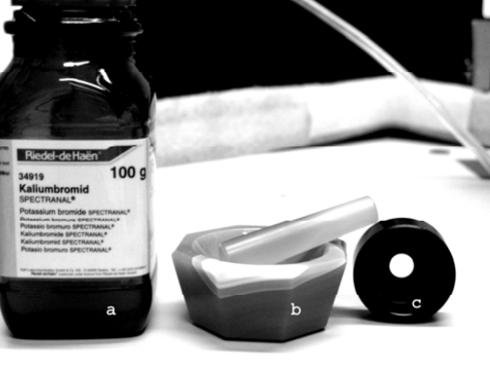

Fig. 25. potassium bromide (a) an agate mortar (b) and the cylinder
to fill the container sample using a set-top box to diffuse reflection (s)

Sample preparation should be done in the conditions preventing qualitative and quantitative changes in the sample. The particle size of the sample should be as small as possible to avoid scattering the infrared radiation and loss of information.
Fig. 25. presents some devices used for sample preparation and obtaining spectra of samples. Despite the fact that many samples during grinding can alter their physicochemical properties, previously as treated sample. This is especially important when dealing with the diffuse reflection of the sample and compressing tablets dispersed in an inert material. Moreover, careful grinding required when the sample is dispersed in vaseline oil. For the purpose of reducing the size of the particles under study can be used such materials in the absorption bands that do not have or do not prevent the quality (and sometimes important quantitative) analysis of samples. Such materials may be referred agate mortar, is optically transparent over a wide range of infrared radiation.
At that time, as there are many methods of sample preparation and IR options, one of the most widely used methods is the use of salt panes, which is one of the simplest methods. When sample preparation cell can often be used with salt-based glass halide salts of alkali and alkaline earth metals. Many of them are hygroscopic and must be stored in a desiccator. However, we must be very careful when using these glasses, as they can be easily damaged and scratched. For storage use desiccators or special containers with desiccants.
The most common method of sample preparation of the test substance is considered pressing with KBr. In some cases as filler in the manufacture of tablets using other alkali metal halides - KC1, NaCl, AgCl. Tabletting mold used various designs; most of them are designed to receive tablets of a diameter or a width of 10-20 mm, which is necessary for the press force of 10-20 m. The tablet size is determined by the width of the entrance slit of a spectrophotometer.
- Preparation of potassium bromide: Potassium bromide has no absorption band in the range of 4000 to 400 cm⁻¹. The pressed tablet of potassium bromide 1 mm passes at 250 cm⁻¹ to 30% of the radiation. The refractive indices of many organic solvents close to the refraction index of potassium bromide. At work, you can use any brand of potassium bromide, pre-clearing it from the comoving reference impurities and water. However, if there is potassium bromide, designed specifically for the spectral analysis, the amount of auxiliary operations is reduced only to a grinding and drying of potassium bromide. Note that the micronized potassium bromide is able to absorb impurities, so it must be dried and closet individually. Check for cleanliness and lack of moisture in the KBr is carried out by recording of the spectrograms.
Monocrystalline bromide triturated in an agate mortar and dried in an oven at 150-160 °C to completely remove traces of water. Check the cleanliness of powdered potassium bromide and its degree of drying by the lack of absorption bands in the region 4000-600 cm⁻¹. Dry and pure potassium bromide in this interval writes straight line, the oscillations of the molecules of water of hydration are manifested in the form of intense absorption bands in the region of 3700-3300, 1640-1610 and 1400 cm⁻¹. Prepared KBr stored in weighing bottle with the cover in a desiccator.
The analyzed sample is ground in an agate mortar to a fine state manually to a "powder" (when rubbed between the fingers is not felt "stiffness" of the powder). Powdered samples were dried to constant weight in an oven at 50-60 °C under vacuum or at ambient temperature.
To take an accurate analysis requires weighed (to the nearest 0.0001 g) of potassium bromide and a test sample. Sample mass to mass ratio of potassium bromide has to be 1:100 or 1.5 mg and 150.0 mg samples of prepared KBr.
The ratio may vary depending on the nature of the substance. Expedient to prepare tablets containing the test substance from 0.5 to 5%. For substances, having a large number of groups of atoms characterized by a significant absorption, reduce the amount of material to a ratio of 1:200.
After weighing the sample and the dispersing agent is carried out thoroughly mixing in an agate mortar for 5-10 minutes, then take a sample of a mass of 100.0 mg of the mixture and transferred to a mold. The mixture is compressed to form tablets. KBr crystals at high pressure are formed and a transparent plastic matrix in which is uniformly distributed powder analyte.
3. Pressing tablets: It is recommended to use a mold with a rectangular cross-section of the working surface, the proposed SCG IOC USSR (Fig. 26). The working surface of the mold (plate) in contact with the tablet material, made of hardened steel, polished and chrome plated. A portion of the mixture is distributed evenly across the channel by glass blades, the mold is closed and placed in a press. A weighed sample is pressed for 5 min, then dismantled and the mold using tweezers to transfer the finished tablet tabletkoderzhatel (properly compressed tablet is completely transparent and has constant dimensions 4 × 25 × 0.5 mm).

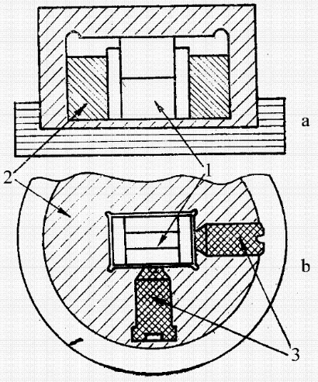

1 – working plate; 2 – plate holder;
3 – the adjusting screws (As a side view; b: a top view)

Fig. 26. The mold with a rectangular worktop.

After manufacturing the tablet mold must be cleaned alkali metal traces of halides in order to avoid corrosion of the working surface: the mold is first rubbed with a cotton swab moistened in distilled water nym, then swab dipped in alcohol, and carefully wipe cloth of stories or cotton cloth to remove all traces of moisture.
Agate mortar, scalpels, forceps and glass spatula after each tablet preparation was washed first with distilled water and then with rectified alcohol to remove traces of the sample. Consumption rectified alcohol - 30 ml to prepare a tablet.
4. Registration of the spectrum: Enable, setup and adjustment of the instrument is carried out strictly according to the instruction.
a) Register spectra IR spectrometer with a two-beam scheme. The spectrum was recorded on a similar infrared spectrometer pressed potassium bromide tablet which is used in the first beam channel to exclude background absorption. The working channel spectrophotometer with double-beam scheme tablet keeper placed the sample in the comparison channel – tablet keeper with a tablet of pure potassium bromide.
b) In the case of single-beam spectrometer with a pre-reduction scheme taking background spectrum from a tablet with KBr, and then record the IR spectrum of the analyzed sample. Spectra were recorded in the frequency range of 4000-400 cm⁻¹. Treat the spectrograms, hoping to exact the position of the absorption maxima. The interpretation of the spectra is carried out research using the literature.
5. Identification of substances: Identification of substances by IR spectra were coincidentally absorption bands tabulated values ​​of the absorption bands of standard substances.
Identification of methyl uracil.

С5Н6N2O2

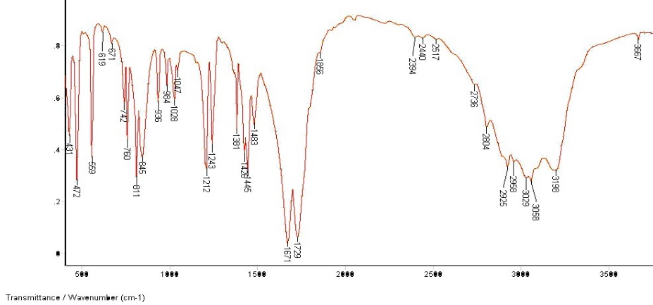

Fig. 27. IR methyluracil

IR of methyl uracil must have full coincidence of absorption bands with stripes on the accompanying figure (Fig. 27).

Laboratory work № 23

Identification of the substance of IR spectrum of a sample suspended in liquid paraffin

Objective: To establish the authenticity of the substances on the infrared spectra of the medicine dispersed in mineral oil.
Stages of work
1. Dispersing agent in vaseline oil.
2. Registration and identification of substances of the spectrum.
Instrumentation, Materials and reagents
1. IR spectrometer with Fourier transform and dispersive IR spectrometer.
2. An optically transparent window.
3. Mortar and pestle (agate and malachite).
4. Press.
5. Cotton.
6. Ethanol.
7. Scalpel, tweezers and glass paddle.
Completing of the work
The most widely used for the preparation of solids suspensions of received mineral oil (Nujol) - a mixture of high-boiling petroleum fractions. The vaseline oil IR spectrum (Fig. 28) absorption bands are present only stretching and deformation vibrations groups -CH₃ And -CH₂- in 3000-2800, 1500-1300, and 772 cm⁻¹.

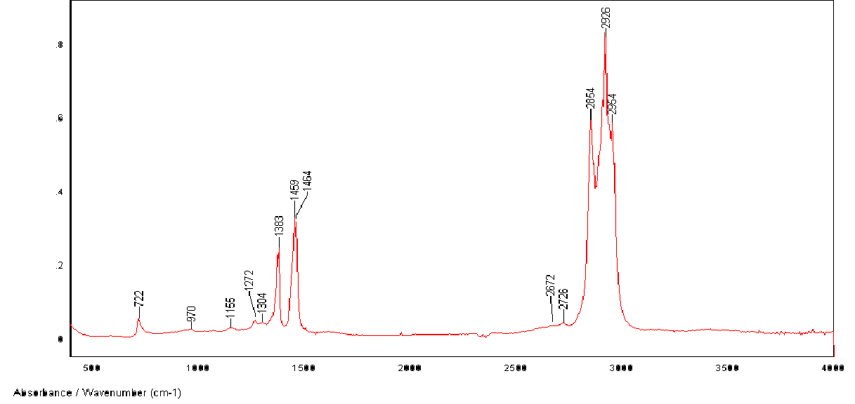
Fig. 28. IR paraffin oil (Nujol)

Vaseline oil is readily soluble in carbon tetrachloride which is used for washing plates of potassium bromide. For studies of the spectrum corresponding to the absorption of liquid paraffin, used fluorinated oil, but a mixture of fluorinated hydrocarbons is difficult to remove from the cuvette windows.
1. Dispersing agent in vaseline oil
A sample of the dried and pulverized material in an amount of
2-5 mg is mixed in an agate mortar with 10 drops of vaseline oil until a uniform suspension. Then, 3-4 drops of suspension placed by flat layer on the cover of the KBr (NaCl) cell, the second cover clamped and placed in the cuvette holder. Similarly measure the intensity of the absorption bands in the infrared spectra of the suspensions is not possible, because it is impossible to define the thickness of the test sample (the concentration of the substance in the slurry). When you use dispersive spectrometers to compensate for the absorbed liquid paraffin in comparison channel put the cuvette with pure mineral oil.
When using FTIR-spectroscopy background spectrum previously removed by placing in the optical cell vaseline oil placed on plates as described above. However, this option can lead to the appearance of the spectrum of the test sample strips of negative intensity.
2. Registration of the spectrum and identification of substances.
The registration of the spectrum is carried out in the same way as described above. The interpretation of the spectra is carried out using the literature, performing the assignment of absorption bands vibrations of atoms. The results of classifying bands bring in
Table16.
Table 16
The assignment of the absorption bands of groups of atoms in the IR spectra

Number | wave number, cm⁻¹ | Group | atomic vibrations | Notes
1
2

According to the results of classifying bands make conclution on belonging of agents to a particular class of compounds

Task: Indicate which one of the following 6 compounds corresoponds to each of the IR spectra shown below. Indicate the important absorptions that allowed you to make the assignment.

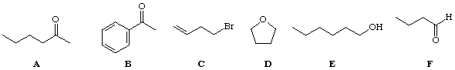

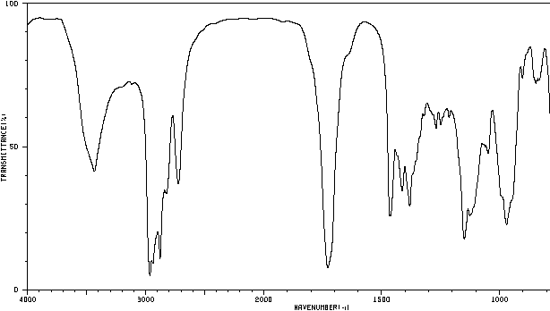

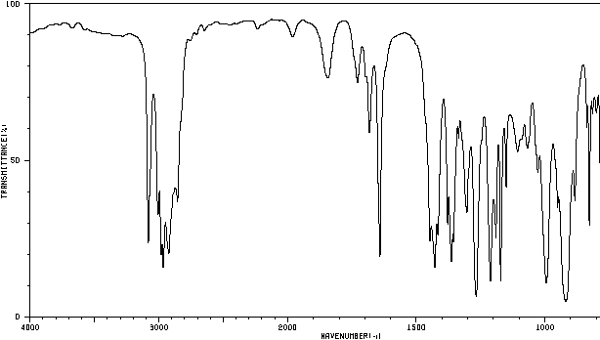
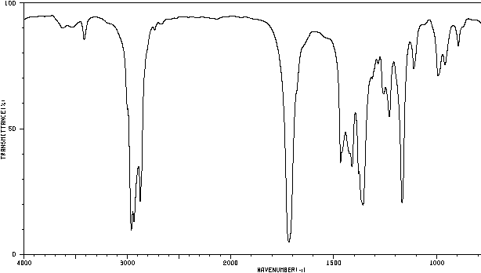

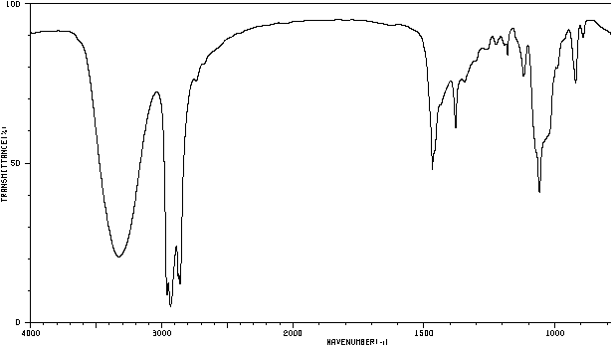

REFERENCES

- Идентификация органических веществ. Малышева Ю.Б.,Федоров А.Ю., Старостина Т.И. Электронное учебное пособие. – Нижний Новгород: Нижегородский госуниверситет, 2010. – 34с.
- A.I. Vogel – “Text book of practical organic chemistry”, 5th Ed. ELBS, London, 1989
- B.B. Dey and M.V. Sitharaman, “Laboratory manual of Organic Chemistry” Revised by T.R. Govindachari, Allied Publishers Ltd., New Delhi, 4th Revised edition, 1992
- Daniel R. Palleros, “Experimental Organic Chemistry” John Wiley & Sons, Inc., New York, 2000
- B.S. Fumiss, A.J. Hannaford, V. Rogers, P. W.G. Smith and A.R. Tatchell, “Text book of Practical Organic Chemistry”, LBS, Singapore, 1994
- Реутов О.А., Курц А.Л., Бутин К.П. Органическая химия: В 4-х частях. 3-е изд. М.: Бином. Лаборатория знаний, 2007.
- Иванов В.Г., Гева О.Н., Гаверова Ю.Г. Практикум по органической химии. – М.: Издательский центр «Академия», 2002. 288с.
- Практическая газовая и жидкостная хроматография : учебн. пособие / Б.В. Столяров [и др.] – СПб. : Изд-во СПб. ун-та, 2002. – 616 с.
- Гольберт К.А. Введение в газовую хроматографию / К.А. Гольберт, М.С. Вигдергауз. – М. : Химия, 1990. – 352 с.
- Сумина Е.Г. Тонкослойная хроматография. Теоретические основы и практическое применение : учеб. пособие / Е.Г. Сумина, С.Н. Штыков, Н.В. Тюрина. – Саратов : Изд-во Саратов. гос. ун-та, 2006. – 112 с.
- Герцберг Г. Колебательные и вращательные спектры многоатомных молекул / Г. Герцберг. – М. : ИЛ, 1949.
- Крос А. Введение в практическую инфракрасную спектроскопию / А. Крос. – М. : ИЛ, 1961. – 110 с.
- Беллами Л. Инфракрасные спектры молекул / Л. Беллами. – М.:ИЛ, 1957. – 444 с.
- Беллами Л. Новые данные по ИК-спектрам сложных молекул /Л. Беллами. – М. : ИЛ, 1971. – 318 с.
- Наканиси К. Инфракрасная спектроскопия и строение органических соединений / К. Наканиси. – М. : Мир, 1965. – 216 с.
- Gordon A.J. The chemist’s companion. A handbook of practical data, techniques and references / Arnold J. Gordon, Richard A. Ford. – A Wiley- Interscience Publication. John Wiley and sons, 1972.
- Гордон А. Спутник химика. Физико-химические свойства, методики, библиография / А. Гордон ; пер. с англ. Е.Л. Розенберга, С.И. Коп- пель. – М. : Мир, 1976. – 541 с.
- Hadden J.M. A comparison of infrared spectra of proteins in solution and crystalline forms / J.M. Hadden, D. Chapman, D.C. Lee // Biochimica et Biophysica Acta (BBA) / Protein Structure and Molecular Enzymology, 1995. – V. 1248, 2. – P. 115–122.
Appendix 1

Qualitative ORGANIC functional group tests in various homologous series
CHEMICAL TEST FOR | TEST METHOD | OBSERVATIONS | TEST CHEMISTRY and comments
ALKENE or alkyne chemical test i.e. any non–aromatic unsaturated hydrocarbon with a double or triple carbon–carbon bond. | Bubble gas through, or add liquid to, a solution of bromine in hexane or water. | The orange/brown bromine rapidly decolourises, as a saturated colourless organic bromo–compound is formed. | R₂C=CR₂ + Br₂ ==> BrR₂C–CR₂Br  RCCR + 2Br₂ ==> Br₂RC–CRBr₂  R = H, alkyl or aryl  Saturated alkanes give no fast reaction with bromine.
Hydroxy group R–OH chemical test in alcohols and phenols (in 'dry' conditions*)  The first 3 tests (i) – (iii) given on the right are quite general for most alcohols. | (i) Mix it with a few drops of ethanoyl chloride, test fumes with litmus and silver nitrate (* note ethanoyl chloride reacts with water, phenols and amines too!).  (ii) Mix it with a little phosphorus(V) chloride and test as above.  (iii) Warm with a little ethanoic acid and a few drops of conc. sulphuric acid. Pour into water. | (i) Litmus turns red and a white precipitate with silver nitrate_{(aq)} (drop on end of glass rod), if the mixture is poured into water you may detect a 'pleasant' ester odour, can test for HCl but water and amines produce it too!  (ii) as for (1) but no ester smell!  (iii) You should get a 'pleasant' characteristic smell of an ester. | (i) R–OH + CH₃COCl ==> CH₃COOR + HCl  An ester and hydrogen chloride are formed  (ii) R–OH + PCl₅ ==> R–Cl + POCl₃ + HCl  a chloro compound and hydrogen chloride are formed.  (i) and (ii) Ag⁺_{(aq)} + Cl–_{(aq)} ==> AgCl_{(s)} from the hydrogen chloride fumes dissolved in water.  (iii) CH₃COOH + ROH ==> CH₃COOR + H₂O
Primary alcohol chemical test  RCH₂OH, R = H, alkyl or aryl (NOT a phenol).  (ii) is not a good test on its own, since so many other readily reducible organic compounds will give the same reaction, though following it up by testing for an aldehyde gives it much more validity. | (i) Lucas test – shake a few drops with cold zinc chloride in conc. HCl_{(aq)}  (ii) Distil with potassium dichromate(VI) and mod. conc. H₂SO_{4(aq)} | (i) Solution remains clear.  (ii) If product distilled off immediately an aldehyde odour can be detected and the solution colour changes from orange to green. | (i) Not usually reactive enough to form a primary halogenoalkane  (ii) R–CH₂OH + [O] => R–CHO + H₂O or the full works!  3R–CH₂OH + Cr₂O₇^{2–} + 8H⁺ ==>2Cr³⁺ + 3R–CHO + 7H₂O  The orange dichromate(VI) ion is reduced to the green chromium(III) ion. If the organic product is collected you could test for an aldehyde.
Secondary alcohol chemical test  R₂CHOH, R = alkyl or aryl. | (i) Lucas test.  (ii) Distil with K₂Cr₂O₇/H₂SO_{4(aq)} | (i) Solution may cloud very slowly or remains clear (hit and miss) | (i) May be reactive enough to slowly form an insoluble secondary halogenoalkane: R₂CHOH + HCl => R₂CHCl + H₂O
(ii) is not a good test on its own, since so many other reducible organic compounds will give the same reaction, though following it up by testing for a ketone gives it much more validity. |  | (ii) If product distilled off immediately a ketone odour can be detected and the solution colour changes from orange to green. | (ii) R₂CHOH + [O] => R–CO–R + H₂O or the full works!  3R₂CHOH + Cr₂O₇^{2–} + 8H⁺ ==>2Cr³⁺ + 3R–CO–R + 7H₂O  The orange dichromate(VI) ion is reduced to the green chromium(III) ion. If the organic product is collected you could test for an aldehyde.
Tertiary alcohol chemical test  R₃COH, R = alkyl or aryl. | (i) Lucas test.  (ii) Distil with K₂Cr₂O₇/H₂SO_{4(aq)} | (i) Goes cloudy very quickly.  (ii) No aldehyde or ketone readily formed | (i) Reactive enough to immediately form an insoluble tertiary halogenoalkane R₃COH + HCl => R₃CCl + H₂O  (iii) Stable to modest oxidation.
Phenols (OH group is attached directly to aromatic ring) chemical test. R–OH, where R is aryl e.g. C₆H₅OH | Add a few drops of iron(III) chloride solution to a little of the phenol in water. | Usually gives a purple colour. | (see also test for primary aromatic amines – use it in reverse starting with a known primary aromatic amine!)
Carboxylic acids chemical test  RCOOH | Mix the carboxylic acid with water and add a little sodium hydrogencarbonate solid or solution. | fizzing, colourless gas gives white precipitate with limewater | RCOOH + NaHCO₃ ==> RCOONa + H₂O + CO₂  (see also salts of aliphatic carboxylic acids below)
Salts of aliphatic carboxylic acids e.g. RCOO–Na⁺ or (RCOO–)₂Mg etc. | Add a little dilute hydrochloric/sulfuric acid to a suspected salt of an aliphatic carboxylic acid. | The solid or solution should have no strong odour, but after adding the mineral acid you should get a pungent odour of the original aliphatic acid. If its the salt of an aromatic carboxylic acid, you get little odour and maybe a white crystalline precipitate. | The stronger acid, HCl/H₂SO₄ displaces the weaker aliphatic carboxylic acid which have strong–pungent characteristic odours e.g.  ethanoic acid from an ethanoate salt (smell of acetic acid, vinegar) and butanoates release butanoic acid (butyric acid, rancid odour).
Acid or Acyl Chloride chemical test  RCOCl  Fumes in air forming HCl_{(g)} | (i) Add a few drops to water, test with litmus and silver nitrate solution.  (ii) Add to a little ethanol and pour the mixture into water. | (i) Litmus turns red and a white precipitate with silver nitrate.  (ii) As above and you may detect a 'pleasant' ester odour. | (i) RCOCl + H₂O ==> RCOOH + HCl  The acid chloride is hydrolysed to form HCl acid (chloride ions) and the original carboxylic acid.  (ii) CH₃CH₂OH + RCOCl ==> RCOOCH₂CH₃ + HCl  an ethyl ester and hydrogen chloride are formed
Acid Amide chemical test  RCONH₂ | Boil the suspected amide with dilute sodium hydroxide solution, see in inorganic for ammonia tests. | ammonia evolved on boiling (no heat required to form ammonia, if it was an ammonium salt) | RCONH₂ + NaOH ==> RCOONa + NH₃
Aliphatic amines (primary, where R = alkyl) chemical test R–NH₂  e.g. CH₃CH₂CH₂–NH₂ | (i) Lower members soluble in water but a very fishy smell! test with red litmus and conc. HCl(aq) fumes.  (ii) If a suspected salt of an amine, then add sodium hydroxide solution to free the amine. | (i) A fishy odour, litmus turns blue, white clouds with HCl.  (ii) The above is not observed until after adding the alkali. | (i) Unless its a liquid or solid, only the more fishy odour distinguishes it from ammonia.  (ii) The reaction is e.g.  R–NH₃⁺ + OH– ==> R–NH₂ + H₂O
Aromatic amines chemical test (where R = aryl with the amine or amino group directly attached to an aromatic ring) R–NH₂  e.g. C₆H₅–NH₂ | (i) Dissolve the primary aromatic amine in dilute hydrochloric acid at 5ºC and mix with sodium nitrite solution.  (ii) Add a phenol dissolved in dilute sodium hydroxide. | (i) It should be a clear solution with few, if any, brown fumes.  (ii) A coloured precipitate [red – brown – yellow etc.] | (i) If a primary aromatic amine, a 'stable' diazonium salt is formed. Diazonium salts from aliphatic amines decompose rapidly evolving colourless nitrogen.  (ii) An azo dyestuff molecule is formed in a coupling reaction e.g.  C₆H₅–N=N–C₆H₄–OH
Aldehydes chemical test (R–CHO, R = H, alkyl or aryl) to distinguish from ketones (R₂C=O, R = alkyl or aryl) and also reducing sugars.  Note  (1) Test (b)(i) and (ii) can be used to distinguish aldehydes (reaction) and ketones (no reaction).  (2) Aromatic aldehydes do NOT give a positive result with (b)(ii) Benedict's or Fehling's reagent).  (3) Reducing sugars may also give a positive test with (b)(i)/(ii) reagent e.g. glucose (aldohexose) but not fructose? (ketohexose)? | (a) Add a few drops of the suspected carbonyl compound to Brady's reagent (2,4–dinitrophenylhydrazine solution) | (a) A yellow–orange precipitate forms with both types of carbonyl compound. | The aldehyde or ketone 2,4–dinitrophenylhydrazone is formed  R₂C=O + (NO₂)₂C₆H₃NHNH₂ ==>  (NO₂)₂C₆H₃NHN=CR₂ + H₂O  (R = H, alkyl or aryl)  This tells you its an aldehyde or ketone, but can't distinguish them, read on below!
 | (b)(i) warm a few drops of the compound with Tollens' reagent [ammoniacal silver nitrate]  (b)(ii) simmer with Fehling's or Benedicts solution [a blue complex of Cu²⁺_{(aq)}] | (b) Only the aldehyde produces (i) A silver mirror on the side of the test tube.  (ii) A brown or brick red ppt. | Aldehydes are stronger reducing agents than ketones and reduce the metal ion and are oxidised in the process  i.e. RCHO + [O] ==> RCOOH  (i) reduction of silver(I) ion to silver metal  RCHO + 2Ag⁺ + H₂O ==> RCOOH + 2Ag + 2H⁺  (ii) reduction of copper(II) to copper(I) i.e. the blue solution of the Cu²⁺ complex changes to the brown/brick red colour of insoluble copper(I) oxide Cu₂O.  RCHO + 2Cu²⁺ + 2H₂O ==> RCOOH + Cu₂O + 4H⁺  With (b)(i)/(ii) no reactions with ketones.
Halogenoalkanes (haloalkanes) chemical test R–X where R = alkyl, X = Cl, Br or I  The halide is covalently bound (C–X bond), so the halogen X cannot react with the silver ion to form the ionic Ag⁺X–_{(s)} precipitate until it is converted to the 'free' X– ionic form. Note that aromatic halogen compounds where the X is directly attached to the ring, do NOT readily hydrolyse in this way and no AgX ppt. will be seen. Aromatic C–X is a stronger bond than aliphatic C–X. | (i) Warm a few drops of the haloalkane with aqueous ethanolic silver nitrate solution, the ethanol increases the solubility of the immiscible haloalkanes.  (ii) Gently simmering a few drops with aqueous NaOH (may need to add ethanol to increase solubility and reaction rate). Add dilute nitric acid followed by aqueous silver nitrate solution. | (i) Observe colour of precipitate and the effect of ammonia solution on it (for rest of details see the (i) notes for chloride, bromide and iodide tests above in inorganic)  (ii) see the (i) notes as above for more details. | (i) AgNO₃ + RX ==> R–NO₃? + AgX_{(s)}  (ii) The sodium hydroxide converts the halogen atom into the ionic halide ion in a hydrolysis reaction.  RX_{(aq)} + NaOH_{(aq)} ==> ROH_{(aq)} + NaX_{(aq)}  then Ag⁺_{(aq)} + X–_{(aq)} ==> AgX_{(s)}  The addition of dilute nitric acid prevents the precipitation of other silver salts or silver oxide (e.g. Ag₂O forms if solution alkaline).
Esters chemical test RCOOR'  R = H, alkyl or aryl  R' = alkyl or aryl  There is no simple test for an ester. Usually a colourless liquid with a pleasant 'odour'. | The ester can be reacted with saturated ethanolic hydroxylamine hydrochloride + 20% methanolic KOH and gently heated until boiling. Then mixture acidified with 1M HCl_{(aq)} and FeCl_{3(aq)} added dropwise. | Deep red or purple colour formed. The test depends on the formation of a hydroxamic acid R–C(=NOH)OH which forms coloured salts with Fe³⁺_{(aq)} ion. | The reaction is also given by acid chlorides and acid anhydrides, and phenols give a purple colour with iron(III) chloride, so frankly, the test is not that good. This test is not likely to be expected
Iodoform test  The formation of CHI₃, triiodomethane (or old name 'iodoform'. | NaOH_{(aq)} is added to a solution of iodine in potassium iodide solution until most of the colour has gone. The organic compound is warmed with this solution. | A yellow solid is formed with the smell of an antiseptic, CHI₃, tri–iodomethane, melting point 119ºC. | This reaction is given by the alcohol ethanol CH₃CH₂OH and all alcohols with the 2–ol structure –CHOH–CH₃ and  the aldehyde ethanal CH₃CHO and all ketones with the 2–one structure R–CO–CH₃ ('methyl ketones')  Its a combination of halogenation and oxidation and is not a definitive test for anything, it just indicates a possible part of a olecules structure.

Appendix 2

Table 1
R_{f} of simplest amino acids by chromatography on paper as "fast"

Amino acids | Solvent system and the value of R_{f}
Amino acids | I | II | III | IV | V | VI | VII | VIII | IX
Glycine ………………… | 0,45 | 0,07 | 0,02 | 0,03 | 0,36 | 0,44 | 0,28 | 0,41 | 0,15
Alanine ………………… | 0,55 | 0,10 | 0,03 | 0,05 | 0,44 | 0,67 | 0,43 | 0,54 | 0,24
Norvaline………………… | - | 0,22 | 0,12 | 0,19 | 0,71 | - | - | - | -
Valine …………………. | 0,62 | 0,18 | 0,11 | 0,15 | 0,65 | 0,73 | 0,64 | 0,65 | 0,43
Isoleucine ……………… | 0,67 | 0,31 | 0,18 | 0,27 | 0,76 | 0,78 | 0,71 | 0,66 | 0,43
Leucine ………………… | 0,69 | 0,36 | 0,21 | 0,31 | 0,78 | 0,78 | 0,72 | 0,68 | 0,43
Phenylalanine …………… | 0,64 | 0,36 | 0,36 | 0,33 | 0,79 | 0,73 | 0,66 | 0,66 | 0,52
Serene …………………. | 0,47 | 0,08 | 0,01 | 0,02 | 0,34 | 0,48 | 0,34 | 0,51 | 0,14
Proline ………………… | 0,58 | 0,11 | 0,12 | 0,12 | 0,57 | 0,73 | 0,49 | 0,56 | 0,42
Tryptophan ……………… | 0,58 | - | - | 0,30 | - | 0,78 | 0,70 | 0,63 | 0,43
Ornithine ………………… | 0,16 | 0,02 | 0,00 | 0,00 | 0,24 | 0,30 | 0,31 | 0,29 | 0,10
Lysine…………………… | - | 0,02 | 0,00 | 0,01 | - | - | - | - | 0,13
Aspartic acid …… | 0,45 | 0,02 | 0,00 | 0,00 | 0,31 | 0,38 | 0,15 | 0,48 | 0,07
Glutamic acid …… | 0,51 | 0,02 | 0,00 | 0,01 | 0,38 | 0,45 | 0,19 | 0,48 | 0,09
Cystine ..................... | - | 0,02 | 0,00 | 0,00 | 0,25 | - | 0,20 | - | 0,06

* Solvent system: I - acetone - water 3: 2; II - tert - amyl alcohol; III - benzyl alcohol; IV - n - butanol - benzyl alcohol 1: 1; V - isobutyric acid; VI - tetrahydrofuran - water 3: 2; VII - tetrahydrofurfuryl alcohol - water = 4: 1; VIII - pyridine - water 65:35; IX furfuryl alcohol - pyridine - water 67: 8: 25.
Appendix 3

Table 2
R_{f} of simple carbohydrates and relatedto its compounds by chromatography on paper of the "fast"
Compounds | Solvent system and the value of R_{f}
Compounds | I* | II | III | IV
D - Glucose ……………………………….  D - Galactose …………………………….  D - Mannose …………………………  L - sorbose ………………………………  D - Fructose ………………………………  D - Xylose ………………………………  D-Arabinose …………………………  D - Ribose ……………………………  D - Deoxyribose ………………………  Lactose …………………………………  Maltose …………………………………  Sucrose………………………………  Askorbinovaya acid …………………… | 0,18  0,16  0,20  0,20  0,23  0,28  0,21  0,31  -  0,09  0,11  0,14  0,38 | 0,13  0,14  0,15  0,16  0,18  0,19  0,21  0,22  -  0,07  0,08  -  0,19 | 0,16  0,12  0,22  -  0,21  0,29  0,22  -  0,32  0,03  0,07  -  - | 0,45  0,41  0,49  -  0,48  0,54  0,48  -  -  0,34  0,39  -  -

* Solvent systems: I - n-butanol - acetic acid - water 4: 1: 5; II - i-Oily acid; III - lutidine - tert - amyl alcohol - water 7: 7: 6; IV - pyridine - iso-amyl alcohol - water 7: 7: 6.

Appendix 4
Table of IR Absorptions

Functional Group | Characteristic Absorption(s) (cm⁻¹) | Notes
1 | 2 | 3
Alkyl C-H Stretch | 2950 - 2850 (m or s) | Alkane C-H bonds are fairly ubiquitous and therefore usually less useful in determining structure.
Alkenyl C-H Stretch  Alkenyl C=C Stretch | 3100 - 3010 (m)  1680 - 1620 (v) | Absorption peaks above 3000 cm⁻¹ are frequently diagnostic of unsaturation
Alkynyl C-H Stretch  Alkynyl C=C Stretch | ~3300 (s)  2260 - 2100 (v)
Aromatic C-H Stretch  Aromatic C-H Bending  Aromatic C=C Bending | ~3030 (v)  860 - 680 (s)  1700 - 1500 (m,m)
Alcohol/Phenol O-H Stretch | 3550 - 3200 (broad, s) | It is possible to acquire IR spectra of hydroxyl-containing compounds without seeing this broad signal. By creating a very dilute solution of the sample, or acquiring the IR spectra in the gas phase, hydrogen bonding is prevented through lack of molecular contact. Even in concentrated solution, larger compounds may sterically hinder hydrogen bonding, preventing exchange. In these situations the broad O-H peak is replaced by a sharp signal around 3600 cm⁻¹.
Carboxylic Acid O-H Stretch | 3000 - 2500 (broad, v)
Amine N-H Stretch | 3500 - 3300 (m) | Primary amines produce two N-H stretch absorptions, secondary amides only one, and tetriary none.
1 | 2 | 3
Nitrile C=N Stretch | 2260 - 2220 (m)
Aldehyde C=O Stretch  Ketone C=O Stretch  Ester C=O Stretch  Carboxylic Acid C=O Stretch  Amide C=O Stretch | 1740 - 1690 (s)  1750 - 1680 (s)  1750 - 1735 (s)  1780 - 1710 (s)  1690 - 1630 (s) | The carbonyl stretching absorption is one of the strongest IR absorptions, and is very useful in structure determination as one can determine both the number of carbonyl groups (assuming peaks do not overlap) but also an estimation of which types.
Amide N-H Stretch | 3700 - 3500 (m) | As with amines, an amide produces zero to two N-H absorptions depending on its type.

All figures are for the typical case only -- signal positions and intensities may vary depending on the particular bond environment.

Educational issue

Iminova Rizvangul Sinyasulkyzy

PRACTICAL WORKS ON IDENTIFICATION
OF ORGANIC SUBSTANCES

Methodical manual

Computer page makeup and
cover designer N. Bazarbaeva

IS No.
Signed for publishing 26.04.17. Format 60x84 1/16. Offset paper.
Digital printing. Volume 8,25 printer’s sheet.
Edition 160. Order No.
Publishing house «Qazaq university»
Al-Farabi Kazakh National University, 71 Al-Farabi, 050040, Almaty

Printed in the printing office of the «Qazaq university» publishing house

