ASSESMENT OF SOCIAL MEDIA INFLUENCE ON TOURISM DEVELOPMENT IN THE REPUBLIC OF KAZAKHSTAN

ZHANNAT N. ALIYEVA¹, ZAURE K. KALIASKAROVA², YELDAR NURULY³

¹Candidate of Geographic Sciences, Associate Professor at the Department of Recreational Geography and Tourism of the Faculty of Geography and Environmental Sciences, Al-Farabi Kazakh National University, Almaty, Kazakhstan. E-mail: azhn99@mail.ru
²Candidate of Geographic Sciences, Associate Professor at the Department of Geography, Land management and Cadastre of the Faculty of Geography and Environmental Sciences, Al-Farabi Kazakh National University, Almaty, Kazakhstan. E-mail: roza.08@mail.ru,
³Master degree student at the Department of Recreational Geography and Tourism of the Faculty of Geography and Environmental Sciences, project manager and SMM-manager of the Al-Farabi Kazakh National University "Science and Technology Park", Almaty, Kazakhstan. E-mail: eldar_nuruly@mail.ru

Abstract. Today, the industry of hospitality and tourism undergo cardinal changes associated with the development of information and communication technologies. In particular, the activities of companies in the industry and the consumer practices of its customers affected by the spread of social media. It is hard to imagine a modern man, who somehow was not associated with social media. The massive use of social media is also observed in the field of tourism. The appearance of such resources as on-line tourism market has become a new trend, which has affected the basic social and economic aspects of modern tourism industry. This area is under continuous development, providing users with regularly improved process models and services to travel - thus obvious relevance of this article. Unfortunately, social media in tourism insufficiently investigated in Kazakhstan. In this regard, the article discusses social media as an important tool of marketing communication in the tourism market of Kazakhstan and one of the most important channels for promoting a product / service, advertising, event management and customer search.
This publication provides an overview of the main trends of research, survey results among professionals in the tourism industry, a new vision of the classification of social media, problems and prospects, strategic advice, and also reflects the direction of possible research on the role and characteristics of social media in the domestic industry of tourism and hospitality.
Key words: social media, social networking, internet, tourism industry, social media marketing (SMM), information and communication technologies.

Introduction. The impact of the Internet on certain aspects of a person's life is really impressive. Radio took 38 years to win an audience of 50 million listeners, TV reached the same figure in 13 years, and the Internet – for four years. In less than 9 months of the Facebook audience of over 100 million users. Today the blog and social networking services are more popular than e-mail.
With the growing importance of the Internet online travel resources in social media format has become an important part of modern tourism industry, that are able to compete with traditional forms of marketing communications. Considering the obvious trend of social media and increasing their role in the industry of hospitality and tourism, the companies, operating in the sphere of economic activity, need to understand the attitude of the consumers in using the social media, and to find ways to use them for their own benefit.
In this regard, there is an urgent need to conduct a study, which gives the opportunity to analyze the nature and character of the communications of companies in the industry of hospitality and tourism and their customers, in particular, consumer practices of information and decision-making collections related to trip planning and travelling by Kazakhstan consumers of tourism services with the use of social media. Meanwhile, identification of specific use and assessment of the impact of social media in making such decisions by Kazakhstan consumers is not reflected in the domestic literature nor practical, nor from a methodological point of view. These key moments determine the necessity and urgency of holding a special exploratory study on the strategic impact of social media on the development of the industry of hospitality and tourism in the next decade. In addition, the President of Kazakhstan Nursultan A. Nazarbayev noted that in recent years social networks, which are the structural part of the social media have become an important platform for public debate, and in the "Concept of development of the tourism industry of the Republic of Kazakhstan till 2020" highlighted the importance of the impact of social media in order to achieve a rapid effect in the construction of image strategy [1].
Despite the fact that social media marketing is existing more than ten years, information on this topic is still quite small. And more importantly, most of the articles on the subject written by western experts are based on "that" reality. They do not consider that in Kazakhstan the #1 social network is VKontakte rather than Facebook. They do not know that the portrait of the typical user of Twitter in Kazakhstan is not the same as in Western countries. Finally, they lose sight of the fact that Westerners are much more actively engaged with brands as a whole, and it imposes a serious mark on the marketing strategy on the Internet.
Currently, the concept of "social media" is not scientifically figured out, and circulated among Internet professionals (for example, the position of "social media manager" in the company, the business books on a given topic). There are two most common approaches to the concept of "social media" that can be distinguished: as a technology and as a variety of internet-sites.
Within the framework of this work, the social media refers to websites category, which provides the ability to publish, share and discuss the content with the wide range of users. "Web site" means a place on the Internet, which is determined by its location (URL), it is its owner, and consist of web pages, which are perceived as a whole. The expression "a wide range of users" points out that to implement the above activities the user does not required to have special knowledge and skills (programming, professional photography, video, the ability to write texts, etc.).
Terminology and history. The concept of "social media" appeared not so long ago in connection with the emergence of a number of new technologies (RSS, blogs, etc.) and online resources (online social networking, video hosting, etc.). Range of these, at first sight, disparate phenomenas unites that they all serve the facilitation of information exchange between users, compared to previous generation technology, when the Internet consisted largely of static pages.
Let's start with a definition taken from the "Dictionary of the blogger": "Social media – websites, build community, and some interaction around a particular type of content (text, video, photos). For example: blogs, forums, social networks, wiki-projects" [2].
In 2007, the American scholar B. Solis in his article "Defining Social Media" gives several definitions of social media, one of them arouse a particular interest: "Social media, in general terms – it is a way by which people discover, read, and comment on news, information and content. This fusion of the social component and high technology, transforming the monologue (one to many) into dialog (many to many)" [3].
In the book of McConnell "Content epidemic. Marketing on social networks and the blogosphere" it is proposed to understand by social media "a community of people, expressing the thoughts online, as well as those who interact" with them [4].
The following definition was published by one of the researchers of social media J. Tornleem: "Social Media – an online communication, in which the individual gradually and flexibly changing its role, acting as the audience, as the author. For this purpose, social software, which allows anyone without specialized knowledge in the field of coding, to post, comment, move, edit information and create communities around shared interests" [5].
The well-known American author Robert Scoble in his article "What Is Social Media" describes in detail what are the distinctive characteristics of social media:
1. The ability to adjust the published information.
2. Interactivity.
3. Affordable tracking the popularity of publications.
4. Fast availability of old materials.
5. Multimedia.
6. No material approval procedures.
7. Unbounded by volume.
8. Links to other materials.
9. Incomplete control over the content of the page [6].
Although social media are changing the way people communicate, and you can not find two people giving the same definition of social media. For example, Mark Dykeman (2008) says, "Social media – a tool for anyone to publish digital creative information; to provide and receive feedback in real time through online discussions, comments and ratings; and incorporate changes or corrections to the original content" [7]. Wikipedia (2016) proposes as follows: "Social media – view of mass communication via the Internet. It has a number of significant differences from the traditional types. Social forms of communication via the Internet is a historically new type of communication. Here producers of content messages enter into a relationship with the consumers of these messages, which are thus themselves involved in its further production when each reader/follower of the blog can serve as author, acting as a commentator, reporter, photojournalist and/or the editor of this service " [8 ]. Most people call Social media as "media generated by the consumer" or "content, user-generated".
A phenomenon covered by the term «social media» intersects with a number of concepts and, consequently, there is a need to clearly distinguish between their values. In particular, "social media" are not synonymous with the concept of "new media". The term "new media" appeared to describe the mass media that have arisen under the influence of the spread of digital computer technology in the 80 years of the twentieth century. They, in particular, include the Internet, computer games, satellite TV. New technology has greatly affected the traditional media (for example, the use of photo and text editors in the preparation of the material in the newspaper). Social media is a part of the "new media" and is a special part of the Internet that has the properties listed above. On the other hand, it is impossible to limit the scope of this concept of a specific technology, for example, to equate it to the "blogosphere" or to "social networks". Social media includes both blogs and social networks, but are not limited to.
Along with the term "social media" it often uses the term "Web 2.0", entered into wide use by Tim O'Reilly in 2004 and considered them from the point of view of those companies that are "returned" to the Internet after the "dot-com crisis" of 2001. It defines a "Web 2.0" as "a set of economic, social and technological trends, under the influence of which formed the basis for the next generation of the Internet – a more mature and isolated environment, characterized by the participation of users, openness, and network effects" [9]. Inventor of the World Wide Web, Tim Berners-Lee has questioned the validity of this definition, pointing out that many of the technological components of "Web 2.0" acted with the earliest days of the web [10].
Modern approaches to the study of social media were formed under the influence of long-term development of sociology, social science, set theory, statistics, mathematical linguistics, and others. It is believed that in the scientific revolution, the term "social network" was introduced in 1954 by sociologist D. Barnes in "Classes and the collection in the Norwegian island parish", published in the collection of "Human relations". D. Barnes developed the approach of G. Moreno to research of the relationships between people using sociograms, ie, visual diagrams, in which individuals are presented in the form of points, and connections between them – in the form of lines. It is no coincidence that the pioneers in the development of the methodology of modern network analysis become anthropologists, which was important to fix the differences in the structures of small and traditional societies and to develop methods for their empirical research [11]. A. Radcliffe-Brown [12] first used the terminology of network research and encouraged to consider the social structure as a network of social relations. Subsequently, the main directions of research online communities were established in the methodological apparatus of P. Lazarsfeld, J. Moreno, J. Homans, F. Heiser, A. Beyvlas, J. Coleman, S. Naydel, S. Milgram, M. Granovetter.
Tourism and social media. Recent research on the role of social media at the current stage caused by rapidly increase of their impact, including, in the modern tourism industry. Most people talk about the positive effects of Internet communications. Not far behind and the modern tourism industry. Social media in the context of tourist information actively use 25% of travelers.
Social media users escorted from the moment of consultation in respect of travel, during the travel and after it. When planning a trip, after consultation with social media, more than a third of users change the selection of the hotel, 15% - the airline and the same - the agent/operator, 12% - the country of destination (Figure 1). Social media is becoming a powerful marketing and branding tool that allows you to monitor, adjust, edit and create information on the individual company, region or country, keep in touch with clients. That is why today, no company, especially in such a dynamic industry as the modern tourism industry can not ignore them [13].

Figure 1. Plannig travels and after consultation with social media ... [13]

Social media marketing (SMM) – a type of marketing activity to attract the target audience for a dialogue with the tourism company in the sphere of social media, the involvement of users in the life of the company, creating ownership of its ideology and values. One of the most effective ways to interact with the organization of tourist potential customer is the Internet in general and social networks in particular.
Tasks that helps solve the SMM:
- Company promotion;
- Increasing loyalty;
- Enhance the visibility;
- An increase in site traffic.
Representing operators in the most popular social networks can be confidently called the hallmark of the company. With the right approach to their promotion, they can become, if not the main, one of the most important sources for attracting a professional audience, which will ensure the growth in sales of tourist products to the final customers [14].
Social media in Kazakhstan. Kazakhstan business turned to SMM as a marketing tool not more than 4-5 years ago, and today almost every self-respecting tourism company has active pages on social networks, which, sometimes, are more visited than the official sites of the same company. The main objective of SMM – promoting companies, products and services. But many experts say that this tool is not as straightforward as the usual marketing techniques. Here you can expect an increase in sales, but not direct; You can increase the traffic of visitors to the site or its users to leave the page in the social network; can be neutralized or contrary exacerbate the negative information about the company; significantly increase or decrease brand loyalty.
According to TNS Web Index data (media channel in Kazakhstan) in July 2015 the number of Internet users in Kazakhstan has reached 3.47 million. That is 71% of the population aged 12 to 54 years old login to the network at least once a month.
Women on the internet prevail over men with 52.2% share. Women aged 25 to 34 years old occupy 19.1% of the audience (it is the largest segment of the Kaznet). The most numerous segment of the male audience – ages 18 to 24 years – is only 13.5%. Thus, the "average" Internet user in Kazakhstan – a woman 25 years of age or older.
Additionally, users are also active in the network outfit. Despite the fact that the country's share of online sales is only 1% of the total retail market, the volume of e-commerce is about $1.5 billion and increasing annually by 25%. However, the purchases are made mainly abroad - the share of national shopping is only 10%. So, you should expect to see a large number of local players in this arena [15].
It should be noted that Kazakhstan is not lagging behind global trends and actively uses the Internet "on the go". According to J'son & Partners, in late 2013 the penetration of mobile Internet in the country was 69%. And by the end of 2014 already 72% of households used a type of wireless access to the network, and 27% preferred the high-speed mobile communication. According to a survey portal Kolesa.kz, up to 20% of users come to the site from mobile devices – smartphones or tablets. Distribution of operating systems roughly equal – at 42-43% for Apple and Android [16]. Given this feature, it is important for brands to plan adaptation and advertising platforms to watch from small, but numerous screens of tablets and phones.
By the nature of the activity, the most numerous group is a group of workers and employees, which together account for nearly half of the users, and the more "advanced" category managers and specialists add up to a quarter. Considering that online media channels often specialize by the interests, topics, and sometimes even a sort of activity, most of the companies have the opportunity to actively contact to its customers.
According to the analysis of TNS media consumption, the Internet is generally used for e-mail, information searching and watching the news. Plus, watch the movies 54% of users, 43% listen to music [15].
According to the rating SimilarWeb, the most popular sites in Kazakhstan – social networks (VKontakte, Odnoklassniki, Facebook), search engines (Google, Yandex), portal Mail.ru, as well as video hosting YouTube. However, the top 10 favorite sites include country representatives and other categories. For example, 8th place takes the Chinese trading platform AliExpress, 9 – Local auto Kolesa.kz, a rating service closes photo sharing and video content Instagram [17]. While the Internet in general is used for the leisure time, in the near future we can expect the addition of the ranks of the frequently used areas of household services – from ticketing to internet banking.

Table 1. Reasons for visiting the web sites [15], [17]

Internet using | Percent, % | Social Media and Web Sites | Rating
Email | 67,9% | VKontakte | 1
Email | 67,9% | Mail.ru | 2
Search information | 59,8% | YouTube | 3
Search information | 59,8% | Google | 4
Search movies | 53,9% | Odnoklassniki | 5
Search movies | 53,9% | Yandex | 6
View of news | 48,8% | Facebook | 7
View of news | 48,8% | Aliexpress.com | 8
Listen and download music | 43,4% | Kolesa.kz | 9
Listen and download music | 43,4% | Instagram | 10

Social Media for business in Kazakhstan is more like a new toy: attractive, but it is not very clear what to do with it. Sometimes companies do it is simply: there is the actual purpose of feeling that social networks can not be ignored – and connect one another and wait for the result. As a result, you can find dozens of strange corporate pages in social networks, some incomprehensible cases. The most important component of the promotion in social media, which many tour companies miss is the development strategy. Need for a clear statement of objectives and compliance with certain rules, which establish themselves users of social networks.
Volume of SMM market in the Republic of Kazakhstan. In recent years, Kazakhstan has started to develop intensively market of SMM services. There were many young agency, positioning itself as a Digital Agency, available at SMM services.
According to Action Global Communications Kazakhstan, SMM market volume is not as big as the market of PR-services. According to some reports, the volume of SMM market ranges between 700 thousand and 3 million dollars [18]. The potential for expansion and development of this market is quite large, even taking into account the fact that small and medium businesses are also willing to go into this area because social networks are a convenient channel for direct contact with final users. But, despite the expansion of the market of SMM-services Kazakhstan tourist companies are still reluctant to work in this space.
Kazakhstan tourism companies do not pay attention to the history of the company, do not talk about their values, do not bring together customers with the company, communication strategy in social media or poorly developed or does not exist.
As shows the experience of tourism companies in the CIS and Western countries, social media can be a very useful tool for PR and marketing. First, work with customers through social media can increase loyalty to the company, improve customer service, as well as provide an additional channel that helps call-centers of tourist enterprise. Second, social media can help the travel company (including hotels) sell additional services to its customers. Thirdly, social media are a powerful communication channel and PR. Social networks can help to create a trust relationship to the company and improve its reputation. The process of work in social media is inevitable and tourist enterprises, sooner or later, will have to come to this area. It is better to take the initiative in this direction now, till the competition in this area is not so acute.
Materials and methods research. Theoretical and methodological basis of research were fundamental and applied scientific works of foreign scientists in the field of tourism, social media, marketing, materials, and scientific of periodical press, Internet resources, statistics, statutes and normative legal documents.
In this research study were used the survey method and the classification method. The survey method is a set of proposed survey respondent questions, the answers to which form the primary information. The survey is finding out the position of people or getting from them an information to the question. Specifically from the survey forms were used "expert surveys" and "mass surveys." The aim of the mass survey is to obtain the information about the knowledge, beliefs, value orientations and attitudes of respondents, reflecting their attitudes to certain events, phenomenas of reality. The purpose of the expert survey is to obtain information about the actual events and phenomenas of reality, reflected in knowledge, opinions and assessments of experts.
The great importance in the study has different formal-logical method – classification. Classification involves dividing a set of events that have some common features and the same time differences. Their community can be reflected in the criteria, the difference between them - Group supplies [19].
In order to identify and assess the impact of the practical effectiveness of social media in the tourist market of Kazakhstan there was conducted an overview research survey. The survey consisted of two components. The first one, in real time conducted among professionals and specialists of the tourism industry and marketing, and the second one was conducted on online social network VKontakte with the links to other sources.
By the basis of the method of research (conducting a survey) were drawn the works of G.V. Osipov and E.P. Andreyev "Methods of measurement in sociology" (Moscow, 1977) [20]. The survey worked and figured out based on the method of carrying out the survey, sampling volume, by which you can determine the number of respondents, depending on the population in the area carried out. For example, if a population of 1000 people, the survey should be conducted among at least 135-178 respondents, if 10 000 people, among 155-217 respondents, and if the population will be 1.5 million people, respectively, survey should be conducted among 161 -248 respondents.
Determination of sample. We define the probability of a confidence level of 95% and a confidence interval of 5.6%, while the sample size can be set according to the formula:

$SS=\frac{Z^{2}*p*(1-p)}{C^{2}}$ , where
SS - the sample size,
Z - Z factor (1.96 for a confidential interval 0.95)
P - the percentage of respondents are interested in. Since the responses distribution statistics are not known, we take this factor of 0.5 for maximum sample satisfying the parameters of accuracy.
C - Confidential Interval.

Table 2. Volume of sample [20]

Population size | Confidential probability 5.6% | Confidential probability 6.6%
1000 | 178 | 135
2000 | 196 | 145
5000 | 208 | 152
10000 | 212 | 154
100000 | 217 | 155
1000000 | 234 | 156
1500000 | 248 | 161

Based on statistical data (1 April 2015) of Almaty city Department of Statistics, the amount of population is 1 million 657.2 thousand people. Now we can easily calculate the required number of respondents. It was in the degree of confidence level in the range 166-263 people. But it is worth noting the fact that we did not expect the quantitative purpose, but qualitative. In many ways, really tried to interview professionals in their fields, since mass-quantitative data would not give any scientific result.
Thus, in our survey participated 304 respondents (n=304). This means that the number of respondents corresponds to conducting scientific research and to identify research results.

Table 3. Short Passport of survey conducted in tourist exhibition KITF-2015 [conducted by the authors]

1 | The purpose of the survey | Determination of the effect and practical effectiveness of social media in tourism with the help of the analysis and synthesis of responses, working in the travel market of Kazakhstan.
2 | The number of respondents (n) | 128 people
3 | Date | 22.04.2015-24.04.2015
4 | The number of questions | 15
5 | The number of countries | 24
6 | Languages of the survey | Russian, Kazakh and English
7 | Location | Almaty, Atakent pavilions 10-11

The survey was carried out at the International Exhibition "Tourism and Travel» - KITF-2015, since it is a meeting of tourism experts from different parts of the world. KITF-2015 Exhibition held on 22-24 April in the exhibition halls of Almaty Atakent. Respondents (n=128) were asked for 15 open and closed questions. Most of the respondents (45.3%) were representatives of tour operators/agencies. But employees of the hotel sector (26.6%) were also well represented. Representatives of the health centers totaled 7 percent of respondents, while 4.7 per cent worked in the positions of government bodies for tourism, 5.5 percent – from the SPA salons, 3.9 percent of the airline, 4.7 percent - in the protected areas and 2.3 per cent were tourists.

Figure 2. Percentage of representatives of various tourism sectors [conducted by the authors]

It was about the same gap between female (53%) and male (47%) respondents.

Figure 3. The sex composition of the respondents [conducted by the authors]

Answers clearly were divided into different age groups, which was 6% of those under 18 years, 44% between 18 and 24, 33% between 25 and 34, 17% of the 35 and older.

Figure 4. The age structure of the respondents [conducted by the authors]

Geography research included 24 countries. If we show the tourism regions by the UNWTO, the majority (54.1%) were from Europe, 29.2% from Asia and the Pacific, 8.3% in South Asia and 1% from the Middle East and the Americas region. Countries: Kazakhstan, Russia, Ukraine, Azerbaijan, Georgia, Singapore, the United Arab Emirates, Maldives, Indonesia, India, Turkey, Malaysia, Thailand, South Korea, China, Vietnam, Slovenia, Latvia, Lithuania, Austria, Germany, Spain, USA, Italy.

Figure 5. Geography of the respondents, in the context of tourist regions in the UNWTO [compiled by the authors]

In online mode in social network Vkontakte we have conducted an open voting in the personal profile of the third co-author (Nuruly Ye.), where the voting participants were asked to answer a single question. The number of voters was 176 people. The results of this work are listed below in the following part of the article [21].
Results and discussion. To reveal the survey results let’s do the analysis on some of the questions posed during the survey.
The results of the open voting in the social network VKontakte radically different from the results of a survey conducted on KITF international exhibition. Voters responded to one question: "What social networks do you mostly use?". 68.8% of the participants responded - VKontakte, Instagram – 17,6%, 4,5% - Google+, 2,8% - YouTube, by 2.3% Moi Mir and Facebook and 0.6% of the participants voted in favor of the social network Twitter, LinkedIn and Foursquare. For social network Odnoklassniki has not been given a single vote. However, one must take into account that in this vote, basically, is actively involved young age group. And the fact that for Odnoklassniki was not given any voice due to the fact that most of the young people is VKontakte, and Odnoklassniki is for people of middle-aged and older. Although this trend is changing rapidly.
Also, in addition, the participants were left in the comments and other forms of social media, which for some reason were not included in the list. Most people pointed popular social networks from the same list, because only one answer can be selected for technological reasons. But surprising was the fact that there was not mentioned any single Kazakhstan's network. And it shows that Kazakhstan social platforms are underdeveloped and insufficiently popular.
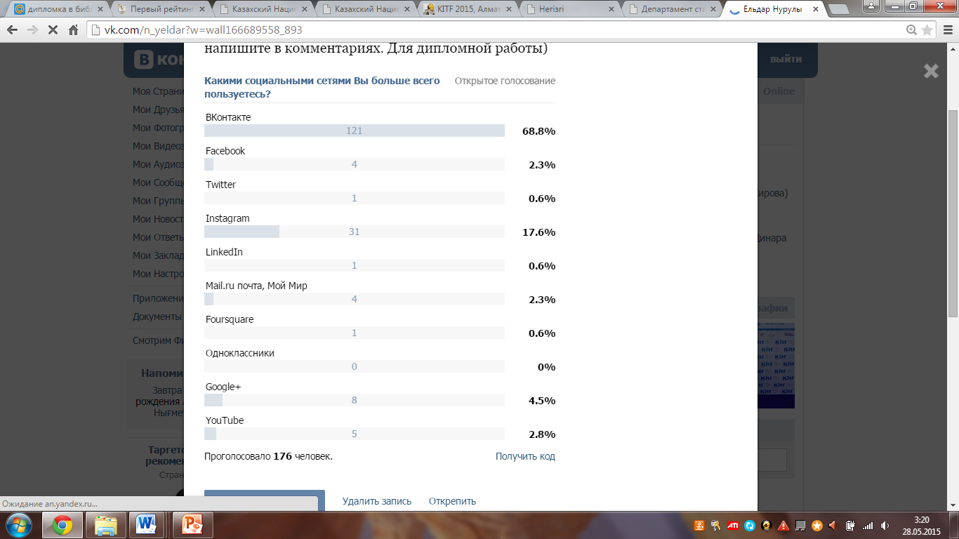
Figure 6. The result of voting in social network "VKontakte" [21]

The results of a survey conducted on the tourism exhibition KITF-2015 were significantly different in terms of performance of the online voting. The reason is that most of the participants were foreigners, as in other countries in the market may prevail completely different types of social networks compared to our domestic market. Thus, the following results were obtained: Facebook - 51%, the Instagram - 16%, Twitter - 11%, the YouTube - 8% of LinkedIn - 7%, Google+ - 4%, the remaining 3% - other social media.

Figure 7. The results of the survey conducted in the exhibition KITF-2015 - an indicator of the use of social media [conducted by the authors]

Almost all of the respondents told that they spend a lot of time in social media. Less than 1 hour per day 11 per cent, 16 per cent of 1-3 hours, 4-6 hours 38 per cent, and the remaining 35 percent said that spend more than 6 hours of time in social media.
During the trip, people often believe online reviews than the official data. Many people before the dispatch read online reviews of experienced travelers and their advices about the visited country or locality. Because the online reviews are truthful, written in a real time and affect a person psychologically. But of course it is necessary to take into account the fact that online reviews have a subjective assessment rather than objective. And yet, some of the negative reviews of competitors of a company can also be placed on the Internet.
Nevertheless, we decided to interview experts and asked them a question: "When you travel, do you trust the official information, or an online consumer reviews?" and got some interesting data: 15.5% of respondents said that they trust only the official data, online reviews trusted by 51.5%, trust both 26% and 8% of respondents said they do not believe any of them, and listen only to themselves. These data are presented in a diagram.

Figure 8. Confidence point of view to the common types of information [conducted by the authors]

However, respondents were asked and closed types of questions:

Figure 9. Closed questions and answers given by the respondents [conducted by the authors]
During the survey, respondents we were asked: "Do you use social media to attract and increase the number of customers?" And the following answers were given as a percentage: the majority (65%) of respondents said that they use this important marketing tool, 15% respondents answered - sometimes used, 6% - have never used social media, while 14% of respondents answered that it is not one of them, because this segment of the respondents did not work in the private business sector.

Figure 10. Use social media to increase customer [conducted by the authors]

In general, the survey had other questions, but was selected by the most basic. Through carrying out a survey found out that social media is not only penetrated in almost every person's life, but also showed the dynamism of its development, which is growing rapidly and is updated every day. At the same time, it was determined the degree of use of social media by foreign guests certainly working in the tourist market of Kazakhstan. In accordance with this, the authors believe that the need to develop domestic tourism, and develop their own tourism model based on foreign experience in social media, taking into account specific features.
Classification of social media. At the present stage, for the understanding of the impact of virtual communities, implemented on the basis of social media on society and its development, it is necessary to carry out additional theoretical and practical studies related primarily to the need for reflection and systematization of species and types of social media. Therefore, relevant, in our view, is the task of carrying out such a classification of social media, which would allow identifying the links between different types of social media, directions, and the possibility of switching from one type of social media to the next in the development process.
The existing classification of social media on the Internet are mainly carried out by type of services provided (personal communication, business communication, geolocation, blogging, etc.), according to availability (open, closed, mixed), the region (world, country, organization). This approach to classification ascertains the current status, allows you to group the social media only on technological grounds, without revealing the influence of social media on the change in the structure of social communities.
Thus, the emergence and development of social networks contribute to the development of a new culture and society. This method of communication performs many functions, allows a person to self-actualize, to get new useful information to cultivate and evaluate the results. But the main purpose of the person using social networks, is the socialization and integration, the desire to establish relations with other users with the ability to move this relationship in more realistic. Any function of the social network is intertwined with communication and, eventually, transformed into communication.

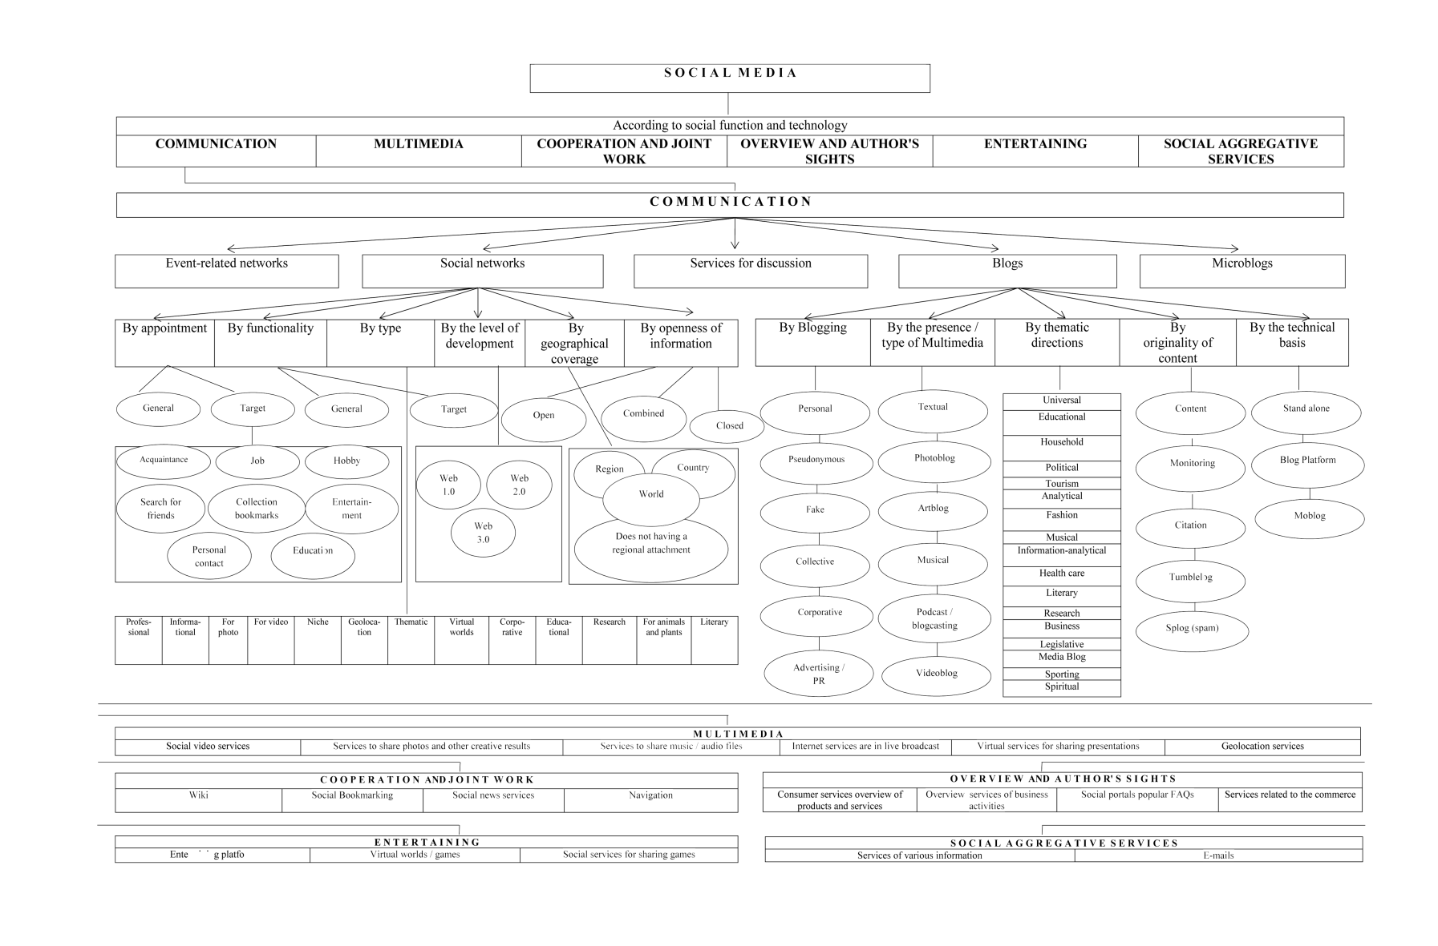
Figure 11. Classification of social media [22]

Limitations and research opportunities. Since this study mostly is the overview, the present study had limitations that were not originally determined by preliminary tests and other measurements. If it had an opportunity to review the questionnaire, they would have added some changes. For example, many people now receive information directly from the web site, it would be wiser to include and compare the WorldWideWeb (www) with social media in this study.
Also, we were able to examine and evaluate social media in tourism by sending pre-prepared questionnaire by e-mail to various companies / agencies in the field of tourism and marketing. But unfortunately, due to lack of time to do this would not be possible in the shortest time.
Since the main purpose of this study was to collect benchmarks of 2015 year, in respect of which it will be possible to carry out research in the coming years, the authors would seriously consider some modification in the survey to collect additional data.

Conclusion
In this work the authors have done the following:
- an analysis of statistical data, scientific and practical results of the study of social media in modern tourism industry;
- sufficiently reviewed studies of foreign scientists in the field of social media;
- made extensive new classification of social media with new directions;
- conducted a survey with the participation of international experts in the field of tourism marketing to assess the impact of social media on the development of tourism in Kazakhstan;
- conducted an online survey on the social network VKontakte through voting;
- the features and the role of social media in the domestic industry of tourism and hospitality;
- made the assessment of social media in the tourism market of Kazakhstan;
- made a prognosis and identifies new trends for tourism enterprises.
Today, the company's reputation depends on the information field, which was formed around it on the Internet. So, for example any tourist before buying a tourist product, most often interested in feedback on his chosen tourism company, read reviews about this tour. Negative feedback can ruin a reputation, positive – make your brand a cult. Thus, it is important to manage this information on your company, distributed on the Internet. Encourage positive feedback, work with the negative, to be open for consumers who are ready to acknowledge and correct their mistakes.
Concerning the SMM prospects of the market, experts agree that it is for a long time. From year to year we heard arguments about how much is still left to social networks, though actually seen positive increase of Internet users, which consequently says of growth that have created themselves a page in Facebook, or for example, Odnoklassniki. Sure, things are changing, there are new social networks, some lose their grounds, users can change their preferences, but nevertheless all are remaining online.

References

Journal paper
[10] Anderson P. (2007). What is Web 2.0? Ideas, technologies and implications for education. JISC Technology and Standards Watch
[13] Aliyeva Zh.N., Nuruly Ye. (2014). Social media in the modern tourism industry (in kaz.) // KazNU Bulletin (Geographic Series). – №2 (39). – S. 71-75.
[22] Nuruly Ye. The role of social media in tourism: diploma work - under the guidance of Aliyeva Zh.N. - Al-Farabi Kazakh National University, Almaty.
Book
[3] Solis B., Breakenridge D. (2009). Putting the Public Back in Public Relations: How Social Media Is Reinventing the Aging Business of PR. Upper Saddle River: Pearson Education Inc.
[4] McConnell B., Huba J. (2008). Epidemic content. Marketing on social networks and the blogosphere. – Ed. Vertex.
[9] Musser J., O'Reilly T., O'Reilly Radar Team. (2007). Web 2.0 Principles and Best Practices. O'Reilly Media, Inc., 1005 Gravenstein Highway North, Sebastopol, CA 95472
[11] Barnes J. (1954). Class and Committees in a Norwegian Island Parish. Human Relations. P. 11-17.
[12] Radcliffe-Brown A.R. (1952). Structure and Function in Primitive Society: Essays and Addresses. L.: Cohen & West
[14] Novikov V.S. (2007). Innovation in tourism. Tutorial. – M.: Academy
[19] Korotkov E.M. (2000). Research of management systems: a tutorial. - M .: DECA
[20] Osipov G.V., Andreev E.P. (1977). Measurement methods in sociology. - M .: Science
Internet
[2] Dictionary of the blogger. URL: http://blogtips.ru/slovar-blogera
[5] Thornley J. What is «Social media»? URL: http://propr.ca/2008/what-is-social-media/
[6] Scoble R. What is social media? URL: http://scobleizer.com/what-is-social-media/
[7] Dykeman M. Social media marketing – a tale of two Potters. URL: http://www.socialmediaexplorer.com/digital-marketing/social-media-marketing-a-tale-of-two-potters/
[8] Social Media. URL: https://ru.wikipedia.org/wiki/Социальные_медиа
[15] Kazakhstan TNS Web Index. Internet audience. (2015). Almaty, Kazakhstan. URL: http://www.tns-global.kz/ru/research/research_smi.php
[16] J'son & Partners Сonsulting. The mobile Internet market in the CIS countries following the results of 2013. URL: http://json.tv/ict_telecom_analytics_view/rynok-mobilnogo-interneta-v-stranah-sng-po-itogam-2013-goda
[17] Rating SimilarWeb. The most popular site in Kazakhstan. URL: http://www.similarweb.com/country/kazakhstan
[18] Action Global Communications of Kazakhstan. URL: http://communications.kz/tags/action-global-communications/
[21] Nuruly Ye. Survey conducted in the personal profile of social network VKontakte. URL: http://vk.com/n_yeldar?w=wall166689558_893
Other sources
[1] About Decree of the President of the Republic of Kazakhstan "On Approval of the Concept of development of the tourism industry of the Republic of Kazakhstan till 2020" // Resolution of the Government of the Republic of Kazakhstan dated February 28, 2013 № 192

