Climate changing and non-equilibrium atmosphere.
Nurgaliyeva K, Tlekova K.
Al-Farabi Kazakh State University, Almaty, Kazakhstan
Abstract
This work is a first step to solve the problem on creation of the theory of evolution of non-equilibrium open systems. Any atmospheric changes somehow depend on external parameters variations: solar activity variation, magnetic storms, anthropogenic carbon dioxide fluxes and so on. In order to understand their influence to atmosphere we should to take into account the openness of atmosphere that’s mean its non-equilibrium. We should to know how external parameters variations changes influence on atmospheric processes. But today we practically don’t understand mechanisms that define the dependence character of non-equilibrium systems dynamics at external conditions and system parameters changes. There aren’t necessary fundamental theories which could help to create evolutional mathematical atmosphere models.
The mean factors forming atmospheric structures are radiation fluxes. So in order to understand atmospheric evolutional processes it is a necessary to consider atmospheric gas in continuity with radiation. This problem couldn’t be solved in the frames of traditional gas dynamics equations because of dissipative structures in any systems including atmosphere and radiation causes by entropy production and interchange and this don’t describing in the frames of traditional gas dynamics. But for this aim we could use more complex non-equilibrium (non-equilibrium) thermodynamics equations which taking into account exchange processes in such systems.
The behavior of wave disturbances in non-equilibrium medium: atmospheric gas – solar radiation taking into account atmospheric structures and radiation flux interrelations was investigated in this work. The dispersion relation of acoustic-gravity waves was found from reductive atmospheric gas - solar radiation system dynamic equations set in the frames of non-equilibrium thermodynamics. Calculations show that the taking into account of solar radiation leads to slowly decreasing of pressure with height than without taking it into account. The maximum deviation of pressure comes to heights of 10-15 km and amounts about 3 percents. The dependence of AGW spectra deviation in non-equilibrium atmosphere from the spectra in equilibrium atmosphere from the height was estimated. It was found that in the frames of non-equilibrium spectra shifts into high-frequency region. Numerical calculations also shows that in the heights of ionosphere these effects shown up sharply at transitionally times at abrupt change of solar energy influx into atmosphere. Analysis of pressure variations shows the experimental prove of existing of obvious trend of spectra shift into high-frequency region of daytime spectra relatively to nighttime spectra and the difference made 10 percents and proves the correctness of theoretical calculations.
There is a destruction of climatic machine on the Earth. Thawed the Arctic and Antarctic ice, Tien Shan, Alps, Greenland glaciers melt away and the mean temperature of Earth grows [1,2]. Moreover the quantity of weather anomalies sharply increased. The rate of climate change on Earth is higher than thought scientists. In thear prognosis on Arctic ice thawing researches mistakes approximately for 30 years. Today the danger of disappearance concerns not only living creatures of earth but even continents [3-5].

In accordance with known laws of non-equilibrium dynamics all these signs significant for bifurcation change. After crossing of bifurcation point climate wouldn’t be restored. It would have rather different characteristics than now. It creates serious danger for humankind. That why the mean problem of mankind is to understand the causes and mechanism of climate changing in order to take the necessary steps on prevention or even decreasing of catastrophic aftermath.

For nowadays we for certain know that there are two causes of these phenomena. First bind with natural circle climate changes. The second depend on anthropogenic activity. And it is not ruled out that these causes overlay. But we couldn’t say that kind of scenario would realize actually.

There is a reason to say that the climate changing course of anthropogenic activity. Really the fact of atmosphere existing related with existence of live on the Earth [6]. The modern atmosphere composition made by living organism. They change original Earth climate. On the first level of development atmosphere of Earth haven’t free oxygen, it was composition of carbon dioxide. It hence on chemical composition of iron compound of these periods. Approximately 1.8 billion years ago (the Earth age is about 40 billion years) in the result of microorganisms activity the oxygen exists in atmosphere. It’s lead to existing of ozone layer at the heights of 20—50 km. As a result the living organisms which could live out of solar radiation have a possibility to spread over all the Earth and having an advantages to survive change the atmosphere composition some more.

For the advantage of anthropogenic mechanism of climate changing testify the striking coincidence of annual planetary temperature changing rate with carbon dioxide consantration change rate. [7,8] The serious reason for assumption on curtail human role in climate changing is the increasing of observing weather fluctuations in different Earth regions. It’s very difficult to explain the rate of this change by natural circles. That’s why most of scientists thought that the climate changing caused by human activity.

World public already now tries to make some efforts against climate changing. But it’s very difficult to wait efficiency of any efforts when we don’t know the causes of running processes. Today science limited by observation of existing processes and by mapping empiric prognosis which only could gave epignosis. The existing mathematical atmospheric models adopted for numerical weather calculation. They made weather prognosis but couldn’t answer the question on climate changing. It is a due to rough atmosphere parameters used in numerical calculations. That’s why it’s important to reveal the mechanisms of weather and climate formation. Without knowing it we couldn’t answer the question on prevention measures.

Any atmospheric changes somehow depend on external parameters variations: solar activity variation, magnetic storms, anthropogenic carbon dioxide fluxes and so on. In order to understand their influence to atmosphere we should to take into account the openness of atmosphere that’s mean its non-equilibrium. We should to know how external parameters variations changes influence on atmospheric processes. But today we practically don’t understand mechanisms that define the dependence character of non-equilibrium systems dynamics at external conditions and system parameters changes. There aren’t necessary fundamental theories which could help to create evolutional mathematical atmosphere models. These set a problem for science to create the theory of evolution of non-equilibrium open systems. [9-11].

The mean factors forming atmospheric structures are radiation fluxes. They cause such dissipative strictures as ionosphere, ozone layer, temperature and other atmospheric inhomogeneities. These structures are non-equilibrium since their existence due to constant interchange of energy between atmosphere and cosmic space. So in order to understand atmospheric evolutional processes it is a necessary to consider atmospheric gas in continuity with radiation. This problem couldn’t be solved in the frames of traditional gas dynamics equations because of dissipative structures in any systems including atmosphere and radiation causes by entropy production and interchange and this don’t describing in the frames of traditional gas dynamics. But for this aim we could use more complex non-equilibrium (non-equilibrium) thermodynamics equations which taking into account exchange processes in such systems. Of course this essentially complicated the problem but we couldn’t find simpler path for understanding of evolutional processes.

The systems of atmosphere dynamic equations in the frames of non-equilibrium (non-equilibrium) thermodynamics are written as:
, (1)
, (2)
, (3)
. (4)

where:– time; ρ – atmospheric gas density; Т – temperature; – gas transference velocity; – pressure; – acceleration of gravity; – heat capacities at constant volume and pressure correspondingly; – photon beam with frequency ; – specific radiation absorption coefficient; -thermal flux and ; κ – thermal conductivity coefficient; – atmospheric gas thermal emission; μ – average coefficient of solar radiation absorption. The flow of solar radiation is directed downward.

Calculations showed that the consideration of atmosphere as non-equilibrium system: non-equilibrium atmosphere considering as interacting medium – atmospheric gas and incoming and outgoing radiation flow leads to instability of atmospheric parameters for the radiation parameters changes (Fig.1). Calculations showed that the taking into account of solar radiation leads to slowly decreasing of pressure with height in comparison with the case without taking into account of solar radiation. The maximum deviation of pressure takes place at heights of 10-15 km with amounts about 3 percents (Fig.2). The atmospheric parameters defined on the basis of existing models of atmosphere.

Calculations were done for different means of albedo and radiation absorption coefficients. It was found that in the frames of parameters allowed values obtained temperature and density profiles essentially depend on surface temperature, absorption coefficient and albedo. So non-equilibrium atmospheric background model calculations shows that atmosphere is extremely unstable for radiation parameters changing (Fig.3).

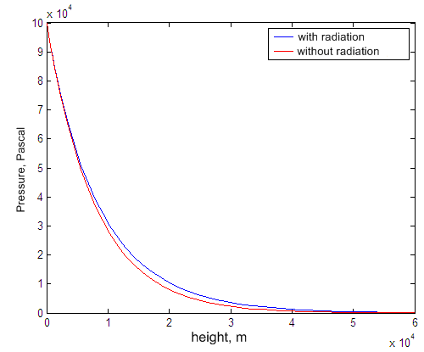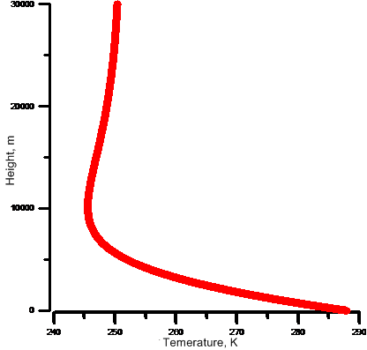
Fig.1. Pressure and temperature profile

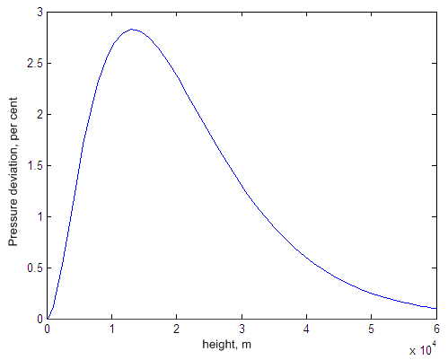
Fig.2. Deviation from barometric formula at radiation consideration

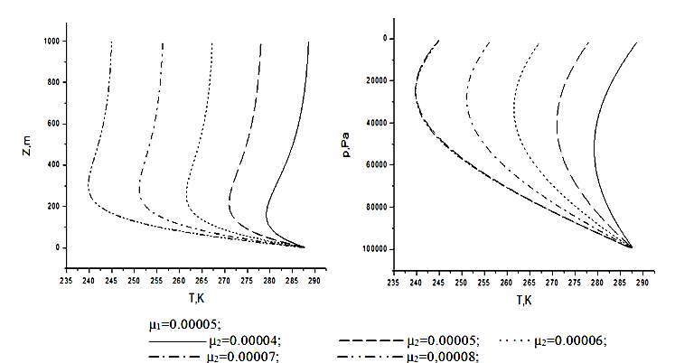
Fig.3. Dependence of temperature profile on on surface temperature, absorption coefficient and albedo changes

The non-equilibrium spectrum of atmospheric oscillations was calculated based on the set of equations of non-equilibrium thermodynamics (1)-(4) written taking into account the interaction between the atmospheric gas and radiation. The set includes equations of continuity, energy, and momentum. The energy equation includes the terms related to the interaction of the atmospheric gas with solar radiation and thermal conductivity and radiation of the atmosphere. The set of gas dynamic equations is supplemented with the simpliﬁed equation for solar radiation ﬂux absorbed by the atmospheric gas. Solar radiation ﬂux absorbed by the atmosphere and atmospheric density are interrelated quantities. Therefore, all four equations are self-consistent.

The dispersion equation corresponding to the linearized equations of the set (1)–(4) for the non-equilibrium spectrum of atmospheric gas natural oscillations has the form

$$w^{4}−\frac{4{σT}_{0}^{3}}{ρ_{0}c_{V}}k_{z}w^{3}−gγ\left({\text{Hk}}^{2}−{\text{ik}}_{z}\right)w^{2}+\frac{4{σT}_{0}^{3}gγ}{{\text{γρ}}_{0}c_{V}}{\text{ik}}_{z}\left({\text{iHk}}^{2}+k_{z}\right)w+$$
$+\frac{{μc}^{2}}{{γT}_{0}c_{V}}\frac{{\text{ik}}_{z}J_{0}k^{2}}{{\text{ik}}_{z}−{\text{μρ}}_{0}}w+g^{2}\left(γ−1\right)k_{x}^{2}=0$ (5)

Here $i$- imaginary unit; $w$ - harmonic frequency, $k_{x},k_{z}$- are the corresponding wavevector harmonics along the $x,z$ axes, and $k^{2}=k_{x}^{2}+k_{z}^{2}$; $γ=\frac{c_{p}}{c_{V}}$; $H={c^{2}}/(gγ)$ - is the so-called height of the homogeneous atmosphere.

If we omit the fourth equation in the set (1)–(4) and neglect three last terms in the energy equation, then the dispersion equation for AGWs in the equilibrium atmosphere [Gershman, 1974] will correspond to the obtained set of equations. The same dispersion equation can be obtained immediately from (5) by rejecting all even terms related to energy exchange between gas and radiation.

The dependence of difference between AGW spectra for non-equilibrium and equilibrium atmosphere on height was estimated. It is found that for non-equilibrium atmosphere AGW spectra is shifted into high-frequency region (fig. 4). Also numerical calculations show that at the heights of ionosphere these effects become brighter at transition times, when the solar energy input changes abruptly (fig 5).

To calculate the equilibrium spectrum of oscillations, we used the traditional equation of the AGW spectrum [12]. As was noted above, this equation can be obtained immediately from (5) by eliminating the terms related to energy exchange between radiation and the atmospheric gas. The dispersion relation was numerically analyzed for different conditions: in the presence of solar radiation in the atmosphere and without this radiation, as well as for the equilibrium case at different atmospheric altitudes. The temperature values were taken from the existing atmosphere/ionosphere models up to 250 km. The average temperature difference in daytime and nighttime hours is approximately 20 K in the selected altitude interval. According to these results, in both cases the oscillation spectrum shifts into the HF spectral region with increasing temperature.

Thus, according to the numerical estimates, the presence of non-equilibrium in the atmospheric gas should lead to a shift of the atmospheric natural oscillation spectrum. The difference of the atmospheric temperature in daytime and nighttime hours for the equilibrium model of the atmospheric gas cannot result in such a spectrum shift. Therefore, an experimental detection of the shift of the atmospheric natural oscillation spectrum will be a necessary argument for the substantial role of non-equilibrium in the dynamics of the atmosphere.

Fig. 4 Variations in the oscillation frequency ω vs. λ_{z} in the nonequilibrium (non-equilibrium) daytime (circles, line 3) and nighttime (asterisks, line 2) atmosphere and in the equilibrium case (line 1) calculated using the background values of the
parameters at an altitude of h = 50 km.

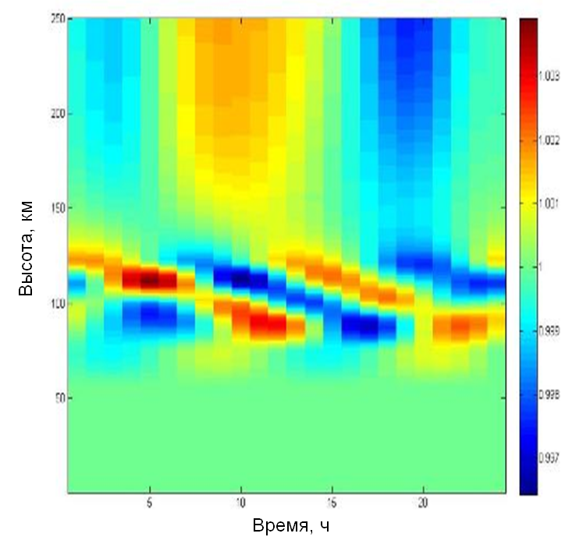
Fig. 5 Ratio of non-equilibrium and equilibrium spectrum for heights 0-250 km.

To confirm the theoretically founded spectra shifts into high-frequency region, the analysis of pressure variations for August, September and December of 2002 measured on high-mountain station of cosmic rays of Ionosphere Institute, Almaty, Kazakhstan and Ukraine station ”Academic Vernadskii”, Antarctica was made [13].. The analysis proved the existing of obvious trend of daytime spectra shift into high-frequency region relatively to nighttime spectra at about of 10 percents. The analysis of ionospheric data for Mach, June, September and December of 2005 on Ukraine station ”Academic Vernadskii”, Antarctica also proved obtained theoretical results for the ionosphere heights (Fig. 6).

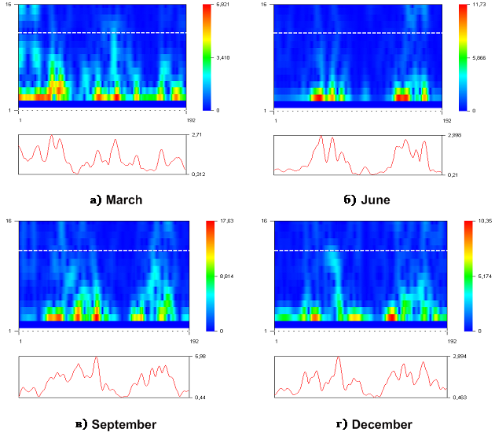
Fig.6 Spectrogram of ionosphere data

As further investigations on this field it should be studied the interrelation of cosmic factors variations with dynamical processes on Earth atmosphere on the basis of open non-equilibrium systems theory and experimenta data of radiation fluxes in atmosphere

ACKNOWLEDGMENTS

We are grateful to the Ukrainian Antarctic Center for presented meteorological data from Akademik Vernadsky station. The participation of the researchers of RI NAN Ukraine in this work was partially supported by NIR “Resonansy” UATs MON Ukraine

Research was made in the frames of projects “Development of non-equilibrium atmosphere researches”, reg. num. 0112PK00294

References
1 Coumou, D., Robinson, A., Rahmstorf, S. (2013): Global increase in record-breaking monthly -mean temperatures. Climatic Change (online) [doi:10.1007/s1 0584-012-0668-1] Weblink to the article: http://link.springer.com/article/10.1007/s10584-012-0668-1,
2 Paul Edwards, A Vast Machine: Computer Models, Climate Data, and the Politics of Global Warming (Cambridge, MA: MIT Press, 2010).
3. Tobias Bolch. Climate change and glacier retreat in northern Tien Shan (Kazakhstan/Kyrgyzstan) using remote sensing data, Global and Planetary Change, V 61, 2008. 4. Kerry Emanuel. Increasing destructiveness of tropical cyclones over the past 30 years, Nature, Letter, Vol 4364, August 2005.
5. D. A. Stainforth, T. Aina1, C. Christensen, et. al. Uncertainty in predictions of the climate response to rising levels of greenhouse gases, NATURE, |VOL 433,| 27 JANUARY 20, 2005.
6. Smirnov B.M. Ecological problems of earth. Uspehi phizicheskih nauk, Vol. 117, Issue. 2, 1975, p. 313-322.
7 National Research Council Global Emissions | U.S. Emissions
8 James Hansen, Larissa Nazarenko, Reto Ruedy, Makiko Sato, Josh Willis, Anthony Del Genio, Dorothy Koch, Andrew Lacis, Ken Lo, Surabi Menon, Tica Novakov, Judith Perlwitz, Gary Russell, Gavin A. Schmidt, Nicholas Tausnev. Earth’s Energy Non-equilibrium: Confirmation and Implications. www.sciencemag.org SCIENCE VOL 308 3 JUNE 2005
9 N. Essex, “Radiation and Irreversible Thermodynamics of Climate,” J. Atmos. Sci. 41 (12), 1985–1991 (1986).
10 M. N. Izakov, “Self-Organization and Information on Planets and in Ecosystems,” Usp. Fiz. Nauk 167 (10), 1087–1094 (1997)
11 Variational and Extremum Principles in Macroscopic Systems /Editors: Stanislaw Sieniutycz and Henrik Farkas. – Elsevier Science, Oxford – 2004 – Р. 791.
12 B. N. Gershman, Ionospheric Plasma Dynamics (Nauka, Moscow, 1974) [in Russian]
13 Antonova V.P, Dungenbaeva K.E.. Zaliaovskii A.V, Inchin A.S., Kryukov S.V., Somsikov V.M., Yampol’skii Yu. M. Difference between the spectra of Acoustic Gravity Waves in Daytime and Nighttime Hours due to Nonequilibrium Effects in the atmosphere // Geomag. &Aeron. – 2006. - V. 46, No 1. - Р. 101-109

