KazNU named after al-Farabi
Smagulova G.S. c.e.s, associate professor, Irgebayeva L.M.

COMPETITIVENESS OF NATIONAL ECONOMICS

A nation’s standard of living is increasingly dependent on the competitiveness of its firms. Competitiveness is vital if the nation’s firms are to take advantage of the opportunities opened up for them in the international arena. World trade and foreign investment have grown faster than world output in the last several decades.
Competitiveness in industries subject to international trade and foreign direct investment can, therefore, provide substantial leverage for economic growth. This is especially true for small nations, where competitiveness can allow firms to overcome the limitations of their small home markets in order to achieve their maximum potential.
Competitiveness is also vital if a nation’s firms are to guard against the threats posed by the international economy, indeed, International competition has become fiercer than ever before. Lower costs for transportation and communication, reduced trade barriers, and the spread of technology have fused to sharpen international competition. This competition has put unprecedented pressure on all national economic actors, including management, labor, and government. In an environment in which the nation’s firms must improve continually in order to meet the threat from an ever-widening array of competitors, the failure of management, labor, or government to rise up to the challenge can spell out incalculable disasters for the nation’s firms.
The paper focuses on future economic development of Kazakhstan. Further, the paper introduces the development key parameters of development and increase of competitiveness of the national economy. The modern market economy of the world developed countries is cemented by general functional-moving origin industrial capital that has transformed the commodity-money relations into the defining mechanism of economic development. It is thought, that increase of national competitiveness in Kazakhstan is possible only on the basis of proportional transformation of sphere of goods production, and also its database. As a result, these transformations should lead, as in all industrially developed countries, to the creation of mixed economy as the elements unity of the classical market and corporate structures. A state in this system is called to carry out the major function of the integrating element providing connection of the market subjects in the system whole. In Kazakhstan market formation is carried out on a way of privatization and privatization of rigidly centralized economy and its transformation to multistructural. It demands a special approach. It is required to add to the aforesaid that the existing technological level of the production industrial base of our country, it also imposes some peculiarities on this process. In the modern economy of Kazakhstan, formation of the competitive environment is connected with decision of some primary goals such as creation of the enterprise sector of economy, formation of organizational legal conditions to overcome monopolistic disproportions, abuse of the Leading position in the commodity markets, the prevention of unfair competition, and, at last, the elimination of artificial administrative barriers hampering equal competition. The major value for the future economic development of Kazakhstan has a basic choice between raw and technological orientation of economy. Till now the state support of technological competitive advantages of the firms in Kazakhstan was carried out by means of: restructuring of the state ownership stimulation of domestic competition of economy in Kazakhstan and weakening of pressure on producers of monopolistic factors; privatization of services sphere allowing flexibility increase [1].
Competitiveness of domestic business – main task of country's economic policy.
The competiveness of any economy directly depends on the quality and effectiveness of business, its qualitative characteristics, competiveness of the strategy and tactics. As the world experience shows, active and speedily developing small and medium enterprises make a decisive contribution to the economic development and increase of competitiveness of a country. In this regard, the world pays special attention to the development of entrepreneurship.
A range of different instruments for support of entrepreneurs starting from indirect instruments to direct state support has been developed in the world. The main purpose of such measures is both creation of favorable business climate and targeted support of some business types and directions important for a certain country.
Kazakhstan has paid special attention to the development of business since gaining independence. The Head of the State has emphasized and emphasizes the role of this sector of the economy with great development potential in provision of forced economic development of the country (table 1) [2].
Table1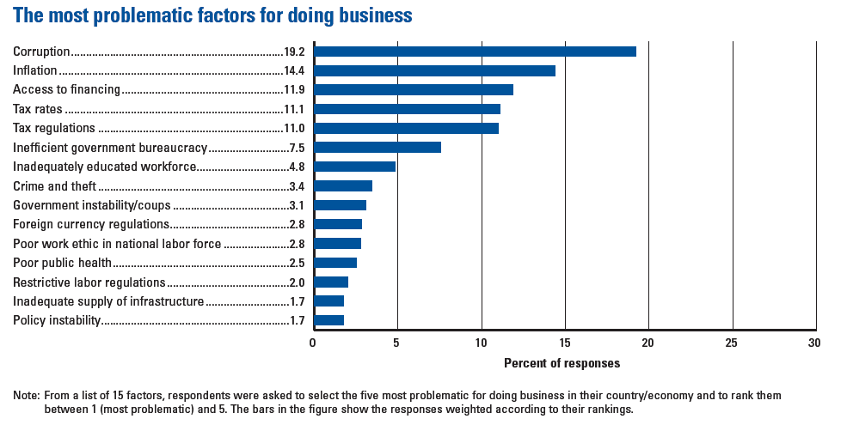
Over the past period of time six state programs and a number of sectoral programs somehow touching upon the issues of domestic business development have been realized.
Both qualitative and quantitative characteristics of the Kazakh business were improved due to the goal-oriented work conducted at all stages of the state policy realization.
Thus, the number of registered small and medium business increased over four times reaching one mln entities in last ten years. The production volumes of small and medium business increase. The business activity in the country doesn't decrease despite the world economic situation. Production of goods and service of small and medium business entities increased by 4.8% in January-May, 2010 compared to January-May last year.
Positive results of the system work on business climate improvement resulted in the dynamics of assessments of foreign experts – Kazakhstan improved its position in the World Bank's "Doing Business" ratings (from 71st place in 2008 to 63rd place in 2010).
The further work on this direction is aimed at Kazakhstan's entering the top 50 and later top 30 countries with the most favorable business climate.
In recent years Kazakhstan has undertaken many efforts on entrepreneurship development. In particular, system steps on administrative barriers reduction were taken.
On January, 1 2009 the Laws "On competition" and "On amendments to some legislative acts of Kazakhstan on the issues of competition" were brought into force. The main amendments of the Law on competition are aimed at stimulation of business activity, limitation of negative governmental intervention, modernization of forms and methods of restriction of monopolistic activity and prevention of unfair competition.
At the present stage of development the formation of competitive SMEs is crucial for further strengthening of the competitive advantages of Kazakhstan. In the next five-ten years Kazakhstan will have to implement the task of diversification and development of innovative economy. A new stage of economic development requires new approaches to strengthening the small business sector.
The current economic policy of supporting business includes the following:
- financial support of small and medium businesses through "Samruk-Kazyna" National Welfare Fund and specialized Fund for Entrepreneurship Development "Damu";
- reduction of administrative barriers by means of improving the licensing system and reforming the regulatory system;
- introduction of new forms of business support, such as development of public-private partnership, promotion of exports of Kazakhstan's entrepreneurs, improvement of business procedures.
According to President of Kazakhstan Nursultan Nazarbayev, entrepreneurship, which is a driving force of economic modernization, will be a core of Kazakhstan's economy diversification. Thus the key task of the strategic plan of Kazakhstan's development till 2020 is the formation of multi-industry competitive domestic business.
Therefore, raising competitiveness, implementation of strategic goals and search for new global opportunities should be the motto of domestic entrepreneurship in the modern conditions [3].
In order to increase the competiveness of Kazakhstan according to the Industrial-innovation program it was planned to create new enterprises, which are equipped with high technologies (imported or using local know-how). Presently the second stage of industrial-innovative strategy is realized. Some efforts are made for development of processing industry, and creation of techno parks, clusters and incubators.
Adaptation process of Kazakhstan to the world tendencies of scientific-technological and industrial integration is on the beginning stage, even though it is completely clear that integration into global innovation sphere is the main factor of national sectors development of high technologies. International scientific and technological partnership contributes to the increase of companies’ competiveness and promotion of high technologies on domestic market.
For most of Kazakhstan enterprises the main goal of innovation development is a partnership with world producers. One of the most effective strategies is a long-term cooperation and alliance with world leaders. The partnership of Kazakhstan companies with foreign partners shows that the further they advanced by the way of understanding problems and advantages of entering world markets, the more stable is their financial and economic position. Development of national science and innovation activities follow more and more economic advisability.

Table 2
Global Competitiveness Index 2010–2011 rankings and 2009–2010 comparisons*
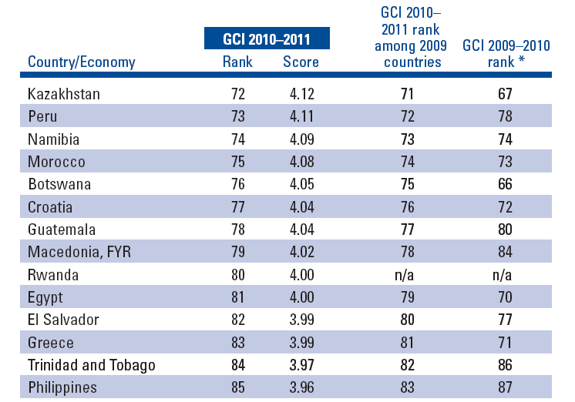

* World Economic Forum . “The Global Competitiveness Report 2010-2011”, 2010.
* The 2009–2010 rank shown is the one published last year out of 133 countries. One country that was included last year, Suriname, has been excluded this year for lack of Survey data. Suriname’s rank of 102 from last year is therefore not shown in the table.

In conditions of globalization no country can put aside tendencies of the world development as connection and comparable evaluation in a system of the world economic relations turn into one of the most important factors determining competiveness of national economy.
The competitiveness of Kazakhstan in 2009 reduced again. In the overall rating of GCI, Kazakhstan dropped one place down from 66th to 67th, although, in comparison with the majority of other Post-Soviet countries, the situation with Kazakhstan does not look dramatic.
According to the WEF’s methodology, to Kazakhstan, the weightiest, from the point of view of contribution in the total GCI ranking, is the Basic Requirements subindex. Following the serious drop by 8 positions in 2008, Kazakhstan’s position by this subindex in 2009 remained unchanged ranking 74th (table 2) [4].
This is despite that two of four pillars, constituting the subindex, demonstrated considerable leaps: “Institutions” dropped from 81st to 86th, while “Macroeconomic stability” won back partly the last year’s crisis drop, having risen 15 places up from 74th to 59th. It seems that the various directions of these trends leveled their effect on the overall result.
Kazakhstan’s position in the Innovation and Sophistication Factors subindex dropped one place down to 78th. Both of the pillars, constituting this index, the “Business sophistication” and “Innovation”, demonstrated a fall two positions down.
Traditionally, of the three subindexes that form GCI, the best situation to Kazakhstan is with the Efficiency Enhancers subindex. Even with this, the more anxious the situation as seen in the last few years: Kazakhstan ranked 56th in 2006, 58th in 2007, and 64th in 2008. In 2009, this subindex dropped five more places, placing the country 69th. In particular, by the goods market efficiency Kazakhstan now ranks 84th, having dropped four places down, by labor market efficiency 18th (-6), while the “financial market sophistication” pillar worsened in Kazakhstan, dropping 14 positions to 111th. The only pillar of this subindex that demonstrated betterment was the technological readiness – 69th (+6) [5].
In general, of 110 indicators only 19 characterize positively the competitiveness of our economy. Compared to last year’s ranking, the list of indicators, by which Kazakhstan holds the place in a ranking above 50, has not undergone considerable changes. We managed to win back our competitiveness from the viewpoint of the “government surplus/deficit”, – the 29th place (+30), while losing it with regard to ease of doing business. Thus, the indicator of a “number of procedures required to start a business” lost 16 positions, dropped to 60th, while in the “time required to start a business“ we are now ranking 62nd (-18).
Among the most prominent competitive advantages of our country, besides the “government surplus/deficit”, is another macroeconomic indicator – the “national savings rate” – 14th place (+34). Such sharp positive changes only prove the fact that despite the serious drop in positions in the first year of the crisis, the macroeconomic policy of Kazakhstan is still our chief merit. Here, one can refer the “government debt” – 11th place in the world. By itself, this indicator reflects the independence of the sovereign from the international creditor’s claims. Nevertheless, as the crisis showed, the state had to finally pay for the private banking structures’ debts; to say exactly, the population had to. Besides, we must not forget that in 2009 Kazakhstan has already raised directly external borrowings and FDI, in the amount of $25 billion. This means that the burden on the given indicator will increase seriously.
Our chances to develop innovative components of the competitiveness are high as ever. At least, from the point of view of capacity for innovation, Kazakhstan is now holding the same 50th place. This is only the potential by now, which we have to manage to develop.
By the tertiary enrollment, our republic is placed relatively high 45th position. Although this seems quite good, nevertheless, we cannot omit one drawback: Quantity and quality are not the same. Thus, by the quality of the educational system, on the whole, we are ranked only 66th, while by our local management schools even worse – 97th. Of course, private educational institutions are profitable ventures, from the financial point of view. However, the surface approach, which, according to formal inspections and publications in local mass media, prevails in domestic institutions of higher education, bears negative consequences already.
The WEF’s ranking assesses positively the domestic labor market efficiency: The result is 18th place in the world. In particular, by the hiring and firing practices indicator, Kazakhstan ranks 12th, outstripping not only Russia (43rd) and China (77th), but the GCI’s ranking leader, Switzerland (15th), as well. This picture is overshadowed by the low indicators of the level of “cooperation in labor-employer relations” – 76th place (-13) and the “reliance on professional management” – 100th place (-21). Although, taking into account the above-said low quality of business schools, the latest corporate scandals (for example, in the banking sector), as well as the anti-crisis cut of expenses, occurring everywhere, (including at the expense of personnel laying off), such trends can hardly be called a surprise.
Table 3
Global Competitiveness Index*
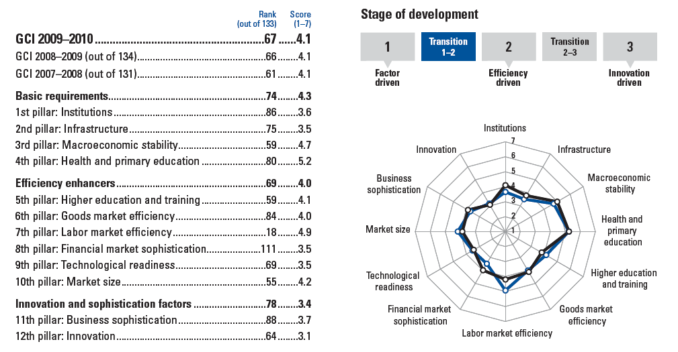
* World Economic Forum . “The Global Competitiveness Report 2009-2010”, 2010.

One of our big headaches is institutional development. Within the framework of this category, there is no ranking above 50th awarded to Kazakhstan. The WEF experts constantly pay attention to the aspect that the key to successful economic development is efficient state and public institutions. If they operate successfully, this positively affects those pillars within the framework of other indexes, since the efficient political structure system is usually a security of successful economic policy.
At that time when President of Kazakhstan posed a problem to join 50 the most competitive countries of the world, WEF had used Growth Competiveness Index, which was later substituted by Global Competiveness Index. One of the leading creators of the of Global Competiveness Index, chief economist and the head of WEF’s global competiveness network A. Lopes-Klaros proposed to evaluate country’s position on the basis of some subindexes (‘pillars’) (table 3) [6].

LIST OF THE USED LITERATURE
- Sabden O. (2007). Competiveness of national economy: evaluation criteria and methods of its improvement. Almaty: Economics.
- Short statistical year-book. Almaty: Statistical Agency of the Republic of Kazakhstan, 2009.
- KAZINFORM / “Competitiveness of domestic business - main task of country's economic policy” Maksat Mukhanov/, Astana. 2010, October 6. www.kazinform.kz
- Executive Summary. Global Competitiveness Report 2009. www.wefo-ru.org
- World Economic Forum . “The Global Competitiveness Report 2010-2011”, 2010.
- Kazakhstan falls file places to 67th rank in the world economic forums 2010 global competitiveness rankings. Word Economic Forum press release. Geneva, Switzerland 27 September 2010. www.weforum.org

