http://apps.webofknowledge.com/CitationReport.do?product=UA&search_mode=CitationReport&SID=W1QipqtXeNYi8MyKPYb&page=1&cr_pqid=1&viewType=summary
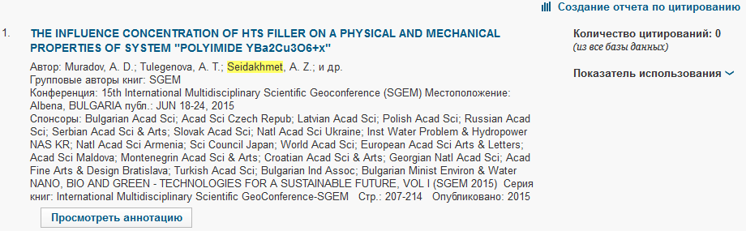
scopus.com
