

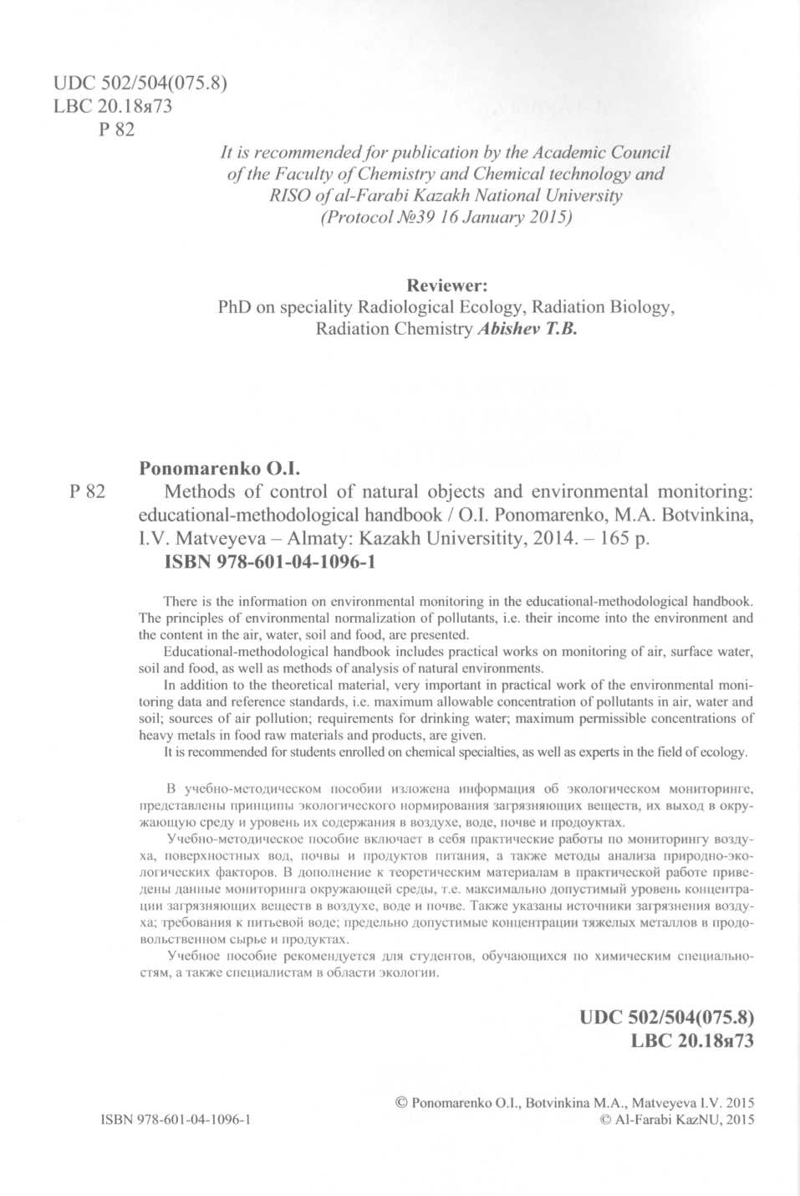


Computer page makeup: K. Umirbekova Cover designer: K. Umirbekova
www.http://gis-lab.info/docs/osgeo/ru/overview/kosmo_overview.html

