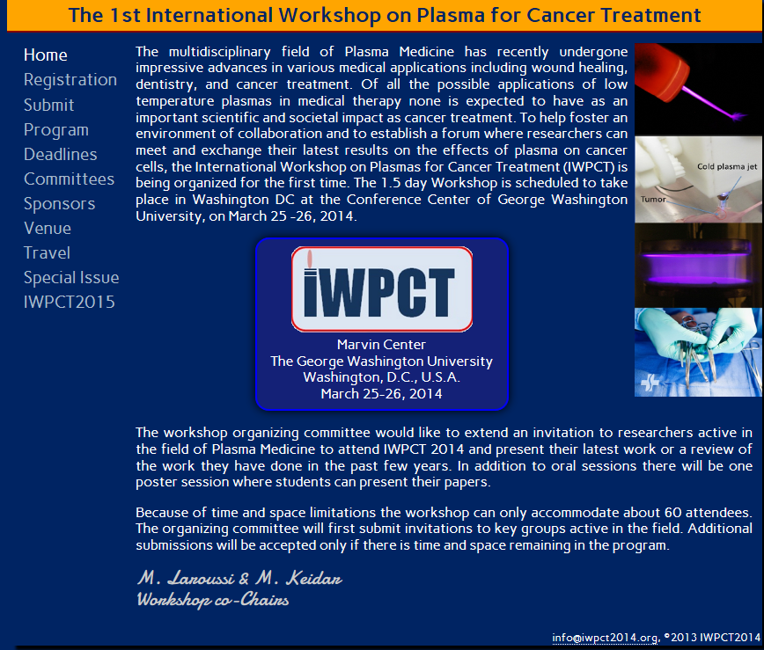
http://www.iwpct2014.org/

The 1st International Workshop on Plasma for Cancer Treatment
IWPCT2014 Technical Program

March 25, 2014
Welcome / Introduction
Session Chairs: M. Laroussi & M. Keidar
8:00 - 8:30 | Welcome Remarks by:  Dean David Dolling SEAS/VPR  Leo Chalupa, GWU  Dean Oktay Baysal, ODU

Oral Session 1: Plasma - Cell and Plasma - Tissue Interaction
Session Chair: M. Laroussi, Old Dominion University, Norfolk, VA, USA
8:30 - 9:30 | Plasma Treatment of Complex Tissues, K. Masur¹², S. Hasse¹², K. Wende¹², A. Schmidt¹², K. D. Weltmann², T. von Woedtke²  ¹ Center of Innovation Competence plasmatis - 17489 Greifswald, Germany  ² Leibniz Institute for Plasma Science and Technology (INP Greifswald), Felix-Hausdorff-St 2, 17489 Greifswald, Germany
9:00 - 9:30 | DNA and Protein Degradation Induced by Atmospheric Pressure Microplasma Jets, P-M Girard¹, M. Bitu¹, L. Tessier¹, C. Douat², J. Santos-Sousa², G. Bauville², M. Fleury², V. Puech²  ¹ Institut Curie, CNRS UMR3348, Orsay, France  ² Laboratoire de Physique des Gaz et des Plasma, CNRS and Univ. Paris-Sud, Orsay, France
9:30 - 10:00 | Future Perspective of Strategic Plasma Therapy for Refractory Epithelial Ovarian Cancer, H. Kajiyama, K. Nakamura, F. Utsumi, H. Tanaka, M. Hori, F. Kikkawa  ¹ Nagoya University, Nagoya, Japan
10:00 - 10:20 | Morning Coffee Break

Oral Session 2: Cancer Treatment and Animal Studies
Session Chair: S. Reuter, INP, Greifswald, Germany
10:20 - 10:50 | Clinical Application of Hybrid and Cold Atmospheric Plasma Technology in Surgery: A New Approach to the Eradication of Cancer, J. Canady¹, K. Wiley¹, A. Shashurin², M. Keidar², T. Zhuang¹, M. Kanaan¹, E. Jung¹, S. Wigh¹, B. Trink³  ¹ Department of Plasma and biomedical Engineering, Jerome Canady Institute for Advanced Biological and Technical Science, Plasma Medicine Life Science, Takoma Park, MD, USA  ² Department of Mechanical and Aerospace Engineering, The George Washington University, Washington, DC, USA  ³ Department of Otolaryngology Head and Neck surgery, Rambam Medical Center, Haifa, Israel
10:50 - 11:20 | On the Various Strategies for Cancer Treatment with the Plasma Gun, E. Robert¹, M. Vandamme¹, G. Collet¹², C. Kieda², J. M. Pouvesle¹  ¹ GREMI UMR 7344 CNRS-Universite d' Orleans, France  ² CBM UPR 4301 CNRS Orleans, France
11:20 - 11:50 | Utility of Plasma Devices to Treat Cancer, N. Barekzi and M. Laroussi  ¹ Laser and Plasma Engineering Institute, Old Dominion University, Norfolk, VA, USA
11:50 - 1:00 | Lunch & ISC luncheon meeting
1:00 - 2:30 | Poster Session (see list of papers at the end of this document)
2:30 - 3:00 | Afternoon Coffee Break

Oral Session 3: Modeling of Plasma Tissue Interactions
Session Chair: M. Keidar, George Washington University, Washington DC, USA
3:00 - 3:30 | Reactive Species from Air Plasma: Implications for Therapeutic Applications, D. B. Graves  ¹ University of California Berkeley, Berkeley, CA, USA, 94720
3:30 - 4:00 | Modeling of Plasma-Biomolecule Interactions for a Better Understanding of Plasma medicine, A. Bogaerts, M. Yusupov, J. V. der Paal, C. Verlackt, E. Neyts  ¹ University of Antwerp, Research group PLASMANT, Belgium
4:00 - 4:30 | Plasma Assisted Drug Delivery - The Oncologist View, J. Schlegel¹, V. Boxhammer¹,², J. Koritzer¹,², J. Zimmermann²  ¹ Division of Neuropathology, Institute of Pathology, Technische Universitat Munchen  ² Max-Planck Institute of Extraterrestrial Physics

Oral Session 4: Destruction of Cancer Cells by Low Temperature Plasmas
Session Chair: X. Lu, Huazhong University of Science and Technology, Wuhan, China
4:30 - 5:00 | The Effect of Differing Cold Plasma Composition on Glioblastoma Cell Viability, X. Cheng¹, J. Sherman², W. Murphy³, E. Ratovitski¹,⁴, J. Canady⁵, M. Keidar¹  ¹ Department of Mechanical and Aerospace Engineering, The George Washington University  ² Department of Neurological Surgery, The George Washington University  ³ Department of Electrical and Computer Engineering, The George Washington University  ⁴ Head and Neck Cancer Research Division, John Hopkins University School of Medicine  ⁵ Department of Plasma and biomedical Engineering, Jerome Canady Institute for Advanced Biological and Technical Science, Plasma Medicine Life Science, Takoma Park, MD, USA
5:00 - 5:30 | Low Temperature Plasma Treatment of Prostate Cancer Cell Lines and Primary Cells, A. M. Hirst¹, F.M. Frame², N. J. Maitland², D. O'Connell¹  ¹ York Plasma Institute, Department of physics, University of York, UK  ² YCR Cancer Research Unit, Department of Biology, University of York, UK
5:30 - 6:00 | Antineoplastic Effects of Nonthermal Plasma, V. Miller¹, D. Dobrynin¹, G. Fridman¹, A. Brooks², A. Fridman¹  ¹ AJ Drexel Plasma Institute, Drexel University, Philadelphia, PA, USA  ² Endocrine and Oncologic Surgery, Pennsylvania Hospital, Philadelphia, PA
7:00 - 7:30 | Reception
7:30 - 9:30 | Dinner

March 26, 2014
Oral Session 5: Plasma - Cell and Plasma - Tissue Interaction
Session Chair: A. Bogaerts, University of Antwerp, Antwerp, Belgium
8:00 - 8:30 | Differential Death of Human Lung Cancer (H460) and Normal Lung Cancer (L132) in the Biosolutions by Nonthermal Atmospheric Pressure Plasma, E. H. Choi, Y. H. Kim, Y. J. Hong, K. Y. Baik, K. Panngom, H. S. Uhm  ¹ Plasma Bioscience Research Center, Kwangwoon University, Seoul,139-701, Korea
8:30 - 9:00 | Selective Neuronal Differentiation of Neural Stem Cells Induced by C-APPJ, X. Lu¹, Z. Xiong¹, S. Zhao², G. Y. He²  ¹ State Key Laboratory of Advance Electromagnetic Engineering and Technology, Huazhong University of Science and Technology, Wuhan, Hubei 430030, P. R. China  ² College of Life Science and Technology, Huazhong University of Science and Technology (HUST), Wuhan, Hubei 430074, P. R. China
9:00 - 9:30 | Intracellular Molecular Mechanisms of Apoptosis in Cancer Cells by Plasma-Activated Medium, H. Tanaka¹, M. Mizuno¹, K. Ishikawa¹, K. Takeda¹, K. Nakamura¹, F. Utsumi¹, H. Kajiyama¹, H. Kano², Y. Okazaki¹, S. Toyokuni¹, S. Maruyama¹, F. Kikkawa¹, M. Hori¹  ¹ Nagoya University  ² NU-Eco Engineering
9:30 - 10:00 | Coffee Break

Oral Session 6: Plasma Sources Used in Cancer Research
Session Chair: D. O' Connell, University of York, UK
10:20 - 10:50 | The Challenge of Plasma Diagnostics in Plasma Medicine: From Plasma to Liquids to Cells, S. Reuter¹, H. Tresp¹, J. Winter¹, M. Hammer¹, A. Schmidt-Bleker¹, S. Iseni¹, M. Dunnbier¹, K. Masur¹, A. Barton¹, K. Wende¹, Th. von Woedtke², K. -D. Weltmann²  ¹ Center for Innovation Competence (ZIK) plasmatis at the INP Greifswald, Felix-Hausdorff-Str. 2, 17489 Greifswald, Germany  ² Leibniz Institute for Plasma Science and Technology (INP Greifswald e.V.), Felix-Hausdorff-Strasse 2, 17489, Greifswald, Germany
10:50 - 11:20 | Physical, Chemical, and Biological Aspects of Helium Based kHz Plasma Jets, W. G. Graham  ¹ Center for Plasma Physics, Queen's University, Belfast, Northern Ireland, UK
11:20 - 11:50 | Plasma Cancer Endoscopy and Therapy, S-O. Kim  ¹ Holcombe Department of Electrical and computer Engineering, Center for Optical Materials Science and Engineering Technologies (COMSET), Clemson University, Clemson, SC, USA, 29634

Discussion Session
Moderators: M. Laroussi, M. Keidar, A. Bogaerts, D. Graves, S. Reuter, W. Graham
11:30 - 12:15 | General Discussion
12:15 - 12:30 | Closing Note

Poster Session
Cold Plasma Facilitates Oxidative and Nitrative Stress and Endoplasmic Reticulum Stress Dependent Apoptosis, S. Zhao¹, X. Lu², Z. Xiong², G. Y. He¹
¹ College of Life Science and Technology, Huazhong University of Science and Technology (HUST), Wuhan, 430074, P. R. China
² State Key Laboratory of Advance Electromagnetic Engineering and Technology, Huazhong University of Science and Technology, Wuhan, Hubei 430030, P. R. China
Organotypic Slice Cultures as a Model for the Investigation of Plasma Selectivity in Brain Tissue, J. Koritzer¹, V. Boxhammer¹, A. Steiner-Mezzadri², G. A. Pilz², M. Gotz², J. Schlegel³, J. L. Zimmermann²
¹ Max-Planck Institute for Extraterrestrial Physics, Giessenbachstr, Garching Germany
² Institute of Stem Cell Research, Helmholtz Centre Munich, Neuherberg, Germany
³ Neuropathology, Institute for Pathology, Trogerstr, Munich, Germany
Atmospheric Pressure Non-thermal Plasma Intercation with Liquid: Bactericidal Effect and ESR Studies, W. D. Zhu¹, P. Sun², H. Wu², N. Bai², H. Zhou², R. Wang², H. Feng², J. Zhang², J. Fang²
¹ Saint Peter's University, Jersey City, NJ, USA
² Peking University, Beijing, China
Efficacy of the Plasma Pencil Against Cancerous Cells, S. Mohades, N. Barekzi, M. Laroussi
¹ Laser and Plasma Engineering Institute, Old Dominion University, Norfolk, VA, USA
Interactions of Non-thermal Atmospheric Pressure Plasma Effluent with PC-3 Prostate Cancer Cells, A. R. Gibson¹, H. O. McCarthy², A. Ali², D. O'Connell¹,³, W. G. Graham¹
¹ Center for Plasma Physics, Queen's University Belfast, Northern Ireland, UK
² School of Pharmacy, Queen's University Belfast, Northern Ireland, UK
Non-equilibrium Plasma Induces Several Types of DNA Damage, V. Limonnik¹, D. Dobrynin², J. Azizkhan-Clifford¹
¹ Department of Biochemistry and Molecular Biology, Drexel University College of Medicine, Philadelphia, PA
² Drexel Plasma Institute, Camden, NJ
Towards Plasma Designing: Ozone or Nitrogen Regime, V. Boxhammer¹, T. Shimizu¹, J. Koritzer¹, Claire Delbridge², J. L. Zimmermann¹, G. Isbary³
¹ Max-Planck Institute for Extraterrestrial Physics
² Division of Neuropathology, Institute of Pathology, Technical University Munich
³ Departments of Dermatology, Allergology and Environmental Medicine Hospital Munich Schwabing
Plasma Jet Interactions with Dry and Wet Tissue, S. Norberg, W. Tian, and Mark Kushner
¹ University of Michigan, Ann Arbor, MI, 48109-2122 USA
Non-equilibrium Atmospheric Pressure Plasma Jets: Diagnostics and Application for Cancer Treatment, A. Shashurin¹, M. N. Schneider², D. Scott¹, M. Keidar¹
¹ The George Washington University, Department of Mechanical and Aerospace Engineering, Washington, DC, 20052
² Princeton University, Department of Mechanical and Aerospace Engineering, Princeton, NJ 08544
Modeling of Plasma Effect on Tumor Area, W. Murphy¹, C. Carroll¹, M. Keidar²
¹ The George Washington University1Department of Electrical and computer Engineering
² The George Washington University, Department of Mechanical and Aerospace Engineering
Microwave Diagnostics of Atmospheric Plasmas, D. Scott, A. Shashurin, M. Keidar
¹ Mechanical and Aerospace Engineering, George Washington University, Washington DC 20052
The Key Mediate Role of Cell Culture Media in Killing U87 Cancer Cells Using Cold Atmospheric Plasma, D. Yan, X. Cheng, M. Keidar
¹ Department of Mechanical and Aerospace Engineering, School of Engineering and Applied Science, The George Washington University, Washington, DC 20052, USA
Cold Atmospheric Plasma and Gold Nanoparticles Interaction in Cancer Therapy, X. Cheng¹, D. Yan¹, W. Murphy¹, J. Sherman², M. Keidar¹
¹ Department of Mechanical and Aerospace Engineering, The George Washington University
² Department of Neurosurgery, The George Washington University
Atmospheric pressure Dielectric Barrier Discharge Interaction with Wet Tissue - Modeling Long(er) Term Exposure, W. Tian¹ and Mark Kushner²
¹ Dept. Nuclear Engr. & Radiol. Sci. Ann Arbor, MI, 48109-2104 USA
² Dept. Electrical Engr. & Computer Sci., Ann Arbor, MI, 48109-2122 USA
Cold Atmospheric Plasma for Selectively Ablating Metastatic Breast Cancer Cells, Wei Zhu¹, Xiaoqian Chen¹, Jerome Canady², Michael Keidar¹, Lijie Grace Zhang¹³
¹ Department of Mechanical and Aerospace Engineering, The George Washington University, Washington, District of Columbia, United States of America
² Jerome Canady Institute for Advanced Biological and Technical Sciences and Plasma Medicine Life Science, Takoma Park, MD, United States of America
³ Department of Medicine, The George Washington University, Washington, District of Columbia, United States of America
Concurrent imaging and treatment of epithelial cancers using Optical Coherent Tomography and cold plasmas, Jason Zara, Meron Ghebremedhin, Yash Jain, Olga Volotskova, Xioaquian Cheng, Alexey Shashurin, Mary Ann Stepp, Nader Sadeghi, Michael Keidar
¹ The George Washington University, Washington DC
Nonthermal Plasma Modulates Metastatic Prostate Cancer Homeostatis by Targeting Mitochondria Metabolism, A. Zhunussova¹², S. Tuleuhanov¹, A. Rai², B. Polyak², A. Brooks³, G. Friedman⁴, Z.Orynbayeva²
¹ Al-Farabi Kazakh National University, Almaty, Kasakhstan
² Department of Surgery, Drexel University College of Medicine, Philadelphia, USA
³ Department of Surgery, University of Pennsylvania, Philadelphia, USA
⁴ Department of Electrical and Computer Engineering, Drexel University College of Medicine, Philadelphia, USA
Comparative Analysis of Dielectric Barrier Discharge Atmospheric Cold Plasma and Atmospheric Cold Plasma Jet for Wound Healing and Cytotoxicity, Caitlin Heslin¹, Daniela Boehm¹, Vladimir Milosavljevic¹, PJ Cullen¹², and Paula Bourke¹
¹ Plasma Research Group, College of Science and Health, Dublin Insitute of Technology, Dublin, 1, Ireland
² School of Chemical Engineering, University of New South Wales, Sydney, Australia

