

**Cтуденттер мен жас ғалымдардың**

# «ФАРАБИ ӘЛЕМІ»

**атты халықаралық ғылыми конференциясы Алматы, Қазақстан, 4-6 сәуір 2024 жыл**

**Международная научная конференция студентов и молодых ученых**

# «ФАРАБИ ӘЛЕМІ»

**Алматы, Казахстан, 4-6 апреля 2024 года**

**International Scientific Conference of Students and Young Scientists**

# “FARABI ALEMI»

**Almaty, Kazakhstan, April 4-6, 2024**

ƏЛ-ФАРАБИ АТЫНДАҒЫ ҚАЗАҚ ҰЛТТЫҚ УНИВЕРСИТЕТІ КАЗАХСКИЙ НАЦИОНАЛЬНЫЙ УНИВЕРСИТЕТ ИМЕНИ АЛЬ-ФАРАБИ AL-FARABI KAZAKH NATIONAL UNIVERSITY

ЭКОНОМИКА ЖƏНЕ БИЗНЕС ЖОҒАРЫ МЕКТЕБІ ВЫСШАЯ ШКОЛА ЭКОНОМИКИ И БИЗНЕСА HIGHER SCHOOL OF ECONOMICS AND BUSINESS

«Қаржы және есеп» кафедрасы кафедра «Финансы и учет»

«ФАРАБИ ƏЛЕМІ»

атты студенттер мен жас ғалымдардың халықаралық ғылыми конференция МАТЕРИАЛДАРЫ

Алматы, Қазақстан, 4-5 сәуір 2024 жыл

МАТЕРИАЛЫ

международной научной конференции студентов и молодых ученых

«ФАРАБИ ƏЛЕМІ»

Алматы, Казахстан, 4-5 апреля 2024 годa

MATERIALS

International Scientific Conference оf Students and Young Scientists

«FARABI ALEMI»

Almaty, Kazakhstan, April 4-5, 2024

Алматы

“Қазақ университеті” 2024

развития. Однако пути этого развития различны и зависят от специфики экономической политики, структуры экономики и внешних факторов.

Литература:

1. [https://stat.uz/img/press-relizlar/01_-vvp_press-reliz-2023-g rus.pdf](https://stat.uz/img/press-relizlar/01_-vvp_press-reliz-2023-g__rus.pdf)
2. https:/[/www.aa.com.tr/ru/мир/численность-населения-узбекистана-превысила-36-](http://www.aa.com.tr/ru/мир/численность-населения-узбекистана-превысила-36-) млн-человек/2804022#:~:text=К%20началу%202023%20года%20из,население%20—

%2017%2C69%20миллиона

1. <https://stat.gov.kz/ru/industries/economy/national-accounts/publications/117664/>
2. https://kapital.kz/economic/121673/vvp-na-dushu-naseleniya-v-kazakhstane-v-2023- godu-sostavil-13-3-tysyachi.html
3. https://data.worldbank.org/indicator/NY.GDP.PCAP.CD?locale=ru&locations=UZ&nam e_desc=false
4. <https://data.worldbank.org/indicator/NY.GDP.MKTP.CD?locations=KZ>
5. ​

<https://data.worldbank.org/indicator/NY.GDP.MKTP.CD?locations=UZ&name_desc=false>

## GREEN BANKING PROMOTES ENVIRONMENTALLY-FRIENDLY FINANCIAL

**PRACTICES**

Ussembay Nurzhan Higher School of Economics and Business

Finance and Accounting Academic advisor: Zhumadilova Tolkyn Master of economics, PhD student

### Introduction

A recent development in finance is the concept of "green banking," in which banks reposition their investment strategies to emphasize environmentally friendly projects and sustainable technologies. It emphasizes the importance of banks shifting their investment strategies towards environmentally-friendly initiatives and promoting clean energy. The reference to the Paris Climate Agreement underscores the global momentum towards combating climate change and the role of financial institutions in supporting this effort.

The mention of the IPCC's projections serves as a stark reminder of the potential consequences of inaction on climate change, including extreme weather events and economic losses. It underscores the urgency for businesses, including banks, to take responsibility and reduce greenhouse gas emissions through their activities. The statistic regarding investments in fossil fuel projects by large private banks raises concerns about the compatibility of such investments with climate goals. It highlights the need for banks to align their financing practices with sustainability principles to avoid undermining global efforts to address climate change effectively.

However, the adoption of green banking principles by major banks in recent years is a positive development. It suggests a growing recognition of the importance of environmental sustainability within the financial sector and the potential for banks to drive positive change by prioritizing clean energy investments and climate resiliency [1].

### Literature Review

The studies mentioned provide valuable insights into the relationship between green credit and various aspects of bank performance in the Chinese banking industry. Luo et al. (2021) find that green credit positively affects the core competence of commercial banks in China. This suggests that integrating environmental considerations into lending practices can enhance overall banking performance, including factors such as profitability, liquidity, safety, growth, and competence. This aligns with the idea that sustainability practices can contribute to long-term financial viability. Zhou et al. (2021) explore the mediating role of green credit in the relationship between corporate social responsibility (CSR) and bank performance. They find that while CSR may initially have a negative impact on bank performance, the presence of green credit can mitigate this effect, ultimately leading to positive outcomes in the long run. This underscores the importance of considering environmental factors in CSR initiatives to enhance overall performance. Yin et al. (2021) take a comprehensive approach by investigating the inter- relationships among green credit, bank performance, and bank risk. Their findings suggest that green lending contributes to increased bank profitability in China. This highlights the potential synergies between environmental sustainability, financial performance, and risk management within the banking industry [2].

Thomas & Rasmus (2019) concluded that green banking positively impacts customer loyalty and is crucial for improving the financial sector in the future. Aubhi (2016) suggested that the government should play a role in promoting green banking practices in Bangladesh. Lenin (2021) determined that the implementation of green banking practices contributes to the development of the banking sector.Tanima & Imrul (2017) found that customers in Bangladesh prefer green banking practices, emphasizing the need for banks to promote such initiatives [3].

Zhang et al. (2021) and Zhou et al. (2020) contended that over the past decade, green finance has experienced rapid growth and popularity, largely attributed to the emergence of various green financial instruments such as green bonds, green loans, green investment funds, green insurance, and green checks. They noted that the issuance of the first green bond in 2008 marked a significant milestone in the development of the green finance market, leading to increased global interest in financing environmentally sustainable projects. This trend aligns with the United Nations' emphasis on achieving sustainable development goals, comprising 17 overarching goals and 169 associated long-term objectives. These initiatives have spurred the creation of innovative structures and governance frameworks geared towards promoting green finance [4].

Focusing solely on financial gains in development is identified as the primary driver behind climate change, global warming, and the rise in Earth's temperature. There is increasing support for the concept of sustainable development, which is expected to facilitate the fusion of economic and environmental sustainability concerns. This integration can serve as a strategy for economic transformation, improve public access to justice, and alleviate poverty. However, sustainable development requires adequate funding. Sustainable finance, a method for securing capital, funds, and investments for long-term sustainable development, has emerged as a solution. Although sustainability is relatively new, it has made significant strides in recent decades [5].

According to the concept of green banking perceives the banking sector as a key economic player capable of fostering economic growth while minimizing long-term environmental repercussions. Green banking encompasses various practices such as eco-friendly communication, marketing strategies, and investments, along with the utilization of mobile banking, internet

banking, paperless transactions, branchless services, environmentally friendly ATMs, green marketing initiatives, and construction of green buildings powered by renewable energy sources [6].

Green banking involves banks conducting their daily operations with a strong sense of social responsibility, considering both internal and external environmental sustainability factors. Banks that prioritize these efforts are often referred to as green or sustainable banks, as stated by Hossain, Rahman, Hossain, and Karim (2020). In the competitive landscape of modern banking, Choudhury, Salim, Bashir, and Saha (2013) emphasized the necessity for every bank to innovate and introduce new environmentally friendly products with increased stakeholder involvement and sustainable development (SD) focus [7].

The concept of green banking encompasses various interpretations, including the notion that banks, akin to ethical banks, bear a societal responsibility towards environmental preservation (Marzio, 2007). However, the term "green banking" extends beyond environmental concerns alone, encompassing broader aspects associated with community development and fostering improved social conditions. At its core, green banking is founded on the principle of enhancing a bank's risk management capabilities, particularly in relation to environmental factors, and promoting the expansion of its financing portfolio towards environmentally friendly endeavors. These may include investments in renewable energy, initiatives for energy efficiency, support for organic agriculture, development of eco-tourism, promotion of environmentally sustainable transportation, and the endorsement of various eco-labeled products (Yuniarti, 2013) [8].

Ahuja (2015) conducted a literature review on green banking to construct a conceptual framework. Within her review, she pinpointed challenges in implementing the green concept, highlighting customer education and awareness as a major concern. She observed that private sector banks tend to execute the concept more effectively. Additionally, she delved into the green initiatives undertaken by SBI to illustrate the practice of green banking.

Islam and Das (2013) examined green banking practices in Bangladesh. Their analysis involved gathering secondary data from bank websites and scrutinizing statistics on Green fund allocation, online banking, and mobile banking. They concluded that the concept of Green Banking is still nascent in Bangladeshi banks and requires further development [9].

Chowdari Prasad (2002) examined the effects of economic reforms on the Indian banking system, offering insights into how the sector would confront shifts and obstacles. Hopwood (2005) emphasized the necessity for a paradigm shift, asserting that altering the conventional model is crucial for comprehending the banking sector's transition towards sustainability. Mohmed Aminul Islam (2010) noted the growing significance of Green Banking in contemporary contexts. As the banking industry undergoes computerization and networking, the adoption of online banking is naturally gaining traction [10].

### Methodology

Kazakhstan's banks are displaying insufficient urgency in transitioning towards environmentally sustainable lending practices, specifically lending that facilitates environmentally responsible endeavors. In a previous blog post, we outlined a dual strategy aimed at fostering eco- friendly lending within Kazakhstani banks. In this publication, we will delve deeper into the concern of banks' vulnerability to transition risks, which entail risks associated with industries reliant on fossil fuels, amidst global shifts towards more environmentally conscious economic activities. We will examine the carbon footprint associated with lending and assess the primary

measures undertaken by banking regulatory authorities in Kazakhstan [11].

### Results and discussion

In 2017, as part of a collaborative effort between the AIFC and the European Bank for Reconstruction and Development (EBRD), a preliminary blueprint for fostering a sustainable financial system in Kazakhstan was crafted and made available through the center's platform. This blueprint served as the cornerstone for advancing sustainable finance initiatives. Within the AIFC's jurisdiction, the International Financial Centre (IFC) possesses the authority to implement standards divergent from those mandated at the national level. This enables the IFC to serve as a pioneering entity, trialing and refining established regulations in their nascent stages before wider adoption across the nation. Furthermore, the AIFC has proposed several legislative measures. The green bond market was launched in 2007 through the issuance of the European Investment Bank (EIB) and the World Bank. The broader bond market began to react after the first $1 billion worth of green bonds were sold within an hour of the International Finance Corporation's issue in March 2013 [Table1].

Table 1. The Green Bond Market

|  |  |
| --- | --- |
| In 2013 | The first "green" bonds worth $1 billion were sold within an hour after the issue of the International Finance Corporation in March 2013. |
| In 2014 | At that time, $37 billion worth of "green" securities were issued. |
| From 2015 to 2017 | The market doubled annually due to the signing of the Paris Agreement. |
| In 2018 | The issue of "green" bonds amounted to $167.3 billion, setting another record. |
| In 2019 | The market beat all experts' expectations, reaching $255 billion. |
| In 2020 | It is expected that by the end of 2020, the cumulative market of "green" bonds will amount to $ 1 trillion. |

In November 2017, the AIFC embraced the AIFC Regional Leadership Strategy aimed at positioning itself as a center for green finance within the region. Since then, the AIFC has embarked on several initiatives to establish a functional regulatory framework for green financing. This includes the formulation of protocols and guidelines for issuing green bonds adhering to international standards. Additionally, the AIFC has devised incentives and mechanisms to support green bonds issuance and has drafted a working taxonomy outlining green projects, tailored to reflect the specificities of the country. [12]

Table 2. GREEN BONDS

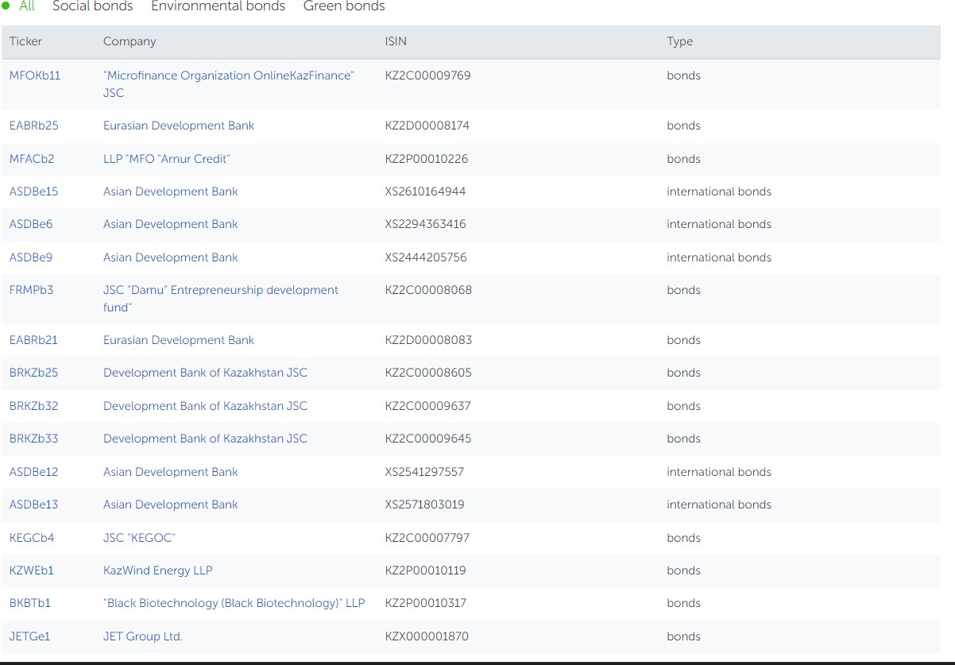

Sustainable Development Bonds (ESG bonds) are aimed at financing projects in the field of ecology, environmental protection and social field. They are represented by green bonds, social bonds and other bonds issued specifically to finance sustainable development projects.

In April 2019, the AIFC Exchange became a signatory to the Principles of Green Investment under the Belt and Road program, underscoring its commitment to sustainable finance. Moreover, to foster the growth and dissemination of green finance in Kazakhstan and the wider Central Asian region, the AIFC has established the Green Center for Green Finance [12].

### Conclusion

In conclusion, in this article, I explained about green banks, its full meaning and reported on green finance in the Republic of Kazakhstan. Currently, "green banking" is a topic under discussion within the bustling banking sector, considering various aspects of green banking. These aspects encompass "green marketing," "green financing," "green operations," and so forth.

References

1. Curious About Green Banking? By Nikky Engelen makechange.aspiration.com/green- banking/
2. Green light for green credit? Evidence from its impact on bank efficiency. By Jorge E. Galan Yong Ta
3. Impact of Green Banking Practices on Sustainable Environmental Performance and Profitability of Private Sector Banks. By Bhuvanesh Kumar Sharma\
4. Role of Green Finance in Supporting Sustainable Energy Investments Perspective of Energy Sector in Jordan Talal ALQURRAN1* , Murad ALKASEASBEH
5. E. Ruhiyat and E. Murwaningsari, “Development of sustainable banking in Indonesia,” International Journal of Business, Economics and Law, vol. 20, no. 5, pp. 177–185, 2019.
6. Meena, Ravi. 2013. “Green Banking: As Initiative for Sustainable Development.”, Global Journal of Management and Business Studies 3 (10): 1181–1186.
7. [https://www.emerald.com/insight/content/doi/10.1108/AGJSR-04-2022-](https://www.emerald.com/insight/content/doi/10.1108/AGJSR-04-2022-0017/full/html#sec002) [0017/full/html#sec002](https://www.emerald.com/insight/content/doi/10.1108/AGJSR-04-2022-0017/full/html#sec002)
8. Innovation Green Banking in Banking Service (Electronic Banking) Resi Juariah Susanto STIE EKUITAS, Jalan PHH Mustofa No. 31 Bandung, Indonesia
9. PERCEPTION ON GREEN BANKING PRACTICES IN SELECTED COMMERCIAL

BANKS IN KERALA *Sarath Chandran M.C. & **Dr. B. Sathiyabama

1. “GREEN BANKING - A STUDY ON ROLE OF TECHNOLOGY TOWARDS GREEN BANKING” MATEEN SHARIFF
2. «Green Finance» <https://qazaqgreen.com/journal-qazaqgreen/green-finance/241/>
3. <https://kase.kz/en/esg/bonds/>

## «КӨМІРТЕГІ САЛЫҒЫ ТҰРАҚТЫ ДАМУ ҚҰРАЛЫ РЕТІНДЕ: ЕЛДЕРДІҢ ТӘЖІРИБЕСІ ЖӘНЕ ЕНГІЗУ ПЕРСПЕКТИВАЛАРЫ»

Қаржау Жанар Əл-Фараби атындағы ҚазҰУ, ЭжБЖМ,

Қаржы, 1 курс Ғылыми жетекші: Сырлыбаева Н.Ш.

э.ғ.к., аға оқытушы

Жыл сайын шамамен 6,5-7 миллион адам ауаның ластануымен байланысты факторлардың әсерінен мерзімінен бұрын қайтыс болады, оның ішінде 500 мыңнан астам 5 жасқа дейінгі балалар. Біріккен Ұлттар Ұйымының Қоршаған ортаны қорғау бағдарламасы бұл ластану адам денсаулығына ең үлкен әсер етеді деп есептейді. Дүниежүзілік денсаулық сақтау ұйымы ауадағы ұсақ бөлшектердің (PM2.5) мөлшерін жылына 5 мкг/м3 дейін қалыпты деп санауды ұсынады. Ауаның ластануы бойынша ең проблемалы аймақтар Африка мен Азияда. Мысалы, Египетте ауаның ластану деңгейі 68 мкг/м3, ал Непалда 83 мкг/м3. Ресейдегі орташа көрсеткіш 12 мкг/м3 құрайды. Ауаның ластануы мен парниктік эффект арасында тікелей байланыс бар. Біріншіден, ауаны ластайтын барлық негізгі заттар озон қабатына әсер етіп, климаттық дағдарысты одан сайын нашарлатады. Екіншіден, парниктік газдар мен ауаны ластаушы заттардың көздері жиі сәйкес келеді.

Ресурстардың энергетикалық мәні көміртегі мен сутегі атомдарынан тұрады. Олардың тотығуы жылу энергиясын шығарады, сонымен бірге атмосферада қалып, жаһандық климаттың өзгеруіне ықпал ететін көмірқышқыл газын шығарады.

Көміртек салығы көптеген елдердің экологиялық емес ресурстарды пайдалануды азайтуға бағытталған саясатының негізгі бөлігі болып табылады. Мұндай салықты алу жағымсыз отынды тұтынушылардың қоршаған ортаға келтірген зиянын өтеуге көмектеседі. Салықтың идеясы жоғары мөлшерлеме бизнесті таза энергияға көшуге ынталандырады. Шығарылатын СО2 мөлшері отынның көміртегі құрамына пропорционалды, бұл өндіру немесе импорттау сатысында салықты алуға мүмкіндік береді,

реттеуді жеңілдетеді.