COVID-19 challenges for China and Central Asia cooperation within the Belt and road initiative.

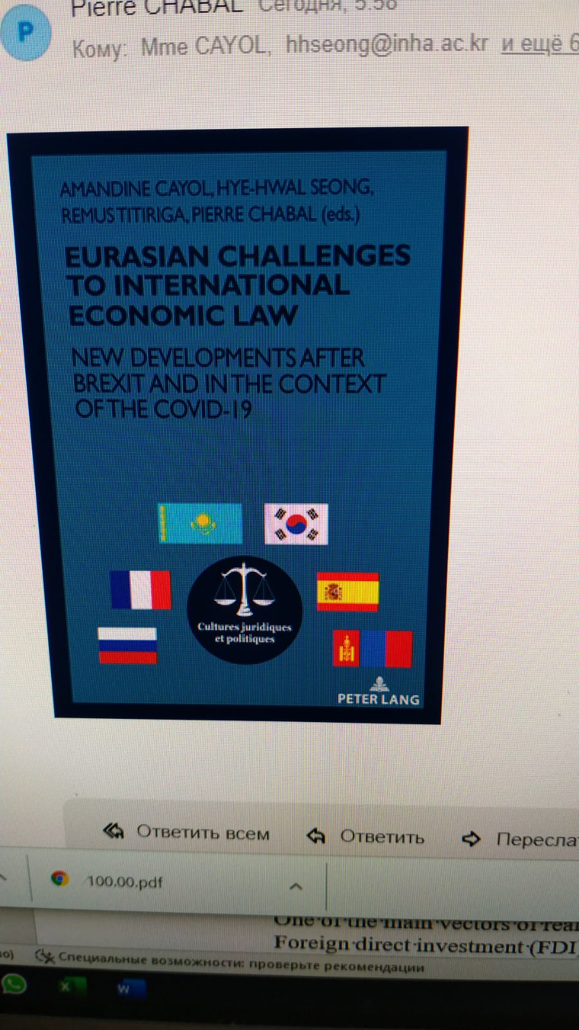 | 