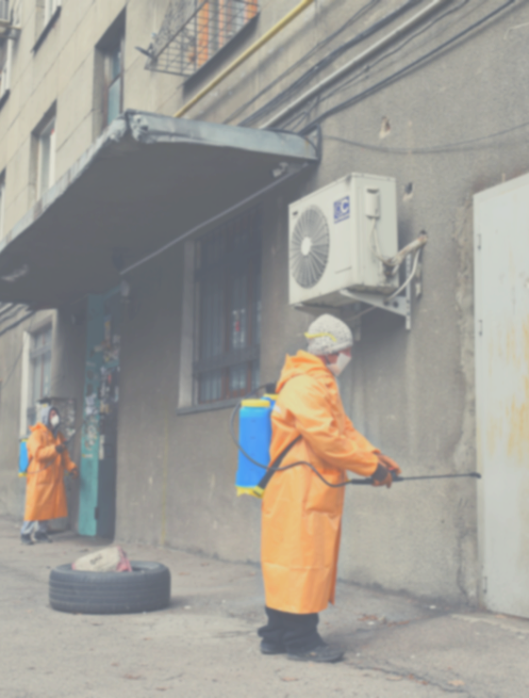
Central Asia Program Institute for European, Russian, and Eurasian Studies The George Washington University
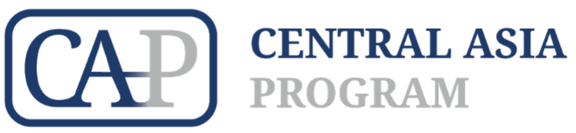
January 2021
COVID-19 PANDEMIC AND CENTRAL ASIA
Crisis Management, Economic Impact, and Social Transformations
Marlene Laruelle, editor
Washington, D.C.: The George Washington University, Central Asia Program, 2021
www.centralasiaprogram.org
COVID-19 Pandemic and Central Asia sheds new light on the consequences of the pandemic on Central Asian countries by giving voice to diverse experts around the world. Chapters focus on the social, political, economic, and geopolitical impacts of COVID-19 and its dramatic effects on the region. The pandemic has exposed major flaws in healthcare and economic systems around the world, and Central Asia is no exception. The region's countries have been hit by a plunge in oil prices and lower demand for their export commodities; local labor markets and migrants’ opportunities abroad have been disrupted, and prospects for investment and tourism have been reduced. Public health and educational networks lack the resources to extend into rural areas, and authorities are using digital tools to increase control over the population. At the same time, increasing tensions between the U.S. and China may jeopardize the hopes of Central Asians for the region to serve as a transit hub amidst a prosperous Eurasia.
Central Asia Program Institute for European, Russian and Eurasian Studies Elliott School of International Affairs The George Washington University 1957 E St, NW, Suite 412, Washington DC 20052, USA
For more on the Central Asia Program, please visit: www.centralasiaprogram.org.
© 2021 Central Asia Program, The George Washington University. All Rights Reserved. Cover design: Jennet Akmyradova
No part of this publication may be reproduced or transmitted in any form by any means, electronic or mechanical, including photocopy, or any information storage and retrieval system, without permission from the Central Asia Program.
ISBN: 978-0-9996214-6-2
Washington, D.C.: The George Washington University, Central Asia Program, 2021
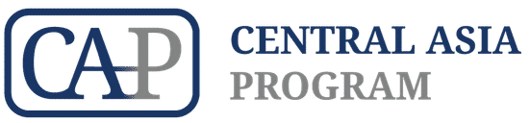
PART I. A COVID-19 WORLD? PANDEMIC AND THE REGIONAL BALANCE
Chapter 1. Post-COVID-19: Can Central Asia be Central to Eurasian Integration? 7 Marsha McCraw Olive
Chapter 2. Beijing Binds: COVID-19 and the China-Central Asia Relationship 3 Raffaello Pantucci
Chapter 3. Post-COVID-19 Central Asia and the Sino-American Geopolitical Competition 1 Furqan Khan
Chapter 4. The Shanghai Cooperation Organization and OSCE: Organizational Efforts vs COVID-19 9 in Central Asia Matthew Neapole
PART II. CRISIS MANAGEMENT AND POLITICAL REGIMES
Chapter 5. Responses to COVID-19 and the Strengthening of Authoritarian Governance in Central Asia 51 Edward Lemon and Oleg Antonov
Chapter 6. COVID-19 in Kazakhstan: Economic Consequences and Policy Implications 61 Zhandos Ybrayev
Chapter 7. Post-COVID-19 Regime Stability in Uzbekistan 77
Bekzod Zakirov
Contents
Chapter 8. Uzbekistan and COVID-19: A Communication Perspective 5 David Cancarini
Chapter 9. The Authoritarian Treatment of COVID-19: The Case of Tajikistan 1 Hafiz Boboyorov
Bakhtiyar Nurumov, Gulnur Berkenova, Eric Freedman, and Galiya Ibrayeva
Chapter 10. Informing the Public about the Dangers of a Pandemic. Early COVID-19 Coverage by News 9 Organizations in Kazakhstan
PART III. THE MULTIFACETED SOCIAL IMPACT OF THE COVID-19
Chapter 11. COVID-19 Outbreak in Post-Soviet Central Asia: Has the Time Come 5 for Social Innovations?
Bakhrom Radjabov
Chapter 12. Kyrgyzstan: The Socioeconomic Consequences of the COVID-19 Crisis 7 Julien Bruley and Iliias Mamadiiarov
5
Chapter 13. Identity-Based Discrimination in Kazakhstan: Migrant Workers in Pandemic Times 143
Preety Sahu
Chapter 14. Migration and COVID-19: Challenges and Policy Responses in Kyrgyzstan 149
Irina Kuznetsova, Roman Mogilevskii, Asel Murzakulova, Aigoul Abdoubaetova, Alexander Wolters, and John Round
Chapter 15. Women Face-to-Face with Domestic Abuse during COVID-19 Lockdown: 159 The Case of Kyrgyzstan Asylai Akisheva
https://www.centralasiaprogram.org/archives/18786

