INFLUENCE OF CARBON NANOTUBE FILLERS ON CHANGE OF MECHANICAL PROPERTIES OF POLYIMIDE
COMPOSITE FILMS

Gulmira Yar-Mukhamedova
Abyl Muradov
Kanat Mukashev
Shynaray Myrzakul

Al-Farabi Kazakh National University, IETP

Abstract

Features of the change in mechanical properties under the influence of the fillers of their carbon nanotubes were studied by methods of uniaxial tension on an «Instron 5982» tensile machine with the Bluehill 3 program. Comparative tests of pure and composite polyimide films with concentration of filler C = 0.005 - 0.07 mass. % and thickness d = 75 - 82 µm were carried out. It has been established that with an increase in the concentration of carbon nanotubes in polyimide composite films, the mechanical strength increases significantly as compared to a pure polyimide film. The results of research have shown that when filler concentration C is 0.005 mass. %, the breaking point σ ≈ 60 MPa, which is 10 MPa lower than the strength of a pure polyimide film, and at filler concentration C = 0.07 mass. % the breaking point σ ≈ 133 MPa, the strength of the material increased by almost 73 MPa.

Key words: carbon nanotubes, polyimide composite films, mechanical properties, strength.

Introduction
In modern conditions of industrial development, it becomes extremely important and urgent to create materials with improved properties and parameters in comparison with the existing ones. Therefore, it becomes promising to create composite materials based on polymers that have high specific characteristics, such as strength, stiffness, plasticity, etc., making it possible to obtain materials with desired functional properties [1].
Currently, the most interesting and promising are the use of carbon-based particles in the form of a large number of allotropic states, such as: carbon nanotubes, ultradispersed diamonds, fullerenes, etc. The properties of the final polymer composite material depend on the interaction between the matrix and filler particles, and also structural features of interphase regions and interatomic bonds.
In this regard, the use of polyimide films as a filler, which have high thermal stability and mechanical strength, becomes promising. Therefore, it becomes relevant and important task of great scientific and practical interest to study the nature of the interaction of the components of the polymer-carbon nanotube system (CNT) and the concentration dependence of the parameters that determine the structural and mechanical properties of composite materials, as well as the study of their strength and other mechanical characteristics and their prediction behavior in time [2, 3].
The purpose of this work is to study the effect of fillers in the form of various concentrations of single-walled carbon nanotubes on the mechanical properties of polyimide films.

Methods of experiment

Polymer composite materials (PCM) based on a polyimide matrix with a filler in the form of single-wall carbon nanotubes were chosen as the objects of study.
The choice of polyimide to create a polymer matrix was based on the fact that it belongs to cyclocycle-based heterocyclic polymers with high tensile strength and electrical insulation properties (electrical strength), as well as high chemical resistance [4].
The available literature material indicates that many physical characteristics of polymers are significantly improved by their modification by small additions of nanoparticles-fullerenes, nanotubes, nanofibers, inorganic nanoparticles, etc. [5].
The main feature of the CNTS in contrast to other nanofillers (ultra dispersion particles, organogeny) is smooth on the atomic scale the surface. This feature leads to the stretching of the polymer - matrix macromolecules on this surface and the formation of a densely Packed interfacial layer of the polymer matrix-carbon nanotubes system. As a result, nanocomposites of such a system have the effect of increasing plasticity, which is due to the formation of densely Packed interfacial areas on the surface of nanotubes [5].
The consequence of this process is a change in the molecular and structural characteristics of the polymer matrix.
The mechanical properties of composite materials increase with decreasing particle size of the dispersed phase. Dispersion of filler agglomerates leads to its destruction. The agglomerate is a formation consisting of several primary filler particles, the number of which varies from several tens to tens of thousands, connected by physical bonds. In the powdered state, the filler consists of such agglomerates. Mixing the filler powder with the polymer leads to the separation of large agglomerates into smaller ones. Simultaneously with this process, the polymer is wetted on the newly formed surface of the filler. In many cases, no matter how carefully the mixing is carried out, the destruction of the agglomerates to the primary particles does not occur.
A composite tape with a homogeneous structure was prepared in the following manner: in the beginning was determined by the weight of the portion of the filler, based on the concentrations of the second component. Then a mixture of polyamide varnish with polyester resin in a given proportion was poured into a three-neck flask, and then there was additionally poured m-cresol. The obtained mixture was stirred uniformly heated to 170˚С. After receiving the viscous solution was diluted to 7% and added to the calculated charge of the NT. The resulting solution was continued to mix for 6 hours with ultrasonic treatment at the same temperature. At the same time, a glass substrate was prepared, the surface of which was wiped with alcohol and dried in a muffle furnace at 100˚C. Then the mixture was poured on this substrate and the film of a given size was rolled out, followed by drying at 100˚C in a muffle furnace.
PCM samples were tape with different concentrations (C) of filler: C = 0.005% by weight., thickness (d) = 75 µm; C = 0.010% mass., d = 78 µm; C = 0.020% by mass., d = 82 µm, C = 0.03% by mass., d = 80 µm, C = 0.035% mass., d = 82 µm, C = 0.07% mass., d = 81 µm,. A film of pure polyimide d = 40 µm thick was taken as a control sample. Each sample was cut into four equal parts with dimensions of 13x13 mm and a working area of 10x10 mm.
Mechanical tests for uniaxial tensile PCM were carried out on a tensile testing machine brand "Instron 5982" with the program Bluehill 3 according to GOST R 50583-93 and American standard D 3039/D 3039M - 00, at room temperature.
Technical characteristics of the machine "Instron 5982" were: maximum load 100 kN, load measurement error and strain ± 0,5% of the measured value.

Discussion of results

At the beginning we investigated the mechanical properties of pure polyimide film. The change in its relative elongation (ε) from the applied external mechanical load (σ) to the rupture that occurred at a voltage of σ = 70 MPa and a relative elongation ε = 45% was studied (Fig. 1).
At the initial moment of application of the load from 0 to 1MPa, there was a sharp jump in elongation by 3%. This change in elongation is due to the fact that at the beginning of the deformation process, the macromolecules of the polyimide quickly straighten in the direction of the load. This process causes the transition of macromolecules from the global state to the extended one. When applying stresses from 1 to 40 MPa, there was a linear increase in the relative elongation of the material, obeying Hooke's law. This behavior of the film indicates its elastic tension. Obviously, at this range of load action macromolecules are stretched in the form of fibers in the direction of polymer flow [6]. At this point in the film develops forced elasticity, which is associated with the rupture of lateral bonds in macromolecules (‒ C = O).

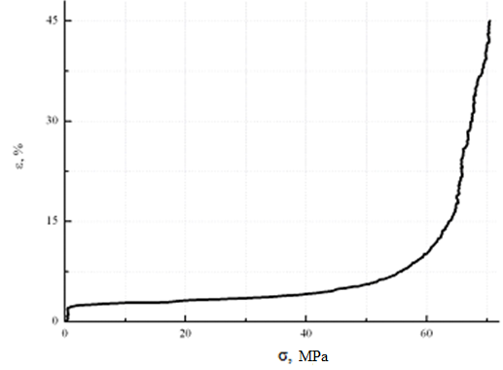
Figure 1-Change in the relative elongation (ε) of the pure polyimide tape from the value of the applied mechanical load (σ) at uniaxial tension
The subsequent application of the load leads to a change in the behavior of the stretching of the film. Its elongation, at σ = (40 ÷ 50) MPa, is carried out according to the nonlinear law with the preservation of elastic properties, but not subject to Hooke's law. An increase in the load to σ ≥ 50 MPa causes the plastic flow of the sample, which is accompanied by an exponential increase in the relative elongation and ends with its rupture. The last stage of film stretching (σ ≥ 50 MPa) causes it to break the bonds between the benzene rings of macromolecules and the polymer itself is destructed.
Figure 2 shows the experimental dependences of the applied stress (σ) on the relative elongation (ε) for a polyimide film with CNT filler of different concentrations (C) under uniaxial tension. It shows that with the increase in the concentration of carbon nanotubes in polymer composite films mechanical strength increases significantly compared to pure polyimide film. So, at C = 0.005% by weight. σ ≈ 60 MPa, which is 10 MPa lower than the strength of the pure polyimide film, and at C = 0.07% by weight.- σ ≈ 133 MPa, the strength of the material increased by almost 73 MPa. This is due to the fact that with increasing filler concentration the area of the densely Packed interfacial layer of the polymer matrix-carbon nanotubes system increases. This affects the increase in the strength of the films.
However, the plasticity of PCM deteriorated compared to that of pure polyimide tape. At the same time, with an increase in the filler concentration, it grows, but the value of 45% tensile elongation, as in a clean film, did not reach.
Figure 3 shows the change in the tensile strength of polyimide composite films from the concentration of CNT filler. It can be seen that with the increase in the concentration of the filler, their tensile strength increases.
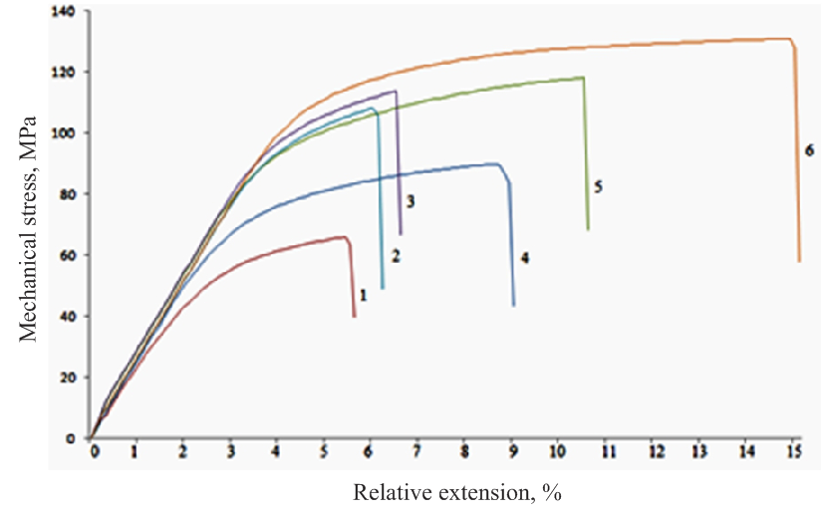

1 – 0,005 % mass; 2 – 0,01 % mass; 3 – 0,02 % mass; 4 - 0,03 % mass; 5 – 0,035 % mass; 6 – 0,07 % mass

Figure 2 - effect of CNT concentration on the dependence of the applied mechanical load (σ) on the change in the relative elongation (ε) of polyimide composite films under uniaxial tension

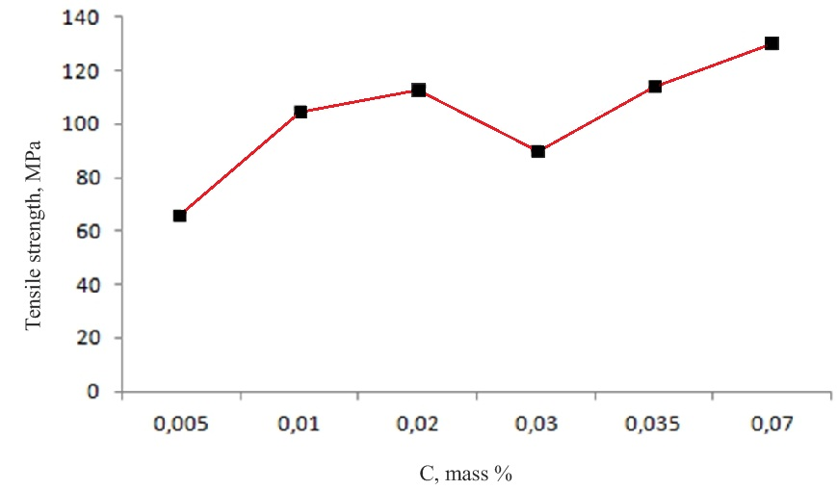

Figure 3 - change of ultimate strength (σ) of polyimide composite tape from concentration (C) of CNT filler
However, at C = 0.03 mass.% there is a slight decline. We assume that this change is due to a deviation in the technology of film production, which affected the strength of the material.
Figure 4 shows the effect of CNT filler concentration on the tensile elongation of polymer composite tape. It is seen that with the increase in the concentration of the filler increases the plasticity of the tapes, which tends to its linear growth. It is also noticeable that even a small introduction of the filler CNT as C = 0.005 mass.% , causes a significant decrease in the plasticity of polyimide tape by 40%, compared with pure polyimide tape.
Summing up the results of the study, it can be concluded that on the basis of the obtained dependences presented in figures 2, 3 and 4, that small concentrations of CNT filler for polyimide films cause significant changes in their mechanical properties, such as an increase in tensile strength and a decrease in plasticity, compared with pure polyimide tapes.
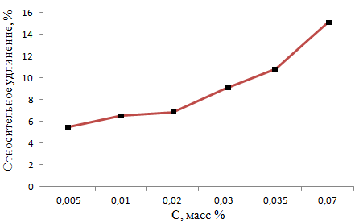

Figure 4 - change of tensile elongation (ε) of polyimide composite tape from the concentration (C) of CNT filler

Acknowledgments
This work was supported by al-Farabi Kazakh National University, Institute of Experimental & Theoretical Physics by AP05130069 project “Development of nanotechnology for the synthesis of functional galvanic coatings for electrical equipment components.”

References

- Suzdalev I.P. Nanotkhnologiya. Phiziko-khimiya nanoklasterov, nanostruktur I nanomaterialov. 2006. 592 p. (in Rus).
- Yanovskij Yu.G., Kozlov G.V., Burya A.I., Lipatov Yu.S. Teplovoe rasshirenie polimernyh kompozitov, napolnennyh uglerodnymi nanotrubkami // Fizicheskaya mezomekhanika, 2007. ‒ T. 10. ‒ № 6. ‒ S. 63-67. (in Rus).
- V. N. Khabashesku, E. V. Barrera, R. F. M. Lobo. Confined Tubular Carbon Nanostructures for Nanoreactors and Synthons // Current Research in Nanotechnology, 2007. ‒ V.1. ‒ №.2. ‒ P. 165-182.
- Kryzhanovskij V.K., Burlov V.V. Tekhnicheskie svojstva polimernyh materialov. – SPb.: Professiya, 2005 – 248 s. (in Rus).
- Wang C., Guo Z.-X., Fu S., Wu W., Zhu D. Polymers containing fullerene or carbon nanotube structures. // Progres in Polymer Science. 2004.‒ V. 29. ‒ P. 1079–1141. Review.
- A. D. Muradov, N. E. Korobova, A. A. Kyrykbaeva, G. Sh. Yar-Mukhamedova, and K. M. Mukasheva Influence of γ-irradiation on the optical properties of the polyimide– YBa₂Cu₃O_{6.7} system // Journal of Applied Spectroscopy, Vol. 85, No. 2, May, 2018, P. 260 – 266. DOI 10.1007/s10812-018-0642-4

