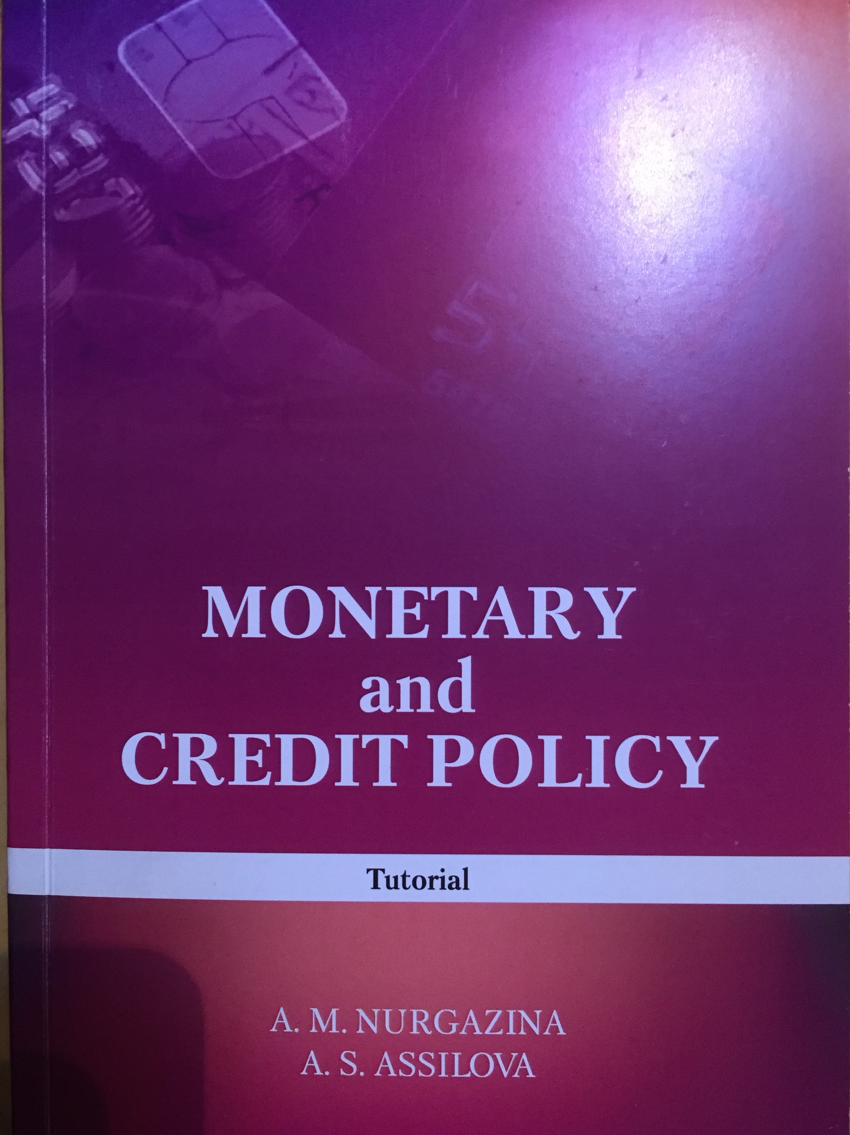

AL-FARABI KAZAKH NATIONAL UNIVERSITY

A. Nurgazina A. Assilova

MONETARY AND CREDIT POLICY

Work book

Almaty «Kazakh University» 2017

2

УДК Н

A.M. Nurgazina, A.S. Assilova Н 90 Monetary and credit policy: work book / А.М. Nurgazina., A.S. Assilova – Almaty: Kazakh University, 2017. – 232 p. ISBN

The training manual covers topics related to the development and implementation of monetary policy, the activities of central banks, the classification of monetary instruments, conditions and procedures for conducting operations on the open market. For the purpose of fixing the material studied, the manual contains questions for self-monitoring, tasks, test questions and assignments. The presented educational material allows to form theoretical knowledge and practical skills in the field of monetary policy. The manual is recommended for students and undergraduates studying in financial and economic specialties, and it can also be used to improve the skills of financial market professionals.

.

УДК
© А.М. Nurgazina, А.S, Assilova 2017 ISBN
© Al-Farabi KazNU, 2017

Introduction

3

CONTENT

LIST OF ACRONYMS .......................................................................................................................................5

INTRODUCTION ...............................................................................................................................................6

I. BASICS OF MONETARY AND CREDIT RELATIONS .............................................................................8
1.1. Theoretical Basics and Historical Development of Monetary and Credit Relations .................................8
1.1.1. Essence of a Monetary and Credit Policy ................................................................................................. 8
1.1.2. Historic development of the Money Theory ........................................................................................... 13
1.2. Basics of the Monetary and Credit regulation .......................................................................................... 24
1.3. Subjects of Money and credit market........................................................................................................ 28
1.4. Main indicators of money market ............................................................................................................. 32

II. MONETARY AND CREDIT POLICY MECHANISM............................................................................. 38
2.1. Central banks activity ............................................................................................................................... 38
2.2. Directions of the Monetary and Credit Policy........................................................................................... 47
2.2.1. Priorities of the Monetary and Credit Policy .......................................................................................... 47
2.2.1. Regimes of the Monetary and Credit Policy .......................................................................................... 53
2.3. Instruments of the Monetary and Credit Policy ....................................................................................... 58
2.4. The implementation of monetary policy under the influence of external factors ................................... 67

III. MONETARY AND CREDIT POLICY OF THE REPUBLIC OF KAZAKHSTAN .............................72
3.1. Main particularities of the Monetary and Credit Policy of the Republic of Kazakhstan ....................... 72
3.2. Analysis of the effectiveness of monetary policy instruments ..................................................................81
3.3. Features of managing gold and foreign currency reserves ....................................................................... 90

CONCLUSION .......................................................................................... 93

GLOSSARY .............................................................................................. 97

TASKS ...................................................................................................... 99

TESTS ....................................................................................................... 111

4

REFERENCES ......................................................................................... 122

Attachment 1 .............................................................................................. 125
Attachment 2 .............................................................................................. 125

