Author: A.Zhaparova
Animality
I. Amphibians: Caecilians; Frogs and toads (like American Bullfrog, American Toad, European Green Toad, Giant Marine Toad, Golden Mantella, Green-and-black Poison Dart Frog, Mountain Chicken, Panamanian Golden Frog, Plains Leopard Frog, Puerto Rican Crested Toad, Surinam Toad, Tomato Frog, Vietnamese Moss Frog, Waxy Tree Frog, White's Tree Frog, Wyoming Toad); Salamanders and Newts (Alligator Newt, Blue-tailed Fire-bellied Newt, Emperor Newt, Fire Salamander, Hellbender, Iberian Ribbed Newt, Marbled Salamander, Mudpuppy, Three-toed Amphiuma, Tiger Salamander, Western Lesser Siren
Text. Amphibians
The Class Amphibia (or amphibians) includes three Orders:
Anura (frogs and toads) – about 5,800 species
Caudata or Urodela (newts and salamanders) – about 580 species
Gymnophiona or Apoda (caecilians) – about 170 species
Frogs and Toads | Newts and Salamanders | Caecilians
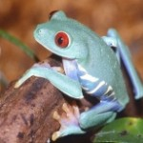 | 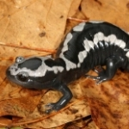 | 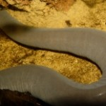
Most people are familiar with frogs, toads, newts and salamanders, but are less familiar with caecilians, which superficially resemble large earthworms. Little is known about most caecilians as they mostly live hidden underground or underwater.
All amphibians are cold-blooded animals and most metamorphose from a juvenile to an adult form. They cannot generate their own body heat, instead relying on the temperature of their environment to help them keep warm or cool enough to survive. There are over 6,500 species of amphibians, and they inhabit all continents except Antarctica, living in varied habitats such as rainforests, rivers and streams, deserts and alpine environments.
Amphibians are important and beneficial in many ways:
They play an important role in nature as both predator and prey, sustaining the delicate balance of nature.
They eat pest insects, benefiting successful agriculture around the world and minimizing the spread of disease, including malaria.
The skin of amphibians has substances that protect them from some microbes and viruses, offering possible medical cures for a variety of human diseases, including AIDS.
Frogs have had a special place in various human cultures for centuries, cherished as agents of life and good luck.
In addition, successful collaboration to save amphibians can help mankind to more confidently face and address other major environmental challenges.
One-third to one-half of the world’s approximately 7,000 known amphibian species could go extinct in our lifetime. This would be the largest mass extinction since the disappearance of the dinosaurs. Amphibians are considered canaries in the coal mine: they are among the first species to be affected by environmental stressors, so when they show declines in the wild, it is a warning to other species, including humans. Their population declines and extinctions signal that changes are occurring in the environment that will also negatively impact humans.
Amphibians are dying in alarming numbers. About 122 species are believed to have become extinct since 1980. About half of the world’s 6,000 species could become extinct within our lifetime with at least 500 species facing imminent extinction. This rate of extinction is unprecedented since the demise of the dinosaurs.
Destruction of habitat, invasive species, pollution, global warming and other human influences threaten many species throughout the animal and plant kingdom. In addition to these challenges, amphibians are being attacked by a lethal disease that has caused unprecedented and unexpected losses, called chytrid fungus. Chytrid quickly and quietly destroys entire species when introduced to new populations in the wild. Chytrid fungus has now been identified in association with amphibian die-offs on every amphibian-inhabited continent. This disease has decimated or wiped out species that had not been considered critically endangered. It happens so quickly that species disappear before anyone realizes they are in trouble {1}

Allamphibians:
- Are vertebrates (which means they have a backbone or spine)
- Are ectothermic. Also known as “cold-blooded,” ectothermic animals cannot regulate their own body heat, so they depend on warmth from sunlight to become warm and active. If they get too hot, they have to find shade or a burrow to help them cool down.
- Breathethroughtheirskin.
- Go through metamorphosis. Young amphibians hatch from eggs, but do not look like their parents. Astheydevelop, theirbodyshapechanges. {2}

II.Arachnids:scorpion, spider, tarantula, harvestmen, ticks and mites

Text.Arachnida
Arachnids are spiders , harvestmen , mites and ticks , and their relatives like scorpions that don't live in Michigan. All arachnids have eight legs, and unlike insects, they don't have antennae. The bodies of arachnids are divided into two sections, the cephalothorax in front and the abdomen behind. Sometimes times small arachnids like mites and harvestmen have the two sections fused close together so you can't see the separation. No arachnids have wings, although some spiders can float on the wind using long strands of silk. Many arachnids use silk, either to catch prey or to help them reproduce. Arachnids lay eggs, and have simple development where babies look like small adults and just get bigger as they grow. Some arachnids, especially the mites, change a lot in different stages of their lives. Arachnids are part of a larger group called arthropods , which also includes insects, myriapods, and crustaceans. All arthropods have an exoskeleton and legs that are jointed (arthropod means "jointed foot"). In order to grow, arthropods must shed their whole exoskeleton all at once; this is called "molting."
There are hundreds of thousands of species of arachnids. Arachnids are found in nearly all land habitats, and there are some in aquatic habitats as well. Most arachnids can only eat liquid food, not solid food, so they squirt digestive chemicals into their prey and suck out the juice. Arachnids are predators on insects and other invertebrates, except for many mites, which feed on all kinds of things, like fungus, plants, dead animals, bacteria, and other invertebrates. {3}

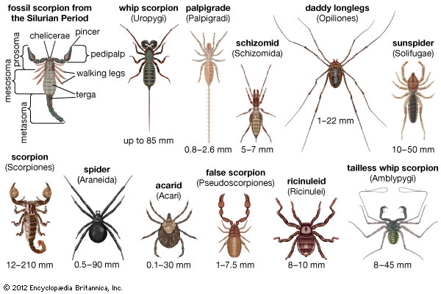

III.Birds

Birds: eagle, albatross, blackbird, jackdaw, jay, duck, owl, falcon, pheasant, finch, flamingo, goose, vulture, hawk, rooster, canary, nuthatch, crow, cuckoo, biddy, kookaburra, swift, tit, gull, nightingale, parrot, pelican, peacock, penguin, piranha, raven, robin, swallow, swan, parakeet, sparrow, woodpecker, mallard, stork, ostrich, dove/pigeon, turkey, kestrel, wren, coat, crest, talon, beak.

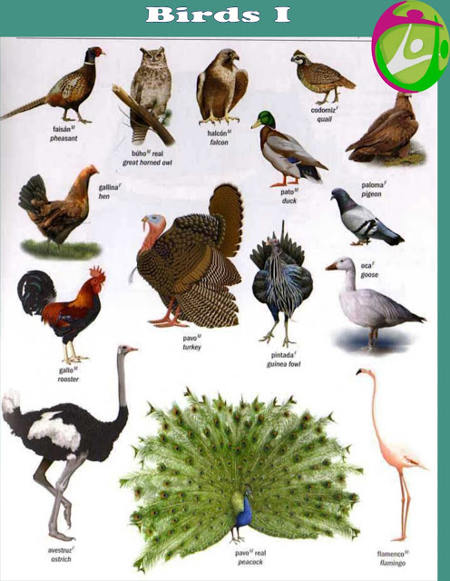

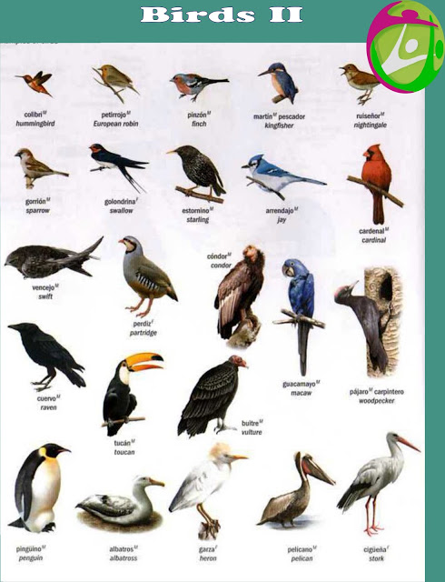

Proverbs about birds
As good be an addled egg as an idle bird.
As the old birds sings, the young ones twitter.
Bad bird, bad egg.
Birds of prey do not sing.
It is hard to catch birds with an empty hand.
Old birds are hard to pluck.
One bird in the dish is better than a hundred in the air.
What bird so white as mine? says the crow.
Birds of a feather flock together.
One beats the bush, and another catches the bird.
It is an ill bird that fouls its own nest.
"I have" is a better bird than "If I had."
As the old birds sing, so the young ones twitter.
One beats the bush, another catches the bird.
As though a bird had flown up from under your feet.
If the bird hadn't sung, it wouldn't have been shot.
The caged bird dreams of clouds.
If you have money, men think you are wise, handsome, and able to sing like a bird.
A bird that you set free may be caught again, but a word that escapes your lips will not return.
A good bird begins chirping while in the egg.
A beautiful bird is the only kind we cage.
A bird can roost but on one branch, a mouse can drink not more than its fill from a river.
Clumsy birds have need of early flight.
Dead songbirds make a sad meal.
Don't waste too many stones on one bird.
It is the beautiful bird which gets caged.
You cannot prevent the birds of sorrow from flying over your head, but you can prevent them from building nests in your hair.
It is the beautiful bird that gets caged.
A bird does not sing because he has the answer to something, he sings because he has a song.
A dead songbird gives us no meat.
Dead song-birds make a sad meal.
Keep a green tree in your heart and perhaps the singing bird will come.
People live like birds in the woods: When the time comes, each must take flight.
The prettiest birds are in a cage.
If I keep a green bough in my heart, then the singing bird will come.
Every bird likes his own nest best.
A bird cannot roost but on one branch. a mouse can drink no more than its fill from a river.
A bird in your hand is worth more than 100 in the forest.
Living at a river, one comes to know the nature of the fish therein; Dwelling by a mountain, one learns to recognize the language of the birds thereupon.
Early bird hops further.
God knows why he has made the wings of some birds shorter.

