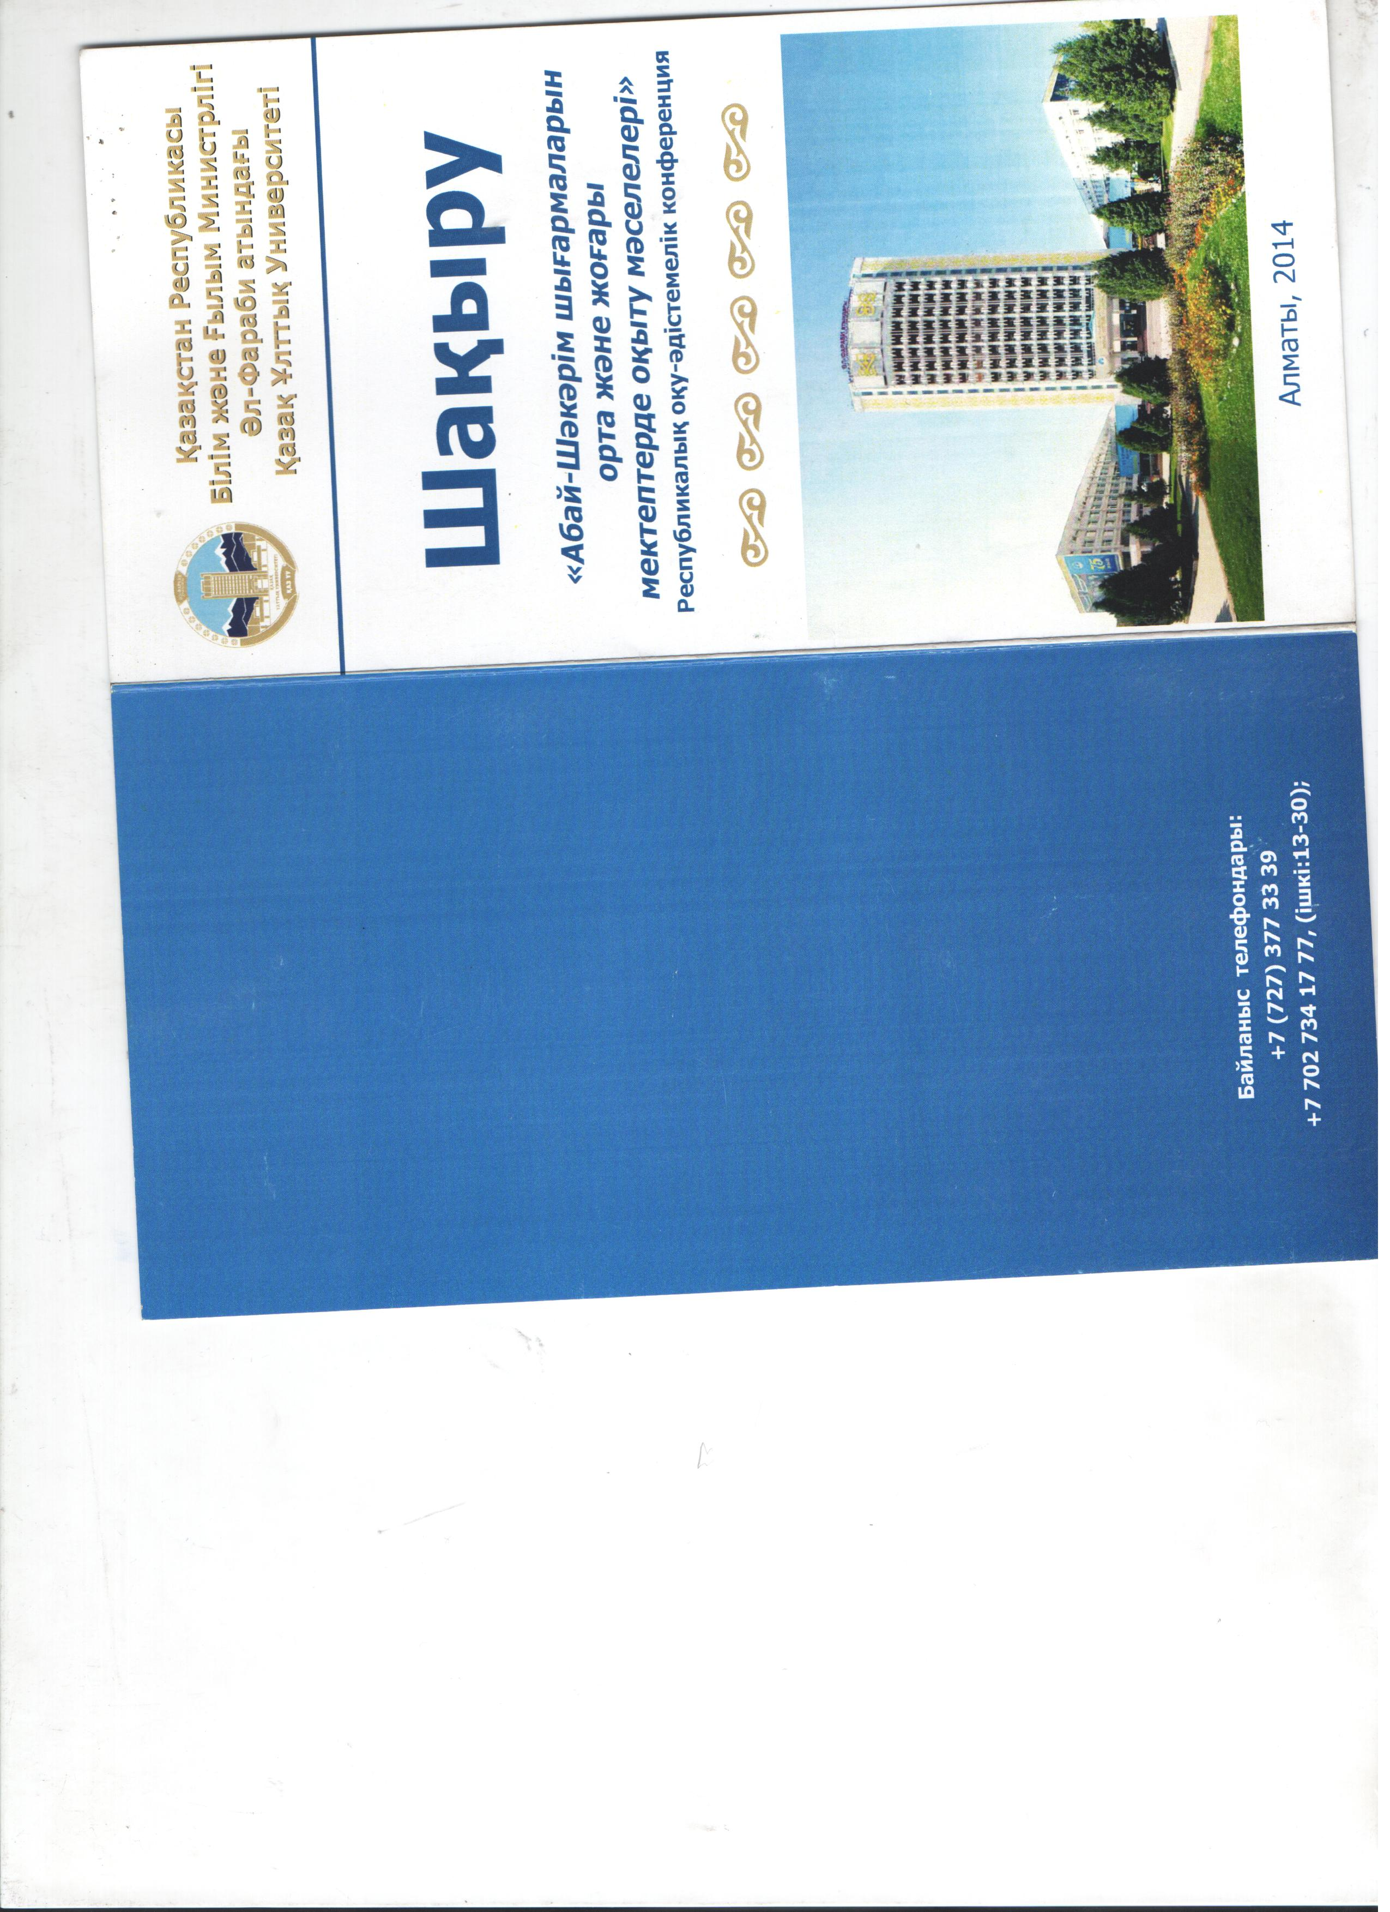

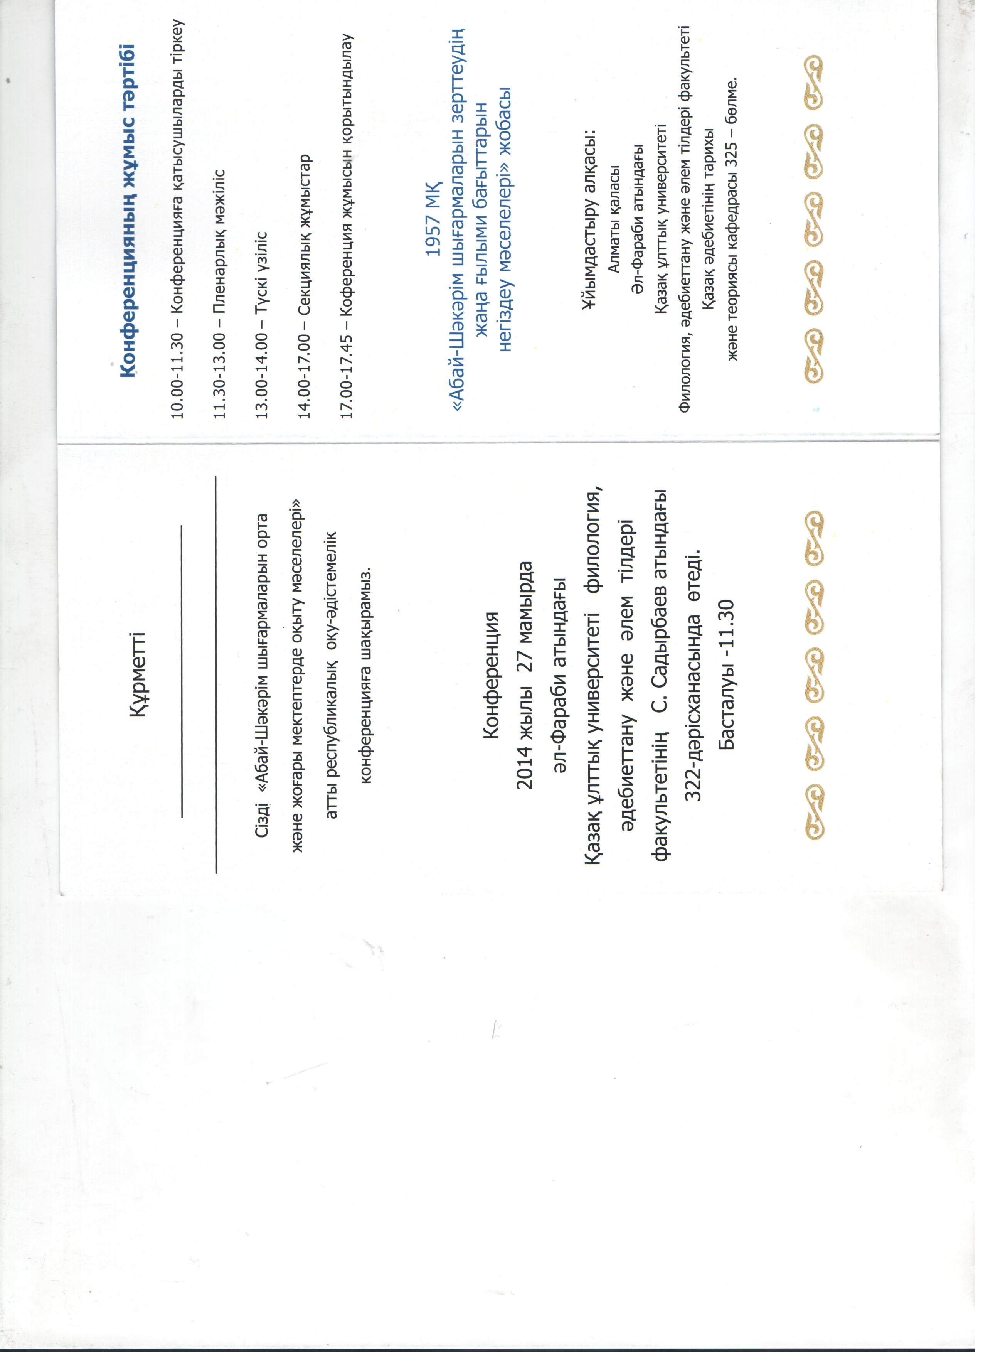Abai Study Issues in teaching
- Zhaparova
KazNU named after Al-Farabi
Abai Kunanbaev is Kazakh great poet, writer, public figure, founder of the modern Kazakh written literature, culture reformer.
Abai Study is an immense, challenging and exciting section of the Kazakh literary. Both Abai’s life and his work are extraordinary, diverse and meaningful so that in different periods of life of one person can manifest in different ways, thus giving some new and unexpected discoveries.
In social science, there is a lot of work on the life and creative activity of Abay ( 1845-1904 ) . Although owing to several reasons, especially due to repression in the 30s, plenty of work and materials were omitted that have long been transferred to oblivion.
During the poet's life only a few poems were published in the newspaper "Dala ualayatynyn gazetі " - " Steppe newspaper ." Throughout the poet's life work not a book was brought out.
Abay’s work was first published in a separate collection in 1909 in St. Petersburg, Abai’s son Turagul Kunanbayev (1875-1934 ) and his cousin Kakitay ( 1868-1915 ) prepared them for printing. A brief biography of the poet was also placed here. For connoisseurs and scholars of poetry, this collection has long remained a valuable tool in the work promotion of Abai .
Objective assessment of creativity Abay was given in pre-revolutionary works of Alikhan Bukeykhanov , Ahmet . Baytursunov , Mirzhakyp Dulatov, Magzhan Zhumabaev .
However, it was only recently learned that the first biographer of Abai was Alikhan Bukeikhanov . His article "Abai ( Ibrahim ) Kunanbayev " - obituary of Kyrgyz national poet in connection with the characteristic of his work was published in the newspaper "Semipalatinsk sheet" in 1905. Then, it was printed with a portrait of Abai in the magazine "Notes of Semipalatinsk section of the West Siberian Department of the Imperial Russian Geographical Society " in 1907.
Kazakh intellectuals , whose life and work existed at the beginning of the century , in the 10th- 30th years Abay’s work was highly appreciated, investigated, promoted. So , in 1914 in Semipalatinsk the first memorial evening devoted to the 10th anniversary of the death of poet Abai was officially held , an active social activist , teacher, writer and translator Nazipa Kulzhanova ( 1887-1934 ) made ​​a presentation about him there.
After the October Revolution , in the 20th -30th years there were conflicting, contradictory opinions about artistic creations of the poet , there was a discrepancy of his poetry , there were both positive and negative judgments about the work of Abai.
According to Mukhtar Auezov " in the first years after the revolution ,- up to the 1936-1937 years , along with a true socialist heritage assessment of Abay, they was various conservative wrong judgment about his work. They tried to make Abay "their Abay ", their inspirer . "
Despite the fact that after the October Revolution objectively correct attitude to heritage Abai was not immediately formed, his poet constantly aroused great interest among the public.
In 1928 Ilyas Kaboulov published his article "The Philosophy of Kazakh poet and critic" in the newspaper "Soviet steppe", where he criticized Abai’s social views. Against such a categorical assessment of the revival Idiriss Mustambaev made his speech in the same newspaper. His article also had some mistakes. But in general, in the assessment of the poet he was largely objective, stressing that Abay was genuinely popular poet in the history of literature and journalism. It is quite rare when a writer shares such great success among the popular masses, which had our poet Abai Kunanbayev . So in the thirties in Kazakhstan his poetic master was thoroughly discussed .
Subsequently, it is this kind of research on creativity of Abay including biased - contradictory , formed the basis for the creation of a new section of the Kazakh literary science called Abai Study . In 1940 Mukhtar Auezov addressed to the Abai’s heritage researchers through Semipalatinsk regional newspaper " Ekpindi ". He pointed to the need for further data collection and recording works of Abay and he emphasized the need for careful selection of new poems in order to establish the true identity of their author.
Mukhtar Auezov pointed to the rigorous collection of various kinds of information that are relevant to the characterization of the environment Abay - to develop a better understanding of the nature and content of his poetry. With his active participation Abai Study was developed , deepened its scientific level .
The life and work of Abay was comprehensively and deeply studied , and today it is the property of the masses. In the study and knowledge of everything created by Abai , the role of the outstanding figure of Kazakh culture , one of the classics of Kazakh literature M.Auezov is awesome. He was the founder of the whole scientific field in Kazakh literary - Abai Study. Throughout his scientific and creative activities M.Auezov continually extended and deepened the knowledge of Abai . He wrote the first scientific biography of the poet, which revealed deep meaning and content , civic enthusiasm , humanism of Abai .
In working on a comprehensive study of the life and work of Abai, many cultural figures - S.Mukanov , Musrepov G. , H. Zhumaliev , M.Silchenko, K. Beisembiev , T.Tazhibaev , B.Kenzhebaev , M . Karataev Nurkatov A. , R. Syzdykova , Zhirenchin A. , B. Gabdullin, Z. Akhmetov , H. Suyunshaliev , T. Alimkulov and other poets and writers made their huge and significant contribution.
In Abai Study a scientific analysis of innovation of Abai’s poetry has already been given, research on his role in the enrichment of the national language , the poet revealed the depth of understanding the essence of public purposes in the spiritual culture of the people were done.
During his life only four of his poems were printed, but no kind of book was published. Before the October Revolution Progressive people of his time were engaged with in the popularization of Abai’s poetry . In the study and promulgation of the heritage of the poet t Kakitay Kunanbayev did tremendous work . The poems of Abai were first collected and published in the book in 1909 in St. Petersburg.
According to many scientists, throughout 1917-1945 years period of the Abai was formed. But it is necessary to divide it into two phases. In the first phase, 1917-1933 years, development of the literary heritage was mainly determined by the general principles, in general, particularly Abai’s work. By 1945, when poet’s 100th anniversary was celebrated, the emergence of this fundamental concept completed - and there was an independent branch of the Kazakh literary – Abai Study.
Many prominent scholars and scientists did and have done much to investigate, research, study the life, work, philosophy of outstanding Abai. He is the greatest poet and thinker. The way he showed to his people, to his contemporaries, to the next generation is awesome and considerable. He still lightens our life with his books, work, quotations. We do study his huge work at the schools, universities, institutes, academies. It should be like that, we can not behave ourselves otherwise. He presented much and it is our duty to scrutinize his assignment further and further. The most important, key and major concept one should be aware of, know, investigate in Abai’s work is his attitude to people in general, his concept of «complete person or human-being». Abai Kunanbayes teaches us, our students, our people, with the help of his deep knowledge, wisdom and education we are teachers can give incredible cognition, principles, consciousness.

