RESEARCH WITH PURPOSE OF FINDING OPTIMAL VARIANT OF THE GUIDE BLADES OF THE VORTEX WIND POWER INSTALLATION
D. E. Turalina¹, D. A. Bolysbek^{2*}
¹ Kazakh National University named after Al-Farabi, Dept. of mechanics, Al-Farabi 71, Almaty, Kazakhstan
² Kazakh National University named after Al-Farabi, Dept. of mechanics, Al-Farabi 71, Almaty, Kazakhstan
bolysbek.darezhat@gamil.com

In this paper we present the results of the research conducted to determine the effective version of guide blades of wind power installation (concentrator).
The aim of the theoretical study is to determine the effect of speed and pressure on the motion of the welding wind in order to determine the effective version of the blades, by adjusting the geometrical parameters of the guide shafts.
As a result of the theoretical study, the thickness of the spindle blades and their shapes at different wind speeds were determined for the distribution of pressure and velocity in the wind power installation’s concentrator. The shape of the sheets was constructed in the COMSOL Multiphysics program, and the air pressure variation along the spindle pressure was investigated according to the shape and thickness of the blade. The Navier-Stokes equation for computable liquids was extracted into the COMSOL Multiphysics program using the Reynolds Averaged Numerical Simulation (RANS).
Keywords: Wind energy, wind turbine, guide vanes, blades, COMSOL multiphysics, energy efficiency.

INTRODUCTION
As known, one of the significant factors of the decrease in the efficiency of wind power installation (WPI) is the random nature of the variations in the speed and direction of the air flow. In order to create the required air flow, several designs of wind turbine designs have been proposed in recent years using airflow concentrators [1-3]. Concentrators in many projects are in the form of fixed constructions of diffuser or confuser types. However, their use is not always effective due to large losses of wind energy (from 15 to 25%). As is known, the flow of air entering into such concentrators, air flow contact with the walls of the concentrator and swirls, forming a certain turbulence, creating a rather serious resistance. This disadvantage is absent in multi-channel concentrators, with guide blades. In JS KazISR on energy under the leadership of M.B. Koshumbayev conducts scientific research to develop and create an experimental design for a vortex wind power installation with a flow concentrator [4-7]. In the concentrator, the guide channels operate on the principle of a Venturi tube [8], that is, a decrease in the cross-section of the channel makes it possible to increase the flow velocity leading to the wind wheel, consequently, the rotation speed of the wind wheel will increase and, accordingly, the energy efficiency of the vortex wind power installation (VWPI) will increase. However, due to its limited size, the experimental setup does not allow experimental studies to be carried out in a wide range of basic parameters. In this connection, the authors of the project suggest conducting an experimental study using computer simulation methods [8]. Numerical modeling of the model makes it possible to determine the main characteristics of processes, optimize the design and operation modes of a projected VWPI model with a flow concentrator. As a result of the computational experiment, the optimum configurations (the radius of curvature, thickness and number) of the guide blades of the flow concentrator will be determined, which will allow optimizing the design and increasing the energy efficiency of the VWPI.
Construction of VWPI
The aim of the work is that to show velocity and pressure distribution when changing the thickness and shape of the guide blades (concentrator).
The scheme of the general wind power installation is shown in Figures 1, 2 and 3. These pictures depict the wind power installation structure. Figure 1 shows a profile, 2 is a vertical image showing a picture A-A in Figure 3.
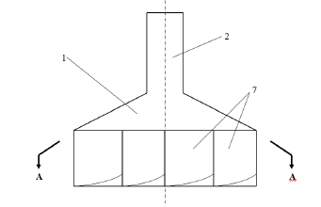
Fig.1. Vortex wind power installation profile [9]
The installation operates as follows. The flow of air flows into the concentrator and moves along the tension rod 1 and the cone 4 toward the curvilinear walls 7. Under the effect of solar energy, the roof and the tube heat up 2, so the air flow temperature increases. The heated air moves along the curvilinear channel and its velocity increases due to the temperature rise and the downstream channel. The air flow is directed to the suction pipe and the vortex motion is generated on the pipe. Air flow decreases hydrodynamic pressure only to one of the blades, does not affect the airflow backbone, so that the blade does not interfere [9].
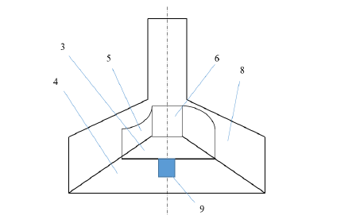
Fig.2. Vortex wind power installation [9]

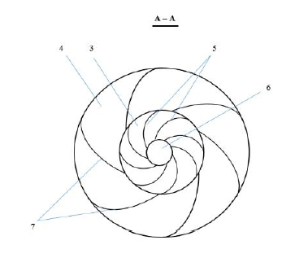
Fig.3. VWPI - A-A cross-section [9]

The generator 9 locates down of the construction and locates along with rod. This can help to increase the efficiency of the operation, and also reduces the center of gravity of the design as compared to prototypes. The energy of the vortex movement is given by curvilinear blades 5. Air flow is not affected by the curves of the blades. Even in holes in the ventilation ducts, the airflow does not overwhelm it when it changes its direction. When turned on, the torque returns to the generator 9, and the generator converts mechanical rotation energy into electricity. The flow of air flows into the hub and moves to the center by the helix. The air spiral movement is caused by the orientation of walls and blades. The angular velocity of the cave depends on the wall curvature. The capacity of the unit increases as the concentration does not exceed the radius.
Figure 4 depicts the geometrical 3D model of winding unit winding unit, which is a subject of research.
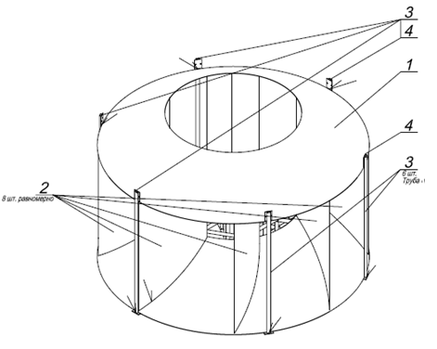
1 - cone, 2 - rectilinear blades, 3 - booth stands, 4 - roof rails with a conical wound.
Fig.4. A general view of the concentrator.

FORMULATION OF THE PROBLEM
- Mathematical model
The research was carried out in 2d model of concentrator of VWPI. Geometrical model is shown in the figure 5.

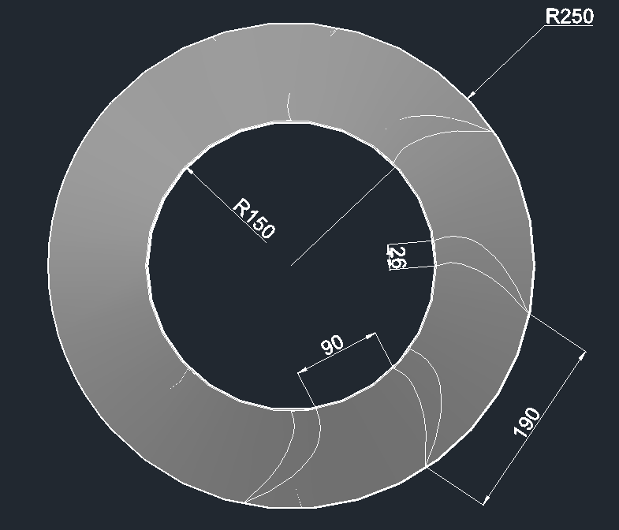

Fig.5. Geometric 2D image of wind power installation concentrator (dimensions are given in mm)

In this study, the flow of air flowing through the guide blades in turbulent mode was investigated. In general, the COMSOL Multiphysics model uses the Reynolds equations for the modeling of turbulent flows (RANS) and several turbulence models: L-VEL, yPlus, Spencer-Allemar, k-ε, k-ω and SST. Including the model k-ω. Because this model gives good results when considering internal flows and curves on bending ducts. At the same time, wall functions are taken into account. This is most important when you examine turbulent flows.
Boundary conditions: Figure 6 shows the air entrances (INLET) and Outlet (OUTLET), the remaining walls are WALLS.

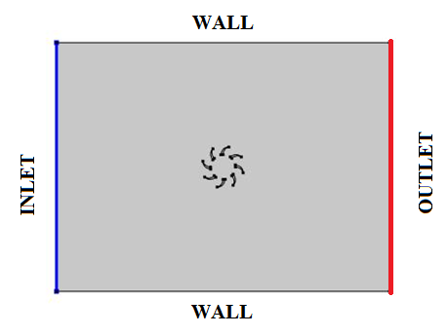
$$\text{INLET}:u_{\text{ref}}=u_{0},k=k_{0},ω=ω_{0}$$
$$\text{OUTLET}:p_{0}=0$$
$$\text{WALLS}:u⋅n=0,∇ω⋅n=0,∇ω⋅n=0$$
Fig.6. 2d model and boundary conditions of the VWPI’s concentrator

It was created a grid with the creation of automatic grid function in COMSOL Multiphysics. (Figure 7)

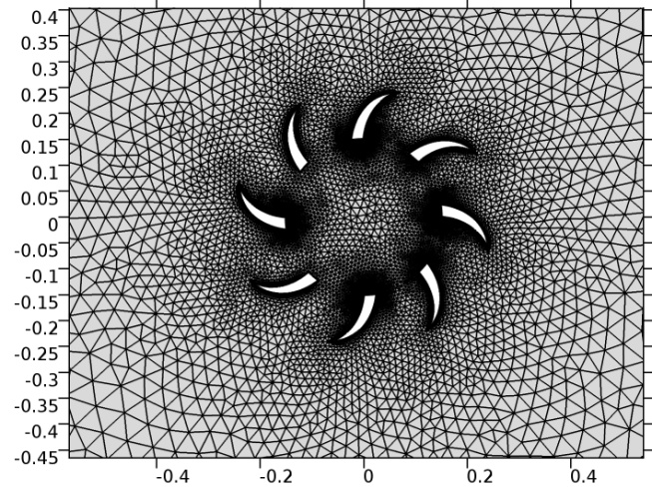
Fig.7. Computational grid for 2d geometrical model of concentrator.

The medium you are looking at is compressible, viscous and steady. The general law of conservation of law and movement equation is written as follows:

$ρ(u⋅∇)u=∇⋅[−ρI+(μ+μ_{T})(∇u+(∇u)^{T})+F$ (1)

$∇⋅ρ(u)=0$ (2)

The medium turbulent and obtained k-ω model, the following additional equations are added:
Kinematic viscosity:

$ν_{T}=\frac{k}{ω},\tilde{ω}=\text{max}\left\{ω,C_{\text{lim}}\sqrt{\frac{2S_{\text{ij}}S_{\text{ij}}}{β^{}}}\right\},C_{\text{lim}}=\frac{7}{8}$ (3)

Turbulent kinetic energy:
$U_{j}\frac{∂k}{∂x_{j}}=τ_{\text{ij}}\frac{∂U_{i}}{∂x_{j}}−β^{}kω+\frac{∂U_{i}}{∂x_{j}}[(ν+σ^{}\frac{k}{ω})\frac{∂k}{∂x_{j}}]$ (4)
Specific frequency of dissipation:
$U_{j}\frac{∂ω}{∂x_{j}}=α\frac{ω}{k}τ_{\text{ij}}\frac{∂U_{i}}{∂x_{j}}−{\text{βω}}^{2}+\frac{σ_{d}}{ω}\frac{∂k}{∂x_{j}}\frac{∂ω}{∂x_{j}}+\frac{∂}{∂x_{j}}[(ν+σ\frac{k}{ω})\frac{∂ω}{∂x_{j}}]$ (5)
Coefficients and additional relationships:
$α=\frac{\text{13}}{\text{25}},$ $β=β_{0}f_{β,},$ $β^{}=\frac{9}{\text{100}},σ=\frac{1}{2},$ $σ^{}=\frac{3}{5},$ $σ_{\text{do}}=\frac{1}{8}$ (6)
$σ_{d}=$ (7)
$ε=β^{}ωk$ , $l={k^{1/2}}/ω$ (8)
2. Results and discussions
The thickness of the guiding blade was considered as 14, 26, and 70 mm, and the circumstances under which the shape (curvature) was changed. The air velocity was 10, 15, 20 m / sec for each case. The flow is directed from left to right and is given in several degrees (0, 15, 30, 45). The results, when the velocity is 15 and 20 m / s, are analogous to the results with a velocity of 10 m / s, and the results, given at 0, 15, 30, 45 degrees, are analogous to the initial, i.e. velocity of 10 m / s, 0 g in the following illustrations.
- Shape of the guide blades is vertical and near to curve, the flow moves from right to the left (Figures 8-9).

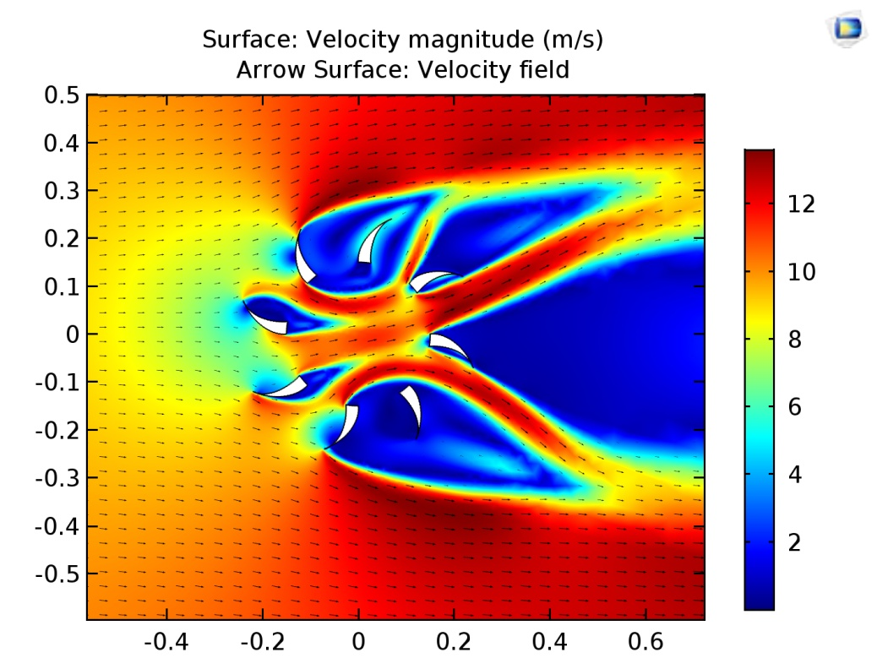
Fig.8. Velocity distribution when initial velocity was 10 m/s.
As we can see that in the figure 8, the form of blades does not create vortex motion. It creates resist to wind turbine which will locate in the centre of this concentrator.

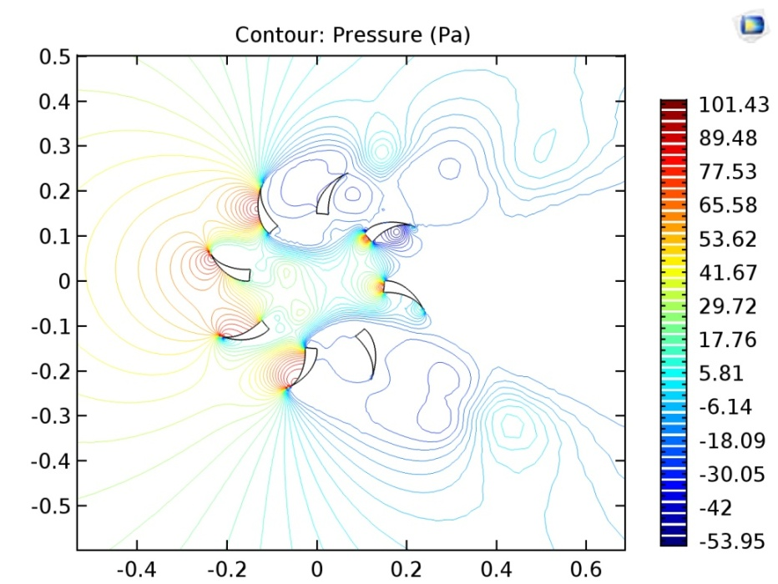
Fig.9. Pressure distribution, velocity was 10 m/s.
- Results in the case when curvature radius of the blades was changed. Velocity of the flow - 10 m/sec (Figures 10-11).

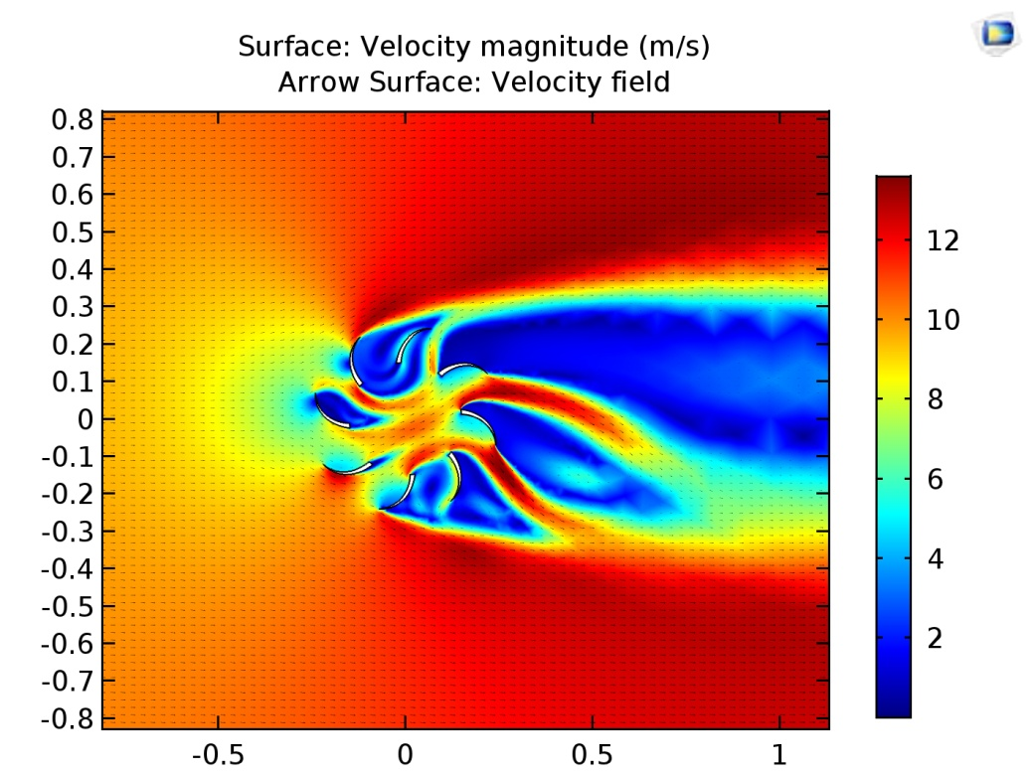
Fig.10. Velocity distribution. The thickness of blades is 14 mm.

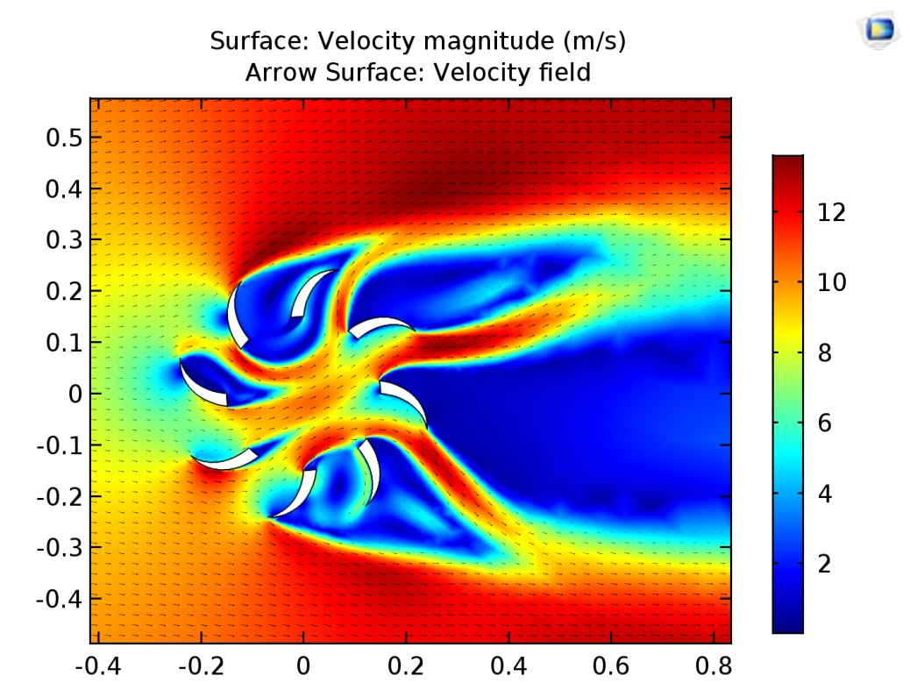
Fig.11. Velocity distribution. The thickness of blades is 26 mm.

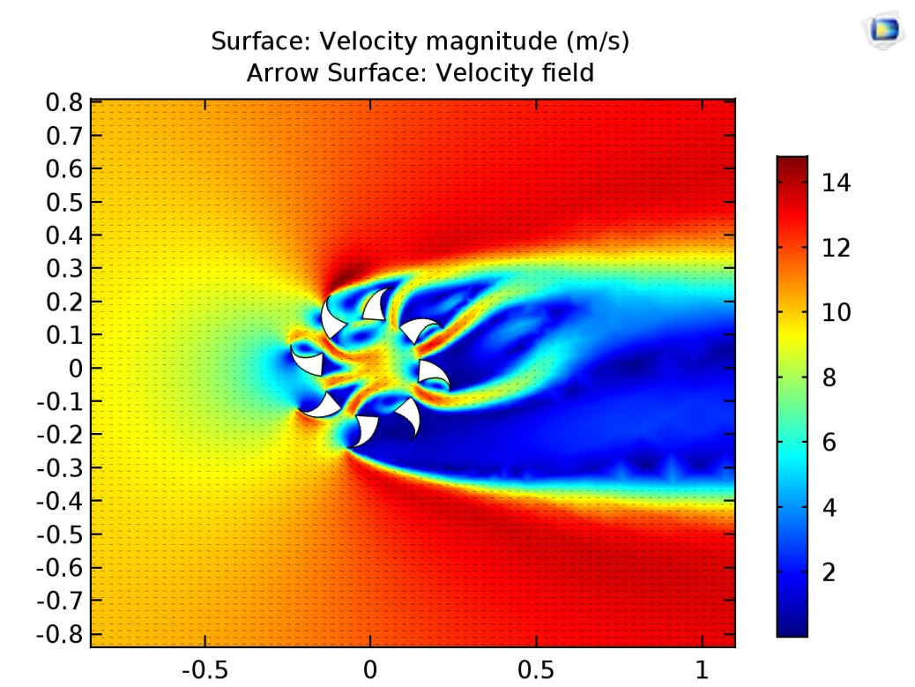
Fig.12. Velocity distribution. The thickness of blades is 70 mm.

In these figures we also can conclude that it creates resist to rotational motion of turbine which will locate in the center of this installation. But we can see that when we increase thickness of blades, then velocity increases. It means that spending material will increase.

- The case when curvature of the blades chosen to create vortex motion.
Results when blades locate vertically and thickness is 26 mm:

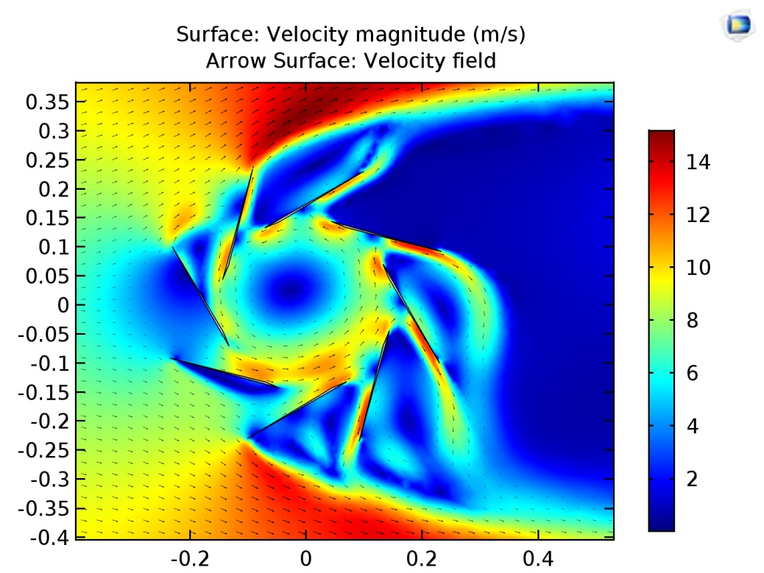
Fig.13. Velocity distribution when velocity was equal to 10 m/s.

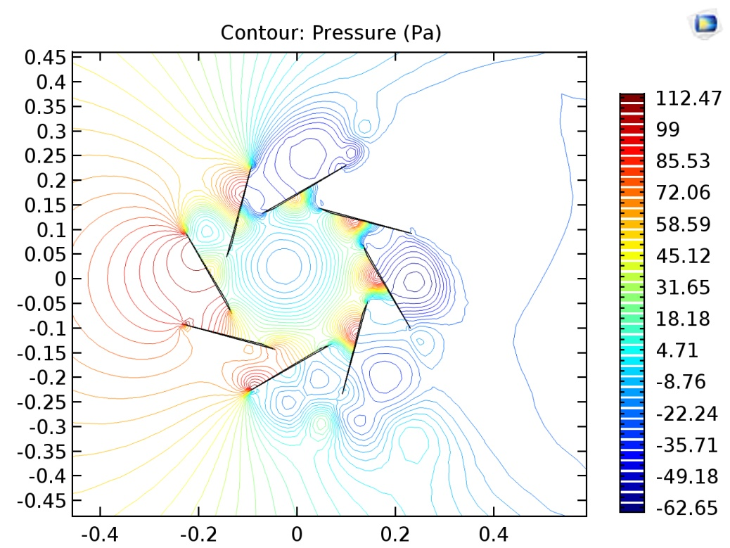
Fig.14. Pressure distribution when velocity was equal to 10 m/s.

The following results when form of the blades was changed:

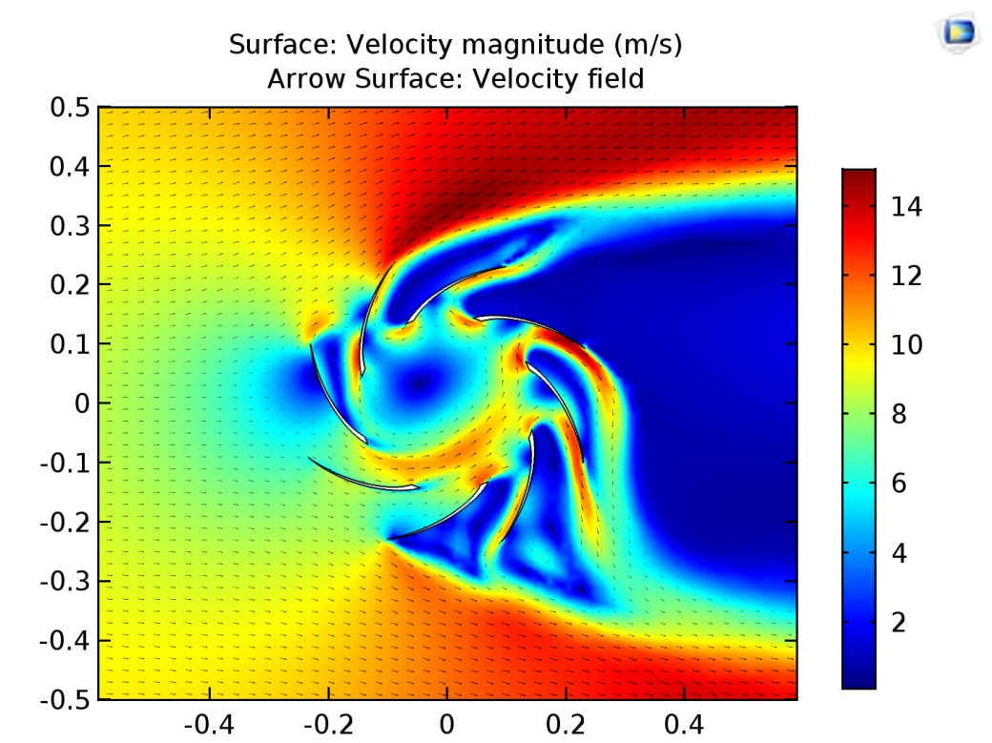
Fig.15. Velocity distribution when thickness was 14 mm (velocity of flow is 10 m/s)

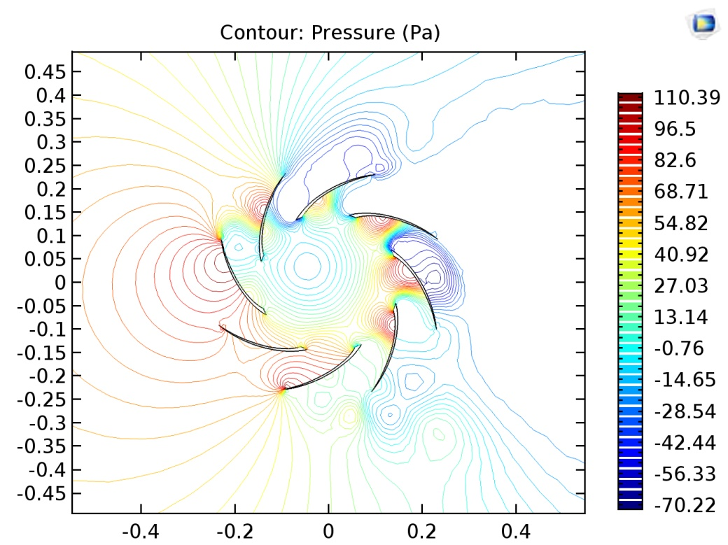
Fig.16. Pressure distribution when thickness was 14 mm (velocity of flow is 10 m/s)

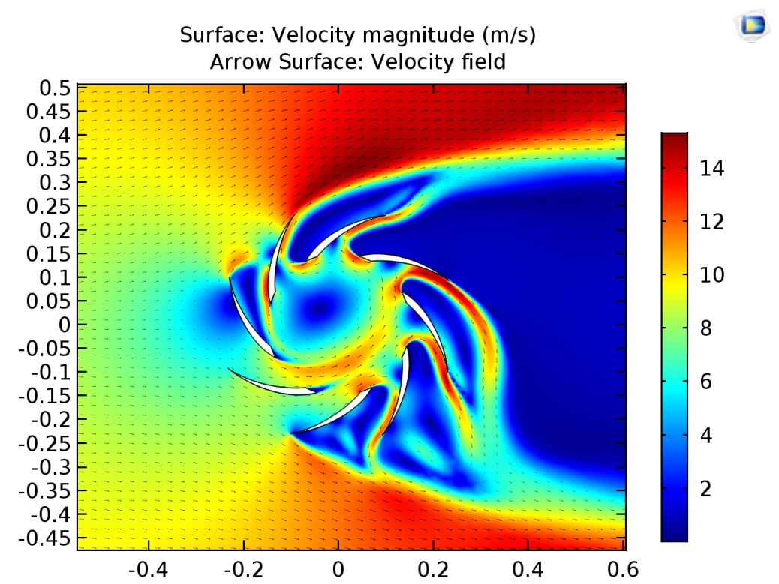
Fig.17. Velocity distribution when thickness was 26 mm (velocity of flow is 10 m/s)

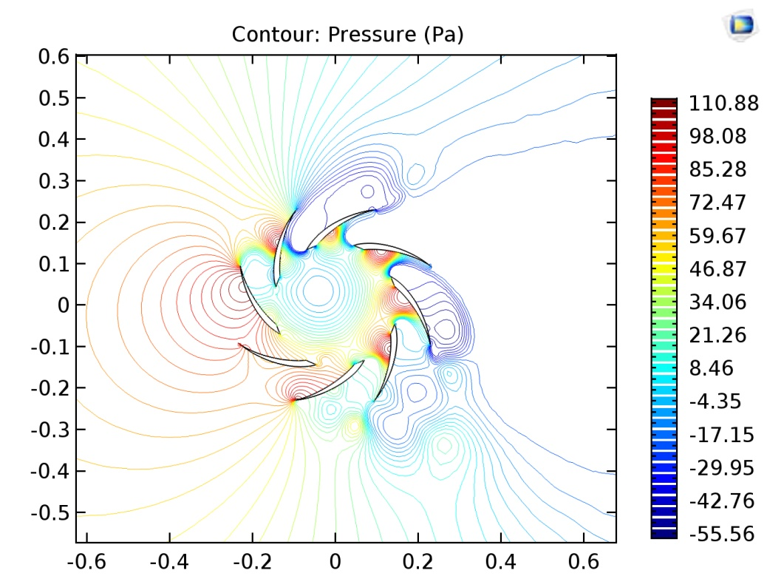
Fig.18. Pressure distribution when thickness was 26 mm (velocity of flow is 10 m/s)

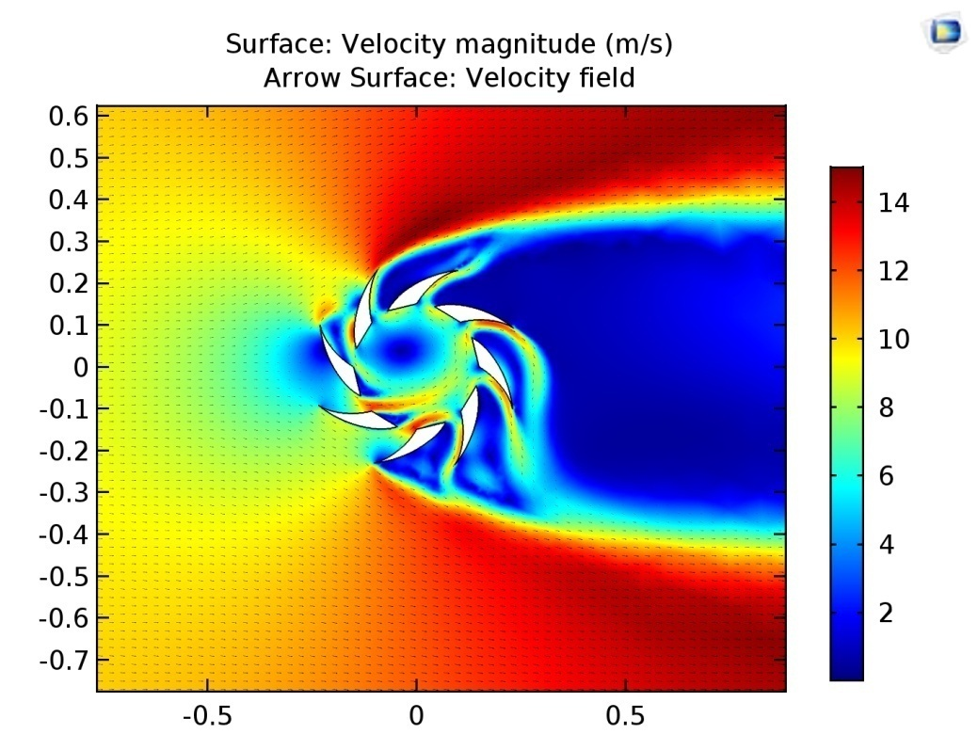
Fig.19. Velocity distribution when thickness was 70 mm (velocity of flow is 10 m/s)

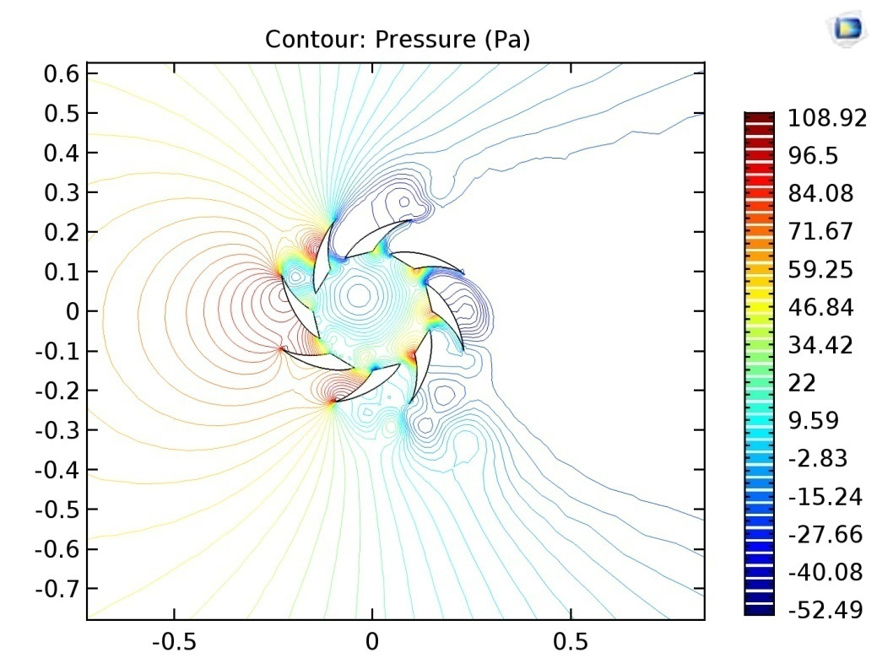
Fig.18. Pressure distribution when thickness was 70 mm (velocity of flow is 10 m/s)

So, There was no significant change in the pressure of blades thickness. Significant differences are observed in the speed spectrum. The number is quite different when considering the speed at the entrance to both blades. When the blade thickness is 14 mm and 26 mm, the air flow velocity between the two blades increases by 10-20%. And when the blade thickness was 70 mm, the velocity increased by 40%. Although the thickness of the blades increase, then velocity increases too. At the same time, the cost of the material should be taken into account.
In the case when blades’ are vertical and locates with some curvature Fig. 13), it is difficult for the airflow to flow continuously in the concentrator. Influence of the pressure on the walls increase also. (Figure 14).
CONCLUSIONS
The research work was carried out within the framework of the scientific project "Creation of optimal wind power installation (WPI) with concentrator of flow" at the Ch.Chokin Energy Research Institute.
In this paper, a study was conducted to determine the optimal version of the blades VWPI’s concentrator.
Three types of blades were used to guide the wind direction to the wind power unit through the guide blades. The research results were obtained due to their thicknesses (14, 26, and 70 mm), location and wind velocity (10, 15, 20 m / s). Airflow varied in several degrees and the result was analog (0, 15, 30, 45). The study was carried out in the COMSOL Multiphysics application packages using the RANS method for the Navier-Stokes equation for incompressible liquids. The speed and pressure distribution were investigated and the results were graphically illustrated.
By analyzing the results of the calculations, as the thickness of the wind power installation guide blade increases the thickness of the air duct was decreased, velocity increased. When the form was as an arc, the air flow turned into a vortex motion, with increasing of velocity of 10-20%. Initially, when the blade thickness was 14 mm and 26 mm, velocity at the entrance increased by 20%, and the velocity increased by 40% when the thickness was 70 mm. This work needs further research. The future is focused on determining the effective type of its thickness and determining the shape of the blade, its radius of curvature.

NOMENCLATURE
$C_{\text{lim}}$ - Stress limiting factor;
$k$ - Kinetic energy;
$ω$ - Specific frequency of dissipation;
$S_{\text{ki}}$ - Velocity averaged deformation tensor;
$τ_{\text{ij}}$ - Specific stress tensor;
$χ_{ω}$ - Dimensionless parameter of vortex tension;
$Ω_{\text{ij}}$ - Averaged vortex tensor;
$β$ - Equilibrium parameter;
$ε$ - Dissipation per mass.
Subscripts
VWPI – vortex wind power installation;
RANS – Reynolds averaged numerical simulation.

REFERENCES
1. Sovremennoye sostoyaniye i perspektivy razvitiya vetroenergetiki. – M.: AO «Informenergo», 2000. – 157s.
2. Bubenchikov A. A., Gorlinskiy N. A., Shcherbinov V. V., Sikorskiy S. P., Kulak K. S. Kontsentratory potokov dlya vetroenergeticheskikh ustanovok // Molodoy uchenyy. - 2016. - №28.2. - S. 10-14.
3. Takho-Godi A.Z. Kontsentrator vozdushnogo potoka dlya vetroelektricheskoy stantsii, upravlyayemyy sledyashchey sistemoy s konturom optimal'nogo regulirovaniya ugla rastrubnosti // Fundamental'nyye issledovaniya. – 2015. – № 2-14. – S. 3056-3058. https://www.fundamental-research.ru/ru/article/view?id=37690
4. W. T. Chong , S. C. Poh, A. Fazlizan, K. C. Pan. Vertical axis wind turbine with omni-directional-guide-vane for urban high-rise buildings // Journal of Central South University of Technology. Central South University Press and Springer - Verlag Berlin. Heidelberg, Procedia Engineering 67. p. 59 – 69, 2013.
5. Koshumbayev M.B., Myrzakulov B.K., Toleukhanova A.B. Teoreticheskiye i eksperimental'nyye issledovaniya po razrabotke novoy konstruktsii vetroenergeticheskoy ustanovki s kontsentratorom potoka // Sovmestnyy VSH mezhdunarodnyy simpozium «Goreniye i plazmokhimiya», RGP «Institut Problem Goreniya», 16-18 sentyabrya 2015 g., g. Almaty, S.160-165.
6. Novaya konstruktsiya vetroenergeticheskoy ustanovki (VEU) s kontsentratorom potoka // Nauchno-tekhnicheskiy zhurnal «Kazakhstan Innovations», 2017 g., g.Astana, S.63-64.
7. Koshumbayeva M. B. Myrzakulov B.K., Abdrasulov I.A. Rezul'taty modelirovaniya vozdushnogo turbulentnogo potoka v iskrivlennom kanale kontsentratora vetrovoy ustanovki // Mezhdunarodnyy zhurnal «Simvol nauki», Ufa, RF, № 1, 2016. – s. 58-60.
8. Koshumbayev M. B. Primeneniye vikhrevogo effekta v vetroagregate //Sovremennyy nauchnyy vestnik. - Belgorod: Rusnauchkniga, 2007. - № 4.
9. Koshumbayev M.B., Turalina D.Ye., Toleukhanova A.B. Baġyttaushy apparaty bar zhelenegetikalykˌ kˌondyrġysynyң zhaңa kontstruktsiyasyn zhasau boyynsha teoriyalykˌ zhəne təzhíribelík zertteuler//Vestnik KazNU,seriya mekhanika, matematika, informatika. №2(85) – Almaty, 2015, 81-93 b.

