Kazakh National University named after Al-Farabi

**TURALINA DINARA, BOSINOV DANIYAR**

LABORATORY WORKS FROM FLUID AND GAS MECHANICS

***Manual book***

Almaty

«Kazakh university»

2018

UDK

*Recommended by the publishing council and the Scientific Council of the Faculty of Mechanics and Mathematics of the Kazakh National University of Al-Farabi*

*(№ protocol 2018 year)*

**Author of review:**

PhD K. Alibaeva

**Туралина Д.Е.**

Experiments for fluid and gas mechanics: manual book / Turslina D.E. – Almaty: Kazakh university, 2018. – 63 p.

**ISBN**

The manual was developed in accordance with the program of the discipline "Mechanics of liquids and gases", which is studied on the professional module block, specialty 5B060300 - Mechanics.

The manual contains explanation of 7 laboratory works related to the mechanics of liquids and gases. The purpose of each laboratory work, a brief theoretical introduction, explanation of experimental devices, the order of work execution, tasks and topics.

The manual is intended for students studying on the specialty of Universities

**UDK**

© Turalina D.E., 2018

ISBN ©KazNU named after Al-Farabi, 2018

**CONTENTS**

INTRODUCTION 3

1. HYDROSTATICS 11

1.1. Basic concepts of hydrostatics 11

1.1.1. Devices of liquids 17

1.1.2. Pressure force fluid on the flat walls 23

1.2. DESCRIPTION LABORATORY BENCH "HYDROSTATIC HS" 27

1.3. Laboratory work at the stand «Hydrostatics – HS» 29

1.3.1. Determination hydrostatic pressures

Laboratory work №1.3.1 29

1.3.2. Determination of density of an unknown liquid.

Laboratory work №1.3.2 32

1.3.3. Determine the force the fluid pressure at a flat wall

Laboratory work №1.3.3 36

2. HYDRODYNAMICS 57

2.1. BASIC CONCEPTS OF HYDRODYNAMICS 57

2.2. DESCRIPTION LABORATORY BENCH «HYDRODYNAMICS» 64

2.3. PREPARING TO WORK BENCH 68

2.4. LABORATORY WORK at the stand «HY DRODYNAMICS HD» 68

2.4.1. Pressure losses on pipe length 68

2.4.2. Diagramming the Bernoulli equation 78

2.4.3. Pressure loss at sudden axisymmetric expansion of pipe

2.4.4. Researching the changes of flow regimes 9

APPLICATIONS 50

REFERENCES 105

**INTRODUCTION**

*"Laboratory work on the mechanics of liquids and gases ", which included the content of the" Mechanics of liquids and gases "," Mechanics of liquids and gases "and" Practical hydromechanics ", specialty" 5B060300 - Mechanics ", compiled in accordance with the content of the main curriculum of these disciplines.*

*The manual book explains the practical exercises in the laboratory "Hydrostatics" and "Hydrodynamics" in the field of mechanics of liquids and gases. The purpose of each laboratory work is to summarize the short theories, the interpretation of experimental devices, the order of the practice, the tasks and the self-exam questions and reports. Each laboratory work was supplemented by visual illustrations, tables, and the list of available basic and additional literature.*

The educational and methodical manual is offered to students, teachers and specialists in the field of mechanics of liquids and gases specialty "5B060300 - Mechanics".

*Your comments and suggestions to improve the content and quality of the teaching manual will be welcomed by the writer and will be considered in the following issue.*

*Author*

*dinara.turalina@kaznu.kz*

**1. HYDROSTATICS**

**1.1. BASIC CONCEPTS OF HYDROSTATICS**

Hydrostatics - a section of Hydromechanics in which we study the conditions and laws of equilibrium of fluids under the influence of forces applied to them, as well as the impact of resting liquids immersed in them the body and on the vascular wall. Hydrostatic pressure distribution in considering a quiescent fluid, determination of the magnitude, direction and point of application of the force of fluid pressure on flat and curved walls.

Normal stress at a quiescent fluid is a quantity that characterizes the intensity of the forces acting on an area element ΔS the contraction of this area to the point:

 (1.1)

Since this stress is applied normal to the ground and is not dependent on the orientation of the site, it can be represented as:

 (1.2)

The quantity p, appearing in (1.2) is the absolute value of the normal stress at a point called the *hydrostatic pressure.* Hydrostatic pressure is always positive:.

As for the positive stress is taken tensile stress, the "-" sign in the expression (1.2) shows that in the liquid are only compressive stress. Tensile stresses can not withstand real liquid. Thus, the pressure at point coordinate function is not dependent on the orientation of the site on which it acts. In hydrostatics considered *absolute* pressure , *excess* (manometric) pressure (),  *vacuum* pressure and *atmospheric* pressure .

These pressures are related by, illustrated Figure 1.1 and formulas (1.3) - (1.4).

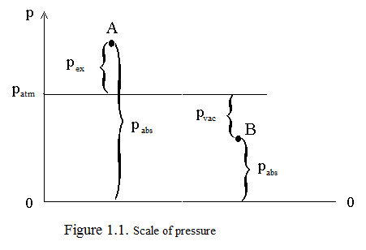

If the fluid is at rest in a relaxed state, that is, it lacks the compressive stress, the hydrostatic pressure is equal to zero: p = 0. Pressure values measured from this zero, called absolute.

Excess (manometric) pressure at point A is called exceeding absolute pressure over atmospheric:

 (1.3)

Vacuum pressure at point B is formed as a lack of absolute pressure until atmospheric pressure:

 (1.4)

If pressure is known at any point 0 of the fluid at rest, the pressure at another point 1 of this liquid can be determined from the basic hydrostatic formula:

 (1.5)

where – the vertical distance from the measured point to the point *0* on the condition that a point above the point *0 i*s *1*, or, which is the same, equivalently,  – burying point *1* relative to the point *0;* – density of the liquid; – acceleration of gravity.

 term represents an additional ***weight pressure*** of the liquid column height  . If the point *0* is the free surface of the liquid, the pressure equals the gas phase located above the liquid surface (external pressure). In the particular case - the ***atmospheric pressure*** above the free surface:

.

Of hydrostatic formula (1.5) it follows that any change in the external pressure causes a change in pressure  in all points of the stationary liquid to the same value. This conclusion is known as **Pascal's law.**

In general, if the point with these pressures p1 and p0 are several pillars of liquids of different densities, the desired pressure is repeated application of hydrostatic basic formula (1.5) to the interfaces between liquids:

 (1.6)

From formula (1.5), written in the form , that the quantities of surplus, vacuum and absolute pressure can be expressed in terms of linear quantities:

, *(pabs> patm)* (1.7)

, *(pabs< patm)* (1.8)

, (1.9)

In the formulas (7) - (9) indicated:

 *–* piezometric height;

 *–* vacuum height;

 *–* reduced height.

As follows from (1.1) and (1.2), the pressure p - scalar value (unlike vector quantities force pressure and tension). Dimension of pressure in the SI system:

** (*pascal*).

For practical calculations often use multiple units:

*1 КPa = 103 Pа; 1МPа = 106 Pа.*

However, not all devices used to measure pressure, calibrated in units of multiple Pa. In technology and industry generally use Common Units - 1 technical atmosphere:

*1 atm =1 kgs/sm2 = 9,81· 104 Pа.* (1.10)

Furthermore, as follows from the formula (1.7) - (1.9), the pressure can be expressed by the height of a column of liquid. Easy to see that a pressure of *1 atm* created such columns of water and mercury:

*1 atm ~ 10 m the water column*;

(1.11)

*1 atm ~735 mm the mercury column.*

Relations (1.10) and (1.11) allow a recount in any of used systems pressure measurements.

The actual atmospheric pressure may be higher or lower than *1 atm*, and therefore in Figure 1.1 in the above formula is a floating point.

Requirements of modern science and technology to instruments for measuring pressure, extremely diverse.

First of all, a very wide range of measured values. Thus, in vacuum technology has to be measured a pressure of about millionths of a millimeter of mercury column, and in the practice of science applied pressure of hundreds of thousands of atmospheres.

Requirements increase measurement accuracy, complicated objects of study, imposing additional conditions on the constructive design of devices.

Conventionally, all blood pressure measuring devices can be classified according to the following criteria:

- by the nature of the measured value;

- by the principle of operation;

- by the accuracy class.

By the nature of the measured value, depending on the need to measure atmospheric pressure, absolute, excess pressure or vacuum, there are several types of devices.

Instruments for measuring atmospheric pressure, called ***barometers*** , for measuring the excess pressure – ***manometers***, for measuring the vacuum – ***vacuum meters***.

Devices, that measure excess and vacuum pressure are called pressure-vacuum gages.

For absolute pressure measurement requires two devices - a barometer and a manometer if the absolute pressure greater than atmospheric pressure, and the barometer and vacuum meters if the absolute pressure less than atmospheric. In some cases, it is enough to know the difference in pressure at two different points; measuring the pressure difference can be performed with a ***differential manometers.***

By an action principle all devices can be classified into fluid, mechanical, electrical and combined.

Liquid instruments based on the hydrostatic principle of action, implemented by the hydrostatic core (1.5): the measured pressure is balanced by the pressure of the liquid column height is determined directly or by calculation.

The principle of operation of mechanical devices lies in the fact that under pressure, the deformation of a resilient element, and the magnitude of this deformation is a measure of the measured pressure.

In the type of electric devices receiving element which converts the pressure in one or other electrical signal is a pressure sensor.

For combined are those devices whose operation is mixed.

According to the accuracy of the all commercially available devices are divided into classes. Accuracy class of the instrument called the number expressing the maximum possible error in the percentage of full-scale value of the device.

***1.1.1.* *Devices of liquids***

Liquid instruments are widespread due to the ease of performance and accuracy. The magnitude of the measured pressure is hydrostatic formulas (1.5) or (1.6), and the corresponding height - by formulas (1.7) - (1.9). In Figure 1.2 - 1.4 shows some types of liquid instruments.

The simplest liquid instrument is a ***piezometer*** - transparent tube, one end lowered into the test point, the other - open to the atmosphere (Figure 1.2).

Excess pressure at the point A is defined piezometric height , a vacuum pressure at point B - the height  vacuum:

;  (1.12)

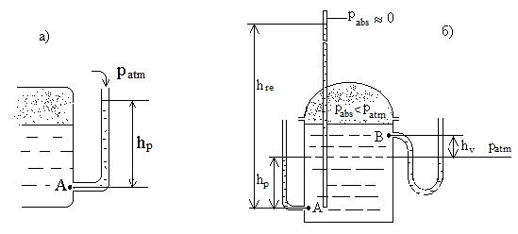

Figure 1.2. Measurement of excess pressure and vacuum pressure using piezometer

The absolute pressure at point A can be determined from the reduced height  - height of the column of liquid in a sealed tube from which air is removed so that the pressure on the free surface therein is close to zero:.

The same principle is used in a device called ***cup-shaped pressure-vacuum gages*** (Figure 1.3, formula (1.12)).

To measure the difference (differential) pressure is ***U - shaped pressure-vacuum gages*** (Figure 1.4). The pressure value is also determined by (1.12).

For measuring small excess or vacuum pressure devices are used with high accuracy scales (in particular, with the inclined scale, Figure 1.5), which are filled with working fluid with a relatively low density (eg, alcohol) and called ***micromanometers***. Excess (*pressure-vacuum gages*) pressure determined by the length *l* of the liquid column and dip angle scale :



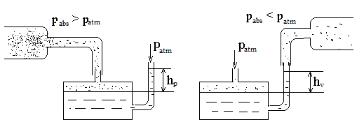

Figure 1.3. Cup-shaped pressure - vacuum gages

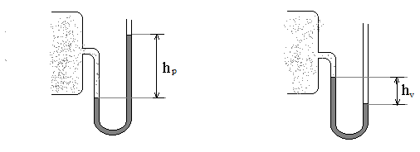

Figure 1.4. U –shaped pressure-vacuum gages

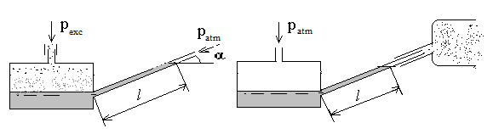

Figure 1.5. Micromanometers

Liquid instruments for measuring pressure are very useful in the study of fluid flow.

So, sometimes not enough to know the absolute values of pressure, differential pressure and only at some points.

Devices based on the measurement of the pressure difference, called ***differential manometers***. Differential pressure in the flow of moving fluid can be used as a flow meter (Figure 1.6).

Gas Liquid

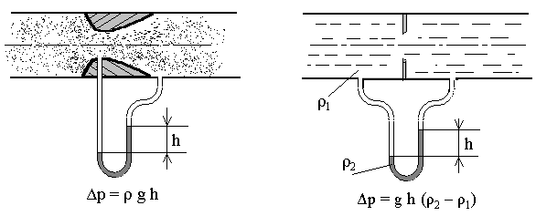

Figure 1.6. Differential manometers

A significant drawback of liquid instruments is the narrowness of the range of measured pressures. You can extend this range by using multiple series connected U – shaped manometer. Such a device is called a ***battery pressure-vacuum gages*** (Figure 1.7).

oil water

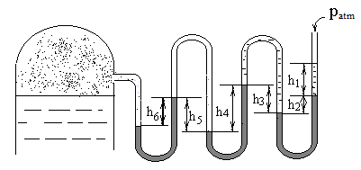

mercury

### Figure 1.7. Battery pressure-vacuum gages

The air pressure in the tank is balanced by the liquid level differences in the manometer tubes. In different bends can be filled different liquid. Thus, for pressure-pressure-vacuum gages readings on the battery pressure-vacuum gages figure1.7 calculation pressure in the tank is determined by summing the formula (1.6), all level changes from the open end to attach it to the tank:

 (1.13)

Weight air pressure at the left end of the battery pressure-vacuum gages because of its smallness neglected.

***1.1.2. Pressure force fluid on the flat walls***

Fluid pressure on the surface of the structural parts with which it comes into contact. If the structure is exposed to air that is at atmospheric pressure, then for determining the hydrostatic pressure forces usually operate a pressure or vacuum as the atmospheric pressure acts on the calculated design on all sides and can therefore be disregarded. In determining the pressure forces use the term piezometric plane or plane atmospheric pressure. This horizontal plane P - P (Figure1-8) passing through the liquid level in the piezometer attached to the vessel.

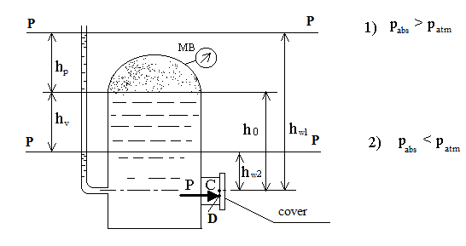

Figure 1.8. Definition of the pressure on the flat wall

The liquid surface level piezometric only plane exposed to atmospheric pressure, so . If the vessel with the liquid open to the atmosphere, the piezometric plane coincides with the free liquid surface. In the case of the hermetically sealed container, it may be located above or below the free surface depending on the pressure above the free surface. The vertical distance to the plane defined by the piezometric height respectively or by the formula (7), if pabs> patm (position 1 in Figure 8), or the height of the vacuum by the formula (8), if pabs <patm (position 2).

Fluid pressure force on the flat wall (for example, Figure 1.8 on the hatch cover) is directed along the normal to the wall, and its value is equal to:

 (1.14)

where  - pressure at the center of gravity of the wall (point C); *S* - area of the wall;  - the distance to the center of gravity of the wall from the piezometric plane.

This distance depends on the penetration wall h0 at the free surface, and the value of external pressure(see Figure 1.8).

For the first case, when , ,

in the second case, when , .

Pressure force P is applied at the center of pressure (point D)*1)

To measure the strength of the experimental fluid pressure to the wall can be used bellows dynamometer (Figure 1.9).

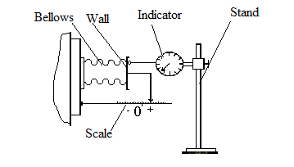

Figure 1.9. Bellows dynamometer

___________________________________________________________________

1The position of the center of pressure hd connected with the center of gravity equation: , where *I* - moment of inertia of the cap relative to the horizontal axis passing through the center of gravity of the section.

As an elastic element in the dynamometer used bellows, which is a metal thin walled chamber with a corrugated lateral surface, able to expand and contract as the pressure fluid. Here the free end of the bellows plane moves parallel to itself by an amount proportional to the magnitude of the pressure change.

Movement of the bellows can be either positive or negative depending on whether the vessel creates an overpressure or vacuum. Largest displacement , counted on the position of the pointer on the scale of the bellows, and the calibration curve  is determined by the experimental value of the force acting on the wall:

 (1.15)

where *C* - a calibration reference bellows [*N / mm*]

 - moving solid wall [*mm*].

A more thorough definition of movement of the bellows using a dial indicator will determine the required amount of pressure with greater accuracy.

Since the vessel was initially filled with working fluid, the bellows already deformed by the force . Therefore, using the bellows dynamometer can only determine the additional force caused by the change of air pressure in the vessel. Estimated value of the additional pressure force:

|  |  |  |  |
| --- | --- | --- | --- |
|  | for case |  | (1.16) |
|  | for case |  |

**1.2 DESCRIPTION LABORATORY BENCH "HYDROSTATIC HS"**

The bench consists of a desktop 1 (Figure 2.1), fixed on this tank 2 and shield 3 with battery pressure-vacuum gage P3. Next to the desktop is fixed shield wall piezometers 4. ¾ tank filled with working fluid. With the compressor 5 and 6 of the vacuum cleaner mounted on the lower shelf of the table, under the lid of the tank can be created by excess or a vacuum pressure. Necessary mode is provided by the control unit 7 taps and T1 and T2. Air pressure in the tank is registered mechanical device – pressure-vacuum gage MB1. On the front and side walls of the tank are located flanges, which bellows through 8 are attached two test flat wall 9 - vertical and horizontal. The flanges fixed line with the scales used to define moving walls (see fig.1.9). Knee battery mono vacuum metric P3 fluid-filled (generally liquid may be different). The left end of the battery is connected to the pressure-vacuum gage upper part of the tank, air-filled, right open to the atmosphere.

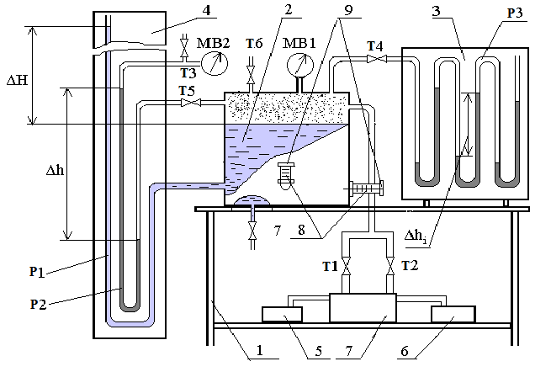

**Figure 2.1.** Laboratory bench "Hydrostatic HS"

On wall panel 4 piezometers placed piezometer P1 connected to filled with working fluid of the tank, and the U-shaped pressure-vacuum gage P2, filled with test liquid unknown density. One end is connected to the pressure-vacuum gage P2 upper (air) of the tank, and the second put into a mechanical device - pressure-vacuum gage MB2. Taps T5 and T3 are used for pressure-vacuum gage block P2 during the experiments on the pressure or vacuum, exceeding the limits of the measuring liquid instrument. Taps T6 and T7 are used to fill the tank with working fluid and emptying it.

**1.3. Experimeemtal works on the «Hydrostatics – HS» installation**

***1.3.1 Determination hydrostatic pressures***

**Laboratory work №1.3.1**

Purpose of the work: .

The aim of this work is the development of methods for measuring student hydrostatic pressure. In preparation for the work in progress and work in the processing of the experimental results the student must:

- familiar with the measurement of different pressures;

- determine the pressure under the tank cover on the piezometer indications and battery pressure-vacuum gage and compare them with the indications of  a mechanical device.

The procedure for conducting experiments designed to measure hydrostatic pressure.

*Mode excess pressure (experiment № 1)*

1. To write indications H0 of the piezometer P1 corresponding to the level of the free liquid surface in the tank at atmospheric pressure;
2. With the compressor installed in the tank mode exceed pressure. For this it is necessary to do the following operations:

* Close the tap T5, cutting P2 pressure-vacuum gage from the tank (tap open while T3, see Figure 2.1);
* On the remote control to close the tap T2 "absorption"; open tap T1 "Delivery";
* Turn on the tumbler "Network";
* To install the tumbler "modes" to "Delivery";
* Click "Start", and install the piezometer indications necessary pressure P1;

*NB! Do not allow working fluid under excess pressure spilled through the open end of P1. Considering inertia of the liquid and slow filling it piezometer must periodically release the "Start" button, waiting for stabilization of liquid level in P1.*

* 6. Release the "Start" button and close the tap "Delivery".

3. To fix piezometer H1 indications P1, P3 the manometer battery indications and indications mechanical device MB1; write these indications in Table 1 and Table 2 (see Appendix 1);

4. Reset excess pressure in the tank, which open the tap T1 "Delivery" T2 "absorption" and tap T5.

5. Written by the barometer indications atmospheric pressure and density of the liquids.

*Mode vacuum pressure (experiment №2)*

6. Written indications H0 piezometer P1 corresponding to the level of the free liquid surface in the tank at atmospheric pressure;

7. Use a vacuum cleaner install in the tank vacuum pressure mode. To do this:

* Close the tap T5, cutting pressure-vacuum gage P2 from the tank (tap open while T3);
* Close the tap T1 "Delivery", the tap T2 "Absorption ";
* Turn on the tumbler "Network";
* To install the tumbler "modes" to "Delivery";
* Click "Start", and install the piezometer indications necessary pressure P1;

*NB! Ensure that the liquid under the influence of vacuum pressure did not fall to the bottom edge of the piezometer P1;*

* Release the "Start" button and close the tap "Delivery";

Next repeat pp 3, 4.

**1.3.2 *Determine of density of an unknown liquid***

**Laboratory work №1.3.2**

Purpose of the work - to determine the density of skills unknown to the testimony of liquid fluid and mechanical devices.

**The order of execution of work simultaneously with the laboratory work № 1.3.1**

Proceed as follows:

1. Relieve pressure under the tank cover to atmospheric;

2. Open the tap T5 (T3 tap must also be open);

3. Complete p.p.3.2.1, 3.2.2 (tap T5 - open!) thus it is necessary to make sure that the test fluid has not reached the highest point of the left knee P2;

*NB! It is also necessary to control the position of the working fluid in the left channel piezometer P1 according to item 5 p.p.3.2.2 as the test liquid may have a density greater than the density of the working fluid.*

4. Record readings in accordance with paragraphs 2.3.3;

5. Fix indications and  U - shaped pressure-vacuum gage P2 and bring them in Table 3.

**Execution order in the definition of the fluid density using mechanical devices**

Construction piezometric shield 4 and piezometers P1 and P2 is as follows (see Figure 2.1) that the possible modes implemented (gauge and vacuum) difference *Δh* in piezometer *P2* always smaller drop in *ΔH* piezometer *P1* (unless the density of the unknown liquid is much less than than the density of the working fluid.) To broaden the range of operating pressures up designed into piezometer *P1* with simultaneous determination of density of an unknown liquid is provided an opportunity to "under thrust" left the U-tube pressure-vacuum gage pressure measurement with *P2* in the tube using a mechanical device - pressure-vacuum gage MB2. To do the work necessary to:

1. Open the tap T5; close tap T3;

2. Install desired mode with exceptional precautions when performing p.p.2.3.2, 2.3.7 and 2.3;

3. Written indications and the indications of pressure-vacuum gage P2 mechanical device MB2 in Table 3.

**Handling of the results of experiments in laboratory work №1 and № 2.**

1. Create calculation formulas to determine the gauge ,  in vacuum and absolute pressure  under the tank cover on the indications of the piezometer P1 and P3 pressure-vacuum gage battery for two modes;

2. Calculate the value ,  and  on indications of liquid instruments;

3. Compare the calculated values with indications a mechanical device;

4. 4. Calculate the density of an unknown liquid by indications liquid instruments (when tap is open T3) or pressure-vacuum gage indications MB2 (when the tap is closed T3):



where  - liquid pressure-vacuum gage indications;  - the pressure calculated from the indications liquid instruments (when tap is open T3). In case of working T3 when the tap is closed the pressure determined by the difference of pressure by indications a mechanical device MB2 and  pressure in the tank is determined either by liquid instrument, or by indications a mechanical device MB1:



Evaluate the absolute and relative error of measurement of pressure, calculated by indications of the piezometer P1 arising from neglect of lowering (raising) fluid level in the tank.

Changes in the level in the tank can be estimated from the balance equation in the volume of liquid in the tank and a piezometer:

*;* *;* ,

where  -decrease (increase) the volume of liquid in the tank;  - increase (decrease) the volume of liquid in the piezometer;  - section area of the tank;  - lowering the value (rise) level; *d* - the inner diameter of the tube of the piezometer *P1*;  - rising(lowering) the liquid level in the piezometer.

**1.3.3.Determine the force fluid pressure at a flat wall**

**Laboratory work №1.3.3**

Purpose of the work:

- Demonstration of Pascal's law;

- skills determining the force excess pressure on the flat horizontal and vertical walls.

The order of work performance

Work can be combined with laboratory work № 1.3.1

1. Install under the tank cover atmospheric pressure;

2. Written the initial position of the pointer on the scales for the horizontal and vertical walls;

3. Complete pp 1-4 Section 1.3.1, creating excess pressure under the cover;

4. Written pointer position on the scales of the bellows;

1. 5. Repeat experiments for vacuum-pressure gage under the cover.[1]*1)

Processing of the results

1. Determined by the amount of movement of the wall and calibration characteristics of the bellows by the formula (1.15), additional efforts on the walls;
2. Calculated from the indications of instruments and liquid (1.15) increments efforts on the walls;
3. Bring the results in Table 4.

**The questions to check**

1. Give the definition of hydrostatic pressure.
2. Give the definition of the absolute value of the hydrostatic pressure.
3. What is called excess (gauge) pressure, as it is is expressed through absolute?
4. What is called the pressure-vacuumgage ; as it is is expressed through absolute and excess pressure?
5. List the most common pressure units and specify what is the relationship between them.
6. What principles of action devices for measuring the pressures do you know?
7. What is the principle of action of liquid instruments? Their advantages and disadvantages.
8. Write down the basic formula of hydrostatic and give an explanation of its components.
9. Formulate the Pascal's law.
10. Define the concepts: the reduced height, piezometric pressure, vacuum height. Explain the pattern.
11. What is called the piezometric plane?
12. Explain the effect on the density of the fluid pressure distribution over the height of its volume in the gravitational field.
13. List the parameters that determine the magnitude of the force of hydrostatic pressure on a flat surface.
14. What is called the center of pressure? Where it is located about the center of gravity of the surface?
15. Explain how a change in the external pressure on the free surface of the liquid at a pressure force which the liquid exerts on a flat vertical hatch cover in the vessel wall.
16. Why is liquid differential U - shaped pressure gauge? Draw a diagram measurement with it.

**2 HYDRODYNAMICS**

2.1 BASIC CONCEPTS OF HYDRODYNAMICS

Hydrodynamics - a section of Hydromechanics, which studies the motion of a viscous incompressible fluid. Theoretical propositions and equations under «Hydrodynamics» based on the principal physical conservation laws: the law of conservation of energy and mass conservation law. For the simplest one-dimensional model of a viscous incompressible fluid, commonly used in technical applications, these laws can be reduced in two equations:

Bernoulli's equation:

 (2.1)

and the continuity equation :

 (2.2)

Bernoulli equation (1) is written for two settlement sections 1 and 2 smoothly varying flow. All members of the equations are linear dimension, but they can give energy and geometric interpretation:

* *z1* and *z2* - determine the energy position of the fluid mass in sections 1 and 2. Indeed, if the fluid mass m is raised above a certain plane of comparison, in the gravity field, it has potential energy provisions *mgz.* Attributing this to the weight of the fluid energy mg, we find that the value of z is the specific potential energy situation. Geometric meaning of the members *z1* and *z2* - the distance measured vertically from the plane of the comparison to the corresponding section of the center of gravity;
* - the specific energy of the fluid pressure in the corresponding cross section of the (compressive pressure forces) . Fluid particle of mass m at a pressure p has the ability to rise to the height  and position of the energy purchased ; attributing this to the weight of the fluid, we obtain . If a *p* understands overpressure in the center of gravity design sections, the geometrical point of view - piezometric pressure;
* - specific potential energy or piezometric pressure;
*  - specific kinetic energy of the fluid in the appropriate section or velocity pressure; *v* - the average flow velocity in the cross section;
*  - total specific mechanical energy of the fluid or hydrodynamic pressure ;
* *α* - coefficient of kinetic energy (Coriolis coefficient), taking into account the non-uniformity of the velocity distribution in the living section. Its magnitude depends on the shape and velocity profile is always larger than unity. For turbulent flow in a circular tube usually take *α = 1.1,* for laminar *- α = 2 .*
* *hс* - term that determines the loss of specific mechanical energy of the fluid between the considered design section or pressure loss.
* In Equation (2.2 ) *Q*- liquid volumetric flow rate; *v -* mean flow velocity in the cross section; *S* - open area.

*Hc* pressure loss in the equation due to the Bernoulli effect in the real fluid flow resistance forces. Hydraulic resistance can be divided into two types: the resistance along the length and local resistance. The first kind - is the resistance associated with the liquid flow friction against the walls of the tube. The loss in this case are uniformly distributed along the length of flow and called the length loss - *hд*. This type of loss occurs in a uniform flow, i.e. in a constant flow over the length of the average speed.

Another type of hydraulic resistance due to a sharp change in the shape of the boundary surfaces of flow on a short stretch. Losses caused by the deformation of boundary surfaces, accompanied by rearrangement of the velocity profile, change it , both in magnitude and direction and form zones of vortex motion of fluids. Such areas are called local hydraulic resistance, and caused those losses - local pressure loss (specific energy) *hм* .

In real hydraulic areas of uniform motion is usually interspersed with the local resistance. If local resistance separate with uniform motion areas, i.e. do not affect each other, then when calculating the total pressure losses can be applied the principle of addition:

*Hc* = *hд* + *hм* 

The pressure loss in length and loss of local resistances conveniently expressed as a fraction of the velocity pressure:

 (2.3)

 (2.4)

where *hд* and *hм* - pressure loss in length and local hydraulic resistance , respectively;

- Hydraulic friction coefficient at various sections of the pipeline;

- Coefficients of the local hydraulic resistance.

When studying the motion of a viscous fluid are two modes: laminar and turbulent. Laminar (layered), characterized for the fact that the fluid particles move at different velocities parallel to the tube axis without stirring. In turbulent flow, on the contrary, the liquid particles move randomly, chaotically. This stream together with the main reciprocating movement of the particles along the tube, seen in transverse movement and rotational movement of the particles , which lead to an intensive mixing of the liquid. Transition from laminar to turbulent motion occurs suddenly when a certain set of dimensionless critical value Re. The complex is called the Reynolds number Re and for a circular tube has the form:

 (2.5)

The numerical value of the criterion called the Reynolds number. In formula (2.5) is indicated:  - the average flow velocity in the cross section; *d* - diameter of the pipe; *ν* - the kinematic viscosity.

 The transition from laminar to turbulent flow occurs when the upper critical Reynolds number *Recr* and from laminar to turbulent - including at the lower critical . Lower critical Reynolds number is much more resistant to external factors, so it is usually believed that the critical number . determined by the value of the lower critical number . By experiments Reynolds circular tube *Recr ≈ 2300*. Note that the critical values of Reynolds numbers do not depend on the type of fluid and the pipe diameter.

The value of the hydraulic coefficient of friction (2.3) depends on the flow regime and the condition of the inner surface of the tube:

λ *= f (Re, Δ/d),* (2.6)

where *Δ/d* - relative roughness of the pipe; *Δ* - absolute roughness of the pipe.

Type of relation (6) defined in the pipe flow area. Experimental studies provide the following empirical relationship:

Zone 1 - zone of laminar flow ()

 (2.7)

Zone 2 - Zone smooth- flow (zone hydraulically smooth pipes; ). Blasius formula holds:

 (2.8)

Zone3 - Zone to quadratic resistance ();

4 zone - zone quadratic resistance (). Shifrinson formula:

 (2.9)

Dependence of the hydraulic friction coefficient for turbulent flow regime in zones 2, 3, 4 Altshulle satisfactorily described by the formula:

 (2.10)

Values of the coefficients local hydraulic resistance  depend on the geometry of the resistance and the flow regime:.Bernoulli's equation can be represented on a plot, called a diagram of the Bernoulli equation.

**2.2 DESCRIPTION LABORATORY BENCH "HYDRODYNAMICS** "

Appearance stand presented in Figure 2.1.

The stand consists of a table 1, 2 tank, shield 6 piezometers , pumps H1 10 and H2 16, instrumentation and valves . On the table 1 there are two flowmeter 3 , 4 power modules , module 5 and shield piezometers 5 .

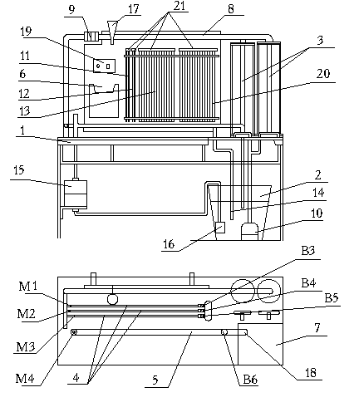

Figure 2.1. Stand scheme "Hydrodynamics"

1 - table;

2 - tank;

3 - flowmeters;

4 - power modules M1, M2, M3;

5 - module M4;

6 - shield piezometers;

7 - Panel;

8 - pressure line;

9 - dimensional aperture;

10 - Pump H1;

11-13 and 20 groups of piezometers;

14 - the drain hose;

15 - expansion tank;

16 - Pump H2;

17 - funnel;

18 - drain nipple;

19 - Control Panel;

21 - collectors;

B3-B6 - valves.

Under the table 1 is 2 supply tanks to fill with water. In tank 2 shipped water pump 10 and drain line 18.

On the table 1 are fixed two flow meter 3, the top flanges through which pipelines are brought to the pressure line 8 , which is mounted dimensional aperture 9. Flow meters lower flanges 3 through pipe fittings summed up to the pump 10. Gates V1i B2 installed before rotameters (not pictured shown). The pressure is brought to 8 backbone unit modules 4. Unit modules 4 consist of three test modules that constitute flow channels of different configurations:

M1 - module "Building chart Bernoulli equation ";

M2 - module «Pressure loss at sudden axisymmetric expansion pipe»;

M3 - module « pressure loss along the pipe. »

Modules M1, M2, M3 pezometrirovany calculated in sections. This cross section through a nozzle connected by flexible tubes with groups pezometres12, 13 and 20. Inputs three modules share a common collector. Outlet manifold block valves modules through B3, B4; B5 is fed to the drain hose 14.

M4 module (item 5) is designed to study the change of flow regimes. Login module M4 via the expansion tank 15 is connected to a flexible hose to the pump H2 (pos.16). Fitting this module is connected by a flexible tube with a funnel 17, filled with colored liquid. Output of the module through the valve V6 is fed to the drain fitting 18, which is put on the hose to drain water during operation.

On the rear rack attached table 1 piezometers shield 6. Piezometers located on the shield panel 19 , four groups of 11 piezometers (from the diaphragm), 12(M3), 13(M1) and 20(M2), a tripod with a funnel 17 and pocket for reference. On the control panel 19 is a network switch and network lamp indication.

Each of the four groups 11-13 and piezometers 20 composed of transparent tubes, the upper ends of which are joined together for each group of common manifold 21. Withdraw into the manifold tube for equalizing pressure across the diaphragm 9, and measuring each of the three modules. The lower ends of the piezometric tubes connected to the diaphragm fittings and power modules 4 .

* 1. PREPARING TO WORK BENCH

1. Open the valves B3, B4 and B5 of modules M1, M2, M3.

2. Open the valves B1 and B2 to rotameters (not shown in Figure 2.1).

3. Turn on the pump and fill the system H1 water.

4. Remove air from the modules and measuring diaphragm 9.

5. Opening clips manifolds 21, to remove air from piezometers.

6. Close clamps collectors.

7. Close valves B3 - B5, turn off the pump.

8. Set with clamp collector aperture dimensional water level in the piezometers before and after about the middle of the aperture scale piezometric shield.

9. For a particular module by an appropriate clamp manifold set water level in the piezometers connected with the test unit, as follows: the module M1 - at 2 /3 of the span; for modules M2 and M3 - in the middle of the scale.

**2.4. LABORATORY WORK**

**2.4.1. Diagramming the Bernoulli equation**

**Laboratory work № 2.4.1**

**Objective:**

- Study of the energy characteristics of the steady flow of a viscous incompressible fluid in a circular tube of variable cross-section;

- A graphical illustration of the Bernoulli equation, the construction of piezometric line and total pressure (energy lines) .

**Brief description of module M1**.

Calculated modulus plot represents the Venturi Pipe. Formed part of the tube is schematically shown in Figure 2.2. Settlement plot piezometred: placed on the module output to the piezometric fitting shield with an arbitrary reference plane . Work is carried out at two successively established flow: Q0 and 0.5Q0, The working flow is determined by the testimony of one or two flowmeters, parallel to the pressure line, and on the testimony of measuring diaphragm.

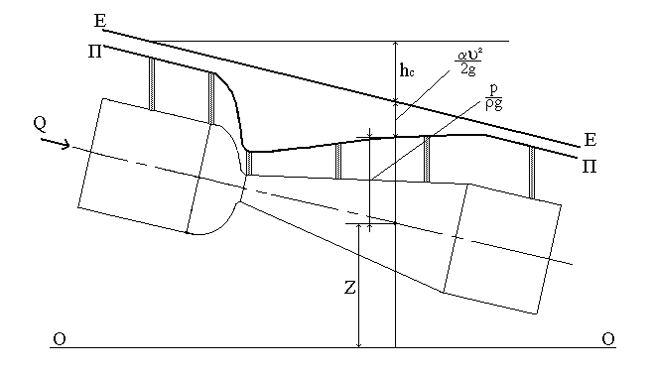

**Figure 2.2.** Scheme of Venturi pipe

**The order of execution of work.**

1. Stand Prepare to work in accordance with Section 3.

2. Enable pump H1, open valves B1 and B2 .

3. Open valve B3 module M1.

4. Install using gates B1 and B2 as an expense to the piezometer readings in the lowest section of the pipe were close to the bottom of the scale piezometric shield; measure the volumetric flow rate ******.

5. Measure the piezometric pressure  in the pipe sections where withdrawn mouth piezometers.

6. Decrease by a valve B3 water consumption by half and repeat the measurements.

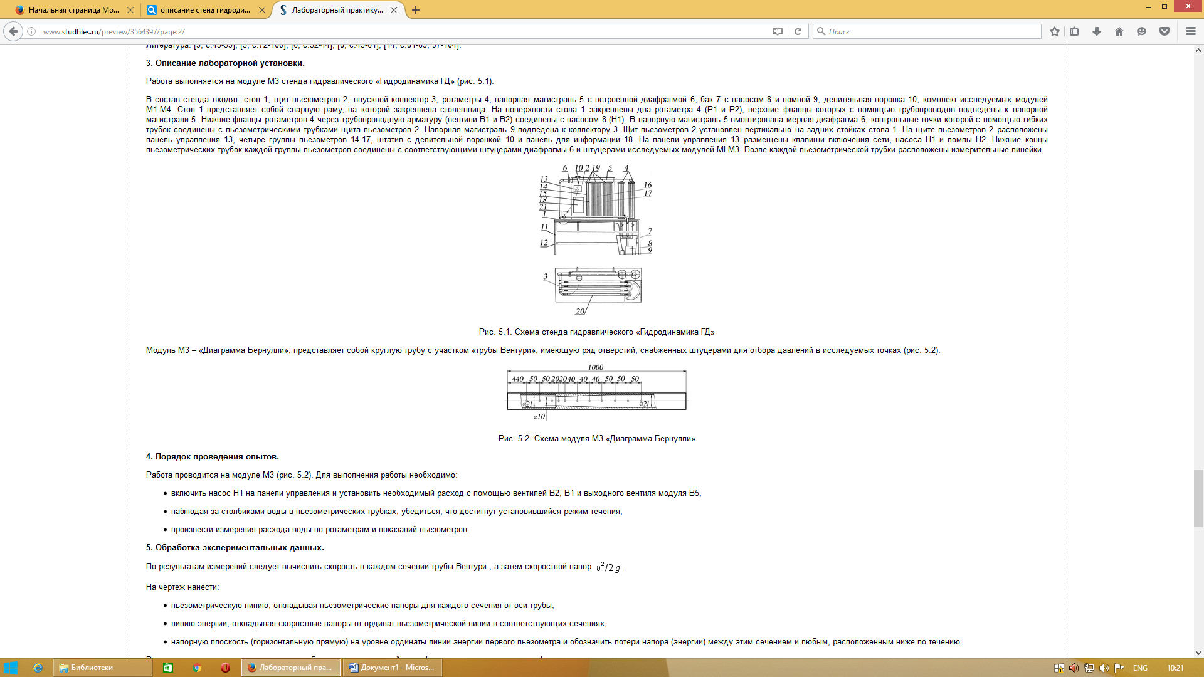

**Figure 2.3.**

**Processing the results of experiments.**

1. The known cross-sectional size pipes and water flow measurements to calculate the velocity pressure  in the stream sections in which measured piezometric pressure.

2. Calculate the hydrodynamic pressure****** in the same cross sections.

3. Calculate hс pressure loss between the first and all subsequent sections of the pipe.

4 . According to the results of measurements and calculations piezometrical build line PP and energy line E-E.

5 . Repeat all calculations when other water flows in the pipe.

**Tables for results of experiments**

**Experimental data and results of computation**

Table 2.1

|  |  |  |  |  |  |  |  |  |  |  |  |  |  |  |  |  |
| --- | --- | --- | --- | --- | --- | --- | --- | --- | --- | --- | --- | --- | --- | --- | --- | --- |
| № | Units | Cross sectional of the pipe | | | | | | | | | | | | | | |
| 1 | 2 | 3 | 4 | | 5 | 6 | 7 | | 8 | 9 | 10 | | 11 | 12 |
| 1 | Diameter of tube's crossection,, м |  |  |  |  | |  |  |  | |  |  |  | |  |  |
| 2 | Area of tube's crossection, |  |  |  |  | |  |  |  | |  |  |  | |  |  |
| 3 | Volume of the measuring flask, V, |  | | | | | | | | | | | | | | |
| 4 | Time of filling the water of the volumetric flask, t, s | t1, с | | | | t2, с | | | | t3, с | | | | tср, с | | |
| 5 | Flow rate |  | | | | | | | | | | | | | | |
| 6 | Avarege velocity |  |  |  |  | |  |  |  | |  |  |  | |  |  |
| 8 | piezometric pressure, |  |  |  |  | |  |  |  | |  |  |  | |  |  |
| 9 | Velocity pressure , *м* |  |  |  |  | |  |  |  | |  |  |  | |  |  |
| 10 | Hydrodynamic pressure , *м* |  |  |  |  | |  |  |  | |  |  |  | |  |  |

**Control questions:**

1. The installation of laboratory stand

2. Flow rate: physical meaning; volume, weight и mass flow rates, methods, equipments and units of measure.

3. physical meaning of the geometric, piezometric, high-speed and full flow rates, the method of experimental determination.

4. appointment and physical meaning of the Bernoulli equation.

5. Pressure and piezometric line: appointment, the method of building

6. Physical meaning of hydraulic and piezometric deviations.

**Laboratory work № 2.4.2.**

**Pressure loss at sudden axisymmetric expansion of pipe**

**Purposes:**

* Research losses at the local hydraulic resistance - sudden expansion pipe ;
* Experimental determination of the sudden expansion coefficient ζse;
* Establishment of the dependence of the sudden expansion of the Reynolds number ζse = *f (Re);*
* Comparison of experimental values ζse with its theoretical value for the quadratic zone.

**Brief description of module M2.**

The module consists of two concentric pipes of different diameters (Figure 2.4). The sharp change in the diameter of the pipeline is local resistance (sudden expansion), the hydraulic resistance coefficient is determined in the work. Local resistance sufficiently far from the entrance to the module so that the flow to the sudden expansion of the uniform. On the current site - to local resistance and after – pipeline is piezometred.

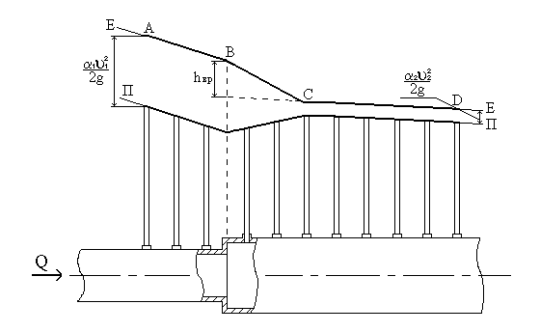

**Figure 2.4.** Scheme axisymmetric sudden expansion

Change in flow produced valve B4 and its measurement - flow measuring and measuring diaphragm.

**The order of execution of work.**

1. Prepare the stand to work in accordance with Section 3 .

2 . Switch on the pump H1, open valves B1 and B2 , and B4.

3 . Set the maximum flow rate, measure it.

4 . Measure Piezometric pressure in all piezometers.

5. Repeat the measurements at 4 - 5 lower rates.

6. Measure the temperature of the water; determine the schedule of kinematic viscosity coefficient.

**Processing the results of experiments.**

1. For each flow build piezometric line (line II-II in Figure 2.4).

2. Determine for each flow average velocity values in both pipes and the corresponding velocity pressure  and  taking *α1=α2=1.1.*

3. Construct for each test line energy (line E-E in Figure2.4). On the segment AB to the local slope of the resistance is determined by the energy pressure loss along the length of the tube in a smaller diameter at the site CD - pressure loss in the pipe of larger diameter, so the angle of inclination to the horizontal line AB is greater than the angle of inclination of the CD. BC portion corresponds to the portion of the local resistance. At this site constrained circulating transit flow area, and live sections, and hence the rate is unknown. Therefore, on a plot line BC energy can be made only expectation.

4. Select the graphs on the pressure loss *hse* sudden expansion, extending the dotted line to line CD section with an abrupt change in diameter of the pipe.

5. Each experiment to determine the coefficient of the local resistance of the formula (2.4):



and calculate the Reynolds number .

6. Construct the experimental data graph , noting it quadratic resistance zone.

7. Calculate and note on the chart  theoretical value of the coefficient of hydraulic resistance to the sudden expansion of the flow for the quadratic zone:

 ,

where S1 and S2 - sectional area of the pipe, smaller and larger diameter ditch.

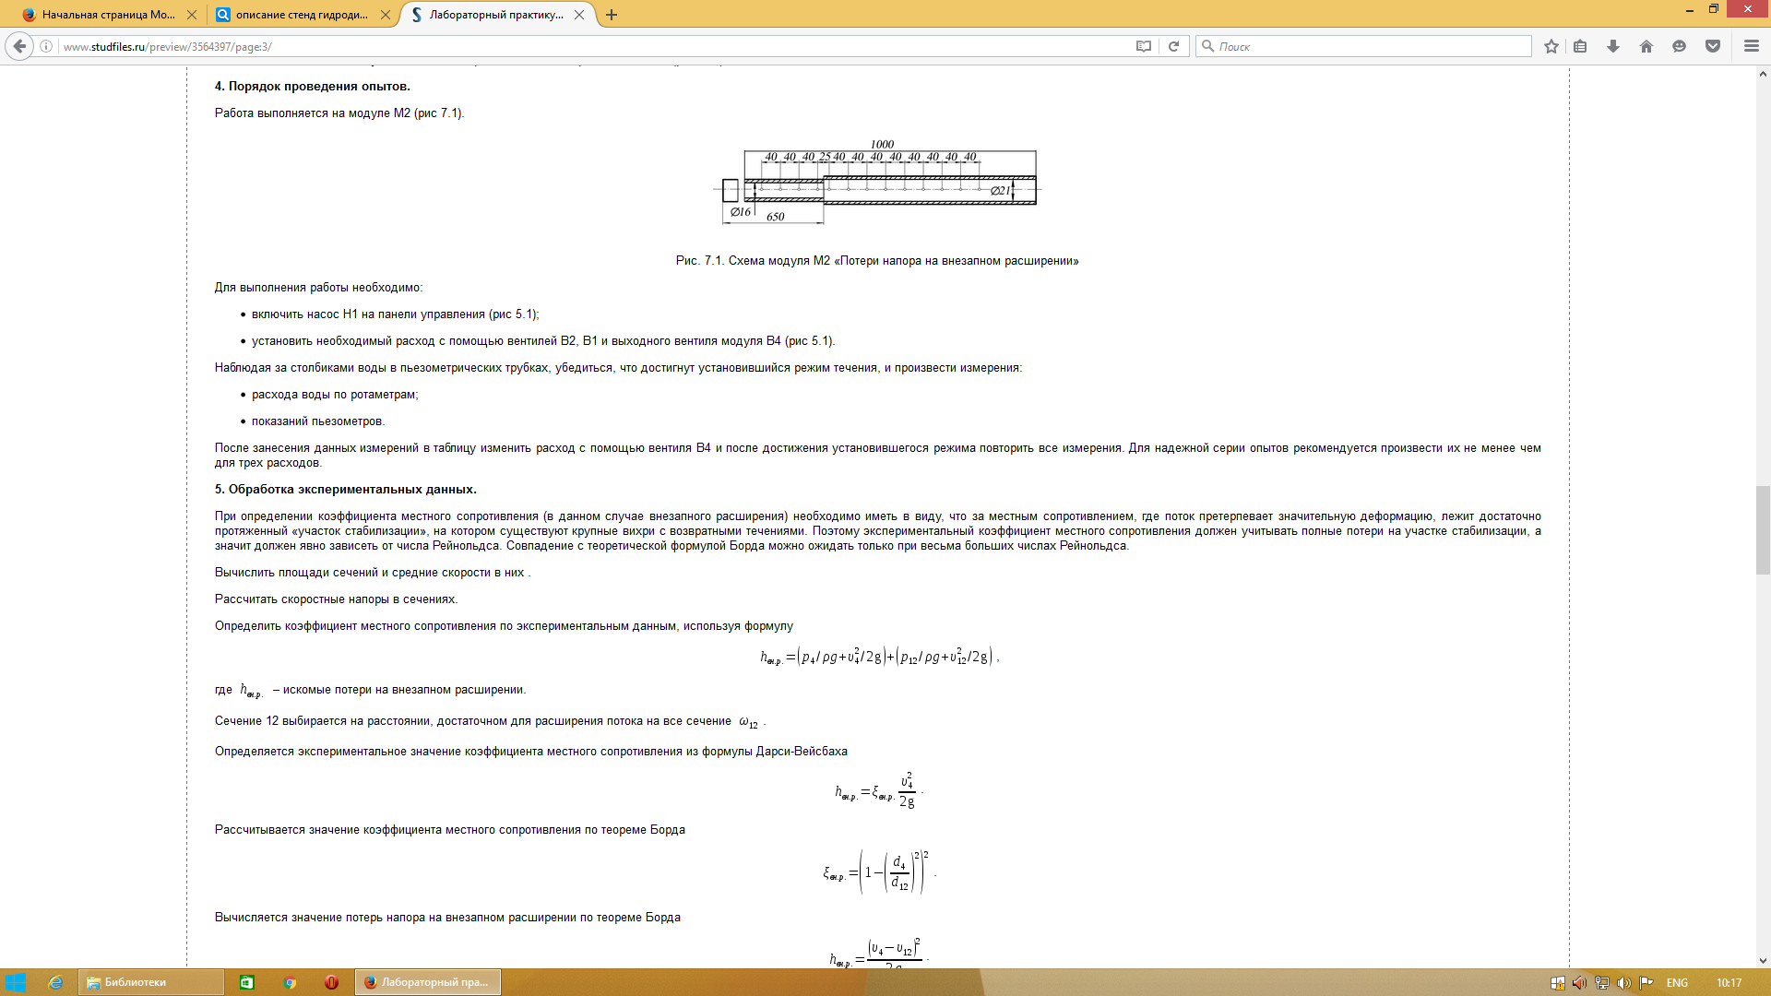

**Figure 2.5.**

**Tables for results of experiments**

**Experimental data and results of computation**

*Table 2.2*

|  |  |  |  |  |  |  |  |  |  |  |  |  |  |  |  |  |
| --- | --- | --- | --- | --- | --- | --- | --- | --- | --- | --- | --- | --- | --- | --- | --- | --- |
| № | Units | Cross sectional of the pipe | | | | | | | | | | | | | | |
| 1 | 2 | 3 | 4 | | 5 | 6 | 7 | | 8 | 9 | 10 | | 11 | 12 |
| 1 | Diameter of tube's cross section,, м |  |  |  |  | |  |  |  | |  |  |  | |  |  |
| 2 | Area of tube's cross section, |  |  |  |  | |  |  |  | |  |  |  | |  |  |
| 3 | Volume of the measuring flask, V, |  | | | | | | | | | | | | | | |
| 4 | Time of filling the water of the volumetric flask, t, s | t1, с | | | | t2, с | | | | t3, с | | | | tср, с | | |
| 5 | Flow rate |  | | | | | | | | | | | | | | |
| 6 | Average velocity |  |  |  |  | |  |  |  | |  |  |  | |  |  |
| 7 | Piezometric indication |  |  |  |  | |  |  |  | |  |  |  | |  |  |
| 8 | Reynolds number |  | | | | | | | | | | | | | | |
| 9 | The loss of the pressure at sudden expansion |  | | | | | | | | | | | | | | |
| 10 | Coefficient of the local resistance |  | | | | | | | | | | | | | | |
| 11 | Coefficient of the local resistance |  | | | | | | | | | | | | | | |

**Control questions:**

1 Give a definition of a local resistance.

1. Name the main species of local resistance.

2 Explain the reasons for the loss of pressure in local resistance.

3 What is the procedure for the experimental determination of ?

5 What factors affect the value  for laminar and turbulent flow regimes

**Laboratory work № 2.4.3.**

**PRESSURE LOSSES ON PIPE LENGTH**

**Purposes:**

- Experimental determination of the hydraulic friction coefficient values for different modes; plotted λ (Re).

- To establish the relationship of pressure loss along the length of the flow velocity ; determine empirical coefficients of this dependence.

- Find the equivalent roughness Δe of pipeline.

**Brief description of module M3.**

On a constant-diameter pipe at the beginning and end of the billing portion of length L are two piezometer (Figure 2.6.). First downstream piezometer located at such a distance from the entrance to the module, which has already become a uniform flow. Regulation of fluid flow and its measurement is the same number as in the works of number 2, 3, i.e., valves at the outlet of the pump H1 and rotameter.

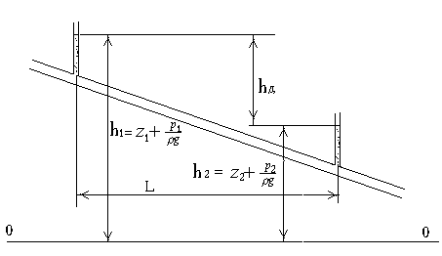

Figure 2.6. The pipeline scheme for measurement of losses of a pressure on length

**The order of execution of work.**

1. Prepare the stand to work in accordance with Section 2.2.

2. Switch on pump H1 , open valves B1, B2 and B5.

3. Set the maximum flow, measure it.

4. Measure the piezometric pressure in the beginning and end of the working area.

5. Repeat measurements at 12 - 15 lower cost.

6. Measure the temperature of the water; determine the schedule of kinematic viscosity coefficient.

**Processing the results of experiments.**

From the Bernoulli equation (2.1) it follows that for a horizontal pipe of constant diameter (Figure 2.7.) in the area of uniform motion is true: ; ; .

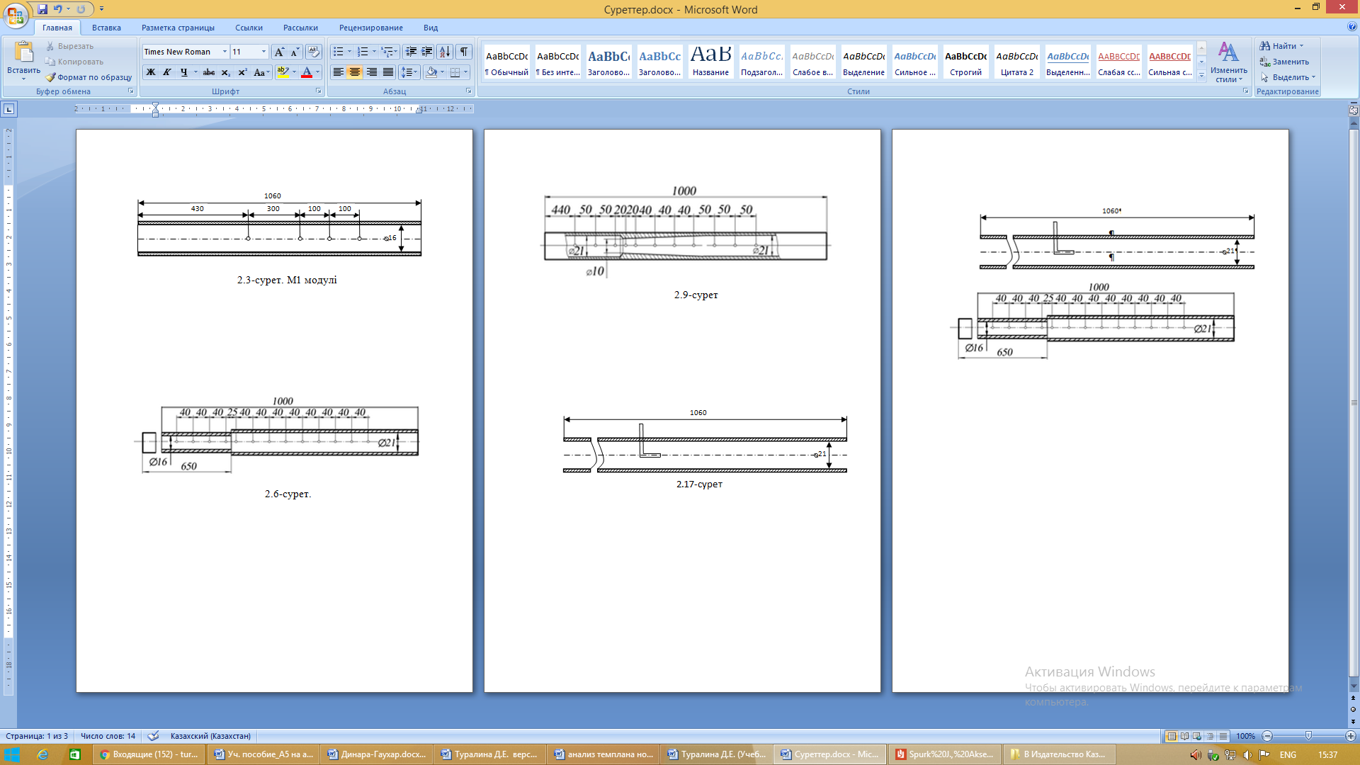

**Figure 2.7.**

2. Thus, the total loss of pressure losses are determined by the length . Then

*.*

Given that, depending on the type of flow regime empirical formulas for hydraulic friction coefficient is different (see 2.7-2.10), the formula for the pressure losses along the length of (2.3) can be represented in general form :  or

 (2.11)

Equation (2.11) represents a straight line on the graph in the coordinates - . Processing the experimental results it is necessary to perform the following sequence:

1. Each experiment to determine the losses by length.

2. Using equation (2.3), find the values of the hydraulic friction coefficient:

.

3. Plot the (), approximating the set of experimental points by straight lines. Select the border zones of resistance.

4. To determine the zone of the quadratic formula (2.9) equivalent to the roughness value:

*Δэ = (λ/0.11)4 d.*

**Tables for results of experiments**

**Experimental data and results of computation**

*Table 2.3.*

|  |  |  |  |  |  |
| --- | --- | --- | --- | --- | --- |
| 1 | Diameter of tube's cross section,, м |  | | | |
| 2 | Area of tube's cross section, |  | | | |
| 3 | Volume of the measuring flask, V, |  | | | |
| 4 | Time of filling the water of the volumetric flask, t, s | t1, с | t2, с | t3, с | tср, с |
| 5 | Flow rate |  | | | |
| 6 | Distance between two sections,  *L , м.* |  | | | |

**Результаты расчета**

*Table 2.4.*

|  |  |  |  |  |  |  |  |
| --- | --- | --- | --- | --- | --- | --- | --- |
| №  Number | Flow rate , | Piezometric indication | | The loss of the pressure | Average velocity | Coefficient of hydraulic friction | Reynolds number |
|  |  |
| 1 |  |  | |  |  |  |  |
| 2 |  |  | |  |  |  |  |
| 3 |  |  | |  |  |  |  |
| 4 |  |  | |  |  |  |  |
| 5 |  |  | |  |  |  |  |

**Control questions:**

1. Installation of the laboratory stand.

2. How to determine the pressure drop along the length of the pipeline?

3. Method of experimental determination of the coefficient of hydraulic friction.

4. Method of computational determination of the coefficient of hydraulic friction.

5. What factors affect the amount of frictional losses along the length of the pipeline?

6. What is hydraulically smooth and hydraulically rough pipes?

**Laboratory work № 2.3.4.**

**RESEARCHING THE CHANGES OF FLOW REGIMES**

**Purposes:**

- Read the laminar and turbulent flow regimes fluid, study the transition from one mode to another;

- Determine the appropriate Reynolds number and the critical Reynolds number.

**Brief description of module M4.**

The module is a constant-diameter pipe (Figure 2.8.), made of transparent material. A pump for liquid H2 16 (see Figure 2.1), supplying fluid through restful tank connected to the module. Flow regime installed by valve V6. At the input to the small-diameter pipe is installed, connected with the tank 17 filled with the tinted liquid.

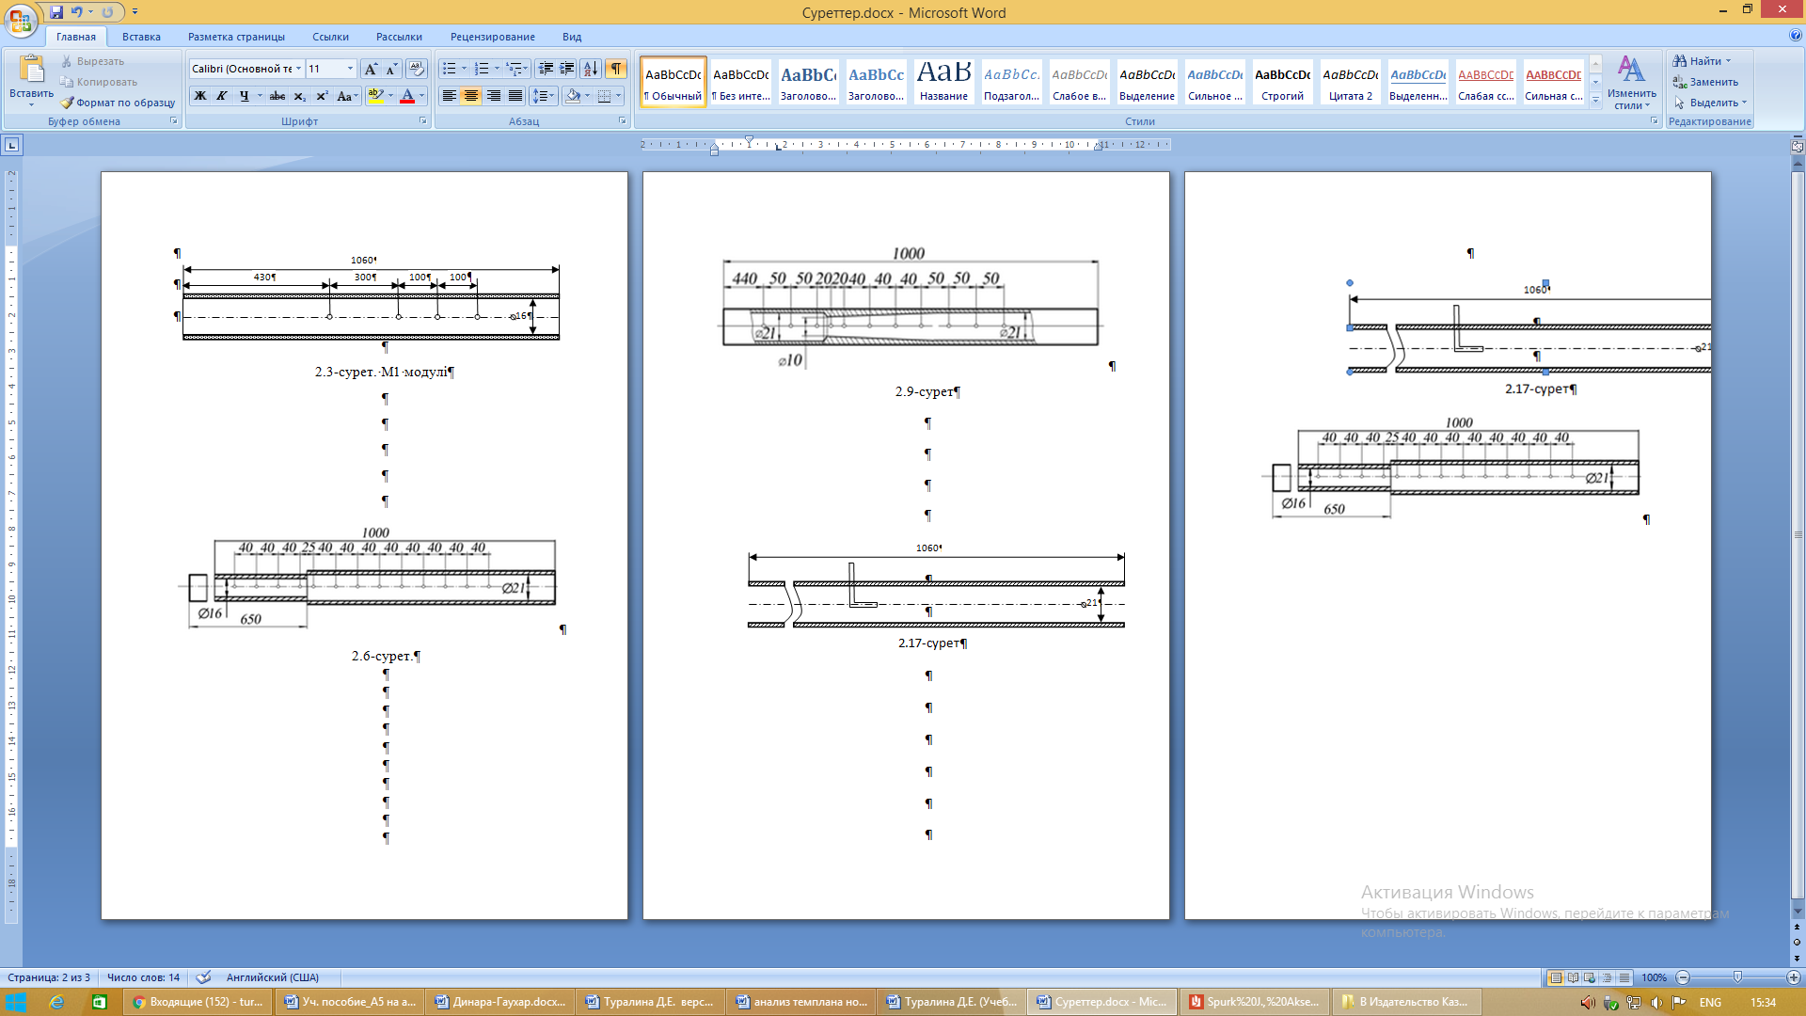

Figure 2.8.

**The order of execution of work and processing of the experimental results.**

1. Switch on the pump H1.

2. Install by B6 valve low flow rate of the liquid.

3. Open the valve at the inlet of the module and let tinted liquid.

4. Set by the valve B6 laminar regime. The evaluation of the current behavior is performed visually by the tinted liquid to trickle flow.

5. Measure liquid flow by gravimetric or volumetric method.

6. Gradually increasing valve opening B6, note any change in the laminar to turbulent; measure flow rate.

7. Set the turbulent flow in a pipe, the valve is fully open ; measure fuel .

8. Reducing valve opening, to fix the time of transition to turbulent flow is laminar; measure flow rate.

9. Measure the temperature of the liquid in the tank; determine the value of the kinematic viscosity coefficient.

10 . Each of the four regimes (laminar , transition from laminar to turbulent , and the transition from turbulent to laminar, turbulent ) calculated from the known diameter of the pipe average flow velocity and the Reynolds number according to the formula(2.5); compare the results for the critical Reynolds number with the literature data.

11. For all cases, plot the structure of flow.

**Tables for results of experiments**

**Experimental data and results of computation**

*Table 2.5*

|  |  |  |  |  |  |
| --- | --- | --- | --- | --- | --- |
| 1 | Diameter of tube's cross section,, м |  | | | |
| 2 | Area of tube's cross section, |  | | | |
| 3 | Volume of the measuring flask, V, |  | | | |
| 4 | Time of filling the water of the volumetric flask, t, s | t1, с | t2, с | t3, с | tср, с |
| 5 | Flow rate |  | | | |

**Результаты расчета**

*Table 2.6*

|  |  |  |  |  |
| --- | --- | --- | --- | --- |
| №  Номер опыта | Flow rate  , | Average velocity | Reynolds number | Visual structure of the fluid |
| 1 |  |  |  |  |
| 2 |  |  |  |  |
| 3 |  |  |  |  |

**Контрольные вопросы:**

1. Flow rate: physical meaning; volume, weight и mass flow rates, methods, equipments and units of measure.

2. Modes of fluid flow and gases.

3. Necessity of determining the flow regime.

4. The procedure for determining flow regimes

5. Critical Reynolds number.

6. Causes of changing the regime of fluid flow.

***APPLICATIONS***

**APPLICATION 1**

**Form of tables for record the results of experiments**

Designation:

*,*  – fluid levels in *P1* before and after the establishment of the regime; ;

, – levels in the unknown liquid left and right tubes *P2*; ;

, , – densities of the working fluid in the tank, the liquid in the battery manometers *P3* and an unknown liquid, espectively;

*,* – absolute pressure in the tank, the gauge (vacuum-gauge);

**-** liquid level in the tube left the i-th knee;

**-** liquid level in the tube on the right the i-th knee;

 – drop fluid in the i-th knee.

Indexes:

*i* – number of knee pressure-vacuum gage battery;

(before) – the initial liquid level in the respective tube at atmospheric pressure under the cover of the tank;

(after) – the level of liquid in the tube after the establishment of appropriate under the tank cover a desired mode.

*Table 1.1.*

*Table 1.2.*

*NB!*

*When using pressure-vacuum gage battery occurs following difficulty: the fluid levels in the left and right knees tubes are not in equilibrium , forming a difference ( positive or negative) . This is due to the emergence of a vacuum or positive pressure in the space between the knees . Since before the establishment of the regime pressure above the free surface in the left tube extreme left knee and right fielder right knee tube atmospheric , the total drop in all the tribes of zero. Therefore, the calculation of pressure can be made to the emerging differences (Formula 1) or without ( Formula 2) . The result in both cases is the same. This experience confirms done (see Table 2).*

 *(1)*

  *(2)*

*Table 1.3.*

*Table 1.4.*

APPLICATION 3.

|  |  |  |  |  |  |
| --- | --- | --- | --- | --- | --- |
| Зависимость плотности воды от температуры | | | | | |
| The dependence of water density on temperature | | | | | |
| Temperature, | density, | Temperature, | density, | Temperature, | density, |
| 0 | 999,87 | 57 | 984,75 | 79 | 972,45 |
| 4 | 1000 | 58 | 984,25 | 80 | 972,83 |
| 10 | 999,73 | 59 | 983,75 | 81 | 971,23 |
| 20 | 998,23 | 60 | 983,24 | 82 | 970,57 |
| 30 | 995,67 | 61 | 982,72 | 83 | 969,94 |
| 40 | 992,24 | 62 | 982,20 | 84 | 969,30 |
| 41 | 991,86 | 63 | 981,67 | 85 | 968,65 |
| 42 | 991,47 | 64 | 981,13 | 86 | 968,00 |
| 43 | 991,07 | 65 | 980,59 | 87 | 967,24 |
| 44 | 990,66 | 66 | 980,05 | 88 | 966,68 |
| 45 | 990,25 | 67 | 979,50 | 89 | 966,01 |
| 46 | 989,82 | 68 | 978,94 | 90 | 965,34 |
| 47 | 989,40 | 69 | 978,38 | 91 | 964,67 |
| 48 | 988,96 | 70 | 977,81 | 92 | 963,99 |
| 49 | 988,52 | 71 | 977,23 | 93 | 963,30 |
| 50 | 988,07 | 72 | 976,66 | 94 | 962,61 |
| 51 | 987,62 | 73 | 976,07 | 95 | 961,92 |
| 52 | 987,15 | 74 | 975,48 | 96 | 961,22 |
| 53 | 986,69 | 75 | 974,89 | 97 | 960,51 |
| 54 | 986,21 | 76 | 974,29 | 98 | 959,81 |
| 55 | 985,73 | 77 | 973,68 | 99 | 959,09 |
| 56 | 985,25 | 78 | 973,07 |  |  |

APPLICATION 4.

|  |  |  |
| --- | --- | --- |
| Зависимость коэффициента вязкости воды от температуры | | |
| Dependence of water viscosity coefficient on temperature | | |
| Temperature, |  |  |
| 0 | 1,792 | 1,792 |
| 5 | 1,519 | 1,519 |
| 10 | 1,308 | 1,308 |
| 15 | 1,140 | 1,141 |
| 20 | 1,005 | 1,007 |
| 25 | 0,894 | 0,897 |
| 30 | 0,801 | 0,804 |
| 35 | 0,723 | 0,727 |
| 40 | 0,656 | 0,661 |
| 45 | 0,599 | 0,605 |
| 50 | 0,549 | 0,556 |
| 60 | 0,469 | 0,477 |
| 70 | 0,406 | 0,415 |
| 80 | 0,357 | 0,367 |
| 90 | 0,317 | 0,328 |
| 100 | 0,284 | 0,296 |

Where

- is the dynamic coefficient of viscosity;

- is the kinematic coefficient of viscosity;

.

**References**

**The main books**

1. Седов Л.И. Методы подобия и размерности в механике. - М.: Наука, 1972.– 430с.
2. Горлин С.М., Слезингер И.И. Аэромеханические измерения.- М.: Наука, 1964. - 423с.

3. Горлин С.М. Экспериментальная аэромеханика. -М.: Высшая школа, 1970. - 423 с

4. Преображенский В.П. Теплотехнические измерения и приборы. М.- Л.: Госэнергоиздат, 1978г.

5. Руководство к лабораторным работам по аэрогазо- динамике: Уч.пособие / Белова А.В., и др.-СПб: Изд-во С.-Петерб. Ун-та, 2004.- 344 с.

6. Туралина Д.Е.. Тәжірибелік аэромеханика бойынша зертханалық жұмыстар.- Алматы: «Қазақ университеті». 2011.-86с.

7. Cameron Tropea, Alexander L.Yarin, John F.Foss. Springer Handbook of Experimental Fluid Mechanics. Springer-Verlag Berlin-Heidelberg. 2007-

8. Қалтаев А., Бекбауов Б.Е., Алибаева Қ.А. Сұйық және газ механикасынан есептер жинағы: Оқу құралы. Алматы: Қазақ университеті, 2016.-178 бет.

9. Туралина Д.Е.. Сұйықтар мен газдар механикасы бойынша зертханалық жұмыстар Оқу -әдістемелік құралы-Алматы: Қазақ университеті, 2017.96 бет.

10. Туралина Д.Е. Тәжірибелік гидромеханика бойынша зертханалық жұмыстар (1бөлім) Оқу-әдістемелік құралы. Алматы: Қазақ университеті, 2017. 88 бет.

**Additional books**

1. Лойцянский Л.Г. Механика жидкости и газа: Учебник для вузов. 7-е изд. испр. - М.:Дрофа, 2003.-840с.

2. Фабер Т.Е. Гидроаэродинамика. - М.: Постмаркет. - 2011. -560 с.

3. Robert W. Fox, Alan T. McDonald, Philip J. Pritchad Introduction to Fluid Mechanics, International Student Version, 8th Edition.-USA: John Wiley&Sons Inc. 2011.- 896 p.

4. J. H. Spurk. Fluid mechanics. Problems and solutions. –Springer, 1997-600 p.

5. Лойцянский Л.Г. Механика жидкости и газа, М., Наука, 1987.-736с.

6. Кубышкина В.Д. Основные методы математической обработки результатов физического эксперимента (уч. пособие).-А-Ата, 1974г.

7. Прикладная аэродинамика (под. ред. Краснова Н.Ф.) - М.: Высшая школа, 1974г.

8. Механика. Общий физический практикум для студентов высших учебных заведений / С.И.Исатаев и др. Алматы.: Қазақ университеті, 2002.-207 с.

***Educational edition***

Laboratory works from fluid and gas mechanics

***Оқу құралы***

***D.E.Turalina***

Almaty

«Kazakh university»

2017

1. * 1)Laboratory work № 1.3.3 can be performed without a of work № 1.3.1 In this case, the calculated values of the additional force of pressure on the wall is determined by indications a mechanical device MB1.