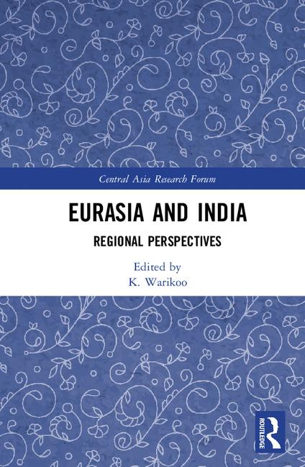

Eurasia and India
Eurasia has assumed importance in the post-Soviet period and the peoples of Siberia have distinctive historico-cultural similarities with the Indian Himalayas due to common traditions and Buddhist culture. The Eurasianism of Russia brings it closer to India in historico-cultural, political and economic terms. Another important player in Eurasia is Kazakhstan, which has been highlighting the importance of Eurasianism. These relations provide an opportunity for India to engage in collaborative endeavours with the Eurasian countries.
This book provides detailed analyses on the historico-cultural linkages between Eurasia (Buryatia, Khakassia ,Tuva and Altai Republics of Russian Federation) and India through history. It also examines the process of the revival of indigenous traditions in the region in the post-Soviet period, the importance of the Eurasian vector in Russian and Kazakhstan's foreign policy and the development of the Eurasian Economic Union and the implications this will have for India. Eminent academics and area specialists from Buryatia, Altai, Khakassia, Moscow, Kazakhstan and India have contributed to this book which provides a first hand view of the linkages between India and the Siberian region of India. Eurasia and India also includes rare photographs of the traces of Indian culture in Siberia.
Offering a new understanding of the significant and strategic Indian ties to Eurasian states, this book will be of interest to academics studying Eurasian and Central Asian society and geopolitics, International Relations and South and Central Asian Studies.
FORMAT
Hardcover
CONDITION
Brand New

Author Biography
Dr. K. Warikoo is Professor at the Centre for Inner Asian Studies, School of International Studies, Jawaharlal Nehru University, New Delhi. Author of several books on Kashmir, Central Asia and Afghanistan, he is the founding Editor of Himalayan and Central Asian Studies, which was first published in 1997. His books Xinjiang: China's North West Frontier (2016); Religion and Security in South and Central Asia (2011); Himalayan Frontiers of India (2009) were also published by Routledge.

Table of Contents
1. Introduction, Devendra Kaushik
2. Historical and Cultural Role of Indian Mitra & Maitreya Cults in the Uniting Process of Eurasia, Sergey Lepekhov
3. The Vedic Constants of Historical and Cultural Kinship of the Peoples of Siberia and India, I.A. Zhernosenko
4. Eurasia and India: Historical-Cultural Linkages, K. Warikoo
5. Cultural links of Southern Siberia and India: Fine Arts and Music, M. V. Dorina
6. Indian Buddhist Heritage in Central Asia and Eurasia, Baatr U. Kitinov
7. Nikolai Roerich and Eurasia: The Ambivalent Horizon Line, Rashmi Doraiswamy
8. Shamanism in Central Asia, V. N. Tuguzhekova
9. Eurasian Factor in Russian Foreign Policy: Implications for India, Tatiana Shaumyan
10. Eurasian Vector of Kazakhstan's Policy: Relevance for India, Fatima Kukeyeva
11. Eurasianism and Kazakhstan's Foreign Policy, Angira Sen Sarma
12. International Transport Corridors of Eurasia: History, Problems and Perspectives, M. Baldano
13. Eurasian Regional Economic Cooperation: Opportunities and Challenges, Gatikrushna Mahanta

Details
ISBN1138048003
Year 2017
ISBN-10 1138048003
ISBN-13 9781138048003
Format Hardcover
Series Central Asia Research Forum
Imprint Routledge
Subtitle Regional Perspectives
Place of Publication London
Country of Publication United Kingdom
Edited by K. Warikoo
Publisher Taylor & Francis Ltd
DEWEY 327.54058
Affiliation Jawaharlal Nehru University, India
Pages 174
Illustrations 21 Halftones, black and white; 21 Illustrations, black and white
Publication Date 2017-09-18
Dimensions160mm x 241mm

