Rakhimzhanova Lyazzat, Khakimova Tiyshtik
al-Farabi Kazakh National university
RESEARCH METHOD IN PROJECT-ORIENTED TRAINING

Abstract. The article deals with the application of the research method in project-oriented learning in the course "Object-Oriented Programming". For a student, a project is an opportunity to maximize the disclosure of one's creative potential, a means of self-realization. This is an activity that allows you to express yourself individually or in a group, try your strengths, apply your knowledge, benefit, show a publicly achieved result. For the teacher, the educational project is an integrative didactic means of development, education and upbringing, which allows to students develop specific skills and project activities, as well as carry out joint information search, self-study, research and creative activities.

Increase of interest, activity of training, i.e. the effectiveness of training, the demand for our graduates in the labor market requires the study and application of increasingly new learning technologies. Modern methods, along with traditional methods, include research methods of teaching that promote the development of self-education, self-development, self-improvement and outside the university. The main result of the application of the research method in project-oriented learning is the suitability for the employment of graduates of the course.
The method of projects is a method of achieving a didactic goal through the detailed elaboration of a problem that ends with a real, tangible, practical result, drawn up in a certain way [1].
Education (training) is central place which can be approached from three different prisms of learning: science (empirical learning, see Figure 1), practice (practical training), individual (reflexive learning), a so-called didactic triangle is formed [2]. From the side of science, empirical training more stimulates a person to his own conclusions, rather than situations when he simply receives advice. On the part of practical training there is a division into the choice of the future profession, its demand on the labor market on the one hand and the civil responsibility of the society on the other are taken into account. From the individual's side, individualization and socialization are considered in training.
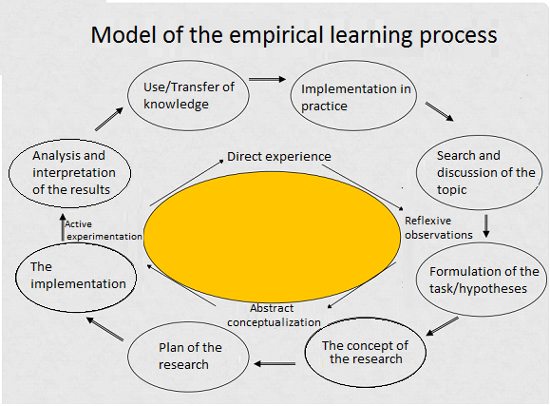
Figure 1. Model of empirical learning processes

Project-oriented training can be implemented in elective courses for technical specialties in different levels. The first is a problematic presentation of the project implementation process, in which the teacher constructs his message in the form of reproducing the logic of highlighting a problem from a given problem situation; Search, hypothesis advancement; their justification and verification, as well as evaluating the results. The second is the implementation of the project by students under the guidance of a teacher. The teacher can set the benchmarks for the implementation of the project chosen by the students in the form of generalized problematic issues related to significant moments, then each concrete action will be built by the student himself, but the general direction of his search will not be rigidly assigned. The third is the independent fulfillment by students of an educational research project. In this level, the research activity of the specialists of the profile under study is modeled to solve their professional problems.
Here is an example of a project in the course "Object-Oriented Programming" for the specialty "Computer Engineering". The project activity is typical for the sphere of the use of information technology. Therefore, the research method in the project-oriented learning of this course will make a significant contribution to the professional self-determination of students. The teacher poses the following problem: to create a small software product simulating a computational experiment of a plot, an "undelivered" task.
At the next stage of the organization of the project activity under the guidance of the teacher, the student plans the type of activity. The teacher explains that the plot tasks are built on the basis of real objects, processes, situations, etc. For example, playing chess, modeling traffic at a crossroads, playing basketball, moving fish in water or working the elevator, etc. And objects should be tied to input and output parameters. For example, the machine object (ready-made or drawn in the program drawing), which has a speed, depending on it, the machine moves to a certain state. It is necessary to compile such a program so that while developing a graphical interface on a computer screen you could change such variables. This clearly shows to the user of the program the process of the experiment itself, that is, how the output parameters change, and how the input parameters affects to them. Also, during the experiment, the parameters can be changed automatically step by step or in randomly set.
Students learn new types of educational activity, skills that are formed while studying the problem posed, which are general scientific and general intellectual in modern conditions. These include, in particular:
1. Search, collection, analysis, organization, presentation, transfer of information in open information society and the whole surrounding reality;
2. Projecting on the basis of information modeling of objects and processes;
3. The ability to solve fundamentally new problems, generated by the new informational approach introduced by informatics to the analysis of the surrounding reality.
4. The necessity of using the knowledge gained from other disciplines, i.e. interdisciplinary must necessarily be used while choosing a particular problem.
Experience shows that in most cases students experience difficulties in solving non-standard tasks in object-oriented programming (OOP). It can be explained by the absence of problematic situations associated with OOP, while developing a graphical user interface, the use of which does not allow students to gain sufficient experience in solving problem situations. Tasks and lab works on building a graphical user interface are not suitable for teaching students to the implementation of object decomposition in practice.
Therefore, in the process of training the PLO, it is recommended to use plot tasks, laboratory works and projects that will help to students in the formation of experience in solving problem situations in OOP, learning object decomposition and contributing to the development of sustainable cognitive motivation. The construction of graphical user interface should be considered as an addition to the training projects.
After the end of the project activity, feedback is necessarily needed. As a reflection, it is necessary to draw up a written report about the progress of work, which describes all the stages of the work.
The use of the research method in project-oriented learning in the course will allow to integrate the knowledge of students on various topics, to show their interrelation; To develop the creative talents of each student, as the student can choose the forms and methods of research and fix the results; Develop critical thinking , as well as skills in finding answers to questions and making decisions. In addition, project activities tend to be related to work in team and will contribute to the develop such important abilities as the ability to act together with other people, take into account the positions and interests of partners, enter into communication, understand and be understood by other people. These abilities are considered now as important components of educational results.
References
- Polat E.S. Project method in foreign language lessons / Foreign languages in school - № № 2, 3 - 2000 г.
- Bianca Roters, Ralf Schneider, Barbara Koch-Priewe, Jorg Thiele, Johannes Wildt (Hrsg.) Forschendes Lernen im Lehramtsstudium. Hochschuldidaktik Professionalisirung Kompetenzentwicklung. 2009. 296 Seiten.

