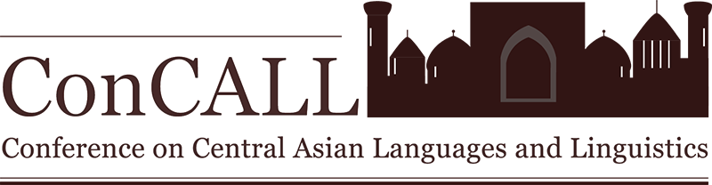
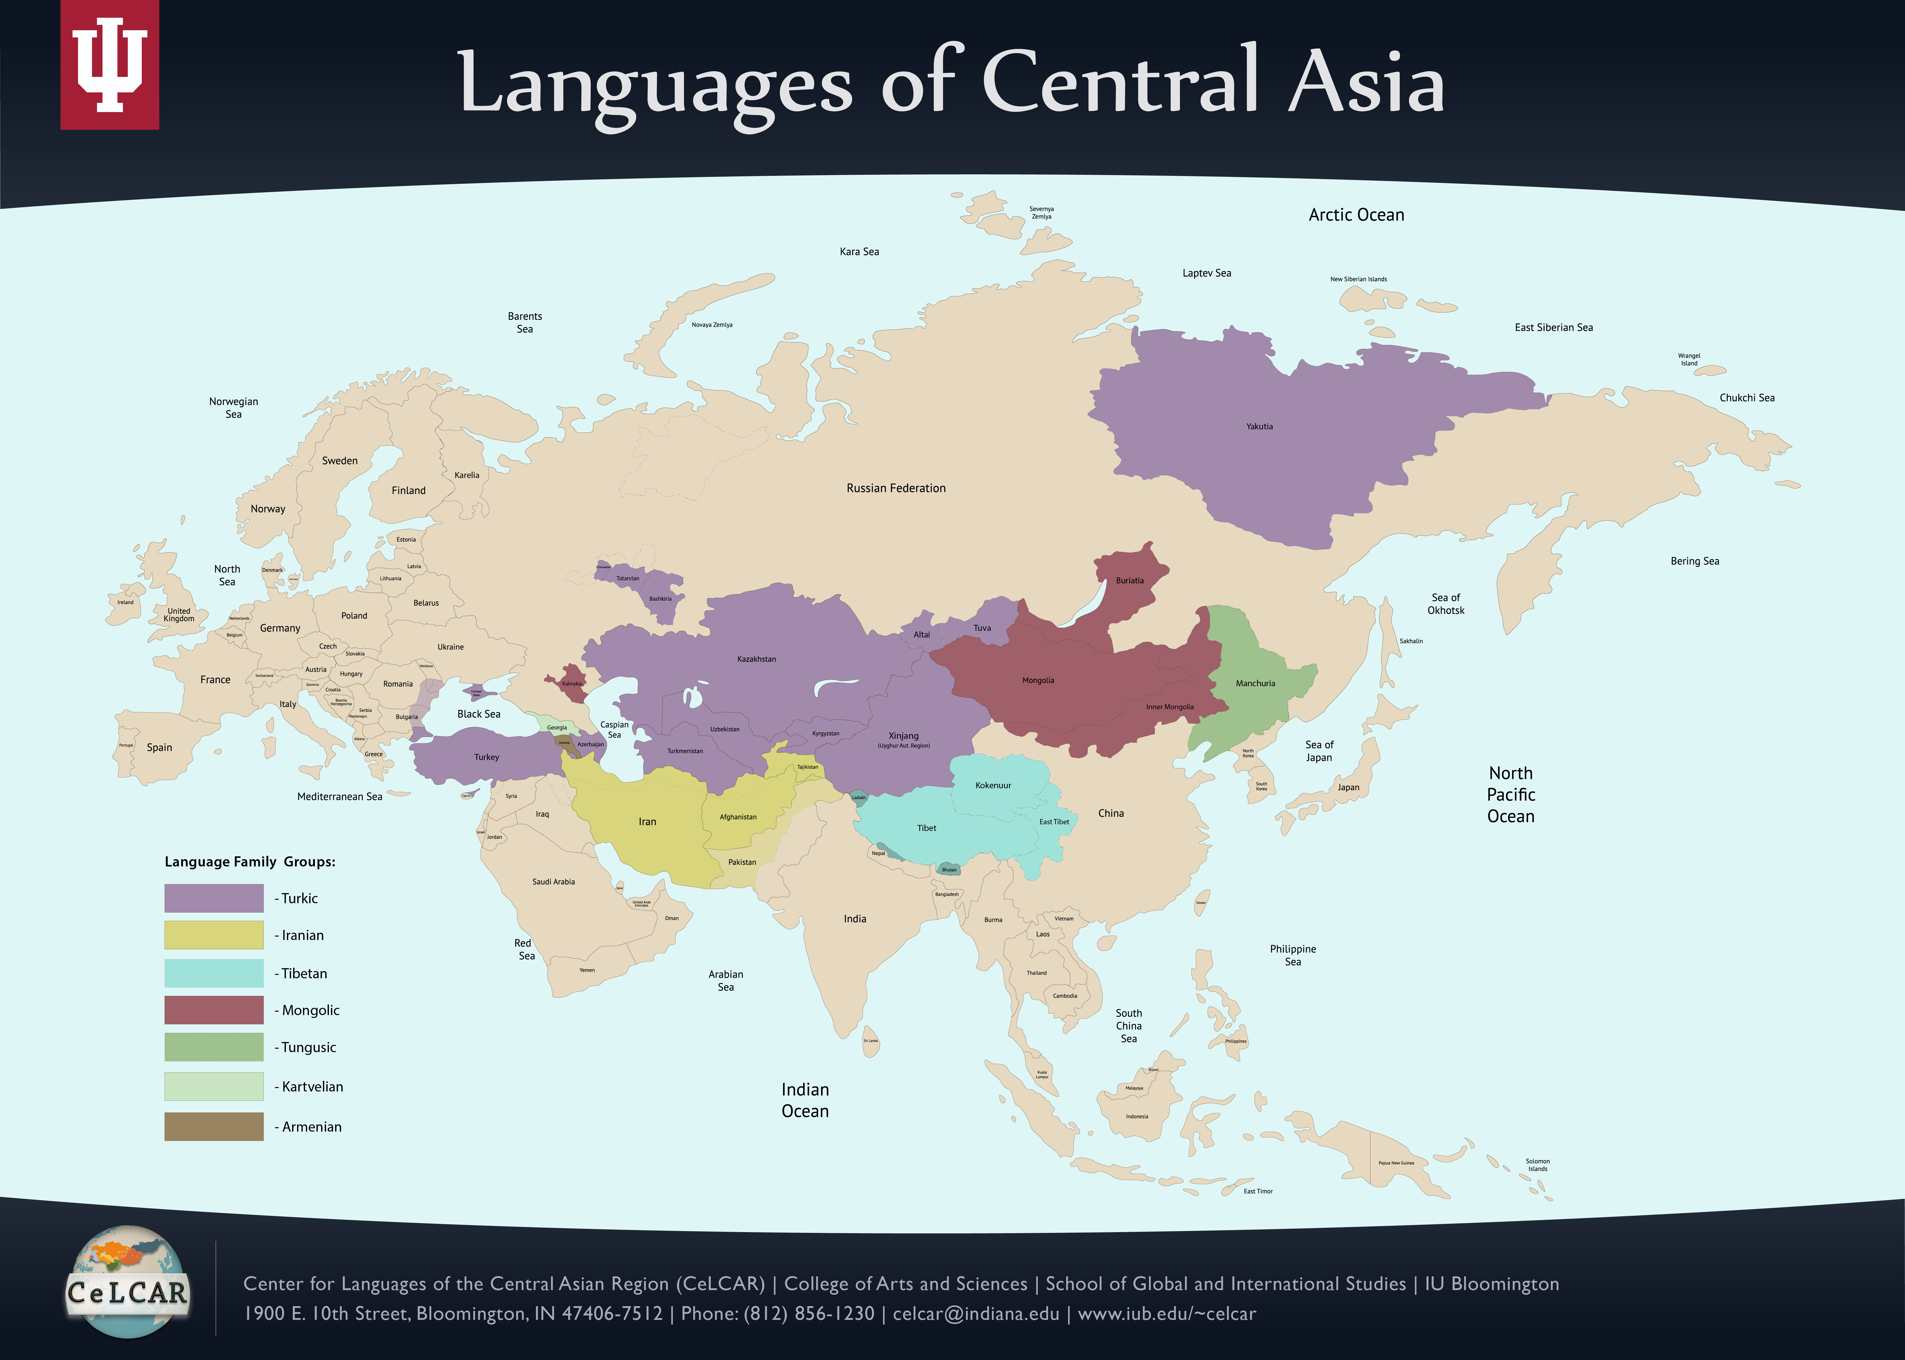  Click to Enlarge Map | Download a digital copy of the conference program here..
  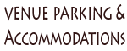
  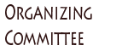
  Friday, May 16, 2014
  8:00 am – 8:45 am | Registration and continental breakfast (State Room-West)
  8:45 am – 9:00 am | Opening Remarks by Oner Ozcelik, Director of Center for Languages of the Central Asian Region (CeLCAR), Indiana University (Georgian Room)
  9:00 am – 11:00 am | Parallel Session 1
    (Georgian Room) | (State Room-East)
    Esra Predolac,  University of Kansas/Cornell University,  Revisiting Finite Complement Clauses | Farid Saydee and Shahnaz Ahmadeian Fard,  San Diego State University,  Determinant Factors in Effective Teaching and Learning of Dari and Pashto Languages: An Action Research Paper?
    Ali Bolgun,  Monterey Institute of International Studies,  Why situation-theory cannot explain the accusative case marking in Turkish | Nadezda Novakovic and Yama Meerzada,  San Diego State University,  Raising the L2 motivation of the military personnel learning Pashto
    Ghazaleh Kazeminejad,  University of Kentucky,  Rethinking the quirky case of psych predicates in colloquial Persian | Daniel Thornhill and Shabnam Entezar,  US Special Operations Command,  The Effect of Learner-Centered Curricula on Motivation and Proficiency Measures
    Atakan Ince,  CACI,  Sluicing Is Still Sluicing in Turkish | Clay Leishman and Dr. Marla Federe,  Naval Special Warfare,  Developing a Learner-Centered Pashtu Curriculum for Navy SEALs: A Case Study
  11:00 am – 11:15 am | Refreshment Break (State Room-East)
  11:15 am – 12:15 pm | Plenary Session 1: Jaklin Kornfilt, Department of Linguistics, Syracuse University (Georgian Room)  Turkish Relative Clauses: How Exceptional are they from a Central Asian Turkic Perspective?
  12:15 pm – 1:15 pm | Lunch - Boxed Lunches Provided (State Room - East)
  1:15 pm – 2:15 pm | Poster Session I (Georgian Room)
    Kalibunur Abdurahman and YuHong Zhi, Northwest University for Nationalities, The Research on Uyghur Consonants from Perspective of EPG
    Raushangul Avakova, Kazakh National University of Al-Farabi, Peculiarities of Language Consciousness in Cultural Values
    Biplab Chakraborty, University of Calcutta, Syntactic Structures and Style of Lokaabharan
    Duygu Demir, Hacettepe University, Adverbial Clauses in Modern Turkish
    Johnathan Krause, Western Carolina University, How Afghan languages (Dari and Pashto) are a source of unity, rather than division
    Kaiser Abdurusul ÖzHun, International Pen Uyghur Centre, Uyghur language is in danger under the regional bilingual education policy of China
  2:15 pm – 3:15 pm | Parallel Session 2
    (Georgian Room) | (State Room-East)
    Yasuhiro Yamakoshi,  Tokyo University of Foreign Studies,  How Can We Define The "Participles" In Mongolic Languages: Two Problems In Shinekhen Buryat | Zeinekan Kuzekova,  Nazarbayev University,  Functional Semantic Fields in the Teaching of Kazakh Language
    Invited Guest Speaker: Antonia Schleicher (Georgian Room)
    Executive Director of NCOLCTL and IU Joint LRCs
    Creating a Standards Development Committee for LCTLs
  3:15 pm – 3:30 pm | Refreshment Break (State Room-East)
  3:30 pm – 4:30 pm | Parallel Session 3
    (Georgian Room) | (State Room-East)
    Daniel Barry,  CUNY - Brooklyn College,  On the Re-Analysis of the Phoneme /k/ in Kyrgyz Loanwords in Wakhi | Mariam Alamyar,  Purdue University,  Language Controversy in Afghanistan: The Sociolinguistics of Farsi Dari and Pashtu at Kabul University
    Mahire Yakup,  University of Kansas, Reduplication in Uyghur | Farooq Babrakzai,  Defense Language Institute,  Movement and Direction in Pashto Grammar
  4:30 pm – 5:30 pm | Plenary Session 2: Jorge Hankamer, Department of Linguistics, University of California, Santa Cruz (Georgian Room)  Turkish Suspended Affixation
  5:30 pm – 6:30 pm | Hors d’oeuvre Reception (State Room-East)
  Saturday, May 17, 2014
  8:00 am – 8:30 am | Continental breakfast (State Room-West)
  8:30 am – 10:00 am | Parallel Session 4
    (Georgian Room) | (State Room-East)
    Alexander Sugar,  University of Washington  Implementing a Machine-Readable Grammar of Uyghur | Mamadsho Ilolov,  Academy of Sciences of the Republic Tajikistan,  Pamiri languages and problems of written language
    Narges Nematollahi,  Indiana University,  Development of the Progressive Construction in Modern Persian | Parvina Abdulhamidova,  Khorog State University,  Language regeneration in Shughnani and the Internet
    Hassan Bokhari and Jonathan Washington,  Indiana University,  Stress in Saudi Diaspora Uzbek and Its relation to stress in Turkish | Sukhrob Karimov,  Indiana University,  M-Learning: Adding Mobile to Your Learning Environment
  10:00 am – 10:15 am | Refreshment Break (State Room-East)
  10:15 am – 11:15 am | Plenary Session 3: Simin Karimi, Department of Linguistics, University of Arizona (Georgian Room)  Contrast in Focus Persian and Turkish focus constructions
  11:15 am – 12:15 pm | Parallel Session 5
    (Georgian Room) | (State Room-East)
    Joshua Meyers,  University of Arizona,  Phonological Processing in Kyrgyz-Russian Bilinguals | Ari Stern-Gottschalk,  Indiana University,  Trends in US-based Central Asian Language Instruction
    Sangyub Baek,  Hokkaido University,  Tungusic Converb -mi from the Perspective of Linguistic area | Pooneh Paydar,  San Diego State University,  Creating language and culture content for Novice Language Learners also Engaging Learners with Customized and Personalized Online Language Activities
  12:15 pm – 1:15 pm | Lunch - Boxed Lunches Provided (State Room - East)
  1:15 pm – 2:15 pm | Poster Session II (Georgian Room)
    Chuguluke Abudulimu, Yale University and Sherin Arslan, American University, Teaching Uyghur Noun Cases to English Speaking Students
    Gaziza Imanaliyeva, Kazakh National University Al Farabi, Some Problems of Emotiveness in Kazakh language
    Odilbek Kattaev, Arizona State University, Low-Level Learners and Study Abroad: A Case Study
    Savas Sahin, Amasya University, Metaphorical Approach to Mental Verbs in Turkmen Turkish
    Anarkul Salkynbay, Kazakh National University of Al-Farabi, Metaphorical word-building meaning in the Kazakh language
    Arzhaana Syuryun, Institute for Linguistic Studies of the Russian Academy of Sciences, The Tofalar Language Nowadays
  2:15 pm – 3:15 pm | Plenary Session 4: Chris Beckwith, Department of Central Eurasian Studies, Indiana University (Georgian Room)  What Did the Earliest Central Asian Languages Sound Like?
  3:15 pm – 3:30 pm | Refreshment Break (State Room-East)
  3:30 pm – 4:30 pm | Parallel Session 6
    (Georgian Room) | (State Room-East)
    Cigdem Harding,  Indiana University,  Can we save Crimean Tatar? Story of an endangered language. | Aliya Kuryshzhanova,  Hankuk University of Foreign Studies,  Lingvo-Methodical Objectives and Frequency-Specific Approaches for Kazakh Language
    Shinsuke Hidaka,  Tokyo University,  Uzbek’s Suffix Expressing Possession -li | Sharifa Djurabaeva,  Ball State University,  Definition and clarification discourse markers in the speech of Uzbek speakers
  4:30 pm – 4:45 pm | Refreshment Break (State Room-East)
  4:45 pm – 5:00 pm | Closing Remarks (Georgian Room)
IU Bloomington | College of Arts and Sciences | School of Global and International Studies | CeLCAR
1900 E. 10th Street, Bloomington, IN 47406-7512 | Phone: (812) 856-1230 | celcar@indiana.edu
Copyright © 2013 the Trustees of Indiana University | Copyright Complaints | Privacy Notice

