Obtaining thin-films based on chitosan and carboxymethylcellulose with antibacterial properties for biomedical devices
¹Aliya K. Ospanova, ¹Balzhan E. Savdenbekova, ²Mariam K. Iskakova,
¹Balnur Zh. Nussip, ¹Aibek S. Abdikadyr
Abstract—The physico-chemical studies of produsing nanocoating in the form of multilayers on the basis of chitosan and carboxymethyl cellulose were done. Was justified the use of triclosan, chlorhexidine, silver ions and iodine as potential antibacterial agents in the composition of nano-coating for medical and biological implantable systems. Preliminary studies of antibacterial activity of the resulting multilayers on silicon plate showed good activity against many bacteria.

Key words—multilayer, chitosan, carboxymethyl cellulose, antibacterial properties.

Introduction
A major problem in medicine is the formation of bacterial films observed on the surfaces of implants and other biomedical devices. This leads to the emergence of the infectious complications and the need for premature removal and replacement of such devices. Since the adhesion of bacteria is the initial stage of formation of biofilm, creating conditions that prevent the emergence of bacterial colonies on the surface of implants, can greatly slow down or completely inhibit its formation [1-3]. A promising direction in traumatology and orthopedics is the creation of such properties of the implant in which does not occur biofilm formation. Currently, a number of researchers try to solve this problem by applying of the implants coating on the surface with different antibiotics or spraying silver [4]. One solution to the problem of implant-associated infections is applying special coatings to implants that provide local time prolonged release of antibacterial substances in immediate proximity from the implant.
Complex nanostructural coating applied to the surface of the implant, should consist of antibacterial chemical agent and inherently biodegradable polymer and have pronounced universal bactericidal effect in the early postoperative period (1-2 weeks) in respect of all clinically relevant microorganisms [5].
Authors [6] have been established optimal conditions of producing the multilayer films based on (Heparin / chitosan) 10 - (polyvinylpyrrolidone / polyacrylic acid)) 10 [(HEP/CHI)10−(PVP/PAA)10]. The interaction between polyelectrolytes has a purely electrostatic character, and the layers (PVP / PAA) 10 of the multilayer film are held by hydrogen bonds. PAA molecules then sewn to form anhydride groups by heat treatment at 110 °C for 16 h.
Obtained nanofilms show enhanced antimicrobial activity and may be promising for application in medical implants, tissue engineering, and etc. Studies [7] allow to develop a method of producing a multilayer film on a silicon surface catheters by treatment with amino cellulose nanospheres (ACNSs) with hyaluronic acid (HA).
Antibacterial effect of the HA / ACNSs (amino cellulose nanosphere) multilayers was 40% higher in comparison with others. Five bilayer coatings based on HA / ACNSs was enough, to prevent the formation of bacteria biofilm. The paper presents a scheme of action of the antibacterial agent on a signal of emergence of bacteria colonies.
In many papers multilayer coatings formed by synthetic polymers were studied, but natural ionic polyelectrolytes have the greatest potential for application in the field of biomedical coatings. The wide use of polysaccharides in such studies are explained by their biocompatibility.
Today, it offers two alternative approaches to obtain biomedical devices on the surface of antiadhesive nanoscale functional coatings containing of ionic polysaccharides [8] 1) covalent immobilization of chitosan; 2) formation of multilayers of polyelectrolyte complexes of chitosan and carrageenans. Properly studied features of formation of multilayers with the participation of carrageenans in different conformational states optimized conditions for producing coatings with controlled architecture, and substantiated the mechanism of the exponential growth of multilayers.
In adhesion mode antimicrobial and antiadhesive properties of the resulting coatings were studied. It based on the example of enterococcus faecalis bacteria. It was shown that chitosan-containing coatings can significantly reduce bacterial adhesion, thus multilayers providing decreased adhesion 50-100 times, and the less hydrated covalently grafted coating - 10-20 times compared to the initial substrate.
The basic material for producing implants is titanium and therefore studies [9] are related to obtaining antibacterial multilayer coatings on the surface of Ti substrate with chitosan and alginate multilayer by self-assembly method. In this study, the surface of Ti substrate at first hydroxylated, and then treated with 3-aminopropyltriethoxysilane (ATPES) for producing amino functionalized Ti substrates. After this, Ti substrate alternately covered with alginate and chitosan by LBL self-assembly. The clinical significance is that the loading of a minocycline on implants surfaces can impart to implant stable antimicrobial activity. The current state of scientific research in of modified antibacterial coatings by self-assembly (LBL) for medical and biological products are well represented in a number of generic articles [10-11], from which it follows their theoretical and practical importance.
In this regard, this paper presents the results of physico-chemical foundations of obtaining multilayers based on chitosan and sodium carboxymethyl cellulose applied to silicon and titanium plates and containing in polylayers antibacterial agents such as triclosan, chlorhexidine, silver and iodine ions.

Experimental section
Маterials. Triclosan, chlorhexidine digluconate (0.05 % solution, manufacturer Ltd. "Sultan" Republic of Kazakhstan), silver ions (analytical grade, GOST 1277-75, CRIS Analyte), molecular iodine (chemical grade, GOST TU), sulfuric acid, buffer solutions (4.0 and 9.18, Uralhiminvest, GOST 8,135-2004), glutaraldehyde (50% solution, Mw 100.11, manufacturer Amresco), low molecular chitosan (M_{w} 50-190 kDa) and sodium carboxymethylcellulose (Mw 700 kDa) (Sigma Aldrich). All chemicals were used without further purification. Filtered water with a resistivity of 18.2 MΩ was used in all experiments. Silicon (110) plates are the highest grade, p-type (the thickness of the dopant - 525 ± 25 µm, the thickness of the oxide layer - 2 mn.) (Cemat Silicon, South Australia). Titanium orthopedic plates.
Applying multilayers. Polyelectrolyte multilayers were applied on silicon and titanium plates.
Silicon plates were immersed in concentrated sulfuric acid solution for 2 h, and then thoroughly washed with Milli-Q water. Further silicon plates were immersed into
0.2 M NaOH solution for 10 min, washed repeatedly with water and dried at room temperature.
Titanium plates were treated with a solution of acetic acid with a concentration of of 5 M, followed by washing with water. Preparation of multilayers on the substrate surface was performed using 0.01 M solutions of polyelectrolytes. Polyanions and polycations were adsorbed sequentially for 10 min. Each deposition step was followed by washing with buffer solution at the same pH. All received multilayers further sewn in glutaraldehyde solution at room temperature for 12 h.
The implantation of antibacterial agent into the layers. To load an antibacterial agent, multilayer films were exposed to a 0.01 M solution of chlorhexidine, triclosan, silver ions and molecular iodine for 48 h to achieve complete absorption inside of films, and then plates was dried with nitrogen flow.
Scanning electron microscopy. The surface structure was examined by scanning electron microscopy (SEM). SEM images images were obtained by a scanning electron microscope Auriga. Silicon plates were attached to the SEM rack with conductive tape. Au-Pt alloy was sprayed onto the surface of samples of RF-plasma chamber for 10 s. The applied voltage was varied from 1 to 3 kV.

Result and discussion
In this study to obtain multilayers polyelectrolytes such as sodium carboxymethyl cellulose and chitosan were used as a polymer matrix. T obtain nanofilms silicon and titanium plates were used as a model of solid substrate. As antibacterial agents were chosen: triclosan, chlorhexidine, silver ions and molecular iodine.
The authors [12-13] were investigated processes of interacting chitosan hydrochloride with sodium carboxymethyl cellulose in an aqueous solution by potentiometric, conductometric and turbidimetric titration, as well as in the solid state by FTIR spectra, and thermogravimetric analysis.
All methods titration have proved complex formation of in a stoichiometric ratio 1:1 between chitosan and carboxymethyl cellulose, interaction has electrostatic character. The mechanism of electrostatic interaction of the polyelectrolyte in the binary system can be explained by the emergence of a positive charge on chitosan and negative - on the surface of the CMC molecules as follows, Fig. 1.

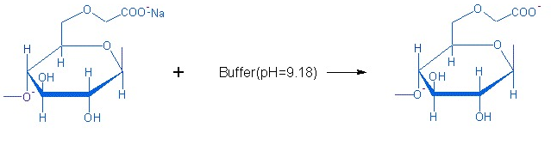
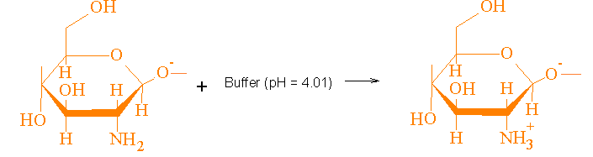
Fig. 1. The emergence on the charges of polyelectrolyte macromolecules at handling with buffer solutions.

Obtaining of multilayer nanocoating on the surface of platelets based on chitosan with carboxymethylcellulose with applied antibacterial agents carried out as follows,
Fig. 2.

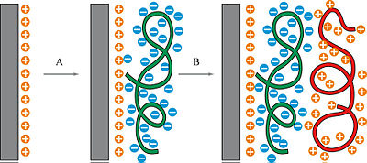
Fig. 2. The scheme for obtaining multilayers with antibacterial properties: orange layers- chitosan; blue - sodium CMC, green and red - antibacterial agents.

Study of the dependence of thickness and the roughness of coatings on the number of bilayers revealed that the coating thickness is linearly dependent on the number of multilayers, Figure 3, and at the most near to the plate layers bond cleanly, apparently, electrostatic, and with the growth of the layers in formation of multilayers play a major role pure hydrogen bonds. The roughness of the surfaces obtained Nanofilms increases with the number of films, Fig 3, which is associated with an increase functional groups of both reagents [14].

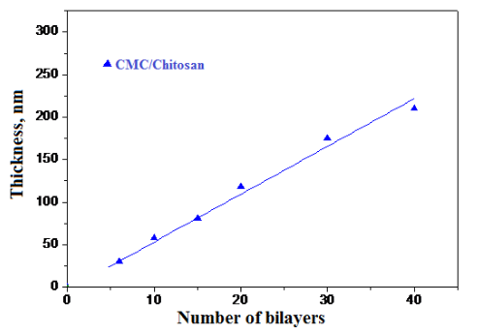

Fig. 3. The dependence of the coating thickness on the number of bilayers for the system
chitosan – sodium CMC.

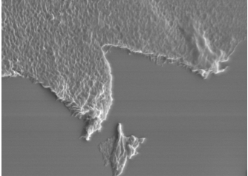 | 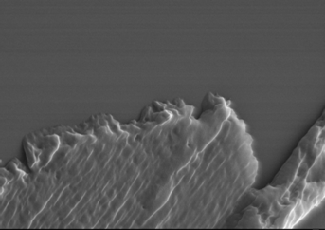
a) | b)

Fig. 4. The thickness of the films on the silica plate а) 15 bilayers,
б) 30 bilayers.

For binding of biologically active compounds multilayer films obtained as described above were immersed in solutions of antibacterial agents concentration (0,05 mol / L) in water at a pH of 2-3 for 12-16 h. In addition for comparing were taken triclosan, chlorhexidine, silver nitrate, iodine-containing drugs, and the silver-containing control agent. After saturation of the film antibacterial agents films are dried at a temperature of 100-110 °C. Further heat-treated films are sewed in the glutaraldehyde solution at room temperature and dried in a nitrogen stream.
Determination of antimicrobial activity of silicon and titanium plates (SP) with antibacterial coatings based on their ability to inhibit the growth of microorganisms. Determination was performed by the method of diffusion in agar-agar on thick nutrient medium by comparing the sizes of zones inhibition of growth test microbes formed during the test of solutions of certain concentrations.
Into a sterile Petri dish was poured 20 mL of nutrient agar. The thickness of the agar layer affects on the results of the determination, therefore strictly observed the specified amount of the nutrient medium. As the nutrient media used Mueller-Hinton medium and Saburo agar.
For obtaining lawns prepared homogeneous suspension of the bacterial cells in a physiological solution, corresponding to standard 0.5 by McFarland turbidity units. Bacterial suspension applied with sterile gauze to the surface of the agar in three different directions. After 5-10 min after inoculation on the dried up surface of the agar applied plate with antimicrobial properties.
Plates for 30 min were left at room temperature, and then, without inverting incubated in a thermostat at a temperature of 28-37 °C for 24-48 h to 5 days. Microbial growth inhibition zones were measured by millimeter ruler. The results of these studies are shown in Fig. 5.

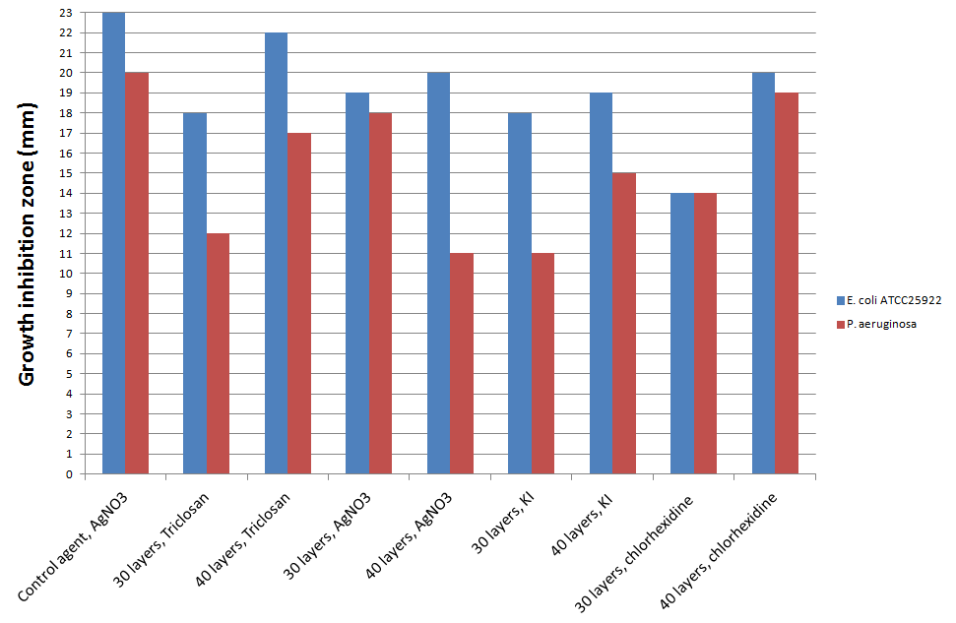
Fig. 5. The study of the antimicrobial activity of multilayer films by method of diffusion.

The study of antimicrobial activity of plates by the method of diffusion and comparison with the control experiment showed that all studied dental plates (DP) had antibacterial effect against museum strain E. coli ATSS25922 and wild strain P. aeruginosa; thus the most acting (with a greater zone of inhibition growth of bacteria) on studied museum and wild strains of bacteria were plates with triclosan, showing sensitivity to E. coli ATSS25922 and P. aeruginosa; further antibacterial action had a plate with chlorhexidine, inhibited the growth of E. coli ATSS25922 and P. aeruginosa, while plate DP - 40 layers with chlorhexidine inhibited the growth of S. aureus ATSS29213. Dental plates with silver nitrate showed antibacterial effect against E. coli ATSS25922, plate with 30 layers AgNO₃ influenced also on P. aeruginosa. Plate with iodine also affected with big zone of inhibition growth on E. coli ATSS25922 and P. aeruginosa, the impact on microorganisms of plates with potassium and chitosan were about the same - with antibacterial effect action on E. coli ATSS25922 and with an average action (11-15 mm) on P. aeruginosa. The preliminary carried out tests showed good antibacterial activity of multilayers fixed the silicon and titanium plates, indicating the prospect of such research.

CONCLUSION
The study of physical and chemical conditions of obtaining antibacterial coatings on silicon and titanium plates allowed choose the optimum conditions for obtaining nanofilms based on chitosan and carboxymethyl cellulose. The thickness and the roughness of coatings in multilayers increases in direct proportion with the increase of bilayers. Interaction between the polymer carrier on the surface of plates purely electrostatic and antibacterial agents associated with the basics of nanofilms, probably due to the forces of adsorption and hydrogen bonds. Antimicrobial activity such coatings due to the presence of bioactive functional groups on the surface of agents such as triclosan, chlorhexidine, silver ions and iodine.

References
- Jinhong Fu, Jian Ji, Weiyong Yuan, Jiacong Shen. “Construction of anti-adhesive and antibacterial multilayer films via layer-by-layer assembly of heparin and chitosan” Biomaterials, vol.26, pp. 6684-6692, June 2005.
- Poh-Hui Chua, Koon-Gee Neoh, En-Tang Kang, Wilson Wang. “Surface functionalization of titanium with hyaluronic acid/chitosan polyelectrolyte multilayers and RGD for promoting osteoblast functions and inhibiting bacterial adhesion” Biomaterials vol. 29, pp. 1412-1421, January 2008.
- Heveline D. M. Follmann, Alessandro F. Martins, Adriana P. Gerola, Thiago A. L. Burgo, Celso V. Nakamura, Adley F. Rubira, Edvani C. Muniz. “Antiadhesive and Antibacterial Multilayer Films via Layer-by-Layer Assembly of TMC/Heparin Complexes” Biomacromolecules, vol. 13, pp. 3711-3722, November 2012.
- Jinhong Fu, Jian Ji, Dezeng Fan, Jiacong Shen. “Construction of antibacterial multilayer films containing nanosilver via layer-by-layer assembly of heparin and chitosan-silver ions complex” Biomedical Materials Research Part A, vol. 79, pp. 665-674, December 2006.
- Chun-Hong Gu, Jia-Jun Wang, Yang Yu, Hui Sun, Ning Shuai, Bing Wei. “Biodegradable multilayer barrier films based on alginate/polyethyleneimine and biaxially oriented poly(lactic acid)” Carbohydrate polymers, vol. 92, pp. 1579-1585, November 2012.
- Bai-liang Wang, Ke-feng Ren, Hao Chang, Jin-lei Wang, and Jian Ji. “Construction of Degradable Multilayer Films for Enhanced Antibacterial Properties” Applied Materials and Interfaces, vol. 5, pp. 4136-4143, May 2013.
- A. Francesko, М. Fernandes, K. Ivanova, S. Amorim , Rui L. Reis, I. Pashkuleva, E. Mendoza, A. Pfeifer, T. Heinze,
T. Tzanov. “Bacteria-responsive multilayer coatings comprising polycationic nanospheres for bacteria biofilm prevention on urinary catheters” Acta Biometrialia, vol. 33, pp. 203-212, March 2016.
- S. Bratskaya. “Multilayer and covalently grafted functional coatings based on polysaccharides for prevention of bacterial adhesion” Bulletin FEB RAS, vol. 2, pp. 84-92, 2009. (In Russian).
- Hongbin Lv, Zhen Chen, Xiaoping Yang, Lian Cen, Xu Zhang, Ping Gao. “Layer-by-layer self-assembly of minocyclineloaded chitosan/alginate multilayer on titanium substrates to inhibit biofilm formation” Journal of Dentistry, vol. 42, pp. 1464-1472, Jun. 2014.
- S. Sukhishvili, E. Kharlampieva. “Hydrogen-Bonded Layer-by-Layer Films” Мacromolecular science, vol. 46, pp. 377-395, Nov. 2006.
- Lydie Séon, Philippe Lavalle, Pierre Schaaf, Fouzia Boulmedais. “Polyelectrolyte Multilayers: A Versatile Tool for Preparing Antimicrobial Coatings” Langmiur, vol. 31, pp. 12856-12872. October 2015.
- A. Ospanova , R. Omarova, U. Abdurazakov, R. Jartybaev, M. Iskakova, B. Savdenbekova, M. Amkhadova. “Method of multilayer assembly as alternative to antibacterial coverings of medico biological implants” Stomatology. vol. 95, pp. 9-13. 2016. (In Russ.).
- Carmen Rosca, Marcel Ionel Popa, Gabriela Lisa, Gabrielle Charlotte Chitanu, “Interaction of chitosan with natural or synthetic anionic polyelectrolytes. The chitosan–carboxymethylcellulose complex” Carbohydrate Polymers, vol. 62, pp. 35–41. 2005.
- A. Mentbayeva, A. Ospanova, Zh. Tashmuhambetova, V. Sokolova, S. Sukhishvili. “Polymer-metal complexes in polyelectrolyte multilayer films as catalysts for oxidation of toluene” Langmuir, vol. 28, pp. 11948-11955, July 2012.

A.K. Ospanova In 1975 graduated Al-Farabi Kazakh National University, in 1994 - received the rank of assistant professor, in 2003 - the degree of Doctor, in 2005 - professor. "The best teacher of the university " in 2005, "The best teacher of the university " in 2010.

Manuscript received February 28, 2016. This work was supported in part by the Republic of Kazakhstan . Department of Chemistry and chemical technology under Grant 3445/GF4. ¹ Department of chemistry and chemical technology, al-Farabi Kazakh national university. Al-Farabi 71, Almaty, Republic of Kazakhstan. E-mail:ospanova_a@mail.ru ² Department of stomatology, Asfendiyarov S.D. Kazakh national medical university. Tole Bi St. 94., Almaty, Republic of Kazakhstan. E-mail: iskakova-maryam@mail.ru

