

-

м





|  |  |
| --- | --- |
| X | ■ l; |
|  | |
|  | |
|  |  |



MATERIALY XIII MI^DZYNARODOWEJ N AU КО Wl -P RAKTYCZN E J KONFERENCJI

NAUKOWA MYSL IN FORM AC Y J N E J POWIEKI- 2017

07 -15 marca 2017

Tom 4

Filologiczne nauki Historia Psychologia i socjologia Filozofia



■^ПхтАті rrr\

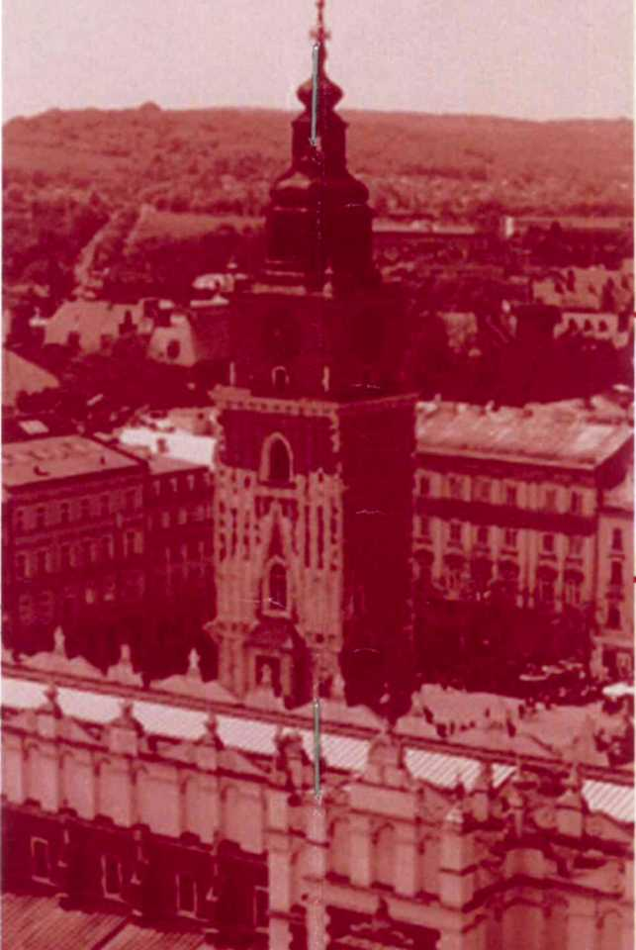

04-03-08-2017

■ о

•fvj

! I

\o \ I in !o

! I

jo • *



Przemysl Nauka i studia 2017

MATERIALY

ХІП MI^DZYNARODOWEJ NAUKOWI-PRAKTYCZNEJ KONFERENC^

NAUKOWA MYSL INFORMACYJNEJ POWIEKI- 2017»

07-15 marca 2017 roku

Tom 4

Filologiczne nauki Historia Psychologia i socjologia Filozofia

Przemysl Nauka i studia 2017

MATE RIAL Y MIE^DZYNARODOWEJ NAUKOWI-PRAKTYCZNEJ KONFERENCJ! * 07-15 marca 2017 roku

«Naukowa mysl informacyjnej powieki- 2017» * Tom 4

FILOLOGICZNE NAUKI

Metodyka wyktadania jezyka i literatury

Adres wydawcy i redacji: 37-700 Przemysl, ul. Lukasiriskiego 7

Materiafy XIII Miedzynarodowej naukowi-praktycznej konferencji «Naukowa mysl informacyjnej powieki- 2017»,Tom 4 : Filozofia . Psychologia i socjologia . Historia . Filologiczne nauki. Przemysl: Nauka i

studia -124 str.

Zespot redakcyjny: dr hab.Jerzy Ciborowski (redaktor prowadzacy), mgr inz. Piotr Jedrzejczyk, mgr inz Zofia Przybylski, mgr inz Dorota Michatowska, mgr inz Elzbieta Zawadzki, Andrzej Smoluk, Mieczysiaw Luty, mgr inz Andrzej Lesniak, Katarzyna Szuszkiewicz.

Materialy XIII Miedzynarodowej naukowi-praktycznej konferencji, «Naukowa mysl informacyjnej powieki- 2017», 07 -15 marca 2017 roku po sekcjach: Filozofia . Psychologia i socjologia . Historia . Filologiczne

nauki.

e-mail: [praha@rusnauka.com](mailto:praha@rusnauka.com)

Cena 54,90 zt (w tym VAT 23%)

ISBN 978-966-8736-05-6

© Kolektyw autorow, 2017

© Sp. z o.o. «Nauka i studia», 2017

Kruzhkova Y., Omarova A.

Karaganda State University named after Buketov Y.A., Kazakhstan

THE QUESTION OF PROFESSIONALLY-ORIENTED TEACHING OF FOREIGN LANGUAGES THROUGH E-LEARNING MANUAL

The changes taking place in contemporary society are reflected in the changed requirements to the content of education. General requirements for the content of education described in the article 13 of the Law of the Republic of Kazakhstan "Education", where education - a system (complex) of knowledge for each level of education.Additionally, this is also a basis for the formation of competence and developmentchildren's personalities [1]. The principle of professionalisation is one of the important principles of the national education system in the concept of foreign language education in the Republic of Kazakhstan.This principle implies the usage of a foreign language for professional purposes, and is supposed to be used for professional trainings within a specific specialty using a foreign language for specific purposes (LSP).

The professionally-oriented approach for learning a foreign language at universities obtained a significant attention. This approach provides the formation of students' ability for foreign language communication in specific professional, business and scientific spheres and situations, taking into account the characteristics of professional thinking, in the organisation of motivating and research oriented activities. Education based on the students' needs in the study of a foreign language, dictated by the peculiarities of their future profession or specialty is meant by professionally-oriented principle. It involves a combination of professionally-oriented mastering a foreign language with the development of personal qualities of students, knowledge of the culture of the country of studied language and the acquisition of of special skills based on professional and linguistic knowledge. The essence of professionally-oriented foreign language teaching lies in its integration with subspecialties in order to obtain additional professional knowledge and formation of professionally significant qualities of a person. Foreign Language in this case is a means of enhancing professional

2

3

MATERIALY WEDZYNAROOOWEJ NAUKOWI-PRAKTYCZNEJ KONFERENCJI * 07 -15 marca 2017 roku

Socjalna filozofia

Karabayeva A.G. ,Ismagambetova Z.N., Moldabekov Zh.Zh.

al-Faraby Kazakh National University, Republic of Kazakhstan

THE DEVELOPMENT OF INTELLECTUAL CAPITAL IN THE MODERNIZING SOCIETY

The process of globalization and modernization of the social sphere today is directly dependent on the intellectual resources of different communities and countries. Modernization is connected with innovation and economic competitiveness and cultural transformation. Modernization reflects global changes in a concrete society. Global changes are directly related to the ability of the society effectively respond to the systemic crisis and the restructuring of the economic and political sphere as well as geopolitical challenges. Following tendencies of the forming of intellectual nation are considered today: the development of the system of innovations, solving the problems of the country's competitiveness, development of the human capital, formation of intellectual person in the conditions of global civilization, the development of advanced branches of science, forming of critical thinking, strengthening the health of nation, the development of "information criteria" for the development and evaluation of cultural evolution and contemporary culture, modernization of the national education system. These tendencies replied to the most urgent needs anddemands of Kazakhstan's society. Kazakhstan society addresses to the problem of preservation of cultural roots and values as the basis of social and spiritual life of modern society.

Search the way to the "sustainable development for all" presupposes intelligent investment in the socio-political sphere; improving the mechanisms for realization the resources of regions and human capital; forming of united front of fight against the negative sources of political conflicts and confrontations; strengthening communication in cross-cultural and inter-ethnic relations, including the development of relations and interactions for advancement of institutional, scientific and innovative elaborations and achievements.

Major trends of the development of contemporary society are manifested in the divergence of interests, attitudes, strategies and actions of various social and political forces, in the undermining the moral principles and traditions in modern society, in the

94

«Naukowa mysl informacyjnej powieki- 2017» * Tom 4

total dehumanization of relations against the background of acute problems and crises in the world economy and politics. Split of the intellectual elites and divergence of social interests of various social groups, the gap between the "high" ideas, values and reality can be distinguished as the causes of the crisis and the barometer of socio-political climate of contemporary society. The requirements and expectations of the constant exchange of knowledge, innovative experience and information resources are important conditions for modernizing development. The innovation process is evaluated and developed in accordance to the non-linear model of development. «Non-linear - that is non-obvious, non-incremental - innovation will produce long-term wealth creation» [1, p. 3].

Sharp and fundamental problems of our time are revealing in the focus of renewed interest and requests of sovereign states: the issues of effective impact on world public opinion, ensuring wide publicity and transparency of the social and political processes and decisions These changes is connected with reforming national and global system of higher education, formation of civilized dialogue as a necessary condition for concord, harmony and construction of the contemporary society.

Key priorities of Kazakhstan's strategy of sustainable development are expressed in the following requirements and purposes:

* correction of the priorities and essence of economic activity, one of which is addressed to solving issues and problems relating to the quality of life of people as well as health care, development of science, education and culture;
* reassessment of the environmental factor as a compulsory condition for the sustainable development of human civilization;
* sustainable development of human capital;
* reducing the growing gap between rich and poor;

• solve the problem of unemployment in conditions of technological

progress;

• developing effective approaches to the problem of the correlation of the national culture and universal values of contemporary culture in the implementation of the principles of cultural polycentric with equal value of every culture of the world civilization;

* re-comprehension the paradigm of total competition against the background of controversial and deep integration processes;
* creation of a new world order which taking into account not only the geopolitical changes but also the growing role of regional organizations and processes;

• an effective fight against terrorism and extremism;

95

MATERIALY MIE.DZYNARODOWEJ NAUKOWI-PRAKTYCZNEJ KONFERENCJI * 07-15 marca 2017 roku

CONTENTS

FILOLOGICZNE NAUKI

Metodyka wykladania jezyka i literatury

Kruzhkova Y., Omarova A. THE QUESTION OF PROFESSIONALLY-ORIENTED TEACHING OF FOREIGN LANGUAGES THROUGH E-

LEARNING MANUAL 3

Гордиенко H.H. ПРИМЕНЕНИЕ КОНЦЕПЦИИ НЕЙРОЛОГИЧЕСКИХ УРОВНЕЙ В ПРОЦЕССЕ ПРЕПОДАВАНИЯ ИНОСТРАННОГО ЯЗЫКА ....7

Retoryka i stylistyka

Алпысова Н.С., Сәкен Ж.Н.,Канапина С.Ғ. Т. АХТАНОВТЫҢ «БОРАН»  
РОМАНЫНДҒЫ ТЕҢЕУДІҢ СТИЛЬДІК ҚОЛДАНЫСЫ 10

Teoretyczne i metodologiczne problemy badania mowy

Желуденко M.O., Липницька K.B. ОСОБЛИВОСТІ СЛОВОТВОРУ У

ФОРМУВАННІ НІМЕЦЬКИХ АВІАЦІЙНИХ ТЕРМІНІВ 13

Беликова О.В., Орлова А. ОБРАЗ ГЛАВНОЙ ГЕРОИНИ РОМАНА

ТОМАСА ГАРДИ «ТЭСС ИЗ РОДА Д'ЭРБЕРВИЛЛЕЙ» 16

Борковська І.П. АН АЛ 13 ДОСЛЩНИЦЬКОГО КОРПУСУ ЗАПОЗИЧЕНЬ

ТРАНСПОРТН01 СФЕРИ ЗА СЕМАНТИЧНИМ АСПЕКТОМ 20

Қалжан Аружан, Маматкадыр Гүлнара ҚАЗАҚ ТІЛ БІЛІМІНДЕ МАКАЛ -  
МӘТЕЛДЕРДІҢ ЗЕРТТЕЛУ ЖАЙЫ 22

Aktualne problemy tkimaczenia

Тунникова В.А., Трутников В.Э. К ПРОБЛЕМЕ ЗАИМСТВОВАНИЯ  
БАНКОВСКИХ ТЕРМИНОВ ИЗ АНГЛИЙСКОГО ЯЗЫКА 26

«Naukowa mysl informacyjnej powieki- 2017» * Тот 4

Mowa, mowna komunikacja

Mikhelson S.V. INTERCULTURAL BUSINESS COMMUNICATION AND THE

INFLUENCE ON IT 31

Муеаева K.C. АҒЫЛШЫН ЖӘНЕ ҚАЗАҚ ТІЛІНДЕГІ ФРАЗЕОЛОГИЯЛЫҚ  
TIPKECTEP ҚАТАРЫНДАҒЫ СОМАТИЗМ 35

Jezyk ojczysty i literature

Sultan Y. THE PROBLEMS OF GENRE BOUNDARIES IN NOVEL  
TRANSFORMATION 38

PSYCHOLOGIA I SOCJOLOGIA

Problemy rozwoju osobowosci w nowoczesnych warunkach

Аязбаева M..C, Фатихова H.A., Аманқұлова Қ.Ы. ЖЕТІМ БАЛАПАР ТҰЛҒАСЫН ХАЛЫҚ ПЕДАГОГИКАСЫ НЕГІЗІНДЕ ҚАЛЫПТАСТЫРУ

ЖОЛДАРЫ .". 42

Кусаинова А.Т., Кабылбекова Ж.К., Абилов Д.К. «СТРЕСС» ӘЛЕУМЕТТІК ҚЫЗМЕТКЕРДІҢ НЕГАТИВТІ НЕМЕСЕ ТАБЫСЫНЫҢ

ФАКТОРЫ РЕТІНДЕ 46

Синицын Д.В., Богданова А.А. ГРУППИРОВКИ СМЕРТИ 51

Синицын Д.В., Богданова А.А. НРАВСТВЕННОСТЬ В СОВРЕМЕННОМ

МИРЕ 53

Жолымбекова А.С. МЕКТЕП ЖАСЫНА ДЕЙІНГІ БАЛАПАРДЫҢ ЕСТЕ  
САҚТАУ ҚАБІЛЕТТЕРІН ПСИХОЛОГИЯЛЫҚ ДАМЫТУ МӘСЕЛЕЛЕРІ 55

Kliniczna psychologia

Корніснко В.В.„ Зозуля Д.В. ПРО ПСИХОЛОГІЧНІ СКЛАДОВІ  
СОЦІАЛЬНОІ ВІДПОВІДАЛЬНОСТІ ПРАЦІВНИКІВ АПАРАТІВ СУДІВ  
УКРАІНИ 58

MATERIALY MIEDZYNARODOWEJ NAUKOWI-PRAKTYCZNEJ KONFERENCJI * 07-15 marca 2017 roku

Ogolna psychologia

Кравчук СЛ. ПСИХОЛОПЧНІ ОСОБЛИВОСТІ ДУХОВНИХ ЦІННОСТЕЙ ТА НЕКОНСТРУКТИВНИХ ФОРМ ПОВЕДІНКИ МОЛОДІ У ПОЛІТИКО-

ПРАВОВІЙ СФЕРІ В УМОВАХ ВОСННОГО КОНФЛІКТУ 61

Pedagogiczna psychologia

Абдраманова Н.Ш., Ешімкүл А.С., Жунисбекова Ж.А.  
ПСИХОЛОГИЯЛЫҚ-ПЕДАГОГИКАЛЫҚ ҒЫЛЫМЫНЫҢ КЕЙБІР  
АСПЕКТІЛЕРІ 64

HISTORIA

Ogolna historia

Благирева Д.А., Лобанова О.Б., Колокольникова З.У. ВЫБОРЫ

ШКОЛЬНЫХ РАБОТНИКОВ В 20-Е ГОДЫ XX В 67

Яушкина Н.Н. КОНФЕССИОНАЛЬНАЯ ПОЛИТИКА АЛЕКСАНДРА III И

ВАРИАНТЫ ИЗУЧЕНИЯ В ШКОЛЬНОМ КУРСЕ ИСТОРИИ 70

Яушкина Н.Н. ОСНОВНЫЕ НАПРАВЛЕНИЯ РАЗВИТИЯ КУЛЬТУРЫ

РОССИИ В ПЕРВОЙ ПОЛОВИНЕ XIX ВЕКА 72

Яушкина Н.Н. РАЗВИТИЕ НАУКИ В РОССИИ В ПЕРВОЙ ПОЛОВИНЕ

XIX ВЕКА ?. 74

Яушкина Н.Н. РАЗВИТИЕ ПРОСВЕЩЕНИЯ В РОССИИ В ПЕРВОЙ

ПОЛОВИНЕ XIX ВЕКА 76

Яушкина Н.Н. ВЗАИМООТНОШЕНИЯ РУССКОЙ ПРАВОСЛАВНОЙ  
ЦЕРКВИ И РОССИЙСКОГО ГОСУДАРСТВА В КОНЦЕ XIX - НАЧАЛЕ XX  
ВВ. И ВАРИАНТЫ ИХ ИЗУЧЕНИЯ В ШКОЛЬНОМ КУРСЕ ИСТОРИИ 78

Лобанова О.Б., Мазурова Н.А., Тюрюмина Е.А. НЕКОТОРЫЕ АСПЕКТЫ  
РАЗВИТИЯ ДЕТСКОЙ ЛИТЕРАТУРЫ В ПЕРИОД СТАНОВЛЕНИЯ  
СОВЕТСКОГО ГОСУДАРСТВА 80

«Naukowa mysl informacyjnej powieki- 2017» * Tom 4

Historia nauki i techniki

Zhumaliyeva L.T.., Bekzhanova T.K.HISTORICAL PROBLEMS OF  
INNOVATION OF THE LABOUR MARKET 85

Etnografia

Яушкина Н.Н. ВЛИЯНИЕ ПРАВОСЛАВИЯ НА СОЦИОКУЛЬТУРНУЮ  
ЖИЗНЬ МОРДОВСКОГО ЭТНОСА В XX - НАЧАЛЕ XXI В 88

FILOZOFIA

Filozofia literatury i sztuki ,•

Қурманбаева Л.Т., Ляпбаева Н.И., Анасова К.Т. ПСИХОЛОГИЯЛЫҚ  
ҚАУІПСІЗДІК МӘСЕЛЕСІ 90

Socjalna filozofia

Karabayeva A.G., Ismagambetova Z.N., Moldabekov Zh. Zh THE  
DEVELOPMENT OF INTELLECTUAL CAPITAL IN THE MODERNIZING  
SOCIETY 94

Filozofia religii

Kuat Kabdolda SOCIAL IMPORTANCE OF WAGF 99

Манатова С. А, Андреева О. А ЭСХАТОЛОГИЯ В МИРОВОЗЗРЕНИИ

ИСЛАМА 106

Ниязов А.З. МУҒТАЗИЛА АҒЫМЫНЫҢ ШЫҒУ СЕБЕПТЕРІ 109

Filozofia nauki

Сыбанбаев Қ.У. ШЫҒАРМАШЫЛЫҚ - АДАМНЫҢ МАҚСАТТЫ EPKIH

ІС-ӘРЕКЕТІ us

CONTENTS 120