INFLUENCE OF SYNTHETIC AND NATURAL POLYMERS ON THE PHYSICAL AND MECHANICAL PROPERTIES AND THERMAL CONDUCTIVITY OF DIATOMITE HEAT INSULATORS

Assoc. Prof. E.E. Dilmukhambetov¹
Assoc. Prof. P.I. Urkimbayeva²
PhD student B. Bakytzhanuly²
Master student A. Erkin²
Dr. Prof. G.A. Mun²
¹Kazakh National Agrarian University, Almaty, Kazakhstan
²Al-Farabi Kazakh National University, Almaty, Kazakhstan

ABSTRACT
Thermal insulating materials were obtained from diatomite and with burnable reinforcing additives, modified by synthetic and natural polymers. As burnable additives used rice husk, reinforcing additive is a basalt fiber, modifying polymer is polyvinyl alcohol and starch. Thermal insulating material obtained by mixing dry water mixtures at various ratios of components followed by drying and calcining at a temperature of 750 C.
Parameters were determined linear shrinkage, density, compressive strength, the bending strength and thermal conductivity depending on the polymer content.
It was found that the polymer additives have a positive impact on virtually all defined characteristics of thermal insulation materials, when the content of polymers from 0 to 1% by weight. The coefficients of linear shrinkage decreases from 14.5 to 4.5%, the compressive strength increased from 1.01 to 1.83 MPa, the bending strength increases from 0.2 to 0.4 MPa, the thermal conductivity decreases from 0.08 to 0.048 W/m∙K. In this material the density is in the range 0.42-0.50 g/cm³.
These materials are of practical importance for the manufacture of rigid insulation products used in thermal power generation.
Key words: diatomite, polyvinyl alcohol, starch, shrinkage, thermal conductivity.
INTRODUCTION
Rigid insulating products based on diatomite in the form of semi-cylinders, segments and blocks are widely used in the practice of repairs of thermal units of the thermal power plant [1]. Typically, these products include lightweight fillers in the form of expanded perlite, vermiculite, asbestos, etc., which providing heat insulation properties. Of great interest are various burn-out additives in the production of porous heat-insulating products As burn-out additives used wood sawdust, fine coal, plant materials etc. [2-4]. The technology is known for the production of a porous building brick based on diatomite and rice husks as a burn-out component [5]. Rice husk as one of the components used to develop lightweight thermal insulation concrete [6-7]. Application of rice husk in the composition of ceramic, composite and concrete materials seems appropriate from the point of view of the utilization of crop waste [8].
The purpose of this work is experimental studies of thermal insulation materials based on diatomite with various additives, including burnt. To improve the physicomechanical and thermophysical characteristics, water-swelling polymers based on polyvinyl alcohol and starch, which used as additives.
MATERIALS AND METHODS
For the production of thermal insulation materials was used the natural diatomite of the Mugodzhar (Kazakhstan) deposit. The chemical composition of diatomite is mainly represented by silicon, aluminum and iron oxides in the form of complex aluminosilicates. The chemical composition corresponded to the following oxide content, in %: SiO₂ – 80,23, Al₂O₃ – 10,38, FeO – 3,09, MgO – 1,26, K₂O– 1,42, CaO – 0,48, TiO₂ – 0,62, Na₂O– 0,93, SO₂ – 0,19, ClO₂ – 1,40.
Heat-insulating compounds were made in the form of dry mixtures containing ground diatomite (Dt), ground rice husks (Rh), basalt fiber (Bf), expanded perlite (Pr) and polymer additives in various proportions. The dry mixes were covered with water in a ratio of 1: 1.
To determine the physico-mechanical characteristics, samples were made in the form of cubes with dimensions of 40x40x40 mm. Determination of the coefficients of thermal conductivity was carried out on samples in the form of tiles with dimensions of 150x150x20 mm.
The prepared samples were calcining in a muffle furnace at 750 ° C.
Measurements of the strength limits on compression and bending were carried out using the laboratory press E160 D "Matest" (Italy), while the flexural strengths were measured by three-point loading order samples of rectangular cross-section with dimensions of 125x10x15 mm.
Measurements of the coefficients of thermal conductivity performed on the ITS-1 (Russia).
As modifying additives used synthetic polymer - polyvinyl alcohol (PVA), natural polymer –corn starch (St).
The synthesis of polyvinyl alcohol was carried out according to a standard procedure [9].
The limits of compressive strengths were calculated by equation:
$σ_{с}=F/S$, (1)
F - breaking load, N; S – face area of a cubic sample, m².
The bending strengths were calculated by the formula:
$σ_{b}$ = 3Fl/2bh² (2)
l – width of the sample, m; b – distance between supports, m; һ – sample thickness, m.
RESULTS AND DISCUSSION
Influence of polymers on the physical and mechanical properties materials
It was measured the physico-mechanical characteristics of the samples of heat-insulating materials at different ratios of the main components in the original dry mixtures. It has been established that the rice husk as a burning additive effectively reduces the density of diatomite materials. At the same time, strength indicators are critically reduced with increasing content of rice husk. For optimization the density-strength relationship, expanded perlite was added to the composition as filler and basalt fiber as a dispersion-reinforcing additive.
It has been established that the addition of polymers of PVA and starch exert a noticeable influence on the linear shrinkage, density and strength of the materials. Thus, for compositions with the optimum ratios of components Dt:Rh:Bf – 65:24:11 (%) the linear shrinkage of the cubic sample after drying and calcination at 750 ° C is 14.5%. The addition of a mixture of PVA and St polymers, taken in a 95: 5 ratio, in an amount of 1% of the total mass of the mixture leads to a reduction in linear shrinkage to 5%. For these compositions, the densities also undergo changes. Table 1 shows the changes of densities and linear shrinkage, depending on the total mixture of polymers in the samples and their ratio to each other.
Table 1. Effect of polymers on the density and linear shrinkage of the material without perlite
Content of polymer,  % | PVA:St  95:5 |  | PVA:St  90:10 |  | PVA:St  80:20
 | ρ, g/cm³ | ΔL/, % | ρ, g/cm³ | ΔL, % | ρ, g/cm³ | ΔL, %
0 | 0.491 | 14,5 | 0.491 | 14,5 | 0.491 | 14,5
0,25 | 0,476 | 9 | 0.495 | 10 | 0.508 | 9
0.5 | 0.473 | 7 | 0.504 | 8 | 0.512 | 7,5
0,8 | 0.471 | 6 | 0.510 | 5,5 | 0.519 | 6,5
1,0 | 0.467 | 5 | 0.524 | 5 | 0.531 | 5,5
For compositions containing perlite, with the optimum component ratios Dt:Rh:Bf:Pr – 70:15:11:4 (%) linear shrinkage of the cubic sample after drying and calcination at 750 oС is 11%. The addition of a mixture of PVA and St polymers, taken in a ratio of 95:5 in an amount of 1% of the total mass of the mixture, results in a reduction in linear shrinkage to 4.5%. The changes of densities and linear shrinkage, depending on the total content of the mixture of polymers and their ratio to each other, are presented in table 2.
Table 2. Effect of polymers on the density and linear shrinkage of the material with perlite
Content of polymer,  % | PVA:St  95:5 |  | PVA:St  90:10 |  | PVA:St  80:20
 | ρ, g/cm³ | ΔL, % | ρ, g/cm³ | ΔL, % | ρ, g/cm³ | ΔL, %
0 | 0,471 | 11 | 0,471 | 11 | 0,471 | 11
0,25 | 0,462 | 7 | 0,465 | 8,5 | 0.498 | 8
0.5 | 0.448 | 5,5 | 0.467 | 6,5 | 0.519 | 7
0,8 | 0.437 | 5 | 0.474 | 6,5 | 0.536 | 6
1,0 | 0.429 | 4,5 | 0.482 | 6 | 0.551 | 5

The results presented in tables 1 and 2 show that the weight ratios of the synthetic and natural polymer in the compositions also affect the density and shrinkage of the materials.
It is of interest to measure the strength limits on compression and the bending of insulating materials based on diatomite.
The results of determining the compressive strength and bending strength of material samples with the addition of perlite and without perlite are shown in figures 1 and 2:

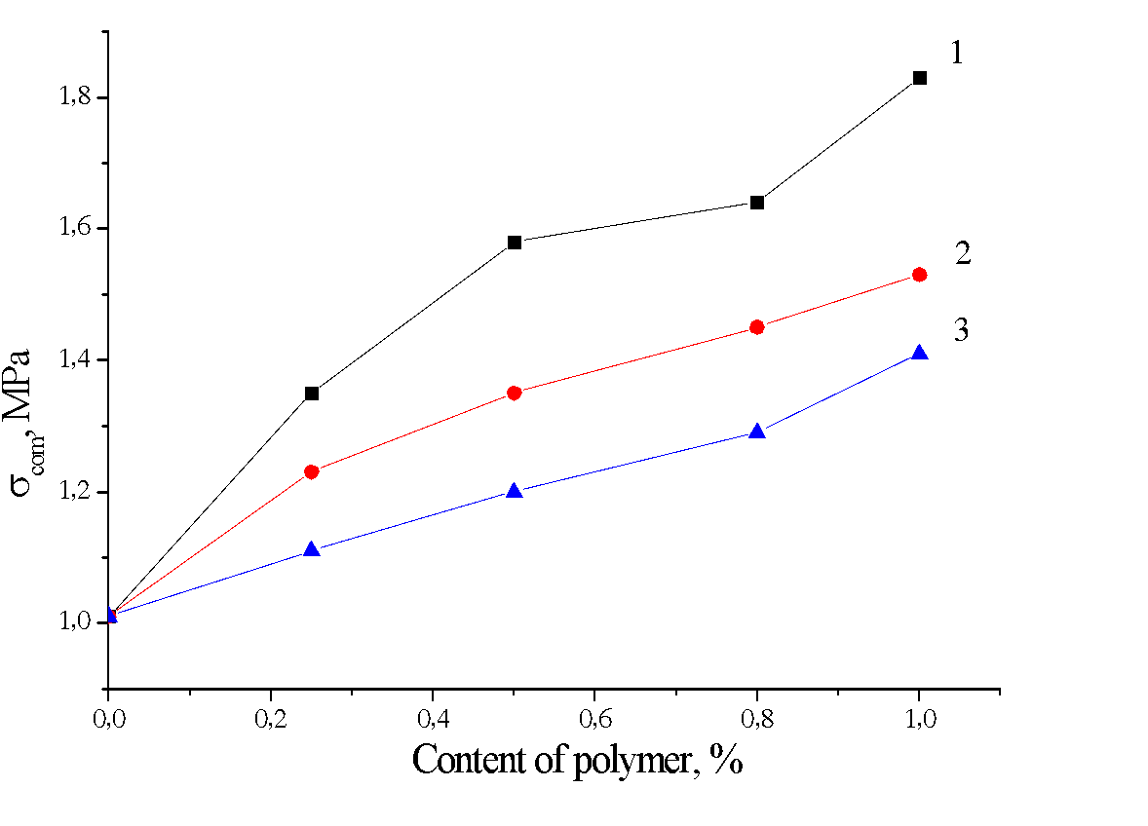 | a
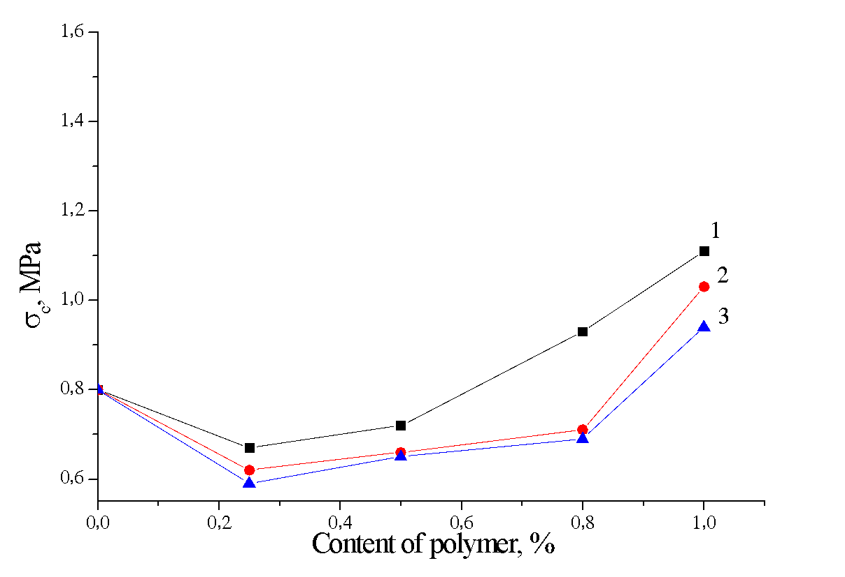 | b

Figure 1. Effect of polymers PVA:St – 95:5 (1), 90:10 (2), 80:20 (3) on the compressive strength of the materials with perlite (a) and without perlite (b)

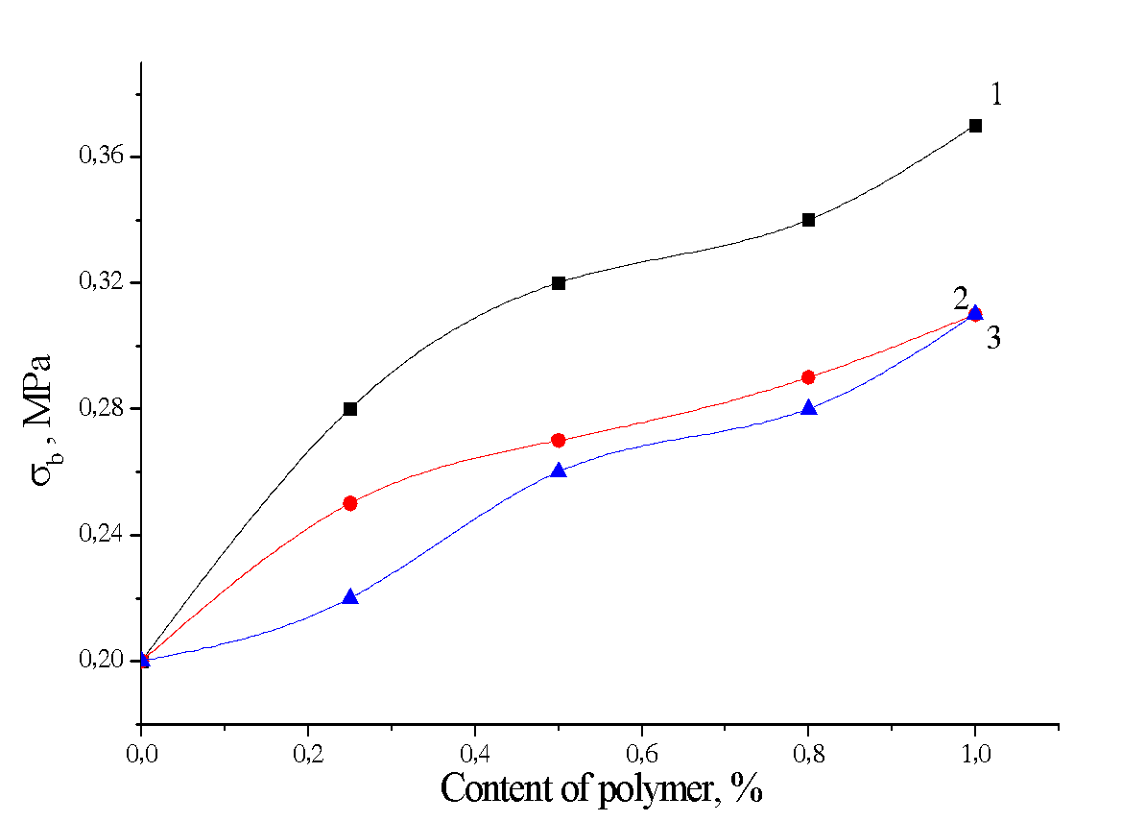 | a

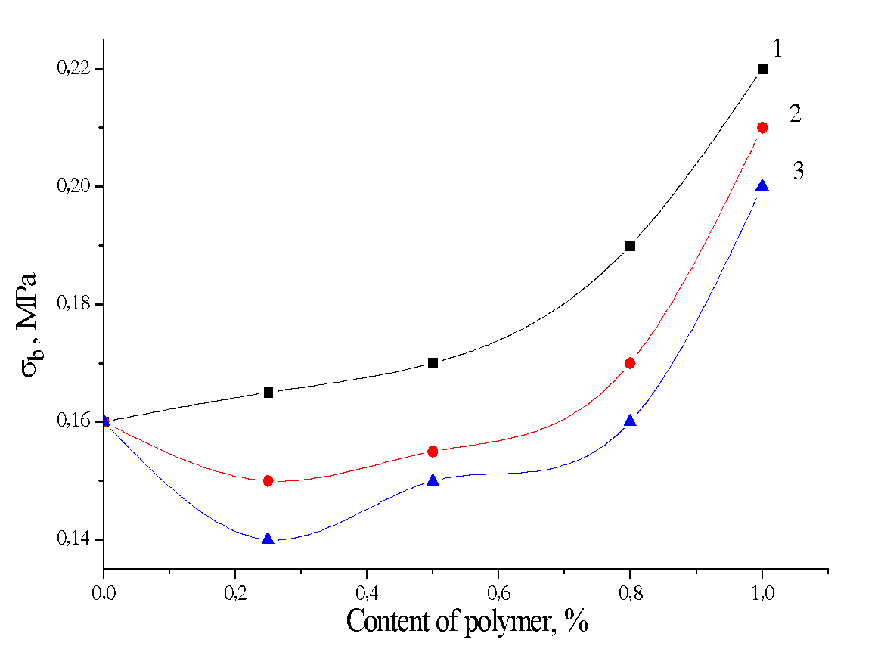 | b

Figure 2. Effect of polymers PVA:St – 95: 5 (1), 90:10 (2), 80:20 (3) on the bending strength of the material with perlite (a) and without perlite (b).
These results indicate that the addition of mixtures of synthetic and natural polymer in thermal insulation compositions in small amounts leads to a marked increase in strength characteristics.

Thermal conductivity of materials based on diatomite
The most important characteristic of thermal insulation materials are the coefficients of thermal conductivity. According to the measurements, the coefficient of thermal conductivity of the material with the optimum ratio of dry components ratios Dt:Rh:Bf:Pr – 70:15:11:4 (%) is 0.068 W/(m∙K).
Changes in the coefficient of thermal conductivity of such a material with the addition of polymers are shown in figure 3.
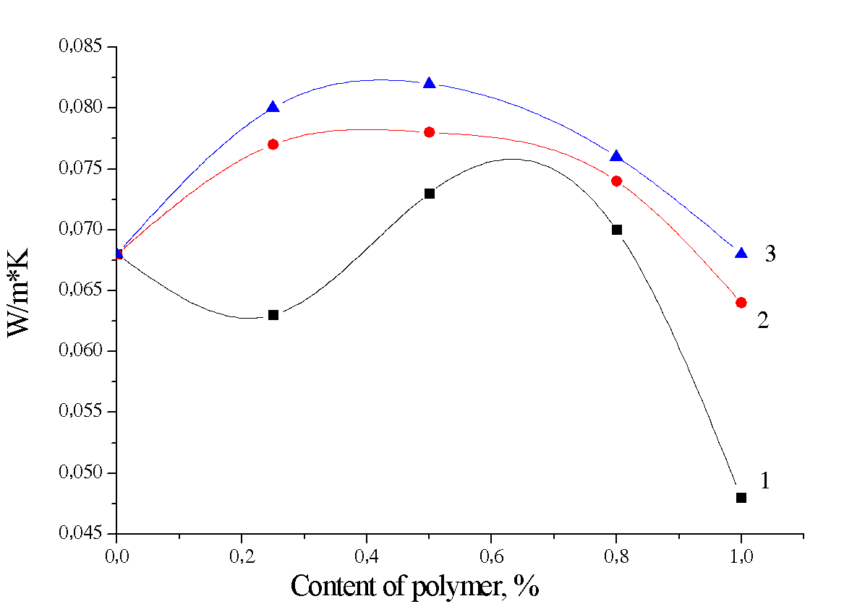

Figure 3. Effect of polymers PVA:St – 95: 5 (1), 90:10 (2) and 80:20 (3) on the thermal conductivity of the material
As can be seen from the figure, the greatest effect on the thermal conductivity is due to the mass ratio of the synthetic and natural polymer. Effective reduction of the thermal conductivity is achieved with a ratio of PVA:St equal to 95: 5.

CONCLUSION

Established that polymer additives have a positive effect to all characteristics of a heat-insulating material based on diatomite - density, linear shrinkage, compressive and flexural strengths, thermal conductivity. It is important that these characteristics undergo significant changes with a relatively small content of polymers - up to 1%, by weight. The studied materials based on diatomite in terms of their physicomechanical and thermophysical properties are of considerable interest for the manufacture of rigid insulation products used in thermal power generation.

REFERENCES
[1] Bobrov Yu.L., Ovcharenko E.G., Shoichet B.M., Petukhova E.Yu., Thermal insulation materials and constructions, by "Infra-M", Russia, 2003, pp. 67-68.
[2] Peletskii V.E., Shur B. A., Experimental study of the thermal conductivity of heat insulation materials based on expanded vermiculite, Refractories and industrial ceramics,vol.2, pp 25-26, 2007.
- [3] Yurkov A. L., Aksel'rod L.M., Properties of Heat-Insulating Materials, Refractories and Industrial Ceramics, vol.46, issue 3, pp 170-174, 2005.
[4] Ahmet Tandiroglu, Temperature-dependent thermal conductivity of high strength lightweight raw perlite aggregate concrete, International journal of thermophysics, vol.21, pp 124-129, 2010.
[5] Emmanuel O.E., Benjamin I.U., Sunday A.L., Utibe M. D., Effect of Rice Husk and Diatomite on the Insulating Properties of Kaolin - Clay Firebricks Electronic, Journal of Practices and Technologies, vol. 6, issue 11, pp 122-129, 2007.
[6] Chabannes M., Benezet, J.C., Clerc L., Garcia Diaz, Use of raw rice husk as natural aggregate in a lightweight insulating concrete, Construction and Building Materials, vol. 70, pp 428-438, 2014
[7] Aliu Adekunle O., Daramola A.S., Optimisation for the use of rice husk ash and sawdust as alternative binder for concrete, The International Journal of Engineering and Science, vol. 2, issue 10, pp 39-42, 2013.
[8] Efremova S.V., Rice husk as a renewable raw material and ways of its processing, Russian chemical journal, vol.1, pp 57-62, 2013.
[9] Dilmukhambetov E.E., Shatabayeva E.O., Urkimbayeva P.I., Zhetpisbayev Sh.R., Kaldybekov D.B., The effect of craft copolymers based on polyethylene glycol and n-vinylcaprolactam on physicochemical properties of cement pastes,15th International Multidisciplinary Scientific GeoConference SGEM 2015, Bulgaria, 2015, vol.2, pp 335-342.

