SYNTHESIS AT SUPERHYDROPHOBIC SOOT FLAMES AND ITS APPLIED ASPECTS
Zulkhair A. Mansurov, Meruert Nazhipkyzy, Bakhytzhan T. Lesbaev, Nikolay G. Prikhodko, Tatyana V. Chernoglazova, Dmitri I. Chenchik, Gauhar Т. Smagulova
Combustion Problems Institute, 172 Bogenbay Batyr St., 050012, Almaty, Republic of Kazakhstan
E-mail: ZMansurov@kaznu.kz

Introduction
At present time a demand urges of new technologies for production of waterproofing materials with low prime-cost. Especially the issue is very relevant in the construction industry, where moisture is a major cause of destruction of buildings made of metal, concrete and porous materials. Under certain conditions of hydrocarbon fuels combustion is soot producing which has superhydrophobic properties and can be used then as filler to waterproofing materials. In recent time a lot of works associated with synthesizing of hydrophobic carbon surfaces in flames were published [1-5].

Experimental
Synthesis of superhydrophobic soot was carried out with employment of burner and heating furnace by pyrolysis, general forms of which are shown in Fig. 1 (a, b).
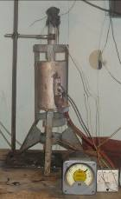
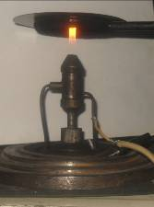

(а) (b)

Fig. 1 Synthesis of soot in burner (s) and pyrolysis (b).

Fig. 1 (b) shows a general view of the laboratory plant for pyrolysis of hydrocarbons and their mixtures. Thermal decomposition of hydrocarbons and their mixtures is carried out in dynamic conditions at jet plant. Pyrolysis of hydrocarbons occurs in a flow quartz reactor which is a quartz tube with inner diameter of 26 mm heating in an electric furnace. The gas mixture was fed by the single-channel quartz tube of 180 mm in length, the end of which is placed at the beginning of constant temperature zone. Consumption of each gas ranged from 115 cm³/min to 600 cm³/min. The additional flow of argon with volume of 475 cm³/min was fed to the head of reactor for puffing of forming soot. Since the experiments were performed close to the threshold value of soot formation the impact of reactor diameter on experimental results was exercised. The reactor of 26 mm in diameter was chosen as a reasonable compromise between the relative increase of unwanted contribution of heterogeneous reactions on reactor walls under decreasing of reactor’s diameter, and, on the other hand, the deterioration of temperature profile in isothermal part under increasing diameter of the reactor. Argon and acetylene were used in experiments without special treatment. The isothermal is a feature in conditions of hydrocarbons and their mixtures pyrolisis in presented quartz reactor. Isothermal of soot formation conditions is insured by feeding of hydrocarbon gases mixture to constant temperature zone of the reactor through a capillary. The constant temperature zone is 55-60 mm.
Due to the large endothermic and unsaturation acetylene is one of the most explosive gases used in industry. Therefore, exploitation of pyrolysis’ modes with use of acetylene is a critical task. With slow heating of acetylene up to 700-800°C there occur mainly the polymerization reactions with formation of aromatic hydrocarbons and resins. Rapid heating leads to self-ignition at 550 - 600°C. Heating of pure propane showed that pyrolysis in the mode of soot formation begins at about 1100-1150°C depending on the speed of gas feeding into the reaction zone (the time of hydrocarbon presence in the reaction zone).

Results and Discussion
With pyrolysis of hydrocarbon gases the simultaneous formation of different forms of carbon (mainly soot and pyrocarbon) with a large spread of particles by sizes, condensing on the walls of the reactor, takes place. If pyrolysis is conducted under isothermal conditions, ie to regulate the residence time of gas in the zone of high temperatures, it is possible to make conditions that ensure the formation of soot particles of required size and with a small spread in size. To determine the effect of isothermal pyrolysis conditions on the formation of soot particles a series of control experiments with non-isothermal conditions were carried out. These experiments were performed with a mixture of C₂H₂ (40ob%) /Ar (60ob.%) at a temperature in the reactor zone 1100°C. Found that under these conditions soot particles with a large spread in size are forming. Studies of soot formation under isothermal conditions of hydrocarbon pyrolysis at 800°C showed that in this case soot particles with a narrow particle size distribution are formed. For non-isothermal conditions the majority of soot particles have a size of 80 to 120 nm and with isothermal pyrolysis this index is 50-80 nm, Fig. 2.

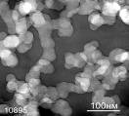
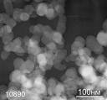

Fig. 2 Electron microscopic images of samples of soot.

Thus, investigations have shown that isothermal of conditions pyrolysis enable to produce more monodisperse material. Most of the soot, formed in a reaction volume, removed from the reactor with gas stream and captured by filter made of carbon fabrics. Combustion products are deposited on the walls of reactor consisted of pyrocarbon, which was collected and examined separately.
The produced soot under isothermal conditions was investigated on the subject of hydrophobicity. With this aim, from produced soot was prepared emulsion in 70% of alcohol solution. Produced emulsion was applied with a thin layer on the substrate surface, dried at room temperature and examined obtained surface on the subject of hydrophobicity by using of sessile drop technique.
Preliminary, the studies on evaluation of time absorption of water droplet in clean washed fabric were carried out. The dynamics of the process of absorption of water droplet by time is shown in Fig. 3. Found that the absorption of water droplet occurs in 1 minute 15 seconds.
Fig. 4 shows the dynamics of water absorption into the fabric treated by the Obruchev method. Found that a water droplet starts to absorb into the fabric after 10 minutes.
For increasing of hydrophobic properties of the fabric the Obruchev method with addition of hydrophobic soot was used. With this aim, the fabric was lowered into the prepared alcoholic solution of hydrophobic soot and dried at room temperature. Fig. 5 shows photographs of water droplets behavior on the surface of the fabric treated with 70% alcoholic solution containing superhydrophobic soot.
Start 15 sec 30 sec
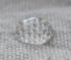
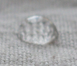
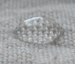

45 sec 1 min 1 min 15 sec
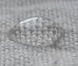
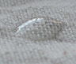
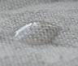

Fig. 3 Dynamics of absorption of water droplet into the washed fabric.
Start 5 min 10 min
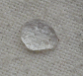
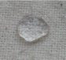
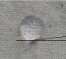

Fig. 4 Water droplet on the washed fabric treated by the Obruchev method.

Start 1 min 2 min
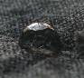

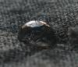

3 мин 4 мин 5 мин

3 min 4 min 5 min
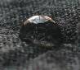

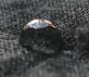

Fig. 5 Water droplet on the fabric treated with 70% alcohol solution containing superhydrophobic soot.

Found that fabric surface has a hydrophobic property with contact angle less than 150⁰. After 5 minutes the absorption of water droplet into the fabric is starting (Fig. 5).
The obtained fabric samples pretreated in 70% alcohol solution containing superhydrophobic soot, and then were treated with soapy water and placed to saturated solution of potash alum for 5 minutes. Drying of fabric at room temperature spent 3 hours. After complete drying, the fabric was subjected on hydrophobicity. The results show that the absorption of water droplets into the fabric does not occur even in a long time. For evaluation of fabric hydrophobicity with a different percentage of its volume saturation with hydrophobic soot the investigations were carried out. With this aim, the emulsion of alcoholic soot solution containing 5, 50, 75, 100 mg of superhydrophobic soot was prepared. The results showed that the exceptional water-resistant property has a fabric, treated in an alcohol solution containing 100 mg of soot. The results are shown in Fig. 6. In this case contact angle made more than 170⁰, indicating of superhydrophobic property of resulted surface.
Obtained with isothermal conditions submicron soot was added as hydrophobic filler to T-37 type polymer coating with concentrations of 1, 2, 3, and 4% from mass of the original material. The resulting mixture was mixed, applied to the drywall and dried for 5 days at room temperature. After five days, the samples were examined for hydrophobicity by the sessile drop technique, Fig. 7. Studies have shown that with increasing of soot concentrations in the origin material hydrophobicity increases and the contact angle higher than 150º. The adding of hydrophobic filler allows water repelling not only the surface layer of the coating, but also its volume, which significantly improves the quality of protection against moisture penetration. In addition, hydrophobic coating has high adhesion to different surfaces and high penetrating power due to nano-sized particles of polymer and filler.

25 mg 50 mg
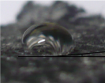
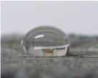

75 mg 100 mg
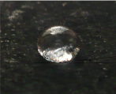
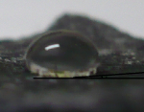

Fig. 6 Water droplet on a fabric treated in alcohol emulsion with the addition of soot and method of Obruchev.

1% 2%
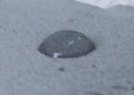
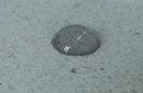

3% 4%
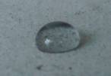
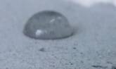

Fig. 7 Water droplet on coating layer deposited on drywall.

Conclusions
The results showed that treatment of fabric with mechanical method the hydrophobicity of obtained fabric samples is inferior to the hydrophobicity of the samples treated by Obruchev method. During co-treatment of fabric samples by mechanical and Obruchev methods, hydrophobicity increases significantly. In this case the contact angle is more than 170⁰, indicating the superhydrophobic property of the resulting surface.
It was discovered that the addition of hydrophobic soot into polymer coating with amount of 4% from mass of the origin material gives hydrophobic properties to coated surface. In this case, the contact angle is higher than 150⁰.

Acknowledgment. This work is carried out under financial support of the Ministry of Education and Science of the Republic of Kazakhstan (The program of Fundamental research 120 by the budget program "Grant funding for research").

References
[1] Sayangdev Naha, Swarnendu Sen, Ishwar K. Puri. Flame synthesis of superhydrophobic amorphous carbon surfaces. Carbon 2007; 45:1696–1716.
[2] Levesque A, Binh VT, Semet V, Guillot D, Fillit RY, Brookes MD, et al. Mono disperse carbon nanopearls in a foam-like arrangement: a new carbon nano-compound for cold cathodes. Thin Solid Films 2004;(464–465):308–314.
[3] Sen S, Puri IK. Flame synthesis of carbon nanofibers and nanofiber composites containing encapsulated metal particles. Nanotechnology 2004;15(3):264–268.
[4] Nazhipkyzy M., Mansurov Z.A., Puri I.K., Lesbayev B.T., Shabanova T.A., Tsyganov I.A. Preparation of superhydrophobic surfaces of carbon during combustion of propane. Oil and gas 2010: (5):27 - 33.
[5] Nazhipkyzy M. Shabanov T.A., Lesbayev B.T., Antoniuk V.I., Mansurov Z.A., Puri I.K.Carbon deposits formed in the flame (electron microscopy and XRD studies.) Combustion and plasma chemistry 2010;8(2):169 - 173.

