THE MECHANISM OF FIVE-MEMBERED RINGS PAH-FULLERENES EMBRYOS FORMATION UNDER COMBINED COMBUSTION WITH IMPACT OF ELECTRIC FIELD
Nikolay G. Prikhodko, Gauhar Т. Smagulova, Bakhytzhan T. Lesbayev, Moldir Auyelkhankyzy, Ajagoz Bakara, Zulkhair A. Mansurov, Meruert Nazhipkyzy

Institute of Combustion Problems, 172 Bogenbai Batyr St., 050012, Almaty, Republic of Kazakhstan E-mail: nik99951@mail.ru

Introduction
Flame is a complex subject for study. It is still not possible to resolve all questions and fully understand the processes occurring in the flame. There are different approaches to explain the mechanism of formation of PAH and fullerenes [1-4]. The formation of products (PAH, fullerenes, carbon black, etc.) when burning is the fast reaction, in which the time from 10⁻⁵ to 10⁻³ with the solid phase is formed. In this case the conversion of fossil fuels leads to a multiple increase in the atomic weight of the particles (for example, benzene, from 78 to 720 amu (C₆₀), 840 amu (C₇₀), and more). The formation and further transformation PAH until fullerenes and soot particles during combustion of hydrocarbon fuels is a complex multistage process, which is closely related to the general kinetic mechanism of combustion. This paper presents a possible mechanism for the formation of five-membered rings PAH combustion premixed benzene-oxygen-argon mixture with an effect on the peripheral part of the acetylene-oxygen flame and the electric field at low pressure.

Experimental
Synthesis of fullerene-containing soot was studied at a combined process of burning benzene-oxygen-argon mixtures and acetylene-oxygen flame with an electric field at low pressure. Experiments were performed to identify the effect of pressure in the range from 20 to 100 Torr on the yield of fullerenes with a ratio C / O = 1.0. The duration of one experiment was 20 minutes. After completing the experiment, soot collected on the inside surface of the burner, filter sazhesbornika and prepared for further studies. To identify and PAH fullerene soot samples in the quantity mc = 100 mg were subjected to cold extraction in benzene for 72 hours, and then the resulting extract was analyzed for FT-IR spectrometer, the company «Perkin Elmer».

Results and Discussion
There is currently no single point of view on the mechanisms of formation of fullerenes in flames, but most scholars are inclined to believe that during the formation of fullerenes play a fundamental role of polycyclic structures containing five-membered ring. It should be noted that the five-membered rings are the constituent elements of certain molecules PAH (for example, korannulena C₂₀H₁₀). In turn, the formation of a five-membered PAH structures in the flame has not been fully elucidated. One of the main mechanisms of formation of aromatic molecules containing five-membered ring (aryl-5), the oxidation of six-membered aromatic rings (aryl-6) in the oxy-PAH (aryl-6-O) as they interact with O₂ and subsequent decomposition of aryl-6- On to the aryl-5 and CO [2]. Further interaction of aryl-5 with acetylene forms PAH with an odd number of C atoms in the molecule [5]. It is established that the primary products of oxidation of benzene-oxygen flame containing phenol [5]. One of the possible mechanisms of PAH a five-membered rings in the flame may be a reaction of phenol with molecular oxygen-containing radicals, such as the radical Н-С˙=С=О, formed by the interaction of acetylene (an intermediate product of combustion of hydrocarbon fuels) and atomic oxygen:
С₂Н₂ + О˙ → Н-С˙=С=О + Н˙
In Fig. 1 shows the possible reaction of phenol molecules with the radicals H-C ˙=C=O, which leads to the formation of a five-membered rings PAH, which may also occur in several stages. Such a reaction is thermodynamically favorable due to the energy release, the formation of water molecules.
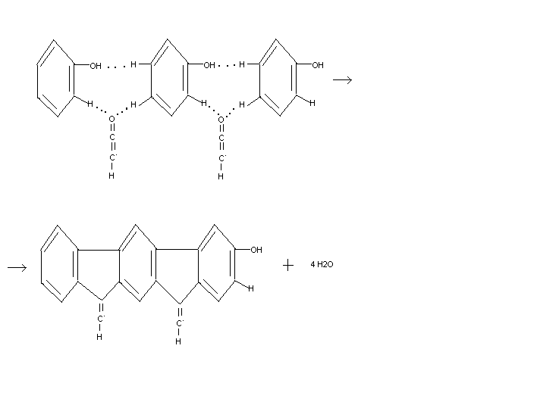

Fig. 1 Scheme of the possible reaction of phenol and the radical Н-С˙=С=О.

We can assume that during the formation of a five-member rings PAH can participate aryl radicals and H-C˙=O, formed during the combustion of hydrocarbon flames, the number of which is further enhanced by adding a buffer gas pressure reduction system. The participation of radicals VAT is precisely in the formation of nucleation of polycyclic structures with five-member rings, shown in Fig. 2.

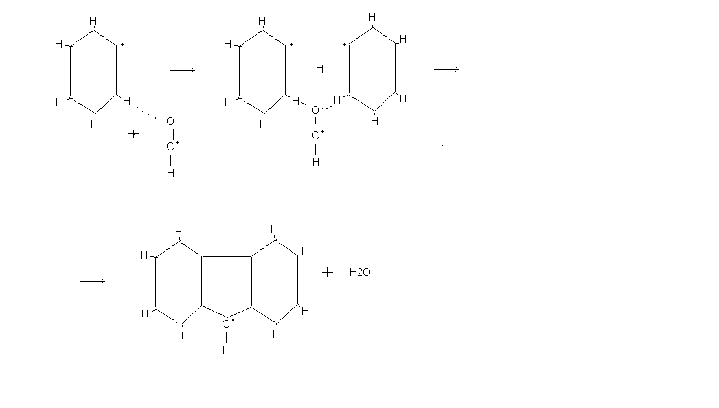

Fig. 2 Scheme of possible mechanism for the formation of five-member rings PAH the interaction of aryl radicals and НСО.
The reaction proceeds in several stages. Further growth of the molecule PAH with five-membered rings (up to the formation of the fullerene molecule) goes with the molecules of acetylene and aryl radicals. Furthermore, the nonlinearity of the radical НСО creates prerequisite for the formation of polycyclic structures have not linear, and three-dimensional structure, which increases the probability of involvement of these structures in the process of nucleation of fullerenes, and soot particles are not.
The most likely of the above possible mechanisms for the formation of five-membered rings PAH is a mechanism in which the aryl radicals are involved, and НСО. The formation of structure by pentanomial particle removal of CO molecules from the aryl-O has a high activation energy barrier, so the probability of this reaction is not high. In turn, the reaction of PAH with the five-member rings with phenol is less likely compared to the third mechanism, since the concentration of phenol molecules in the flame radical concentration is less HCO.
The experimental results obtained at different pressures is consistent with the proposed formation mechanisms PAH with the five-member rings. The concentration of radicals НСО s strongly dependent on pressure, so increasing the pressure of the system increases the overall yield of soot, rather than fullerenes, which could be due to insufficient concentration of the radical НСО, required for the formation of five-member rings PAH In addition, in favor of the latter mechanism is that when you add an inert gas into the flame of an increasing number of radical, НСО, and diluted with an inert gas system is a prerequisite for the formation of fullerenes.
Experimentally it was found that when exposed to fullerenobrazuyuschee benzene-oxygen flame outside acetylene-oxygen flame and the electric field, the total yield of fullerenes increases. The positive effect of the acetylene flame is not only the temperature of the reaction zone of the main benzene-oxygen flame and increase the degree of ionization, but maybe an additional input НСО radicals formed during combustion of acetylene, benzene into the reaction zone of the flame. The total concentration of these radicals in the reaction zone is increased, thereby increasing the likelihood of PAH a five-member rings at the same time by an electric discharge occurs in the time between intense flame radicals O, H, OH, is actively involved in the processes of branching chain reactions, which slows down the process of soot formation and creates the conditions for preferential formation of fullerenes.
Thus, the findings speak in favor of a mechanism based on the interaction of aryl radicals, and VAT and has been suggested that this mechanism contributes more to the formation of a five-member rings PAH.

Conclusions
Analysis of the results of experimental studies of synthesis of fullerenes in the combined combustion showed that the predominant mechanism for the formation of five-membered rings PAH embryos which are fullerenes, can be a mechanism for the interaction of aryl radicals and НСО.

References
[1] Bachmann M., Wiese W., Homann K.H. PAH and aromers: precursors of fullerenes and soot. Proc. Combust. Inst. 1996;26:2259–2267.
[2] Kunioshi N., Touda M., Fukutani S.. Computational study on the formation of five-membered rings in PAH through reaction with O₂. Combust. Flame 2002;128(3):292–300.
[3] Richter H., Howard J.B. Formation and consumption of single-ring aromatic hydrocarbons and their precursors in premixed acetylene, ethylene and benzene flames Phys. Chem. Chem. Phys. 2002;4(11):2038-2055.
[4] Richter H., Granata S., Green W.H., Howard J.B. Detailed modeling of PAH and soot formation in laminar preliminary mixture benzene/oxygen/argon at low pressure flame. Proc. Combust. Inst. 2004;30:1397-1405.
[5] Homann K.H. Fullerenes and soot Formation – New Pathways to Large Particles in Flames. Angew. Chem. Int. Ed. Engl. 1998;37:2434-2451.

