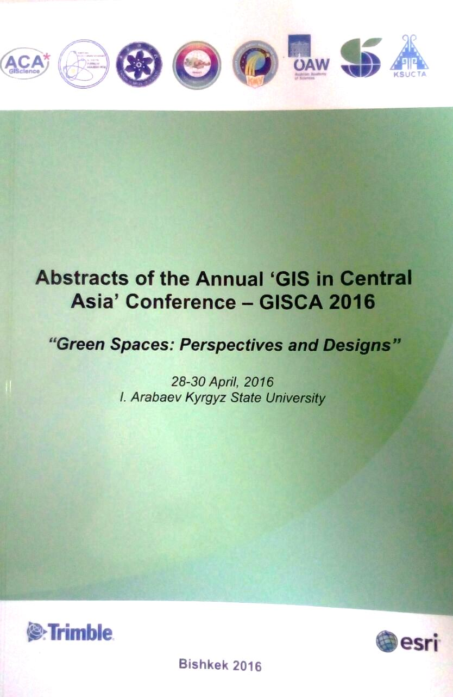
Seasonal home range characteristics of Saiga tatarica in Kazakhstan with estimates of livestock/saiga overlap areas
Nurkuisa Rametov ¹, Mukhit Orynbayev ¹, Muratbek Kudaibergenov ², Jason Blackburn^{3,4}

¹Research Institute for Biological Safety Problems, Monitoring bacterial and viral infection laboratory
²Al-Farabi Kazakh National University
³University of Florida, Department of Geography & Emerging Pathogens Institute, Spatial Epidemiology & Ecology Research Laboratory
⁴Kyrgyz Consortium for GIS Excellence, Bishkek, Kyrgyzstan

In recent years, the total number of Saiga antelope (Saiga tatarica tatarica) in Kazakhstan has declined rapidly due to several factors. The Kazakh saiga population is concentrated in two major herds. Here we focus on the Volga-Ural saiga population in the West Kazakhstan region. Annually, as the saiga population concentrates in certain habitats, the density of animals within those habitats and the number of contacts with domestic livestock increase. As a result of mixing of wild and domestic animals, pathogen exchange is possible and the risk of saiga disease increases. Saiga are a migratory species, and may serve as vectors for infectious diseases across their migration corridors. Therefore, it is necessary to define the characteristics of seasonal migrations and congregation areas to better understand epidemiological and environmental factors that may drive transmission between saiga and livestock (from wildlife to livestock and livestock to wildlife).
The aim of this study was to determine the season home ranges, routes of seasonal migrations, calving places and rutting sites. We deployed 10 GPS Plus Collars on saiga from two groups; 8 animals in the western group and 2 in the eastern group of the Volga-Ural population. Spatial data, ambient temperature and other data were recorded and transmitted via satellite daily. GPS Plus X, ArcGIS 10, and Q-GIS (v2.4.1) were used for data processing. We use the T-LoCoH package in R to construct localized-hull based seasonal home range estimates for each group [http://tlocoh.r-forge.r-project.org/]. These analyses provide conservative estimates of saiga seasonal ranges, allowing for comparison between the west and east groups and will allow us to quantify livestock habitat/overlap zones within those ranges.

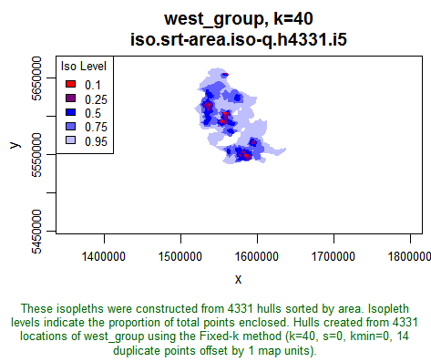
Fig. 1 T-LoCoH analyses for spatial data.

