Design of catalysts of carbon dioxide conversion of methane

A.V. Mironenko, А.B. Kazieva, Zh.B. Kudyarova, Z.А. Mansurov
The Institute of Combustion Problems, 172 Bogenbai batyr str. Almaty, Kazakhstan
*anamir.48@mail.ru

Keywords: methane, carbon dioxide, syngas, fiberglass, nanostructured catalyst

Introduction
The reaction of carbon dioxide conversion of methane (DR) is one way that allowing to convert natural gas – methane into valuable end products, representing the gas mixture of hydrogen and carbon monoxide in different ratios [1]. From this viewpoint, it is the most secure method, in contrast to the partial oxidation of methane by atmospheric oxygen and steam-oxygen conversion.
In this reaction, the contacts on the basis of nickel oxide have maximum spreading, however, in spite of high activity of these catalysts, their use is limited by significant carbonization processes [2, 3]. In this regard, at the present time a search of new catalytically-active compounds is occurred, these compounds can became as an alternative to nickel contacts. From this viewpoint, the catalysts consisting of cobalt oxides and its compounds are modified with other oxides are of interest.
In recent years, the high-temperature fiberglass is used as a basis in the various processes, in spite of the low surface area, its hydraulic, technological characteristics as well as flexibility in application is vastly superior to traditionally used contacts, including block system of catalysts.

Experimental/methodology
The synthesis "solution combustion" is carried out according to the equation:

Me(NO₃)₂*6H₂O +2NH₂CH₂COOH + 4.5O₂ → MeO + 4CO₂ + 11H₂O + 2NO₂

Investigations on catalytic activity in reaction of RD of polyoxide catalysts system on the basis of fiberglass consisting of magnesium oxides, nickel and cobalt were carried out. The activity of catalysts was tested on-line with using of gas chromatographic analysis method on device «ХРОМОС ГХ-1000», is equipped with software (SW), and data recording to the computer.
Synthesized samples are examined by XRF, SEM, TEM methods as well as thermo-programmed reduction by hydrogen.

3 Results and discussion

X-ray analysis showed that after passing of synthesis by "solution combustion" method, on the surface of samples, depending on the initial composition of the charge (nitrate salts), there is phase formation of nanostructured systems is occurred: Co3O4, MgO, NiCo2O4, 3CoO • 5NiO, MgNiO2.
The obtained TEM-images have shown that linear dimension of surface structures on the fiberglass is in interval 5-17 nm. The data of TIS indicates on step process for recovery of active components.

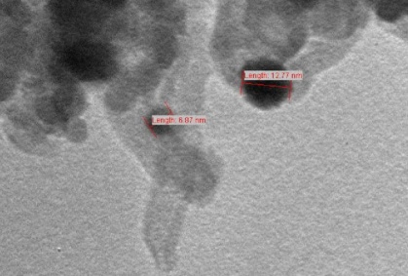
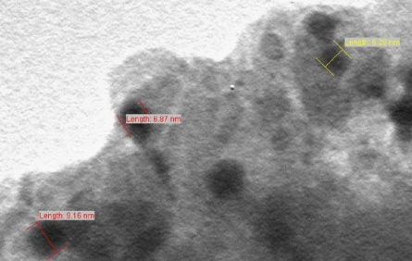

Fig. 1- TEM images from different locations of sample №9

The temperature effect and composition of (MgO, NiO, CoO) polyoxide catalysts on their catalytic activity in the reaction of DR is studied. It was found that the temperature in the interval of 850-900 0C is the optimal temperature of the process.
Variation of sample composition at the temperature 850 ⁰С has shown that samples containing magnesium oxide – 2 %, nickel – 1,4% and cobalt – 1,6 % have optimal characteristics.
Also, the influence of volume velocity on activity of synthesized samples was investigated. It was found that in the interval of 3200-9600 h-1 the activity of catalyst is almost on the same level: the conversion of initial products is 98-99%, the yield of hydrogen is - 42-43%, and carbon monoxide is - 52-53%.
The analysis of experimental data, is based on the ratio H₂O/CO, shows that most complete conversion of methane and carbon dioxide into reaction products is occurred on the catalyst at temperatures of 850-900 °C: H₂O/CO = 0,092 and 0,072 respectively. The material balance calculations on carbon have shown that the unbalance on carbon average 0.45% and during the tests was almost on a level with a defection of ± 1%.

4 Conclusions

From obtained experimental data it was found that nanostructured catalysts on the basis of high-temperature fiberglass are exhibit the high catalytic activity during the process of carbon dioxide processing of methane (DR) into the synthesis gas, the ratio H₂/CO is close to 1. It is shown that DR process the conversion of methane and carbon dioxide reaches 98-99% and the yields of hydrogen and carbon monoxide comprises 42 and 52%, respectively. Also it was found that the content of magnesium oxide is introduced into catalyst system has a major influence on the basic characteristics of DR process. It was shown that catalytic activity remains almost constant during 30 hours of catalyzator work at 850 ° C.
Thus, inference should be drawn that catalysts on the basis of fiberglass have fairly good perspectives at processing of natural gas - methane into valuable synthesis gas for chemical industry
References
[1]. О.V. Krylov, Catalytic processing of natural gas / О.V. Krylov // Kinetics and catalysis. – 1999. - Т.40, №1. - P. 151-157.
[2]. The formation of condensation products in the process of carbon dioxide conversion of methane on Ni-contain catalyst / L.V.Galaktionova , L.А. Arkatova, Т.S. Kharlamova, L.N. Kurina, Yu.S. Naiborodenko, N.G. Kasatsky, N.N. Golobokov // Physical chemistry journal. – 2007. – Т.81, № 10. - P.1917-1920.
[3]. Carbon dioxide reforming of methane to synthesis gas over Ni-MCM-41 catalysts / Liu D., Raymond Lau, Armando Borgna, Yanhui Yang // Appl. Catal. A: General.- 1 May 2009. - Vol. 358, Issue 2. – P. 110-118.

