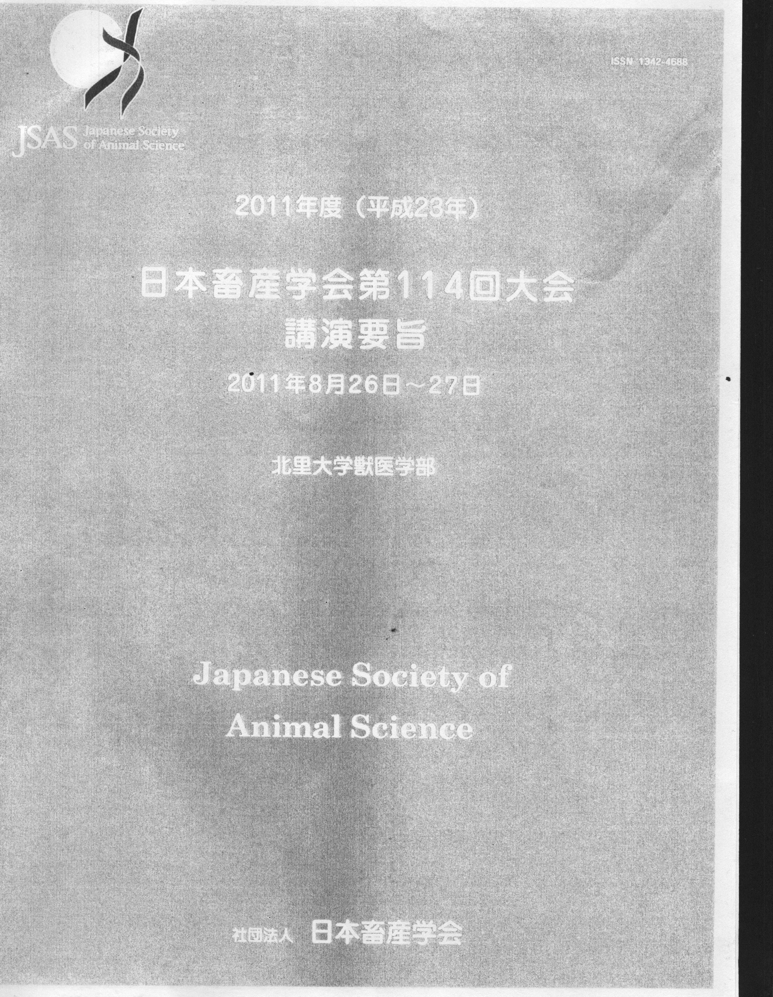


Japanese Society of Animal Science.2011. Vol. 27. P. 175

