IMPACT OF PERSONAL FEATURES OF THE TEACHER ON COPING BEHAVIOUR OF THE STUDENTS
Tashimova Fatima*, Ismagambetova Zukhra, Ibraeva Galiya
Tashimova Fatima, 117-B/7 Dostyk Avenue, Almaty, 050057, Republic of Kazakhstan
Ismagambetova Zukhra, 71, Timiryazev street, Almaty 050057, Republic of Kazakhstan
Ibrayeva Galiya
Abstract
The representation level of the teacher in the inner world of the students is influencing to the success in the study activities (Liimets H.I.). Because they are real accompaniers to students in the learning process, as in the temporal aspect, as well as in content, the question arises about the possibility of their impact on particular coping behavior of students.
According to hypothesis following methods were used in the research: 1. Frydenberg, E., Lewis, R. Adolescent (Coping Scale - ACS), adapted by Krukova T. N. "Scaling of regulatory and personal relations" Mislavskiy Y. A. Processing was carried out by using of factor analysis. The result revealed the following relationship: Students in Group 1 teachers are reflected in both subjects with a high value in the inner world of students, enabling them to achieve, aspirations and self-esteem, as well as close to the I image. The students are characterized by a mobile style of coping with a high focus on problem solving and high level of self-control (egotism). For students in Group 2 teachers reflected as a pleasant personality and accepted, directing their achievements. The style of coping is characterized for the desire for harmony and overcoming psychological defense. In the third group of students the teachers are presented as constraints and do not support their claims, and self-esteem. They are characterized by egocentric style of coping characterized by a predominance of psychological defense mechanisms (withdrawal, Jonah complex, etc.). In the fourth group the teachers are presented in a contradictory version: as supporting their claims and self-esteem and criticizing. The style of coping is characterized by a predominance of the emotional components and the avoidance of responsibility.
Thus, the measure of the representation of teachers and the nature of their reflection in the inner world of students significantly affect not only the success in studies and in the ways of coping mechanisms reflecting the ratio of personal growth and psychological defense.
Key words — personalization (representation); coping behavior; overcoming; psychological defense

IMPACT OF PERSONAL FEATURES OF THE TEACHER ON COPING BEHAVIOUR OF THE STUDENTS
1.INTRODUCTION
The notion of "representation" was first introduced by Al-Farabi [1], the analysis of the subject as "a microcosm which provides a whole macrocosm."
The representation can be regarded as introjections of Freud [2], the "presence" significant other in the person of the subject, which determines its behavior and activity by H.Y.Liymetsu [3]
Representation in this sense - it reflected the importance of the subject of another person, unseen accomplice of sense formation process, which determines the functioning of the internal world of man. [4]. Based on the above, we assumed that the measure of representation in the individual student teacher has a significant impact not only on the success of the training, but also on the particular style of coping, which provides a measure of creative adaptation to the conditions of the integration process.
- METHODS:
According to hypothesis following methods were used in the researcch: 1. Frydenberg, E., Lewis, R. Adolescent (Coping Scale - ACS), adapted by T.N.Krjukova [5]; "Scaling of regulatory and personal relations" Mislavskiy Y. A. [6]

SUBJECTS:

There were 252 students investigated in general. In data analyzing were used: the factor analysis, a method of the main components and calculate the average.
RESULTS:
As a result, ranking as the success of the training was allocated to four groups of students. Group 1 -5 points. Second group of -4.5 b. Group 3 - 4.2. The fourth group - 4,0b. Next, we have examined the characteristics of these groups of students reflect the personality of teachers, which determine the extent of their representation on the results of techniques by Mislavskiy J. A,
Table 1. Reflection of personalization valuable of the teacher in the groups.
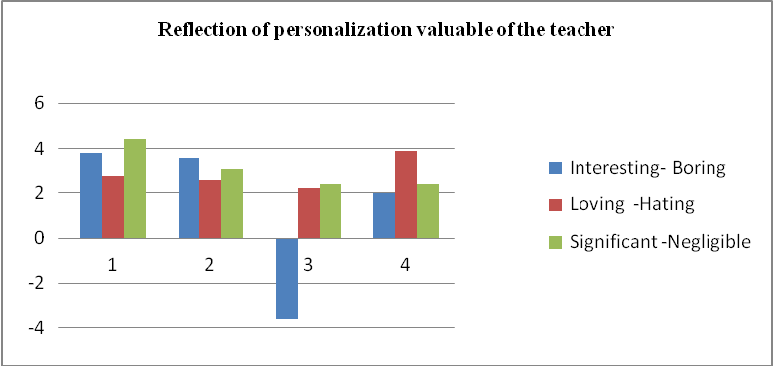

Fig. 1
The analysis of the reflected subjectivity of teachers in terms of the value of their individual representatives of different groups can say the most pronounced its significance in the subjects in Group 1. In group 2, teachers reflected more interesting as, in group 3, they are somewhat negatively, as boring and a little significant, in group 4, they are presented as a favorite. Thus, the greatest teachers of values ​​typical for the group 1, 2 and 4.
Table 2. Stimuli measures of students achievement by the teachers;
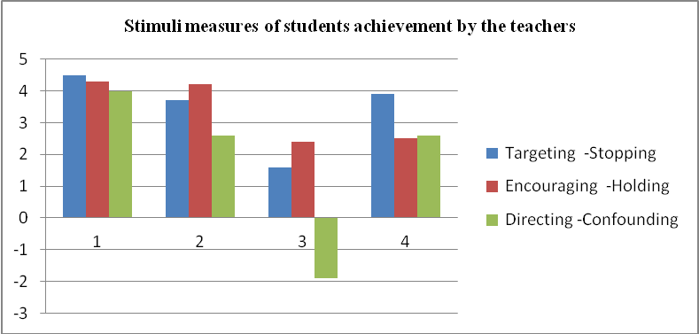
Fig. 2
What is the representation of teachers as contributing to achieving the objectives of the students? In group 1, they are presented as encourage the goals and guides, Group 2 - how to encourage achievement and move, in group 3 - how to capture objectives, in group 4 as the rush to achieve, but not enough to encourage their retention.
Table 3. Measures on orientation by teachers on themselves as an example to imitate
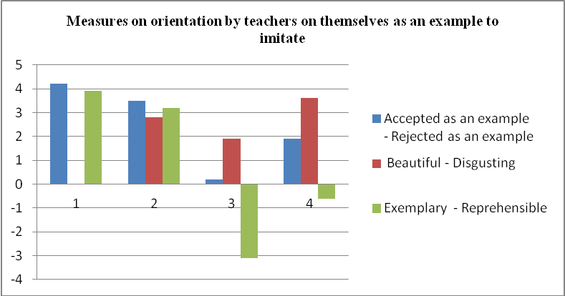
Fig. 3
The extent to which teachers orient themselves as a model of imitation? As a model for emulation and decent teachers are the students in Group 1. As people with whom you can identify to some extent observed in group 2. For students of third group teachers are presented as more or less pleasant people, but not taken as a model and even more reprehensible. In the group 4 teachers are presented as beautiful on their own people, but does not encourage imitation.
Table 4. Degree of affinity of an image "I am teacher to the student";
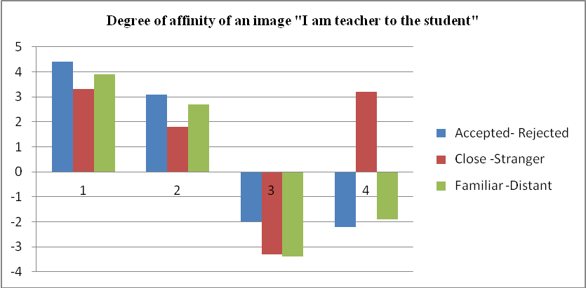
Fig. 4
What is the ratio of the I image of the teacher and students in the degree of closeness and distance? The closest is the I image of the teacher is for students in Group 1. Taken for granted that it makes sense to respect, is presented in group 2, but the image does not quite match their personality. For students of third group self-image of teachers is alien to them. For students of fourth group self-image of teachers is to "own way", but not taken.
Table 5. Measure the stimulus level of aspiration of the student by teachers;
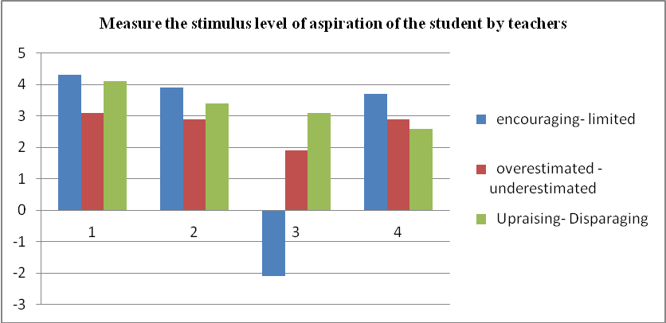
Fig. 5
To what extent, teachers are presented as stimulating students' level of aspiration? According to information received, the students of group1reflect teachers as encouraging and elevating their level of aspiration. The students of 2 group teachers are both promoting their level of aspiration. Students of group 3 reflect teachers to degrade to some extent limit their level of aspiration. The students of group 4 as supporting their level of aspiration.
Table 6. The measure of stimulation of self-estimation of the student by teachers
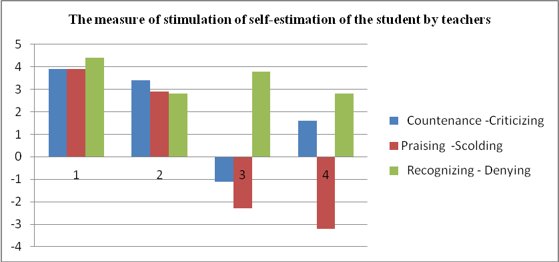
Fig. 6
And finally, how does the representation of teachers influence on students' self-esteem? For students in Group 1 and 2 teachers are reflected as a stimulating and supporting their self-esteem. Students of group 3 reflects how teachers deny their self-esteem. In sociocentric students the teachers are ambivalent: they both unmet self-esteem and at the same time, trying to maintain it.
Now consider what coping styles are applicable to these groups. In this regard, we consider the results of factor analysis by the method of "Youth Coping - the scale" of Fraydenberg and Lewis, adapted by T.L.Kryukova "[]
Table 1 – Illustrated reflection of the factors
Determining factors of the students represented by the following indicators, which reflect those or other coping strategies:
The factor 1 is presented by the following indicators reflecting those or other coping strategy: Focusing on the problems decision (0,635). Needs for social support, discussion of a problem with other people on purpose to secure with their approval and support - (- 607); Persistent work and achievements - (0,583); Dispassionateness, unwillingness to devote others in the cares – (0,561); Self-accusations, the strict relation to, sensation of a private problems responsibility - (0,522); Ignoring, conscious blocking of a problem (-0,491); Productive leisure (playing sports, health maintenance - (- 0,472); Orientation to religious support – (0,405). A discharge (tears, aggression, alcohol, drugs) – (0,382)
The factor 2 is presented by indicators with following factorial scales: Success in study and achievements – (0,752); the Optimistic view on actual problem – (0,698); Considering of a problem from different points of view and the decision (0,499); the Rate on close friends – (0, 482); Active resting (playing sports, health maintenance) – (0,470). Derivations, entertainments in a society – (0,467); the Organization of public actions – (0,379); Anxiety and uneasiness on consequences – (-0,437); Self-accusations, responsibility acceptance on itself (0,385);

The greatest loadings in the factor 3 have following indicators:

Dispassionateness, refusal to devote others in the cares – (0,554); the Discharge – (tears, aggression, alcohol, drugs) - (0,537); Orientation to religious support – (0,513); Hopes of a happy occurrence – (0,455); Success in study and achievements - (0,413); Anxiety, uneasiness for consequences – (0,403); Self-accusations, responsibility acceptance on itself – (0,390); problem Ignoring, their conscious blocking (0,308).
The factor 4 is presented by following indicators: Requirement for social support – (0,674); Feeling of an accessory and search of their approval – (0,642); the Support on close friends – (0,533); Success in study and achievements – (-0,507); Hope of a happy occurrence – (0,504); Refusal of actions, up to painful conditions – (0,491); problem Ignoring, its conscious blocking – (- 0,473); Dispassionateness, refusal to devote others in the cares – (- 455); Orientation to religious support – (0,446).

C.DISCUSSION
The analysis of indicators allows ascertaining that students are defined by different styles of coping behavior. Reflecting mobility and independence in the decision of the life problems, assuming dispassionateness from intervention of others prevail. In this case, dispassionateness strategy can be understood as high concentrations on purposes achievement and concentration on the problems decision, own responsibility connected with comprehension for result. That is, dispassionateness in this case, reflects deepness in a problem solution, self-sufficiency of the subject focused on personal growth.
The given factor reflects high enough level of subject’s self-regulation, more using the overcoming of difficult reality situations strategy, at the limited system of coping ways of protective character. The egotism is most used defense mechanisms as a high level of self-control. Pressure from high concentration overcomes by different defense mechanisms, such as discharge (tears, aggression, more often, directed on itself). Unfortunately, the given factor reflects some ignoring of body care problems, directed on restoring of the forces connected with active rest. According to above, it is possible to tell that the given strategy parity allows to define the given factor as problem-oriented coping style, corresponded with "mobile" style. For this group the high identification with the teachers is typical. They are presented as subjects with a high value in the inner world of students, enabling them to achieve, aspirations and self-esteem, as well as close to I image.
The analysis of second factor indicators allows us to ascertain it as orientation on own system self-effectiveness in overcoming of difficult reality situations, also as an account, and correlation to meaningful positions of others. That is, they are capable on joint activity while decision of difficult reality situations, in difference of the group 1 students, who focused only on themselves. Besides, the indicators analysis allows us to ascertain students' successful regulation of achievements processes and comfort, and also overcoming and expedient protection. The indicators analysis allows to give a name of the given factor, as reflecting "harmonious" coping style. Teachers in this group are positive, but they are not dominant in the inner world.
The analysis of the third factor indicators allows to ascertain a dominating role of dispassionateness. However dispassionateness in the given factor connected not much with concentration on the problems decision, how many on necessity of a discharge. In this case, dispassionateness acts as the protective strategy connected with "leaving" to internal world. Dispassionateness from the surrounding social world stimulates the importance of the intimate interlocutor in the name of god by which support students of the given group are guided. Besides, the orientation to a miracle has important value for them. Despite sufficient level of success in studying, their internal world is often shaken from uncertainty, from self-accusations that stimulates not much as problem solution, as its blocking. Uncertainty also generates an Ions complex. Thus, in the given coping style the defense strategy defines the role of dispassionateness from others. In this connection, we named the given factor as emotionally-focused or reflecting "egocentric" coping style.
Teachers are represented as constraints on the achievement of goals and do not supporttheir claims and self-esteem.
The analysis of the fourth factor indicators allows to conclude significant relation of the subject with others and orientation to their support in process of life difficulties overcoming. According to research results there is a little underestimated comprehension of own self-efficiency. Overcoming is perceived as the situation decision with the "whole world" that reflects the prevalence such strategy as running from responsibility, orientation to the help of others. Results allow to name the given factor as socially-focused coping style or «sociocentric».
Teachers are in a contradictory version: as supporting their claims and self-esteem and as criticizing. In addition, the I image is far from real.
CONCLUSION
Thus, the measure of the representation of teachers and the nature of their reflection in the inner world of students significantly affect both the success of their tuition, and on ways of coping, reflecting the stimulation of various growth mechanisms and protection. As can be seen from the results, teachers are the greatest value, enabling to achieve the level of aspiration and self-esteem of students. This is beautiful testimony to the data of groups of mobile students and harmonious. On the extent to which the teacher is able to stimulate achievements and aspirations of students depends on the measure adopted by the identity of the teacher, and his acceptance of the position and goals, as well as the inner world as a whole. Since teachers are the main objectives of the education and training, then the measure of its personal significance depends on the adoption of learning goals. In circumstances where a teacher is not able to support the processes of goal formation, and its claims of student self-esteem, we can say the development of defense mechanisms for students, which in itself affects the loss of intrapersonal balance in the system and hinders the processes of assimilation and appropriation of the objectives of the educational system as a whole. In this process not only the student is being affected but also the loss of personality of a teacher, his internal rating, as well as an objective rating. He is rejected as a person because his position is not accepted and his surrounding world. Can a teacher in this case, affect the system's values ​​and goals? Not at all. If we do not accept a person, we, first of all, do not accept its values ​​and attitudes and, consequently, in the case the teacher will not be accepted for education. Sometimes, this process gives opposite effects, reflecting the loss of meaning of educational activities for the student. The learning process - a process of interaction between the worlds of holistic, emotional and cognitive states are mutually caused the installation state of each other. In this case, both parties consciously and unconsciously suppress the claims of each other, fostering frustration and giving rise to the actualization of the system of defense for the operation which sometimes spend more energy personality than on other areas of conduct. Actually, this will be reflected on the ways of coping of students in other areas of life by stimulating their non-adaptive to the demands of life.
References:
[1] Tashimova F.S. The Phenomenon of representation in Al-Farabi works and its significance for the subject formation. Materials of international scientific conference «Al-Farabi - Abai: The problem of succession». Almaty: Kazakh University, 2007, p. 163 – 166
[2] Freud S. Introduction to Psychoanalysis: Lectures. М. : Science, 1989 - 456 p.
[3] Liimets H, W.Naumann. Didaktik. Eine Unterrichtstheorie fur die Mittel-und Oberstufe.Volk und Wissen. Volkseigener Verlag Berlin,1982, 365 p.
[4] Tashimova F.S. The psychological basics of sense formation processes . Almaty: « Kazakh University», 2011, tutorial in Russian language. 167 p.
[5] Krukova T.L. Methods of coping behavior research: three coping - scales.- Kostroma: Avntitul, 2007. - 60 p. (in Russian language)
[6] Mislavsky Y. Self-regulation and creativity of the individual. / / Questions of psychology. - 1988. - № 3. - p. 71 - 78.

* Tashimova Fatima. Tel.: +7-777 810 85 69; fax:. E-mail address: fatima_tashimova@mail.ru.

