Effect of added ionic surfactants on the adsorption layer properties of polyvenyl alcohol (PVA) at the solution/air interface as studied by drop profily analysis tensiometry

Zh.B. Ospanova¹, K.B. Mysabekov¹, M.M. Asadov², N. Moradi³ and R. Miller³

¹ al Farabi Kazakh National University, 050040 Almaty, Kazakhstan
² Institute of Catalysis and Inorganic Chemistry, 1142 Baku, Azerbaidzhan
³ Max Planck Institute of Colloids and Interfaces, Potsdam, Germany

Keywords: Surfactant/polymer interaction, drop profile analysis, drop oscillations
Main Topic: Adsorption and interfacial dynamics

Studies on mixed polymer-surfactant systems are increasingly important due to the various types of applications in many modern technologies, such as tertiary oil recovery, pharmacy, cosmetics, food processing (1).
In this paper we investigate the interfacial behaviour of mixtures of polyvinyl alcohol (PVA) with the anionic surfactant sodium dodecyl sulphate (SDS) or the cationic cetyl trimethyl ammonium bromide (CTAB) in aqueous solution. These studies include the dynamic surface tensions and dilational rheology at low frequencies of the aqueous solutions of the individual compounds as well of their mixtures by using drop profile analysis tensiometry (PAT from SINTERFACE Technologies, Germany). PVA is a surface active polymer (2) and forms adsorption layers at the solution/air interface. When adding a surfactant to the polymer solution, aggregates are formed via hydrophobic interactions. Depending on the number of bound surfactants per polymer (concentration of MW of about 20.000) aggregates are formed which become less surface active than the original polymer. By increasing amounts of surfactant a step by step replacement of the polymer from the interface due to hydrophilization and at the same time increasing competition by unbound surfactants the adsorption layer changes from a complete polymer to a complete surfactant covered interface, as discussed recently in (3).
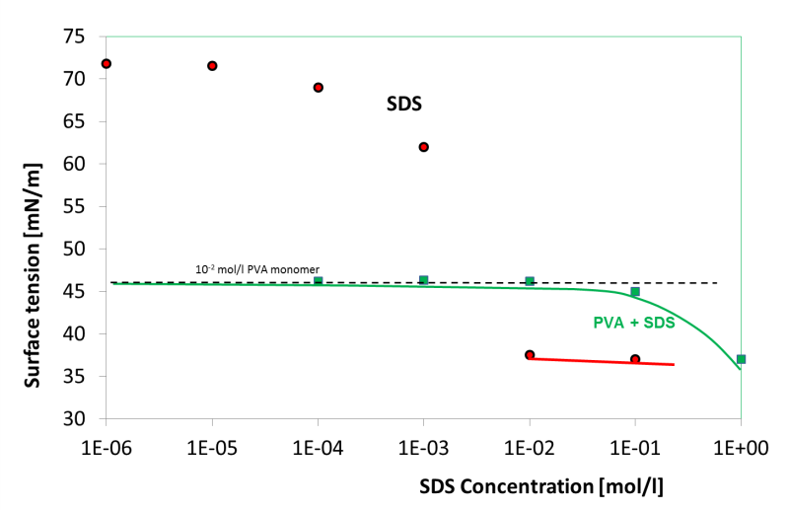

Fig. 1 Surface tension isotherms of pure SDS and of mixtures with PVA at a fixed PVA concentration of
10⁻² mol/l (monomer units), as measured by drop profile analysis tensiometry

1. Applied Surfactants: Principles and Applications, Th.F. Tadros (Ed.), John Wiley & Sons, 2006.
2. F. Boury, Tz. Ivanova, I. Panaı̈otov, J.E. Proust, A. Bois, J. Richou, J. Colloid Interface Sci., 169(1995) 380.
3. A. Sharipova, S. Aidarova, P. Cernoch and R. Miller, Colloids Surfaces A, 438 (2013) 141.

