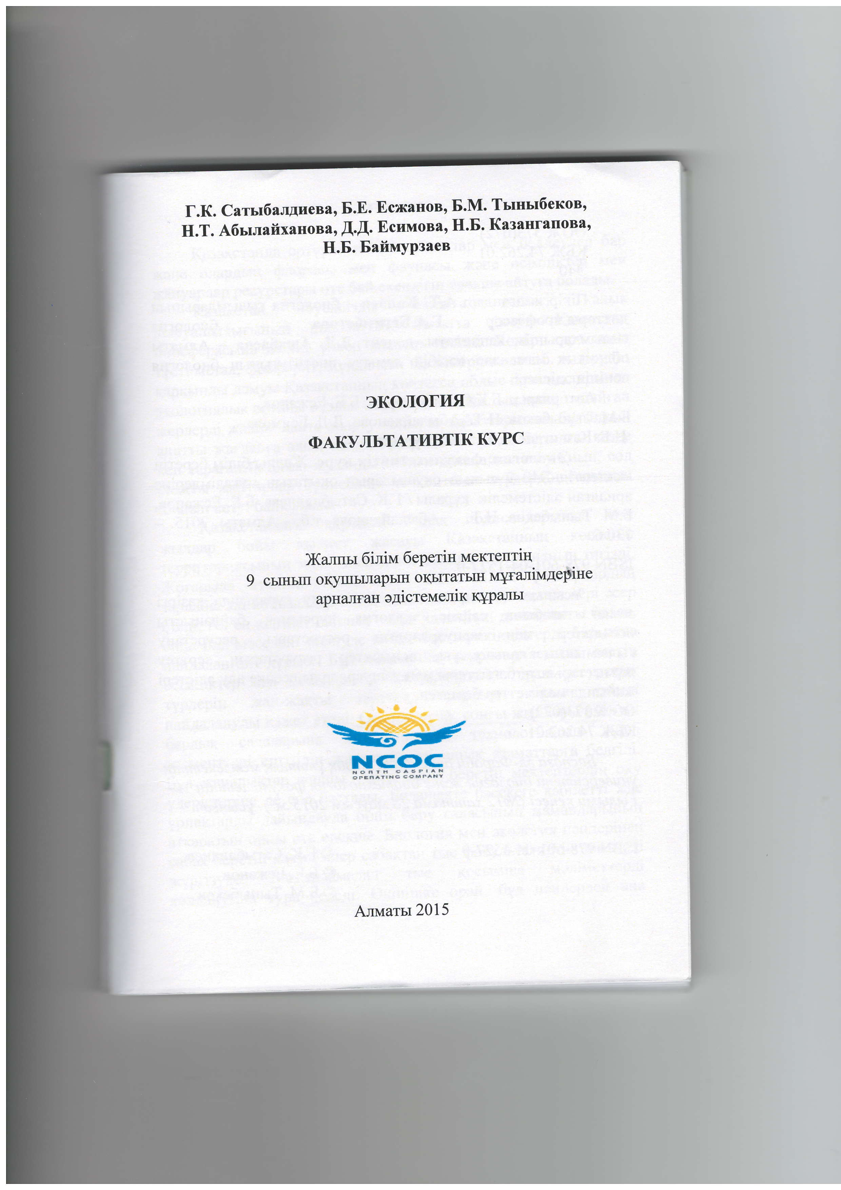
I.K. Caru6algnena, B.E. Ecxanon, E'M' Trrnrrberon'
H.T. Adruraftxanona, .(.[. Ecuruona, H'E' Kalanrauona'
H.E. Eaftuyp3aeB
SKOnOrI4f
OAKYJIbTATIIBTIK KYPC
Xa;lnrr 6inirra 6eperin uercreuriq.
cbrHbllr oKylxbrnapblH O(bITarbIH MYraJIlMAeplHe
apHanraH eAicrevreniK I(YPanbI
N(cGD(c
Anrr,raru 2015

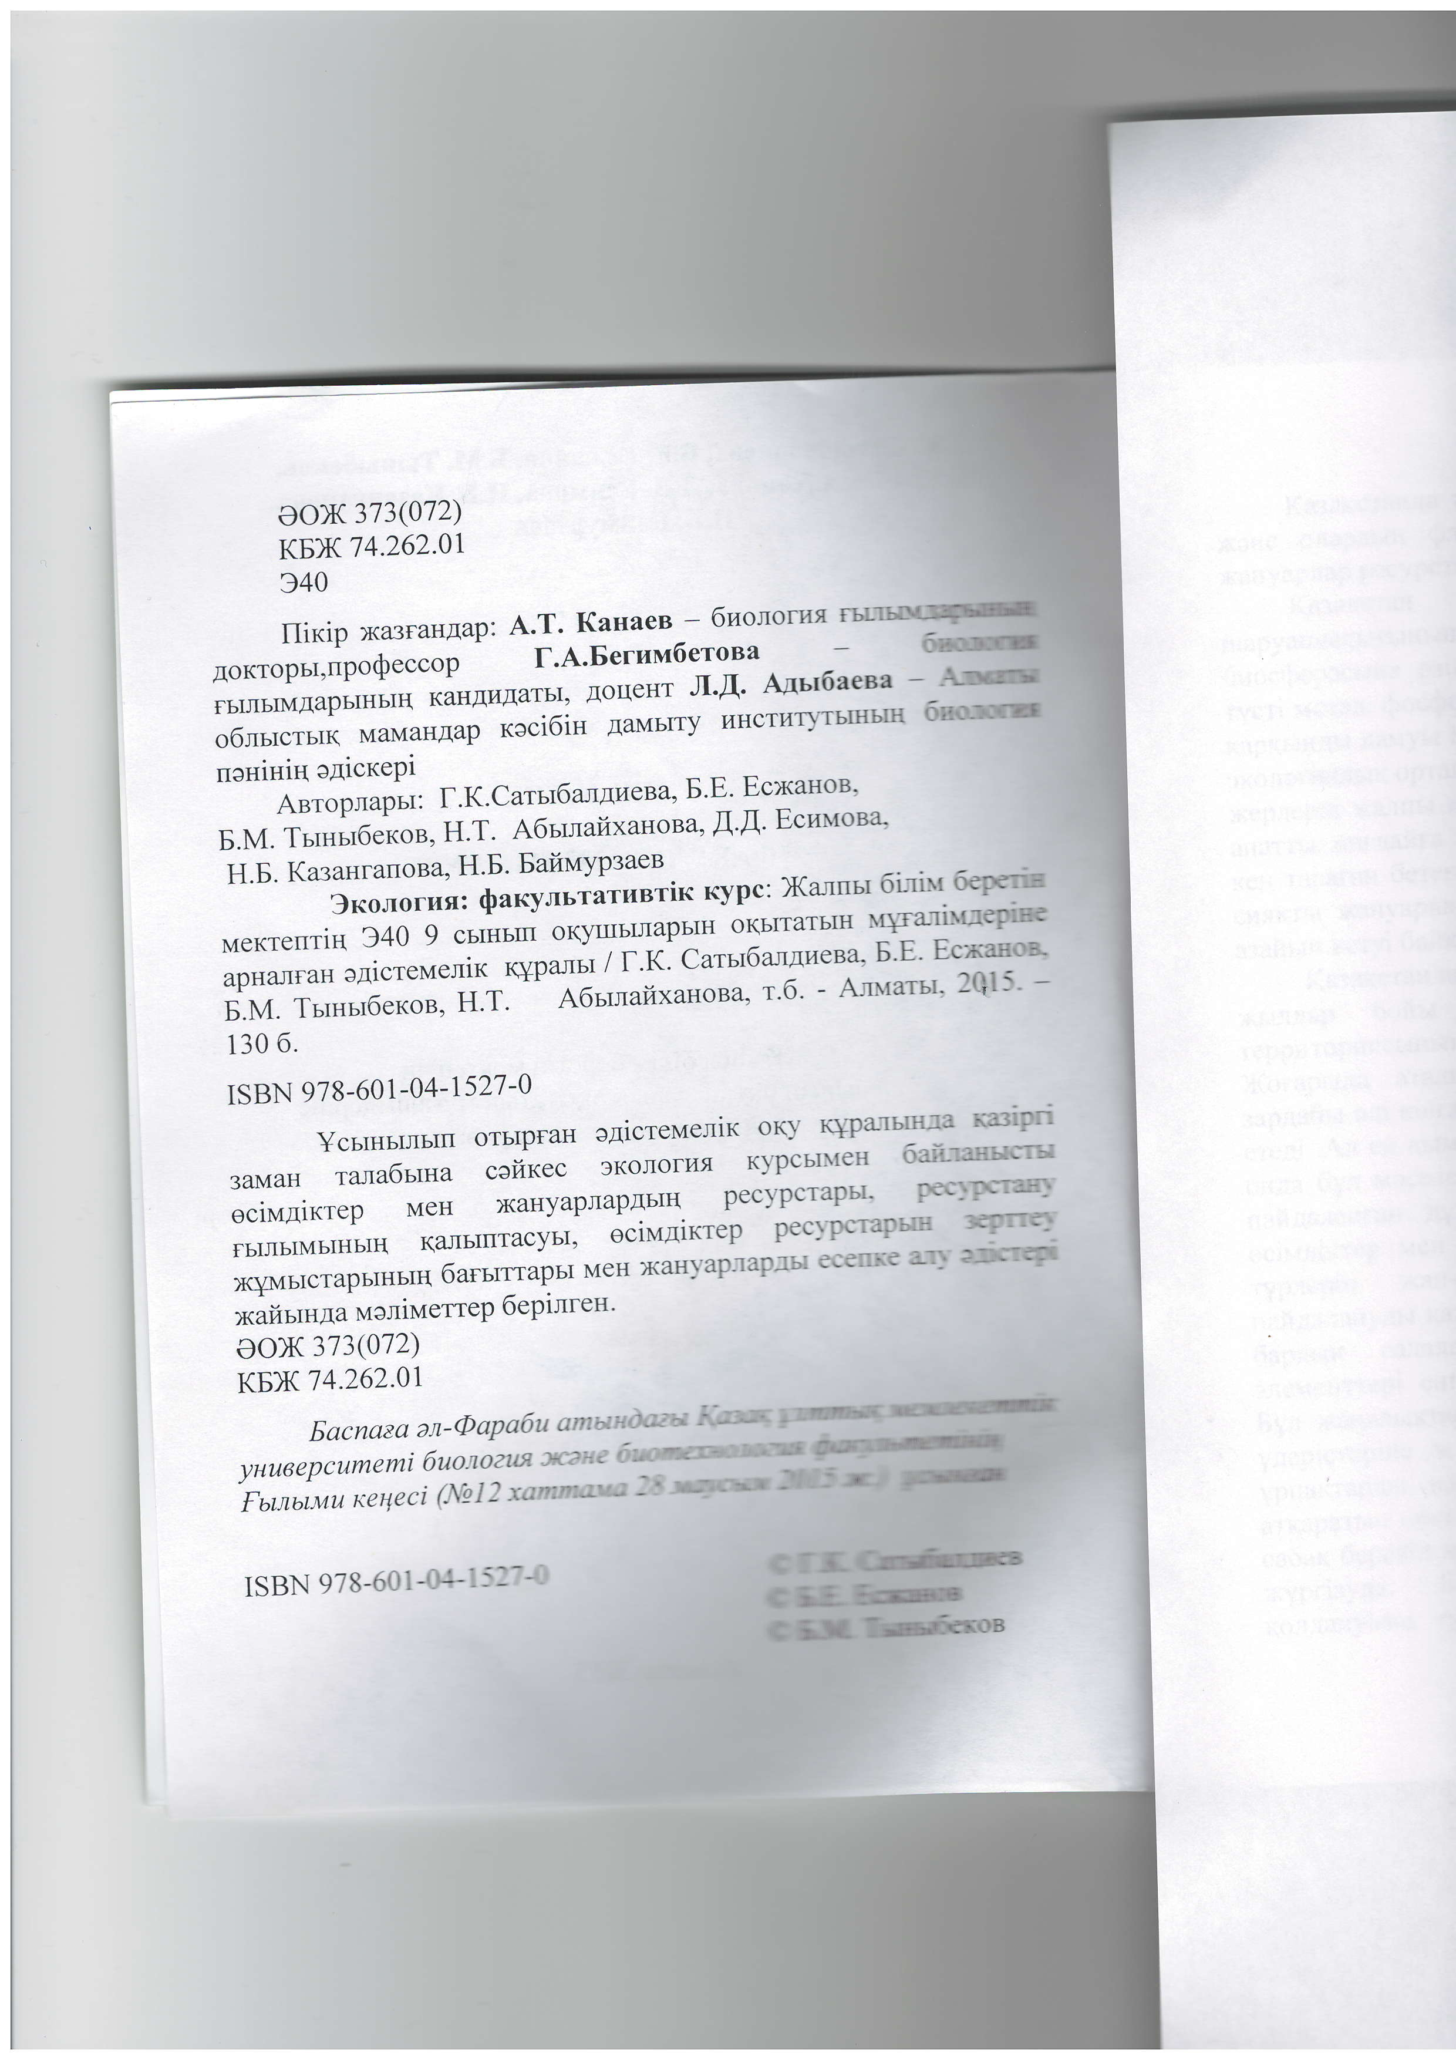
oox 373(072)
KE)K 74.262-0r
340
tlirip xa3raHAap: A'T' Kauaen,-6uonoms r
go*topur,rrpoSeccop I'A'Eerralr6"J"J"^-.,o-
AunruvD!,rryvwvv--r _
rbrJIbIMAapbIHbII{ Kar{AllAarbl', AOIIeHT JI.[. Ansr6aene
I
o6nrrcruK MaMaHAap r<eci6in AaMbITy lrucrl{r5rutffif,q
nesiniq eaicrepi
'**-l;t;prlapbl: f 'K' Catu6 ur;ineBa' B'E' Ecxanon'
B.M. Tlmu6exoe, H'T' A6lurafixauona' ['[' Ecuuona
H.E. Ka-ganrarloBa, H'B' Eafttr'typ3aeB
.
Srcororrq: ifanynnarl{BTrK Kypc: *-]:i 9T:
uerrenrir{ 340 9 cbr'bm oKyIIrbrJIapbIH oKblraruot o*o,;ffi
-'qp
apH arIFaH .lrc'"'"ni* T"j, i : *":3j: ffi ':"ffi *', 2C 5--
;:#1;;"ffi"-"", n'r' A6mnairxaHoBa' r'6' -ArnrarsL
130 6.
ISBN 97 8-601 -04-1521 -0
yc'nrutn orbrpra' eAicreirleliK oKy ry-ryP fiFi
3aMaH rala6uua caftrec 3KoJIorIat KypcbIMeH
xaHyapnapAblH. pecypcrapbr' rd
ffi*t.i^"";;;
fbrrrblMblHblr{ Karlblrracybl, eciuAirrep pecypcra[x[;sq
'ffi;;*p* urr{ 6a,u"tapbl MeH x€Hyapnap*r eff tlt
xaftunAa MeJllMerrep 6epimeu' ,**.*{
eox 373(072)
KBX 74.262.0r
Eacnaea an-@aPa6u anwfu
vHune7cumemi iuonozttt MG o
"Fwniruu rce4eci (l'lbI2 xre
rsBN 978501{l+liln

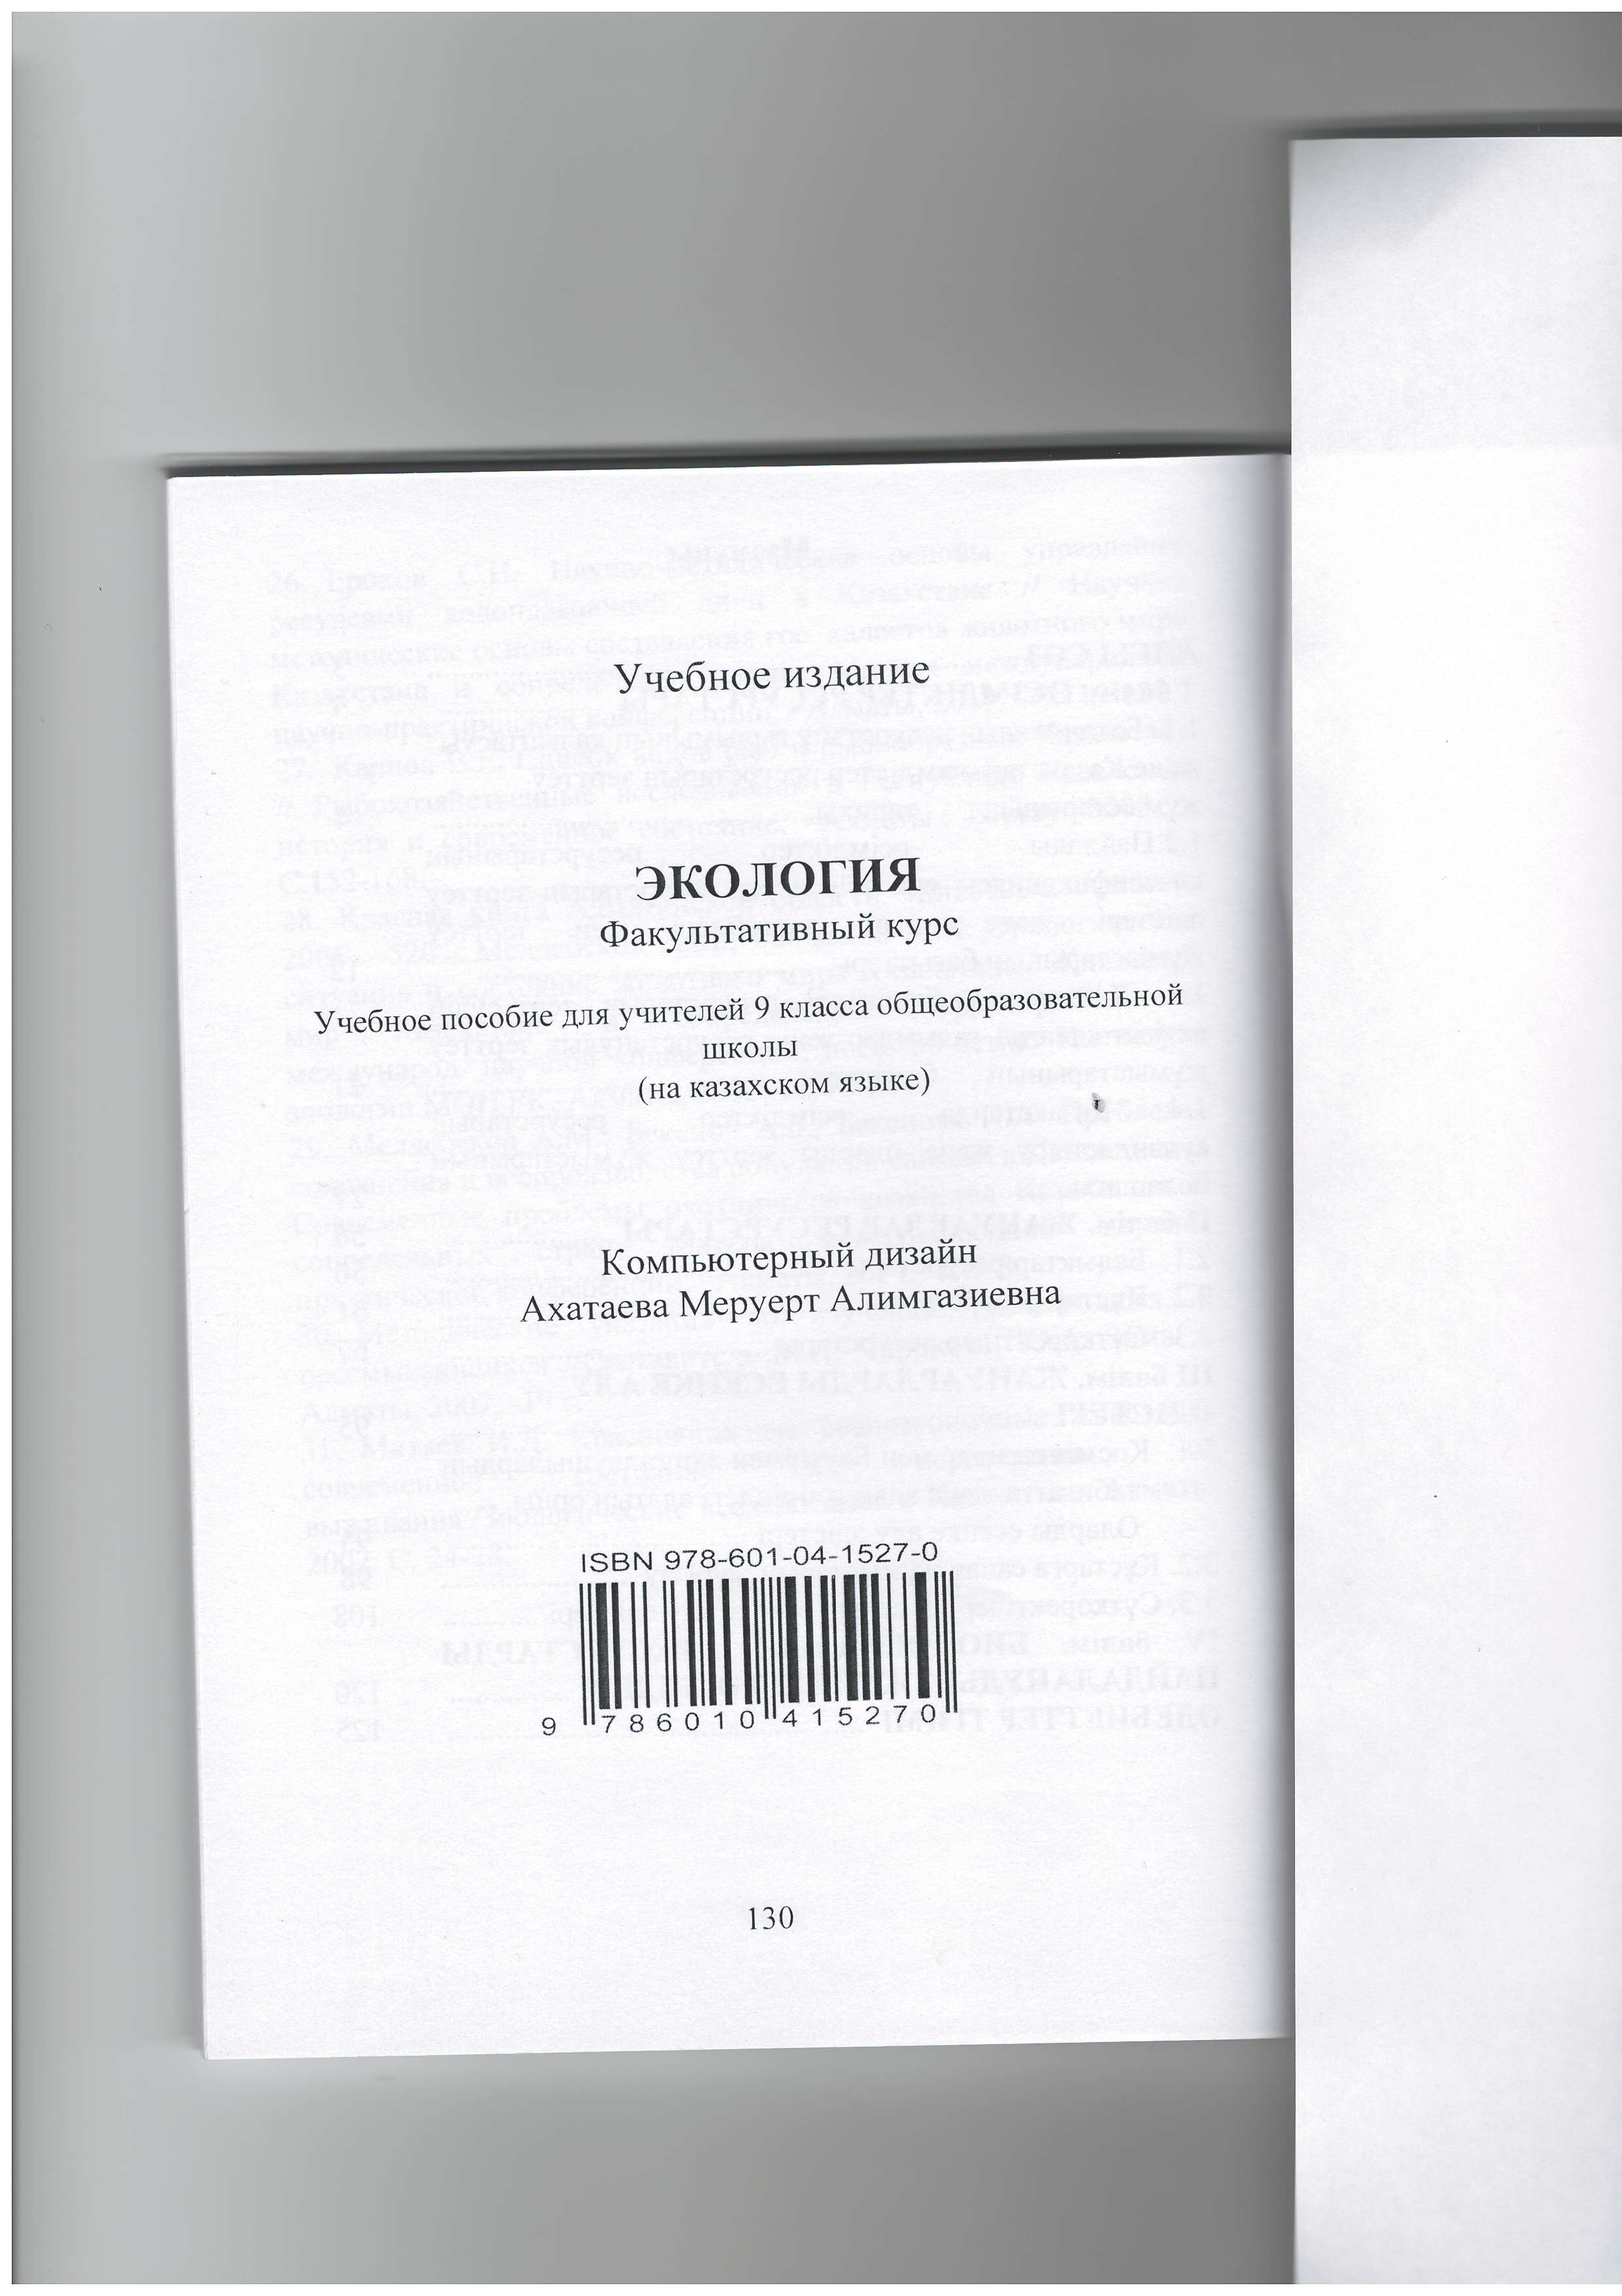
V.{e6Hoe v3I.aune
SKOJIofulfl
@arynrrarneFlrtfi KYPc
Yqe6noe noco6ue Ans yr{Iirenefi 9 r:racca o6ueo6pa:oearerE'F{oft
TIIKOJIbI
(ua xa-aaxcKoM q3blKe )
,
KolanuorePurtfi Avlaafiu
Axaraeea MePYePr Alltura:neBHa
lsBN 978-601 -o4-1 527 -O
t[lilI$llruil$ilffi
130

