Preface
The purpose of the physical workshop is to allow the student to reproduce the basic physical phenomena, to teach him the treatment of the most common devices and to introduce the most important methods of measurement of physical quantities. It is equally important to consolidate the skills of processing measurement results and evaluate the reliability of the results.
In the workshop students get opportunity to come into contact with the basic phenomena and experiments for the first time that exhibit quantum properties of atoms, molecules and solids.
Most of our information about the structure of atoms and molecules is the result of spectroscopic studies. Thus, spectroscopy has made an outstanding contribution to the modern understanding of atomic and molecular physics. Information about the structure of atoms, molecules and their interaction with the surroinding medium can be obtained in various ways from the absorption and emission spectra due to the interaction of electromagnetic radiation with matter.Measurement of wavelengths of spectral lines allows one to determine the energy levels of atomic or molecular systems. The intensity of lines is proportional to the probability of transition, which is a measure of how strongly two levelsof atomic (molecular) transition are bounded. Special high resolution methods can measure the natural width of spectral lines, which allows determining the average life times of the excited atomic (molecular) states. Measurements of Doppler line profiles give velocitydistributions of the emitting or absorbing atoms (molecules) and the temperature of the investigated object. Information about collisional processes and interatomic potentials can be obtained from the broadening and shift of spectral lines. Zeeman and Stark splitting in an external electric and magnetic fields provide an important way of measuring the magnetic or electric moments and determination of the bound type of different angular momenta in atoms and molecules even in cases of complex electronic conFigureurations. A hyperfine structure of line gives information about the interaction between the nuclei and electron cloud and allows determining the magnetic dipole and electric quadrupole moments of nuclei.
In connection with the foregoing, in the atomic workshop mainly laboratory works are associated with the study of atomic and molecular spectra.
The aim of the work 1 is to provide skills in the identification of the spectrum of iron, wavelength determination of spectral lines.
The work 2 is devoted to the use of atomic spectra to determine the composition of substances. The work provides the development of spectral analysis method, a physical method for determining the chemical composition of substances.
Emission spectrum of the hydrogen atomis studied in the work 3. The hydrogen spectrum has the simplest relation with the structure of the atom, which can be explained already at the initial stage of studying atomic physics using the model Bohr theory. Obtained during performing a experimental information is used to determine the Rydberg constant and electron mass, the ionization energy, energy levels and sizes of the hydrogen atom.
The aim of the work 4 is the development of General principles of systematics of the spectra of complex atoms for example: Li, Na, K. The experimental spectroscopic information is used for finding the energy levels, ionization energy, quantum defects.
In the work 5 the fine structure of spectral lines and energy levels of the sodium atom are studied; magnitude of the doublet splitting of the brightest lines in the emission spectrum of the sodium atom is determining, the dependence of the doublet splitting of levels on quantum numbers nandl is studied.
The work 6 is devoted to the study of spectrum structure of the element atoms (Zn, Cd, Hd), with two valence (optical) electrons, the determination of the triplet splitting of spectral lines.
The aim of the work 8 is the study of the physical principles of operation of helium - neon laser, the determination of the main characteristics: the divergence of the laser beam and polarization.
The work 9 is devoted to the study of the electronic spectrum of the diatomic molecule CN₄. From experimentally found regularities of the location of the edges of the bands and lines in the bands determined by the frequency and the coefficient of the unharmonic properties, energy dissociate, the distance between the nuclei of the molecule CN.
The purpose of the work 10 is studying the physical principles of the helium - neon laser, the determination of the main characteristics: the divergence of the laser beam and polarization.
The work 11 is devoted to the study of the electronic radiation spectrum of a diatomic molecule CN₄. The oscillation frequency and the anharmonicity coefficient, dissociation energy, the distance between the nuclei of CN molecules are defining from the experimentally determined patterns location of the edge bands and lines in the bands.
The purpose of the work 12 is studyoing the Zeeman Effect using spectral lamp with cadmium, studying the splitting of spectral lines of cadmium in a magnetic field, the determination of the Bohr magneton.
The work 13 is devoted to the definition of g-factor of a free electron by electron spin resonator
Due to the fact that in atomic workshop it is not possible to conduct practical lessons with photographic registration of spectra, some laboratory worksare performed using pre-recorded on a photographic plate spectra of iron and the investigated substance, ready spectrograms obtained on the medium dispersion spectrograph ISP - 28 and a large variance of the DFS - 8. A set of spectra can be identified from the literature.
To ensure that the students imagined the method to obtain the spectrum itself and the spectral device, in the classroom is highly desirable to show the device, to explain operation principles of basic design elements. In order to diversify the practical work, when along with processing own experimental results (measured on the microscope), it is possible to use a more accurate literature data on the fine structure of spectral lines of alkali elements.
This manual contains a description of the laboratory activities performed by the students of the physical and technicacl faculty of the Al-Farabi Kazakh National University in parallel with teachin of the course of atomic physics. The description of each work contains a summary of the subject of the investigated phenomenon, the experimental method that underlies the study of this phenomenon, information about used equipment. The descriptions of the works implymandatory acquaitance with the literature. The references are given at the end of the book. The annexes contain the necessary reference materials.
General requirements for students performing works as follows:
1. Before starting the laboratory one should be acquainted with the safety regulations for given laboratory and strictly follow them.
2. Getting nextwork, one should acquaintwith the workdescription,device descriptonand recommended literature in details, only then proceed to the execution of the experiment.
A report is compilingonfinishing the laboratory work. The report on each work should contain:
1. The name andthe purpose of the work (brief statement of the task);
2. List of main devices with the technical specifications;
3. A summary of the theoretical (physical) nature of the work;
4. Description of all stages of the work, attachinginstallation schemwith explanations of it;
5. Measurement results and their processing in the form of graphs, tables, etc., and estimation of the errors;
6. Conclusions (discussion of the results, comparing them with the theoretical and literary data).
Obtained experimental materials in the form of spectrograms, spectra, graphs, etc. are attached to the report.

1. STUDYING THE EXTERNAL PHOTOELECTRIC EFFECT PHENOMENON

1.1. The purpose of the work: To study the laws of the external photoelectric effect, to determine the Planck constant.
1.2.The content of the work.
Planck quantum hypothesis was confirmed in explaining the phenomenon of the photoelectric effect. External photo effect is called electron emission of the substance under the influence of electromagnetic radiation. The photoelectric effect was discovered in 1887 by H. Hertz, and later studied in detail by A.G.Stoletov, German physicists W. Hallwachs, F. Lenard and Italian scientist A. Rivi. Studyinglaws of the photoelectric effect were carried out in a device schematically shown in Figure 1.1.
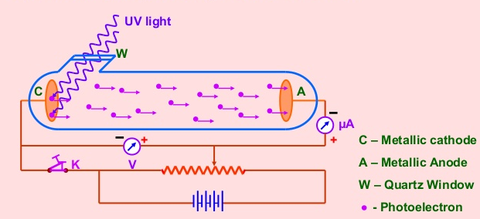
Figure 1.1

In the vacuum tube with the potentiometer R the value of the voltage between the cathode K and the anode A and its sign can be changed. Upon irradiation of the cathode with the light aelectrical current (photocurrent) appearsin chain, measuring by the miliamperemeter(galvanometer).
The dependence of photocurrent i from the applied external voltage U between the cathode K and the anode A are presented in Figure1.2. This graph is called the volt-ampere (current-voltage) characteristics (V-I) of photoelectric effect.

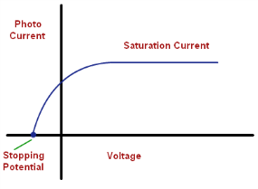
Figure 1.2

This dependence is characterized by the presence of area of the saturation current i_{sat}, when all electrons, pullrd out with the light from the surface of the cathode K are to reach the anode A, and another area, where the photocurrent is reduced to zero by some external retarding voltage U0 (U0<0).
Three basic laws of photoelectric effect have been established by numerous experiments:
1. The saturation photocurrent is proportional to incident light flux (for the same spectral composition). This means that the number of electrons, pulling putby the light every second, is proportion to the light intensity (A. G. StoletovLaw, 1889).
2. There is a minimum light frequency ν_{min} (or maximum wavelength λ_{max}) for each metal, at which still occurs the extraction of electrons. If the wavelength exceeds λ_{max} (or frequency of the light wave is below ν_{min}) so-called red edge of the photoelectric effect, then there is no emission of photoelectrons, even at sufficiently large intensity of incident light (F. Lenard, 1889).
3. The maximum kinetic energy of extracted by the light photoelectrons is proportional to the light frequency and does not depend on its intensity (F. Lenard, 1889).
From the point of view of classical electromagnetic theory of the light the fact that the extraction of electrons from metal is not surprising, since the incident electromagnetic wave induces forced oscillations of the electrons in the metal. In fact, according to this theory the electrons are escapingfrom the metal as a result of their "swaying (oscilation)" in the electric field of the light wave. However, in this case it is unclear why the maximum kinetic energy of electrons depends on the frequency, not the amplitude of the intensity vector E of the electric field of the wave, and therefore on the light intensity. It is impossible to explain the existence of the red boundary of photoeffect. It would seem that increasing the intensity of the light can increase the amplitude of the oscillations of the electron and to transfer him the energy needed to pull him out from metal. However, the red boundary is determined only by the frequency of light and does not depend on its intensity.
Moreover, the sharp divergence of theory and experience occurs at very low light intensity. According to classical wave theory the photoelectric effect in these conditions should proceed with a noticeable delay, since it requires a finite time to accumulate the required energy. Experience shows, however, that the photoelectric effect appears almost immediately, i.e. simultaneously with the start of illumination (the period of time between the beginning of illumination and the apperance of the photocurrent does not exceed 10⁻⁹ sec).
All the difficulties disappear if the photoelectric effect is considered, on the basis of Einstein's hypothesis about light quanta. In accordance with this hypothesis the incident monochromatic radiation is considered as a flux of light quanta – photons, the energy ε are related to the frequency ν by the relation
$ε=hν$, (1.1)
When the photon is absorbed, its energy is ε is entirely transferred to one electron. This energy is spent on electron to leave the metal, i.e. to perform work function A and also on transfer of kinetic energy to te electron. The law of energy conservation for this process is written in the form
$hν=A+\frac{mv_{max}^{2}}{2},$ (1.2)
This is the Einstein equation for photoelectric effect. The energy of the absorbed photon is spent on the performing the electron work function and increasing their kinetic energy.
The Einstein equation would possible to explain the laws of photoelectric effect. So, most of the kinetic energy of the electron is equal to
$$К_{max}=\frac{1}{2}mυ_{max}^{2}=hν-A$$
As the work function for this metal is constant (A = const), the highest kinetic energy is proportional to the frequency of the incident light:
$$K_{max}\sim ν$$
Equation (1.2) also shows that the photoelectric effect is only possible if the photon energy not smaller than the work function А:
hν ≥ A
The minimum frequency at which the photoelectric effect is possible, is determined by the formula
$ν_{min}=\frac{A}{h}$ (1.3)
and the maximum wavelength by the formula
$λ_{max}=\frac{hc}{A}$ (1.4)
This is red (long-wavelength) limit of the photoelectric effect. From (1.4) it follows that λmax depends only on the work function, i.e. the nature of the metal.
With increasing U the photocurrent i is gradually increasing, i.e. the morenumber of photoelectrons reach the anode, and reaches saturation i_{sat}. When U=0, the photocurrent does not disappear, that is, the electrons exctractedfrom the cathode, have some initial velocity υ, allowing them to reach the anode without an external field. In order the photocurrent equals zero, it is necessary to applydelay voltage U₀, by measuring which, one can determine the maximum value of the velocity and kinetic energy of photoelectrons:
$\frac{mv_{max}^{2}}{2}=qU_{0}$. (1.5)
Electrons in a solid can be considered as being in potential well with depth U (Figure1.3). According to quantum theory of metals the free electrons in the potential well fill a number of discrete series of energy levels. At low temperatures (T→0) all the lower levels up to level$E_{f}$, called the Fermi levelbecome filled. For the release of electrons from the metal with the Fermi levels should apply additional energy for the electron, sufficient for overcoming the potential barrier. Minimum additional energy, sufficient for overcoming the potential barrier from the Fermi level is called the work function A. The value of A depends on the properties of the crystal lattice of the solid and the surface condition of the metal.
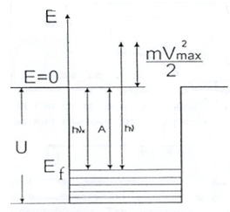

Figure1.3

1.3. Description of the equipment
The installation consists of a investigated object IO and the measuring device MD, in the form of structurally complete products, is installed on the lab table and connected by cable (1) (Figure 1.4).
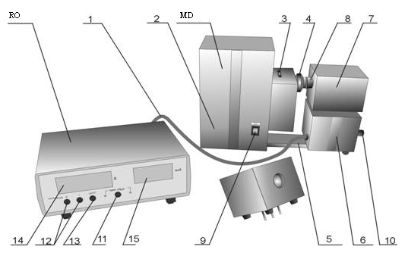
Figure 1.4

IO is designed as a multi-part housing (2), in which the illuminator (spectral mercury lamp) with a power source, the unit of the interference light filters (3) and device for adjusting the illumination (4). The position"0" of the unit of light filters corresponds to the passage of the light withoutlight filters, and can be used to take the integral current-voltage and Lux-ampere characteristics, and position "5" is covering the lamp and is using to set zero. The photocurrent amplifier (6) is attached to the housing by support(5), on the top cover of which a replaceable photodetectors (7) with photocellsare mounted. When installing photodetectors their receiving window is aligning with the output window of the illuminator and closing by lens hood (8).
Network switch with power indicator network (9) is located on the front panel of the investigated object. There are the ground terminals, fuse holder and power cord with plugon the back of the investigated object. Output window of the illuminator (8) and devices for changing the interference light filters (3) and adjusting the illumination (4) are located on the side wall. On the side surfaces of the amplifier of the photocurrent there are connecting cord (1) with plug for connection of the investigated objectto the measurement device and controls ROUGHLY and PRECISELY(10)setting zero in the absence of illumination.
Following controland indication unit are located on the front of the measuring device:
- button (11) DIRECT–REVERSE withcorresponding indicatorsis for switching forward and reverse modes of measurement.
- buttons "+", "-" (1), and RESET (13) is for adjusting the voltage on the photocell and resetting it to zero.
- indicators 14 Vand 15 µA are designed to display voltage values on the photocell and photocurrent during the working proces.
Operation principle of the device is based on measurement of the current through the photocell when changing the polarity and magnitude of the applied voltage and the changes of spectral composition and illumination value of the cathode of photocell.
In the process of implementation of laboratory work the dependence of the current through the photocell on the applied voltage is measured. Wherein the polarity of the voltage is changed (i.e., forward and reverse branches of current-voltage characteristics of the photocell are separately measuring). Characteristics are taken at various illumination values and at changing illumination wavelength of the photocell. According to the measurement results series of current-voltage characteristics are constructed and, using appropriate calculation methods, the value of the Planck constant are numerically estimated.
1.4. Work performance order
1. To set the photodetector (7)with the studying photocell on the investigated object and slide the hood (8) of the illuminator to the photocell window.
2. To turn on the measuring device and the investigated object by switch NETWORK. This should light up the indicators REVERSE, V and µA on the measuring device. After a 5 minute warm-up using handles 10 SETTING ZERO (ROUGHLY and PRECISELY) on the investigated object to set a zero value on the indicators 15(µA) of measuring device.
3. To turn on the investigated object by the NETWORK switch on the front panel. At the same time it should light up the indicator NETWORK on the investigated object.
4. To give the illuminator lamp to warm up for 15 min.
5. Using the button (11) (DIRECT – REVERSE) to select the required measurement mode.
6. To install necessary light filter.
7. By changing the voltage value using buttons (12) ("+" and "-"), and readout of the photocurrentvakuefrom the indicator 15 ("µA") to write down data to plot the current-voltage characteristics.
8. To repeat measurements for the other light filters.
Note 1: If necessary, it is possible to change the illumination of photocell by turning the ring 4, located on the output window of the investigated object.
Note 2: When determining the blocking voltage of the photocell is necessary to read the current zero value at decreasing voltage from zero value by the indicator (14)to the blocking voltagevalue, and not vice versa. It is not recommended to set voltage value below the bloccking one.
1. To turn off the invesitgated object and the measuring device at the end of the work.
2. ToplotCVC.
2. To determine the number of photoelectrons, extracted per unit time:
$n=\frac{i_{H}}{e}$, (1.6)
where e = 1,6·10⁻¹⁹C
3. To estimate the Planck constant for the obtained delay potentials U₀, corresponding to the two λvalues by the formula:

$h=\frac{e(U_{1}-U_{2})}{c(\frac{1}{λ_{1}}-\frac{1}{λ_{2}})},$ (1.7)
whereс = 3·10⁸m/s.
4. To repeat the calculation for other values of λ, to estimate the error.

Literature: [1,2,3,19]

Control questions
1. What is the nature of the external photoelectric effectphenomenon?
2. What is the "red boundary" of the photoelectric effect?
3. To formulate the laws of photoelectric effect.
4. To give the derivation of the second and third laws of photoelectric effect based on the Einstein equations.
5. Explain the course of direct and reverse branches of the graph of the dependence of the photocurrent on the voltage between the cathode and the anod.

2. ELECTRON DIFFRACTION

2.1. The purpose of the work: Studying wave properties of electrons. Check relation that comes from the de Broglie formula dependence of the diffraction pattern size on the accelerating voltage. Determination of the interplanar distancesof the crystal lattice by the electron diffraction pattern.
2.2. Brieftheory
De Broglie waves. After analyzing the experimental data for the photoelectric effect and photochemical action of light on amatter, A.Einstein proposed the photon theory of the light, widening and deepening the quantum hypothesis of M.Planck. According to the photon theory electromagnetic field (light) is a photon flux, in many ways similar to particles. They interact with the matter as a whole, have a certain energy $ε_{φ}=ћω=hν$and momentum $p_{φ}=\frac{hν}{c}=h/λ$, where h is the Planck constant, c is the speed of light, ν is a frequency, λ is a wavelength. At the same time, to explain interference and diffraction phenomena, it is essential to keep the idea of the wave nature of the light. So the problem of wave-corpuscle dualism is appearedin physics.
In 1923 French physicist Louis de Broglie came to the conclusion that wave-particle dualism inherent in all without exception material particles such as electrons, protons, atoms and etc., moreover, the quantitative relationship between wave and corpuscular properties of particles are the same as for photons. If the particle has energy E and momentum p, then associated with it a wave of the frequency $ν=E/h$ and the wavelength is:
$λ=\frac{h}{p}$ (2.1)
Let's find the length of de Broglie waves for the electrons, accelerated by an electric field with a potential difference U. Electrons in this case get the kinetic energy
$K=eU=\frac{{mυ}^{2}}{2}$ (2.2)
At the non-relativistic considering the momentum of the electron is determined by the ratio
$p=\sqrt{2mK}=\sqrt{2meU}$ (2.3)
Substituting (2.3) into (2.1), one can get
$λ=h/\sqrt{2meU}$ , (2.4)
where e and m are charge and mass of an electron respectively.
From this formula it follows that for electrons with energies from 1 to 104 eV the length of the de Broglie waves are in the range from 1 to 0.01 nm, i.e. in the range of x-rays wavelengths. Therefore, the wave properties of electrons must occur, for example when scattering by crystals, i.e. in the same conditions in which x-ray diffractionis observing. In this case the crystal acts as a natural diffraction grating.
When studying diffraction of electrons with energies in tens of keV their velocity becomes comparable with the speed of light. In such circumstances, to determine the electron momentum the relativistic formulas should be used $E=m^{2}c^{4}+p^{2}c^{2}$and$K=E-mc^{2}$,whereЕis the total energy. Excluding from these formulas E, taking into account (2.2) we find
$p=\sqrt{2meU\left[1+eU/\left(mc^{2}\right)\right]}$ (2.5)
Substituting (2.5) into (2.1), we obtain the exact relativistic expression for the de Broglie wavelength:
$λ=\frac{h}{\sqrt{2meU}}\frac{1}{\sqrt{\left[1+eU/\left(mc^{2}\right)\right]}}=\frac{λ^{'}}{\sqrt{\left[1+eU/\left(mc^{2}\right)\right]}}$(2.6)
A natural question arises: what oscillating in the de Broglie wave? The generally accepted interpretation of de Broglie waves is that the some value describing the state of a particle and calling wave function $ψ\left(x,y,z,t\right)$ is obeys the wave laws.The square of the wave function${\left|ψ\left(x,y,z,t\right)\right|}^{2}$is equal to the probability of finding particle at time t in the unit volume near point with coordinates x, y, z. The wave function of a free particle with a precisely defined momentum is a plane monochromatic de Broglie wave
$$ψ\left(x,y,z,t\right)\sim \exp{i\left(\frac{pr}{ћ}-\frac{Et}{ћ}\right)},$$
where $ћ=h/2π$. Thus, de Broglie waves are not any physical or material wave, but the waves of probability amplitude. In other words, the probability amplitude is osillatingin the de Broglie wave.
Electron diffraction.Diffraction is a wave phenomenon, it is observed in the propagation of waves of different nature: light, sound waves, waves on a liquid surface, etc. The presence of particles’ wave properties makes it possible diffraction and for particles, in particular for electrons. The interaction of the electron with a certain object a crystal, a molecule, etc. is leads to change in its motion. Consequently, the nature of the wave distribution associated with the electron is changing, besides it takes place in accordance with the common principles to all wave phenomena. Wave interacts with all points of the object, and they become centers of secondary scattered waves. Secondary waves are interferesuperimposing on each other. The maximum amplification condition of waves is that the path differenceΔof the waves coming in this direction was an integer number of wavelengths: $∆=nλ, n=0,1,2…$. If the path difference is an odd number of half wavelengths: $∆=\left(2n+1\right)λ/2$, $n=0,1,2,…,$ the waves in this direction will weaken each other.
In this work the electron beam hits the coated polycrystalline graphite film and is reflected according to Bragg law (2.7):
$∆≡2dsinθ=nλ, n=0,1,2,… ,$ (2.7)
where d is the distance between planes of atoms,θ is the Bragg angle (slip angle is the angle between the electron beam and the lattice planes) (Figure 2.1).
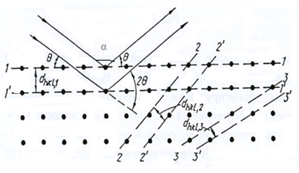
Figure2.1
The reflected beam, determining the position of diffraction maximum, deviates from the direction of incident beam at the angle 2θ.

2.3.Description of the equipment
The device for observing the diffraction of electrons of high energy electron diffraction apparatus is a vacuum device (Figure 2.2).
The electrons emitted from a hot tungsten filament 1, are accelerated by high voltage of 1-10 kV that is applied between the electrostatic focusing electrode and the anode. The generated electron beam passes through a thin (10⁻⁶ – 10⁻⁵cm) film of the investigated substance. Interacting with the substance, the electrons are scattering and creating a diffraction pattern, which is seen on the fluorescent screen (Figure2.2).

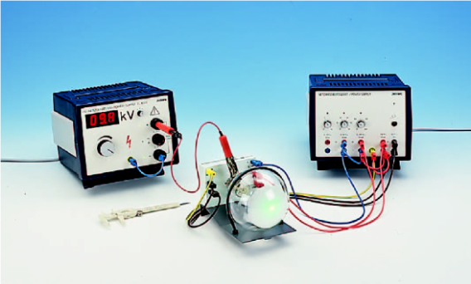
Figure 2.2

If the investigated sample is a polycrystalline film, due to chaotic character in the orientation of individual crystals in the film there is a system of crystal planes located relative to incident beam at angles satisfying the Bragg law(2.7).
Bounds between the individual layers are breakingin crystalline graphite, so their orientation has random character. Therefore, the electron beam spreads in a cone shape and causes the appearance of rings on a fluorescent screen located perpendicular to the incident beam at a distance l from the diffraction pattern rings.
One can calulate the Bragg angle θ (see formula (2.7)) by knowing the radius of the interference ring, but it should be considered that the reflection angle α (Figure 2.1) is twice greater than the Bragg angle α=2θ. FromFigure 2.3one can find
$\sin{2α}=\frac{r}{R},$ (2.8)

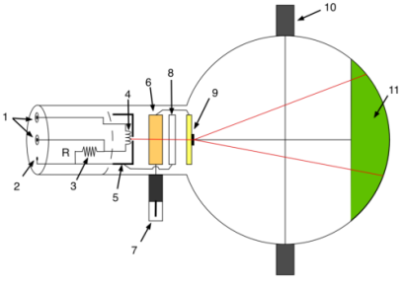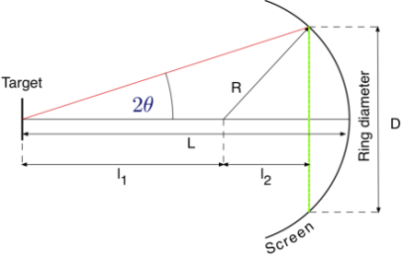

Figure 2.3. Overview of the electron diffraction tube.(1)4-mm socket for filament heating supply, (2) 2-mm socket for cathode connection, (3) internal resistor, (4) filament. (5) Cathode, (6) anode, (7) 4-mm plug for anode connection (HV), (8) focusing electrode, (9) polycrystalline graphite grating, (10) Boss, (11) fluorescent screen.

where R=65mm is the radius of the glass cylinder, аnd$\sin{2α}=2 sinαcosα$.
For small angles$α\left(\cos\left(10\right)\right)=0,985,$ so
$sin2α≈2\sin{α}=2\sin{2θ}=4sinθ=\frac{r}{R}$ (2.9)
Based on (2.8) and (2.9), one can obtain a formula which relates the diffraction ring radius with the wavelength λ of the electrons and the interplanar distance d of atoms of the crystal:
$r=\frac{2 R}{d}nλ, \left(n=1, 2, …\right)$ (2.10)
Two interference rings are apperingas a result of reflection from the lattice planes. Knowing the voltage on the anode according to the formula the wavelength can be calculated.
Using the calculated values of the wavelengths using the formula for the two diffraction rings one can determine the interplanar distance of atoms. The diameter of the rings is measured with millimeter ruler. Diffraction rings formed by electrons that were scattered from a system of planes with different interplanar distances, will have different diameters. Thus, electron diffraction pattern obtained from polycrystalline films consists of concentric rings. The number of rings and their diameters depend on the structure of the crystal.

2.4. Work performance order
1.Obtaining diffraction patterns for thin film samples. Keeping a strict sequence of operations described in the manual of the device, to obtain a diffraction pattern in shape of concentric rings from polycrystalline graphite films.
2.Check the ratio of de Broglie between the electron wavelength and accelerating voltage. Leading relativistic formula (2.6) for wavelength de Broglie to the following form
$λ\left(nm\right)=\frac{C_{1}}{\sqrt{U(кВ)}}\frac{ 1}{\sqrt{1+C_{2}U(кВ)}}=λ^{'}\frac{1}{\sqrt{1+C_{2}U(кВ)}} ,$(2.11)
to find the value of the constant $C_{1}={10}^{9}h/\sqrt{2{·10}^{3}me}$,$C_{2}=\frac{{10}^{3}e}{\left(2mc^{2}\right)}$with accuracy to four significant digits.
To calculate with the accuracy of three significant digits value
$\frac{1}{\sqrt{1+C_{2}U(кВ)}}$, $\frac{C_{1}}{\sqrt{U(кВ)}}\frac{1}{\sqrt{1+C_{2}U(кВ)}}$, $λ^{'}$,$λ$
for voltages at which the electron diffraction patterns were obtained. To analyze the influence of relativistic affects on the de Broglie wavelength.
To calculate the range of de Broglie wavelengths for electrons with energies from 1 to 104 eV.
3.Determination of interplanar distances of atoms of polycrystalline graphite.

Table 2.1. The de Broglie wavelengthsof the electron
U, keV | $$C_{1}=\frac{10^{9}h}{\sqrt{2·10^{3}me}}$$ | $$C_{2}=\frac{10^{3}e}{(2mc^{2})}$$ | $λ^{'}=\frac{C_{1}}{\sqrt{U}}$, nm | $$λ=\frac{λ^{'}}{\sqrt{1+C_{2}U}}$$  nm

Table 2.2. Determination of interplanar distances of atoms of polycrystalline graphite
n  the number of the ring | R  mm | L  mm | r  mm | $λ=\frac{h}{\sqrt{2meU}}$, nm | $d=\frac{2R}{r}nλ$, nm
1
2
3

Task
1. To obtain diffraction pattern from the thin carbon film and explain the obtained Figure.
2. Find the value of the constant C₁ and C₂ in the formula (2.11). For electrons with energies from 1 eV up to 10⁴ eV, calculate the de Broglie wavelength.
3. To build a graph dependence of D on the parameter$1/\sqrt{U\left(1+C_{2}U\right)}$.
4. Find the interplanar distances for the initial three rings.
5. To obtain the Bragg condition.

Literature: [2,3,6,20]

Control questions.
1. What is the wave-particle duality?
2. What is the de Broglie wave and its physical meaning?
3. What does the de Broglie wavelength depend on?
4. What is the interplanar distance of atoms of substance?
5. Obtain the ratio for the diameter of the diffraction rings in the electron diffraction pattern.

3. THEFRANCK-HERTZEXPERIMENTS.

3.1. Thepurposeofthework:Studying the experiment of the Franck – Hertz; the aquaitance with the methodology of taking the current-voltage characteristics of gas discharge devices, experimental determination of the first excitation potential of the gas atoms.
3.2. Theoretical introduction: experimental confirmation of the Bohr postulates.Franck-Hertz Experiment.
The theoretical explanation of the spectral laws observed in hydrogen atom, was first given in the semi-classical Bohr Theory in 1913y. Quantum mechnics gives more detailed and exact solution of the task, which foundation relates to 20-th years of the twentieth century.
There are two postulates in the basis of the hydrogen atom theory proposed by Bohr.
1. The first Bohr postulate (postulate of the stationary states). Atoms can remain long only in certain (stationary) states. In these states, the atoms have energies, forming a discrete series of E₁, E₂, ...E_{n}, which are not changing in time without external influences. In these states, the atom is not emitting or absorbing energy.Stationary states correspond to the well-defined (stationary) orbits in which the electrons are moving.Bohr quantization rule of orbits states that in the stationary states of the atom the electron moving in a circular orbit must have quantized (or discrete) values of angular momentum, satisfying following condtion
$L_{n}=mυr=nℏ \left(n=1, 2, …\right),$ (3.1)
where m is the electron mass, $v$ is velocity of the electron, r is the radius of it’s orbit,$ℏ= h/2$is the Planck constant,n isan integer number.
2. The second Bohr postulate (frequency rules). At transition from one stationary state to another state atoms absorbing or emitting radiation, the frequency ν is determined from the condition
$hν=E_{n}-E_{m}$ (3.2)
In formula (3.2) n and m are numbers of the states, E_{n} and E_{m} are the energies of the stationary states of the atom before and after emition (absorption) of photon respectively. At E_{n}>E_{m} is emition, and at E_{n}<E_{m}is absorption of the photon.
Direct experimental confirmation of Bohr postulates (and the subsequent quantum - mechanical theory) obtained in the experiments of Franck and Hertz. The idea of the experiments is as follows: atoms of a rarefied gas are "bombarding" by slow electrons, and at the same time investigating the distribution of electron velocities before and after the collisions. If the collision of electrons with atoms is elastic, the distribution of the electron velocities as a result of the collision is not changing.On the contrary, atinelastic collisions some of the electrons losingtheir energy by giving it to atoms, thus the velocity distribution is changing.

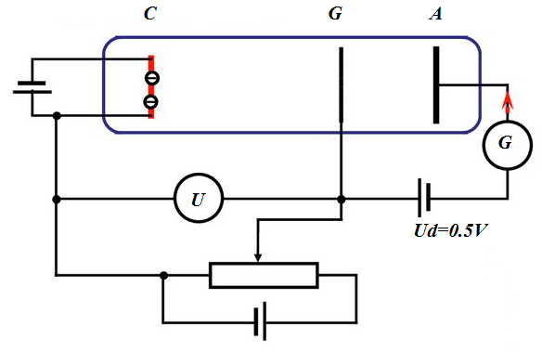
Figure 3.1

A schematic diagram of the Franck-Hertz Experiment is shown in Figure3.1. There is the cathode C and grid G, anode A inside the vessel filled with rarefied gas (p ≈130 Pa).
Potential difference U is applied between the cathode and the grid, accelerating electrons (electron energy equal eU).Delayingpotential difference U_{d}=0.5 V is applied between the grid and the anode, and thereafter keeping it unchangeable.U_{d} value is chosen in the way that electrons which almost completely lost energy due to inelastic collisions, do not fall onto the anode.In the experiment current-voltage characteristic (CVC)the dependence of the anode current I_{a} on the accelerating voltage U is measured. If the vessel was pumped out very well, CVC would correspond to the normal phenomenon of thermal electron emission (Figure 3.2).
Electrons collide with gas atoms in the presence of the rarefied gas. While the energy of the electrons is small, their collisions with atoms are elastic, and they do not lose energy. At increasingenergy of the electrons collisions become inelastic. Electrons in this case with high probability are losing energy and do not reach the anode. The current through the anode sharply decreases. With further increase of the accelerating voltage U electrons gain energy again and the anode current is increasing again. Then again there is a sharp drop in the anode current, and so on.

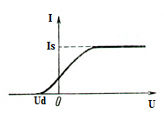
Figure 3.2 ispravit

The position of the first maximum on U scale must be equal to the lowest energy E, getting by atom at inelastic collision, the so-called first excitation potential.
The threshold energy of inelastic collisions of electrons with mercury atoms, measured by Franck and Hertz, was equal to 4.9 eV. As a result of the collision the atom makes a transition from the ground state E₁ to the nearest excited state E₂ (Figure 3.3). So, the atom can not have any values of the internal energy, but only some definite values that is just follows from the first Bohr postulate. Another important result of the Franck - Hertz experiments was the fact that has been discovered the emission of mercury vapor UV light with a wavelength λ = 253.6 nm, which is appeared every time, as soon as the accelerating voltage U was greater than 4.9 V. This radiation is associated with the transition of mercury atoms from the first excited state to the ground state. Indeed, from the condition of Bohr frequency rules (2nd postulate) $ℏω=Е_{2}-Е_{1}$, it follows that
$$Е_{2}-Е_{1}=\frac{2πсℏ}{λ}=\frac{2π∙3∙{10}^{8}∙1,05∙{10}^{-34}}{253,7∙{10}^{-9}∙1,6∙{10}^{-19}}=4,9eV.$$

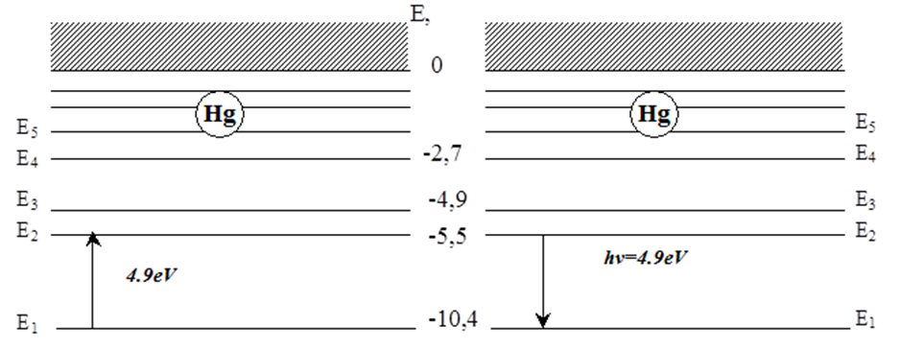
Figure 3.3

Franck and Hertz also observed emission spectra of mercury vapor when bombarded it with electrons. It was found that as soon as the electron energy reaches 4.9 eV, there is a high probability of inelastic collisions with mercury atoms. As a result of the collision mercury atoms are emitting radiation only one ultraviolet line with wavelength, i.e. with energy$hν=\frac{hc}{λ}$ (≈ 4,9eV).
As a result of the experiments of Franck and Hertz has been found:
1. The collisionsare elastic at velocities (energies) of electrons below a certain threshold value, i.e. electrons practically not transfering its energy to the atom and bouncing from the atom, changing only the velocity direction.
2. The impact occurs to be inelastic at velocities (energies) that exceed the thresholdvalue; electron will transfer almost all of its energy to the atom, which then goes into the excited state.
Thus, the atom or do not getting energy (elastic collision) at all, or takes it only in discrete portions that are equal to the energy difference in two stationary states.
If the energy of the electron incident on the atom is not large enough to ionize it, then only elastic collisions are possible in which the electron is almost does not lose energy. By increasing the potential difference between the cathode and grid electron energy increases and becomes sufficient for the excitation of atoms. The kinetic energy of the electron is transferred to the atomic electron st inelastic collisions, transferring it to a higher energy level.
After the passing electrons through the grid their energy decreases, they must overcome the potential barrier of the order of 0.5 V to get to the collecting electrode anode. Anode current is proportional to the number of falling electron on its surface per second and is measured by miliamperemeter.
However, saturation does not occur, since the electron energy becomes sufficient for inelastic collisions, after which some of the electrons almost completely lose its energy and can not overcome the delayed potential barrier between the grid and cathode. As a consequence of this process is decreasing of the current on the current-voltage characteristic.

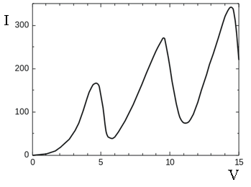
Figure 3.4

With further increase of the grid potential, electrons under inelastic collisions can re-gain energy, and overcome the potential barrier, giving contribution to new growth in the current voltage characteristic. Keep in mind that contribution to overcoming delayed field brings only the longitudinal component of the electron velocity, but not the total velocity, which varies at elastic collisions. This leads to a smoothing of the dependence I(V), and to some shift of the maximum on the curve towards lower energies.
Thus, there are series of maxima and minima on the curve of the dependence of the anode current on the grid-cathode voltage, spaced at a distance ΔU equal to the energy of the first excited state. Forthemercury atom ∆U = 4.9 V.
The potential ∆U is called the critical potential of the mercury atom, or the first excitation potential. If the accelerating voltage in the lamp reaches the first excitation potential, mercury vapors begin to light up and the atom returns to its ground state, emitting energy. This can be seen in the experimentby replacing glass bulbwith quartz ones, transparent to ultraviolet rays.
At wavelength of 253.7 nm, it is possible to calculate the first excitation potential of mercury, using the relation (3.1):
$E_{2}-E_{1}=eV=\frac{hc}{λ}$ (3.3)
One obtainsΔU = 4.887 V, which confirms the result of the Franck and Hertz experiment.
It should be noted that several factors lead to the fact that gaps in the current-voltage characteristics are not perfect (coincident with the theoretical curve):

1. The spread of the electron energy due to the space charge in the near cathode areas of high temperature thermal emission cathode and in the case of direct heating cathode, the potential drop on it;
2. The dependence of the excitation cross section on electron energy. There is a high probability of temporary capture of the electron by atom forming a negative ion atelectron energiesclose to the excitation energy of the atom. Thereafter auto pull out will occur and the atom returns to the ground state.
3. Contribution to overcoming delayed field brings only the longitudinal component of the velocity of the electrons, not the total velocity, which varies in elastic collisions;
4. The presence of the contact potential difference between the cathode and the anode and the cathode and the grid. Contact difference appears from the fact that the electron work function of the cathode is less than that of the anode.
5. The spatial potential created by the electrons itself. Its influence will be maximal in the region of the highest electron density near the cathode and will be shown first of all on the first maximum.

3.3. Description of the equipment
The principle of the installation is to obtainon the oscilloscope screen dependence of the anode currentI_{a}of the triode gas-filled lamps with heated-cathode on the cathode-grid U_{cg}voltage at a fixed voltage anode-grid and with followingvoltage measuring at characteristic points.
The unit consists of the investigated object IO and a measuring deviceMD (Figure3.5). The investigated object is set on the tripod (8) (Figure3.5) and is connected with the measuring device by cable (9).The investigated object is made on the basis of the manometer lamp PMI-2, filled with krypton. The lamp is placed in a metal case, on the basis of which has rack (10) for mounting it in a tripod.
Device is designed as a structurally finished product. Control elements are located on the front panel of the housing (the output of the resistor for setting filament current INCANDESCENCE (11) and handles (2) ROUGHLY and (5) PRECISELY for moving the label), display panel (1) of cathode-grid voltage and outputs (3) and (6) for connecting the oscilloscope and its synchronization (4).
On the back wall of the measuring device are located power switch, power cord, fuses, ground terminal and a plug for connecting the investigated object.

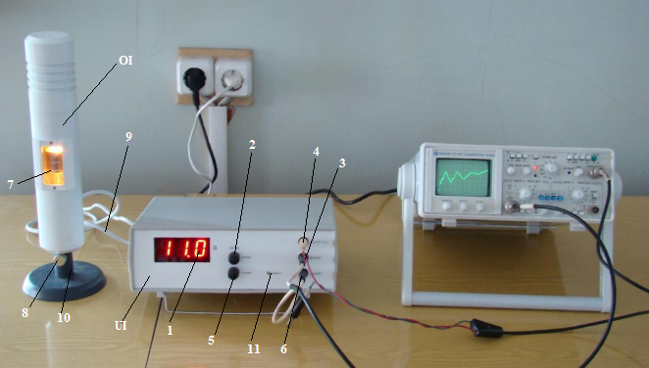

Figure 3.5

The installation operates as follows.
Pulses of amplitude of about 40 V are applied on the investigated object from the generator with saw-like voltage. In addition regulating voltage filament U_{f} and locking voltage U_{lock} that ensure normal operation of the lamp are applied to the investigated object. Anode lamp current I_{a} is converted by the measuring device into voltage proportional to currentand applied to the input of the oscilloscope. The oscilloscope displays the dependence of I_{a}on the voltage U_{cg}.
At the same time the measuring device forms a level on the oscilloscope screen, which can be moved on the screen of the oscilloscope using the handles ROUGHLY and PRECISELY. When pointing the label on interested point of the graph displayed, the reference voltage coincide with instantaneous saw-like voltage that allows to measure voltageU_{cg}with a digital voltmeter.

Work performance order.
1. To set the oscilloscope sweeps 5 ms/point and ammplification 0.5 V / cm.
2. To turn on the oscilloscope and using the handles, «↔ », «↕» and set the sweep beam in the center of the screen.
3. To turn on the measuring device. This will illuminate the investigated object. To keep the lamp switched on for a time at least 10 minutes to determine the operating mode of the lamp.
4. To adjust the oscilloscope synchronization to obtain a stable picture on the screen.
Note: In the case of oscillogram distortion, adjust it with the resistor INCANDESCENCEof the measuring device.
5.Withhandles ROUGHLY and PRECISELY move the labelalongoscillogram, combining the left edge of the label with characteristic points (minima or maxima), and make measurements of U_{cg}on the indicator of the measuring device.
6.Rotating the ROUGHLY and PRECISELY handles on the front panel of MD, set the label on the oscillogramin turn for 3 maximum writing down each time values of the indicator <B>.
7. To determine at least four values of the first excitation potential for the two sets of measurements. To find the average value and estimate the error.

Literature: [5,8,11,21]

Control questions
1. What kind of collisions iscalled the elastic and inelastic, and how they affect on dependence of I_{a} (U) of three electrode lamp?
2. What is the first excitation potential?
3. Why the glow of gas in the tube is possible?
4. Explain the distortion reasons of real current-voltage characteristics of the lamp (the presence of the contact potential difference, smoothing the dependance).

4. OBTAINING AND DECODING SPECTROGRAMS

4.1. The purpose and content of the work: to give skills in identifying iron spectrum; to teach to make precise (accurate) measurements using the atomic spectrum; obtaining skills in decoding spectrograms.
Decoding of the iron spectrum is made on spectroprojector PS - 18 or DSP - 1 using the atlas of the spectral lines. Measuring microscope MIR - 12 was used to measure the relative positions of spectral lines.The work is carried out using captured in advance on the plate ready spectrograms with iron spectrum and the investigated substances obtained using the mean dispersion spectrograph ISP - 28 at excitation of iron spectra and the investigated powders by arc generator IVS - 28. In order to students can imagine the obtaining procedure of spectra and spectral device itself, in classes is highly advisable to show it, to explain the principles of the basic elements of the spectrograph.

4.2. Theoretical introduction
Basic characteristics of electromagnetic radiation.Spectral and other optical methods of investigation are based on using different phenomena and effects, appearing when substance interacts with electromagnetic radiation. Due to the duality of light nature – wave and corpuscle, two types of characteristics to describe light are used: wave and quantum. Wave characteristics are oscillation frequency, wavelength and wave number; a quantum characteristic is energy of quantum.
Oscillation frequency shows amount of oscillations per 1s measured in Hertz (Hz). High frequencies are measured in kilohertz (1 кHz = 10³Hz), megahertz (1 мHz = 10⁶Hz) and etc. For example, red light is characterized with frequency 4⋅10⁴ Hzand green one with frequency – 6⋅10¹⁴ Hz.Wavelength shows minimum distance between two points oscillating in same phases. This is a linear unit and in SI measured in meters (m) and in its fractions – centimeters (cm), millimeters (mm), nanometers (1 nm=10⁻⁹m). For example, green light is an electromagnetic wave with wavelength =500–550 nm. Usually one can distinguish following parts in electromagnetic spectrum depending on wavelength:

Interval of wavelength | Segment of spectrum
10⁻⁴- 0,1 nm, or 10⁻¹³- 10⁻¹⁰m | - radiation
10⁻²- 10 nm, or10⁻¹¹- 10⁻⁸m | X-rays
10 – 400 nm, or10⁻⁸- 4⋅10⁻⁷m | Ultravioletradiation
400–760нм, или4⋅10⁻⁷- 7,6⋅10⁻⁷m | Visiblelight
760 – 10⁶nm, or7,6⋅10⁻⁷- 10⁻³m | Infraredradiation
10⁻³m-1m | Microwavesandultrahighfrequencies
λ>1 m | radiowaves

Wavelength and oscillation frequency related by following expression
$$ν=\frac{c}{λ},$$
where c is speed of light
If speed of light given in cm/s and wavelength in cm, so$ν={10}^{10}/λ$, where v given in Hz.
For example, for green light λ = 500 nm =5⋅10⁻⁵sm, frequency$ν=\frac{{3*10}^{10}}{5}*{10}^{5}=6*{10}^{14}Hz$. A quantity inverse to wavelength is called wave number$\tilde{ν}$and given in inverse centimeters (sm⁻¹). For example, for green light $\tilde{ν}$= 1/5⋅10⁻⁵= 2⋅10⁴sm⁻¹.
Energy of electromagnetic radiation is defined by following relation
$$E=hν,$$
where h–is Plank constant.

4.3. Atomic spectra.
Background information.Structure of external electron shells of atoms determines features of atomic optical spectra of elements. Hence valence electrons are also called as optical electrons. Atoms with similar external electron shells have not only a similar chemical properties, but also optical spectra which are close by its structure. One can observe optical characteristic spectra of elements only in the case when their atoms are isolated i.e. when observing substance is “atomized” and it has a low density. Distribution of electrons on energy levels in an isolated atom corresponds to minimum of its internal energy and it is at ground (or normal ($E_{1}$)) state. The atom under certain conditions can be transited into the excited state or ionization state.
Excited states like ionization states are characterized by extra energy, which can take only certain values. Therefore, internal energy at excitation and ionization changes abruptly. Every element has its own specific energy states of excitation and ionization, which are depend on charge of the atomic nucleus and the structure of electron shells.
The energy required for transferring atom from ground state to any excited state is called excitation energy and the energy required for ionization is ionization energy. Energy states of atom i.e. energy levels are represented by parallel segments, distance between them proportional to energy difference (Figure 4.1). Allowed changes of energy states of atom (ion), so-called allowed (permitted) energy transitions, are represented on diagrams by arrows or by straight lines segments connecting initial and final levels. The number of levels is very great and they appears more often as it goes away from ground stationary level and approaching to the bound, corresponding to ionization energy.
The number of allowed energy states of atom changes periodically with increasing of number of the element. Elements of the first group have more the simplest energy state schemes. They have one external electron at filled previous shells. The most complex systems have “transitional” elements, lanthanides and others with uncompleted lower d- and f- sublevels and with several optical electrons at the last level.
Thus, in range of every period of the periodic table scheme of energy states of atoms become more complicated with increasing atomic number. This increases both the energy difference of neighboring excited levels and energy of the lowest excited level. Thelowestexcitedleveliscalled the resonancelevel.
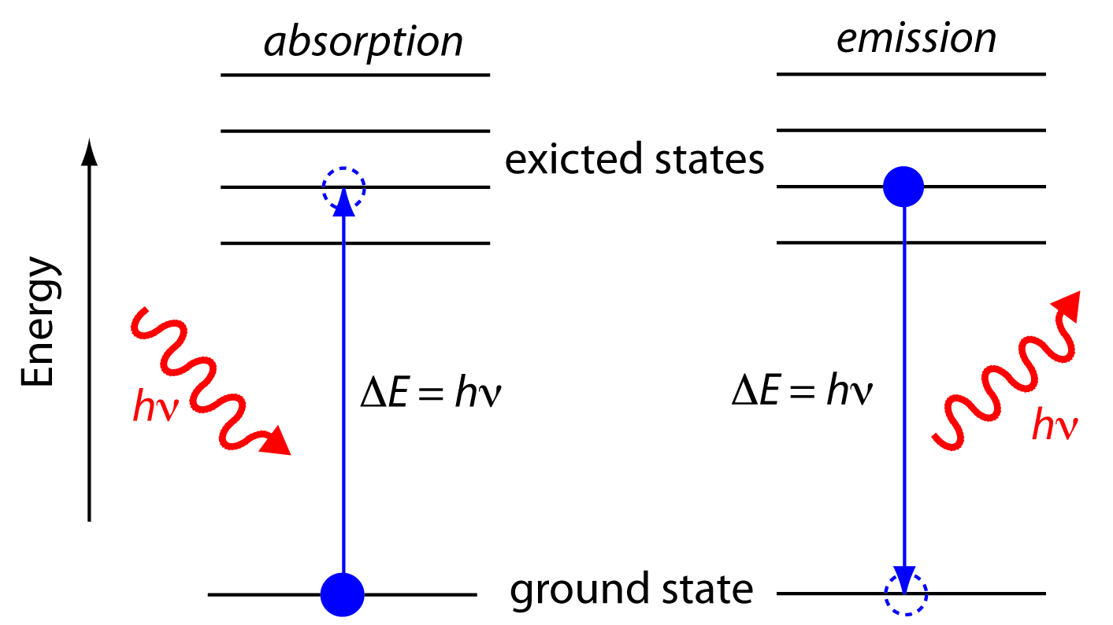
Figure 4.1. Energy states scheme

Elements, atoms of which have filled external electron shells, and the elements that end periods of the periodic table have the highest ionization and excitation energies of resonance levels. Elements that begin periods i.e. have one external optical electron, have the lowest ionization and excitation energy of resonance level. As number of above mentioned elements is increasing, the ionization and resonance level energies also increase. The excited state of atom is unstable; through more or less period of time (10⁻⁶-10⁻⁸ s) atom comes back to its initial state with Е=Е₁ immediately or by a number of consecutive transitions to intermediates levels. Accordingly it loses all excess energy at once or by parts. Transitions may happen spontaneously or forcedly under influence of other particles and radiation.
Ways of excitation and ionization of atoms. Excitation and ionization are achieved by bombing of atom by fast electrons of the investigated substance, as well as the interaction of atoms with radiation. The collision with electrons can cause ionization of the atom with some probability, provided that Е_{k} kinetic energy of electron equal or more than that of ionization Е_{u} of given element.
For excitation of atom in ground stationary state E₁ to any state E₂ or for transition from one excited state E₂ into higher excited state E₃ kinetic energy of electron should not be less than (Е₂ – Е₁) or (Е₃ – Е₂).
Excitation sources of optical spectra are flames and electrical discharges, for example, arc, spark and others, where electrons reach temperature T from thousands to ten thousands of K and substance under investigation is atomized. Electrons make chaotic motion and their average kinetic energy is equal to $\frac{mv^{2}}{2}=\left(\frac{3}{2}\right)kT$where (k_{B} – Boltzmann constant). In this case particles obtain all kinds of velocities: there are slow electrons, they cannot excite, and fast electrons with energies about several electron-volts, which is enough to excite atoms of all elements. As temperature rises, relative number of electrons with high energies increases and fraction of slow electrons decreases which is insufficient to excite atoms. The higher excitation energy of atom the higher should be temperature of electrons for more effective excitation process Interaction with electromagnetic radiation may lead to ionization, when its energy $hν=E_{em}≥E_{i}$. Probability of the each ionization reaches its maximum at energies exceeding corresponding ionization energy, and then it decreases.
Emission Spectra.Discrete set of quanta that are able to emit atoms form characteristic linear spectrum of corresponding element.
Atomic optical spectra consist of great number of lines, distributed on wide segment of optical range of wavelengths, approximately from 100 to 800 nm. Only certain energy transitions are allowed in atom, because of that spectrum of each element consists of number of series, uniting lines with common lower level (Figure 4.2). Series overlap in optical spectrum. Continuous spectrum of recombination begins after series lines, related with grabbing of free electron by ion and its transition to lower level.
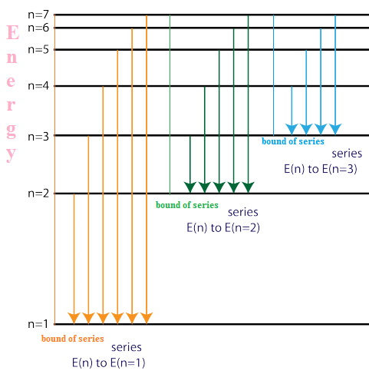
Figure 4.2.Formation series of atomic emission spectra.

When quant of energy grabbed electron, it emits with frequency${ ν}_{0}=\frac{E_{I}-E_{b}}{h}$, corresponding to border of series. However ion is able to grab electron which has any kinetic energy which entirely transferred into radiation. Because of that recombination spectrum consists of continuous frequency series exceeding frequency of border series $v>v_{0}$ Continuous recombination spectrum extending beyond the series creates a background, obstructing analysis because it matches with lines and hides them.
Emission spectrum is usually called emission when emitting atoms are formed mainly due to collision with particles and fluorescent when it is formed under the influence of radiation.
Absorption spectra. The set of various portions of energy (quanta), which can be absorbed by atoms of given element at transition of atom from lower level E₁ to higher level E_{m} creates its absorption spectrum, consisting of great number of lines, which have wavelength $λ_{lm}$and frequency$ν_{lm}$depending on energy difference of both levels.
Absorption spectrum has characteristics at the same degree as emission spectrum, as it is determined by the same system of atomic energy states.
For denoting the line symbol of the element, ion multiplicity index (denoted by Roman numerals) and wavelength in nanometers are used, for example, Na 1 589,59 nm, Fe ІІ 2 261,38 nm, (where index "1" refers to neutral atom, "II" refers to singly charged ion and etc.)
Number of lines and, therefore, the complexity of spectrum increase in the following order: hydrogen and other elements with one valence electron i.e. alkaline metals have the simplest structures; elements of second group have more complex spectra, then spectra become more complicated with increasing group number. The most complicated spectra have elements with uncompleted d-, f- shells, i.e. metals of all secondary sub-groups, except first three elements and in rare-earth metals. All elements of main groups of the periodic table have relatively simple spectra. For example, non-ferrous metals have simple spectra, black and rare earth metals have complex spectra.
Line (discrete) spectrum of complex substance is composed of characteristic spectra of its individual atoms and ions.
For the analysis of chemical composition of substance from complex spectrum by using spectral devices allocate the individual the most suitable for this case lines element being determined.
For spectral analysis resonance lines are very important, as theoretically they provide the highest sensitivity of the analysis. Resonance lines emitted or absorbed in transitions between ground level and the lowest excited level.

4.3. Devices for viewing of spectrogram and measuring distance between lines.
Spectroprojector gives on display increased Figure of spectrograms. Scheme of the device DSP-1 is shown on Figure 4.3. Light from lamp of incandescence 1 go through illuminating system of lenses 2, heat protecting filter 3 and fall on photo plate 4. Objective 6 and prism 7 projected 20 times increased Figure of spectrogram on display 8. For considering different parts of plate table can be transported in horizontal plane in two perpendicular directions.

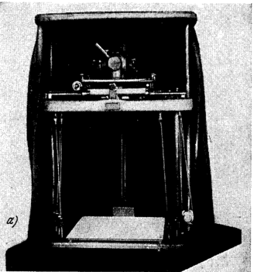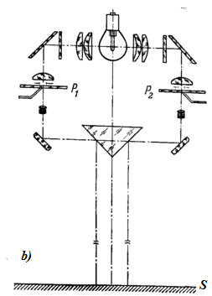

Figure 4.3.Double spectroprojector DSP-1
a-outward; b-optical scheme ; ссылка
1-lamp; 2-capacitor; 3-heat filter; 4-spectrogram; 5-curtain; 6-objective; 7-prism with mirror edges; 8-display
For correct measuring distance between spectral lines is used measuring microscope MIR-12. It (Figure 4.4.) has horizontal table 1, with fixed photo plate. Housing 2 is motile and can be moved by micrometric screw 3 in horizontal direction. Photographic plates fixed to the table so that the movement of the microscope slide was directed along the spectrum. Available in a field of view of the microscope thin cross set in sequence for each spectral line. To set in microscope field of view necessary part of spectrum movable table 1 has along and transverse movement. To clear along way of table it is necessary to press pedal 5. Transverse movement made by hand. The sharpness of the image of the spectrum is achieved by rotating the lens. Installation of field eyepiece grid by turning the rim of the ocular lens. Calculation of distance is made by mm scale 4 and reel 3. Value of division of reel 0.01 mm, accuracy of calculating 0,005 mm carriage of microscope has step 50 mm.

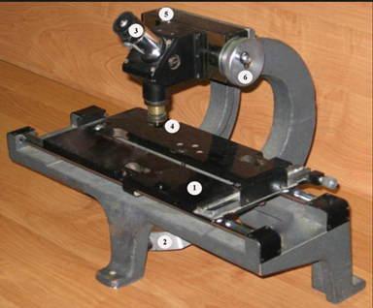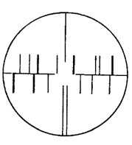
a Figure 4.4. b
The measuring Microscope MIR-12 (а)
and spectrum in its field of vision(b) ссылка

Reference material for high-quality decoding of spectrograms can be found in the tables of spectral lines and atlases.
Tables. There are tables of spectral lines of two types: a) spectral lines of the periodic system of elements arranged in descending order (ascending) wavelength. Tables of this type are useful to identify. b) The lines of each element in the periodic system are listed in a separate table. Such tables are useful for the selection of analytical lines.
Atlases are sets of plates that show the spectra of the elements indicating the wavelengths of spectral lines.
Consider one of the most common atlases for quartz spectrograph of average dispersion (ISP-28, ISP-30). The Atlas consists of 23 tablets. On each plate showed a section of the spectrum of iron, in relation to which the position shown in dashes lines characteristic of other elements.
For each line next to the symbol of the element given wavelength, rounded to 0.01 nm, the sensitivity of the line specified in units (Figure 4.5). Ten-point system is adopted to assess the sensitivity of the line by the. The lines that appear when the concentration of the element of 10% or more, has sensitivity equal to one. Line appearing at a concentration of 0.001% or less, has a sensitivity of 10 (Table 4.1).
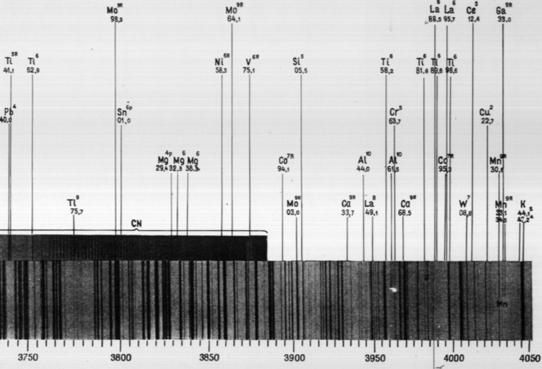

Figure 4.5 ссылка

Table 4.1
The scale of line intensities
Intensity | Concentration of element at which line in etalon spectrum appears, %
1  2-3  3-5  5-7  7-9  10 | 10-1  1-0,1  0,1-0,01  0,01-0,001  <0,001
Given sensitivity estimation in the atlas should be considered as indicative, since the appearance of lines in the spectrogram is mainly depending on the conditions of the obtaing spectrum
These estimates of the sensitivity in the atlas should be considered as indicative since the appearance of the lines on the spectrogram is largely dependent on the conditions of the spectrum.
Under the range of iron plate placed wavelength range, which allows navigating in the spectrum and determining the wavelengths of the lines are not listed in the atlas.
The spectra shown in atlases filmed using a spectrograph ISP-28 and increased in 20 times in accordance with the increase spectroprojector lens - 20X. Therefore, the spectrum on the plates satin exactly coincides with the spectrum shown in the screen spectroprojector.
To quickly find a particular portion of the spectrum in the spectrograms in Table 4.1 (p. 53), the manual "The identification of the spectra of the elements" [16], the characteristic lines of the group of Fe and some common elements, located more or less evenly on the plates of the atlas. These groups are easily remembered and greatly facilitate the orientation of the spectrum.
Carefully looking spectrogram seek out therein and on the plates satin catchy line, for example, on a plate 8 is a group of satin lines, conventionally called '' Twins '' (Figure 4.6.a), and 15 on the tablet - is also very noticeable group (Figure 4.6.b). For a better memorization of these and other memorable scan line groups spectrum iron over the entire length several times, each time looking for the desired line.

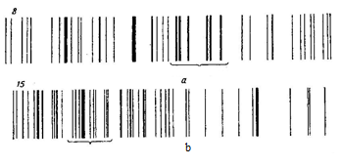
Figure 4.6

4.4. Work performance order
Identifying of the spectral lines is carrying out on the spectropojector PS-18 or DSP-1 using atlas of the iron spectrum.
Exercise 1. Spectrogram decoding. Determination of wavelength of the spectral line.
Determination of the wavelength consists in comparing given wavelength with standard normals for which the wavelengths are measured precisely (accurately).
High-quality decoding of spectrograms made using spectra comparison, the most common of which is the spectrum of iron. The range of iron plays a special role in spectral analysis. His line is filled with visible and ultraviolet regions of the spectrum. Wavelengths cancer lines are defined with great precision. Because of this spectral line cancer can be used as wavelength standard, so-called frames. Without the spectrum of iron butt photographed with the spectrum of the sample, it is impossible to use the atlas.
Methods for determining the wavelength of the spectral line
1. Measurement of the wavelength spectrum from the reference lines of iron.
Spectrum analysis sample photographed beside comparison spectrum is measured by its control of the distance between the two lines located on both sides of the desired line, and the distance between the unknown and one a reference line. The wavelength of the desired line is calculated by the formula
$λ_{x}=λ_{1}+\frac{b}{a}(λ_{2}-λ_{1})$,
where a is the distance between reference lines $λ_{2}$and$λ_{1}$; b is the distance between the reference line $λ_{1}$and the desired line$λ_{x}$; $λ_{1},λ_{2}$ are the wavelength of the reference lines; $λ_{x}$ is the wavelength of the desired line. At the same time $λ_{1}<λ_{2}$;$λ_{1}<λ_{x}<λ_{2}$ (Figure 4.7).
To measure the distance between the lines serves as comparators and measuring microscopes. The most common measuring microscope MIR-12 and ISA-2 comparator.

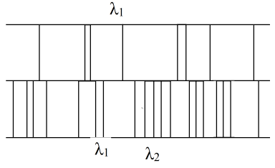
Figure 4.7. Determination of the wavelength of the line using measuring microscope

Determination of the wavelength using the atlas of the spectral lines. On one plate with a diaphragm Hartmann photographed the spectrum of the sample with the spectrum of iron butt. To increase and a careful study of spectrograms obtained using special devices spectroprojectors.To decrypt the spectrogram use atlas of the spectral lines of the elements. The spectrum of iron in the spectrogram projected on the screen, combined with the spectrum of iron plate. The wavelength of the line is determined directly from the atlas.

Task. By experimentally obtained snapshot of the spectrum of iron:
- to find characteristic groups of spectral lines of the investigated substance and plot 3-4 of them;
- to define the length of the two spectral lines using a linear interpolation formula (4.1);
- to decode the spectrogram and to determine whether there are lines of Al, Sn, Pb, Zn in the spectrum.
The measurement results write down into the table.

Literature:[1,2,14,15,18,21].

Control questions:
1. The emission spectrum. Types of spectra.
2. Explain the mechanism of excitation of the line spectrum.
3. Optical range. Optical electrons.
4. The excitation energy, the ionization of an electron in an atom.
5. What is the distribution of energy levels of the atoms at thermodynamic excitation?
6. What is meant by a series of spectral lines? The border of series.
7. What determines the quality and complexity of the structure of the emission spectrum?
8. To be able to describe a scheme of spectral device (explain the purpose of its individual parts); principle of the excitation source (arc discharge) and the radiation detector (photographic plate).

5.THE USE OF ATOMIC SPECTRA TO ANALYZE THE COMPOSITION OF THE SUBSTANCE

5.1. The purpose and content of the work: Introduction to the methodology of determining the composition of matter according to their atomic emission spectra excited in the arc discharge. Getting skills in qualitative analysis. The development of recording spectra of powdered substances and the identification of spectrograms. Identification of the spectral lines on speсtroprojector CPD-I with the help of atlas reference spectrum. Performance of the full and partial qualitative analysis of two samples of different composition.
The spectrum of the sample is photographed next to the iron range by using the diaphragm Hartmann. For an explanation of the spectrogram produce speсtroprojector by using the atlas of the spectral lines of elements. The presence of the element in the sample is judged by the appearance of its last lines in the spectrogram.
The work is carried out using captured in advance on the plate ready spectrograms with spectra of analyzing substances and ethalon source (iron) obtained using the mean dispersion spectrograph ISP - 28 at excitation of spectra by arc generator IVS - 28.

5.2. The qualitative spectral analysis of the powder-like substance on the presence of metals.
The basis of qualitative spectral analysis based on the ability of atoms of each chemical element during excitation radiate a line spectrum. Therefore, any spectral lines of the elements which placed in the spectrum of the sample can serve as proof of his presence in the analyzed object.
By comparison with other analytical methods spectral analysis is the most simple, rapid and sensitive method. Method of spectral analysis, as a rule, does not require separation of analyzed material. The rigging of a few milligram of sample can be during one operation photographically identifying many elements.
Qualitative analysis is reduced to a few steps: 1) vaporizationand excitation spectrum of the analyte; 2) visual observation or photographing of the spectrum; 3) finding the characteristic lines corresponding elements in the spectrum. To find out whether this element is present in the sample is sufficient to establish with absolute certainty the presence of one or two analytical lines in the spectrum. In order to determine whether a given element is presenting in the analyzed sample, it is sufficient to establish with complete certainty the presence of one or two analytical lines in the spectrum.
In the spectrum of each element has a plurality of lines of varying intensity. Typically, for a qualitative analysis of selected lines characteristic of the given element, i.e. check the presence of all the spectral lines irrational (time-consuming). For each item, set a number of the most sensitive lines, which are called the "last" because a decrease in the concentration of the element they disappear last. The concentration at which disappear "last" lines for each item is different. Most items can be detected at a concentration of 0.01-0.001% of the sample and sometimes at a concentration of <0.001%. "Last" line usually has a low excitation potential. Often these lines correspond to the lower and main level so became as a resonant lines. To increase the reliability of analysis definition of each element is carried out not one by one, and often several its "last" lines. "Last" line for all the elements is well known. Their lists are provided in the tables of spectral lines in the spectra atlases.
The spectral method can determine more than 80 elements in periodic systems which are present in the substance in an amount 0.01-0.001% or below. For qualitative analysis is commonly used photographic method of recording the spectrum. The advantage of the photographic plate is that it is simultaneously registered large area of spectrum, and the record is stored indefinitely, which makes it possible opportunity to re-test analysis results.
The decoding of spectrum of the analyzed sample carry out by the considering of received spectrogram on spectroprojector , then compare these spectrum with spectrum of iron by using the atlas. Plates make it easy to find position of the lines of elements relative to iron spectrum. All lines of elements labeled on the plates are provided with the designation of the wavelength corresponding to them and an indication of the intensity in the arc of AC according to the ten-point scale.
Lines of iron deposited near to the scale of the wavelength which divided on a number of intervals. Atlas is made for quartz spectrograph of average dispersion ICP-28 which with an increase equal to the increase, obtained on a screen of spectroprojektor PS-18 or DSP-1. On the atlases accurately reproduce the size and form of the spectrum, received on the devices. Atlas allows you to quickly navigate in the spectrum of various substances, photographed on spectrograph ISP-28.
When decoding the spectra and clarify the possibility of imposing of the spectral lines of some elements on the other must be used tables of spectral lines [13,14,16].
The absence of lines of the desired element on the spectrogram means that the content of the element in the sample is less of limit of sensitivity of method.

5.3. Work performance order
In this work, we propose to make a qualitative analysis of two samples. For one sample is necessary to establish the presence or absence of specific elements which indicated by teacher. The plates are mounted on the table of the spectroprojector, the investigated spectrogramsare projected on the screen of the spectroprojector and starting to decode.In ascending order of the wavelength iron spectrum is superimposed on the spectrogram with the iron spectrum of the corresponding atlas plate.If the spectrum sample contains not very many lines then sequentially identifying each of them, and data are entered into the table.
Using the table of the last lines (Table 5.2), pointing out alllast lines of elements found in the spectrogram of the sample. If the lines of the interfering elements are not imposed on the last lines of any element or such elements are not observed in the sample then one can say with confidence about the presence of the element in the sample, discovering on the spectrogram 2-3 its last lines.If the last element lines are overlapped with lines of the interfering elements then one should selected other lines for the control, less sensitive, but free from overlapping.
Underline in the table all the elements for which the last lines are found, not overlapping by lines of other elements. Decoding resultsare written in the form:

Table 5.1
Wavelength, nm | Characteristic | Disturbing element
If on the spectrogram of the sample so many lines and identification of each of them will require a lot of time and work, then it is easier to conduct decoding only by the last lines of elements, based on the proposal that any metal can be in the sample.

Table 5.2
Spectral lines for qualitative analysis
Element | Main line λ, nm | Sensitivity in carbon arc, % | Interfering elements | Control lines λ, nm
Boron | 249,7724 І | 0,001 | Fe | 249,6773 І
Germanium | 265,1184 І | 0,001 | Pb(>10%) | 303,9064 І  265,1580 І
Gold | 267,595 І | <0,001 | W(1%)  Сo(0,5%)  Nb(0,1%)  Na(0,05%) | 242,795 І
Manganese | 280,1084 І | <0,001 | Zn(>0,1%) | 279,4817 І  279,8270 І
Lead | 283,3069 І | 0,001 | Mn(10%) | 405,7812 І  280,2003 І  287,3316 І
Tin | 283,9989 І | ≤0,001 | Cr(<0,3%)  M(3%)  W(≤3%) | 317,5019 І  303,4121 І
Magnesium | 285,2120 І | 0,0003-0,001 | Na(>1%)Fe | 279,5523 І I  280,2698 І І
Silicon | 288,1595 І | 0,001 |  | 251,6109 І  252,8510 І
Gallium | 294,3639 І | <0,001 | Ni(>0,1%)  Co(1%)  Fe | 294,4175 І  287,4240 І
Indium | 303,9356 І | 0,001 | Ge(0,01%)  Cu(>10%)  W(0,5%)  Fe | 325,6090 І  325,8564 І
Nickel | 305,0819 І | 0,001 | V(0,1%)  Co(>1%) | 341,4765 І
Bismuth | 306,7712 І | <0,001 | Fe(1%)  Mo(1%) | 289,7975 І  298,9029 І
Aluminum | 308,2155 І | 0,001-0,003 | Mn(>5%) | 394,4009 І  396,1527 І
Molybdenum | 317,0333 І | <0,001 | Fe | 313,2591 І  281,6154 І
Vanadium | 318,3982 І | <0,01 | Ti, Ca | 318,5396 І  318,3406 І  295,207 ІІ
Copper | 324,7540 І | 0,0001-0,0003 | Fe | 327,3957 І
Silver | 328,0682 І | <0,0001 | Mn(0,3%)Fe | 338,2891 І
Zink | 334,5020 І | 0,01 | Са(>5%)  Mn(>1%)  Mо(0,01%) | 334,5572 І  328,2333 І  481,0534 І
Titanium | 334,9035 І І | <0,001 |  | 327,2800 І І  308,8027 І І
Scandium | 335,3734 І | <0,001 | W(1%)  Ті(>0,1%)  Cu(>10%) | 336,8946 І І  255,238 І І
Cobalt | 345,3514 І | ≤0,001 | Nі(≈0,1%)  Cr(<1%) | 344,9441 І  344,9170 І  242,4932 І
Calcium | 393,3664 І І  396,8470 І І | <0,001 |  | 422,6728 І  317,9332 І І
Potassium | 404,4145 І  404,7214 І | 0,1-0,3 |  | 344,6380 І  344,741 І
Chromium | 425,4346 І  427,4803 І | <0,001 |  | 301,4760 І  267,719 І І  284,324 І І
Strontium | 460,7331 І | 0,001 | Mn | 407,7714 І І  346,4457 І І
Barium | 493,4086 І І | 0,001 |  | 455,4042 І І  233,5269 І І
Sodium | 588,9953 І  589,5923 І | 0,001-0,0003 |  | 330,234 І  330,294 І
Lithium | 670,7844 І | <0,001 |  | 323,261 І  460,299 І

Literature: [4,6,14,15,18]

Control questions:
1. Principles of the qualitative spectral analysis.
2. What lines are called resonance lines in the spectrum?
3. What do we mean by "last" lines, what are the control lines?
4. How qualitative (partial and full) analysis is conducting? (The role of Hartmann’s diaphragm and Fe spectrum at decoding of spectrograms).
5. Explain how to take into account the overlapping of the spectrum.

6. DETERMINATION OF THE RYDBERG CONSTANT AND ELECTRON MASS

6.1. The purpose and content of the work: Getting know spectrum and system of energy states of hydrogen atoms. Studying a serial pattern in hydrogen spectrum, experimental measuring of wavelength in Balmer series, determination of the Rydberg constant and mass of electron with spectroscopic method; determination of ionization energy, energy levels and size of hydrogen atoms in different quantum conditions.
6.2. Equipment:
Monochromator MUM, mercury-vapor lamp, gas discharge tube with hydrogen, power supply.
6.3. Bried theory:
As result of research, which was made in a second half of XIX century, was established that couple of each chemical element at corresponding excitement radiate a definite spectrum, which consist of a set of separate lines - the so-called line spectrum.And the atoms of each chemical element have its own definite line spectrum.Thus were laid the foundations of spectral analysis physical method of determining the qualitative and quantitative composition of matter by studying its spectrum (Kirchhoff, Bunsen, 1859).Analysis of the line spectra of the elements immediately led to the conclusion that the lines in the spectra are not located randomly, chaotically, but with sense of logic. There was a challenge to establish and explain these patterns.
Studying the line spectrum of hydrogen, a Swiss physics teacher I.Balmer set (1885), that wavelength of while known nine spectral lines can be calculated by the formula

λ=$λ_{0}{n^{2}}/{\left(n^{2}-4\right)}$ (6.1)

Formula (6.1) usually is written in following form
$\tilde{v}=1/λ$ = R$\left(\frac{1}{2^{2}}-\frac{1}{n^{2}}\right)$ (6.2)
where R=10973731,77m⁻¹, n=3,4,5, ... $\tilde{v}=1/λ$is a wave number. Constant R was first defined by R.Rydberg and was called the Rydberg constant. Balmer's formula, first pointed to the special importance of integers in spectral regularities, played a prominent role in the development of the doctrine of the structure of atoms. If we consider good accurateness of spectroscopic measurements, it must be recognized that Balmer's formula is one of the most precise laws of physics. From formula (6.2) we see that all lines, characterized by different values of n, form a group, or a series of lines, called the Balmer series. With increasing n series line closer to each other. The value of n=∞ defines the boundary of the Balmerseries.It corresponds to the wavelength${ λ}_{∞}=\frac{4}{R}=364,4 nm$.
Rydberg showed that the line spectra of not only hydrogen, but also other elements of the observed spectral series, and the wave numbers $\tilde{v}$ all lines of this series satisfy the relation
$\tilde{ν}=T_{n_{2}}-T_{n_{1}},$ (6.3)
where${ n}_{2}$ and $n_{1}$are some integer numbers. Functions T($n_{2}$) and T($n_{1}$) are called spectral therms. For this series $n_{2}$ has a constant value. Change of $n_{1}$ gives all lines of certain series. Careful studies of the hydrogen spectrum have shown that it observed five series of spectral lines.In the ultraviolet region of the spectrum has been detected Laiman series
$\tilde{ν}=R\left(\frac{1}{1^{2}}-\frac{1}{n^{2}}\right), n=2,3,4,…$ . (6.4)
In the infrared region have been found:
Pashen series $\tilde{ν}=R\left(\frac{1}{3^{2}}-\frac{1}{n^{2}}\right), n=4,5,6,…$
Bracket series $\tilde{ν}=R\left(\frac{1}{4^{2}}-\frac{1}{n^{2}}\right), n=5,6,7,…$
Pfunda series $\tilde{ν}=R\left(\frac{1}{5^{2}}-\frac{1}{n^{2}}\right), n=6,7,8,…$
Hamphry series $\tilde{ν}=R\left(\frac{1}{6^{2}}-\frac{1}{n^{2}}\right), n=7,8,9,…$

Thus, all series formulas hydrogen spectrum can be expressed by a single formula
$\tilde{ν}=\frac{1}{λ}=R\left(\frac{1}{m^{2}}-\frac{1}{n^{2}}\right),$ (6.5)
The line spectrum of the hydrogen atom and the laws (6.5) are in direct contradiction with the classical interpretation of Rutherford's atomic model.
The use of classical electrodynamics to the nuclear model of the atom led to a complete contradiction with the experimental facts. According to the classical theory, should occur:
a) continuous loss of electron energy in the form of radiation of electromagnetic waves and the instability of the atom;
b) the existence of only a continuous spectrum. Spectral lines should not exist.
In fact, it turns out that: a) atom is a stable system; b) the atom emits energy only under certain conditions; c) radiation has a line spectrum of the atom.
Way out of this contradictory situation has been proposed by Bohr (1913). In the Bohr theory was the idea of link together the empirical regularities of line spectra, the nuclear model of the atom Rutherford and the quantum nature of the emission and absorption of light (the hypothesis of Planck), confirmed by extensive experimental material.Bohr formulated the laws that describe the state and the movement of electronsin an atom in the form of certain postulates. These postulates are:
1. An electron in an atom can be rotated only in strictly defined fixed orbits whose radii are determined from the condition
$L=mvr=\frac{nh}{2π}≡nћ,$ (6.6)
where L - the angular momentum of the electron; n - the principal quantum number, takes a positive value of 1.2 ... and determine the status of an electron in a particular orbit; h is Planck's constant. All other orbits are "forbidden."Thus, Bohr postulated that the energy of an electron in an atom can take on well-defined discrete values${ E}_{1}$,$E_{2}$, ... $E_{n}$ .... Spinning on stationary orbits, the electron does not emit or absorb electromagnetic waves.
2. Radiation occurs only in the transition of an electron from a steady state with a higher energy the E_{k} to another stationary state with lower energyE_{i}. This emitted energy quantum (a photon) is strictly a particular frequency. Monochromatic radiation of atoms and the frequency is determined by the fundamental relation (Bohr frequency condition)
$E_{k}-E_{i}=h{ ν}_{ik}$ (6.7)
where$h{ ν}_{ik}-$energy of emitted photon.
From (6.7) it follows that the emission occurs when the electron orbits from external to internal. If an electron is transferred from internal to external orbits, the energy is absorbed. Comparison of formula (6.7) and (6.5) allows us to conclude that the energy of an atom in a stationary state
$E_{n}= -{Rhc}/{n^{2}}={-2πRћc}/{n^{2}}$ where n = 1, 2, 3… (6.8)
and spectral therms associated with the energy of the atom by formula
$T(n)={{- E}_{n}}/{hc}=R/{n^{2}}$ (6.9)
Therefore, integers included in the series formulas (6.5) determine the quantum energy value of the atom (the energy levels of the atom). From (6.8) it follows that the energy states of a hydrogen atom form a sequence of power levels that vary depending on the value of n. The energy state corresponding to the value of n = 1 is called the basic or normal (unexcited) state. All states with n> 1 are called excited. When n → ∞, E∞ → 0. The minus sign in the formula (6.8) shows that the electron bound in an atom force of attraction to the nucleus. Therefore, the absolute value of E_{n} in (6.8) considers the boundary energy of an electron in an atom in a state n.
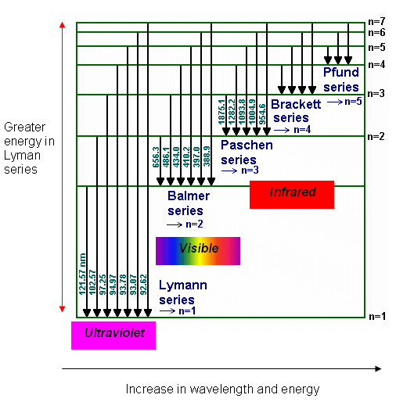
Figure 6.1 ssylka

Figure 6.1 shows a diagram of the energy levels of the hydrogen atom. The arrows indicate the transitions corresponding to emission spectral lines of various series.
Bohr's postulates have allowed to calculate the spectrum of the hydrogen atom and hydrogen-like ions, as well as theoretically calculate the corresponding values of the Rydberg constant, are in good agreement with experiment. Bohr believed that the motion of an electron in a hydrogen system occurs in a circular orbit of radius r under the action of the Coulomb force of attraction of the electron to the nucleus causes the centripetal acceleration, i.e. we can write:
$\frac{e^{2}}{4πε_{0}r_{n}^{2}}=\frac{m_{e}e^{2}}{r_{n}}$$\frac{mv^{2}}{r}$$\frac{Ze^{2}}{4πε_{0 }r^{2}}$ (6.10)
From the formula (6.10), (6.6), we obtain

$r_{n}=\frac{{4πε_{0}ћ}^{2}}{m_{e}Ze^{2}}n^{2}$ (6.11)
The energy of an electron in a hydrogen-like system is the sum of the kinetic energy $E_{k}$ and the potential energy $E_{p}$ in the electrostatic field of the nucleus
$E=E_{K}+E_{P}=\frac{mv^{2}}{2}-\frac{Ze^{2}}{4πε_{0}r}=-\frac{1}{2}\frac{Ze^{2}}{4πε_{0}r}$$\frac{mv^{2}}{2}-\frac{Ze^{2}}{4πε_{0 }r}$$-\frac{1}{2}\frac{Ze^{2}}{4πε_{0 }r}$ (6.12)
Substituting r in (6.12) from (6.11), we obtain

$E_{P}=-{\left(\frac{1}{4πε_{0}}\right)}^{2}\frac{me^{4}}{2ћ^{2}}({\frac{Z}{n})}^{2}$ (6.13)
Comparing (6.8) and (6.13), we obtain
$R_{∞}={\left(\frac{1}{4πε_{0}}\right)}^{2}\frac{me^{4}}{4πћ^{3}c}$ (6.14)
The theoretical value $R_{∞}$is slightly different from the experimental value of R. The discrepancy is explained by the fact that in the derivation of (6.14) is the nuclear of the atom was considered that it fixed (he is credited with an infinitely large mass). In fact, the nucleus has a finite mass, so that there is a movement of both electrons and nuclei around the center of mass of the atom, so instead of the electron mass m in formula (6.14) should introduce the reduced mass:$μ={mM}/{\left(m+M\right)}$, where M nuclei mass. Then
$R_{∞}={\left(\frac{1}{4πε_{0}}\right)}^{2}\frac{μe^{4}}{4πћ^{3}c}$ (6.15)
Consequently, the Rydberg constant must depend on the mass of the nucleus:
$R=\frac{R_{∞}}{(1+m/M)}.$ (6.15а)
The reduced mass μ will have different values for different isotopes, which leads to some difference of energy levels and wavelengths of spectral lines. This phenomenon called isotopic shift. That isotope shift and opened a heavy isotope of hydrogen - deuterium (1932.). Thereby obtain the R value for hydrogen is in good agreement with the data obtained from the spectroscopic measurements.

6.4. Description of the installation
The observation of spectral lines and measuring their position is made on MUM monochromator with glass optics.
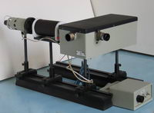
Figure 6.2. ssylka

6.5. Work performance order.
Before carrying out the work it’s necessary thoroughly to acquaint with the recommended literature, content of the work
1. Calibrate barrel’s scale in MUM. Calibration of MUM needed to demonstrate barrel’s scale in wavelength. Mercury-vapor lamp is very useful in calibration. Because, wavelength of spectral lines, that it gives, shown in the table with their relative brightness.The red line of the mercury is very weak in lamp radiation.
By combining in serieswith a pointer of mercury line from red to violet, make notes about monochromator’s barrel. Then repeat the measurement in inverse order from violet to red line. Calculate mean value for spectral lines. Demonstrate results of observation and calculation in tables.
Plot calibration graph on a graph paper that shows scale of barrel in wavelength.On ordinate axis put the angle φ counted from barrel, an on abscissa axis put a wavelength λ. Calibration graph should represent curve line.This curve is plotted by using a pencil patterns
2. Replace mercury-vapor tube with hydrogen tube. In addition, do the same as it written before for the brightest spectral lines for atomic hydrogen Н_{α},Н_{β},Hγ of Balmerseries.In addition, put results of measurement into the Table 6.1
Тable 6.1
№ | Wavelength, λ, nm | $( 1/{2^{2}}$$1/{n^{2}}$ | R,m⁻¹ | m_{e},kg
3. By calibration graph, determine wavelength of three lines ofBalmer series. Calculate Rydberg’s constant for each line of Balmer series using formula (6.2), Determine its mean value <R>.
4.By mean value of Rydberg’s constant calculate the constant $R_{y}=A=Rhc,$in electron volts, value of energy of stationary condition$E_{n}$ for n=1,2,3,4,5,6,7,8, and energy of ionization for hydrogen atom $E_{i}$.
5. Plot the diagram of energy levels of hydrogen atom in scale 1 eV/sm.
6. Compare received mean value <R> with is theoretical value for light hydrogen isotope calculated by formulas (6.14) and (6.15).
7. Determine the border of wavelength of Laiman, BalmerandPashen series, and appropriate energy of photons in eV.
8. Using formula (6.11), calculate the diameter of hydrogen atom in a main state and in state with n = 100.

Literature:[7,8,10,11,18]

Control questions:
1. State the laws of atomic spectra.
2. Under what conditions arise emission spectra and absorption spectra?
3. What is the relation of the Bohr postulates with quantum theory of light?
4. Explain the principles of the diagram of the energy levels of the atom.
5. State the essence of the processes of excitation and ionization of atoms.
6. Relationship between the Balmer formula and Bohr frequencyrules.
7. The energy levels and the spectrum of the hydrogen atom.
8. Explain the physical meaning of the Rydberg constant.
9. What is the basis model considering the hydrogen atom?
10. What is the isotopic shift?

7. STUDYING SERIAL PATTERNS IN SPECTRA OF ATOMS OF ALKALINE ELEMENTS

7.1. The purpose and content of the work
Mastering general principles of spectra systematics of complex atoms. Measuring wavelengths of the brightest lines in the emission spectrum of an atom in Li, Na, K. Finding energy levels, ionization energy, values of the quantum defect and the effective charge of atoms of alkaline elements
The work is carrying out using captured in advance on the plate ready spectrograms with lithium, sodium, potassium and standard source (Fe) spectra obtained using the mean dispersion spectrograph ISP - 28 at excitation of spectra by arc generator IVS – 28. Decoding of the spectrum is made on spectroprojector PS - 18 using the atlas of the iron spectral lines.
7.2. Equipment: Spectrograph ISP-28 (ISP-30), arc generator IVS-28, spectrogram projector DSP-1.

7.3. Theoretical introduction
7.3.1 Structure of atoms of alkaline metals. Atoms of alkaline elements lithium, sodium, potassium, rubidium, cesium, from all the complex atoms, have the simplest external shell consisting of only one electron (Figure7.1).
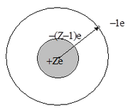
Figure 7.1 pererisovat

Other Z-1 electrons of the atom form with nucleus strong enough atomic core, with the same structure as the preceding to each of them in the periodic system the atom of the noble gas: helium, neon, argon, krypton, xenon, respectively.
It makes the alkali metal atom similar to a hydrogen atom, and the atomic core carries out a role of an effective nucleus with a charge Z*, close by magnitude to one. Differences from the hydrogen atom related with the fact that the outer electron can partially penetrate into the atomic core. Electron in the atom has no strict localization by operation of general quantum laws. In principle it is impossible to specify coordinates of electron, one can only calculate probability of the location in one or another part of the space or as said, probabilistic density of electron cloud. In some states the probabilistic cloud of an external electron appears in an atomic core that, which is naturally, leads to increasing of effective charge Z * with which the electron interacts.
Very significant is the fact that the effective field, in which the external electron moves, has a central symmetry. As a result, the potential energy U depends only on the distance to the center of r: U = U (r). The core electrons screening the nuclear field at large distances, whereby the effective field coincides with the Coulomb field of a point charge + 1e, and potential U (r) is the same as in the hydrogen atom:
$U\left(r\right)=\frac{1}{4πε_{0}}\frac{Ze^{2}}{r}, r→∞$.
Screening does not take place near the nucleus at r→0, and the electron interacts directly with the nucleus, which have a charge + Ze. This potential energy of interaction is equal to
U(r)=$\frac{1}{4πε_{0}}\frac{Ze^{2}}{r}, r→0.$
One can write down following expression for all range of r:
$U(r)=\frac{1}{4πε_{0}}\frac{Z{(r)e}^{2}}{r}$ (7.1)
whereZ(r) represents some function which is smoothly decreasing with increasing r from value Z to 1. Obviously, throughout all range the curve U(r) lies below a curve for hydrogen potential:
$$U_{ii}\left(r\right)=-\frac{1}{4πε_{0}}\frac{Ze^{2}}{r}.$$
Due to the similarity in a structure of alkaline metal atoms and hydrogen atom, it is found that they have similar both location of energy levels and spectra. So, before proceeding to more detailed consideration of the properties of alkali atoms, it is advisable to consider the quantum description of hydrogen atom.
7.3.2. Quantum description of hydrogen atom. The solution of the quantum mechanical equation of Schrödinger for hydrogen atom:
$\frac{ћ^{2}}{2m}∇^{2}ѱ+\left[E-U_{H}\left(r\right)\right]ψ=0$ (7.2)
leads to the following results. First of all, it turns out that bound states of hydrogen atom form a discrete set with defined energy values Е_{n}:
$E_{n}=-\frac{Rhc}{n^{2}}$or${ E}_{n}=-\frac{A}{n^{2}}$, n=1,2,3…, (7.2)
where=13,6 eV–is the ionization energy of hydrogen atom from the ground state; $R=109678 {sm}^{-1}$- is the Rydberg's constant; n is the principal quantum number which can take all integer values starting with one. The energy levels En are degenerate, i.e. to each level (and, consequently, to each number n) corresponds several states which are distinguished by a form of electron cloud and the magnitude of the orbital moment of the electron momentum $\vec{L}$ .
The orbital moment is quantized according to the law
$$\left|L\right|=h\sqrt{l\left(l+1\right),}$$
где - орбитальное квантовое число:
=0,1,2,3,….,n-1. (7.3)
States with various values are designated by Latin letters:
s p d f g h i
= 0 1 2 3 4 5 6
and are called s- states, p - states, d- states, etc. respectively.
The general conception of the shape of the electron clouds in states with different l are shown in Figure 7.2. Graphics of the magnitude${\left|ψ\right|}^{2}r^{2}$ characterizing probability density to find electron in a spherical layer between radii r and r+dr for two states are represented in Figure 7.2.

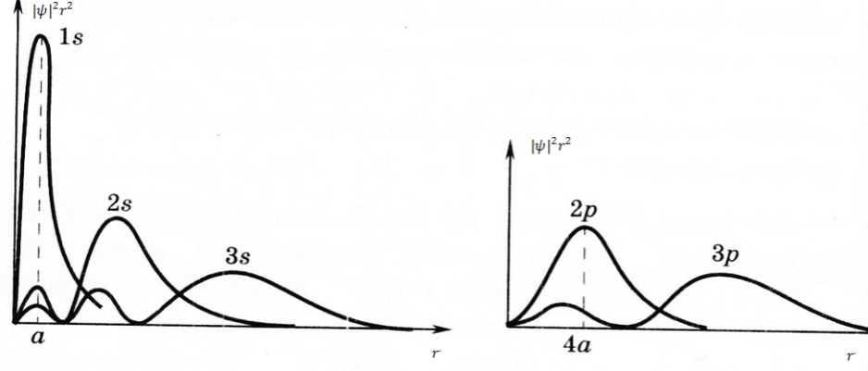
Figure 7.2 ssylka

The general rule is as follows: electronic clouds are increasing in sizes directly proportional to the square of the principal (main) quantum number n and redistributed towards the periphery with increasing the orbital quantum number l. It is necessary to emphasize that energy degeneration by l in hydrogen atom is random and is related with the reason that potential decreases as a function of $(-\frac{1}{r})$.
7.3.3. The energy levels of atoms of alkali elements.
One can find energies of the stationary states of alkali element atom using the Schrodinger equation (*). However, potential energy will be different that of hydrogen atom. If the atom of alkaline element has only Z of electrons, then one can consider that Z-1 electrons together with nucleus forms rather strong core. The external (valent) electron moves in the electric field of the core and weakly coupled with the atomic core. In some senses atoms of alkaline elements are hydrogen-like, but, not completely. The fact is that the external electron slightly deforms the electron core and by that distorts a field in which it moves. As a first approximation the field of the core can be considered as superposition of the field of point charge +е, and the field of point dipole, located in the center of the core. Besides, the axis of dipole is directed all the time towards the external electron. That’s why the movement of the last happens as if the field of the core, despite of distortion, remained spherically–symmetric.
It allows representing potential energy of the external electron in the field of such core as:
$U\left(r\right)=-\frac{e^{2}}{4 πε_{0}}(\frac{1}{r}+\frac{C_{1}}{r^{2}})$ (7.4)
where$(\frac{C_{1}e^{2}}{4 πε_{0}r^{2}})$ is the correction, taking into account difference of the field of alkaline element atoms from the field of hydrogen atom. Electric field of the nuclear core spherically–symmetric, i.e. it is reasonable assume that independent of angles$θ$and$φ$. Then the angular part of the Schrödinger equation is the same as in the case of hydrogen atom.
The Schrödinger equation $R(r)$ for radial wave function would change in the way that instead of energy$U\left(r\right)=-\frac{e^{2}}{4 πε_{0}r}$ it is need to substitute with expression (7.4).
For hydrogen atom the Schrödinger equation for $R(r)$ has the following form:
$\frac{1}{r^{2}}\frac{d}{dr}\left(r^{2}\frac{dR}{dr}\right)+\frac{2m}{ћ^{2}}\left[E+\frac{e^{2}}{4 πε_{0}r}-\frac{ћ^{2}l\left(l+1\right)}{2mr^{2}}\right]R=0$ (7.5)
If to write down this equation for atom of an alkaline element, in the equation (7.5) instead of two last expressions in brackets it is necessary to substitute expression:
$\frac{e^{2}}{4 πε_{0}}-\frac{ћ^{2}}{2mr^{2}}[l\left(l+1\right)-\frac{2mC_{1}}{4 πε_{0}ћ^{2}}]$ (7.6a)
If introduce following designation:
$l^{'}\left(l^{'}+1\right)=cc\left(l+1\right)-\frac{2mC_{1}}{4 πε_{0}c}$ (7.6b)
then instead of (7.5) we obtain the equation of similar form:
$\frac{1}{r^{2}}\frac{d}{dr}\left(r^{2}\frac{dR}{dr}\right)+\frac{2m}{ћ^{2}}\left[E+\frac{e^{2}}{4cr}-\frac{ћ^{2}l^{'}\left(l^{'}+1\right)}{2mr^{2}}\right]R=0$ (7.7)
The solution of equation (7.5) for hydrogen atom is known. Now the solution of equation (7.7), will be same as for hydrogen atom, only here $l$ is replaced by$l^{'}$. Thus for energy of alkaline element atom obtaining expression the same as for hydrogen atom, only the quantum number$l$ will be replaced by $l^{'}$:
$E_{n,l}=-\frac{me^{4}}{32 π^{2}ε_{0}^{2}ћ^{2}{(n^{'}+l^{'}+1)}^{2}}$ (7.8)
The quantum number according to (7.6b), is not an integer number:
$l^{'}≈-\frac{1}{2}+\frac{1}{2}\sqrt{{(2l+1)}^{2}-{\frac{2mC_{1}e}{πε_{0}ћ^{2}}}^{2}}$ (7.9)
Here the first term in radicand is much greater than the second one. Therefore one can write approximately:
$$l^{'}≈-\frac{1}{2}+\frac{1}{2}\left(2l+1\right)\sqrt{1-\frac{2mC_{1}e^{2}}{πε_{0}ћ^{2}{\left(2l+1\right)}^{2}}}=$$
$l-C_{1}\frac{me^{2}}{4πε_{0}ћ^{2}\left(l+\frac{1}{2}\right)}≡l-∆_{l}$ (7.9a)
Thus, it follows from (7.8) that energy levels of atoms of alkaline elements are defined by following formula:
$E_{n,l}=-\frac{me^{4}}{32 π^{2}ε_{0}^{2}ћ^{2}{(n-∆_{l})}^{2}}$ (7.8a)
where$n=n^{'}+l^{'}+1$ - is the principle quantum number. The value $∆_{l}$is called quantum defect. Unlike formula (7.2 for hydrogen-like atom energy levels of atoms of alkaline elements depend not only from the principle quantum number $n$, but also the orbital quantum number $l$. In this case it is said that takes place elimination of degeneration by the orbital quantum number. Correction $∆_{l}$decreases at large values of$l$ (see Table 7.1). Therefore dependence of energy of alkaline atom on number $l$ at its large values is almost imperceptible.On the basis of the above stated considerations on the movement of the external (valence) electron in the field of the atomic core with an effective charge $Z^{*}$, the expression for the energy of the stationary states of alkali metal atoms (similar to formula (7.2) for hydrogen atom) has following form:
$E_{n}=-\frac{Rch}{n^{2}}$, n = 1, 2, 3, … (7.8б)
Spectral terms for atoms of alkaline elements are defined by following formula:
$T_{n,l}=-\frac{E_{n,l}}{hc}-\frac{Rch}{({n-∆_{l})}^{2}}$ (7.10)

Table 7.1
Elements | s | p | d | f
Li | 0.412 | 0.041 | 0.002 | 0.000
Na | 1.373 | 0.883 | 0.010 | 0.001
K | 2.230 | 1.776 | 0.146 | 0.007
Rb | 3.195 | 2.711 | 1.233 | 0.012
Cs | 4.13 | 3.67 | 2.45 | 0.02

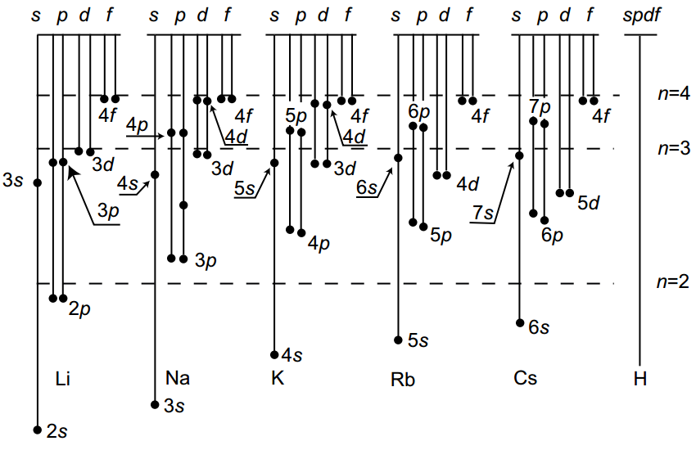
Figure 7.3.The scheme of levels of alkaline metal atoms (levels are represented in the form of points) ssylka

The scheme of levels of alkaline metal atoms is shown in Figure 7.3 (levels are represented in the form of points). Energy levels of hydrogen atom are plotted by dotted line in Figure 7.3 for comparison. Levels of alkaline metal atoms with different $l$, but identical n are located rather far from each other (levels of $H$-atom are degenerated by $l$). As the excitation energy increases rapprochement of levels of alkaline metal atoms has been observed with corresponding levels of$H$-atom Therefore,one can say about "hydrogen like" states of atoms of alkaline metals beginning with certain energy value.
For example, hydrogen-like states are 3d, 4d, and so on for Na atom or f-states of all alkaline metal atoms.
7.3.4. Spectra of alkaline elements.
Emission spectra of alkali metals, as the spectrum of hydrogen atom, consist of a plurality of lines. Laborious systematics of these lines has allowed grouping them in a series, each is related to the transition of the excited atoms to some certain level. For Li, Na, K atoms, it is shown in Figures 7.4 – 7.6.
Investigations of the spectra of alkali metal ions showed that the angular momentum of the atomic core is equal to zero. Consequently, the orbital angular momentum of the alkali metal atom is equal to the moment of its external electron and is determined by the quantum number $l$(as shown in Figures 7.4–7.6).The orbital and spin moments of all internal electrons are mutually compensated, in consequence, the spin, the orbital and the total moments of atom, and also its quantum numbers coincide with the corresponding moments and quantum numbers of the external electron (Table 7.2).
Table 7.2

Element | Li | Na | K | Rb | Cs
Z  n  ground state | 3  2  $$2^{2}s_{1/2}$$ | 11  3  $$3^{2}s_{1/2}$$ | 19  4  $$4^{2}s_{1/2}$$ | 37  5  $$5^{2}s_{1/2}$$ | 55  6  $$6^{2}s_{1/2}$$

Selection rules. Radiation (and absorption) takes place as a transition result of the external electron from one level to another. However not all transitions are possible. There are only those possible in which the orbital quantum number $l$of the external electron changes by one:
$∆l=±1$ (7.11)
At the same time the principal quantum number $n$ can be change to any integer number. This means that transitions are allowed only between s- and p- states between p- and d- states , etc. (Figure 7.4-7.6).
Spectral series.The following series are observed in the spectra of the lithium atoms taking into account the selection rules (11):
Principal: $\tilde{ν }$ =$2s-np n=2,3,4,…$
Sharp: $\tilde{ν }$=$2p-ns n=3,4,5…$ (7.12)
Diffuse: $\tilde{ν }$ =$2p-nd n=3,4,5,…$
Series (7.12) are written down in a symbolical form. In an explicit form they are written down as a difference of two corresponding terms. For example, for the principle Li series:

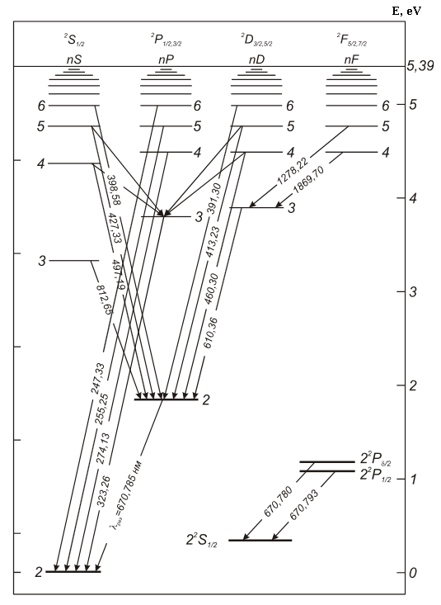

Figure 7.4.The scheme of the energy levels of the lithium atom ssylka
.

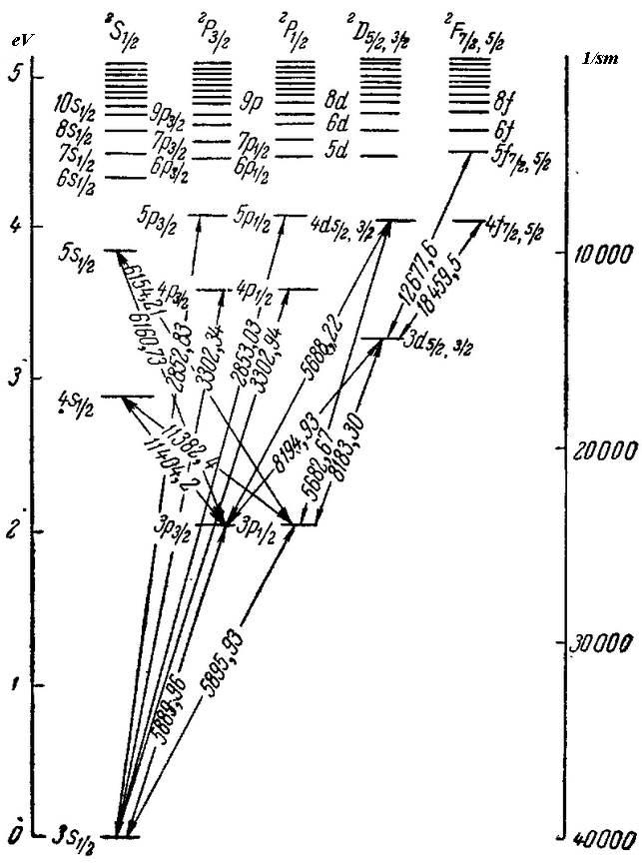

Figure 7.5.The scheme of the energy levels of the sodium atom ssyka
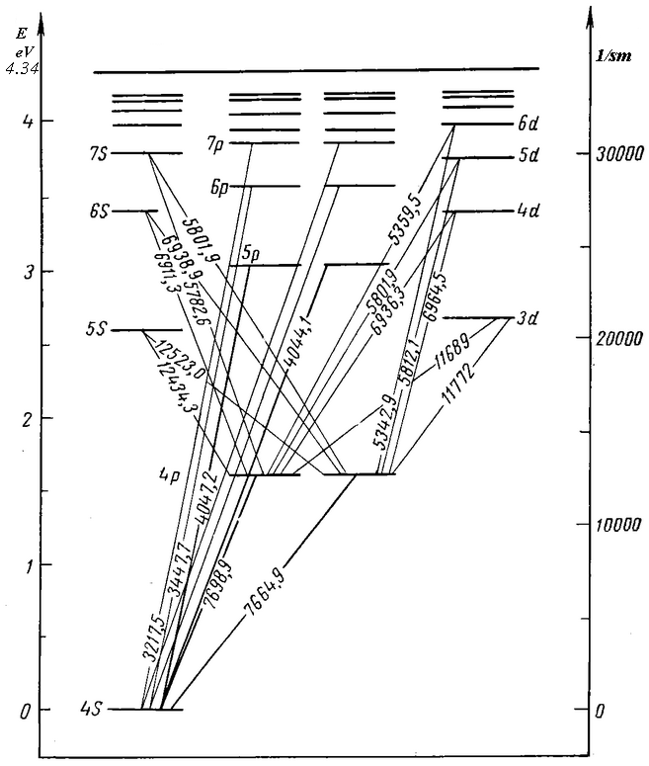

Figure 7.6.The scheme of the energy levels of the potassium atom ssylka

Series (7.12) are written down in a symbolical form. In an explicit form they are written down as a difference of two corresponding terms. For example, for the principle Li series:
$\tilde{ν}=\frac{R}{{(2-∆_{s})}^{2}}-\frac{R}{{\left(n-∆_{p}\right)}^{2}}, n=2,3,4…$ (7.13)
For the other series is the same. Note that the quantum defects $∆_{l}$ within each series are almost constant, but are changing from series to series. The spectral line of the principal series, corresponding to the transition 2s-2p, is the most intense. This line is called resonance.
7.4. Work performance order.
1.Before carrying out the work it is necessary to acquaint carefully with the recommended literature, the content of the work.
2.Carry out decoding of spectra by means of spectral lines atlas on the spectrogram projector of DSP-1. Find lines of alkaline elements, allocate series. Write down results into Table 7.3.
Table 7.3
Element | λ, nm | Transition | Series

3.At first, using hydrogen-like d–states ($∆_{d}=0$), find energy $E_{nd}$ of levels 4D-8D by formula (7.8а).Further by means of the Bohr frequencies rule $E_{n}-E_{m}=hc{\tilde{ν}}_{nm}$ and the scheme of transitions (see Figure 7.4-7.6) find energy of levels 3P and 3s (for Na), 4P and 4S (for K), using the corresponding $<hν>$ valuesFind energy of levels 5S and 6S with the same way. Substituting the obtained values $E_{3s},E_{5s},E_{6s},E_{3p}$(for Na) in formula (7.8а) find quantum defects$∆_{3s},∆_{5s},∆_{6s},∆_{3p}$.
4.According to the obtained data build the scheme of energy levels of atom in scale 0,5 V/cm and indicate on it the transitions corresponding to the observed lines. Find ionization energy $E_{i}$ of Na (Li, K) atom from the ground state analyzing the scheme of energy levels. Define an effective charge of the nuclear core${ Z}_{n,l}^{*}$ by formulas (7.8а) and (7.8b) in $s,p,d,f$– states.
5.Find the minimum and maximum energy of photons, the minimum and maximum wave numbers, and also the minimum and maximum wavelengths for the principal, sharp and diffusion series of Na (Li, K) atom.

Literature: [3, 4, 7, 8,18]

Control questions
1. What is the structure of alkali metal atoms?
2. Compare an alkali metal atom with the hydrogen atom.
3. List the quantum numbers of the hydrogen atom and explain their physical meaning.
4. In what quantum states atoms of alkaline metals can be?
5. What is understood as "degeneration" of energy levels?
6. What the physical reason of removal of energy degeneration ("random" degeneration) of alkaline atoms by the orbital quantum number?
7. What defines the value of the quantum defect $∆_{l}$ ?
8. To be able:
To designate a set of spectral terms for any alkaline metal
• To determine the main (principal) level
• To show the scheme of energy levels
• To show transitions for all observedseries
• To define borders of series and leading lines in each series
• Symbolically to write down transitions in each series.
9. Explain selection rules by $l$.

8. STUDYING THE FINE STRUCTURE OF SODIUM SPECTRAL LINES

8.1. The purpose and content of the work.
Getting acquaint with the fine structure of spectral lines and energy levels of alkali elements; Experimental study of doublet structure of the spectral lines of the sodium atom; Measuring the distance between the fine structure components of the spectral lines; Determination splitting magnitude of P-terms of sodium atom, depending on the value of the principal quantum number n; Determination splitting magnitude of 3P, 3D, 4D levels of Na atom, determination of the screening correction a.
Spectrograph DFS-8, arc generator UGE-4, spectro-projector DSP-1, measuring microscope MIR-12, an atlas and a table of spectral lines.
The work is performing using completed spectrograms, filmed into the photographic plate in advance, with sodium and etalon source (iron) spectra obtained with high dispersion spectrograph DFS-8 by excitation sodium and iron spectra by means of arc generator IVS-28. Decoding of the etalon source spectrum carries out using the atlas and spectral lines using spectroprojector PS-18. To measure distance between components of the fine (doublet) structure of sodium spectral lines measuring microscope MIR-12 is used.

8.2. Brief theory
Due to intensive study of the spectral lines of atoms of alkali elements was discovered so-called the fine structure of spectral lines. Implementation of spectral devices with high dispersion allowed to reveal that the lines of atoms are often double, which are very narrow for lithium, and with increasing atomic mass become wider. As an example, data for the splitting of the resonance lines (Δλ, nm) are provided in Table 8.1.

Table 8.1

Element | z | Δλ,nm
Li | 3 | 0,015
Na | 11 | 0,6
K | 19 | 3,4
Cs | 55 | 42,2

It is natural to assume that the spectral lines’ splitting is due to the fact that electron energy levels are splitting, the transition between them is the result of the appearance of the given spectral line. In other words, the fine structure of spectral lines must be related with the fine structure of the electron energy levels.

8.2.1. The energy spectrum of atoms of alkaline elements
The calculation of the energy spectrum of alkali metal atom, representing a system of many electrons in the Coulomb field of the nucleus, it is a difficult task. Therefore, resorting to this method: assumption that the electrons of the inner shells are located close to the core (nucleus and electrons of the inner shells forming the atomic core) and the outer (valence) electron is weakly bounded with atom, on the contrary, is located at quite large distance from the nucleus, one can consider alkali metal atom as a kind of "hydrogen-like" system (the outer electron – the atomic core). Such consideration, which takes into account the interaction of the outer electron with the other electrons in the atom as a small perturbation imposed on the Coulomb attraction of the atomic core, leads to the expression for the energy of similar expression for the energy of hydrogen atom:
$E_{nl}=-\frac{2πRћc}{{\left(n-∆_{l}\right)}^{2}}=-{\left(\frac{1}{4πε_{0}}\right)}^{2}\frac{me^{4}}{2ћ^{2}n^{*2}}=-\frac{2πRћc {(z-a)}^{2}}{n^{2}}$ (8.1)
where$n^{*}=(n-∆_{l})$ - is the effective quantum number, $n-$is the principal quantum number, $∆_{l}$ - is the quantum defect,$\left(z-a\right)=Z_{ef}$ - is the effective charge of the nucleus, R is the Rydberg constant.
The difference with hydrogen atom is that the effective quantum number то$n_{ef}$–is not an integer number, as in the case of hydrogen, and differs from the corresponding quantum number $n$ by value${ ∆}_{l}$, called the quantum defect. The values${ ∆}_{l}$ are mainly determined by the value of the orbital quantum number l, at given n the quantum defect sharply decreases with increasing l (see. Table 1).
One can see from (8.1) that the energy levels of alkali atoms are located below the corresponding levels of the hydrogen atom, for which the following relation is right:
$E_{n}=-\frac{2πRћc}{n^{2}}$ (8.2)
In addition, since the quantum defect ${ ∆}_{l}$ is strongly dependent on the orbital quantum number l, the energy of the optical (valence) electron in the atom of alkali element depends not only on the principal quantum number n, but also on the orbital quantum number l. The dependence on l is the weaker, the greater l. (see Ref. №7).

8.2.2. The fine structure of the energy levels of hydrogen atom
Two physical factors give rise to the fine structure of the energy levels of hydrogen atom:
1) Relativistic effect of the dependence of the mass of the atomic electron on the velocity of its motion around the nucleus,
2) The interaction of the intrinsic magnetic moment of the electron with the magnetic field produced by the electron at its motion around the nucleus.
The last factor related with the electron spin and its orbital motion also has a relativistic nature.
These factors cannot be taken into account at calculation of the energy spectrum of the atom with the help of the Schrödinger equation, because it does not meet the requirements of the relativity theory. Therefore, one cannot describe the fine structure of the energy spectrum of the atom using the Schrodinger equation. The energy spectrum of the atom and its fine structure can be calculated by using the quantum mechanical equations - Dirac equation, taking into account the requirements of the special relativity theory. One can act in other way; take a less rigorous, but physically more visual way – considering energy corrections to the ground state of the hydrogen atom due to each of the above factors. In our conditions, the second way is more preferable.
Influence of relativistic effects on the energy states of the atom was first considered by Sommerfeld (1916). The final expression for the relativistic energy correction to the energy level $E$has following form:
$∆E_{p}=E_{0}\frac{α^{2}z^{2}}{n}\left(\frac{1}{l+\frac{1}{2}}-\frac{3}{4n}\right)$ (8.3)
here$α=\frac{e^{2}}{\left(4πε_{0}ℏ\right)}=\frac{1}{137}$ – is the constant of the fine structure, $E_{0}=-\frac{me^{4}z^{2}}{(32 π^{2}ε_{0}^{2}ћ^{2}n^{2})}$is the energy of hydrogen atom without relativistic effects.
One can see from (8.3) that the fine structure constant determines the scale of the relativistic energy correction. Magnitude of the correction $∆E_{p}$is of small order $α^{2}E_{0}\sim {10}^{-3}eV$.
Let us now consider the influence of electron spin on its energy in the atom with one valence electron. Due to intrinsic magnetic moment the electron behaves like a "magnetic dipole" placed in a magnetic field produced by the motion of this electron along orbit. In atomic physics, the interaction of the spin magnetic moment with the orbital magnetic field is called the spin-orbit interaction (ls-interaction).Due to this magnetic interaction energy the electron has an additional energy ${∆E}_{ls}$. Now let’s take into account the energy of the spin-orbit interaction. Let us assume that, the magnetic field induction due to the motion of the electron in the nuclear field $\vec{B}$, and the spin magnetic moment of the electron $\vec{μ_{s}}$. Then the energy of the spin-orbit interaction ${∆E}_{ls}$ is equal to
${∆E}_{ls}=-(\vec{μ_{s}}\vec{B})$ (8.4)
Intrinsic (spin) magnetic moment of the electron is given by expression
$\vec{μ_{s}}=-\frac{e}{m}\vec{L_{s}}μ_{s}=2(\frac{eћ}{2m})\sqrt{s(s+1)}$,

where$\left|\vec{L_{s}}\right|=ћ\sqrt{s\left(s+1\right)};μ_{B}=\frac{eћ}{2m}.$
$\vec{L_{s}}$- is the intrinsic angular momentum of an electron, $μ_{B }$is the Bohr magneton,$s$ is the spin quantum number ($s=\frac{1}{2}$ ). To describe the spin-orbit interaction, as well as for the systematics of spectra of atoms vector model of the atom is using. In this model, the angular momentum corresponding to the orbital motion of the electron, represented by vector $\vec{L_{l}}$, and its spin by vector $\vec{L_{s}}$. Due to the spin-orbital interaction the orbital angular momentum $\vec{L_{l}}$ of electron is added with its spin$\vec{L_{s}}$. The resultant vector:
$$\vec{L_{j}}=\vec{L_{l}}+\vec{L_{s}}$$
is called a vector of the total angular momentum of the electron.
The final expression for the energy of ls-interaction ${∆E}_{ls}$ has the form
${∆E}_{ls}=E_{0}\frac{α^{2}z^{2}}{n}\left(\frac{j\left(j+1\right)-l\left(l+1\right)-s(s+1)}{l(l+\frac{1}{2})(l+1)}\right)$ (8.5)
It follows from (8.5) that the magnitude of the energy correction on ls-interaction is depending on the mutual orientation of the vectors $\vec{L_{l}}$and $\vec{L_{s}}$, i.e. on $\vec{L_{j}}$. Besides, since the one-electron atom at given l quantum number j takes two values $j_{1}=l+\frac{1}{2}$ and $j_{2}=l-\frac{1}{2}$, it follows from (8.5) that ls-the interaction leads to the splitting E₀ level, while correction ${∆E}_{p}$ only leads to the shifting. One can see from the last relation that the ${∆E}_{ls}\sim α^{2}E_{0}$. Thus, both effects in fact relativistic and related with spin-orbit interaction have the same order of magnitude:$α^{2}E_{0}\sim {10}^{-3}eV$.
Energetic addition ${∆E}_{ls}$ should be taken into account along with the relativistic correction ${∆E}_{p}$ when determining the energy of the electron in atom.
Thus, the energy of the atom is equal to:
$E=E_{0}+{∆E}_{p}+{∆E}_{ls}$ (8.6)
Substituting in (8.6) with expressions (8.3), (8.5) and taking into account that one-electron atom $j=l±\frac{1}{2}$, we obtain next expression:
$$E=E_{0}+∆E=E_{0}+{∆E}_{p}+{∆E}_{ls}=$$
$E_{0}\left\{1+\frac{α^{2}z^{2}}{n}\left(\frac{1}{j+\frac{1}{2}}-\frac{3}{4n}\right)\right\},$ (8.7)
where
$∆E={∆E}_{p}+{∆E}_{ls}=E_{0}\left\{1+\frac{α^{2}z^{2}}{n}\left(\frac{1}{j+\frac{1}{2}}-\frac{3}{4n}\right)\right\}$ (8.8)
Thus, due to the influence of both factors all levels of the one-electron atom, according to (8.7) are splitting into two sublevels by the number of possible values of the quantum number $j$. This splitting (since it is has small scale) is called thin or multiplet splitting. Therefore, dimensionless constant α, which determines splitting scale, is called the fine structure constant. It follows from (8.7), (8.8) that the magnitude of the splitting level (the energy difference between the sublevels $j_{1}=l+\frac{1}{2}$ and $j_{2}=l-\frac{1}{2}$ of the same level between $E_{j_{1}j_{2}}$) is equal to:
${∆E}_{j_{1}j_{2}}=E_{0}\frac{α^{2}z^{2}}{nl(l+1)}$ (8.9)
One can see from (8.9) that the presence of the doublet level splitting depends on the charge (~z⁴) and rapidly decreases with the increase of the principal (~1/n³) and the orbital quantum numbers (~1/l²).
8.3.3. The fine structure of energy levels of alkali element atoms.
It follows from the results of the previous section, that since when calculating the energy of the valence (optical) electron in alkali element atom one did not take into account the electron spin, then relation (8.2) is need to clarify that is take into account effects in fact relativistic and related with the spin-orbit interaction.
Taking into account of the relativistic correction ${∆E}_{p}$ and energetic addition ${∆E}_{ls}$ carried out by the method similar to that considered in 8.2.2. will lead expression (8.2) to the following form:
${∆E}_{nlj}=E_{nl}\{1+\frac{α^{2}{(z-a_{1})}^{2}}{n}\left(\frac{1}{j+\frac{1}{2}}-\frac{3}{4n}\right)\}$ (8.10)
It’s seen from (8.10) that all of the energy levels of alkali element atom (except s-levels) are split into two sub-levels (by the number of possible values of the quantum number j of the atom with one optical electron). Besides, as it follows from (8.10), the splitting level (the energy difference between the sublevels $j_{1}=l+\frac{1}{2}$ and $j_{2}=l-\frac{1}{2}$of the same level of n, l) is equal to:
${∆E}_{j_{1}j_{2}}=E_{nl}\frac{α^{2}{(z-a_{1})}^{2}}{nl(l+1)}=-\frac{Rhc}{n^{2}}\frac{α^{2}{(z-a_{1})}^{4}}{n}\frac{1}{l(l+1)}$ (8.11)

It follows from comparison of (8.11) and (8.9) that the magnitude of the splitting level of alkaline element atom is significantly greater ($\sim$(z-${a_{1})}^{4}$)), than that of the hydrogen atom (z-a₁-z_{eff}>1; z is equal to 1 for hydrogen); and increases rapidly with increasing Z). This is due to the following fact: the magnitude of the splitting level is proportional to (1/r³) [9], i.e. essentially determined by the region of small values of r. At small distances (inside the atomic core) nucleus charge is not completely shielded by the inner-shell electrons, so the effective charge z_{eff}>e.
According to current theory of the atom (partly seen from the above) state of the electron in the atom can be characterized by a set of four quantum numbers, for example: n, l, j, m_{j}. n is the principal quantum number. It defines in first, very rough approximation, electron energy in the atom, and takes the values n = 1,2,3,4, etc.
l is the orbital quantum number that defines the orbital angular momentum of the electron. For given n, it takes the values l=0,1 ... n -1. Corresponding states with l = 0,1,2,3 etc. are denoted s, p, d, f, etc. s = 1/2 is the spin quantum number that defines the magnitude of the intrinsic angular momentum of the electron.
j is the internal quantum number that defines the total angular momentum of the electron in the atom. It takes, at given l and s, values j = l + s, l + s-1, ..., │ l+s │, i.e. total 2s + 1 values.
m_{j} is the internal magnetic quantum number. It defines the magnitude of the projection of the total angular momentum of the electron on some direction (the direction of the magnetic field). It takes, at given j, values m_{j} = j, j-1, j-2, ..., -j, i.e. total 2j + 1 values.
If there are external fields, despite the fact that the state of electron motion in the atom is characterized by four quantum numbers, the energy of the valence electron in the atom with one optical electron is defined by three quantum numbers n, l, j (there are no external field and dependence on the orientation of the moment, i.e. on m_{j} see (8.10)). However, the energy of hydrogen-like atom depends only on two quantum numbers n, j (See (8.7)).
To indicate the state of the electron in the atom special symbolic is used, that is, a certain writing form of the given set of quantum numbers. It’s written Latin letter, corresponding to the orbital number, at the bottom right of that letter is written the value of the internal quantum number j, at the top left is written the multiplicity, i.e. the value of 2s + 1 (s is the spin quantum number). The value of the principal quantum number n is written before the Latin letter.
The ground state of the optical electron in alkali element atom is recorded as n²S_{1/2}, which corresponds to l=0, s=1/2, j=1/2, n=2 for Li, n=3 for Na, etc.
On the basis of (8.10), in accordance with recent observations, one can graphically represent the energy spectrum of the alkali element atom as shown in Figure 8.1.

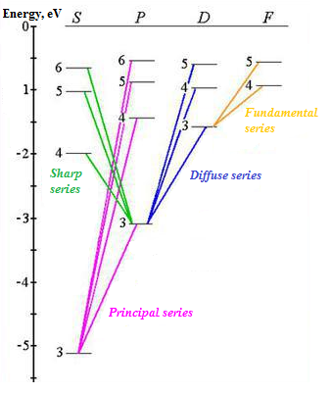

Figure 8.1perechertit

If the atom (e.g., sodium) is at the ground state (3²S_{1/2}), then when excited, according to the selection rules, transitions only to the P-states are possible and thereby appearance of the principal series (3S-nP) are possible. But P-terms (levels) are doublet, so the principal series will be a doublet (see. Figure 8.1). If the lithium atom is at the 3P-state, then transitions to S- and D-states are possible. At the same time in accordance with the selection rules, there are appear doublet lines of the sharp series (3P-nS) and triplet lines of the diffuse series (3P-nD).
Sodium atom. In this work the emission spectrum of sodium atom is studied. On its energy level diagram (Figure 8.1.) for better visibility levels with the same values of the orbital quantum number allocated to the separate "stairs." For comparison the energy levels of hydrogen atom are shown in the same diagram. F- and D-levels of sodium almost have no difference from hydrogen, and the quantum defects for these levels close to zero: $∆_{f}≈0, ∆_{d}≈0.$ However, the location of the lower levels of s- and p- states significantly different from hydrogen. Thus, 4²S level is lies much lower than that of 3²D, i.e. there is already mentioned levels mixing with different n. (In contrast to states the energy levels are denoted by capital letters S, P, D, F, G, etc.)
The fine structure of levels. All levels of l≠0 consist of two closely located components (doublets). This is so-called the fine structure. The fine it is called because that the level splitting is small compared to the distance between the levels n and l. The reason is the magnetic interaction of the spin and the orbital moments of the electron. The spin magnetic moment $\vec{μ_{s}}$ of the electron can take two different orientations in a magnetic field $B_{l}$, which appears as a result of its orbital motion. There is the addition to the energy of the atom ${∆E}_{ls}=-(\vec{μ_{s}}B_{l})$, which takes two different values depending on the mutual orientation of the vectors $\vec{μ_{s}}$ and $B_{l}$. Two values of the internal quantum number j=l-1/2 and j=l+1/2 are responsible for two orientations, the level at j=l-1/2 normally lies below the level at j=l+1/2.
A quantitative analysis of the spin-orbit interaction is simplified in a coordinate system rigidly bound with the electron, as exactly in this system the interaction is a purely magnetic, the $B_{l}$ field caused by the motion of the effective nucleus. The calculation yields following formula:
${∆E}_{l-\frac{1}{2}, l+\frac{1}{2}}=Rhc\frac{α^{2}Z_{g}^{*4}}{n^{3}l(l+1)}$, (8.11а)
which shows the dependence of the splitting magnitude on the orbital quantum number l and the effective nuclear charge $Z_{g}^{*}$. Here α is the fine structure constant, which is equal to:
$α=(\frac{1}{{4πε}_{0}})\frac{e^{2}}{ћc}≈\frac{1}{137}$.
There is no spin-orbit interaction for S-levels. They are not splitting, i.e. they are singlets, because there are no orbital mechanical and magnetic moments and $B_{l}$=0 in s-states.
It should be bear in mind that the effective charge $Z_{g}^{*}$ does not coincide with the effective charge $Z_{n,l}^{*}$ which in formula (8.1) for the electron energy: it is appear significantly greater. This is explained by the fact that the screening of the magnetic interaction by electrons of the atomic core is much weaker compared to the screening of the electrostatic interaction.
Selection rules and spectrum.
Quantum transitions between states of the atom with the emission or absorption of light are possible only under certain restrictions imposed on the change magnitude of the quantum numbers by so-called selection rules.
Transitions are possible if the orbital quantum number of the initial and final states of the atom differs by one, i.e.,
$∆l=±1,$ (8.12)
and quantum number of the total angular momentum of these states either differs by one or has the same values (non zero!):
$∆j=0,±1$. (8.13)
Radiative transitions in other changes of the quantum numbers l and j are prohibited. The principal quantum number n can vary during transitions either to any value or no changing at all.
The selection rule by the orbital quantum number (8.12) related to the conservation law of wave function parity.
The selection rule by quantum number of the total angular momentum (8.13) becomes clear if one take into account that a photon has a spin angular momentum equal to lћ and at birth or absorption of the photon conservation law of angular momentum should be fulfilled. Photon can be oriented by the spin parallel, anti-parallel and perpendicular relative to the total angular momentum of the atom in the final state at escape moment from the atom. If photon spin is parallel to the final momentum of the atom, to fulfill the conservation law of angular momentum the total angular momentum in the final state must be less by lћ than the initial. This takes place due to the decreasing of the orbital angular momentum during photon emission process. In the case anti-parallel orientation of the photon spin relative to the momentum of the final state for the same reason, the total and the orbital angular momenta of the final state should be grater by lћ than that of the initial state. Finally, when the photon spin is perpendicular to the momentum of the final state, the total angular momentum should not change during emission. But the orbital angular momentum is decreased by lћ (after all, it is need to take somewhere momentum equal to lћ necessary for photon formation). However, despite the decreasing of the orbital angular momentum, the total angular momentum is not decreasing because electron spin turns out from the anti-parallel to the parallel position during emission process. This is compensates the decreasing of the orbital angular momentum, that a constituting part of the total momentum.
The selection rule by the orbital quantum number (8.12) related to both conservation law of momentum and conservation law of wave function parity. As the photon has a negative parity, as the result of its emission or absorption wave function parity of the atom must change. The parity P for the atom with one valence number through the ratio P=(-1)^{l}, and transitions without changing l (or Δl=0) are not possible. As for transitions, in which Δl=±3, ±5, ..., then they are imposed a restriction conservation law of angular momentum.
The selection rules by l leads to the appearance of the several series of spectral lines in the emission spectrum of sodium. As is well known, a series formed by spectral lines with common lower level, at the same time they are usually located in the same spectral range (ultraviolet, visible, infrared). Wave numbers $\tilde{ν}=\frac{1}{λ}$ of lines in the series are subject to simple patterns, called the serial formulas. The following are the most important series of sodium atom and serial formulas observed in emission:
Principal series $3^{2}S-n^{2}P:\tilde{ν}=R\left[\frac{1}{{\left(3-∆_{s}\right)}^{2}}-\frac{1}{{\left(n-∆_{p}\right)}^{2}}\right];$
Sharp series $3^{2}P-n^{2}S:\tilde{ν}=R\left[\frac{1}{{\left(3-∆_{p}\right)}^{2}}-\frac{1}{{\left(n-∆_{s}\right)}^{2}}\right];$
Diffusion series $3^{2}P-n^{2}D:\tilde{ν}=R\left[\frac{1}{{\left(3-∆_{p}\right)}^{2}}-\frac{1}{{\left(n-∆_{d}\right)}^{2}}\right];$
Fundamental series $3^{2}D-n^{2}F:\tilde{ν}=R\left[\frac{1}{{\left(3-∆_{d}\right)}^{2}}-\frac{1}{{\left(n-∆_{f}\right)}^{2}}\right];$

where n=4,5,6,… .
The principal series is also observed in absorption spectrum, thus showing similarity with Lyman series for hydrogen. Some quantum transitions from mentioned series are shown in Figure 5.1.
In spectroscopy taken lettering of states with different values of the orbital quantum number l=0,1,2,3 occurs just from the name of the series in the spectra of alkali elements. The letters s, p, d, f are the first letters of the English names of the series s (sharp), p (principal), d (diffuse), f (fundamental).

The fine structure of lines. Knowing the fine structure of the levels, it is not difficult to Figure out the character of the lines splitting of different series. Taking into account the selection rules by $j∆j=0,±1$), one can obtain:
Principal series - doublets
$${}_{}^{2}{S_{\frac{1}{2}}-{}_{}^{2}{P_{\frac{1}{2}}, {}_{}^{2}{S_{\frac{1}{2}}-}{}_{}^{2}{P_{\frac{3}{2}}};}}$$
$ν_{1}=3^{2}{}_{}^{2}{S_{\frac{1}{2}}-}n^{2}{}_{}^{2}{P_{\frac{1}{2}}; ν_{2}=3^{2}{}_{}^{2}{S_{\frac{1}{2}}-}n^{2}{}_{}^{2}{P_{\frac{3}{2}}; }}$

Principal series - doublets
${}_{}^{2}{S_{\frac{1}{2}}^{}}-{}_{}^{2}{P_{\frac{1}{2}}^{}}, {}_{}^{2}{S_{\frac{1}{2}}^{}}-{}_{}^{2}{P_{\frac{3}{2}}^{}};$$\tilde{ν_{1}}=3^{2}S_{\frac{1}{2}}-n^{2}P_{\frac{1}{2}}, \tilde{ν_{2}}=3^{2}S_{\frac{1}{2}}-n^{2}P_{\frac{3}{2}};$
Sharp series – doublets
${}_{}^{2}{P_{\frac{1}{2}}^{}}-{}_{}^{2}{S_{\frac{1}{2}}^{}}, {}_{}^{2}{P_{\frac{3}{2}}^{}}-{}_{}^{2}{S_{\frac{1}{2}}^{}};$$\tilde{ν_{1}}=3^{2}P_{\frac{1}{2}}-n^{2}S_{\frac{1}{2}}, \tilde{ν_{2}}=3^{2}P_{\frac{3}{2}}-n^{2}S_{\frac{1}{2}};$
Diffusion series - triplets
${}_{}^{2}{P_{\frac{1}{2}}^{}}-{}_{}^{2}{D_{\frac{3}{2}}^{}}, {}_{}^{2}{P_{\frac{3}{2}}^{}}-{}_{}^{2}{D_{\frac{3}{2}}^{}},{}_{}^{2}{P_{\frac{3}{2}}^{}}-{}_{}^{2}{D_{\frac{5}{2}}^{}};$$\tilde{ν_{1}}=3^{2}P_{\frac{1}{2}}-n^{2}D_{\frac{3}{2}},$
$$\tilde{ν_{2}}=3^{2}P_{\frac{3}{2}}-n^{2}D_{\frac{3}{2}}, \tilde{ν_{3}}=3^{2}P_{\frac{3}{2}}-n^{2}D_{\frac{5}{2}};$$
Fundamental series - triplets
$${}_{}^{2}{D_{\frac{3}{2}}^{}}-{}_{}^{2}{D_{\frac{5}{2}}^{}}, {}_{}^{2}{D_{\frac{5}{2}}^{}}-{}_{}^{2}{F_{\frac{5}{2}}^{}},{}_{}^{2}{D_{\frac{5}{2}}^{}}-{}_{}^{2}{F_{\frac{7}{2}}^{}}.$$

One should take into account the rapid decrease of the fine splitting with increasing n and l, arising from formula (8.11a) when analyzing experimental data. Doublet splitting of the lines of the principle series is defined by the fine structure of the upper levels ${}_{}^{2}{P_{\frac{1}{2},\frac{3}{2}}^{}}$ as the lower level is a singlet (Figure 8.2). Therefore, the doublet splitting is especially large for the leading line of the principal series $3^{2}S_{\frac{1}{2}}-3^{2}P_{\frac{1}{2},\frac{3}{2}}$. It rapidly decreases at transition to higher, more shortwave terms of the series. Doublet splitting of the lines of the sharp series, in contrast, is completely defined by the fine structure of the lower level ${}_{}^{2}{P_{\frac{1}{2},\frac{3}{2}}^{}}$, and all lines of the sharp series have in the scale of frequencies or wave numbers identical doublet splitting.

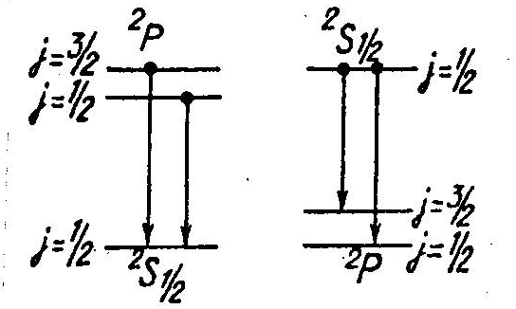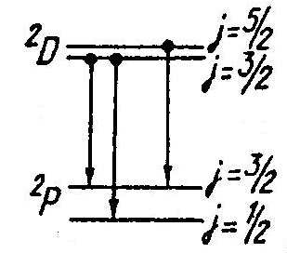
Figure 8.2. перерисовать
Figure 8.3.
The distance between the two components of the triplet ${}_{}^{2}{P_{\frac{1}{2}}^{}}-{}_{}^{2}{D_{\frac{3}{2}}^{}}$ and${}_{}^{2}{P_{\frac{3}{2}}^{}}-{}_{}^{2}{D_{\frac{5}{2}}^{}}$ is determined by the splitting of the lower level and is constant for all lines of the series (Figure 8.3.). The distance between the components ${}_{}^{2}{P_{\frac{1}{2}}^{}}-{}_{}^{2}{D_{\frac{3}{2}}^{}}$ and${}_{}^{2}{P_{\frac{3}{2}}^{}}-{}_{}^{2}{D_{\frac{5}{2}}^{}}$ determining by the splitting of the upper level is much smaller by magnitude and rapidly decreases for higher terms of the series. At low resolving power of the spectral device, these components are not resolving and lines of the diffuse series look like doublets. It is easy to establish lines structure of the fundamental series in similar way
The doublet splitting of the lines in the scale of wave numbers is equal to (see Eq. (8.11a)):
$∆{\tilde{ν}}_{l-\frac{1}{2},l+\frac{1}{2}}=R\frac{α^{2}Z^{*4}}{n^{3}l(l+1)}$ (8.14)

8.3. Work performance order
1. Before carrying out the work it is necessary to acquaint carefully with the recommended literature, the content of this work, the content of the work №4, device and operation principle of devices and write down their main characteristics.
2. Set the iron electrodes on the optical axis of the spectroprojector PS-1 or DSP-1 (emulsion up) and decode sodium spectrum. Write down wavelengths of sodium lines into table (indicateing transitions and series).
3. Establish a photographic plate in the measuring microscope MIR-12 and measure the distance between the components of the fine structure of the spectral lines of sodium. At the same time:
a) measure the distance$∆l$ between the components of the fine structure of the spectral lines of the principle series; then by values of $∆l$ (in mm), using the linear dispersion $D_{l}=0.6nm/mm$ of the spectrograph DFS-8 according to formula $∆λ=D_{l}×∆l$, determine magnitudes of the difference of wavelengths $∆λ$ (in nm) of component of the fine (doublet) structure of the spectral lines of Na;
4. According to table values [14] of the $∆λ$(nm) distance (in wavelength units) between doublet components of the principal and diffuse series of sodium calculate the splitting magnitude$∆E$of 3P, 4P, 5P, ... and 3D, 4D, ... terms of Na atom. Compare the calculated values $∆E$with values obtained experimentally ${∆E}_{exper.}$.
b) determine the splitting magnitude $∆E$ of P-terms of Na atom, depending on the value of the principal quantum number n according to data on paragraph a);
c) determine the splitting magnitude of 3P, 3D, 4D terms of the atom. Explain the obtained result.
5. determine the screening correction a₁ using the relation (8.11) knowing the splitting magnitude of 3P-term of Na,. Compare it with the value of the correction a calculated by formula (8.4) and data in Table 8.1.
5. With the help of the relation (8.1) and data in Table 8.2 calculate for sodium atom energy levels and wavelengths,appearing from following transitions:
For the sharp series 4S→3P
5S→3P
For the diffuse series 4D→3P
5D→3P
For the principle series 3P→3S
7. Write down measurement and calculation results into Table 8.3.
8. Explain the multiplicity of lines of the diffuse series observed in experiments.

Table 8.2.
N | Spectra | Thespectralregionλ, nm | Position  of the  tape | GartmanDiaphragm | Theslitwidth,  mm | Current,  А | Exposuretime,  s
1 | Fe | 580 | 10 | 3 | 0,02 | 4 | 30
2 | Na | 580 | 10 | 4 |  |  | 60
3 | Fe | 300 | 20 | 3 |  |  | 30
4 | Na | 300 | 20 | 4 |  |  | 60
Table 8.3.
λ, nm | Transition | Series | The distance between the fine structure components |  | n | Distancebetween  sublevels
 |  |  | Δ, mm | Δλ, nm

Literature:[7, 8, 10, 11,18]

Control questions
1. What is meant by the multiplicity of terms? What caused it?
2. The quantum numbers n, l, s, j, $m_{l},m_{s},m_{j}.$What are they determining? Taking values.
3. Electron spin.
4. The spin-orbit interaction. The energy of the spin-orbit interaction, ${∆E}_{ls}$ order of magnitude.
5. The fine structure of the spectra. The reason of appearing the fine splitting.The fine structure constant, α.
6. Vector model of the atom (the classical approach, the quantum corrections). What purposes is it used for?
7. Taking into account the fine structure show the scheme of levels for any alkali metal (Li, Na, K, Rb, Cs).
8. Show transitions for series, using the selection rules.
9. What is the fine structure of lines in different series?
10. The difference between the fine splitting of atoms of alkali elements and hydrogen.
11. The Lamb shift.
12. An optical device for observing the fine structure.

9. STUDYING SPECTRUM STRUCTURE OF ATOMS WITH TWO VALENCE ELECTRONS

9.1. The purpose of the work: Investigation of emission spectra of zinc, cadmium and mercury vapors in the visible region, studying spectra structure of these elements, the experimental determination of triplet splitting.
9.2. Equipment: monochromator UM-2, a mercury lamp, VSB-2mercury, cadmium and zinc vapor lamps, power supply PPBL-2.
9.3. Theoretical introduction
To describe the state of the electron in the atom requires four quantum numbers:$n,l, m_{l},m_{s}.$
The principal quantum number n, which is mainly defines electron energy and takes values n = 1,2, ....
The orbital quantum number l that defines the value of the orbital angular momentum of the electron, in accordance with equality$L_{l}=ћ\sqrt{l(l+1)}$; number l can take values l=0,1, ..., (n-1), total n values.
The magnetic quantum number m defining the projection of the angular momentum of the electron on the quantization direction z (for example, the direction of the external magnetic field);$L_{LZ}=ћm$, wherein m=0, 1, 2,…,$±l$, total $2l+1$ values.
The spin quantum number s, which defines the intrinsic (spin) angular momentum of a microparticle$L_{s}=ћ\sqrt{s(s+1)}$. For electron s=1/2, that’s why the projection of its spin angular momentum on the quantization direction (axis z) can take only two values: $L_{SZ}=ћm_{s}, m_{s}= ±l$/2.
In accordance with the value of $l$ the state of the electron in the atom is denoted as follows: if $l=0$ the state is called the s-state (or s-electron), if $l=1$ is the p-states, if $l=2$ is the d-state, and etc. 2p symbol indicates that n=2 and $l=1$, the symbol 3s corresponds to n=3 and $l=0$, symbol 3d corresponds to n=3, $=2$.
According to the Pauli principle in the system of electrons (for example, in the atom) could not be two electrons with the same set of four quantum numbers. This principle together with the principle of the lowest energy defines the distribution of electrons by quantum states (shells), and also relating this distribution with the periodicity of the atom properties.
The chemical and optical properties of electron systems are defined by the number of its valence electrons, so spectra of systems with the same number of valence electrons have much common.
Greater the valence electrons in the atom and greater the atomic number is the more complex spectrum structure.
1. There is only one electron in hydrogen atom which is in the Coulomb field of the nucleus. As shown in quantum mechanics, stationary energy values of its levels depend only on the principal quantum number n.
2. Atoms of alkali metals (Li, Na, K, Rb, Cs) represent a system consisting of a nucleus and electrons of the inner shells and one of the outer (valence) electron. The rest of the Z-1 electrons are forming a stable "shell or core" (the atomic "core") together with the nucleus. Such electron system is considered as a "hydrogen-like" where in the field of the atomic "core" a weakly bound electron is moving. Determination of energy levels of hydrogen-like systems taking into account the perturbations caused by the atomic core, shows that energy value depends not only on the principal quantum number n, but also on the orbital quantum number l of the valence electron, so$E=E_{nl}.$
Stationary energy values corresponding to electron states with the same quantum number n, but with various values of the orbital quantum numbers turn out different. (See, for example, the scheme of the energy levels of the valence electron of Na in Figure 5 from work #7).
The emission and absorption of electromagnetic waves take place at electron transitions from one level to another. In quantum mechanics, it is shown that such transitions are only possible in which the number l changes to one:$∆l=±1$. Transitions in the spectrum of sodium atoms allowed by this rule (oblique lines) are shown in Figure 7.5.
The valence electron of sodium atom except the orbital angular momentum $L_{l}$ has the intrinsic spin angular momentum $L_{s}$ and the total angular momentum of the electron$L_{J}$ is the sum of these momenta. Adding momenta is carried by quantum laws; magnitude of $L_{j}$can take only discrete values:
$L_{j}=ћ\sqrt{j(j+1)}$.
wherej is the new quantum number taking values $\left|l+s\right|, \left|l-s\right|$. When $l=0$ number j has only one value, j=1/2. If $l$ is nonzero, j has two values:$l±1/2.$.
It is known that the mechanical angular momentum of electrons related with the magnetic dipole momenta that interact with each other like the two circuits with current. The energy of this interaction depends on the "mutual orientation" of the orbital and spin magnetic momenta. Consequently, the state with different values of j should have different energies. The quantum-mechanical solution of the problem of finding the stationary energy values taking into account the spin-orbit interaction really shows that energy values now depend on three quantum numbers $n,l,j$, so$E=E_{nlj}.$ This theoretical result is well confirmed experimentally. For example, each energy level ($l=1$) is split into two sub-levels, corresponding to the values of j=1/2 and j=3/2, d-level ($l=2$) into levels with j=3/2 and j=5/2. For every s-level ($l=0$) corresponds only one value, j=1/2, so s-level is not splitting.
Thus, all levels of sodium atom, except s-level, split into two sublayers, the so-called doublets${}_{}^{2}{P_{\frac{3}{2}}^{}},{}_{}^{2}{P_{\frac{1}{2}}^{}}; {}_{}^{2}{D_{\frac{5}{2}}^{}}, {}_{}^{2}{D_{\frac{3}{2}}^{}}$.The right subscript refers to the value of j, the upper left one indicates the multiplicity of levels (Figure 7.5). The designation of electron levels (states) is explained below.
3.The total orbital and spin angular momenta for the many-electron atoms made up of the angular momentum of individual electrons. The total angular momentum for the closed (filled with electrons) shells is zero. The atom as a whole is characterized by the total angular momentum of electrons only of the unfilled (example, the valence ones) shells.
The orbital and spin angular momenta of the valence electrons are formed in compliance with the quantum-mechanical laws of spatial quantization (mutual arrangements of vectors) forming the sum vector $\vec{L_{J}}$of the total angular momentum. The result of such adding is depending on the summation order. Usually, two cases are considered:
1) Firstly, is summing individually the orbital and spin momenta of the valence electrons, and then determining the total angular momentum;
2) At first summing the orbital and intrinsic angular momenta of each valence electron, and then finding the sum of all electrons.
Analysis of the experimental spectra allows understanding which summation order is realized and, therefore, what bound is stronger: the bound of the spins of different electrons or bound of the spin and orbital momenta of each electron. There is a first order bound (so-called LS-bound, the Ressel-Saunders bound) in most cases (for atoms with few electrons).
Vector diagram of the addition of the orbital and spin angular momenta of the atom with two valence electrons in the LS-bound are shown in Figure 9.1. The numerical values of the resultant angular momentum of the atom are determined by the next expressions:
$$L_{L}=ћ\sqrt{L\left(L+1\right)};L=l_{1}+l_{2}; l_{1}+l_{2}-1;....;l_{1}-l_{2};$$
$L_{S}=ћ\sqrt{S\left(S+1\right)};S=s_{1}+s_{2}; s_{1}-s_{2};$ (9.1)
$${ L}_{J}=ћ\sqrt{J\left(J+1\right)};J=L+S;L+S - 1;...;L-S, \left(L>S\right),$$
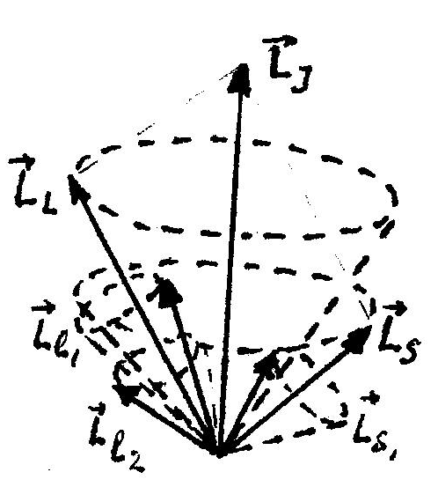where$l_{1}$and $l_{2}$ are the orbital, $s_{1}$ and $s_{1}$ are the quark-spin quantum numbers of the valence electrons. The value of S can be equal to 0 and 1, and$L_{S}$ takes two values $L_{S}=0$ and$L_{S}=ћ\sqrt{2}$ for atoms with two valence electrons. States of atoms with different values of number $J$ are corresponding to different mutual orientation of the orbital and spin angular momenta. So, such states are characterized by different energies.
Figure 9.1.

The number of different values of J at given L and S values as shown by the expression (9.1) is equal to 2S+1. This means that the energy level of the atom with given of L and S at L>S splits into sublevels 2S+1. The number of sub-levels is called the multiplicity. In the system of two electrons S=0 and S=1, therefore, the multiplicity may be 1 and 3, form single levels (singlet) and triplet levels. The multiplicity of energy levels leads to the kind of regularities in the mutual location of the lines in radiation spectrum of atoms. In practice, exactly, the analysis of the spectra for the first time have allowed to obtain information about the relative arrangements of the energy levels of atoms and the electronic structure of atoms and also relate the multiplet structure of the energy levels with a unique and essential feature of electron the quark-spin angular momentum.
4. The term structure is become complex for atoms with two valence electrons like helium, alkaline earths elements and zinc, cadmium and mercury. Unlike a doublet term of alkaline elements are obtained two systems of terms: the system of singlet (single) terms (S=0, J=L) and the system of triplet terms (S=1, J=L+1, L, L-1).
Analysis of emission and absorption spectra of each element in the UV, visible and infrared regions of the spectrum make possible to make a complete scheme of possible terms and transitions. Symbol of terms contains an indication about the multiplicity χ=2S+1 in the index at the top left of the term, the quantum number J the total angular momentum at the bottom right of the term. For example, a symbolic notation ${}_{}^{3}{P_{0},}{}_{}^{3}{P_{1},}{}_{}^{3}{P_{2},}$means triplet term with orbital quantum number L=1, S=1, hence the multiplicity of χ=2S+1=3. Wherein L and S are combined so that J=0,1,2. Singles (singlet) terms symbolically denoted as ${}_{}^{3}{S_{0},}{}_{}^{1}{P_{1},}{}_{}^{1}{D_{2},}$ for which χ=2S+1=1. There are selection rules defined by following formulas for each system of terms (singlet and triplet) at the transitions between the terms of this system:
$∆J=0±1, ∆L=±1$. (9.2)
As a result, singlet terms are combined with each other (singlet-singlet transitions), obtained a series similar to series of alkali element atoms consisting of single lines. Just as in the spectra of alkali elements, these series are often called as the principal, sharp, diffuse and fundamental. Triplet terms also are combined with each other (triplet-triplet transitions), occur a series of similar series of alkaline elements with the same names. The lines related with the transitions between the terms of the triplet system represent triplet (the principal and sharp series) and Sextet (six lines) in the diffuse and fundamental series.
According to the selection rules within each of the terms the following types of transitions are allowed:

Singlet | Triplet

In addition to these transitions there are so-called intercombinational transitions between singlet and triplet terms. The spectra of Zn, Cd, Hg atoms are very similar. The ground state $ns^{21}S_{0}$ of the each one is the deepest term. Diagram of levels and transitions for helium He I is shown in Figure 9.2., and for mercury Hg I is shown in Figure 9.3 respectively.
Diagram of the energy levels of helium atom and the possible transitions are shown in Figure 9.2. There are the same spectral series for He atom exist as for the alkali metal

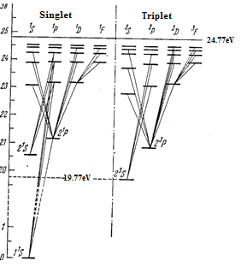
Figure 9.2 перерисовать

Two electrons of He atom fill K-layer (electronic conFigureuration is 1$s^{2}$). This means that the ground states of the He atom are${{ 1}^{1}S}_{0}$. All other states both in the singlet and triplet are excited. Note that the state ${1^{3}S}_{1}$ does not exist. In the experiment was not observed any lines related with this state. At this state, the four quantum numbers of the two electrons is the same:${ n}_{1}=n_{2}=1; l_{1}=l_{2}=0;m_{l_{1}}=m_{l_{2}}=\frac{1}{2};$That is to say, the absence of the term${1^{3}S}_{1}$, is a direct consequence of the Pauli exclusion principle.
The atoms of Zn, Cd, Hg, as He atom, have s-filled outer shell. Their ground state is${ {}_{}^{1}S}_{0}$, and spectra are similar to spectra of He atom.
The dependence on the quantum number J at given L and S values defines a triplet splitting. The reason of the triplet splitting, as in the case of the doublet, is the magnetic interaction between the spin and orbital momenta. The energy of the magnetic spin-orbit interaction in normal LS-bound is expressed by the general formula:
$∆E_{L,S,J}=A\left(L,S\right)\left[J\left(J+1\right)-L\left(L-1\right)-S\left(S+1\right)\right]/2$ (9.3)
where, $A\left(L,S\right)$ is the multiplet splitting factor, depending on L and S values, and defining the absolute magnitude of the multiplet splitting. The distance between adjacent layers, characterized by the quantum numbers J and J+1
$∆E_{L,S,J}=A\left(L,S\right)J\left(J+1\right)$ (9.4)
that is proportional to the quantum number J. This ratio is called the interval rules of thin (multiplet) splitting. The total width of the multipletterm, i.e. the distance between the levels J=L+S and J=L-S, will be A(L,S)(2L+1)S at L≥S; A(L,S)(2S+1)L at L <S.
One have to pay attention to the following fact in the spectra of Zn, Cd and Hg atoms: for the great atomic numbers multiplet splitting due to the spin of electron (the natural splitting of the term) has great value. For example, the triplet term${ 6}^{3}P_{0,1,2}^{0}$of mercury has a splitting of a few electron-volts and triplet components$\tilde{ν}=6^{3}P_{2}^{0}-7^{3}S_{1}^{}$(546.073 nm), $\tilde{ν}=6^{3}P_{1}^{0}-7^{3}S_{1}^{}$ (435.833 nm), $\tilde{ν}=6^{3}P_{0}^{0}-7^{3}S_{1}^{}$ (404.656 nm) lie in different regions of the visible spectrum.
Emission spectrum of zinc, mercury and cadmium vapors are investigating in this laboratory work. The atoms of Zn, Cd and Hg have two electrons in the outer electron shell. The resulting angular momenta $\vec{L_{L}}$and$\vec{{ L}_{S}}$ of the inner shell are equal to zero.

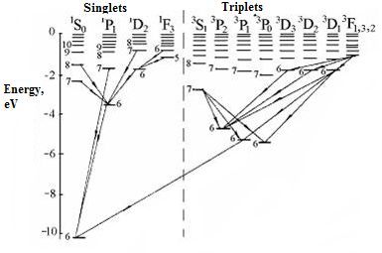
Figure 9.3.The scheme of the energy levels of mercury atom.
Diagram of the energy levels of mercury atom and possible transitions between them are shown in Figure 9.3. In the normal state, both external electrons are 6s-electrons, as their principal quantum number n=6, and orbital$l=0$. Further it is assumed that one of the electrons always remains in unexcited 6s-state, and the second one can be excited with a change of quantum numbers. As $l_{1}$ remains zero, the resulting number $L$coincides with${ l}_{2}$. The resulting spin angular momentum, as noted above, may correspond to S=0 and S=1.
Energy levels (states) of electrons in many-electron atoms which are responsible for the spectral lines are characterized by the terms ${}_{}^{2s+1}{T_{J},}$ where$T≡S,P,D,…$ for the number$L=0,1,2,… .$ The left top index of the term symbol defines the multiplicity of the level, the right bottom defines the number $J$. In this terminology, the possible states of mercury atoms are presented in Table 9.1.
Table 9.1
1st - electron | 2nd-electron | L | S=0 |  | S=1
 |  |  | J | Term symbol | J | Term symbol
6s | 6s | 0 | 0 |  | 1
6s | 6p | 1 | 1 |  | 0,1,2
6s | 7s | 0 | 0 |  | 1
6s | 7p | 1 | 1 |  | 0,1,2
6s | 6d | 2 | 2 |  | 1,2,3

The total energy of the system electron-one valence ion is plotted in the vertical direction in Figure 9.3. For a null value of the energy systems takes the energy corresponding to the complete elimination of a single electron from the atom, so the energy of the system is negative. The numbers 6,7,8 ... correspond to the principal quantum number of the valence electron. Shells with the principal quantum numbers n=1,2,3,4,5 are occupied by 78 inner electrons of mercury atom. These electrons are not involved in the formation of the optical spectrum. The energy level corresponding to the normal state of mercury atom is${6^{1}S}_{0}$ lies on depth of 10.43eV; This means that the ionization work of Hg atom is 10,43eV. Possible transitions between levels (at transitions are performed quantum-mechanical selection rules$∆L=±1$and $∆J=0;±1$) are shown in Figure 9.3. The most typical spectral lines corresponding to transitions:
$6^{1}P_{1}→6^{1}S_{0}$the wavelength is equal to 253.7 nm (ultraviolet region of the spectrum);
$$6^{1}S_{1}→6^{3}P_{0}-λ_{1}=546,1 nm$$
$7^{3}S_{1}→6^{3}P_{1}-λ_{2}=435,8 nm$
$7^{3}S_{1}→6^{3}P_{2}-λ_{3}=404,7 nm$;
-triplets with wavelengths $λ_{1}=546,1 nm,λ_{2}=435,8 nm,λ_{3}=404,7 nm$
The spectra of zinc, cadmium and mercury atoms are similar to each other.
The dependence of the energy on the quantum number J at given L and S values defines the value of the triplet splitting: for the great atomic numbers splitting has great values. One can construct a scheme of the energy levels of atoms, if define wavelengths of the spectral lines. It is needed in this work to detect and measure wavelengths of the spectral lines of the triplet Zn.

9.4. Carrying out the experiment
1. Establish lighted mercury-zinc lamp at the front of the entrance slit of the device and check the illumination of the entrance slit: it should be illuminated uniformly.
2. Turn calibrating drum to the end of the scale, and turning it from the end to the beginning of the scale, observe through a microscope the investigated spectrum.
3. Turning calibrating drum from the beginning to the end of the scale, set each line of the spectrum at the center of the entrance slit and record at the same time the scale division of the drum.
4. Compare the spectrum of the mercury-zinc lamp with a spectrum of mercury (Figure 9.4), select the spectral lines of zinc.
5. Determine wavelengths of the spectral lines of the triplet Zn (triplet lines for Hg, Cd and Zn are marked in Figure9.4) analyzing the obtained results and Figure 9.4 (color of the line, intensity).
6. Fill in the gaps in Table 9.2 on the basis of the measurements and calculations.
7. Draw arrangement scheme of levels ${n^{1}S}_{0}, {{(n+1)}^{3}S}_{1},$ ${n^{3}P}_{0}, {n^{3}P}_{1}, {n^{3}P}_{2}$, (fragments of the complete scheme) of Hg (n=6), Cd (n=5), and Zn (n=4) atoms using the data of Table 9.2 and Figure 9.4.

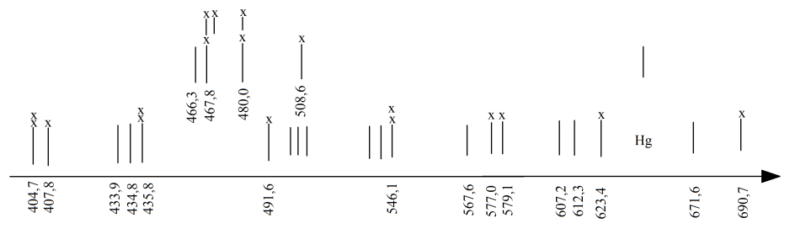
Figure 9.4.

Table 9.2.

Atom
Ionizationenergy, eV | 10,4 | 9,0 | 9,4
1 Transition  , nm  ΔЕ, eV | 253,7  4,9 | 326,1  3,8 | 307,6  4,0
2 Transition  , nm  ΔЕ, eV | 404,7  3,1 | 467,8  2,6
3 Transition  , nm  ΔЕ, eV | 435,8  2,8 | 480,0  2,6
4 Transition  , nm  ΔЕ, eV | 546,1  2,3 | 508,6  2,4

Literature:[3,7,8,10,18]

Control questions
1. Which quantum numbers describe electron state in the atom?
2. Formulate the Pauli principle.
3. Which set of electrons in the atom is called a) electronic layer, b) electron shell? Maximum number of electrons in the layer and shell.
4. What patterns are observed in the spectra of elements with two valence electrons?
5. At which quantum states can be atoms of elements with two valence electrons?
6. What is the physical reason of the triplet and singlet structure of the energy levels the element’s atoms with two valence electrons?
7. What is the fine structure of the lines in different series?

- STUDYING AND OPERATION PRINCIPLE OF HELIUM-NEON LASER.
10.1. The purpose and content of the work:studying the physical principles of operation and design of helium-neon laser, the experimental determination of the main characteristics; laser-beam divergence and polarization; comparative study of the emission spectra of helium, neon and helium-neon laser. Student within the theory should study the issues related to light radiation and absorption, the Einstein coefficients, Planck formula, Bouguer law, Malus law and Brewster angle, as well as to understand the basic principles of operation of the laser. Also should obtain practical treatment skills with gas laser.
10.2. Equipment: a helium-neon laser, the discharge tube with a mixture of helium and neon, power supply, radiation detectors, the polarizer, UM-2 monochromator.
10.3. Brief theory
10.3.1. Spontaneous and induced transitions. The Einstein coefficients
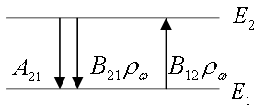1. Numerous experiments demonstrate that an atom cannot be infinitely long stayed in the excited state. After some time, the excited atom releases from its surplus energy through the emission of a photon, transfering to a state with lower energy. There are also exist so-called non-radiative transitions. Such transitions are not accompanied by the appearance of photons specific to the given atom. Separate radiation of the excited atom occurs independently to other atoms at different time moments. Therefore, one can talk about the average lifetime of the atom in excited state. The transitions of the excited atoms with radiation occur "spontaneously." Because of it, they are called spontaneous transitions. Radiation of atoms in spontaneous transitions is incoherent. There is also induced transitions, which occur under the influence of an external field. In this case, the atoms absorbing energy from the field, transferring to the excited state, or induced to emit, transferring to a state with lower energy.
Figure 10.1.

2. Let’s consider two states of an atom with the energies E₁ and E₂. (E₂>E₁) Let us introduce probability of spontaneous transition per unit time A₂₁ from state 2 to 1. The quantity A₂₁ determines the mean value of emissions per unit time for one atom. Assume that there are N₂(t) atoms froming rarefied gas at the energy state E₂ at the time moment t. In the interval of time dt there will be dz₂₁=A₂₁N₂dt transition to the state E₁. The quantity dz₂₁ determines decreasing of the number of atoms at the state E₂and time t, i.e. –dN₂=A₂₁N₂dt. Solving this equation on can obtain that number of atoms at the excited state E₂ decreases according to the law
$N_{2}\left(t\right)=A_{2}(0)e^{-A_{21}t}$ (10.1)
The quantity $\frac{d N_{2}}{N_{2}(0)}$one can consider as the probability measure of spontaneous transitions of atoms in timedt. The average time of such transitions, meaning the average lifetime at the state 2 can be defined by formula:
$τ_{2}=\int_{0}^{∞}{t \frac{d N_{2}}{N_{2}(0)}=A_{21}\int_{0}^{∞}{te^{-A_{21}t}dt}=\frac{1}{A_{21}}.}$ (10.2)
Thus, the probability of spontaneous transition per unit time is inverse of average lifetime at the excited state: $A_{21}=\frac{1}{τ_{2}}$. Intensity of the radiation due to (10.1) decreases according to the law:
$I_{2}\left(t\right)=I_{2}\left(0\right)\exp\left(-\frac{t1}{τ_{2}}\right).$ (10.2а)
3. If the atom at the energy state E1 placed into the external electromagnetic field with the frequency ω, then the atom absorbs the energy of the field if its frequency coincides with frequency $ω_{21}=\frac{(E_{2}-E_{1})}{ћ}$ and transferring to the excited state E₂. Let $ρ_{ω}-$ is spectral density of energy density of electromagnetic radiation, then:
$W_{12}=B_{12}ρ_{ω}$ (10.3)
This quanity gives the meaning of the probability of radiation absorption by atom per unit time.
Along with the absorption process as a result take place transition 1→2 can exists inverse process called induced, stimulated or induced emission, which occurs during transition 2→1 under the influence of external electromagnetic field with the frequency equal to transition frequency:
$W_{21}=B_{21}ρ_{ω}$ (10.3а)
The coefficients A₂₁, B₂₁, B₁₂ were introduced by Einstein in 1916 and are called Einstein coefficients. There are relations between those coefficients
${g_{1}B}_{12}={g_{2}B}_{21},$ (10.4)
$A_{21}=\frac{ћω_{21}^{2}}{π^{2}c^{2}}\frac{g_{1}}{g_{2}}B_{12}.$ (10.4а)
The coefficients g₁ (g₂) is called statistical weight or degeneracy 1st (2nd) state.
4. The measuring of the lifetime of the atom at the excited states is carried out with various methods.
There are exist direct and indirect methods. Assume that electromagnetic radiation with frequency ω and density of energy flux $I_{ω}$ falls to substance layer with thickness dx.(Figure 10.2)
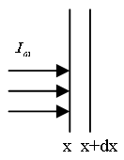During the transition of layer, the flux weakens due to absorption by the substance atoms. Decreasing the flux density -${dI}_{ω}$is directly proportional to flux density of incident radiation and thickness of the layer: -${dI}_{ω}=k_{ω}I_{ω}dx.k_{ω}$ is absorption coefficient. This means that flux density of the radiation at the distance x from incidence plane changes due to Bougier law:
Figure 10.2
$I_{ω}\left(t\right)=I_{ω}\left(0\right)\exp\left(-k_{ω} x\right)$ (10.5)
One can determine absorption coefficient from following considerations. Let’s assume that at upper level E₂ there N₂ atoms per unit volume of substance and N₁ atoms on the level E₁ per unit volume. The transition probabilities of atoms per unit time under the influence of electromagnetic radiation with spectral energy density $ρ_{ω}$ are determined by the formulae (10.3), (10.3a). There are $ρ_{ω}g(ω)B_{21}N_{2}$ transitions of atoms with induced emissions per unit time in unit volume.Here was introduced explicitly form-factor $g\left(ω\right)$ in order to take into account the “smearness” of the frequency. The quantity $ρ_{ω}g(ω)B_{12}N_{1}$ defines the number of absorbed photons per unit time in unit volume. Each photon carries the energy$ћω$. Thus, the difference $ћωρ_{ω}g\left(ω\right){(B}_{12}N_{1}-B_{21}N_{2})$ determines the radiation energy per unit time in unit volume. By multiplying this expression to layer width dx we get expression for changing the energy flux density
$-{dI}_{ω}=ћωρ_{ω}g\left(ω\right){(B}_{12}N_{1}-B_{21}N_{2})dx$. (10.6)
Taking into account the relation $I_{ω}=uρ_{ω},$ where $u=\frac{c}{η}$ is the speed of radiation propagation in the media, $η$ is index of refraction and using (10.5) we get:
$k_{ω}=\frac{ћω}{u}B_{12}N_{1}g\left(ω\right)\left(1-\frac{B_{21}N_{2}}{B_{12}N_{1}}\right).$ (10.7)
Consider now the area of absorption curve using (8.4). This area is defined by integral:
$\int{k_{ω}dω=\frac{ћω}{u}B_{12}N_{1}(1-\frac{g_{1}N_{2}}{g_{2}N_{1}})}=\frac{1}{τ}\frac{πc^{2}g_{2}N_{1}}{2 η^{2}ω_{0}^{2}g_{1}}(1-\frac{g_{1}N_{2}}{g_{2}N_{1}})$ (10.7а)
Thus, by measuring the area of experimentally obtained absorption curve, one can calculate the lifetime $τ$of the atom at excited state. Practically, the area can be found by product of $k_{max}×∆ω$.
Usually the numbers of atoms on the upper energy levels are much less than lower levels, i.e. $N_{2}≪N_{1}$. At thermodynamic equilibrium the ratio of atom number is $\frac{N_{2}}{N_{1}}=\exp\left\{-\frac{E_{2}-E_{1}}{kT}\right\}=exp⁡(\frac{ћω}{kT})$. For example, for visible light $v=7.5*{10}^{15}c^{-1}$ and normal temperature Т=300К ratio is equal to $\frac{ћω}{kT}=1.2*{10}^{3}$. Thus,$N_{2}≪N_{1}$.
10.3.2. General principles induced amplification of electromagnetic radiation. Masers and lasers
1. At normal conditions, the radiation weakens passing through the substance. Then following question is arising: Can the radiation amplify rather than weaken? It turns out that it can. It was discovered, that electromagnetic waves are amplified when it pass through the media, where the concentration of particles or the system of particles at upper energy levels are excess than that of the equilibrium state. It is easy to understand this phenomenon by formula (10.7), from which follows that if the concentration $N_{2}$ is more than $N_{1}$, then the coefficient $k_{ω}$ becomes negative, i.e. occurs negative absorption. As a result, takes place the radiation amplification as it is seen in formula (10.5). Thus, in order to amplification the radiation by medium it should provide the inverse population of energy levels, which is $\frac{N_{2}}{g_{2}}$. The inequality
$\frac{N_{2}}{g_{2}}>\frac{N_{1}}{g_{1}}$ (10.8)
This is the main condition of the inducted amplification. The medium with the inverse population of energy levels is called active medium.
2. Let’s explain the conception of the inverse population of energy levels. At the state of thermodynamic equilibrium, the concentration of particles at level $E_{m}$ is defined by Boltzmann formula:
$N_{m}=g_{m}Cexp\left(-\frac{E_{m}}{kT}\right).$ (10.9)
This implies that the ratio of population of energy levels $E_{1}, E_{2}$is equal to:
$\frac{N_{2}/g_{2}}{N_{1}/g_{1}}=\exp\left({- (E}_{2}-E_{1}\right)/kT).$ (10.9а)
This ratio can be used to determine the temperature:
$T=\frac{E_{2}-E_{1}}{kln(\frac{N_{1}*g_{2}}{N_{2}*g_{1}})}$ (10.9б)

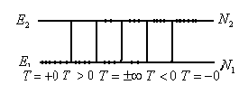
Figure 10.3

The scheme of the population of energy levels is shown in Figure 10.3. Assume that $E_{2}>E_{1}$. If all particles are located on the level $E_{1}$, i.e. $N_{2}=0$
it corresponds to temperature T=+0. If $N_{2}≠0$ and $N_{2}>N_{1}$then the temperature is $T>0$. For the same population of the levels${ N}_{2}=N_{1}$ is corresponding infinitely high value of temperature.
Those infinitely high values of temperature with the signs plus and minus are equivalent: $T=±∞$. At the the inversion $N_{2}>N_{1}$ of energy level population makes the absolute values of temperature negative: $T<0$. The full inversion of energy state $N_{1}=0$ corresponds to approaching the absolute zero of temperature from negative side:$T=-0$. Thus, the expressions “inverse population of the energy levels” and “negative absolute temperature” are equal. Both of them mean that popularity of upper level is more than other one. It is obvious from the stated considerations that reactive medium is at state of thermodynamic non-equilibrium state. The characteristics of that kind of state is negative absolute temperature. This temperate is “hotter” than positive. To get it, i.e. make the most of particle be at excited state, need to apply additional energy. Note that the conception about negative absolute temperature has nothing common with the temperature of medium.
3. The condition (10.8) is necessary for electromagnetic radiation amplification by reactive medium. But it is not enough. The reason is that the radiation is not only amplifies but also weakens in reactive medium. The radiation weakens for example due to absorption, due to scattering on the non-uniformity of medium, due to escaping outside of its volume and so on. If the coefficient of amplification is more than sum of loss coefficient, then the reactive media becomes amplifier for electromagnetic wave passing through it. The media in order to become generator of radiation it is necessary to use positive feedback. In this case, the part of amplified radiation gets back into media and amplifies again. If that kind of amplification is more than loss of amplifier and feedback, then amplifier self-excites and become generator. In order to make positive feedback for radio waves the volume resonators are used, for visible waves system of mirrors, which are called open resonators. Common principles of induced amplification and generation of electromagnetic waves are used in modern quantum devices like masers and laser.
4. The work of quantum generator of any type requires two resonance conditions:
4.1. Classical condition: resonance wave – resonator.The resonator length must fit an integer number of half waves of the generated radiation. If $L$ is the length of resonator, $λ$ is the wavelength, then should be $\frac{sλ}{2}=L,$ where s is an integer number
4.2. Quantum condition: resonance wave –atom. The energy of each photon of generated radiation must be equal to transition energy between two working levels of reactive media.
5. The main feature of reactive media is not only amplifying the electromagnetic passing through it, but also narrowing the radiation spectrum.
Assume that to the beginning of the layer of reactive media at $x=0$ radiation falls. For maximum intensity corresponds frequency $ω_{0}$. During the propagation through the layer with width $x$, the intensity increases according to the law:
$I_{ω_{0}}\left(x\right)=I_{ω_{0}}\left(0\right)\exp\left(\left|{kω}_{0}\right| x\right)$. (10.10)
At the frequency$ω_{0}+∆ω$.the intensity increases analogically. The quantity$∆ω$defines the width of line of radiation at the beginning of the layer. This means than$\frac{I_{ω_{0}}\left(0\right)}{I_{ω_{0}+∆ω}\left(0\right)}=2$.
10.3.3. The Operation principles of helium-neon laser.The scheme of energy levels of He and Ne is shown in Figure 10.4a. The energy levels of helium atom $2^{1}S_{0}$ and $2^{3}S_{1}$ are close to neon energy levels 2s and 3s. The states $2^{1}S_{0}$ and $2^{3}S_{1}$ are metastable. These states get excited during the collisions with electrons in helium-neon discharge tube. During the collisions of second order of helium atoms with neon atoms, neon atoms get excited at the levels 2s and 3s. There also direct excitement of these levels by electron hits. The lifetime of s-states is ${10}^{-7}s$ and p –state is ${10}^{-8}s$. As a result, there are interesting population of energy levels of 2s and 3s rather than 2p and 3p. Thus, the main role of helium atoms is to provide inverse population of energy levels of neon atom. During the transition from excited s- level to p-level is occuring the radiation with different wavelength. The waves with high intensity have the wavelength $λ_{1}≈339*{10}^{-6}$cm, $λ_{2}≈6328\dot{A}$, $λ_{3}≈339*{10}^{-6}$cm. $λ_{1},λ_{3}$ are the infrared part of spectra and $λ_{2}$ –is the red radiation.

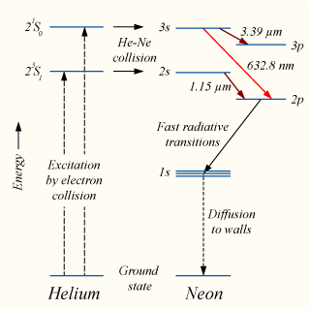

Figure10.4 а. ссылка

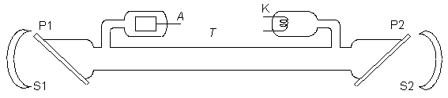

Figure10.4 б.

Generation of laser radiation is shown in Figure 10.4b. The laser is composed from discharge tube T, filled with helium-neon mixture. The length of the tube is from 10s of cm to 1.5 -2m. The diameter is several mm. The end of the tube is closed with glass or quartz plates $P_{1},P_{2}$ which are oriented at Brewster angle to tube axis. The pressure of helium is around 1 mm Hg and neon pressure is around 0.1 mm Hg. Discharge appears using heated cathode K and anode A. The voltage is around 1 – 2.5 kV. The discharge current is 10s of mA. The discharge tube is located between spherical mirrors with multilayer covers $S_{1}$and $S_{2}$. This covers provide positive feedback. The transmittance of one mirror is around 2% and other ones is 1%. At obtaining generation threshold from the side of mirror with higher transmittance goes out the well-collimated intensive beam of red monochromic light. The power of beam is around several 10s of mWt at continuous-wave operation mode. For generation and observation of infrared radiation of helium-neon laser is necessary to provide corresponding conditions (transparent for infrared radiation end plates, mirrors and receiver).
10.4. The experimental installation and measuring technique.
The scheme is shown at Figure 10.5. (a) The experiment setup to generate CV beams. The He-Ne laser produces a linearly polarized light at 632.8 nm wavelength (17 mW, Thorlabs HNL210L-EC). GLP, Glan laser polarizer; HWP, half waveplate; QWP, quarterwaveplate; CCD, charge-coupled device (Coherent LaserCam HR). (b) Schematic drawing of the optical axes in metasurface. (c) The angular dependence of GLP, QWP, and the generated elliptical polarization.

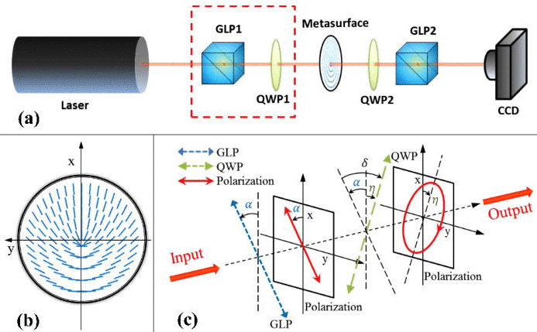
Figure10.5 поменять

1.The determination of laser beam divergence. The scheme of the experiment of beam divergence is shown in Figure 10.5. One should target the laser beam to the screen. By measuring the diameter of the spot on the screen, one can determine divergence $φ$ of the beam by formula $φ=\frac{d}{2}l$, $l$ is full distance that beam has passed. The measured value is comparing with results calculated by formula $v_{0.5}=\frac{λ}{D}$. The diameter is shown on workplace.
2.The study of polarization state of the laser beam. The Polaroid in the frame II have to be set in front photodiode. By rotating it one should set maximum current. Then rotating step by step (10⁰ for step), one should obtain the data of dependence of intensity of light passed through the Polaroid on its angle. The result must be represented in graph dependence of J on the Polaroid rotating angle $J=f (φ)$.
3.Comparative study of radiation spectra of helium, neon and neon-helium laser.
3.1. Observation of neon spectrum. Turn on the neon tube and get spectrum on the plane of the indicator UM-2. Find the brightest line of spectrum of neon and measure the wavelength. Also measure the following lines: a) all bright lines left to the bright yellow line; b) single green and two close green lines right the bright yellow line.
3.2. Observation of helium spectrum. Turn on the laser tube (without mirrors). Study its spectrum. Make sure that laser tube spectrum has all lines from 3.1. of neon radiation. The rest radiation lines are of helium. Measure following bright lines of helium: a) 7 bright lines in the red part of spectra; b) the brightest lines in yellow, yellow-green, blue and violet parts of spectrum.
Using the tables of spectral lines clarify measured values of wavelength of He and Ne.
3.2. Observation neon-helium laser spectrum. Turn on the laser. Find the main line of radiation of laser in red part of the spectrum and determine the wavelength. Clarify that in generation mode none of spontaneous radiation lines of Ne disappear.
All data must be rercorded into the table.
Literature: [3, 4, 5,18]
Control questions
1. What are the common operating principles of the laser?
2. What are spontaneous and induced radiations? What are the differences between them?
3. What physical meaning does Einstein coefficients have? What are the relations between them?
4. What is the inverse population? How is the inverse population provided in lasers?
5. In which spectral lines generation in lasers occurs? Are the conditions of generation of each line independent?
6. What is role of resonator in forming of geometry of beam and its spectral compound?
7. What determines the polarization state of the laser beam?
11. STUDYING THE STRUCTURE OF MOLECULAR SPECTRUM AND DETERMINATION OF THE INTERATOMIC DISTANCE IN CN MOLECULES

11.1. The purpose and content of the work.
Acquaintance with the electron-oscillational-rotational spectra of diatomic molecules (band spectrum) and decoding methods of their oscillational-rotational structure in example of emission spectrum of CN molecule that excited in electric arc. Acquaintance with the system of energy states that related with motion of electrons, oscillation and rotation of diatomic molecules. Determination of the molecular constants$ν_{e}, ν_{e}x_{e}$ and estimation of the dissociation energy. Measuring of the rotational structure of oscillational band in order to determine the inter-nucleus distances.
The work is carried out using captured in advance on the plate ready spectrograms with spectrumof iron and CN molecule obtained using the mean dispersion spectrograph ISP - 28. In order to students can imagine the obtaining procedure of spectra and spectral device itself, in classes is highly advisable to show it, to explain the principles of the basic elements of the spectrograph.
11.2. Brief theoretical introduction
Molecular spectra are more complicated and different than spectra of an atom. It is related with the fact that in case of moleculeconsiderably increasing the factors from which is depending their energy in different quantum states. Energy of the simplest diatomic molecule $E_{mol}$is sum up from three components: 1) Energy$E_{e}$ of electron shell in molecule; 2) oscillation energy $E_{ν}$ of nucleus along the straight line that connect them; 3) rotational energy $E_{r}$of nucleus around common central mass. All these components of energy are discrete and quantized. As result:
$E_{mol}$ =$E_{e}+E_{ν}+E_{r},$ (11.1)
where${ E}_{e}≫E_{ν}≫E_{r}$;
The most change of energy in molecule happens when changes the state of its electron shell. Electron shell of a molecule forms as result of combination of atomic shells, and electron states of a molecule are similar to electron states of the atom (but not equal, because interatomic interaction has great influence on energy of the system). Obviously, that symbolism of electron states of molecules ismostly common with symbolism of atomic states. Similar to orbital quantum number lor with orbital quantum number of multi-electron atom l for molecules considers quantum number Л, that determine (in units of ћ) absolute value of projection of the resulting orbital moment of «electron cloud» on most convenient direction. Most convenient direction for molecule is the direction of its axis, i.e. straight that connects centers of nuclei. Similarly, as denoting by S, P, D symbols the energy states of atoms which corresponds to values L=0, 1, 2…, for the energy states of molecule with Л=0,1,2… correponds symbols Σ,Π,Δ and so on.
However, Σ (as S when describing energy states of atoms) serves to denote the molecular spin quantum number that characterizes absolute value of projection of the resulting spin of electrons on axis of molecule.Like the inner quantum number of atom in the symbolic of energy states of molecule appears quantum number Ω, that determines projection of the total momentum of electron shell on axisof the molecule.
In this way,
Ω =Σ+Л
The same as for atoms, there is observed splitting of energy states in the molecule due to different values and various orientation of the resulting spin relative to the resulting orbital momentumthat determining by expression 2Σ+1. By using these designations electron state of a molecule can be characterized by symbol ${{}_{}^{2Σ+1}Δ}_{Ω}$
Here Лshows that in symbol represents one of Σ, Π or Ω that characterize the magnitude of quantum number Л.
Similarly to atoms exists selection rules for molecules which limits opportunity of transitions from one electron state to another. Permitted transitions are ΔЛ = 0,$±$1; ΔΣ = 0 and ΔΩ = 0, $±1$.

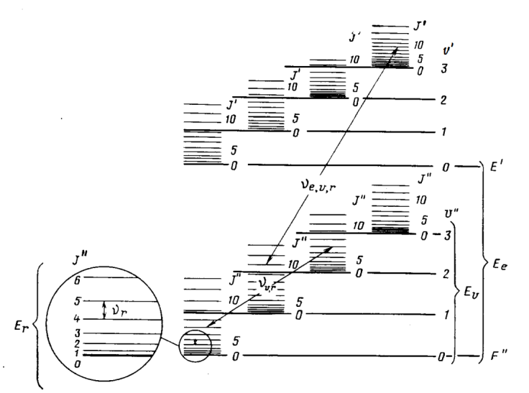
Figure 11.1.ссылка
In a formula (11.1) each term take defined values. For given $E_{e}, E_{ν}, E_{r}$the total energy E_{mol} of the molecule will have a value that corresponds to defined electron-oscillational-rotational state. And is getting the sum of far separated electron states, more close located oscillation states and the most close located rotational states. (Figure11.1).
At transition of a molecule from one state to another at the same time could be changed all three terms of the total energy – electron, rotational and oscillational. Emission and absorption spectra of the molecule consist of three expressed structure – electronic, rotational and oscillational. For transitions with emission and absorption according to frequency condition we have
ν = $\frac{E^{'}-E^{''}}{h}$ = $\frac{(E_{e}^{'}+E_{r}^{'}+E_{ν}^{'})-(E_{e}^{''}+E_{r}^{''}+E_{ν}^{''})}{h}$ = $ν_{e}$+$ν_{r}+ν_{ν}$, (11.2)
where${ E}^{''}$и$E^{'}$– energy of lower and upper electron-oscillational-rotational levels
$ν_{e}$= $\frac{ΔE_{e}}{h}$;$ν_{r}$= $\frac{ΔE_{r}}{h}$ ;$ν_{ν}$= $\frac{ΔE_{ν}}{h}$ ; (11.3)
$ν_{ν}$is characterizing oscillational (banded) structure of spectrum, $ν_{r}$ rotational (the fine) structure.
Change of electronic energy at the same time will lead to the change in oscillational and rotational energy. As result we get electron-oscillational-rotational spectrum which called shortly electron spectrum. Individual bands in these spectracorrespond to different values of $ΔE_{ν }$at given $ΔE_{e}=const$, and individual lines of the fine structure in bandscorrespond to different values of $E_{r}$ at given $ΔE_{ν}$and$ΔE_{e}$.
The difference between electron levels $ΔE_{e}$ is about 1-10eV. Transitions between them yield emission with frequency about ${10}^{14}-{10}^{15}$ Hz i.e. such spectra located in a visible and ultraviolet region of the spectrum.If $ΔE_{e}$= 0, i.e. electron state is constant then oscillational spectrum will appear at changingof oscillational energy. In that case change of oscillational energy will lead to the change of rotational energy i.e.$ν_{}$=$ν_{r}+ν_{ν}$.
For oscillational energy $ΔE_{ν}\sim {10}^{-1}$ – 1 eV and we have transitions with emission frequency${ ν}_{ν}\sim {10}^{11}-{10}^{12}$ Hz. Such emission and absorption spectra are located in near and far infrared region.If $ΔE_{e}$= 0 and then only rotational spectrum is changing, i.e. appear pure rotational spectra. $∆E_{r}\sim {10}^{-3}-{10}^{-2}eV$ corresponds to radiation frequency $ν_{r}\sim {10}^{11}-{10}^{12}$Hz. Pure rotational spectra are located in far infrared and submillimeter-wave region of the spectrum

11.2.1. Rotational spectra.
Let’s consider in first approximation diatomic molecule as hard rotator with masses $m_{1}$ and $m_{2}$ and with distance between gravity centers of atoms r (Figure 11.2). Energy states of a molecule for hard rotator model will be described by next formula
${ E}_{r}=hc[B_{v}J(J+1)]$ (11.4)
term of rotational energy
$F\left(J\right)=\frac{{ E}_{r}}{hc}$ = $B_{e}J(J+1)$ (11.5)
where
$B_{e}$ = $\frac{h}{8π^{2}cI_{e}}$ = $\frac{h}{8π^{2}cμr_{e}^{2}}$ (11.6)
$B_{e}$is the rotational constant in $m^{-1}$, that relates to minimum curve of potential energy; $I_{e}$ = $μr_{e}^{2}$is the moment of inertia in kg$m^{2}$, $μ$ = ${m_{1}m_{2}}/{\left(m_{1}+m_{2}\right)}$is the reduced mass in kg; $r_{e}$is inter-nucleus distance in m; J = 0, 1, 2 … is the rotational quantum number.
In such way, energy states of the molecule depend on its reduced mass and inter-nucleus distance. From equations (11.4),(11.2) taking into account selection rules ΔJ = $±$ 1 it follows
$∆v=2B_{e}(J+1)$ (11.7)
The difference of wave numbers between two neighbor lines in rotational spectrum equals
$∆v=2B_{e}$ (11.8)
Figure 11.2. ссылка

From here one can experimentally find the molecular constant that is moment of inertia. By knowing the mass of atom by expression$I_{e}=μr_{e}^{2}$one can calculate another molecular constant which is inter-nucleus distance.

11.2.2.Oscillational-rotationalspectra.
Terms of oscillational-rotational states are the sum of oscillational and rotational states
$$\frac{E_{νr}}{hc}=G\left(υ\right)+F\left(J\right)={\tilde{ν}}_{e}\left(υ+\frac{1}{2}\right)-{\tilde{ν}}_{e}{\tilde{x}}_{e}{\left(υ+\frac{1}{2}\right)+}^{2}$$
$B_{υ}J(J+1)$ (11.9)
where${ ν}_{e}$is the wave number of oscillation ${cm}^{-1}$ ; $ν$ is the oscillational quantum number taking value 0,1,2…; $ν_{e}x_{e}$ is anharmonicity coefficient of oscillation${ cm}^{-1}$;
1) To simplify consideration, let’s neglecting for a while the rotational structure and considering only oscillational transitions. Fundamental tone (fundamental band) corresponds to transition 1-0 (ν’$→$ν’’). Transitions 2-0, 3-0 and etc. are called overtones. Oscillational frequency of overtones is easy to obtain from the terms difference.
$$G\left(υ\right)-G\left(0\right)={\tilde{ν}}_{e}υ-{\tilde{ν}}_{e}{\tilde{x}}_{e}υ-{\tilde{ν}}_{e}{\tilde{x}}_{e}υ^{2}=$$
$[{\tilde{ν}}_{e}-{\tilde{ν}}_{e}{\tilde{x}}_{e}\left(υ+1\right)]υ$ (11.10)
By using the values of overtone frequencies and main frequenciesone can calculate oscillational frequency $ν_{e}$ and anharmonicity coefficient $ν_{e}x_{e}$. For this purpose, at first one needs to calculate the difference between first overtone and main frequency, between second overtone and first overtone, and so on.
In general case first differences equal to
$$∆_{1}G_{υ+\frac{1}{2}}=G\left(υ+1\right)-G\left(υ\right)={\tilde{ν}}_{e}-2{\tilde{ν}}_{e}{\tilde{x}}_{e}-2{\tilde{ν}}_{e}{\tilde{x}}_{e}υ$$
$={\tilde{ν}}_{e}-2{\tilde{ν}}_{e}{\tilde{x}}_{e}(υ+1$) (11.11)
the physical interpretation of this expression is distance between neighbor terms of oscillational states.
If using the first differences $Δ_{1}G_{ν+1+\frac{1}{2}}$ to find second differences
$∆_{2}G=∆G_{υ+1+\frac{1}{2}}-∆G_{υ+\frac{1}{2}}=-2{\tilde{ν}}_{e}{\tilde{x}}_{e}$ (11.12)
then one can calculate the constant of anharmonicity of $ν_{e}x_{e}$, and knowing it, it is possible to calculate oscillational frequency $ν_{e}$ by formula (11.11).

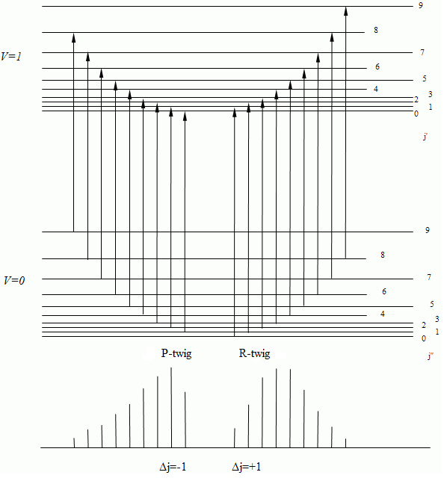
Figure11.3.ссылка
2) Now let’s consider the rotational structure of oscillational- rotational spectrum (Figure 11.3). According to selection rulse ΔJ = $±1$ , that’s why there are two series of transitions between rotational states of different oscillational levels. Respectively two series of lines can be observed in the spectrum which are called branches of bands: R- branches, if ΔJ = $+1$ and P-branches, if ΔJ = $-1$. Between series P and R –branches is locating so called zero gap (beginning of the band) $ν_{0}.$It corresponds to number of oscillational transitions $ν_{0}= {G'(ν_{}^{'})}_{\left(J^{'}=0\right)}-{G''(ν_{}^{''})}_{\left(J^{''}=0\right)}$ which forbidden by selection rules, thus for it ΔJ = $0$. As result countdown of P – line begins at J = J’’= 1. Branch R always located from the side of high frequencies from $ν_{0}$, and first observable line corresponds to J = $0$.
Lines of R- branches for which J’=J’’+1, can be represented by equation
$ν_{R}= ν_{0}+F^{'}\left(J^{'}\right)-F^{''}\left(J^{''}\right)=ν_{0}+B_{ν}^{'}\left(J+1\right)\left(J+2\right)-B_{ν}^{''}J\left(J+1\right)= ν_{0}+2B_{ν}^{'}+\left(3B_{ν}^{'}-B_{ν}^{''}\right)J++\left(B_{ν}^{'}-B_{ν}^{''}\right)J^{2}$ (11.13)
where$J=J^{''}=0,1,2,….$and respectively for P branches for $J^{'}=J^{''}-1$
${\tilde{ν}}_{P}=ν_{0}+F^{'}\left(J^{'}\right)-F^{''}\left(J^{''}\right)={\tilde{ν}}_{0}+{B^{'}}_{υ}\left(J-1\right)J-{B^{''}}_{υ}J\left(J-1\right)={\tilde{ν}}_{0}-\left({B^{'}}_{υ}+{B^{''}}_{υ}\right)J+({B^{'}}_{υ}-{B^{''}}_{υ})J^{2}$ (11.14)
where$J=J^{''}=1,2,3,….$
$3) B_{ν}^{'}-B_{ν}^{''}$is small and we can apply that $B_{ν}^{'}≈B_{ν}^{''}=B_{ν}^{}$ as result
$$ν_{R}= ν_{0}+2B+2BJ;ν_{p}= ν_{0}-2BJ$$
In such approximation distances between two neighbor lines of the rotational structure is equal 2B, asin rotational spectra.
${\tilde{ν}}_{p}= {\tilde{ν}}_{0}+F^{'}\left(J^{'}\right)-F^{''}\left(J^{''}\right)= {\tilde{ν}}_{0}+B_{ν}^{'}J\left(J-1\right)-B_{ν}^{''}J\left(J-1\right)={\tilde{ν}}_{0}-\left(B_{ν}^{'}+B_{ν}^{''}\right)J+\left(B_{ν}^{'}-B_{ν}^{''}\right)J^{2}$ (11.14)
In such approximation distances between two neighbor lines of rotational structure will be equal to 2B, as in rotational spectrum.

11.2.3. Electron-oscillational-rotational spectra.
In general, system of all possible energy states of diatomic molecule can be represented by equation
$$\frac{E_{eυr}}{hc}=T_{e}+G\left(υ\right)+F\left(J\right)=T_{e}+{\tilde{ν}}_{e}\left(υ+\frac{1}{2}\right)-{\tilde{ν}}_{e}x_{e}{\left(υ+\frac{1}{2}\right)}^{2}+$$
$B_{υ}J(J+1)$ (11.15)
where${ T}_{e}$ is a thermonly of electron excitement, which for main electron state is equal to zero.
Now let’s consider only oscillational structure of electron spectrum. In this case location of oscillational stripes described by next equation:
$$\tilde{ν}={\tilde{ν}}_{e}+{\tilde{ν}'}_{e}\left(\tilde{ν}'+\frac{1}{2}\right)-{\tilde{ν}'}_{e}{\tilde{x}'}_{e}{\left(\tilde{ν}'+\frac{1}{2}\right)}^{2}-{{\tilde{ν}}^{''}}_{e}\left({\tilde{ν}}^{''}+\frac{1}{2}\right)-$$
${{\tilde{ν}}^{''}}_{e}{{\tilde{x}}^{''}}_{e}({\tilde{ν}}^{''}+\frac{1}{2)^{2}};$(11.16)
where${ ν}_{e}={T'}_{e}-{T''}_{e}$for electron transition only.
There are no selection rules to transitions with different values ν.
Band series with constant value $v''$ are called progressionsby $v'$, and with constant $v'$is the progressions by$v''$. Band series with constant value $∆v=v^{'}-v''$ are called diagonal series.
All bands observingin the spectrum which belonging to one electron transition can be represented in so called Delandra’s table.
By this table it is easy to make a calculation of a values ${\tilde{ν}}_{e}$and ${\tilde{ν}}_{e}{\tilde{x}}_{e}$formain and excited electron states and value of electron excitation${ \tilde{ν}}_{e}={T'}_{e}-{T''}_{e}$. To consider the fine (rotational) structure of bands, relating with changing of rotational states of the molecule, one needs to accept next value as a constant
$${\tilde{ν}}_{e}+{\tilde{ν}}_{ν}={\tilde{ν}}_{ν'ν''}={\tilde{ν}}_{0}$$
Then rotational structure of electron-oscillational-rotational band is described by next equation.
${\tilde{ν}}_{eνr}={\tilde{ν}}_{0}+F^{'}\left(J^{'}\right)-F^{''}\left(J^{''}\right),$ (11.17)
which similar to equations (11.13, 11.14) in case of oscillational rotational spectrum.
By decoding the fine rotational structure of electron-oscillational-rotational spectra one can determine the rotational constants${ B'}_{ν}$and${ B''}_{ν}$, and using these values one can determine inter-nucleus distance of the molecule atground and excited electron states.
Dissociation energy of diatomic molecules. Dissociation energy is very important characteristic of the molecule, especially when we need to determine frequenciesof reaction in different chemical processes. Dissociation energy of diatomic molecule can be determined by approximated formula of linear extrapolation
$D_{e}=\frac{{{\tilde{ν}}_{e}}^{2}}{4{\tilde{ν}}_{e}{\tilde{x}}_{e}}$ (11.18)
This expression can be derived according to oscillational interval $ΔG_{ν+\frac{1}{2}}$ (11.11) linearly depends on $ν$ and tend to zero at $ν_{max}$. So we can accept that

$$∆G_{υ+\frac{1}{2}}={\tilde{ν}}_{e}-2{\tilde{ν}}_{e}x_{e}-2{\tilde{ν}}_{e}x_{e}υ_{max}=0$$
where
${\tilde{ν}}_{e}x_{e}≪{\tilde{ν}}_{max}=\frac{{\tilde{ν}}_{e}-2{\tilde{ν}}_{e}x_{e}}{2{\tilde{ν}}_{e}x_{e}}≈\frac{{\tilde{ν}}_{e}}{2{\tilde{ν}}_{e}x_{e}}$ (11.19)
By substituting${ ν}_{max}$ into expression for termenergies (11.9) one can determine energy when dissociation of a molecule takes place
$$D_{e}=G\left(υ_{max}\right)={\tilde{ν}}_{e}\left(\frac{{\tilde{ν}}_{e}}{2{\tilde{ν}}_{e}x_{e}}+\frac{1}{2}\right)-{\tilde{ν}}_{e}x_{e}\left(\frac{{\tilde{ν}}_{e}}{2{\tilde{ν}}_{e}x_{e}}+\frac{1}{2}\right)$$
$$≈\frac{{{\tilde{ν}}^{2}}_{e}}{2{\tilde{ν}}_{e}x_{e}}-\frac{{{\tilde{ν}}^{2}}_{e}}{4{\tilde{ν}}_{e}x_{e}}=\frac{{{\tilde{ν}}^{2}}_{e}}{4{\tilde{ν}}_{e}x_{e}}$$
Need to notice that formula (11.18) is approximated and gives an accuracy $\sim 20\%$.
At transition of a molecule from excited electron-rotational-oscillational state to different oscillational-rotational sublevels of zero electron level, take place an emission of a quant of light with energy, which equal to difference between energies with higher and lower energy levels.
On Figure 9.4 shown possible transitions and lines in a emission spectrum of diatomic molecule. Rotational levels aren’t shown.

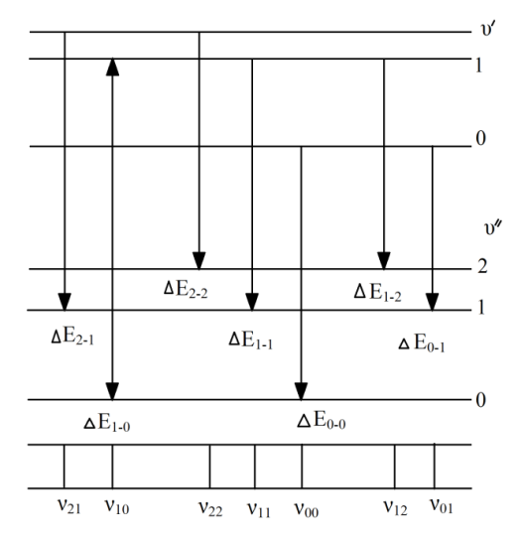
Figure 11.4.Is a scheme of electron-oscillational energy levels and transitions of a molecule.

Electron-rotational-oscillational emission spectrum give a possibility to calculate frequency of oscillation and coefficient of anharmonicity in unexcited and electron-excited states. From Figure 9.4 we can understand that difference of energy transitions $ΔE_{0-0}$ and $ΔE_{0-1}$ is equal to difference between energy of oscillational quantum levels and oscillational quantum numbers 1, 0 i.e.
$${∆E}_{0-0}=hc{\tilde{ν}}_{0-0}; {∆E}_{0-1}=hc{\tilde{ν}}_{0-1}; \frac{{∆E}_{0-0}-{∆E}_{0-1}}{hc}={\tilde{ν}}_{0-0}-{\tilde{ν}}_{0-1};$$
Difference of wave numbers of spectral lines in emission spectrum is equal to wave number, which matches with transition of a molecule from level $ν=0$ to level $ν=1$, i.e. to wave number of main band in a oscillational spectrum.Difference of transition energy $ΔE_{1-1}$ and $ΔE_{1-2}$ matches with transition energy from oscillational quantum level $ν=1$to $ν=2$.

$${∆E}_{1-1}=hc{\tilde{ν}}_{1-1}; {∆E}_{1-2}=hc{\tilde{ν}}_{1-2}; \frac{{∆E}_{1-1}-{∆E}_{1-2}}{hc}=$$
${\tilde{ν}}_{1-1}-{\tilde{ν}}_{1-2}$.
Sum of difference of emission line’s wave numbers
$$\left({\tilde{ν}}_{1-1}-{\tilde{ν}}_{1-2}\right)+({\tilde{ν}}_{0-0}-{\tilde{ν}}_{0-1})$$
is equal to number of first overtone. By applying these data and using equations (11.11), (11.12) we can calculate frequency of oscillation $ν_{e}$ and coefficient of anharmonicity${ ν}_{e}x_{e}$. Similar calculation gives an opportunity to find frequency of oscillation and coefficient of anharmonicity in electron-excited state. Difference $(ΔE_{1-0}-ΔE_{0-0})$ is equal to energy difference on first oscillational quantum level and on zero oscillational quantum level at electron-excited state i.e. gives an opportunity to determine wave number of main band in electron-excited state of a molecule.
Sum of differences $(ΔE_{2-1}-ΔE_{1-1})$ and $(ΔE_{1-0}-ΔE_{0-0})$ is equal to difference of energy levels $ν^{'}=2$and $ν^{'}=0$ in electron-excited state. As result we can determine ${ν'}_{e}$and ${ν'}_{e}{x'}_{e}$. By frequency of oscillation and coefficient of anharmonicity we can calculate energy of chemical bound.
If you will measure mean value of wave number difference of emission line which matches with transitions between rotational levels, then it is possible to find moment of inertia and inter-nucleus distanceby equations (11.6) and (11.8).
11.5. Work performance order:
Exercise 1.The study of radiation spectrum of the molecule.
On the spectrum projector (ПС-18, ДСП-1), using the atlas of standard spectrum determine the wavelength of edging strips (the sharp boundary between light background and blackening maximum. Number the strips. Comparing the wavelength of edging strips with the energy diagram of CN (Figure11.5) decrypt the oscillating structure of the electron spectrum. Write down the results on the Table 11.2.
Table 11.2.

Number of strips | λ, edging strips, nm | Transition  $$v^{'}-v''$$ | Wave number of edging strips, ${\tilde{v}}_{v^{'}v^{''}}$, cm⁻³

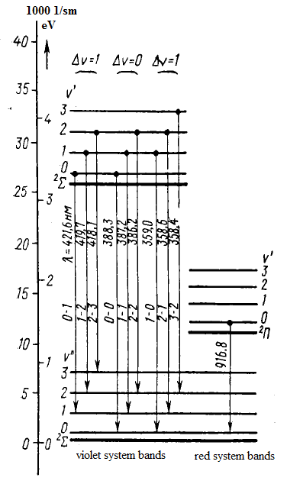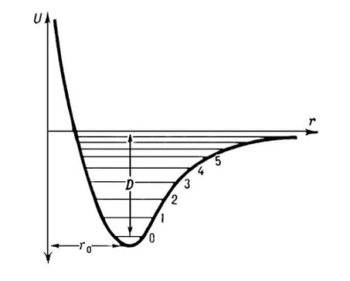

Figure 11.6. Part of the scheme of CN energy levels ссылка нм поменять

Exercise 2. Determination of natural oscillation frequency, coefficients of non-harmonic and chemical bonding energy of CN.
1. Using wave numbers of edging strips ${\tilde{v}}_{v^{'}v^{''}}{(\tilde{v}}_{0-0}$,${\tilde{v}}_{1-0}{\tilde{v}}_{1-1}{\tilde{v}}_{2-1}{\tilde{v}}_{2-2}{\tilde{v}}_{3-2})$ determine the first differences $∆_{1}G=∆_{1}\tilde{v}$ (Figure11.5 formula (11.11))
Which is distance between neighboring oscillating terms of the upper and lower electron state of CN molecule:
$$∆{\tilde{v}}_{1-0}={\tilde{v}}_{0-0}-{\tilde{v}}_{1-0}; {∆\tilde{v}}_{1-2}={\tilde{v}}_{1-1}-{\tilde{v}}_{2-1};{∆\tilde{v}}_{2-3}={\tilde{v}}_{2-2}-{\tilde{v}}_{3-2};$$
2. Using $∆{\tilde{v}}_{0-1}, ∆{\tilde{v}}_{1-2}, ∆{\tilde{v}}_{2-3}$ (formula (9.12)) obtain the second differences
$$∆_{2}G=∆_{2}\tilde{v}={\tilde{v}}_{0-0}-{\tilde{v}}_{1-2},∆_{2}\tilde{v}={\tilde{v}}_{1-2}-{\tilde{v}}_{2-3},$$
Using formula (9.12) determine the non-harmonic coefficients ${\tilde{v}}_{e}{\tilde{x}}_{e}$;
3. Use previous result and determine oscillating ${\tilde{v}}_{e}$ by formula (11.12);
4. Examine disassociation energy $D_{e}$ using formula (11.18) and
$$D_{e}=D_{0}+\frac{1}{2}{\tilde{v}}_{e}-\frac{1}{4}{\tilde{v}}_{e}{\tilde{x}}_{e}$$
5. Determine the value of electron $T_{e}$, using formula
$v_{00}$= $T_{e}$ + $\frac{1}{2}\tilde{v_{e}}'$- $\frac{1}{4}\tilde{v_{e}}'\tilde{x_{e}}'\frac{1}{2}\tilde{v_{e}}''$+$\frac{1}{4}\tilde{v_{e}}''\tilde{x_{e}}''$
Write results in Table 11.3
Table 11.3.
Wave numbers of aging stripes  $$v_{v'v''}$$ | $∆_{1}G$=$∆_{1}\tilde{v}$  cm⁻¹ | $$∆_{2}G$$  cm⁻¹ | $${\tilde{v}}_{e}{\tilde{x}}_{e}$$  cm⁻¹ | $${\tilde{v}}_{e}$$  cm⁻¹ | $$D_{e}$$  J | $$D_{0}$$  J | $$T_{e}$$  cm⁻¹

Exercise 3. Determination of the inter-nuclear distance of the molecule
1. To determine mean distance (in m⁻¹) between neighboring lines of the fine structure of CN molecule spectrum. The spectrogram is putting on the table of the microscope MIR-12 for this purpose, and the distance between two lines of the fine structure is measuring. Knowing the dispersion of the spectrograph DFS-8, dispersion is 0.6 nm/mm, the distance is transferred to the difference of wave numbers $∆\tilde{v}$. The last one is divided into n-1, where n is the number of lines containing between two above mentioned lines (including them).
2. The rotational constant of the molecule is defining according to formula (11.8) using values of $∆\tilde{v}$ obtained for different oscillational bands.
3. To determine the moment of inertia of the molecule by formula (11.6).
4. Toestimatetheinter-nuclear distance of the CN molecule. Tocompareobtainedvalueofrwith literature data [9].
Write down results into the Table 11.4.
Table11.4.
Band  υ′→υ′′ | The distance between two lines  Δ, mm | n-1 | Δλ  nm | Δv  sm⁻¹ | В  sm⁻¹ | I  kg⋅m² | r  sm

Literature: [3, 7, 9,18]

Control questions
1. Structure difference of atom and molecule.
2. Chemicalbond. Bondtypes (showreal examples).
3. Motiontypesinthemoleculeandcorresponding energies.
4. What is the order of magnitude of electron, oscillational and rotational energies of the molecule?
5. Explain the character of the potential curve of the molecule.
6.Give a description of the oscillations in the molecule using models of harmonical and anharmonical oscillator.
7.What is the first energy differences and what are the rules for their measurement?
8. Dissociation energy of the molecule.What is the relation with oscillational parameters of the molecule?
9. What are the types of the molecule spectra, their characteristic frequencies and wavelengths?
10. What are means ? How these quantities are determining?
11. Quantum numbers for diatomic molecule. Designation of the states.
12. To be able to represent energy diagram for the molecule and show the appearance of the band according to thes election rules.
12. ZEEMAN EFFECT

12.1. The purpose of the work: Studying Zeeman Effect with help of spectral lamp with cadmium. Studying spectral lines splitting of cadmium in magnetic field; determining Bohr magneton
12.2. Theoretical introduction
If source of light is placed in magnetic field, spectrum of light emitted by this source will change. Every spectral line split into some components. This phenomenon called Zeeman effect (1896 y.)
There are two type of Zeeman effect:normal and an anomalous Zeeman effect. In case of normal effect spectral line in magnetic field $\vec{B}$ split into two components, they fall behind from each other for $2\frac{μ_{B}B}{h}=2\frac{eB}{2m}$, if observation is carried out along force lines of magnetic field or split into three components with intervals between components $\frac{μ_{Б}B}{ћ}=\frac{eB}{2m}$, if observation is carried out under 90 degree for magnetic field lines. Anomalous-when splitting do not satisfy conditions of normal effect(for example when there are more components of splitting or when there is different interval). Theory show that normal effect is true only for spectral line obtained in result of transition between two singlets terms, in other case anomalous effect appear. In this work Zeeman splitting of cadmium lines studied (or Zn,Hg). Cadmium has two valence electron and consequently terms of two multiplicity- singlet and triplet. Because of that some lines have normal effect and others-anomalous. Zeeman components corresponding to transition without change of magnetic quantum number${ m}_{J}$, polarized linearly, i.e. electrical vector of light wave perform linear oscillations, parallel to direction of magnetic field. These components of line called $π$-components. Components corresponding for transitions with${ ∆m}_{J}=±1$, circularly polarized. They called b-components. Their electrical vector of light wave perform circular oscillations in plane, perpendicular to $\vec{B}.$
Splitting of spectral lines into components happens because of energy levels splitting under effect of magnetic field to atoms. Zeeman splitting of energy levels happens because atoms which has magnetic momentum $μ_{J}$ obtain in magnetic field extra energy
$∆E=-\left({\vec{μ}}_{J}\vec{B}\right)=μ_{JB}B$ (12.1)
where$μ_{JB}$-projection of magnetic momentum to field direction. Appropriate quantum mechanical calculations give for magnetic momentum
$μ_{J}=-μ_{Б}g\sqrt{J\left(J+1\right)}$ (12.2)
where
$g=1+\frac{J\left(J+1\right)+S\left(S+1\right)-L\left(L+1\right)}{2J\left(J+1\right)}$ (12.3)
${ μ}_{Б}=\frac{eћ}{2m}$ (12.4)
Expression (12.3) called Lande factor,(12.4)-Bohr magneton and it is natural unit of magnetic momentum. In case, when total spin angular momentum of atom is equal to zero $\left(S=0\right)$ full momentum coincide with orbital$\left(J=L\right)$. Putting in (12.3) $S=0$and $J=L$, gives $g=1$ and we obtain meaning of momentum determined by formula
$μ_{L}=-\frac{e}{2m}L_{L}=-\frac{eћ}{2m}\sqrt{L\left(L+1\right)}=-μ_{Б}\sqrt{L\left(L+1\right)}$ (12.5)
Presence of minus in formula (12.2) let us obtain projection $μ_{J}$ to direction $\vec{B}$ by simple substitution $\sqrt{J\left(J+1\right)}$for${ m}_{J.}$So,
$μ_{JB}=-μ_{Б}gm_{J}$, $\left(m_{J}=0,±1,…,±J\right)$ (12.6)
Putting this expression into (1) gives
$∆E=μ_{JB}gBm_{J}$, $\left(m_{J}=0,±1,…,±J\right)$ (12.7)
Here we obtain that energy level appropriate to term ${{}_{}^{2S+1}L}_{J}^{}$, split into $2J+$1 equidistant sublevels, value of splitting depends on multiplier of Lande, i.e. depends on quantum numbers L,S,J of this level. Before superposition state fields, which different by values of quantum numbers$m_{J}$, owned same energy, i.e. degeneracy by quantum number $m_{J}$ observed. Magnetic field removes degeneracy by
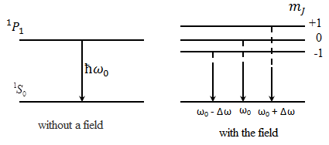
Figure12.1. Splitting of atomic energy ${{}_{}^{1}P}_{1 }^{}$и${{}_{}^{1}S}_{0 }^{}$in magnetic field and allowed transitions between them.
On Figure 12.1 splitting of levels and spectral lines for transitions between states L=1 and L=0 shown (for $P→S$ transitions). When field is absent we may observe one line with frequency which we denote${ ω}_{0}$. When field inserted, except line relatively to it two symmetrically placed lines with frequencies ${ ω}_{0}+∆ω_{0}$and${ ω}_{0}-∆ω_{0}$ appear.

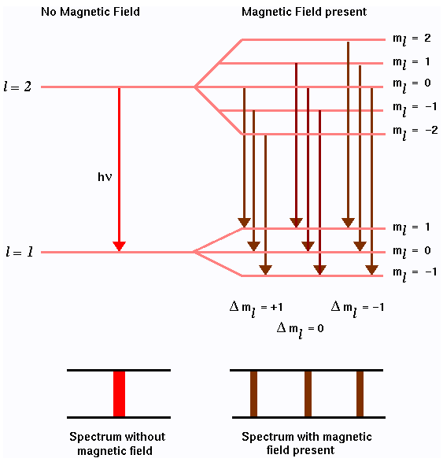

Figure 12.2. Splitting of levels ${{}_{}^{1}D}_{2 }^{}$и${{}_{}^{1}P}_{1 }^{}$in magnetic field and transitions between them.
On Figure 12.2 analogical scheme for more complicated case given-for transitions $D→P$. At first glance it may seem that original line should split into seven components. But really here only three component: line with frequency $ω_{0}$ and two symmetrically due to first line placed lines with frequencies $ω_{0}+∆ω_{0}$and${ ω}_{0}-∆ω_{0}$. It happens because of selection rule for magnetic quantum number $m_{J}$ (and for${ m}_{L}$) due to this rule only following transitions possible:
${∆m}_{J}=0,±1$ (12.9)
Owing to this rule transitions on Figure 12.2 is possible. Finally we obtain three components with frequencies shown on Figure 12.1.
Shift of components $∆ω_{0}$ obtained in previous cases called normal or Lorenz shift. Due to (12.8) shift is equal to
$∆ω_{0}=\frac{μ_{Б}B}{ћ}=\frac{eB}{2m}$. (12.10)
Considered splitting into three components called simple (or normal) Zeeman Effect and two of them spaced from no shifted line for $∆ω_{0}$. Simple Zeeman Effect observed in case, when initial lines have not got fine structure, i.e. they are singlet. Lines having fine structure have more than three structures and magnitude of splitting make up rational fraction from normal shift $∆ω_{0}:$
$∆ω=∆ω_{0}\frac{r}{q}$,$∆\tilde{ν}={∆\tilde{ν}}_{L}\frac{r}{q}[{см}^{-1}]$ (12.11)
$r$and$q$- small integers. This splitting called complicated (or anomalous) Zeeman effect.
Complicated Zeeman Effect explained by dependence of value of level splitting from multiplier Lande, i.e. finally explained by electron spin momentum and doubled magnetism of spin existence. For example let’s consider zeeman splitting of lines ${{}_{}^{ 3}P}_{1}^{}→{{}_{}^{3}S}_{1}^{}$, which are one of the line of blue cadmium triplet.
Energy of atom placed in magnetic field $\vec{B}$equal to
$E=E_{0}+∆E$(12.12)
where
$∆E=μ_{Б}gBm_{J}$ (12.7)
- energy of interaction between magnetic momentum and field $\vec{B}$; $E_{0}$-energy of atom field at$\vec{ B}=0$; $μ_{Б}$and$g$ – Bohr magneton and Lande multiplier..
For state${{}_{}^{3}S}_{1}^{}$:$L=0;S=1;J=1; m_{J}=0,±1;g=2$.
For state${{}_{}^{3}P}_{1}^{}$:$L=1;S=1;J=1; m_{J}=0,±1;g=3/2$.
From (12.12) and (12.7) we have that every level in magnetic field will split into three sublevels (Figure 12.3).
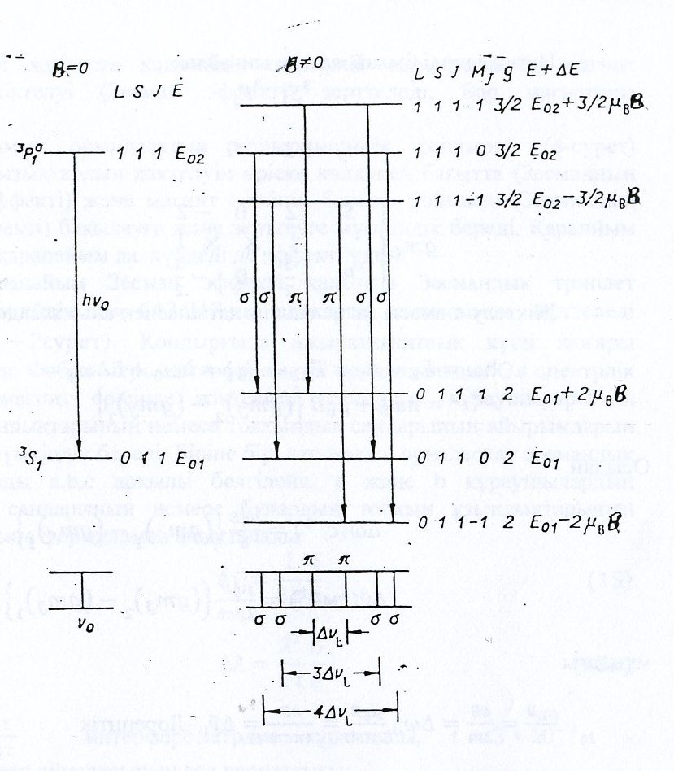

Figure 12.3. Splitting of ${{}_{}^{3}P}_{1}^{}и {{}_{}^{3}S}_{1}^{}$in magnetic field and transitions between them.
In accordance with selection rule for magnetic field of quantum number${ m}_{J}$:${ ∆m}_{J}=0$($π$-components),${ ∆m}_{J}=±1$($b$-components) ${{}_{}^{ 3}P}_{1}^{}→{{}_{}^{3}S}_{1}^{}$ line in magnetic field will split into six components (Figure 3). Transition between sublevels which characterized by value${ ∆m}_{J}=0$, is disabled, because in this case ${ ∆m}_{J}=0$ and $∆J=0$.
Result of Figure12.3:
$${{}_{}^{3}S}_{1}^{}{{}_{}^{3}P}_{1}^{}$$

$$m_{J} +1 0 -1$$
$$gm_{J}\left\{\begin{aligned}{{}_{}^{3}S}_{1}^{} 2 0 -2 \\ ↓ ⤩ ⤩ ↓ \\ {{}_{}^{3}P}_{1}^{}\frac{3}{2} 0 -\frac{3}{2}\end{aligned}\right.$$

Magnitude of splitting determined by
$$ћω=E_{2}-E_{1}=\left(E_{02}-E_{01}\right)\left({∆E}_{2}-{∆E}_{1}\right)={ћω}_{0}+ћ∆ω={ћω}_{0}+μ_{Б}B\left\{{\left(gm_{J}\right)}_{2}-{\left(gm_{J}\right)}_{1}\right\}$$
here we have
$∆ω\left(c^{-1}\right)=\frac{μ_{Б}B}{ћ}\left\{{\left(gm_{J}\right)}_{2}-{\left(gm_{J}\right)}_{1}\right\}$, (12.14)

$∆\tilde{ν}\left({cм}^{-1}\right)=\frac{μ_{Б}B}{2πcћ}\left\{{\left(gm_{J}\right)}_{2}-{\left(gm_{J}\right)}_{1}\right\}$. (12.15)

where$\frac{μ_{B}B}{ħ}=\frac{eB}{2 m}=∆ω_{0}, \frac{μ_{B}B}{2 πc ħ}=\frac{eB}{4πcm}={∆\tilde{ν}}_{0}={∆\tilde{ν}}_{L}$ is the Lorenz shift.
Due to (12.14) and (12.15) and selection rule ${{}_{}^{3}P}_{1}^{}→{{}_{}^{3}S}_{1}^{}$ in magnetic field split into following six components

$∆\tilde{ν}=\frac{eB}{4πcm}\left\{-2;-\frac{3}{2};\left(-1/2\right);\left(1/2\right);\frac{3}{2};2\right\}$. (12.16)

where$\frac{μ_{B}}{h}=\frac{eB}{2 m}=∆ω_{0}, \frac{μ_{B}}{2 πc h}=\frac{eB}{4 πcm}$=${∆\tilde{ν}}_{0}≡{∆\tilde{ν}}_{L}lorenzshift.$

In work splitting of spectral lines of cadmium in magnetic field studied (Zeeman effect), Bohr magneton determined. Work done on experimental device (Figure 12.4),which allow to observe and study splitting of spectral line in transverse direction to field (transverse Zeeman effect) and along to direction of magnetic field (longitudinal Zeeman effect) suitable for simple and complicated Zeeman effect.
During studying of simple Zeeman effect research completed on spectral line of cadmium with 𝝀=643,847nm (${}_{}^{1}{D_{2}}→'P_{1}$),which gives normal Zeeman triplet (Figure 12.2). In device as high quality force interferometer Farbi-Pero used.It allowsdetermining difference in wave lenght and wave number of Zeeman components of spectral lines. Let’s denote close placed zeeman components by a,b,c. Differnce of wave number of components a and b or their wavelength determines by formula:
$∆v͠=\frac{1}{2t}\frac{δ}{∆}$ (12.17)
$∆ƛ=\frac{ƛ^{2}}{2t}\frac{δ}{∆}$(12.17a)
where$\frac{1}{ 2t}$- constant of interferometer, t=3*${10}^{-3}$м-distance between plates of interferometer
$δ=δ_{ab}^{m}$=($D_{bm}^{2}-D_{am}^{2}$) (12.18)
-difference of squared diameters of interferometer rings between neighborhood components (a and b) in every order m,
$∆=∆_{a}^{m,m+1}$=($D_{bm}^{2}-D_{am+1}^{2}$) =4($r_{am}^{2}-r_{am+1}^{2}$) (12.19)
-difference of squared diameters of interferometer rings between neighborhood order (m,m+1)of each components (a and b)
For radiating transitions of electrons in atoms energy change equal to:
$∆E=E_{L,m_{L}}-E_{L-1,m_{,L-1}}$=hc$\frac{∆v͠}{2}$ (12.20)
$∆E$proportional to magnitude of magnetic induction. Bohr magneton determined like coefficient of $∆E иВ$ proportionality:
$∆E=μ_{Б}В$ (12.21)
from (12.20) and (12.21), obtain:
$μ_{Б}=hc\frac{∆ v͠}{2В}$ (12.22)

The performance of the work.

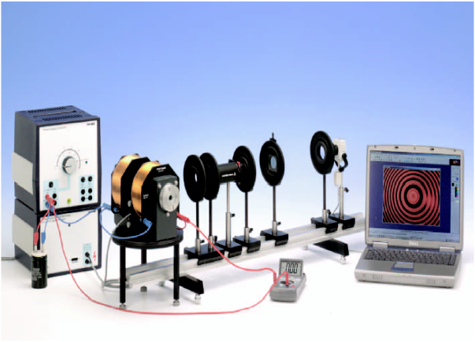
Figure 12.4.The experimental setup for the study of the Zeeman effect ssylka
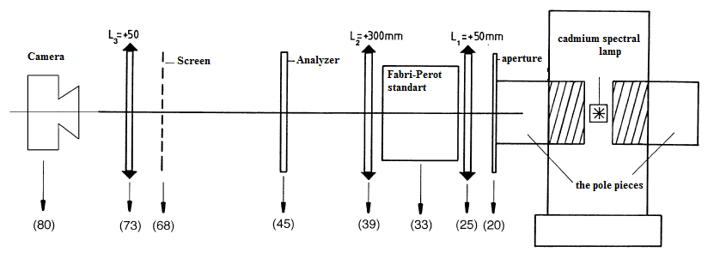
Figure 12.5.Arrangement of the optical components on the optical bench.

Assemble installation.
1. Place the solenoid on a rotating table and secure it with two pole pieces so that there is enough space for a big cadmium lamp (9-11 mm). Secure the tips so they do not move when a magnetic flux. Insert the cadmium lamp between the lugs so that it does not touch the terminals and connect it to the power supply for spectral lamps. Solenoid coils are connected in parallel through the ammeter to a power source (20 V, 12 A). 22,000 mkF capacitor to be connected in parallel with the source output.
2. On the optical bench with a line of the following items as shown in Figure 5 (in brackets given their approximate location in the centimeter marks):
- (80) CCD- camera type,
- (73) lens L3 = +50 mm
- (45) an analyzer
- (39) lens L2 = +300 mm,
- (33) Reference of Fabri-Perot
- (25) lens L1 = +50 mm
- (20) the iris.
The lens and the lens with a focal length of 100 mm in a reference of Fabri-Perot running almost parallel to give a ray of light required to create an interference pattern. The reference of Fabri-Perot filter is replaceable, through whichthe red cadmium line (643.8 nm). The lens ring creates an interference pattern observed through the lens. The diameter of the ring is measured using a camera-type CCD. A camera with an 8 mm lens mounted on the optical bench, and can be adjusted vertically and horizontally.

3. Place the turntable with an electromagnet, the pole pieces and cadmium lamp so that the center hole in the tip located at a distance of 28 cm above the table. Optical bench with all the components should be located near the electromagnet at such a distance that the crop iris and direction of the magnetic field along the direction of observation (along the optical bench) (Figure 5), an outlet of one of the tips coincide with the location of the remote iris (20). Also, make sure the outlet is in the plane of focus of the lens.
4. Turn on a lamp, not including an electromagnet. Moving slightly reference of Fabri-Perot or lens (vertically or horizontally), or by changing the slope of the camera get the interference pattern on the computer screen. The picture should be placed in the center and be clear, balanced, and with the right circles. For pictures go to the menu «File» («File") and select «CaptureWindow» («Picture Window"). Setting brightness, contrast and saturation of the image are regulated «Video Capture Filter» («Filter Images") in the menu «Options» («Options").
The experiment should be conducted in a darkened room.
Task 1.Study longitudinal Zeeman Effect (normal).
1. Prepare the installation to carry out the experiment:
• remove the iris,
• Turn the tips of an electromagnet so that their outlets are located along the optical axis (the direction of observation), the interference pattern,
• Turn the magnetic field, to do so, the magnitude of current in the coils 8A, each interference ring should be divided into two rings.
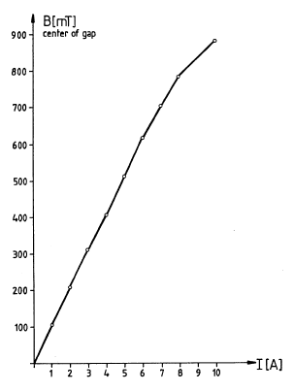
Figure 12.6.The dependence of the magnetic induction in the region of the lamp current from the dual coil.

• Make sure that when the magnitude of the magnetic field (change the current in the coils of an electromagnet) changing the distance between the doublets.
To determine the value of the magnetic field of the coil current value of dual use the graph shown in Figure 6,
• Make sure that the interference pattern does not change when you turn the plane transmittance analyzer
• Make sure that the light is polarized in a circle, using a plate. To do this, insert the plate between the lens and the analyzer. If the optical axis coincides with the vertical plate can be seen as a single ring disappears if the analyzer is at a 45º angle to the vertical, while the other ring disappears at position - 45º.
2. Conduct the experiment:
• Take a photo of the painting (Figure7) at different magnetic field intensity by «StillImage» under «Capture». After that, the menu is automatically minimized and the main window picture appears. Record the current coil in which the image was taken using the option «Text».
• repeat the above process several times for different values ​​of the magnetic field (with a current of 5A, 6A, 8A and 10A). The resulting image to determine the radius of the Rings with the option «Circle» in the menu «Measure»,
• fill in Table 12.1 for five current and four interference rings.
Table 12.1
, А | , мТл | Radius*

In the notation of the radius of the first index - is the number of rings, the second index – marking- σ-components.
3. Spend the processing of experimental data:
• For each value of B, using the formula (12.18) - (12.19), and determine ∆ and σ:
$∆=D_{bm}^{2}-D_{am}^{2}$ (12.18)
$δ=D_{bm}^{2}-D_{am+1}^{2}$ (12.19)

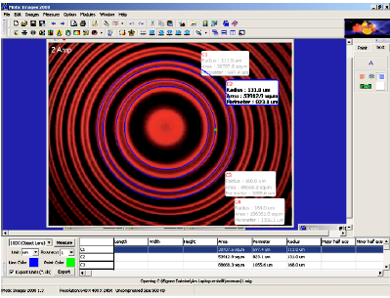
Figure 12.7.Screenshot (definition of interference radii of the rings)

Using formula 12.17 define for five values of magnetic field and fill it to the Table 12.2.

Table 12.2.

, mTl | , m⁻¹

The distance between the plates of the Fabri-Perot$t=3*{10}^{-3}m.$
• Graphically present the data in Table 12.2, draw a linear approximation of data and determine the value of the Bohr magneton. Compare the value obtained with the theoretical:
$$μ_{B,table}=9.273*{10}^{-24}J/Tl$$
Task 1.Study transverseof the Zeeman Effect (normal).
1. Prepare the installation to carry out the experiment:
• Turn the tips of an electromagnet so that their outlets are located perpendicular to the direction of observation, set the iris, the interference pattern,
• Turn the magnetic field, to do so, the magnitude of current in the coils 8A, each interference ring should be divided into components,
• Make sure that when the magnitude of the magnetic field (change the current in the coils of an electromagnet), the distance between the components is changing,
• Make sure that the interference pattern changes when you turn the plane transmittance analyzer: the rotation of the plane of the analyzer are separated by 90 ° ring or two rings (d) or for three (triplets).
2. Conduct an experiment to measure the doublets and processing of experimental data similar to the reference 1, paragraphs 2, 3.

Literature: [6,11,12]

Control questions.
1. What is the Zeeman Effect?
2. What is the transverse / longitudinal Zeeman Effect (normal)?
3. How many components are separated by the energy levels of atoms in a magnetic field?
4. What are the selection rules? Specify the selection rules for the magnetic quantum number.
5. What is the difference - and -components and spectral line?
6. What is the Fabri-Perot interferometer? What are the functions it performs in this work?
7. Record the maximum condition for the interference of the two beams.
8. * Get a formula (12.13).
9. What is the Bohr magneton?

13. ELECTRON PARAMAGNETIC RESONANCE

13.1. The purpose of the work: Determination of g–factor of the free electron by means of electron paramagnetic resonator.
13.2. Equipment. Electron paramagnetic resonator (EPR) with field coils, EPR power supply, EPR control element, double-channel oscillograph for 30 MHz, digital multimeter, cable with the length 750 mm, adapter, connection wiresс (Figure 13.1).

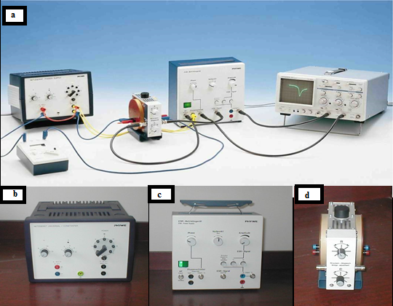

Figure 13.1. Experimental setup for investigation EPR and its components:
а – experimental setup, b – power supply, universal, c – EPR control element, d - electron paramagnetic resonator.

13.3. Brief theory.
There is a splitting of the energy levels into several sublevels in atoms in a magnetic field. Spontaneous transitions from the lower sublevels of the same level to the upper level are not possible. However, such transitions can take place under influence of the external electromagnetic field. The necessary condition for this is the coincidence of the electromagnetic field frequency with the photon frequency corresponding to the energy difference between the split sublevels. Thus, one can observe absorption phenomenon of the electromagnetic energy, which is called magnetic resonance.
Depending on the type of particles, carrier of the magnetic moment, distinguishing electron paramagnetic (spin) resonance (EPR) and nuclear magnetic resonance (NMR).
Under the electronparamagnetic resonanceunderstandsthe resonance absorptionof electromagnetic energy by substances containingparamagnetic particles.Under theparamagnetic particlesare understood:
1. Atomsand moleculeswith odd number ofelectrons(e.g.,nitrogen,hydrogen atoms and NO molecules);
2. Free radicals of the chemical compoundswithunpairedelectrons (e.g., CH₃);
3. Ions with partially filledinner shells(e.g., ions of transition elements);
4. Сolor centersin crystals;
5.Сonduction electronsin metals and semiconductors.
The energy levels of the paramagnetic particle, e.g., of atom with S spin and magnetic moment μ, in constant magnetic field are splitting into 2s+1 sublevels, differing in energy by the magnitude (the Zeeman Effect, Figure 12.2 of the work №12)
$∆E=2μB$ (13.1).

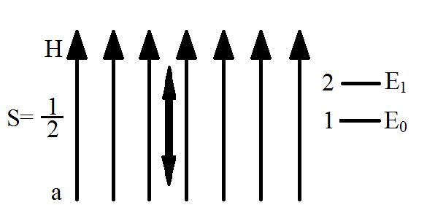

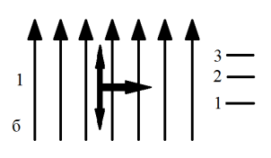

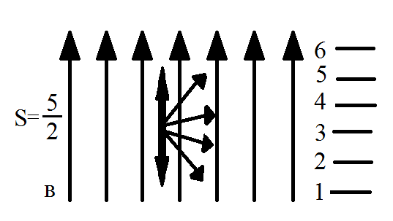

Figure 13.2.Spatial quantization of the spin Sin a magnetic field H and the splitting ofthe energy levels of:а – of the free electron, b – of paramagnetic particle with several electrons and with spin S=1, c – with spin S$=5/2$.

In the simplest caseof the free electron(Figure 13.2a) $s=1/2$ the magnetic moment is equals to:
$μ=g_{s}μ_{B}M_{s}$ (13.2)
where
$$g_{s}=1+\frac{J\left(J+1\right)+S\left(S+1\right)-L(L-1)}{2J(J+1)}=2.0023$$
g is the factor of the free electron, the Landé splitting factor, μ_{B} is the Bohr magneton, $M_{s}=±1/2$ (the magnetic quantum number). Electronenergy Ecantake two valuesin the fieldB:
$E_{1}=-\frac{1}{2}g_{S}μ_{B}B$ (13.3)
$E_{2}=+\frac{1}{2}g_{S}μ_{B}B$(13.4)
Transitions between magnetic sublevels are possible, when the electromagnetic energy quantum ћω is equal to the energy difference ΔЕ between them:
$ћω=∆E=g_{S}μ_{B}B$ (13.5)
$m_{S}=±1$ (13.6)

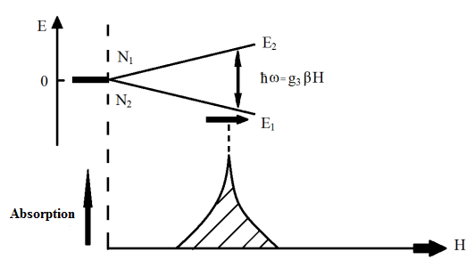

Figure 13.3.Energy absorption of the alternating electromagnetic field by free electrons ina constant magnetic field H

At the transitionfrom the lowerto the upperlevel the energy is absorbedand at the reverse transition is emitted (Figure13.3). The probability ofthese processes are equal, butsince at thethermodynamic equilibrium conditions, according to the Boltzmanndistribution
$\frac{N_{2}}{N_{1}}=e^{-\frac{∆E}{kT}}=e^{-\frac{μ_{S}g_{j}B}{kT}} (13.7$)
The lower level N₁ population is greater than that of the upper N₂, thenthe energy is absorbed. If some how one can create invers ion population N₂>N₁,then under the influence of electromagnetic field, the systemwill emit energy.
Scan take any multiple value of the S 1/2 for particles containing several electrons, (Figure 13.2b, 13.2c.) and the energy levels:
$E=gμ_{B}m_{S}B$(13.8)
Wherem_{S}can take 2S+1 values: S, S-1, … -(S-1), -S. The magnitude of the g–factor is defining by the totalvalue of thespin and orbital angular momentaof the electronandcan be several timesdifferfromg_{S}. Magnetic dipole transitions are possible between levels, differing in the value of m_{S}by the magnitude $Δm_{S}=±1$ and resonance condition will bestilldescribed by the formula (13.5).

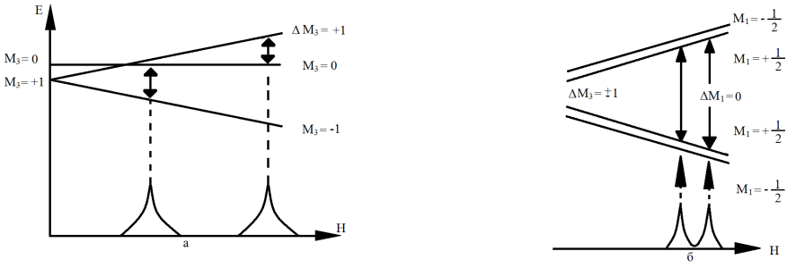
Figure 13.4.Scheme of the level splitting of energy function:
а – at interaction with the crystalline field,
b – taking into account electron-nucleus interaction

Electroninteraction with the electriccrystalline field leads for S≥1to the splitting of energy level swith different $\left|M_{z}\right|$value sand without a magnetic field (at H=0). As a result, in the EPR spectrum several absorption lines (the fine structure; Figure13.4a) occur. Interaction of electrons with nucleus magnetic moment of the paramagnetic atom leads to the appearance in the EPR spectrum ofthe hyperfine structure.
Let's consider the atom in which the unpaired electron interacts with one proton (which spin is $S=\frac{1}{2}$). Two orientations of the magnetic moment of the proton, as well as for an electron, will be possible in an external magnetic field H: along the field $M_{S}=\frac{1}{2}$ and reverse to the field $M_{S}=-\frac{1}{2}$. The magnetic moment of the proton creates the additional magnetic field ΔH₁ at the point of electron location. Therefore, the unpaired electrons of the part of atoms which have $M_{S}=\frac{1}{2}$, at the intensity of the external magnetic field H₀ will be in the total field $H=H_{0}+{∆H}_{C}$ .n an atom in which the value of the total field is equal. The magnitude of the total magnetic field is equal to $H=H_{0}-{∆H}_{C}$ in atoms in which $M_{S}=-\frac{1}{2}$ . Energyof the atoms in the magneticfield, nuclei of which arethe in $M_{S}=\frac{1}{2}$ and$M_{S}=-\frac{1}{2}$ states are almost indistinguishable, and therefore nuclei number in these statesalmost is equal. Hence, then umber of electrons at the additional fields+ΔH₁ and ΔH₁ is alsothe same. Thus each energy level of the unpaired electronis split into twolevels of identical populations (Figure13.4b).
The selection rule for electron transitions ΔM₁ = 0. This means that during the electron transition does take place change of the nuclear spin orientation. It is seen from Figure.13.4b that as a result of the splitting of levels instead of one absorption line appear two lines at intensities of the external magnetic field$H=H_{0}+{∆H}_{C}$ and $H=H_{0}-{∆H}_{C}$ . The distance between the spectrum lines is called the hyperfine splitting and often measured in the units of magnetic field strength, but also can be measured in the units of frequency. The magnitude of α depends on the distribution of electron density. Interaction of electrons of the paramagnetic particles with magnetic moments of the nuclei is splitting EPR line (the hyperfine structure). The study of the hyperfine structure and thesuperhyperfine structures enables us to determine the location of the npaired electrons.
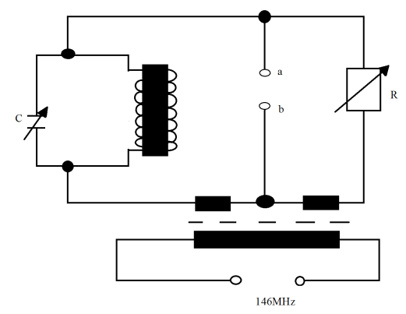

Figure 13.5.Schematic diagram of themeasuringbridgeof the EPR

Schematic diagram of theme a suring bridge of the electron paramagnetic resonator are represented in Figure 13.5. The bridge consists of the resistance box in one branch and resonator circuit in the other. Investigated sample is placed in the coil, located in the resonator circuit. The bridge is designed so that the total resistances (impedances) of branches are the same and the potential difference between a and b points is equal to zero. If one sets the external magnetic field so that the energy is absorbed in the sample, the voltage between aandb points increases.
In this work the Helmholtz coils are used with the number of turns n=250 and the radius R=0.054 m, the external magnetic field at point located on the symmetry axis of the coils can be determined according to the next formula:
$B=0,6445μ_{0}\frac{nI}{R}$ (13.9).
whereμ₀ = 1,256·10⁻⁶T·m/А. Taking into account n and R one can obtain: В = 3,74765·10^{-3·}I in Т/А.
One can obtain for g–factor from formula (13.5):

$g=\frac{hν}{μ_{B}B}$ (13.10)
or
$g=10,43·10^{-3}I/B_{r }$ (13.11)
where B_{r} in Tesla, or
$g=2,7830·10^{-3}I/I_{r }$ (13.12)
where current I_{r} in Ampere.

13.4. Carrying out the work.

Task 1: Determination of the Landé splitting factor with voltmeter.

1. Assemble the installation for the experiment according to Figure 13.6.

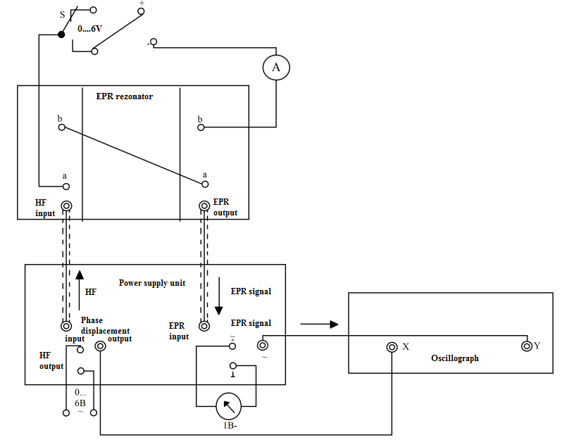

Figure 13.6 Installation diagram

2. Balance the measuring bridge:
- Connect the voltmeter to the control element of the EPR (Figure 13.1c.);
- In the absence of the external magnetic field move to the central position the regulator R on the electron paramagnetic resonator (Figure 13.1d), and the regulator C to the leftmost position;
- On the control element of the ESR set the regulator Zero to the leftmost position. Here press the button “Bridge adjustment” (the balance of the bridge), using regulator Zero get voltmeter indications close to zero values;
- Further rotating knob C on the resonator clockwise register a sharp jump in the voltage on the voltmeter (in the range from 200 to 700 V), then set the voltmeter indication to zero by knob Zero (do not touch anymore the regulator C);
- Press the button “” on the control element of the EPR. If the voltmeter indications deviated from zero, by the adjustable button Zero set zero value on the voltmeter.
3. Apply the external constant displacement field on the resonator:
- Turn knob A on the power supply clockwise up to the limit;
- Changing smoothly the voltage by regulator V, get sharp jump of the voltage on the digital voltmeter (the maximum deviation of indications);
- According to the indications of the amperemeter, write down the resonant current I_{r} into the table;
- Calculate the Landé splitting factor by formula (13.12).
4. Repeat the task 5 times.
5. Calculate the average values and the error of the average.

Task 2: Determination of the Landé splitting factor with the oscilloscope.

1. Balance again the measuring bridge, after set all regulators to the leftmost positions.
2. Apply the external constant displacement field with the frequency 50 Hz (the voltage is 2 V), looping S switch on the power supply on the alternating field. Press the button "~".
3. Turn knob A on the power supply clockwise up to the limit
4. Changing smoothly the voltage by regulator V, get on the oscilloscope sinusoidal curve (turning regulators R and C, one can obtain more accurate curve). Once the signal is appeared, the signal applied to the input X of the oscilloscope must be in phase (the regulator "Phase") with the signal applied to the input Y. (As soon as the resonant frequency of the tuned circuit stops to comply with the generator frequency, asymmetric signal appears). Write down indications of the amperemeter at the moment when the resonance frequency coincides with the generator frequency.
5. Calculate the Landé splitting factor by formula (13.12).
6. Repeat the task 5 times.
7. Calculate the average values and the error of the average.
8. Compare results obtained from tasks 1 and 2.

Literature: [4,10,11,16]

Control questions
1. What is the Zeeman Effect?
2. Give the definition of the magnetic resonance, electron paramagnetic resonance.
3. Under what conditions takes place electron paramagnetic resonance?
4. The physical meaning of the Landé splitting factor.
5. List the experimental methods for the measurement of the EPR.
6. Where EPR isapplied?
7. Derive the calculation formula (13.12) for the Landé splitting factor
8. Describe the measuring method the Landé splitting using electron paramagnetic resonator
.

APLICATIONS

1. Fundamental physical constants
Quantity | Symbol | Value
speed of light in vacuum | c | 299 792 458 m·s⁻¹
Newtonianconstantofgravitation | G | 6.67408(31)×10⁻¹¹ m³·kg⁻¹·s⁻²
Planckconstant | h | 6.626 070 040(81) × 10⁻³⁴ J·s
reducedPlanckconstant | ћ | 1.054 571 800(13) × 10⁻³⁴J·s
Bohrradius | $$a_{B}$$ | 5.291 772 1092(17) × 10⁻¹¹ m
classicalelectronradius | $$r_{e}$$ | 2.817 940 3267(27) × 10⁻¹⁵ m
electronmass | $$m_{e}$$ | 9.109 382 91(40) × 10⁻³¹ kg
fine-structureconstant | α | 7.297 352 5698(24) × 10⁻³
protonmass | $$m_{p}$$ | 1.672 621 777(74) × 10⁻²⁷ kg
Rydbergconstant | R | 10 973 731.568 539(55) m⁻¹

2. Conversion of units
unit of measurement | eV | J | sm⁻¹ | K | MHz
1 eV | 1 | 1.6022·10⁻¹⁹ | 8065.48 | 11604 | 2.418×10⁸
1 J | 6.2415·10¹⁸ | 1 | 5.034·10²² | 7.243·10²² | 1.5092·10²⁷
1 sm⁻¹ | 1.2398·10⁻⁵ | 1.98·10⁻²³ | 1 | 1.4388 | 2.9979·10⁴
1 K | 8.617·10⁻⁵ | 1.38·10⁻²³ | 6.95·10⁻¹ | 1 | 2.083·10⁴
1 MHz | 4.135·10⁻⁹ | 6.626·10⁻²⁸ | 3.33·10⁻⁵ | 4.799·10⁻⁵ | 1

3. List of spectral lines in the wavelength range 400 -650 nm. (Visible spectral lines)
Elements | λ, nm | Elements | λ, nm | Elements | λ, nm
Ag | 405,53 | Cd | 467,82 | H | 410,174
 | 421,09 |  | 479,99 |  | 434,043
 | 421,27 |  | 508,58 |  | 434,050
 | 466,85 |  | 609,92 |  | 486,128
 | 520,91 |  | 643,85 |  | 486,133
 | 546,55 | Cs | 455,53 |  | 656,271
 | 547,15 |  | 459,32 |  | 656,285
Ba | 455,40 |  | 584,47 | He | 402,62
 | 493,41 |  | 621,29 |  | 447,15
 | 553,55 |  | 658,65 |  | 471,31
 | 577,77 |  | 672,33 |  | 492,19
 | 614,17 |  | 687,04 |  | 501,57
 | 649,69 |  | 679,33 |  | 587,56
 | 659,53 |  | 722,85 |  | 667,81
 | 705,99 | Cu | 402,27 |  | 706,57
 | 712,03 |  | 406,27 |  | 728,13
 | 728,03 |  | 453,08 | Hg | 404,66
Ca | 422,67 |  | 458,69 |  | 407,78
 | 445,48 |  | 465,11 |  | 434,75
 | 458,59 |  | 470,47 |  | 435,83
 | 643,91 |  | 510,55 |  | 491,60
 | 714,81 |  | 515,33 |  | 546,07
 | 720,32 |  | 521,82 |  | 567,59
 | 732,61 |  | 570,02 |  | 576,96

4. “Last” lines of elements (nm) in emissions spectra
Element | “Last” lines
Al | 396.15 | 394.40 | 309.27 | 308.22
B | 249.68 | 259.77 | 345.12
Ba | 455.40 | 493.41 | 233.53 | 389.18
Bi | 306.77 | 289.80 | 293.83
C | 247.86 | 426.70 | 229.68
Ca | 393.87 | 422.67 | 396.85 | 317.93 | 315.89
Cd | 228.80 | 326.11 | 226.50 | 346.62 | 298.06
Co | 345.85 | 340.51 | 252.14 | 306.18 | 238.89
Cr | 425.44 | 427.48 | 426.97 | 359.35 | 360.53
Cs | 455.54 | 459.32
Cu | 324.78 | 327.99 | 296.12 | 282.44
Fe | 302.06 | 358.12 | 371.99 | 238.20 | 259.83
Ge | 309.81 | 326.95 | 295.12 | 265.16
Hg | 253.65 | 435.83 | 313.16
K | 404.41 | 404.72 | 344.67 | 344.77
Li | 670.78 | 323.26 | 610.36
Mg | 285.21 | 280.27 | 279.55 | 383.83
Mn | 257.61 | 279.83 | 403.08 | 259.37 | 403.31
Mo | 313.26 | 390.29 | 317.03 | 379.82 | 386.41
Na | 588.99 | 589.59 | 330.23 | 330.30
Ni | 341.48 | 241.61 | 305.08 | 231.60 | 230.30
P | 253.56 | 253.40 | 255.33 | 255.49 | 253.64
Pb | 405.78 | 368.35 | 283.31 | 220.35
Sb | 259.81 | 287.79 | 252.85 | 232.50
Si | 288.16 | 251.61 | 390.55
Sn | 317.50 | 284.00 | 303.41 | 286.33 | 326.23
V | 436.92 | 318.40 | 318.34 | 318.54 | 309.31
Zn | 213.36 | 334.50 | 334.56 | 471.22 | 481.05
Zr | 339.20 | 360.12 | 343.82 | 349.62
W | 400.87 | 430.21 | 294.44 | 289.65
Ti | 337.28 | 334.94 | 336.12

5. Emission spectra for mercury.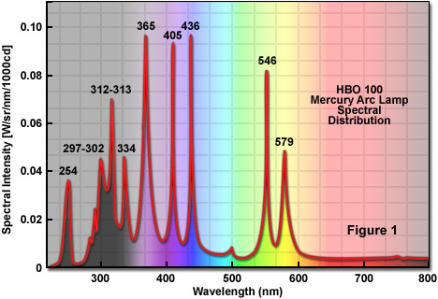

6. Table of Delundra for edges of bands of CN molecules ($\dot{A} and {sm}^{-1}$)
$v^{'}$\ $v^{''}$ | 0 | 1 | 2 | 3 | 4 | 5 | 6
0 | 3883.4  25743.4  (-54.0) | 4216.0  23712.5  (-42.7) | 4606.2  21703.8  (-35.2)
1 | 3590.4  23841.1  (-78.9) | 3871.4  25823.2  (-56.9) | 4197.2  23818.7  (-44.2) | 4578.0  21837.5  (-36.3)
2 |  | 3585.9  27879.1  (-86.2) | 3861.9  25886.7  (-60.2) | 4181.0  23911.0  (-46.2) | 4553.1  21956.9  (-37.2)
3 |  |  | 3583.9  27994.  (-95.4) | 3854.7  25935.0  (-64.2) | 4167.8  23986.7  (-48.2) | 4531.9  22059.6  (-38.4)
4 |  |  |  |  | 3851.0  25959.9  (-69.0) | 4158.1  24042.7  (-50.5) | 4514.8  22143.2  (-39.7)
5 |  |  |  |  |  |  | 4152.4  24075.7  (-53.3)

7. Constants of diatomic molecules
Molecula | State | $$T_{e}, {sm}^{-1}$$ | $$T_{e}, {sm}^{-1}$$ | $$T_{e}, {sm}^{-1}$$ | $$B_{e}, {sm}^{-1}$$ | $$r_{e},\dot{A}$$
AlO | $$X^{2}Σ$$  $$A^{2}Σ$$ | 0  20699.2 | 978  870.1 | 7.2  4.0 | 0.6415  0.6042 | 1.6176  1.6668
$${Br}_{2}$$ | $$X^{1}Σ$$  $$B^{3}Σ$$ | 0  15891,3 | 323,33  167,85 | 1,08  1,73 | 0,0811  0,0585 | 2,281  2,686
CN | $$X^{2}Σ$$  $$B^{2}Σ$$ | 0  25751,8 | 2068,7  2164,1 | 13,1  20,2 | 1,8991  1,9701 | 1,1719  1,506
СО | $$X^{1}Σ$$  $$A^{1}П$$ | 0  65075,6 | 2170,12  1515,61 | 13,37  17,25 | 1,9313  1,6116 | 1,282  1,2351

8. Periodic Table of the Elements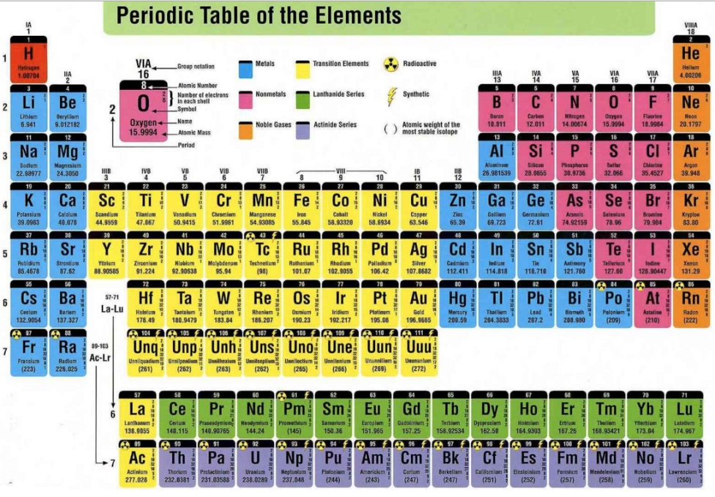

BIBLIOGRAPHY

1. Zajdela.N., G. V. Ostrovskaya, Y. I. Ostrovsky Technique and practice of spectroscopy.-M.: Nauka, 1972; 1976
2. Nagibina I. M., Prokofiev, V. K. Spectral instruments and techniques spectroscopy.-M: Mashgiz, 1967 Nagibina I. M., Michael Y. K. Photographic and photoelectric spectral Primorye emission spectroscopy technique. –Leningrad: Mashinostroenie, 1981.
3. Optics and atomic physics/edited by R. I. Solouhin.-N.: WITH "Science", 1976.
4. Workshop on spectroscopy/edited by Levshin L. V.-M.: MGU,1976.
5. Lebedev V. V. Technique of optical spectroscopy –M.: Moscow state University, 1977.
6. Tarasevich N. M. K. A. Semenenko, and A. D. Khlystova, Methods of spectral and chemical-spectral analysis.-M.: Moscow state University, 1973.
7. Elyashevich M. A. Atomic and molecular spectroscopy. –M.: Fizmatgiz, 1962.
8. Frish S.E. Optical spectra of atoms. –M. Fizmatgiz, 1963.
9. Maltsev A. A. Molecular spectroscopy. –M.: Moscow state University, 1980.
10. Shpolsky E. V. Atomic physics: In 2 T. –M.: Nauka, 1984.
11. Matveev A. N. Atomic physics. –M.: Higher school, 1989.
12. Workshop on nuclear physics / ed. by L. I. Kiselevsky. Mn.: University, 1989.
13. Seidel A. N. and other Tables of spectral lines. –M.: Nauka, 1969.
14. Striganov, A. R., Svetitsky N. With. Tables of spectral lines of neutral and ionized atoms. –M.: Atomizdat, 1966.
15. Kalinin S. K., Avniel A. A., Alekseev A. I., V. L. Marzanov Atlas of spectral lines for quartz spectrograph. M: Gosgeoltekhizdat, 1959.
16. Kalinin S. K., Marzanov L. V., Zamyatina, G. M. Identification of spectra of elements. Almaty, "Science", 1972.
17. Kalinin S. K., Zamyatina, G. M., V. M. Perevertun, Terekhovich S. L. Atlas of spectral lines for a diffraction spectrograph. Alma-ATA, "Nauka", 1967.
18. Zhumanov K.B. Atomic physics. Practicum.(rus)-Almaty:Kazakh universiteti,2009.-132p.
19.
http://gopixdatabase.com/gallery/photoelectric+effect+applications/3
20.
http://www.pravda-tv.ru/tag/fizika/feed
21.
https://www.mwit.ac.th/~physicslab/hbase/FrHz.html
22. http://www.picstopin.com/382/emission-and-absorption-spectra-of-the-elements/http:||chemistry*beloit*edu|BlueLight|thumbs|ab_em_el*jpg/

CONTENT

 | PREFACE…………….....……………………………… | 3
1 | STUDYING THE EXTERNAL PHOTOELECTRIC EFFECT PHENOMENON………......…………………... | 7
2 | ELECTRON DIFFRACTION……….………………....... | 15
3 | THEFRANCK-HERTZEEXPERIMENTS………..…….. | 22
4 | OBTAINING AND DECODING SPECTROGRAMS….. | 31
5 | THE USE OF ATOMIC SPECTRA TO ANALYZE THE COMPOSITION OF THE SUBSTANCE……………….. | 44
6 | DETERMINATION OF THE RYDBERG CONSTANT AND ELECTRON MASS ……………..………………... | 51
7 | STUDYING SERIAL PATTERNS IN SPECTRA OF ATOMS OF ALKALINE ELEMENTS …………..…….. | 59
8 | STUDYING THE FINE STRUCTURE OF SODIUM SPECTRAL LINES ……..……………………….……… | 72
9 | STUDYING SPECTRUM STRUCTURE OF ATOMS WITH TWO VALENCE ELECTRONS ……...………... | 88
10 | STUDYING AND OPERATION PRINCIPLE OF HELIUM-NEON LASER …..………………………...… | 100
11 | STUDYING THE STRUCTURE OF MOLECULAR SPECTRUM AND DETERMINATION OF THE INTERATOMIC DISTANCE IN CN MOLECULES…... | 110
12 | ZEEMAN EFFECT................…………………………... | 124
13 | ELECTRON PARAMAGNETIC RESONANC …..……. | 137
 | APLICATIONS | 147
1 | Fundamentalphysicalconstants……………………........... | 147
2 | Conversionofunits………………………………….......… | 148
3 | List of spectral lines in the wavelength range 400 -650 nm. (Visiblespectrallines)……....……………………….......... | 148
4 | “Last” lines of elements (nm) in emissions spectra…….... | 149
5 | Emissionspectraformercury……....…………………..…... | 150
6 | Table of Delundra for edges of bands of CN molecules..... | 151
7 | Constants of diatomic molecules….....…………………… | 152
8 | Periodic Table of the Elements ……...........…………….. | 152
9 | BIBLIOGRAPHY…………....…………………………… | 153

