ASSESSING THE HUMAN DEVELOPMENT IN THE REPUBLIC OF KAZAKHSTAN
– A REGIONAL LEVEL ANALYSIS

Gulnara Nyussupova, Kalimurzina Aisulu
Al-Farabi Kazakh National University, Almaty,Kazakhstan
gulnaran@mail.ru, kaisl23@mail.ru

Abstract. The objects of research are indicators of human development in Kazakhstan from 1991until today. The subject of scientific research is spatial-existential patterns of socio-demographic processes as a key factor of human potential development in the Republic of Kazakhstan. The importance of scientific work is that the results permit to estimate the level of human development of the Republic of Kazakhstan on the basis of socio-demographic processes. For the first time the basic indicators defining human development in Kazakhstan have been studied in detail and systematized. The aim of the work is to define the laws of the spatial organization of human development and its basic spatial analyses of human development of Kazakhstan.
Kew words: Kazakhstan, regions of Kazakhstan demographic situation, human development, HDI.

- SOCIAL-DEMOGRAPHIC DEVELOPMENT OF THE REPUBLIC OF KAZAKHSTAN
The demographic factor is dominant in social and national development of any country. Therefore, without scientific analysis at districts and oblasts of Republic of Kazakhstan it is impossible to make realistic projections of economic and social development of the country. The problem of demographic development in Kazakhstan is particularly important.
Population density of the neighboring states is very high compared with Republic of Kazakhstan. This indicator in Kazakhstan, which is located on the border with China, Central Asia remains the lowest (only 6,3 people per 1 km², as of 2013) in the CIS (Commonwealth of Independent States including Russia, Georgia, Moldova, Ukraine, Belarus).
Significant impact of the outflow from the country has led to the decrease in population (in total more than 1.7 million people has emigrated over the first 10 years of a sovereign state). Those who left were highly skilled and at working age that respectively influenced the change in age, education and employment structure of the population. According to the 1999 Census, the population was 14.95 million people. The latest census (2009) in the country recorded 16.0 million people; over the past 50 years the whole population has grown by 6.7 million people, or rather with in comparison to the previous census has increased by 1.05 million. During the period of the independent state the republic’s population declined by 353.4 thousand people, not reaching the 1991 level, and it should be noted that this demographic trend was typical for other countries of the CIS where during the first 10 years after the collapse of the USSR population number declined (Agency of Statistics of Republic of Kazakhstan, www.stat.gov.kz).
Kazakhstan pursues its economic policies in line with the ideology of human development, proclaimed by the UN. Sustained improvement in the quality and social standards of living of the population defined by the President of the country is among the main priorities to achieve the objective of the 50 most competitive countries in the world. According to the Human Development Report (UNDP), Kazakhstan and other CIS countries are characterized by two stages of human development. In the first stage (1990-1995) there was a sharp worsening of all basic human development indicators, which led to the displacement of Kazakhstan, from 54thto 93rdplace in the world Human Development Index (HDI). In the second stage (1995 to present) human development indicators are being restored and it will enable Kazakhstan to move 13 positions higher.
Factors which caused the negative trends in human development in the first stage should include: population decline as a result of emigration, especially in the initial years of the state, reduction in fertility (at least by 25% for Central Asian countries), a sharp decline in life expectancy due to declining demographic investment (UNDP Report, 2011).
According to our calculations demographics –mainly life expectancy at birth - played a major role in the deterioration of human development indicators of the republic at the first stage and is not a weighty factor in the growth of this indicator in the next step. Moreover, its level in Kazakhstan is very low (68.6 years) compared with countries with high rates (78 years). In order to be in a top of 50 countries by HDI (to occupy the 43rd place), a life expectancy in Kazakhstan must be higher than now by 10 years.
The analysis of the dynamics of key components of the HDI in the post-Soviet countries in 1990-2012 suggests that one of the main indicators is a life expectancy. The average in the former Soviet Union is about 74 years. The longest life expectancy is in Georgia (in average 76.7 years). The lowest life expectancy is in Tajikistan – 66 years (2011 year). In Kazakhstan, life expectancy in 2009 reached 68.6 years, which corresponded to the 1990 level (Rodionova, 2010). In 2012 life expectancy in Kazakhstan reached 69,6years.
Problems of human reproduction attract the attention of both specialists and the general public, thus gaining increasing importance in connection with the implementation of the most important tasks of demographic policy - to achieve optimum rate of population reproduction. Since independence was gained, the social and demographic development of the republic can be divided into three stages. The first stage (1991-1997) is characterized by a complex situation in the economic and social sphere. The population of the republic during this period decreased from 16.4 to 14.0 million people. This is a result of a decrease in birth rate and stable level of migration from Kazakhstan to other countries. Since 1992 the trend of overall population decline was fixed. In the second period (1997-2003) there was a certain stabilization of the socio-economic sphere, which led to a decrease in the dynamics of some negative trends. At that stage, the foundations were laid for further improvement of the socio-demographic indicators. In the third period (2003 - present) due to improved economic development and the objective demographic factors in Kazakhstan the socio-demographic situation is characterized by positive trends and the growth of many indicators (Nyussupova, 2010).
Social and demographic development of the Republic of Kazakhstan since 1997 is largely defined as an objective process and rapid economic development. As a result of the changes in recent years the socio-demographic situation can be evaluated as favourable: improving fertility rates and life expectancy, reduced overall mortality, a positive balance of migration.Sex and age structure has significant influence on the future trends of population reproduction. This is an important structural component of the population in Kazakhstan and in various age groups. The analysis performed in the research dissertation has shown that the total fertility rate in the country declined from 22 in 1991 to 15‰ in 1999, while fertility decline occurred in all areas. And only in 2012, it increased and reached the 1991 level - 22‰ (Fig. 1). The highest fertility rates were observed in South Kazakhstan and Mangystau (31‰), and the lowest birth rate - in the Kostanay region (15‰).
One of the main problems of the demographic situation in the country is high mortality rate, which in previous years was one of the lowest among the Soviet republics.Death ratemore than birth rate depends on the level of socio-economic development, wealth and health care. In 1991-2012in Kazakhstan 3.3 million people died. In the territorial aspect, high mortality rates were reported in Akmola, Karaganda, Kostanay, East Kazakhstan, and North Kazakhstan regions (oblasts), i.e.,9 for 1,000 population (2012). In some of these areas, the number of deaths exceeded the number of births, so depopulation was observed.
The general rate of natural increase in 1990;5‰ - in 1999; 13‰ - in 2009,14.2‰ - in 2012 (Fig.1). The highest rates of up to 2012 registered in Mangystau and South Kazakhstan regions, respectively, amounted to 25.4 and 24.5‰, and the lowest ones were noticed in the North Kazakhstan and Kostanay regions - 1 and 3‰. In these areas, in 2007 there was a natural decline in population. Relatively low rates of natural increase are typical for Akmola, Karaganda, Pavlodar, and East Kazakhstan regions (5-6 ‰) (Agency of Statistics of Republic of Kazakhstan, www.stat.gov.kz).

Fig. 1. Birth rate, death rate and natural growth rate in the Republic of Kazakhstan in 1990-2012
Explanation: A – birth rate; B – death rate; C – natural growth rate
Source: Agency of Statistics of the Republic of Kazakhstan

The acquisition of independence by Kazakhstan in 1991 connected with the beginning of transformation processes in the space of the former Soviet Union and the return of some ethnic groups to their historical native land (homeland) causedin Kazakhstan and in many other CIS countriesthe trend of the growth of negative migration balance. So, for the first 10 years of independence, migration balance not only completely absorbed natural population growth of this period, but exceeded it by more than two times. Negative balance for 1991-2003 totalled 2.2million people as a whole in 1991-2009. The number of emigrants from Kazakhstan reached 3.4 million people. And only since 2004 in the republicthere has been positive net migration.
Migration decline in 1994 was the highest and exceeded 400 thousand, net migration rate was minus 25 people per 1,000 population. In this case, the largest decline in population occurred in industrial areas - Karaganda, East Kazakhstan, Akmola, Kostanay, North Kazakhstan. The main flow of emigration from Kazakhstan was to the CIS countries, about 2/3 of which came from Russia. Among the CIS countries the greatest flow of emigrants was to Germany, i.e., 90-95% of all emigrants (Tokmagambetova, 2010).
Over the last decade, i.e., in the intercensal period of 1999-2009, life expectancy increased for the whole country by 3 years (for men –by 3 years, for women - by2.6 years). Respectively, in 2009 average life expectancy was 68.6 years;for male – 63.6 years;for women - 73.5 years. In 2012 average life expectancy was 69.6 years; for male – 64.8 years; for women - 74.3 years.The difference in life expectancy between men and women at birth was 9.3 in 1989 and 9.9 years in 2009, exceeding the highest values of life expectancy of women which were observed in the republic in 1996 (11.7 years) and 2007 (11.9 years) (Agency of Statistics of Republic of Kazakhstan, www.stat.gov.kz).
Spatial analysis of life expectancy by gender shows the high life expectancy of the rural population compared with urban population. Thus, the highest life expectancy of the male population of the village in Mangistau and South Kazakhstan regions equals above 68 years. In urban areas the maximum life expectancy is lower than in rural ones (for men - about 61 years , for women - 73 years). All these socio-demographic characteristics of the population have a significant impact on human development indicators. We have conducted a multivariate demographic forecast for the Republic of Kazakhstan, which is based on dynamic historical series of population taken for 1990-2010 years.
By use of the software ArcGIS 9.3 we have compiled a series of maps of demographic, socio-economic and other indicators for the Republic of Kazakhstan in the context of urban and rural areas from a gender perspective.
Creating GIS ‘Socio-demographic processes in the Republic of Kazakhstan’ with the use of ArcGIS technology programme allowed for the spatial-temporal monitoring of evolving geo-demographic situation of Kazakhstan’s regions. As a result, provided analytical support for management decisions for the development of measures aimed at regulating social and economic processes. Thus, for contemporary scientific and practical tasks the required data on the population does not refer to large administrative units, but small territorial entities. Based on studies of small groups, aimed at identifying the factors of human behaviour, one can restore the social detail of all statistical aggregates, which experts used in their work so far, i.e., country, region, many human contributors.
This new research paradigm designed to study relatively small human communities, in contrast to Kazakhstan, is already explained at least two decades by demographers, economists, sociologists from foreign universities. There is a need for a statistical study of patterns of demographic processes in Kazakhstan at the municipal level that can be done with the help of GIS database.

- THE HUMAN DEVELOPMENT INDEX IN REGIONS OF REPUBLIC OF KAZAKHSTAN

It is performed multivariate demographic forecast of the Republic of Kazakhstan, which is based on the analysis of the trends of human development in 1990-2010.The analysis of the regional features of human development formation reveals that the level of the HDI and income is highest in Atyrau (0.939 and 1.186), Mangystau (0.909 and 1.096, respectively) andin Almaty and Astana. These regions belong to a type of human development called ‘prosperous’. HDI is low in Zhambyl (0.770 and 0.686), South Kazakhstan (0.779 and 0.699). This type of regions is called ‘below to medium level’ (Fig. 2, Table 1).

Fig. 2. Typology of regions of the Republic of Kazakhstan by the level of human development

Source: Calculated and formed by Agency of Statistics of the Republic of Kazakhstan

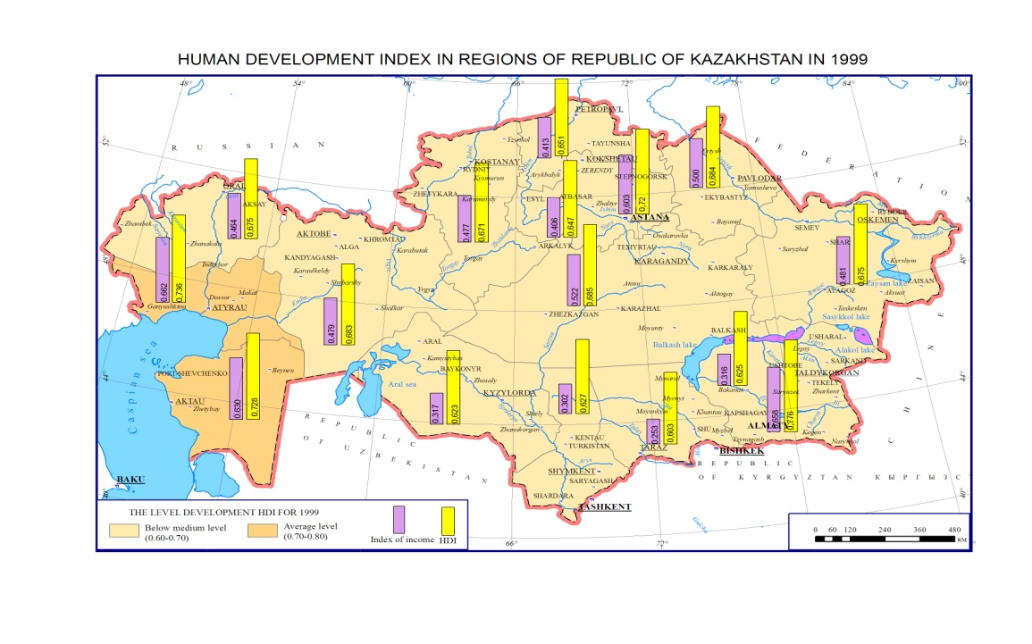
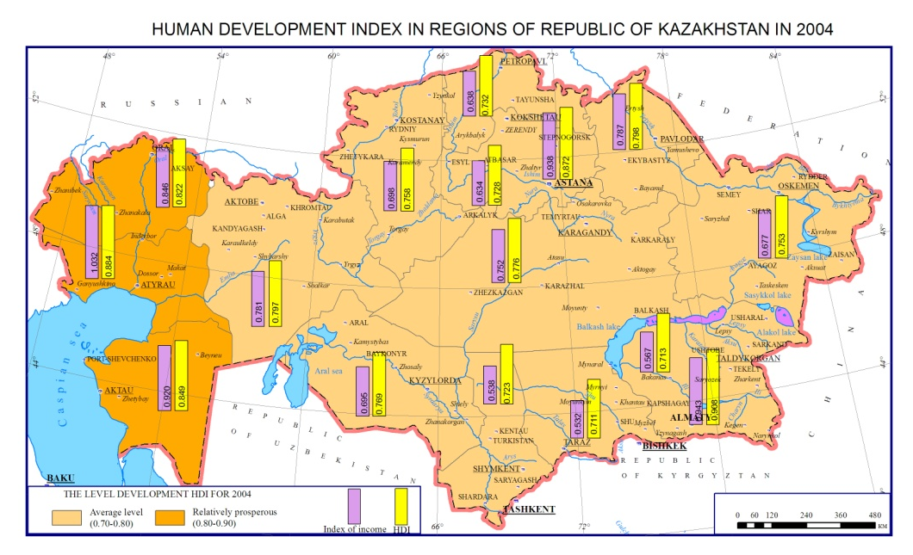

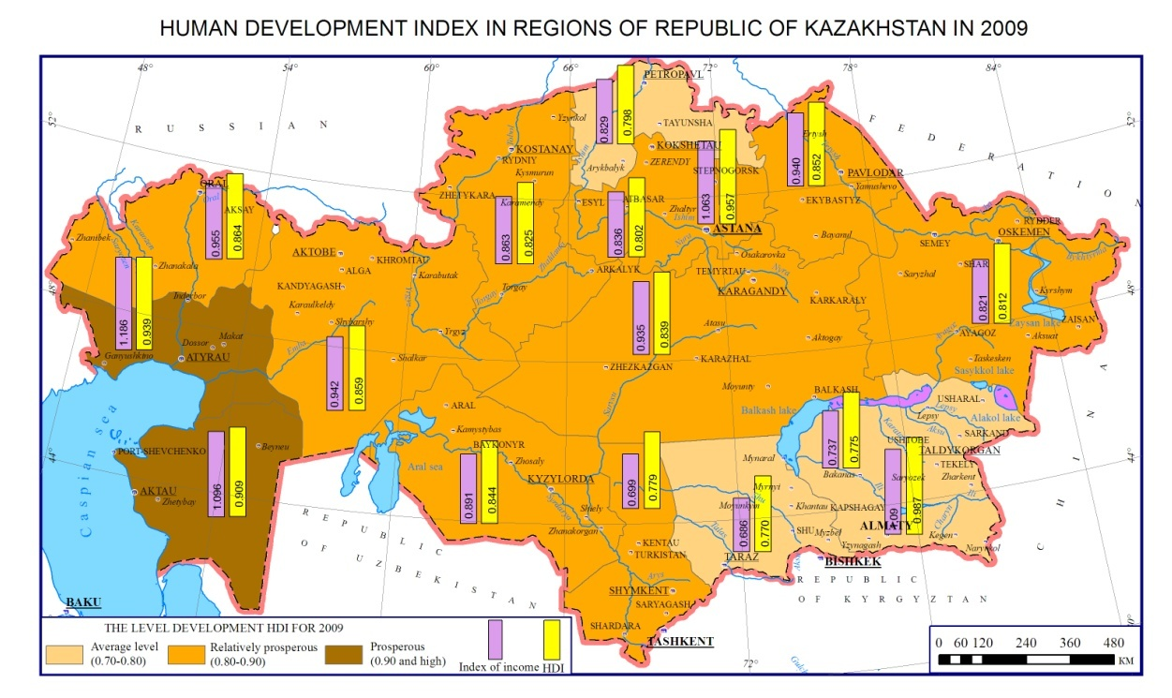

Table 1. HDI indicators and indices of revenue by regions of the Republic of Kazakhstan, for 1999-2009

Region | HDI |  |  | Index of income
 | 1999 | 2004 | 2009 | 1999 | 2004 | 2009
Akmola | 0.647 | 0.728 | 0.802 | 0.406 | 0.634 | 0.836
Aktobe | 0.683 | 0.797 | 0.859 | 0.479 | 0.781 | 0.942
Almaty | 0.625 | 0.713 | 0.775 | 0.316 | 0.567 | 0.737
Atyrau | 0.736 | 0.884 | 0.939 | 0.662 | 1.032 | 1.186
East Kazakhstan | 0.675 | 0.753 | 0.812 | 0.481 | 0.677 | 0.821
Karagandy | 0.685 | 0.776 | 0.839 | 0.522 | 0.752 | 0.935
Kostanay | 0.671 | 0.758 | 0.825 | 0.477 | 0.698 | 0.863
Kyzylorda | 0.623 | 0.769 | 0.844 | 0.317 | 0.695 | 0.891
Mangystau | 0.728 | 0.849 | 0.909 | 0.630 | 0.920 | 1.096
North Kazakhstan | 0.651 | 0.732 | 0.798 | 0.413 | 0.638 | 0.829
Pavlodar | 0.684 | 0.798 | 0.852 | 0.500 | 0.787 | 0.940
South Kazakhstan | 0.627 | 0.723 | 0.779 | 0.302 | 0.538 | 0.699
West Kazakhstan | 0.675 | 0.822 | 0.864 | 0.464 | 0.846 | 0.955
Zhambyl | 0.603 | 0.711 | 0.770 | 0.253 | 0.532 | 0.686

Source: Calculated and formed by Agency of Statistics of the Republic of Kazakhstan

The level of life expectancy with an index of longevity 0.70-0.80 (type average level) is 80% of the total population of the republic, while the indices of income and education of the vast majority of regions belong to the levels of prosperous, that is, with an index of more than 0.90.The typology (Table 2, 3) helps to formulate strategic mission priorities in the limited human resources: to ‘pull’ the weakest regions, financing least prosperous regions, or allocate resources more equitably, ensuring thus noticeable increase in human development level in less critical regions where the depth of problem is not so significant. It seems that the second way is more efficient in terms of raising the level of human development.

Table 2. Type of regions by human development level and index of income of Kazakhstan in 2009

Тype of regions | Number of regions
 | HDI | Index of life expectancy | Index of income | Index of education
Below medium level (0.60-0.70) | - | 2 | 2 | -
Average level (0.70-0.80) | 4 | 13 | 1 | -
Relatively-prosperous (0.80-0.90) | 8 | 1 | 5 | 7
Prosperous (0.90 and high) | 2 | - | 6 | 9

Source: Formed by the authors

Тable 3. The main indicators of socio-economic development and index of human development by regions of Kazakhstan in 1999-2009

Regions | Life expectancy |  | Literacy rate |  | Income per capita |  | Index of longevity
 | 1999 | 2009 | 1999 | 2009 | 1999 | 2009 | 1999 | 2009
Kazakhstan | 65.63 | 68.60 | 99.4 | 99.6 | 886.9 | 6,893.9 | 0.677 | 0.726
Akmola | 64.38 | 66.21 | 99.4 | 99.6 | 647.4 | 4,700.7 | 0.656 | 0.687
Aktobe | 65.25 | 68.21 | 99.6 | 99.8 | 907.3 | 7,643.5 | 0.671 | 0.720
Almaty | 66.74 | 68.57 | 99.7 | 99.5 | 428.5 | 2,973.5 | 0.696 | 0.726
Almaty city | 67.98 | 72.24 | 99.8 | 99.8 | 2,071.5 | 15,159.2 | 0.716 | 0.787
Astana city | 67.60 | 75.74 | 99.7 | 99.7 | 1,606.6 | 13,383.7 | 0.715 | 0.846
Atyrau | 63.86 | 68.21 | 99.5 | 99.7 | 2,109.5 | 23,572.8 | 0.648 | 0.720
East Kazakhstan | 64.93 | 67.22 | 99.5 | 99.5 | 916.8 | 4,386.4 | 0.666 | 0.704
Karagandy | 63.90 | 66.87 | 99.5 | 99.5 | 1,105.1 | 7,399.3 | 0.648 | 0.698
Kazakhstan | 65.63 | 68.60 | 99.4 | 99.6 | 886.9 | 6,893.9 | 0.677 | 0.726
Kostanay | 64.99 | 67.75 | 99.5 | 99.6 | 898.5 | 5,321.1 | 0.667 | 0.713
Kyzylorda | 65.43 | 67.45 | 99.6 | 99.5 | 430.7 | 6,061.2 | 0.674 | 0.708
Mangystau | 64.35 | 68.33 | 99.7 | 99.6 | 1,821.2 | 15,588.4 | 0.656 | 0.722
North Kazakhstan | 65.14 | 67.32 | 99.3 | 99.2 | 668.6 | 4,539.5 | 0.669 | 0.705
Pavlodar | 65.14 | 67.95 | 99.4 | 99.4 | 998.5 | 7,584.4 | 0.669 | 0.716
South Kazakhstan | 67.13 | 69.49 | 99.8 | 99.9 | 401.5 | 2,494.6 | 0.702 | 0.742
West Kazakhstan | 65.23 | 68.61 | 99.4 | 99.4 | 847.4 | 8,136.7 | 0.671 | 0.727

Table 3 continuation

Regions | Index of education |  | Index of income |  | HDI
 | 1999 | 2009 | 1999 | 2009 | 1999 | 2009
Kazakhstan | 0.883 | 0.911 | 0.474 | 0.919 | 0.678 | 0.852
Akmola | 0.878 | 0.883 | 0.406 | 0.836 | 0.647 | 0.802
Aktobe | 0.899 | 0.914 | 0.479 | 0.942 | 0.683 | 0.859
Almaty | 0.864 | 0.863 | 0.316 | 0.737 | 0.625 | 0.775
Almaty city | 0.954 | 1.084 | 0.658 | 1.090 | 0.776 | 0.987
Astana city | 0.848 | 0.962 | 0.603 | 1.063 | 0.725 | 0.957
Atyrau | 0.898 | 0.911 | 0.662 | 1.186 | 0.736 | 0.939
East Kazakhstan | 0.878 | 0.911 | 0.481 | 0.821 | 0.675 | 0.812
Karagandy | 0.884 | 0.883 | 0.522 | 0.935 | 0.685 | 0.839
Kazakhstan | 0.883 | 0.911 | 0.474 | 0.919 | 0.678 | 0.852
Kostanay | 0.870 | 0.898 | 0.477 | 0.863 | 0.671 | 0.825
Kyzylorda | 0.879 | 0.933 | 0.317 | 0.891 | 0.623 | 0.844
Mangystau | 0.899 | 0.908 | 0.630 | 1.096 | 0.728 | 0.909
North Kazakhstan | 0.872 | 0.862 | 0.413 | 0.829 | 0.651 | 0.798
Pavlodar | 0.882 | 0.899 | 0.500 | 0.940 | 0.684 | 0.852
South Kazakhstan | 0.877 | 0.895 | 0.302 | 0.699 | 0.627 | 0.779
West Kazakhstan | 0.891 | 0.909 | 0.464 | 0.955 | 0.675 | 0.864

Source: Agency of Statistics of the Republic of Kazakhstan, Human Development Report 1999-2010 - published for the United Nations Development Programme (UNDP), New York, USA

Kazakhstan requires a national strategy for the development of human capacity for managing regional differences of conditions and factors of socio-economic development. Mechanisms that are suitable for some regions may be insufficient and even inefficient for others. We can identify priority areas for socio-demographic policy: targeting social protection, employment growth, increasing real incomes, reducing mortality and increasing life expectancy, increasing the birth rate and natural population growth. All these will help to improve the level and quality of life in the ‘depressed’ regions.

CONCLUSIONS

Summarizing the results of the study, it is possible to identify the following. The spatial analysis and estimation of human development in the context of the national population policy have shown regional differences in the indicators that determine human development in the country and the lag of the demographic processes’rates in comparison withthe rates of socio-economic processes.
Territorial differences in geo-demographic processes are fixed across the whole country. The regions with the positive dynamics of the natural reproduction of the population are primarily the regions of Southern Kazakhstan. While in other parts, especially in East Kazakhstan there isa demographically complicated situation.
Indicators of reproductive population of the republic, such as fertility, mortality and natural increase in 1991 were exceeded only in 2009 with the beginning of transformation processes of the former Soviet Union and the return of some ethnic groups to their historical homeland in Kazakhstan; a negative migration balance, not only completely absorbed the natural increase of population, but also exceeded it by more than two times. It is especially worth noting that in the external migration the republic lost the most qualified personnel, which could not but affect the quality of human potential. Under modern conditions of economic modernization in Kazakhstan, the ultimate objectives of socio-demographic development should be the increase in the level and quality of life and socio-economic development of all areas of the country. It is necessary to study the processes, using the integration capabilities and sociologic traditional economic geography, which is of great importance for further development of the theory and practice.
An analysis of socio-demographic processes as the foundation of human development must be conducted at a more detailed local (municipal) level. It is impossible to pursue social and demographic policies without taking into account regional aspects. Therefore, the database must be created with the use of GIS for the whole territory of Kazakhstan to monitor and manage human development
While working at and implementing state purpose-oriented programmes for improvement the level of human development, it is necessary to make a complex analysis of regional differentiation of social and demographic processes in the republic.

REFERENCES

Agency of Statistics of Republic of Kazakhstan, www.stat.gov.kz
Nyussupova G.N. (2010). Rol' social'no-demograficheskih pokazatelej v ocenke urovnja chelovecheskogo potenciala RK, Vestnik KazNTU–Habarshi. Serija estestvenno-geograficheskaja, 4(26): 54-58.
Rodionova I. and Gordeeva F. (2010). Human development index and informatisation of society in CIS, Bulletin of Geography Socio-Economic series. Poland 13: 79-87.
Tokmagambetova R.U. (2010). Migracionnye processy v Respublike Kazahstan, Vestnik KazNTU-Habarshi. Serija estestvenno-geograficheskaja, 6(28): 33-41.
UNDP Report Beyond transition towards inclusive societies. 2011 (UNDP) Bratislava, ISBN: 978-92- 95092-31-0.

CORRESPONDENCE TO:

Gulnara Nyussupova
Al-Farabi Kazakh National University
Faculty of Geography and Environmental Science
Department of Geography, Land Management and Cadastre
Al-FarabiAv. 71, 050040, Almaty, Kazakhstan
[e-mail: gulnaran@mail.ru]
Tel.:+7 701 349 20 53

Aisulu Kalimurzina
Al-Farabi Kazakh National University
Faculty of Geography and Environmental Science
Department of Geography, Land Management and Cadastre
Al-Farabi Av. 71, 050040, Almaty, Kazakhstan
[e-mail:kaisl23@mail.ru]
Tel.:+7 702 672 77 03

