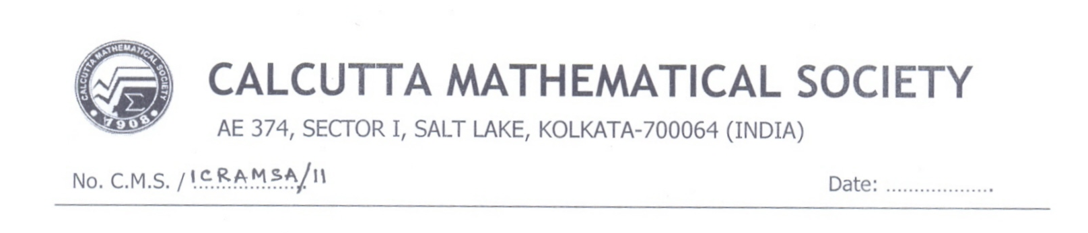

To

Dr. Simon Serovajsky
al-Farabi Kazakh National University, Kazakhstan

Dear Professor

We are glad to inform you that your paper "WEAK APPROXIMATE SOLUTION OF THE OPTIMIZATION PROBLEM FOR A NONLINEAR ELLIPTIC EQUATION WITHOUT CONVEXITY OF THE ADMISSIBLE CONTROL SET" has been accepted for oral presentation in the International Conference on Recent Advances in Mathematical Sciences and Applications (ICRAMSA-2011) organized by Calcutta Mathematical Society to be held during December 09-11, 2011 in the society campus. It is our pleasure to invite you to participate and to deliver the lecture. The local hospitality (accommodation and meals) will be provided during the conference days. You will be accommodated in the hotel “Ashirbad Inn” located at BC-74, Rabindra Pally, Kestopur, West Bengal, India.

With Best Regards,
