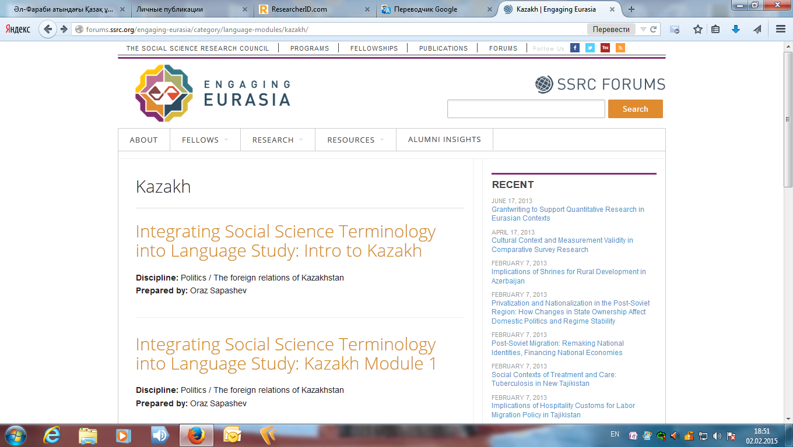
http://forums.ssrc.org/engaging-eurasia/category/language-modules/kazakh/

