Yerekesheva Laura. Youth of Central Asia: Challenges for Peacebuilding: a comprehensive research review. Paris: UNESCO, 2021. (December 2021). 165 p. Аналитический доклад ЮНЕСКО (на англ. и рус. языках)

Youth of Central Asia, challenges for peacebuilding: a comprehensive research review
Corporate author: UNESCO [61646]
Person as author: Yerekesheva, Laura [author] [2]
ISBN: 978-92-3-100497-1
Collation: 165 pages
Language: English
Year of publication: 2021
Licence type: CC BY-SA 3.0 IGO [9676]
Type of document: book

https://unesdoc.unesco.org/ark:/48223/pf0000380326.locale=en

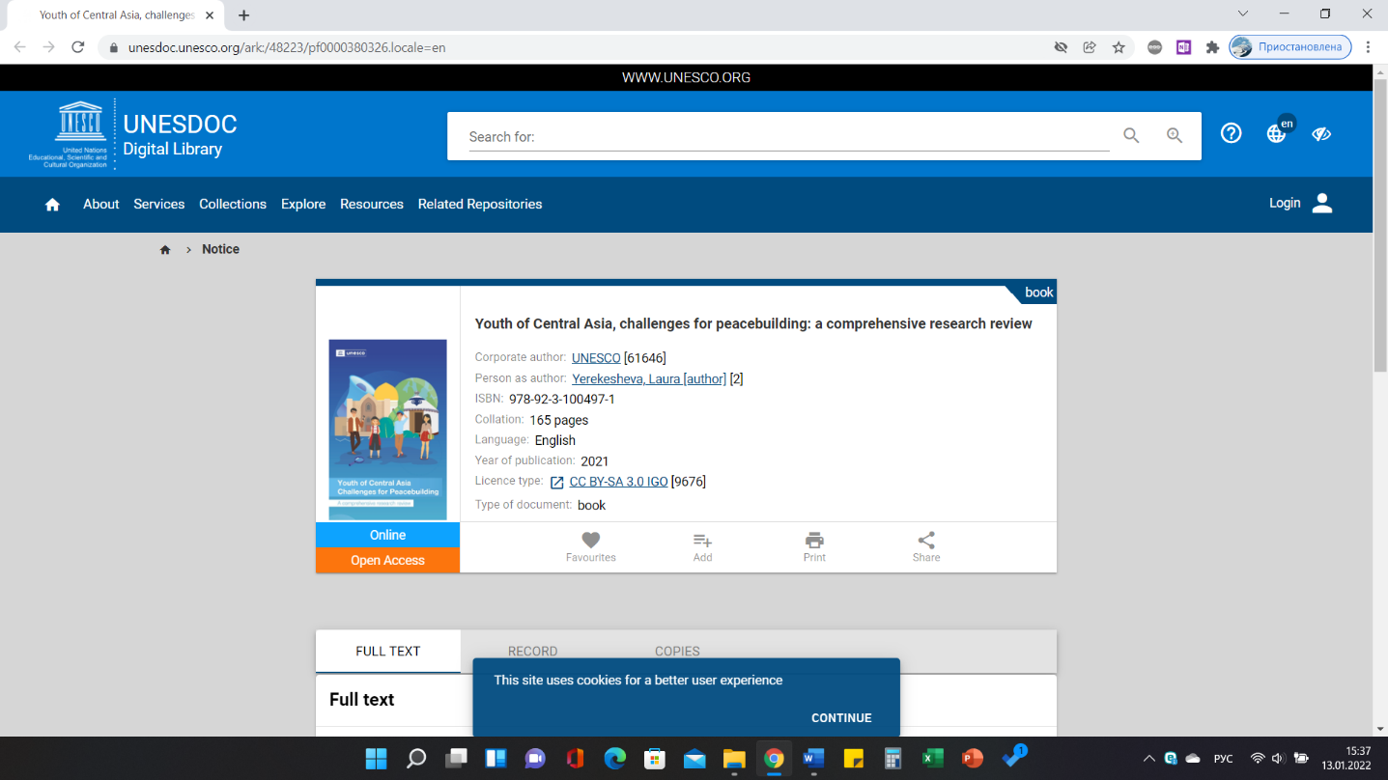
Abstract: The UNESCO Report comprehensively looks at the youth-related challenges for peacebuilding and development in 4 countries of the region (Kazakhstan, Kyrgyzstan, Tajikistan, Uzbekistan). Based on the methodologically defined structural themes, it offers a detailed overview of each of them: (1) formal education, vocational training and skills development; (2) employment engagemen, young people not in education, employment and training (NEET), migration, inclusion, gender, entrepreneurship; (3) religion, preventing violent extremism, intercultural dialogue.
https://www.researchgate.net/publication/357797279_Youth_of_Central_Asia_Challenges_for_Peacebuilding_A_Comprehensive_Research_Review

