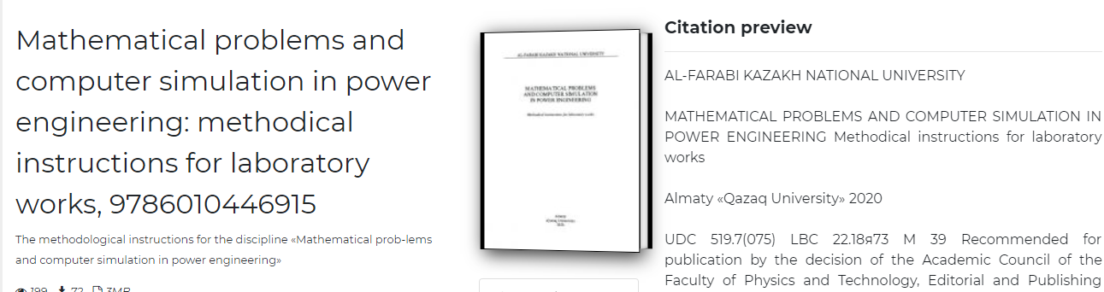
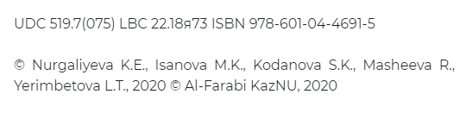
https://dokumen.pub/mathematical-problems-and-computer-simulation-in-power-engineering-methodical-instructions-for-laboratory-works-9786010446915.html

