Significant parameters of the keystroke for the formation of the input field of a convolutional neural network
Ivan Dychka¹[0000-0002-3446-3076], Ihor Tereikovskyi¹[0000-0003-4621-9668], Liudmyla Tereikovska²[0000-0002-8830-0790], Anna Korchenko³[0000-0003-3376-0631] and Volodymyr Pogorelov³[0000-0002-6100-1504]
¹ National Technical University of Ukraine "Igor Sikorsky Kyiv Polytechnic Institute", Kyiv, Ukraine
² Kyiv National University of Construction and Architecture, Kyiv, Ukraine
³ National Aviation University, Kyiv, Ukraine
dychka@scs.ntu-kpi.kiev.ua, terejkowski@ukr.net,
tereikovskal@ukr.net, annakor@ukr.net, volodymyr.pogorelov@gmail.com,
Abstract. The article deals with improvement of personality and emotion recognizers based on the keystroke pattern. The article shows that improvement of those recognizers can be implemented using neural network solutions. Based on the analysis of literature sources, we have determined the potential of using convolutional neural networks. The difficulties of using such networks are largely related to justification of a keystroke parameter list, whereby the input field of the convolutional neural network is determined. We suggest determining the said list with respect to feasibility of using the keystroke parameters that have a positive impact on efficiency of the neural network model. In addition, we assume that for admissible resource intensity the efficiency can be assessed experimentally using indices such as recognition accuracy or training and validation sample losses. The experiments allowed plotting the values of efficiency indices versus the number of training iterations for different options of keystroke parameters. The experimental results have shown that, for an input field formed using one keystroke parameter, the highest recognition accuracy is demonstrated by a convolutional neural network with the input field formed using the key hold time. At the same time, the combination of this parameter with other parameters does not result in any significant positive changes. We have justified the need for further research on improvement of keystroke parameters preprocessing procedures in order to increase their informational value. We have also determined that it is necessary to develop a method for determining the architectural parameters of a convolutional neural network designed to recognize the user personality and emotions based on their keystroke.
Keywords: keystroke recognition, keystroke parameters, recognition accuracy, convolutional neural network, input field.
- Introduction
In the modern context, ever-growing use of biometrics analysis tools is a significant trend in developing the technologies of covert user monitoring in different-purpose information systems [10, 19, 20]. These technologies are successfully used in on-line monitoring of emotional state of the staff operating critical infrastructure facilities, in automatic check of learning content perception by students of distance learning systems, as well as in bank information system to prevent fraud in borrowing loans [2, 5, 6, 7]. Most of the mentioned tools are based on analysis of behavioural biometrics. With regard to the difficulty of forgery, inalienability from the user personality, possibility to register parameters using only standard peripheral equipment, as well as extensive use of password and process data in the form of a character set in information systems, the keystroke-based covert monitoring tools are the most promising ones. It should be noted that the term keystroke (KS) is used to refer to a biometric behavioural personality characteristic that determines the peculiarities of keyboard typing [3, 10, 12]. The specific feature of KS analysis is the need to analyse big multidimensional data, which considerably impairs the efficiency of statistic models traditionally used in monitoring tools. Therefore, improvement of the said tools over the last few years was attributed to the use of neural network models due to the fact that they are well-proven in solving similar tasks [8, 9]. Although a considerable number of researches deals with development of neural network tools for KS analysis, the practical experience and the results of works [11, 13, 19] indicate that it is necessary to further improve them, which determines the relevance of research in this field.
- Analysis of literature sources in the field of research
The analysis of research and practice works [14-17] reveals that main effort in the field of developing the neural network tools for KS analysis are aimed at improving the efficiency of the said tools due to adaptation of the view and the design parameters of neural network models to the set problem statement. For example, neural network tools for KS recognition based on classical neural networks in the form of a two-layer perceptron, PNN, Hopfield network, Kohonen topographic map, and a radial basis function network have been developed in the relatively early research works [4, 10, 11]. It should be noted that classical neural networks have not been widely spread, because limited capabilities of their architecture prevent reaching the acceptable recognition accuracy. More advanced works [21] are influenced by new theoretical advances in the field of neural networks. For example, works [12, 22] suggest performing the KS analysis using a modern recurrent neural network of LSTM type. The suggestion is based on the proved LSTM ability to efficiently analyse textual information with an unlimited number of characters. In the meantime, it is indicated that the suggested solution is limited due to the fact that the LSTM network design is associated with complexity of training sample formation. More promising suggestions are proposed in works [18, 22]. In these works, KS analysis is implemented using a convolutional neural network (CNN) designed in a similar manner to the model of visual image recognition by animals. Even use of early CNN modifications allowed achieving the KS-based user recognition accuracy at a level of 93-94 %. Similar results have been obtained in work [8]. Here, KS analysis was performed using a LeNet CNN in order to improve stability of user password protection. It should be noted that the CNN input was KS time parameters. Article [14] also deals with solving the task of improving neural network systems for KS analysis by employing modern CNN types. It has been established that the difficulties in solving this task are related to the fact that KS parameters must be transformed into a form suitable to be input into the CNN. A transformation procedure has been proposed based on presentation of KS parameters of fixed-size input text as a square multichannel image. Each encrypted character in the text is attributed to an individual image point and described by a corresponding ASCII code and KS parameters such as key hold time (KHT) and time between key presses (TBKP). In addition, the abscissa of an encrypted character corresponds to the position of this character in the text. The ordinate corresponds to the position of the previous text character on the keyboard. If the number of text characters exceeds the number of characters on the keyboard, the image is complemented with rows corresponding to the space character from the top along the axis of ordinates in order to preserve its square shape. If, in contrast, the number of text characters is less than the number of characters on the keyboard, the image is complemented with columns of space characters from the right in order to preserve the shape. The suggested transformation procedure is illustrated in Fig. 1, which presents the fragmentary mapping of text “HEY THERE” encrypted using KHT. Each image point corresponding to the encrypted value of a text character in Fig. 1 is described by two digits recorded in the corresponding cell. The first digit is the ASCII code of an input character, while the second digit is the KHT. For example, the “Y” character corresponds to the image point at the intersection of the third column and the sixth row. The corresponding cell contains values 121 (ASCII code) and 51 (KHT). It has been shown by experiments that use of the suggested procedure provided the error of user emotion and personality recognition at the level of the best modern KS analysis systems. Thus, the analysis of literature sources demonstrates that CNN are currently the most advanced type of neural network models in terms of KS recognition. Notably, in most of the sources analysed, the input field of a CNN was formed using processed time parameters of KS that include: KHT, TBKP, and the ratio of these parameters (PR). In addition, the values of key hold time dynamics (KHTD) and dynamics of time between key presses (TBKPD) can be used. These parameters are calculated using the following equations:
$τ_{r}\left(i\right)=t_{u}\left(i\right)−t_{d}\left(i\right)$, (1)
$τ_{b}\left(i,i−1\right)=t_{u}\left(i\right)−t_{d}\left(i−1\right)$, (2)
$q_{\text{br}}\left(i,i−1\right)=\frac{τ_{b}\left(i,i−1\right)}{τ_{r}\left(i\right)}$, (3)
$v_{r}\left(i,i−1\right)=\frac{τ_{r}\left(i\right)−τ_{r}\left(i−1\right)}{τ_{r}\left(i\right)}$, (4)
$v_{b}\left(i,i−1\right)=\frac{τ_{b}\left(i\right)−τ_{b}\left(i−1\right)}{τ_{b}\left(i\right)}$, (5)
where $τ_{r}$ is KHT, $t_{d}$, $t_{u}$ is time of key press and release, $τ_{b}$ is TBKP, $i$ is the number of key use when typing the text, $q_{\text{br}}$ is PR, $v_{r}$, $v_{b}$ are KHTD and TBKPD.
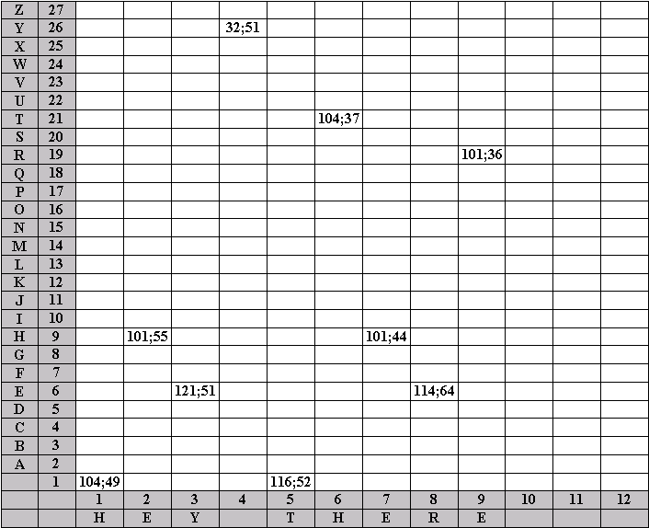
Fig. 1 Mapping of encrypted text “HEY THERE”
It is also arguable that feasibility of using certain KS parameters in CNN-based KS analysis tools is not sufficiently justified. At the same time, theoretical studies in the field of neural networks show that accuracy and resource intensity of a network largely depend on the list of parameters analysed. For example, use of minor parameters can considerably reduce the recognition accuracy due to the noise component introduced into the input data stream. On the other hand, failure to use significant parameters leads to the similar negative result. Therefore, the objective of this work is to determine the keystroke parameters used in formation of the input field of a convolutional neural network designed to recognize the user personality.
- Research environment
Similarly to the data in [1, 2, 5, 9], determination of the CNN input parameters was based on the hypothesis on feasibility of using the KS parameters that have positive impact on efficiency of the neural network model. It has also been assumed that for admissible recourse intensity the efficiency can be assessed using indices such as recognition accuracy (Accuracy), as well as training and validation sample losses (Loss). The values of these indices have been calculated as follows:
$\text{Accuracy}=\frac{N_{\text{right}}}{N}×\text{100}\text{\%}$ , (6)
$\text{Loss}=\frac{1}{N}\sum_{t=1}^{N}{e^{T}\left(t,Q\right)} W\left(θ\right) e\left(t,Q\right)$, (7)
where N_{right} is the number of correctly recognized examples, N is the total number of examples, e(t, Q₎ is n_{y}-by-1 error vector at a given time t, parametrized by the parameter vector Q, n_{y} is the number of neural network outputs, W(Q) is the weighting matrix, specified as a positive semidefinite matrix.
Impact of the used KS parameters on efficiency was assessed experimentally, because neural network theory does not provide a corresponding analytic solution. Based on the results of [21], a CNN of SqueezeNet type was used in the experiments. Its main advantages include small memory footprint, high recognition speed, availability of a pretrained model, possibility of implementation using proved tools, and sufficient recognition accuracy. The SqueezeNet model adapted to the task of recognizing personalities of 10 users based on their KS has been implemented using the application package MATLAB R2018b. The structural chart of SqueezeNet visualized using MATLAB tools is shown in Fig. 2.
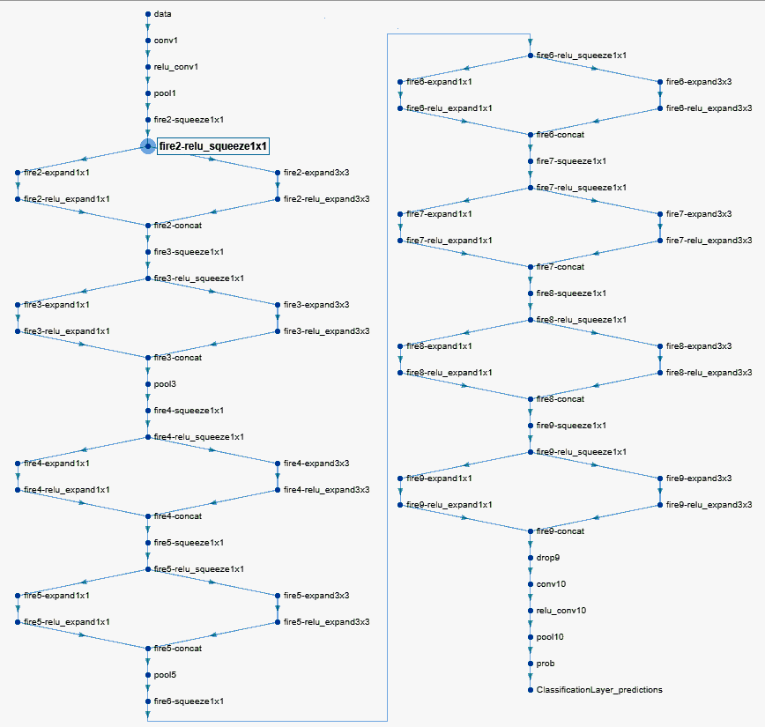
Fig. 2 Structure of the convolutional neural network of SqueezeNet type
The experiments were conducted on a personal computer with CPU Intel Core i7-8700 (3.2 - 4.6 GHz), 16 GB RAM, graphics card nVidia GeForce GTX 1660Ti, under operating system Microsoft Windows 10.
- Experiments and discussion of the results
Following the first set of experiments, values of the efficiency indices have been plotted against the number of training stages for each individual KS parameter (KHT, TBKP, KHTD, TBKPD). For example, Figs. 3 and 4 show plots of these dependencies based on training and validation data for KHT and TBKP. In order to improve clearness of the results obtained for the training sample, smoothed values were calculated for the accuracy index (Accuracy_smoothed) and the loss index (Loss_smoothed), with their respective plots also shown in Fig. 3 and Fig. 4.

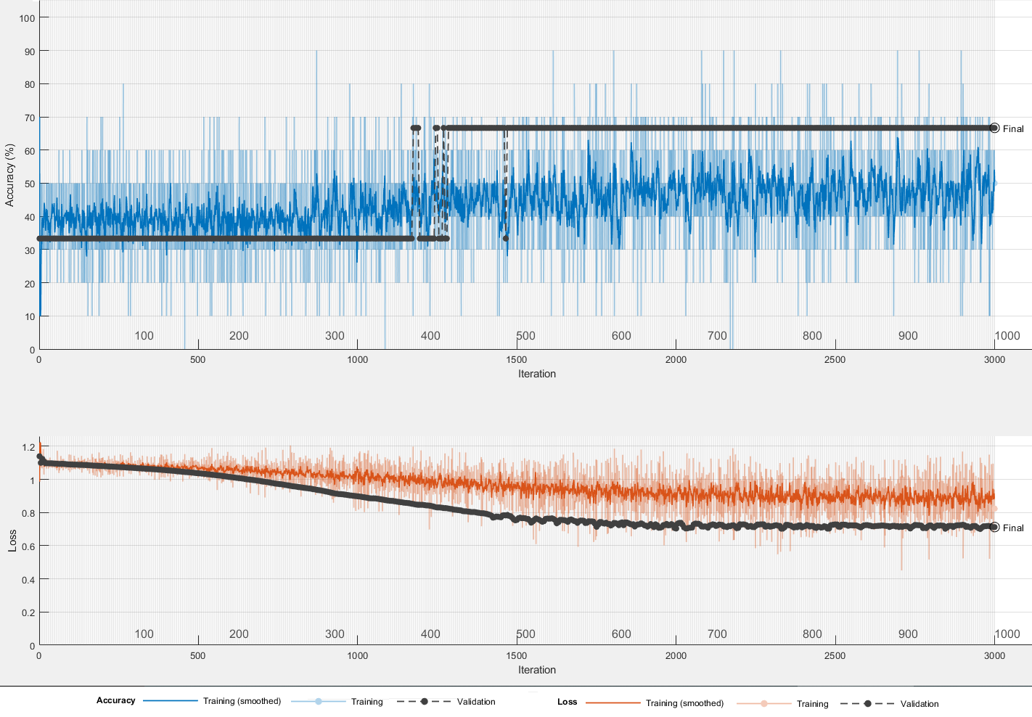
Fig. 3 Plot of recognition accuracy and loss against number of training iterations when using KHT

According to the recommendations of [20-22], the training process lasted 1,000 stages. However, the experiments have shown that the efficiency indices stabilize after 400-500 learning stages, which is demonstrated by plots in Fig. 3 and Fig. 4. Therefore, part of the experiments was limited to 500 stages in order to speed up the research. Since the CNN input field can be presented as a multichannel raster image, the second part of the experiments dealt with different options of simultaneous use of several KS parameters combined. For example, Fig. 5 shows plots of efficiency indices for the combination of two parameters (KHT and KHTD) at 500 training stages.
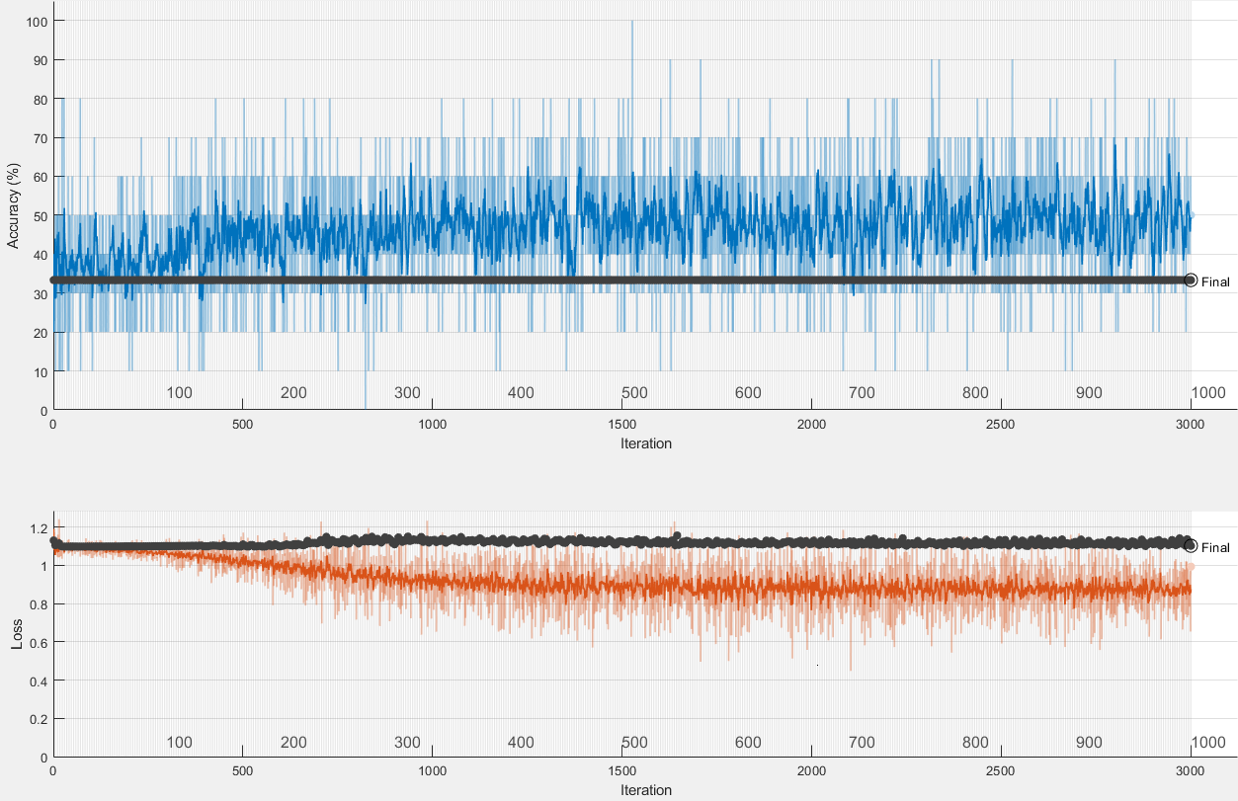
Fig. 4 Plot of recognition accuracy and loss against number of training stages when using TBKP

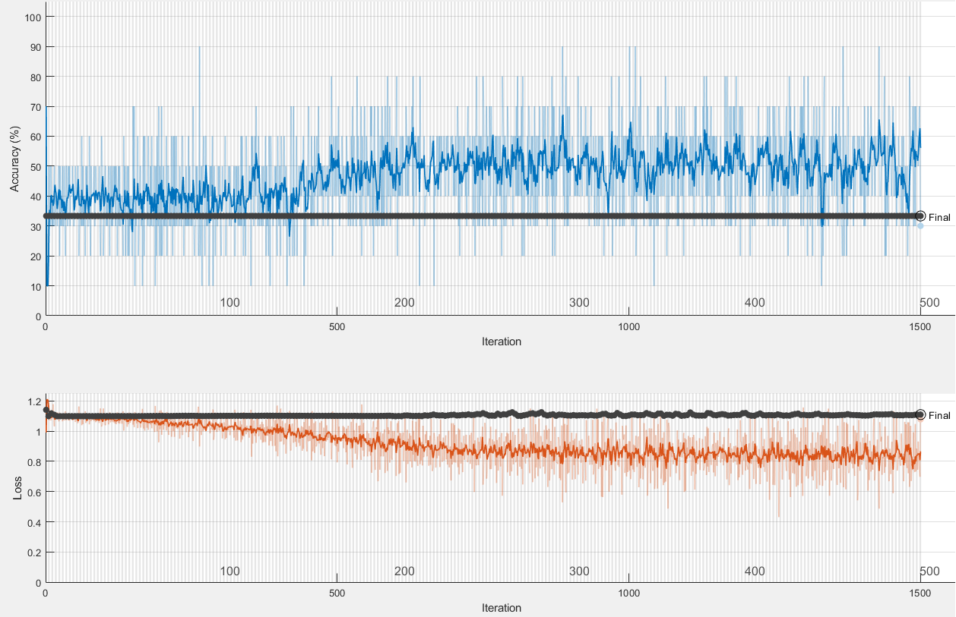
Fig. 5 Plot of recognition accuracy and loss against number of training stages when using KHT and KHTD
Key results of the experiments are summarized in Table 1, which shows the efficiency indices of a neural network model when using different KS parameters.
Table 1. Values of efficiency indices for different KS parameters
Parameters used | Training sample accuracy (%) | Validation sample accuracy (%) | Training sample loss (%) | Validation sample loss (%)
KHT | 71 | 67 | 0.76 | 0.76
TBKP | 70 | 33 | 1.01 | 1.17
TBKP, KHTD | 40 | 33 | 0.78 | 1.18
TBKPD | 50 | 32 | 0.83 | 0.84
PR | 67 | 33 | 0.95 | 4.5
KHT, KHTD | 68 | 53 | 0.67 | 1.16
KHT, TBKPD | 71 | 66 | 0.8 | 0.8
TBKP, KHTD | 70 | 34 | 1 | 1.17
KHT, TBKP, KHTD | 70 | 35 | 0.68 | 1.17

According to the analysis of data presented in Table 1, if the input field is formed using one KS parameter, the highest recognition accuracy is demonstrated by the CNN with the input field formed based on KHT. At the same time, the combination of this parameter with other parameters does not result in any significant positive changes. It should be noted that the result obtained is consistent with the findings of work [10], in which KS was analysed using a fairly simple probabilistic neural network, and is somewhat in contrast to the findings of work [19], in which KS was analysed using a bimodal statistical model after complex preprocessing. This demonstrates the need for further research on improvement of KS parameters preprocessing procedures in order to increase their informational value. In addition, developing a method for determination of architectural parameters of a CNN designed for KS analysis is of interest.
- Conclusion
It has been demonstrated that improvement of mathematical support of tools for user personality and emotions recognition based on keystroke through the use of neural network solutions is an important direction for the development of such tools. Based on the analysis of literature sources, we have determined the potential of using convolutional neural networks. The difficulties of using such networks are largely related to justification of a keystroke parameter list, whereby the input field of the convolutional neural network is determined. We suggest determining the said list with respect to feasibility of using the keystroke parameters that have a positive impact on efficiency of the neural network model. In addition, we assume that for admissible resource intensity the efficiency can be assessed experimentally using indices such as recognition accuracy or training and validation sample losses. The experiments allowed plotting the values of efficiency indices versus the number of training iterations for different options of keystroke parameters. The experimental results have shown that, for an input field formed using one keystroke parameter, the highest recognition accuracy is demonstrated by a convolutional neural network with the input field formed using the key hold time. At the same time, the combination of this parameter with other parameters does not result in any significant positive changes. We have justified the need for further research on improvement of keystroke parameters preprocessing procedures in order to increase their informational value. It is also necessary to develop a method for determining the architectural parameters of a convolutional neural network designed to recognize the user personality and emotions based on their keystroke.

References
- Aitchanov, B., Korchenko, A., Tereykovskiy, I., Bapiyev, I. Perspectives for using classical neural network models and methods of counteracting attacks on network resources of information systems. (2017). // News of the national academy of sciences of the republic of Kazakhstan series of geology and technical sciences. Volume 5, Number 425 (2017), 202 – 212.
- Akhmetov B., Tereykovsky I., Doszhanova A., Tereykovskaya L. (2018) Determination of input parameters of the neural network model, intended for phoneme recognition of a voice signal in the systems of distance learning. International Journal of Electronics and Telecommunications. Vol 64, No 4 (2018), pp. 425-432.
- Akhmetov, B., Lakhno, V., Malyukov, V., Sarsimbayeva, S., Zhumadilova, M., Kartbayev, T. Decision support system about investments in smart сity in conditions of incomplete information, (2019) International Journal of Civil Engineering and Technology, 10 (2), pp. 661-670.
- Akhmetov, B., Lakhno, V., Akhmetov, B., Alimseitova, Z. Development of sectoral intellectualized expert systems and decision making support systems in cybersecurity, (2019) Advances in Intelligent Systems and Computing, 860, pp. 162-171.
- Alghamdi S. J., Elrefaei L. A. Dynamic user verification using touch keystroke based on medians vector proximity. In Computational Intelligence, Communication Systems and Networks (CICSyN), 2015 7th International Conference on, pages 121–126. IEEE, 2015.
- Dychka, I., Tereikovskyi, I., Tereikovska, L., Pogorelov, V., Mussiraliyeva, S. Deobfuscation of computer virus malware code with value state dependence graph // Advances in Intelligent Systems and Computing. 2018. Volume 754, pp. 370-379.
- Gnatyuk S., Critical Aviation Information Systems Cybersecurity, Meeting Security Challenges Through Data Analytics and Decision Support, NATO Science for Peace and Security Series, D: Information and Communication Security. - IOS Press Ebooks, Vol.47, №3, рр. 308-316, 2016.
- S. Gnatyuk, V. Sydorenko, M. Aleksander, Unified data model for defining state critical information infrastructure in civil aviation, Proceedings of the 2018 IEEE 9th International Conference on Dependable Systems, Services and Technologies (DESSERT), Kyiv, Ukraine, May 24-27, 2018, pp. 37-42.
- Hayreddin Ç., Shambhu U. Sensitivity analysis in keystroke dynamics using convolutional neural networks 2017 IEEE Workshop on Information Forensics and Security (WIFS) 4-7 Dec. 2017 Page(s): 1-6.
- Hu, Z., Tereykovskiy, I., Zorin, Y., Tereykovska, L., Zhibek, A. Optimization of convolutional neural network structure for biometric authentication by face geometry // Advances in Intelligent Systems and Computing. 2018. Volume 754, pp 567-577.
- Jyoti Malik,Dhiraj Girdhar,Ratna Dahiya,G. Sainarayanan,"Reference Threshold Calculation for Biometric Authentication", IJIGSP, vol.6, no.2, pp.46-53, 2014.
- Kobojek P., Saeed K., Application of Recurrent Neural Networks for User Verification based on Keystroke Dynamics Journal of telecommunication and information technology, N3 2016 pp. 80-90.
- Lakhno, V.A., Tretynyk, V.V. Information technologies for maintaining of management activity of universities, (2019) Advances in Intelligent Systems and Computing, 754, pp. 663-672.
- Liu, M., Guan, J. User keystroke authentication based on convolutional neural network , Communications in Computer and Information Science 2019, 971, pp. 157-168.
- Lin, C.-H., Liu, J.-C., Lee, K.-Y. On neural networks for biometric authentication based on keystroke dynamics. Sensors and Materials 2018 30(3), pp. 385-396.
- Oyebade K. Oyedotun, Kamil Dimililer,"Pattern Recognition: Invariance Learning in Convolutional Auto Encoder Network", International Journal of Image, Graphics and Signal Processing (IJIGSP), Vol.8, No.3, pp.19-27, 2016.
- Saket M., Soumyajit G., Vikram P., Deep Secure: A Fast and Simple Neural Network based approach for User Authentication and Identification via Keystroke Dynamics Conference: IWAISe, International Joint Conference on Artificial Intelligence (IJCAI) - 2017At: Melbourne, Australia pp. 34-40.
- Sassi A., Ouarda W., Amar C., Miguet S., "Sky-CNN: A CNN-based Learning Approach for Skyline Scene Understanding", International Journal of Intelligent Systems and Applications (IJISA), Vol.11, No.4, pp.14-25, 2019.
- Savinov, A.N. Matematicheskaya model mehanizma raspoznavaniya klaviaturnogo pocherka na osnove Gaussovskogo raspredeleniya / A.N. Savinov, I.G. Sidorkina // Izvestiya Kabardino-Balkarskogo nauchnogo centra RAN. Vyp. I. - Nalchik: Kabardino-Balkarskij nauchnyj centr RAN, 2013. - S. 26-32.
- Tereikovskyi I, Chernyshev D., Tereikovska L.A., Mussiraliyeva S, Akhmed G. The Procedure for the Determination of Structural Parameters of a Convolutional Neural Network to Fingerprint Recognition. Journal of Theoretical and Applied Information Technology, No 8, Volume 97, 2019, pp. 2381-2392.
- Yunbin Deng and Yu Zhong Keystroke Dynamics Advances for Mobile Devices Using Deep Neural Network GCSR Vol. 2, pp. 59-70, 2015.
- Xiaofeng, L., Shengfei, Z., Shengwei, Y. Continuous authentication by free-text keystroke based on CNN plus RNN Procedia Computer Science 147, pp. 314-318, 2019.

