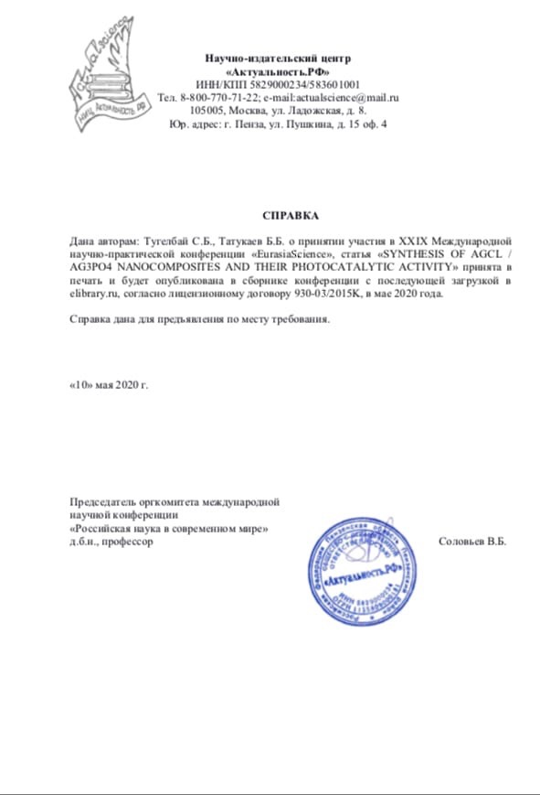

SYNTHESIS OF AgCl / Ag₃PO₄ NANOCOMPOSITES AND THEIR PHOTOCATALYTIC ACTIVITY.
Tugelbay S.B., Tatykayev B.B.
Kazakh National University, Almaty, Kazakhstan
t.sapar96@mail.ru
Nanocomposites AgCl / Ag3PO4 were obtained by mechanochemical method and was determined the optimal state of mechanical activation. The characteristics of the obtained nanocomposite were determined using the XRD, SEM, SF-56 method. Their photocatalytic activity was evaluated in accordance with the methylene blue under ultraviolet light.
Key words: silver halides, silver chloride, Mechanochemistry, mechanochemical activation, nanoparticle, nanocomposites, photocatalytic activity.
In the last decade, silver halide nanocomposites have been widely used in many industries, including chemical technology, medicine, and electronics. An urgent problem is the identification of new methods for the synthesis of silver halide nanoparticles and the growth of their production. In this paper, we propose a new method for synthesizing AgCl / Ag3PO4 nanocomposites by mechanical activation. The method is used in the solid phase of sodium chloride, phosphate and silver nitrate. In addition, the work is based on the simplest ion exchange reaction between reagents and the photosensitivity of silver chloride. Silver chloride is easily broken down by ultraviolet rays (382 nm-241 nm).
This work also provides for the possibility of further development of the mechanical method proposed by McCormick, obtaining highly specialized products.
Objective, synthesis of AgCl / Ag3PO4 nanocomposites with high photocatalytic activity by mechanical activation and evaluation of their photocatalytic activity. Assessment of the decomposition activity of methylene blue photocatalysts AgCl / Ag3PO4 under sunlight (light intensity 15 mW / cm2)
In mechanical synthesis, the agglomeration process always interferes with the synthesis of nanoparticles. Agglomeration is an alternative way to reduce the surface energy of nanoparticles. Agglomeration also occurs at low temperatures and can be irreversible. If agglomerates are formed during the synthesis of small particles, their backscattering is difficult. Therefore, it is very important to synthesize nanoparticles in conditions that prevent agglomeration. This work has found a solution to this problem. A diluent is added to prevent agglomeration.
For the synthesis of AgCl / Ag3PO4 nanocomposites in the process of mechanical activation, a planetary ball mill"Activator-2SL" and a SF - 56 (spectrophotometer) were used to check the photocatalytic activity. The following physical and chemical methods were used to determine the phase composition and morphology of synthesized nanocomposites: dynamic light scattering analysis (DRS), x-ray phase analysis (XRF), differential scanning calorimetry (DSC), and scanning electron microscopy (SEM).
Used for the experiment: AgNO3 (XT), NaNO3 (XT), NaCl (XT), Na3PO4 (XT), H2O (distilled water), methylene gas.The relations of AgCl / Ag3PO4 photocatalysts are obtained in the following sequence:
1) 1:0 2) 0.75:0.25 3) 0.5:0.5 4) 0.25:0.75 5) 0:1
The mechanochemical activity of the systems listed below is performed by the McCormick method. Reaction equations for mechanochemical synthesis of AgCl / Ag3PO4 nanocomposites:
1) AgNO₃ + 5 NaNO₃ A
2) хNaCl + уNa₃PO₄ + 3NaNO₃ В
3) А+В C C – target product.
The MA process is performed in the following case: rotation speed = 3000 rpm, ball-sample ratio = 1: 20, synthesis duration = 10-20 min.
To remove the non-target product in the powder, the reaction was washed with distilled water and ethanol. It is very important to study the photocatalytic properties of synthesized nanoparticles to make sure that the synthesized nanoparticles are a photocatalyst.
A solution of methylene blue 0.1 g / l was obtained as an organic pollutant. 40 ml of methylene blue solution and 20 mg of nanoparticles are placed in a 50 ml glass. The process began with stirring in a magnetic stirrer. For better mixing with the solution of nanoparticles, 60 minutes were mixed in a Packed form with foil paper. After that, the process was performed under ultraviolet radiation. A sample was taken every 15 minutes. The experiment was conducted before the organic dye was discolored.
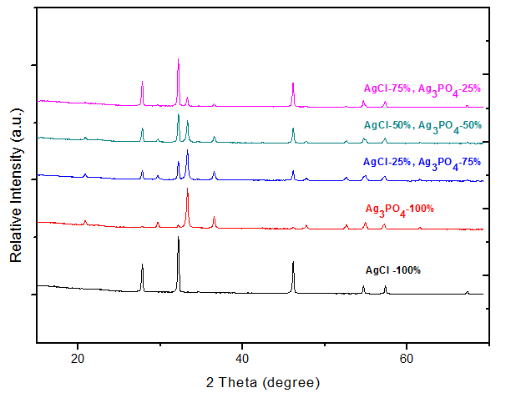
Fig. 1. X-ray image of all nanopowders
It is clearly visible here that all photocatalysts were purely synthesized. The figure shows one hundred percent silver chloride and silver phosphate. And then their composites are 75%, 50%, 25%.

Fig. 2. Nanoparticles of AgCl / Ag₃PO₄ 75:25 images on a scanning electron microscopy (SEM).

The above picture clearly can see that it is not 100% silver chloride or silver (I) orthophosphate. Here it is another compound or composite.

Fig. 3. Photocatalytic degradation profiles of MB over AgCl, Ag₃PO₄and
AgCl/Ag₃PO₄ catalysts under visible light irradiation.
References:
Zhang Ch., Liu Q., Zhan N., Yang Q., Song Y., Sun L., Wang H., Li Y. A novel approach to prepare silver chloride nanoparticles grown on the surface of PAN nanofibre via electrospinning combined with gas-solid reaction //Colloids and Surfaces A: Physicochemical and Engineering Aspects. – 2010. – Vol. 353, № 1. - P.64-68.
Yingying L., Yi D. Porous AgCl/Ag nanocomposites with enhanced visible light photocatalytic properties // The Journal of Physical Chemistry C. - 2010. -Vol.114, № 7. – P. 3175-3179
Naik K., Kowshik M. 2014. Anti-biofilm efficacy of low temperature processed AgCl-TiO2 nanocomposite coating // Materials Science and Engineering C. – 2014. – Vol. 34, № 1. P. 62-68.
Sun L., Zhang R., Wang Y., Chen W. Plasmonic Ag@AgCl nanotubes fabricated from copper nanowires as high-performance visible light photocatalyst //ACS Applied Materials & Interfaces. – 2014. - Vol. 6, № 17. - P. 14819-14826.

Анкета участника конференции

1 | Фамилия, имя, отчество автора (ов) | Тугелбай Сапарбек Батырбекулы
2 | Название статьи и количество страниц | SYNTHESIS OF AgCl / Ag3PO4 NANOCOMPOSITES AND THEIR PHOTOCATALYTIC ACTIVITY.  Количество страниц – 3.
3 | Название конференции и секции | XXIX Международная научно-практическая телеконференция  «Eurasiascience»,  СЕКЦИЯ 06. Химические науки.
4 | Место работы или учебы (полное название учреждения, без сокращений), | Казахский Национальный Университет
5 | Должность, ученая степень, звание | PhD докторант 1-го курса
6 | E-mail | t.sapar96@mail.ru
7 | Телефон для контактов | +77073990498
9 | Необходим ли сборник в печатном виде?  (1 экз. 350 руб, с доставкой за пределы России 1000 руб.) | Нет
10 | Нужна ли справка, о факте принятия материалов к печати  (да/ нет) | Да
11 | Необходим ли диплом участника конференции (в электронном виде)  (да/ нет) (100 руб.) | Да

