**Financial-Lending Stimulation of the Development of the Agro-Industrial Complex in Kazakhstan and in the Russian Federation**

doi: [https://doi.org/10.14505//jarle.v9.6(36).18](https://doi.org/10.14505/jarle.v9.6(36).18).

<https://journals.aserspublishing.eu/jarle> на журнал

<https://journals.aserspublishing.eu/jarle/article/view/3969> на статью

* **Kazila Erikenovich KUBAYEV**Al-Farabi Kazakh National University, Almaty, Kazakhstan
* **Karlygash Sovetovna BAISHOLANOVA**Al-Farabi Kazakh National University, Almaty, Kazakhstan
* **Gulnara Toktarovna SEITOVA**Kostanay State University A. Baitursynov, Kostanay, Kazakhstan
* **Alexandra TARASOVA**Altai State University, Barnaul, Russian Federation
* **Olga A. MISHCHENKO**Altai State University, Barnaul, Russian Federation

**DOI:**[https://doi.org/10.14505//jarle.v9.6(36).18](https://doi.org/10.14505/jarle.v9.6(36).18)

**Abstract**

This paper examines a set of measures for enhancing the financial-lending mechanism of government regulation and support of the agro-industrial complex (AIC) as part of the implementation of the Government Program for the Development of the Agro-Industrial Complex in Kazakhstan for the Period 2017–2021 and Russia’s Government Program for the Development of Agriculture and Regulation of Markets for Agricultural Produce, Raw Materials, and Food for the Period 2013–2020. The authors have analyzed the volumes of investment and subsidies directed at carrying into effect a set of activities on stimulating investment activity in the AIC. The paper brings forward a set of ways to enhance the mechanism of funding agricultural entities for the purpose of boosting the efficiency of agricultural production in the country.

**References**

[1] Bedelbayeva, A.E., Lukhmanova, G.K. 2016. Trends and problems of biofuel market development in Kazakhstan. Materials Science Forum, 870, 683–687.  
[2] Demishkevich, G., Petrov, A., Botasheva, L. 2018. Activation of investment attraction in the dairy sub-complex of the agro-industrial complex on the basis of public-private partnership. In MATEC Web of Conferences, 212.  
[3] Gerbens-Leenes, W., Nonhebel, S. 2005. Food and land use. The influence of consumption patterns on the use of agricultural resources. Appetite, 45, 24–31.   
[4] Government of the Republic of Kazakhstan. 2013. Programma po razvitiyu agropromyshlennogo kompleksa v Respublike Kazakhstan na 2013–2020 gody “Agrobiznes-2020” [The ‘Agrobiznes-2020’ Program for the Development of the Agro-Industrial Complex in the Republic of Kazakhstan for the Period 2013–2020]. http://ru.government.kz/ru/programmy/2246-proekt-razvitiya-eksportnogo-potentsiala-myasa-krupnogo-rogatogo-skota.html   
[5] Kubayev, K.E. 2018. The Process of Fund-Saving In the Theory of Innovative Economy [Special issue]. The Journal of Social Sciences Research, 3, 149-156.  
[6] Lukhmanova, G.K., Sakibaeva, K.S., Seisekenova, M.B., Kuralbayeva, R.E., Orysbayeva, M.S. 2018. Improving the competitiveness of crop production in the Republic of Kazakhstan [Special issue]. The Journal of Social Sciences Research, 3, 178–181.   
[7] Ministry of Agriculture of the Republic of Kazakhstan. 2018. Gosudarstvennaya programma razvitiya agropromyshlennogo kompleksa Respubliki Kazakhstan na 2017–2021 gody [Government Program for the Development of the Agro-Industrial Complex in the Republic of Kazakhstan for the Period 2017–2021]. https://moa.gov.kz/documents/1538732758.pdf  
[8] Ministry of Agriculture of the Russian Federation. 2018. Natsional'nyi doklad “O khode i rezul'tatakh realizatsii v 2017 godu Gosudarstvennoi programmy razvitiya sel'skogo khozyaistva i regulirovaniya rynkov sel'skokhozyaistvennoi produktsii, syr'ya i prodovol'stviya na 2013–2020 gody” [The national report ‘On the 2017 Progress and Outcomes of the Implementation of the Government Program for the Development of Agriculture and Regulation of Markets for Agricultural Produce, Raw Materials, and Food for the Period 2013–2020’]. https://bit.ly/2Hdu4XK   
[9] Zaitenova, N.K., Baibulekova, L.A. 2016. Evaluation of Influence of Macroeconomic Shocks on the Banking Sector of Kazakhstan. International Journal of Economics and Financial Issues, 6(S2), 188-194.

[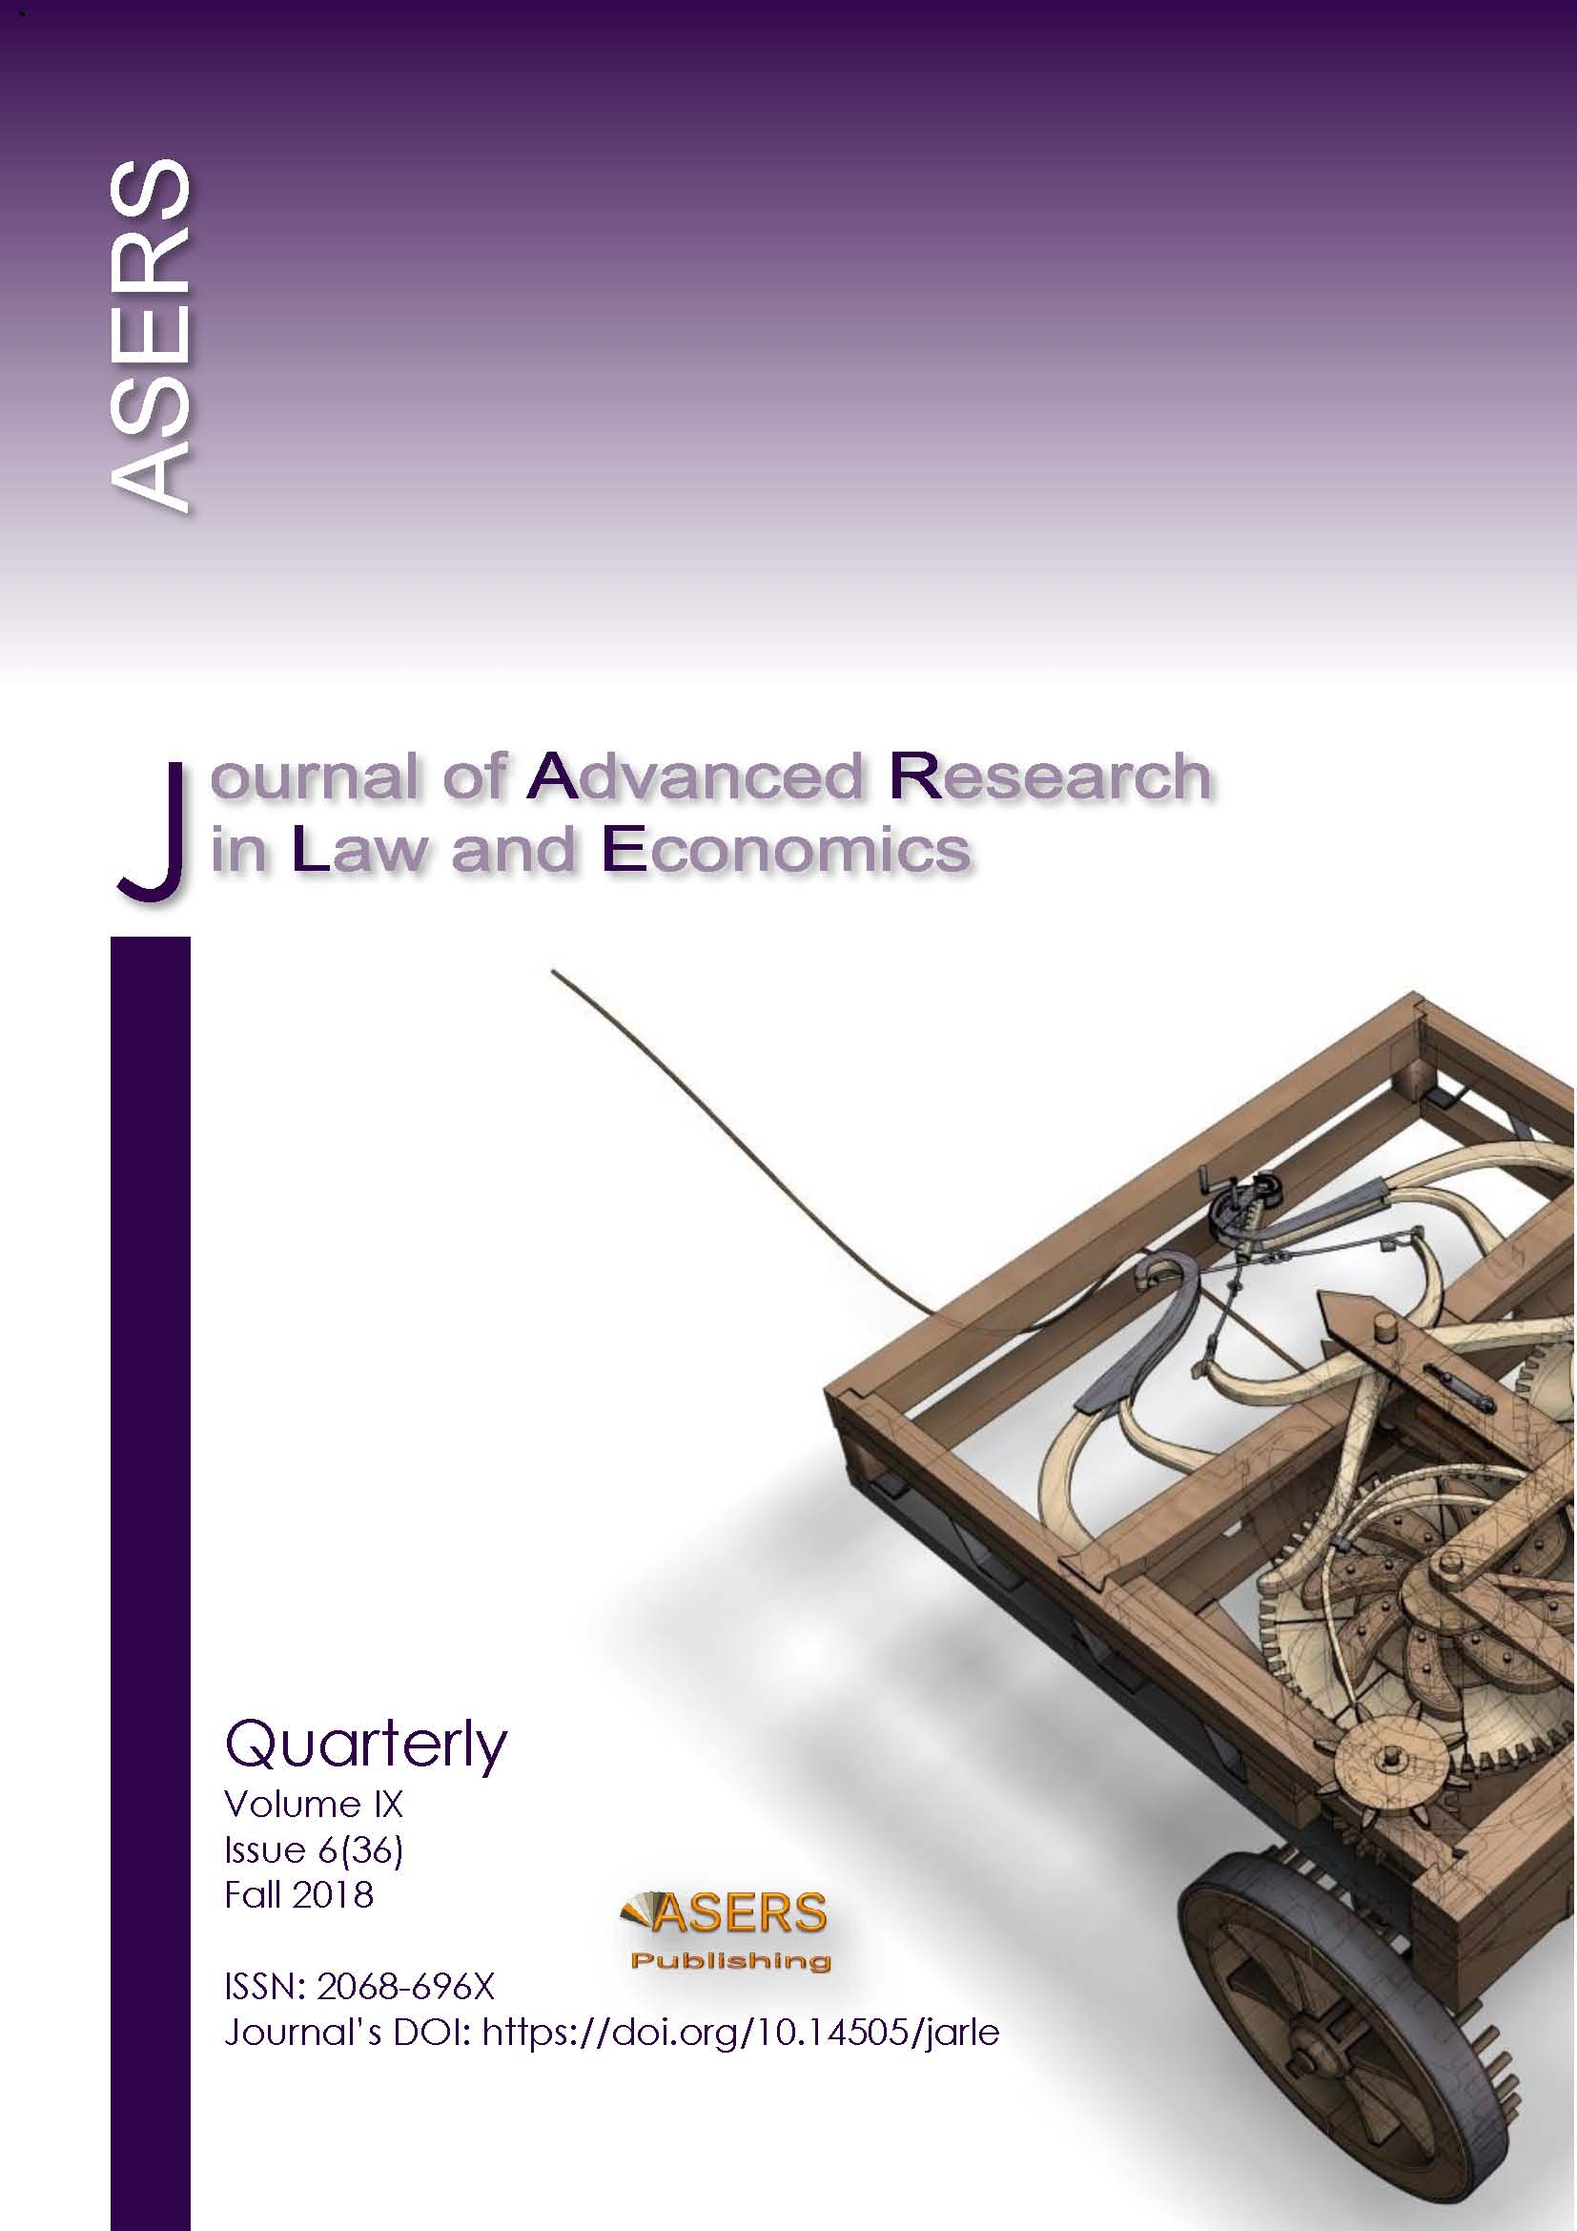](https://journals.aserspublishing.eu/jarle/issue/view/173)

* [Requires Subscriptionpdf](https://journals.aserspublishing.eu/jarle/article/view/3969)

Published

2019-10-30

How to Cite

KUBAYEV, Kazila Erikenovich et al. Financial-Lending Stimulation of the Development of the Agro-Industrial Complex in Kazakhstan and in the Russian Federation. **Journal of Advanced Research in Law and Economics**, [S.l.], v. 9, n. 6, p. 2042-2046, oct. 2019. ISSN 2068-696X. Available at: <<https://journals.aserspublishing.eu/jarle/article/view/3969>>. Date accessed: 17 nov. 2019. doi: [https://doi.org/10.14505//jarle.v9.6(36).18](https://doi.org/10.14505/jarle.v9.6(36).18).

Citation Formats

* [ABNT](https://journals.aserspublishing.eu/jarle/article/cite/3969/AbntCitationPlugin)
* [APA](https://journals.aserspublishing.eu/jarle/article/cite/3969/ApaCitationPlugin)
* [BibTeX](https://journals.aserspublishing.eu/jarle/article/cite/3969/BibtexCitationPlugin)
* [CBE](https://journals.aserspublishing.eu/jarle/article/cite/3969/CbeCitationPlugin)
* [EndNote - EndNote format (Macintosh & Windows)](https://journals.aserspublishing.eu/jarle/article/cite/3969/EndNoteCitationPlugin)
* [MLA](https://journals.aserspublishing.eu/jarle/article/cite/3969/MlaCitationPlugin)
* [ProCite - RIS format (Macintosh & Windows)](https://journals.aserspublishing.eu/jarle/article/cite/3969/ProCiteCitationPlugin)
* [RefWorks](https://journals.aserspublishing.eu/jarle/article/cite/3969/RefWorksCitationPlugin)
* [Reference Manager - RIS format (Windows only)](https://journals.aserspublishing.eu/jarle/article/cite/3969/RefManCitationPlugin)
* [Turabian](https://journals.aserspublishing.eu/jarle/article/cite/3969/TurabianCitationPlugin)

Issue

[Vol 9 No 6 (2018): JARLE Volume IX Issue 6(36) Fall 2018](https://journals.aserspublishing.eu/jarle/issue/view/173)

published by The Publisher, or is with drawn by the author(s) before acceptance by the Publisher.