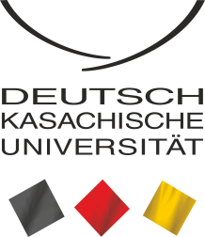

____________________________________________________
DKU International Conference
'Transformations in Central Asia since 1991'
24-26 April 2019
______________________________________________

Conference venue:

Conference room at Grand Tien Shan Hotel
Bogenbay batyr Str. 115
050000 Almaty, Kazakhstan

Kazakh-German University
Pushkin Str. 111
050010 Almaty, Kazakhstan

Dear Conference Participants,
Welcome to the XV International Conference hosted by Kazakh-German University in Almaty. The conference was made possible thanks to generous support by Konrad Adenauer Foundation in Kazakhstan. This year’s conference is dedicated to the process of transformation in Central Asia since 1991. By selecting this topic we acknowledge the need of critical evaluation of the transformation processes that took place in the region since independence. More than two decades have passed since the collapse of the Soviet Union. For the societies of Central Asia this time period has signified profound changes of their political, economic, social and cultural structures.

Over the past few years a significant body of literature has emerged trying to evaluate the scale of changes in the region using different theoretical perspectives. On base of this literature it can be stated that transformation processes in the countries of Central Asia have so far proceeded in a differentiated way, from as little changes as in Turkmenistan, whose political leadership continues to isolate society from the outside world, to more profound transformations such as for example, in Kazakhstan, which has noticeably surpassed its Central Asian neighbors with regard to the development of a market economy and social reforms such as education.

Taking into account the particular importance of the transformation processes that have covered the region of Central Asia since 1991, and to meet the growing interest in the transformation processes in the region among scientists and practitioners from business and politics, the German-Kazakh University with support of the Konrad Adenauer Foundation is organizing this international conference. The aim of the conference is to evaluate and compare the processes of transformation in the countries of Central Asia since the collapse of the Soviet Union. This not only includes describing the historical transformations, but also analyzing the current dynamics of transformation and assessing future perspectives and goals.

Panel Speakers

Dr. Andrea Schmitz

Dr. Andrea Schmitz is researcher at the Foundation for Science and Politics in Berlin, Germany. Dr. Schmitz has published extensively on politics in Central Asia. Her research interests include regime change in Central Asia, EU foreign policy, political Islam, and resource management.

Dr. Dina Sharipova

Dr. Sharipova is associate professor at the Nazarbaev University. She obtained her PhD degree in political science from Indiana University Bloomington. Dr. Sharipova has published on state- and national building in Central Asia. She recently published a book on ‘State-Building in Kazakhstan: Continuity and Transformation of Informal Institutions’ with Lexington Books Publishing.

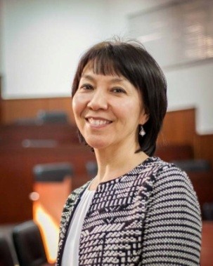

Dr. Azamat Junisbai
Dr. Azamat Junisbai is associate professor at the Pitzer College in US and is now invited professor at the Kazakh National University named after Al-Farabi. Dr. Junisbai has published extensively on attitudinal change, trust toward political institutions, and democratic values in Central Asia, particularly so in Kyrgyzstan and Kazakhstan.
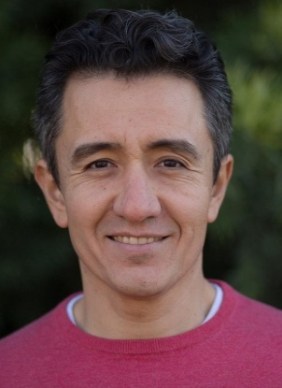

Dr. Vadim Volovoj

Dr. Vadim Volovoj is associate professor at the Mikolas Romeris University in Vilnjus. He published on Central Asian politics in academic journals as well as for Eurasia.net, Sputnik.ru. His research fields include foreign and security policy in Central Asia.

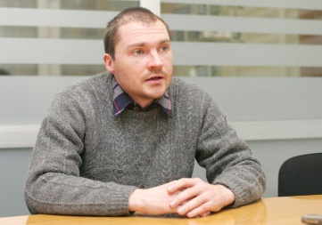

Dr. Dossym Satpayev (tbc)

Dr. Dossym Satpayev is prominent political analyst, founder and head of the NGO “Risks Assessment Group - Kazakhstan”, in additiojn, he is co-founder of the Alliance of Analytical Organizations of Kazakhstan and founder of the private cultural and educational fund "Soz"

Dr. Thomas Helm

Dr. Thomas Helm is Resident Representative of the Konrad Adenauer Foundation in Kazakhstan. He was in a leadership of a global public relations firm Ketchum and has worked for CDU/CSU fractions in German Bundestag for 11 years.

Program Overview

Day 1: Wednesday, April 24
Conference Venue: Grand Tien-Shan Hotel,

13:00 – 14:00 Registration, coffee-break and networking
14:00 – 14:30 Opening and Welcoming the Conference Participants moderated by Dr.
Serik Beimenbetov, DKU:

- Mr. Jörn Rosenberg, German Consulate General in Almaty
- Mr. Prof. Dr. Laszlo Ungvari, DKU
- Mr. Thomas Helm, Konrad Adenauer Foundation in Kazakhstan

14:30 – 16:00 Keynote speeches moderated by Prof. Dr. Irina Chernykh, DKU:

- Dr. Andrea Schmitz
- Dr. Vadim Volovoj
- Dr. Dina Sharipova
- Dr. Azamat Junisbai
- Dr. Dossym Satpayev (tbc)

16:00 – 16:30 Coffee-break

16:30 – 18:00 Panel Discussion with the keynote speakers moderated by Prof. Dr.
Irina Chernykh, DKU

18:00 – 19:30 Dinner

Day 2: Thursday, April 25
Conference Venue: DKU, Pushkin Str. 111/113

09:30 – 10:00 Registration

10:00 – 12:00 Session I

POL 01: Regional security in Central Asia (Room NN)
Moderator: Dr. Sebastian Mayer

- Aben Dauren, Regional Security in Central Asia: Addressing Existing and Potential Threats and Challenges
- Kydykov Azizbek, Development of international transport corridors in Central Asia
- Zhelobov Dmitry & Anikhenimu Mumin, Risks of the implementation of the Silk Road Economic Belt initiative in Central Asia

LAW 01: Legal transformation in Central Asia (Room NN)
Moderator: NN

- Sanabayeva Diana, The problems of definition of the notion ‘terrorism’
- Sayapin Sergey, Central Asia and International Law
- Shaimerdenova A. & Glushan L., Transformation of land relations under the influence of market conditions in Kazakhstan

ECON 01: Economic transformations in Central Asia (Room NN)
Moderator: NN

- Yesufbekov Karim, Market reforms and economic development in the countries of Central Asia
- Enikeeva Zalina, Central Asia and the influence of the development of continental transport and trade on agriculture in the region since independence
- Mirzomustaqimova Firuza, Enhancement of CA transport routes: an approach to boost trade in the region
- Kegenbekov Zhandos, Development of a master program for resource-efficient production logistics: opportunities and difficulties

SOC 01: Society of Central Asia in transformation (Room NN)
Moderator: NN

- Prilutskaya Xenia, Juggling risk: lay perceptions of ecological and health risks in post-Soviet mono-industrial Temirtau
- Rodionov Adil & Medeuov Darkhan & Zhaksylyk Sabitov & Rodionova Kamila & Meritocracy, Matthew Effect of Social Capital? Evidence from the state research grant program of Kazakhstan
- Ten Alexander, The Sociolinguistic Regime in Kazakhstan: A Sociology of Knowledge Approach to Discourse Analysis
- Rakhmatullaeva Nilufar, Central Asian Studies as an Independent Field in Regional Studies

EDU 01: Transformation of education in Central Asia
Moderator: NN

- Borisova Nina, Problems and tendencies in the development of education since 1991
- Belokon Pavel & Mukhtarbekova Rasita, Information systems in the formation of curricula based on state education standards
- Abdygapparova Saule & Sarenova Aigul, Enhancement of qualification of teaching staff as the basis for education quality improvement
- Bachurka Mariya, Axiological aspect of pedagogical discourse as one of the main components influencing the quality of educational process
- Sailaubekov Nurlan & Mynzhanova Gulzhakan, A complex method for assessing university rankings by labor motivation of faculty

12:00-13:00 Lunch
13.00-15.00 Session II
ECON 02: New developments in energy and environmental sector in Central Asia (Room NN)
Moderator: Dr. Aliya Mussina

- Kerimova Zhansaya & Akhapov Erlan, Environmental policy of Almaty city government in the field of transport and logistics
- Zeinolla Saule & Tleppaev Arsen, Rating assessment of projects in energy efficiency
- Aiyupova Zarina, Influence of design - thinking on the effectiveness of the company
- Malabayev Salamat, Corruption as main cause of weakened sovereignty and power change

POL 02: Regional cooperation in Central Asia (Room NN)
Moderator: NN

- Beimenbetov Serik & Mayer Sebastian, Regional (Non-) Integration in Central Asia: Models, Trajectories, Limitations
- Nurpeisova L. & Nurpeisova N., Development trends of the political and economic situation in the countries of Central Asia
- Nurseit Nurlan, Regional cooperation in Central Asia: state and perspectives
- Ordabayev Asset, BRI and SINO-Russian Relations in Central Asia

ECON 03: Digital transformation in Central Asia (Room NN)
Moderator: NN

- Askarov Dauren, Political economy of digitalization in Kazakhstan
- Naribayev Marat & Abdurashitov I., Trends and problems of digital transformation of economic actors in the context of globalization
- Kabakanova Yuliya & Pershina Irina, Use of digital technologies in higher education
- Nakispekov A. & Imasheva B., Transition from an object-relational database management system to a column management system for storing and processing business information

SOC 02: Gender and migration in Central Asia (Room NN)
Moderator: NN

- Abdullaeva Madina, Compatriots abroad: why states of Central Asia need them?
- Abzhapparova Aigul, Problems of student migration in Kazakhstan
- Baskynbayeva Nazym, Transformation of the image of a woman in modern Kazakhstan: a socio-cultural analysis
- Kassymova Didar, Chechen women in a non-Chechen society

15:00-15:30 Coffee break

15:30-16:30 Session III
POL 03: Foreign policy and security in Central Asia (Room NN)
Moderator: Dr. Sebastian Mayer

- Fominykh Alexei, American public diplomacy in Soviet Kazakhstan: Photography in the USA exhibition (Alma-Ata, 1976) in documents and memories
- Melich Jiri, Modernization in Kazakhstan and Its Constraining Political Administrative Aspects
- Muzykina Elena, Transformation of state policy toward religious affairs in Central Asia: Kazakhstan as case study
- Kislova Alla, Soft power of the USA and Russia in Kyrgyzstan

ECON 03: New economic trends in Central Asia (Room NN)
Moderator: NN

- Assylbekova Bayan, Ranking of intellectual capital components according to investment attractiveness
- Asylbekov Amanbai, Predictors of Kazakhstan Stock Exchange Development
- Bodo Lochmann, The transition of the national economy of the Republic of Kazakhstan toward innovative development: prerequisites, achievements, obstacles
- Umetaliyev Akylbek, Modernization of Kyrgyzstan's economy as alternative to protests and revolutions

EDU 02: Transformation of education in Central Asia (Room NN)
Moderator: NN

- Myamesheva Galiya, Modernization of higher education in Kazakhstan since independence
- Kazakbaeva Zamirgul & Dzhumalieva Gulnara & Karybekova Nurgul, Information and communication technologies in the educational process: case study of KTU Manas
- Mustafina Altynay, Governance Equalizer: Neoliberal Reforms in Higher Education of Kazakhstan
- Tokbergenova Bakhytkul, Perceptions of mobile learning at Kazakh-German University

16:30 – 17:00 Coffee break
17:00 – 18:00 Concluding remarks and closing ceremony
Day 3: Friday, April 26
Conference Venue: DKU, Pushkin Str. 111/113, Room 27

10.00-12.30 Master-class on Academic Publishing
by Dr. Dina Sharipova, Dr. Andrea Schmitz, Dr. Sebastian Mayer and Dr. Serik Beimenbetov

12.30 – 13.00 Coffee break

