Composition, Structure and Corrosion Resistance of Iron-Cobalt-Tungsten Coatings deposited by pulse current

Maryna V. Ved’, Nikolay D. Sakhnenko, Iryna Yu. Yermolenko,
National Technical University “Kharkiv Polytechnic Institute”
2, Kyrpychova str., Kharkiv, Ukraine, 61002

Abstract. Principles of Fe-Co-W alloys electrodeposition from complex Fe (III) based citrate electrolytes are discussed. It is shown, that deposition of ternary alloys proceeds through competitive reduction of cobalt and tungsten with iron. With increasing ligand concentration coatings are enriched with a refractory component; however, increasing current density favors a reverse trend. The effect of both current density and pulse on/off time on the quality, composition and surface morphology of the electrolytic alloys were determined. The application of pulsed electrolysis provides increasing tungsten content up to 13 at.%, at current efficiency of 70–75 %. Globular surface of Fe-Co-W coatings is caused by refractory metals incorporation, and crystalline and amorphous parts of structure are visualized by X-ray spectroscopy, including inter-metallic phases Co₇W₆, Fe₇W₆ along with α-Fe and Fe₃C. The crystallite size of the amorphous part is near 7–8 nm. Corrosion resistance of the coatings is 1.3–2.0 orders of magnitude higher than the substrate parameters as follows from data of polarization resistance method and electrode impedance spectroscopy.
Key words: electrodeposition, corrosion resistance, citrate electrolyte, iron-cobalt-tungsten alloys, impedance spectroscopy, amorphous phase.

Solving the applied problems in extending a range of functional materials predetermines interest in the electrolytic multi-component alloys. Special attention is paid to the co-deposition of iron triad metals with refractory elements [1 – 3]. Such coatings are interesting by the possibility of combining functional properties that exceed alloying metals. Spheres of multi-component coatings application are replacement of electrolytic toxic chromium and hardening of the surface [4-9], corrosion protection [10, 11], magnetic films with increased microhardness [12, 13], catalytic materials for heterogeneous red-ox processes [14, 15] and for electrodes in fuel cells (FC) and various red-ox flow batteries (RFB) [16–21].
Utilization of the electrochemical methods for thin alloy coatings synthesis displays interactions in the chain “process parameters – composition and structure of the material – properties – functions – application”. Of course, the advantage of above techniques for deposition thin-film multi-component systems is the possibility to flexibly control the content of components, rate of deposition, surface condition through the variation of the composition of electrolytes and regimes of polarization (static or pulse, reverse current or a decrease in potential) [22–26].
It should be noted that publications mainly reflect the binary Fe(Ni, Co)-Mo(W) alloys deposition and properties, but there are some positive results of the multi-component alloys deposition from the gluconate-chloride [4], citrate and citrate-ammonia [27], pyrophosphate [28], sulfate-citrate [29] electrolytes in galvanostatic and non-stationary mode. However, the main problem of the presented technologies remains the low content of refractory components and current efficiency [30, 31].
Given this, a study of electrolyte composition and pulse electrolysis parameters influence on the composition, morphology and, consequently, properties of Fe-Co-W alloys is required.

Experimental

Ternary coatings were deposited onto planar samples out of two metals: copper and mild steel. Pretreatment of copper samples surface included mechanical polishing, degreasing, chemical etching in a mixture of the 50% nitric and 50% sulfuric acids, thorough washing with distilled water and drying. Pretreatment of steel samples included grinding, degreasing in a solution of sodium carbonate at 50 °C, and washing, etching in a mixture of hydrochloric acid and sulfuric acid at a temperature of 20 °C, and thoroughly washing in flowing water.
Coatings Fe-Co-W were formed from electrolytes of the composition provided in table 1; the pH value was adjusted within the range 3.8–4.6 by addition of sulfuric acid or sodium hydroxide.
Table 1 Electrolytes for deposition Fe-Co-W coating
Components  concentration,  mol/dm ³ | The ratio  с(Fe³⁺) : с(Со²⁺) : с(WO₄^{2–}) : с(Cit^{3–})
Components  concentration,  mol/dm ³ | 1 | 2
Components  concentration,  mol/dm ³ | 1 : 1.3 : 0.6 : 2.7 | 1 : 1.3 : 0.6 : 3.3
Fe₂(SO₄)₃∙9H₂O | 0.075 | 0.075
CoSO₄∙7H₂O | 0.2 | 0.2
Na₂WO₄∙2H₂O | 0.06 | 0.06
Na₃Cit∙2H₂O | 0.4 | 0.5
Na₂SO₄ | 0.15 | 0.15
H₃BO₃ | 0.1 | 0.1
рН | 4.3 | 4.55

All electrolytes were prepared from analytically pure reagents, dissolved in a small amount of distilled water following by solution mixture in a certain sequence, based on the ionic equilibrium study results [32–34]. The acidity of solutions was controlled by pH-meter pH-150M with the glass electrode ESL-6307. Electrolyte temperature during deposition was varied in the range of 25–35 C.
The Fe-Co-W coatings were formed in two modes: (i) galvanostatic with the current density i 2–7 A/dm² and (ii) unipolar pulsed with current amplitude i of 2–6 A/dm² at an on-time (pulse duration) t_{on} = 1∙10^{–2}–2∙10^{–2} s and off-time (pause duration) t_{off} = 1∙10^{–2}–5∙10^{–2} s. As anode served plates of AISI 304 steel; the cathode-to-anode area ratio was 1 : 5, volume current density was kept at the level 2 A/dm³.
Both the galvanostatic and pulse electrolysis were performed using dc and pulse current supply unit (ZY-100±12).
The electrode potentials were measured relative to an EVL-1M1 silver chloride reference electrode connected to the working cell via a salt bridge filled with saturated potassium chloride solution jellied with Ceylon gelatin. The potentials presented in the paper are given relative to the standard hydrogen electrode (SHE).
The electrodeposition current efficiency Ce (%) was determined from the weight and chemical composition of the deposited alloys and the charge passed using the electrochemical equivalent of the alloy. The thickness of the deposits was calculated from a sample actual weight increase after the electrolysis.
The chemical composition of the coatings was determined by energy dispersive X-ray spectroscopy (EDS) on an Oxford INCA Energy 350 electron probe microanalysis integrated into the system of the SEM. The X-rays were excited by exposure of the samples to a beam of 15 keV electrons. The surface morphology of the deposits was studied with a Zeiss EVO 40XVP scanning electron microscope (SEM). Images were recorded by the registration of secondary electrons (SEs) via scanning with an electron beam; this mode made it possible to study the topography with a high resolution and contrast ratio.
The surface morphology of thin films was studied by an atomic force microscopy AFM using a NT–206 scanning probe microscope. The tapping mode was conducted to measure samples surface morphologies. Scanning was performed by using the contact probe CSC-37 with a cantilever lateral resolution of 3 nm [35]. The scan area sizes were fixed at different scopes namely 39.9 × 39.9 μm, 20.0 × 20.0 μm, 10.0 × 10.0 μm and 5.0 × 5.0 μm and the height of the surface relief was recorded at the resolution of 256 × 256 pixels. For each sample, a variety of scans were obtained at random locations on the surface of thin films. In order to analysis the AFM images, all image data were converted into Surface Explorer software.
The structure of the deposits was examined by X-ray diffraction analysis using a diffractometer (DRON-2.0) in the emission of iron (cobalt) anode and CuKα radiation. X-ray patterns were recorded in discrete mode with a step 2θ = 0.1 ° with the exposure at each point for 20 sec; operating voltage was 35 kV, and current 20 mA.
Corrosion tests of coated samples were carried out in a model media of 1 M sodium sulfate with the addition of sulfuric acid to pH 3 or potassium hydroxide to pH 11 and in 3 % potassium chloride (pH 7). The corrosion current was determined by the polarization resistance technique using digital analysis of anodic and cathodic plots in Tafel coordinates within the range 200−300 mV from open circuit potential [36]. The potentiostat IPC-Pro controlled by PC was used for voltammetry measurements with scan rate 1 mV/sec. Corrosion depth index k_{h} (mm per year) was converted from corrosion current:
k_{h} = (8.76k_{e}i_{cor})/ρ,
where k_{e} − the electrochemical equivalent of alloy, kg·C⁻¹; i_{cor} − corrosion current density, A/m²; ρ − density of the alloy, kg/m³. Electrochemical equivalent k_{e} and density ρ of the alloys were determined considering their quantitative composition [37].
The results were verified by spectroscopy of electrode impedance SEI in solution 2% NaCl. SEI was recorded in a two-electrode cell on electrodes of 1 cm², located planar at a distance of 1 cm apart using module Autolab-30 (model PGSTAT301N Metrohm Autolab) with module FRA-2 (Frequency Response Analyzer) in frequency range 10⁻² – 10⁶ Hz. Module management was performed using Autolab 4.9 under the standard procedure, followed by processing of the data in the Zview 2.0 package. The modeling of the structure and the state of the phase boundary was performed by the method of equivalent substitution schemes. Parameters with an error in simulating an equivalent circuit of not more than 10% are taken into consideration. Measurements are carried out at temperature 18±1 ºС.
Increasing concentration of citrate ions in solution at fixed Fe³⁺ content that's what expectedly increases the electrolyte pH (Table 1). The protonation of citrate anions decreases with pH, as well as degree of Fe³⁺ hydrolysis increasing, therefore ionic forms of complexing agents and ligand in the electrolytes are different. Consequently, the composition of particles discharged at the electrode varies, which effect the composition of coatings.
Fe-Co-W alloy deposition occurs by competitive reduction of iron, cobalt and tungsten [27, 32, 34]. The form of competition depends on the ratio of electrolyte components and electrolysis parameters (Fig. 1). We observed a decrease in the cobalt and tungsten content in favor the iron portion in the alloy at all current densities (Fig. 1a), if the ratio of electrolyte components concentration с(Fe³⁺) : с(Со²⁺) : с(WO₄^{2–}) : с(Cit^{3–}) is 1 : 1.3 : 0.6 : 2.7 (electrolyte 1, Table 1). This occurs as a result of competitive reduction of alloying components from hetero-nuclear complexes. The cobalt content exceeds the iron portion in coatings deposited at current densities of 37 A/dm². A trend to gradually decreasing the cobalt content is observed with increasing current density (Fig. 1a). Iron and cobalt are co-deposited in the alloy in the ratio 1 : 1 at a current density of 6 A/dm². Further rising i_{c} promotes a significant increase in iron content at the expense of cobalt and tungsten. The refractory component content in the alloy varies within 810 at.% with tendency to decrease at rising current density. It should be noted that iron, cobalt and tungsten are co-deposited at the alloy in proportion to 4.5 : 5 : 1 respectively, if alloying metals ratio in the electrolyte is с(Fe³⁺) : с(Со²⁺) : с(WO₄^{2–}) = 2.5 : 3 : 1.
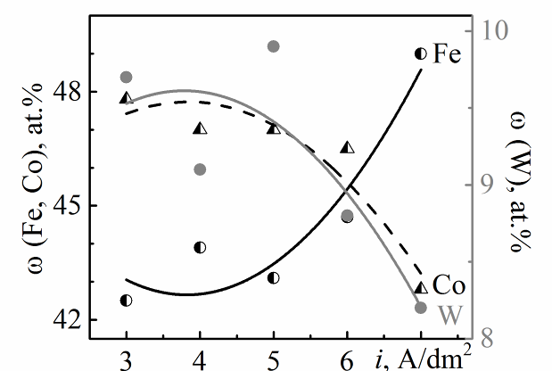 | 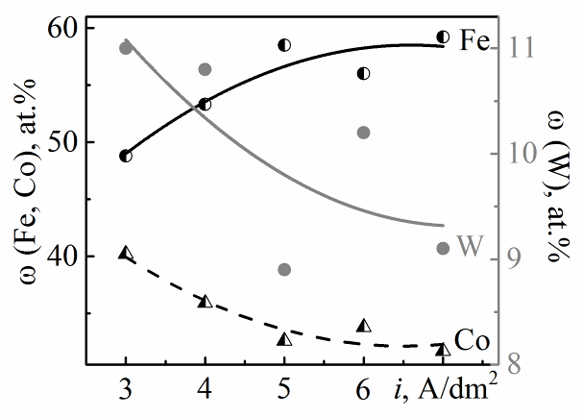
а | b
Fig. 1 Current density effect on Fe-Co-W coatings composition deposited from electrolytes:
1 (a) and 2 (b)
Tungsten content increases slightly (9−11 at.%) if the citrate concentration in the solution is 0.5 mol/dm³ other things being equal (Fig. 1b). However, the trend to tungsten content decreasing with rising current density is maintained. At the same time, the competitive reduction of iron and cobalt becomes more significant. The iron content in the coating increases to 59 at.% with a simultaneous decreasing in cobalt portion to 30 at.% when rising current density from 3 A/dm² to 7 A/dm² as we can see from Fig 1b.
The efficiency of galvanostatic deposition does not exceed 45%, regardless of the electrolyte concentration. Increasing і_{c} to 7 A/dm² reduces the current efficiency to 27% due to side reaction of hydrogen evolution. Deposited in stationary mode Fe-Co-W coatings have globular morphology of surface with a grain sizes of 2−6 μm (Fig. 2a). Coatings deposited in pulse mode contain expand amount of refractory metals, and are more uniform (Fig. 2b). The tungsten content in the coatings deposited by pulse current from electrolyte W2 (Table 1) is of 12.5 at.%. On more developed surface of enriched with tungsten coatings, we can see agglomerates of spheroids (Fig. 2c).
Time parameters of pulsed electrolysis are an effective tool for controlling the composition and nature of the coating surface. Prolong pulse at a fixed pause time contributes an increasing of cobalt and tungsten content in the alloy at studied current densities (Fig. 3). At the same time, observed for the galvanostatic regime rising trend of iron content at the expense of cobalt and tungsten with increasing current density is preserved, as one can see on Fig. 3a, b.
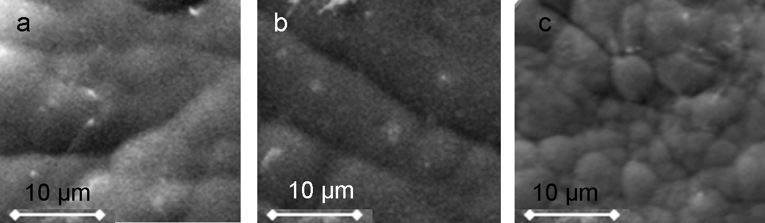
Fe – 55.8, Co – 38.4,  W – 5.8 | Fe – 58.4, Co – 35.4,  W – 6.2 | Fe – 54.8, Co – 32.7,  W – 12.5
Fig. 2 The morphology and composition (at%) of Fe-Co-W coatings deposited from electrolytes: 1 (a, b), 2 (c) in galvanostatic (a) and pulse (b, c) modes.
a – i=3 A/dm²; b – i=3 A/dm², t_{on}/t_{off}=50/50 ms; c – i=5 A/dm², t_{on}/t_{off}=20/20 ms

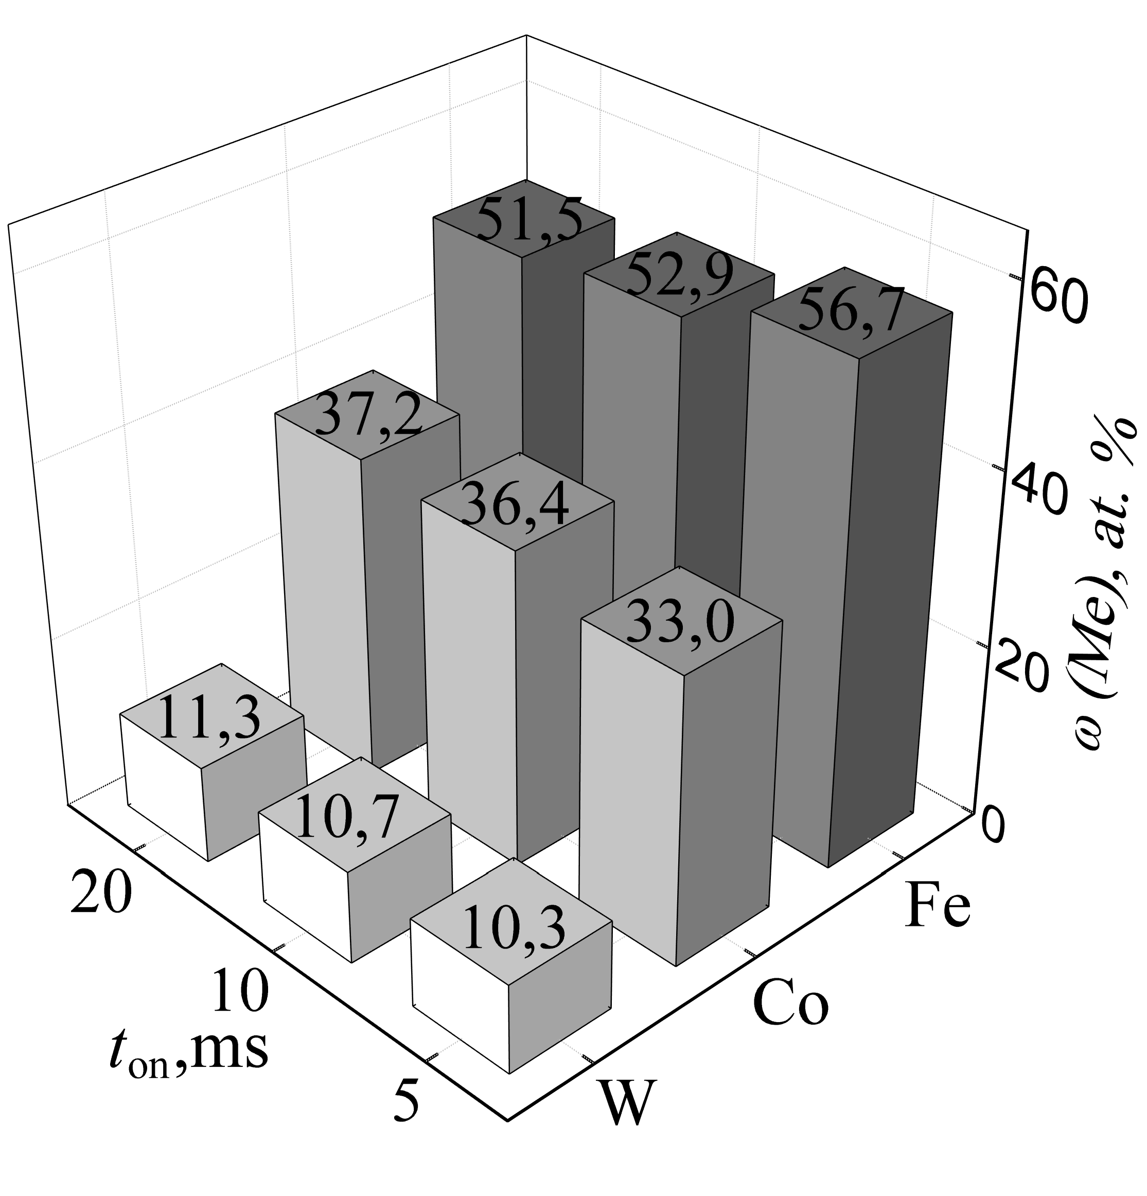 | 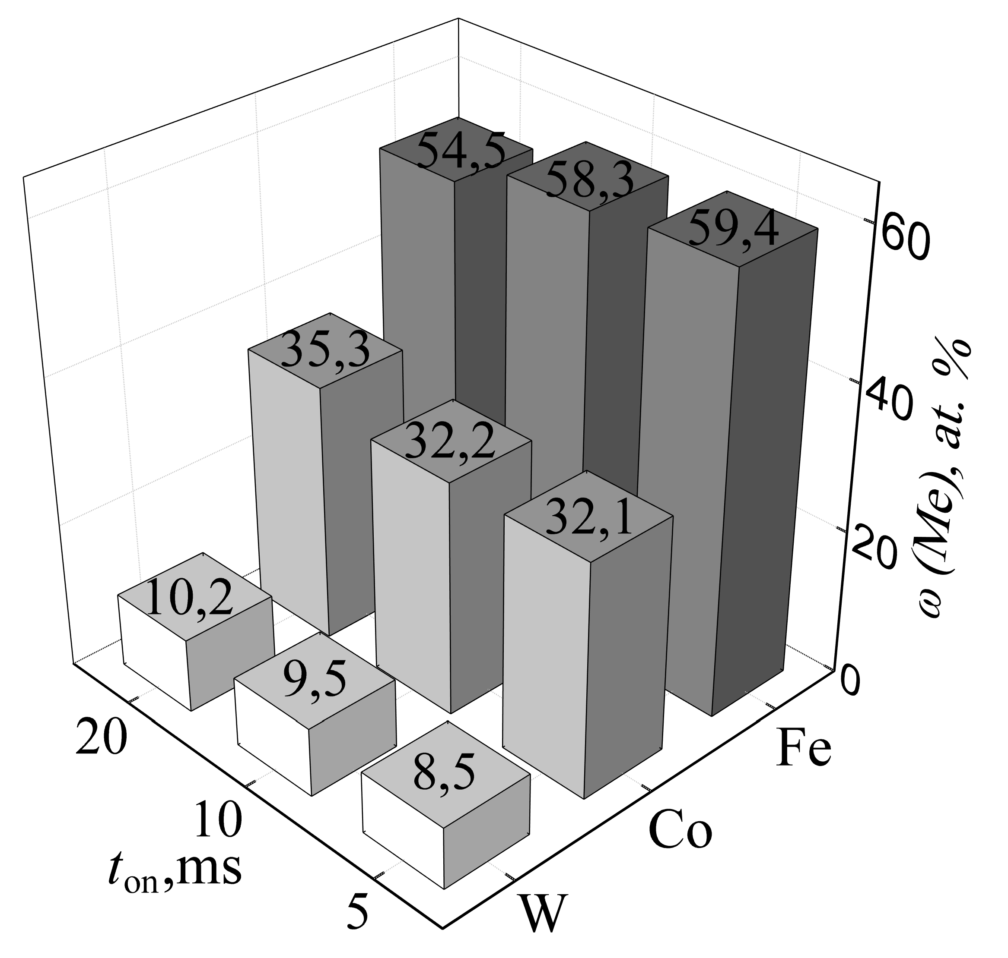
a | b
Fig. 3 Pulse duration effect on the composition Fe-Co-W alloy deposited from electrolyte W2 at t_{off} = 10 ms; current density і, A/dm²: a – 5, b – 6.

The deposition efficiency increases almost twice when applying pulse current as compared with galvanostatic regime: at a current density of 3 A/dm² the current efficiency is 70−75 %, and at 4 A/dm² Ce decreases to 63−68 %, due to site hydrogen evolution reaction.
The roughness of galvanic coatings is the result of the alloy deposition and may serve as an additional indicator of the surface development as well as topography. The coating samples Fe-Co-W containing refractory components of 10–12 at.% deposited on mild steel were studied by AFM analysis. The substrate of mild steel is characterized by evenly surface (Fig. 4) with roughness R_{a} = 0.008 and R_{q} = 0.011. However, the structure of surface is not ordered. The cross section profile between markers 1 and 2 indicates that the grain sizes are in the range of 2–3 μm as one can see from Fig. 4.
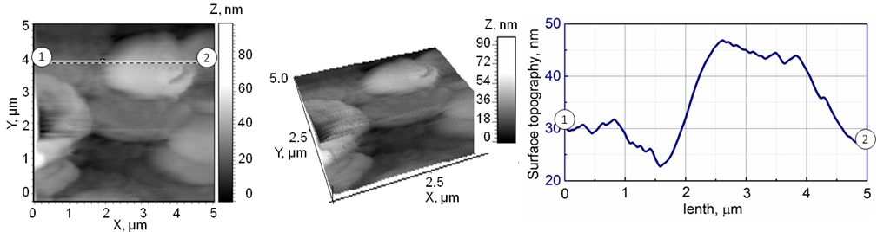
Fig. 4 2D- and 3D maps of the surface and cross section profile between markers 1 and 2 for mild steel substrate. Scan area AFM 5.0×5.0 μm.
The data of the AFM analysis demonstrate the globular surface of the Fe-Co-W coatings. Wherein larger spheroids of size of 2.5–3.5 µm is formed with a smaller grains of sizes of 0.2−0.5 µm as one can see from Fig. 5. It was found earlier [3, 7, 11] that globular structure of the surface is caused by the refractory metals incorporation into alloy. Such composition and character of the surface are favorable for increasing microhardness, corrosion resistance, and catalytic activity of the material [4, 15, 21]. Surface roughness parameters at scanning area 5×5 μm are defined as Ra=0.06 and Rq=0.07 that much higher than those for the substrate and shows substantial development of the surface.
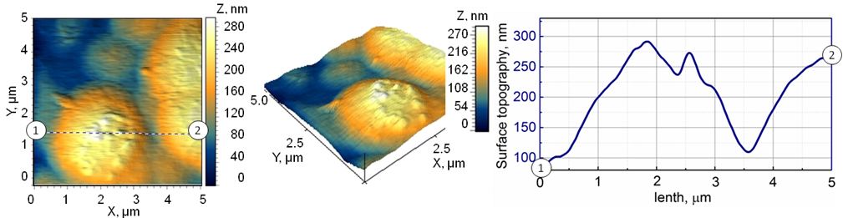
Fig.5 2D-, 3D-map and cross section profile between markers 1–2 for Fe-Co-W deposited in pulse mode at current density 4 A/dm²; t_{on}/t_{off} = 10/10 ms; T = 25 °C; рН 3.8; plated time 30 min. Scan area 5.0x5.0 μm
Figure 6 shows the results of X-ray diffraction analysis and phase structure for Fe-Co-W coatings of composition (in terms of metal) at.%: Fe – 54, Co – 36, W – 10, which deposited on a copper substrate, a thickness of coating is of 30 μm. The X-ray diffraction pattern indicates an amorphous-crystalline structure of the Fe-Co-W alloy (Fig. 6). We can see some lines of copper substrate, and lines corresponding to inter-metallic phases Co₇W₆ and Fe₇W₆, as well as α-Fe and cementite Fe₃C at diffraction patterns. Besides, a low halo with width about 10º is detected at angles 2θ 50–55º (Fig. 6), that corresponds to amorphous structure. The crystallite size of the amorphous part is 8 nm.
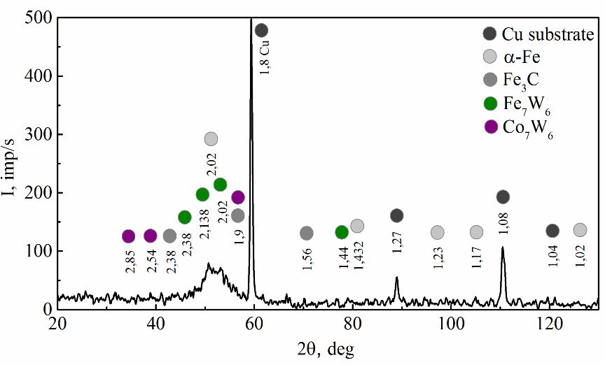
Fig. 6 X-ray diffraction patterns for deposit Fe-Co-W, the composition is similar to Fig. 2b

Phases Co₇W₆, Fe₇W₆, α-Fe and Fe₃C found in Fe-Co-W deposits, reflect the competition of alloying metals reduction from hetero-nuclear complexes, and confirm mechanism of co-deposition proposed in [23, 34].
Corrosion of cobalt based electrolytic coatings as it follows from the nature of alloying components proceeds predominantly with hydrogen depolarization in an acidic medium (Fig. 7), and oxygen is a depolarizer in neutral and alkaline media. The open circuit potential of Fe-Co-W coatings shifts to the negative side compared with the steel substrate at all solution pH, indicating cathodic control of the corrosion process.
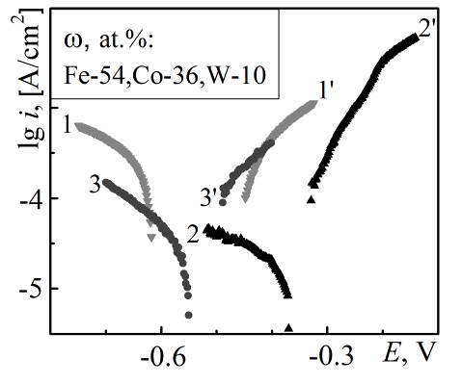 | Fig. 7 The cathodic (1, 2, 3) and anodic (1', 2', 3') polarization dependences of the coatings in corrosive environment with  pH 3 (1, 1'), pH 5 (2, 2') and pH 9.5 (3, 3').
The cathode reaction is inhibited due to the depolarizer (oxygen) transport deceleration caused by acidic non-stoichiometric tungsten oxides. Thus, the coatings enrichment with tungsten, which occurs predominantly at the expense of iron content, contributes increasing corrosion resistance in acidic media. Corrosion current decreasing in a neutral media indicates the formation and stability of alloying components passive oxide film, even in the presence of activating Cl– ions. In the alkaline media, on the contrary, the cathode reaction inhibition is ensured by insoluble iron hydroxides formed on the alloy surface, which prevent depolarizer transport to the substrate. The highest corrosion resistance in alkaline medium is observed for Fe-Co-W coatings with iron content 59 at. % and tungsten 8 at. % (Table 2).
Table 2 Corrosion indexes of steel substrate and Fe-Co-W coatings
Composition  of alloy,  ω, at.% | рН 3 |  | рН 5 |  | рН 9.5
Composition  of alloy,  ω, at.% | E_{cor}, V | lg i_{cor},  A/cm² | E_{cor}, V | lg i_{cor},  A/cm² | Е_{cor}, V | lg i_{cor},  A/cm²
Steel | –0.34 | –2.8 | –0.35 | –3.0 | –0.32 | –2.8
Fe54Co36W10 | –0.54 | –4.7 | –0.36 | –5.1 | –0.53 | –5.2
Fe59Co33W8 | –0.35 | –4.1 | –0.39 | –4.8 | –0.36 | –5.5
The Nyquist plots for Fe-Co-W alloy is a connection of two conjugate semicircles with different time constants τ = RC (Fig. 8a), that reflects the presence of two phases and, respectively, two boundaries, which can be attributed as: 1 – electrolyte / oxide on the surface of the electrode; 2 –electrolyte / metal.
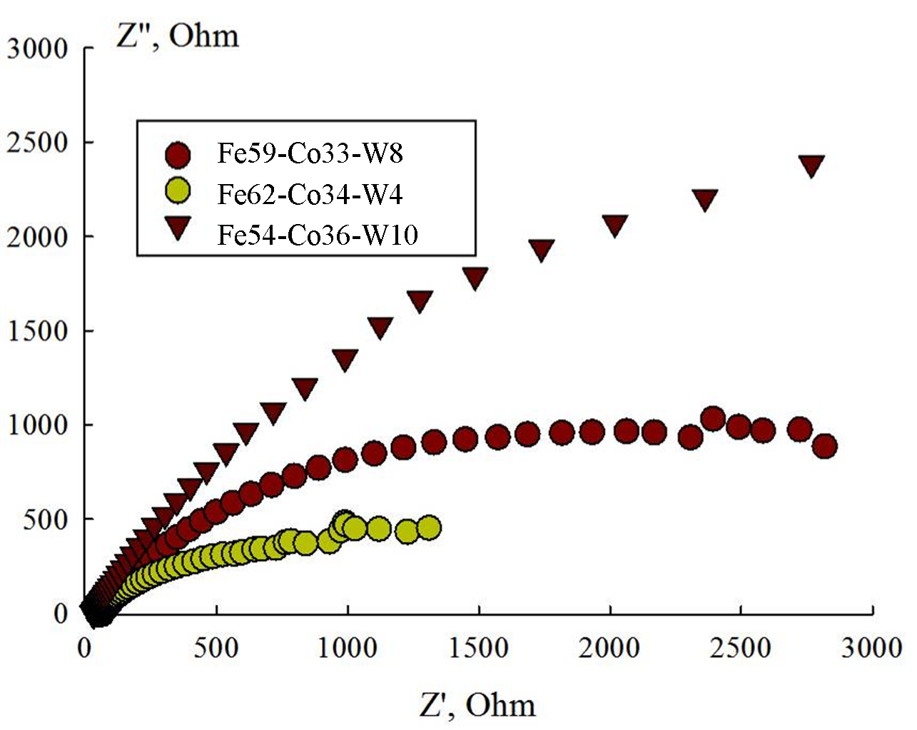
a
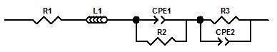
b
Fig. 8 The Nyquist plots (a) and substitution equivalent circuit (b) for steel electrode and Fe-Co-W alloys in a neutral chloride-containing environment

The equivalent scheme (Fig. 8b) contains the elements: R1 is the resistance of the electrolyte, L1 is the inductive component of the impedance, CPE1 is the capacity of the inter-phase boundary electrolyte / oxide on the electrode surface, R2 is the resistance of the oxide layer, CPE2 is the capacity of inter-phase boundary electrolyte / metal and R3 is resistance, equivalent to corrosion resistance R_{cor}. The resistance of inductance L1 is due to the appearance of galvano-magnetic Hall effects at high frequencies and associated with the magnetic properties of the coatings, as well as forming metals oxide films, which differ in specific resistance and capacity and cause several conduction paths. Parameter R_{cor} for tested materials decreases in the range: R_{cor}(Fe-Co-W10) > R_{cor}(Fe-Co-W8) >> R_{cor}(steel).
The relatively near values of the corrosion current density, calculated from data of polarization resistance technique and EIS, are also evidence of correctness both the parameters of corrosion process determination, and the validity of the electrochemical systems equivalent circuit.
Conclusions
(i) Thus ternary Fe-Co-W alloys with micro-globular surface of different composition were deposited by direct and pulse current from citrate Fe(III) based electrolyte. Current density and time parameters of pulse electrolysis are shown to be affective tools to control the refractory metals content and electrolysis efficiency.
(ii) Micro-globular surface of Fe-Co-W alloys is caused by tungsten incorporation. It was found the amorphous-crystalline structure of deposits with crystallite sizes of the amorphous part 8 nm.
(iii) Deposited coatings are characterized by increased corrosion resistance in acidic environment due to the acidic nature of refractory oxide components, in neutral resistance to pitting corrosion, which generally exceeds the chemical resistance of substrates and binary coatings.
References
1. Tsyntsaru N, Cesiulis H, Donten M, Sort J, Pellicer E, Podlaha-Murphy EJ (2012) Modern Trends in Tungsten Alloys Electrodeposition with Iron Group Metals. Surf Eng Appl Electrochem 48(6):491–520
2. Podlaha EJ, Landolt D (1997) Induced codeposition: III. Molybdenum alloys with nickel, cobalt and iron. J Electrochem Soc 144(5):1672–1680
3. Yar-Mukhamedova G, Ved' M, Sakhnenko N, Karakurkchi A, Yermolenko I (2016) Iron binary and ternary coatings with molybdenum and tungsten. Appl Surf Sci 383:346-352. DOI: http://dx.doi.org/10.1016/j.apsusc.2016.04.046
4. Capel H, Shipway PH, Harris SJ (2003) Sliding wear behaviour of electrodeposited cobalt–tungsten and cobalt–tungsten–iron alloys. Wear 255:917–923. doi:10.1016/S0043-1648(03)00241-2
5. Ved’ MV, Sakhnenko MD, Karakurkchi HV, Ermolenko IYu, Fomina LP (2016) Functional Properties of Fe−Mo and Fe−Mo−W Galvanic Alloys. Materials Science 51(5):701–710. DOI: 10.1007/s11003-016-9893-5
6. Feng-jiao H, Jing-tian L, Xin L, Yu-ning H (2004) Friction and wear behavior of electrodeposited amorphous Fe-Co-W alloy deposits. Trans Nonferrous Met Soc China 14(5):901–906
7. G. Yar-Mukhamedova, M. Ved’, N. Sakhnenko, M. Koziar Ternary cobalt-molybdenum-zirconium coatings for alternative energies // Applied Surface Science, 2017, V. 421 PA, pp. 68–76. DOI 10.1016/j.apsusc.2017.01.196
8. Silkin SA, Gotelyak AV, Tsyntsaru N, Dikusar AI, Kreivaitis R, Padgurskas J (2016) Effect of bulk current density on tribological properties of Fe-W, Co-W and Ni-W coatings. În: Proceedings of the 8th International Scientific Conference "BALTTRIB 2015". Published on-line 25 February 2016 by Aleksandras Stulginskis University. Kaunas, Lithuania, 51–56. Doi: 10.15544/balttrib.2015.10.
9. Salt Liwen Ma, Xiaoli Xi, Zuoren Nie, Tingting Dong, Yuhui Mao (2017) Electrodeposition and Characterization of Co-W Alloy from Regenerated Tungsten. Int J Electrochem Sci 12:1034–1051. doi: 10.20964/2017.02.37
10. Tsyntsaru N, Dikusar A, Cesiulis H, Celis J-P, Bobanova Zh, Sidel’nikova S, Belevskii S, Yapontseva Yu, Bersirova O, Kublanovskii V (2009) Tribological and corrosive characteristics of electrochemical coatings based on cobalt and iron superalloys. Powder Metallurgy and Metal Ceramics 48(7-8):419–428
11. Yapontseva YS, Dikusar AI, & Kyblanovskii VS (2014) Study of the composition, corrosion, and catalytic properties of Co-W alloys electrodeposited from a citrate pyrophosphate electrolyte. Surf Engin Appl Electrochem 50:330. doi:10.3103/S1068375514040139
12. Gomez E, Pellicer E, Valles E (2001) Electrodeposited cobalt–molybdenum magnetic materials. Journal of Electroanalytical Chemistry 517:109–116
13. Gómez E, Pellicer E, Vallés E (2004) Electrodeposition of soft-magnetic cobalt–molybdenum coatings containing low molybdenum percentages. J Electroanal Chem 568:29–36. http://dx.doi.org/10.1016/j.jelechem.2003.12.032
14. Kublanovsky VS, Yapontseva YuS (2014) Electrocatalytic Properties of Co-Mo Alloys Electrodeposited from a Citrate-Pyrophosphate Electrolyte. Electrocatalysis 5:372–378. DOI 10.1007/s12678-014-0197-y
15. Glushkova M, Bairachna T, Ved M, & Sakhnenko M (2013) Electrodeposited cobalt alloys as materials for energy technology. In MRS Proceedings 1491:mrsf12-1491. Cambridge University Press
16. Larminie J, Dicks A (2003) Fuel cell systems explained, 2nd ed. John Wiley & Sons Ltd, Chichester 121–137
17. Tomantschger K, Kordesch KV (1989) Structural analysis of alkaline fuel cell electrodes and electrode materials. J Power Sources 25195–214
18. Skyllas-Kazakos M, Chakrabarti MH, Hajimolana S et al (2011) Progress in flow battery research and development. J Electrochem Soc 158R55–R79.
19. Haile SM (2003) Fuel cell materials and components. Acta Materialia 515981–6000
20. Sakhnenko ND, Ved MV, Hapon YuK, Nenastina TA (2015) Functional coatings of ternary alloys of cobalt with refractory metals. Russ J Appl Chem 87:1941–1945. DOI: 10.1134/S1070427215012006X
21. Vernickaite E, Tsyntsaru N, Cesiulis H (2016) Electrodeposited Co-W alloys and their prospects as effective anode for methanol oxidation in acidic media. Surf & Coatings Tech http://dx.doi.org/10.1016/j.surfcoat.2016.07.049
22. Yermolenko IY, Ved MV, Sakhnenko ND, Sachanova YI (2017) Composition, Morphology, and Topography of Galvanic Coatings Fe-Co-W and Fe-Co-Mo. Nanoscale Research Letters 12(1):352. DOI 10.1186/s11671-017-2128-3
23. Ved’ MV, Sakhnenko ND, Karakurchi AV, Zyubanova SI (2014) Electrodeposition of Iron–Molybdenum Coatings from Citrate Electrolyte. Russ J Appl Chem 87:276−282. DOI: 10.1134/S1070427214030057
24. Shao II, Vereecken PM, Chien CL, Cammarata RC, and Searson PC (2003) Electrochemical Deposition of FeCo and FeCoV Alloys. J Electrochem Soc 150:C184–C188
25. Tsyntsaru N, Cesiulis H, Budreika A (2012) The effect of electrodeposition conditions and post-annealing on nanostructure of Co–W coatings. Surf Coat Technol 206:4262–4269
26. Grabco DZ, Dikusar IA, Petrenko VI,. Harea EE (2007) Micromechanical Properties of Co–W Alloys Electrodeposited under Pulse Conditions. Surf Eng and Appl Electrochem 43:11–17
27. Karakurkchi AV, Ved’ MV, Sakhnenko ND, Ermolenko IYu (2015) Electrodeposition of Iron–Molybdenum–Tungsten Coatings from Citrate Electrolytes. Russ J Appl Chem 88:1860−1869. doi 10.1134/S1070427215011018X
28. Elezović N, Grgur BN, Krstajić NV, and Jović VD (2005) Electrodeposition and characterization of Fe–Mo alloys as cathodes for hydrogen evolution in the process of chlorate production. J Serb Chem Soc 70(6):879–889
29. Gomez E, Pellicer E, Alcobe X, Valles E (2004) Properties of Co-Mo coatings obtained by electrodeposition at pH 6.6. J Solid State Eletrochem 8:497–504. DOI 10.1007/s10008-004-0495-z
30. Danilov FI, Sknar IV, Sknar YuE (2014) Electroplating of Ni-Fe Alloys from Methanesulfonate Electrolytes. Russ J Electrochem 50:293‒296
31. Weston DP, Harris SJ, Shipway PH, Weston NJ, Yap GN (2010) Establishing Relationships between Bath Chemistry, Electrodeposition and Microstructure of Co-W Alloy Coatings Produced from a Gluconate Bath. Electrochimica Acta 55:5695‒5708
32. M. D. Sakhnenko, M. V. Ved’, I. Yu. Ermolenko, Yu. K. Hapon, M. O. Kozyar. Design, Synthesis, and Diagnostics of Functional Galvanic Coatings Made of Multicomponent Alloys. Materials Science, V. 53 (2017). №5 pp. 680–686 DOI: 10.1007/s11003-017-0009-7
33. Ćirović N, Spasojević P, Ribić-Zelenović L, Mašković P, Spasojević M (2015) Synthesis, Structure and Properties of Nickel-Iron-Tungsten Alloy Electrodeposits PART I: Effect of Synthesis Parameters on Chemical Composition, Microstructure and Morphology. Sci of Sintering 47:347–365. doi: 10.2298/SOS1503347C
34. Yermolenko IY, Ved’ MV, Karakurkchi AV, Sakhnenko ND, Kolupaieva ZI (2017) Electrochemical behavior of Fe³⁺–WO₄^{2–}–Cit^{3–} and Fe³⁺–MoO₄^{2–}–WO₄^{2–}–Cit^{3–} systems. The Issues of Chemistry and Chemical Technology 2(III):4‒14
35. Labardi M, Allegrini M, Salerno M, Fredriani C, Ascoli C (1994) Dynamical friction coefficient map using a scanning force and friction force microscope. Appl Phys 59:3
36. Karakurkchi AV, Ved' MV, Sakhnenko ND et al (2015) Functional properties of multicomponent galvanic alloys of iron with molybdenum and tungsten. Func Mater 22:181–187. doi:http://dx.doi.org/10.15407/fm22.02.181
37. Glushkova MO, Ved MV, Sakhnenko MD (2013) Corrosion Properties of Cobalt–Silver Alloy Electroplates. Mater Sci 49:292–297. DOI: 10.1007/s11003-013-9613-3

