PHASE TRANSITION OF HEXAGONAL Be NANOCRYSTAL INTO CUBIC SUPERLATTICE UNDER X-RAY RADIATION

Associated Prof. Mels Boranbayev ¹
Prof. DrSc Gulmira Yar-Mukhamedova¹
PhD Farabi Bozheyev²
Dr Zhasulan Nakysbekov¹,
Dr Madi Aitzhanov¹,

¹Al-Farabi Kazakh National University, IETP, 71 Al-Farabi Avenue, Kazakhstan
²National Research Tomsk Polytechnic University, Institute of High Technology Physics, Lenin avenue 30, 634050 Tomsk, Russia

ABSTRACT
The structure and phase composition of annealed and irradiated beryllium plates were studied by X-ray analysis. Durable X-ray irradiation leads to phase transition of a normal hexagonal beryllium lattice into a beryllium superlattice. This superlattice is composed of beryllium superatoms that form a face-centered cubic lattice with the lattice parameter of 6.2205 Å and a superatom core that crystalizes into a diamond-type lattice with the lattice parameter of 1.5703Å. It is shown that beryllium has three phase states: normal (hexagonal lattice), a superlattice which composed of nanocrystals beryllium and form F-structure, a nanocrystallites core which is composed of 56 atoms (the magic number) crystallizes in a diamond-type lattice. It was found that by doping with beryllium various alloys after heat treatment, it is relatively easy to form covalent bonds between the atoms of “Be” and alloys. This results in increased strength, hardness, elasticity, and corrosion resistance of the resulting materials (alloys). Good reflectivity of neutrons can be explained by a very high density and magnetic moment of superatom.
Keywords: nanocrystal, superlattice, x-ray radiation, beryllium, superatom

INTRODUCTION
The prerequisites for our research were the results published by Russian scientists. Professor K.M. Yerokhin under the guidance of Academician Yu. E. Nesterikhin made model calculations for metal crystals in which they showed that with an electron deficit of 14%, the new phases are formed which should lead to the splitting of the main metal peaks [1, 2]. We first observed this effect in all metals from beryllium to tungsten under the irradiation of metals by high-energy electrons (3 MeV). A similar effect we found on beryllium when irradiated with X-rays.
It is known that for super atoms in 1987, chemists received the Nobel Prize, and Japanese scientists, when they studying nano-powders by mass spectroscopic methods, observed nano-clusters with magic numbers [3]. Since nano-clusters with magic numbers are more stable than others, then binding energy in these clusters should be higher. It means that the distance between atoms will be much smaller, which in turn leads to a decrease in parameters of quasi-cells. As for massive poly crystals, they consist of individual crystallites with dimensions of about 10⁻⁸-10⁻⁷ m, there are fillers from individual atoms, amorphous compounds 10⁻¹⁰-10⁻⁸ m and fine crystallites 10⁻⁹-10⁻ ⁸ m between them [4-5]. Consequently, we should observe our effects in massive samples.
Fundamental properties of nanosized structures like quantum dots and wells, quantum wires, clusters etc. were actively researched in the last decades with a view to create new materials with controlled mechanical, electrical, magnetic and optoelectronic properties, particularly for construction of new microelectronic devices. Formations from one to thousands of atoms attract interest among the microscopic objects clusters since they are in intermediate state between individual atoms and solid, and these formations show properties that are completely different from both of these states [6-9]. The understanding of how transition occurs from atoms to solid (including changes in their properties) opens way for getting fundamental knowledge as well as practical application.
Metallic clusters take a special place among various types of clusters as they have unique future due to their electronic structure and simplicity of their production [10], [11], [12]. In this respect beryllium becomes a strategic material that is widely used in practical human activity. Doping of steel, copper and other alloys with beryllium allows production of hard and corrosion resistive materials widely used in nuclear power plants as well as in producing materials for rocket and cosmic industries [13], [14], [15].
In this paper we report on a new phase of Be with the face-centered cubic superlattice that contains beryllium superatoms or clusters in the lattice nodes with the diamond-type lattice. We have done a systematic research of phase transition of beryllium treated by high temperature and X-ray irradiation into a Be superlattice.

MATERIALS AND EXPERIMENTAL PROCEDURE
The material for the study was taken pure beryllium plate. Beryllium plates was studied without processing, after annealing, after 10 hours and after a long time(up to 100 hours)exposure with X-rays. The annealing procedure of pure beryllium plates was performed in an argon atmosphere at 1000 °C for 15 min. Irradiation of beryllium plate was performed by CuK_{α} radiation (1.5408 Å) for 10 h and for more than 100 h. The structure and phase composition of the plates were characterized by scanning electron microscope Quante 3D 200i and X-ray diffractometer DRON-7.
Sample’s features. Microstructure and energy disperse X-ray analysis of beryllium samples presented in Table 1 shows the content of Be, C, O elements. Discrepancy of the content of elements in the table and intensity of peaks in the figure is explained by fact that beryllium is a very light metal, and diffraction pattern is created mainly from the inner electrons, beryllium has only two electrons, but carbon and oxygen have more inner electrons. Energy dispersive X-ray (EDX) analysis showed that initial beryllium plate consists mostly of beryllium and small amount of oxygen and carbon. X-ray patterns of initial, annealed and irradiated beryllium samples are shown in Figure 1. Beside characteristic beryllium peaks noted as H (hexagonal) there are also low angle peaks. These peaks are called superstructural because they correspond to the elementary unit cell with the bigger lattice parameter [12]. After treatment by high temperature and X-ray irradiation the intensities of the peaks change considerably, e.g., the cubic crystal reflections as (110), (111), and for hexagonal – (111), (002), etc. In the Table 2 structure-sensitive peaks of three beryllium phases are reduced to one scale. After long X-ray irradiation treatment the content of Be superlattice is increased by two orders of magnitude. Our research strives to understandand explain this phenomenon.

Table 1 EDX analysis of pure beryllium plate
Element | Wt% | At%
BeK | 89.99 | 92.72
CK | 7.61 | 5.89
OK | 2.40 | 1.39

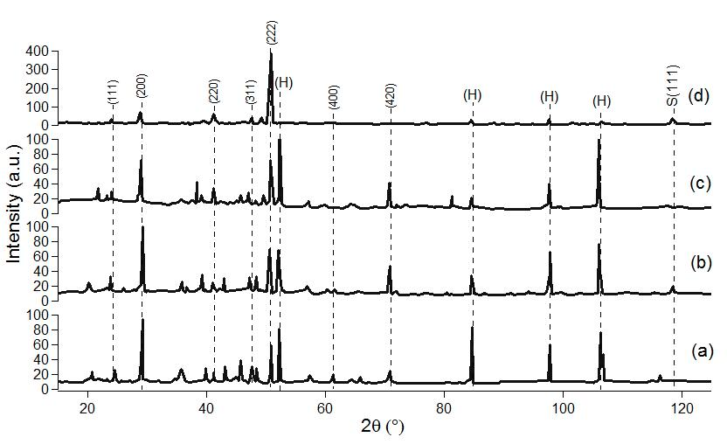
Figure 1. X-ray patterns of a) initial Be (sample 1), b) annealed (sample 2), c) irradiated during 10 hours (sample 3), and d) more than 100 hours (sample 4).
Table 2 Intensities of the peaks reduced to one scale
Be | Superlattice, а=6.2205 Å |  | Hexagonal (Н) |  | Superatom core, а=1.55 Å
(hkl) | (200) | (222) | (011) | (110) | (111)
Pure | 0.255 | 0.140 | 0.226 | 0.193 | -
Annealed | 0.243 | 0.180 | 0.180 | 0.146 | 0.054
Irradiated, 10 h | 0.405 | 0.300 | 0.155 | 0.111 | 0.012
Irradiated, more than 100 h | 0.200 | 1.000 | 0.0081 | 0.081 | 0.138

The X-ray diffraction patterns showsuperlattice reflections that correspond to a hexagonal close packed (H) and cubic close packed lattices (F-lattice), see Fig. 2. The calculated parameteres of the hexagonal unit cell are a = 5.0786 Å and c = 10.77 Å, and the parameter of the unit cell of the face-centered cubic lattice (F-lattice) is 6.2205 Å. This cubic cell fits into the hexagonal cell, see Fig. 2a. It should be noted that the parameter of the superlattice exceeds the standart value of the beryllium lattice.

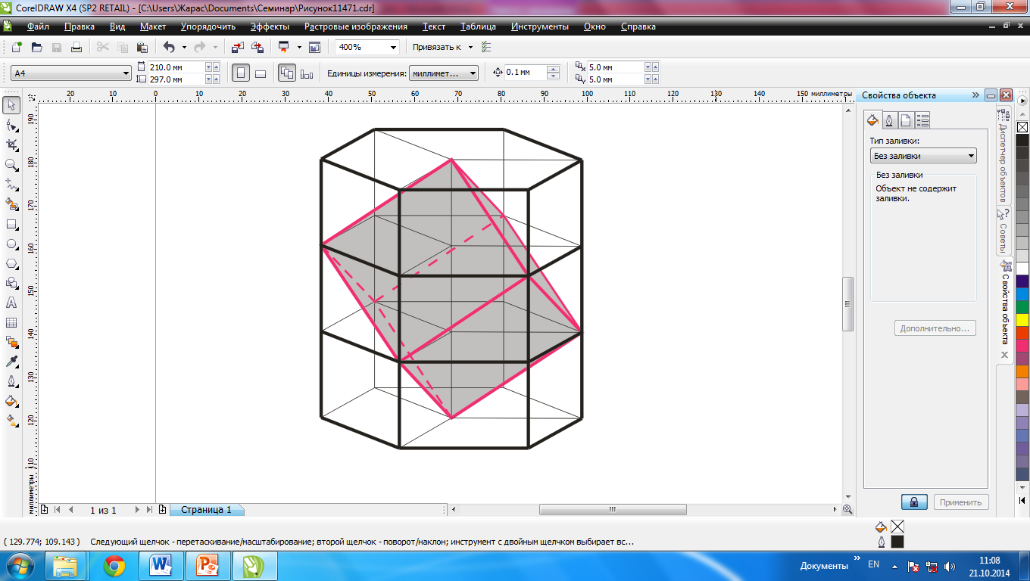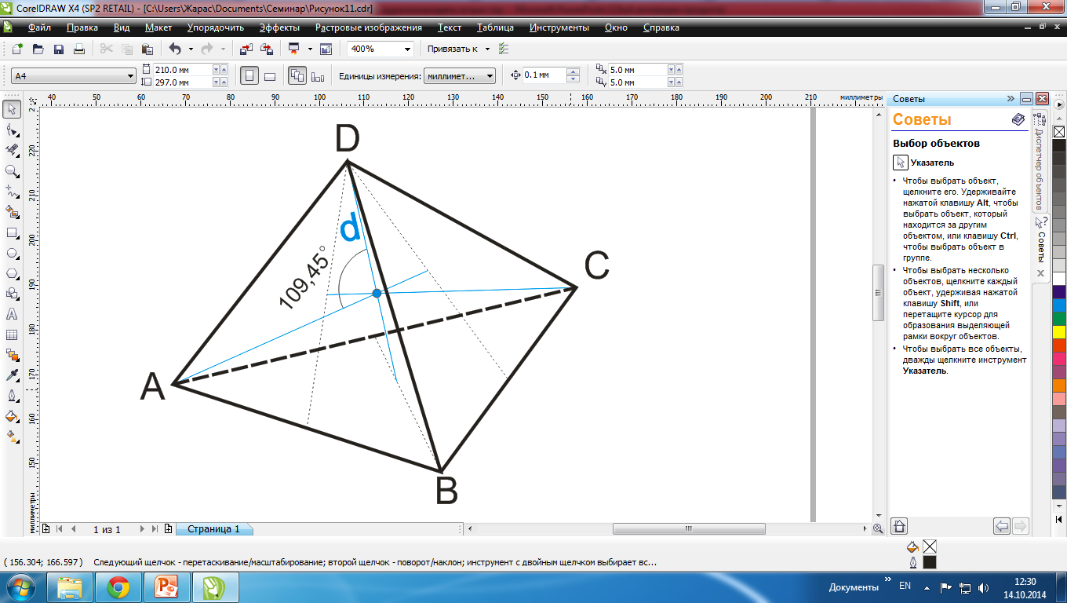
(a)
(b)
Figure 2. A cubic superlattice presented in hexagonal lattice (a) and a diamond-type lattice (b)

Therefore clusters (nanoparticles) larger than beryllium atom should be (seated) at each node of the superlattice.The radius of such cluster (nanoparticle) was determined from the next relation: R=a/4=2.199 Å. The calculated value of the radius is greater than the radius of beryllium atom (1.43 Å). Comparing the radius of beryllium atom and the radius of the beryllium nanoparticle we can make a conclusion that the nanoparticle cannot consist of beryllium atoms. It is possible that Be is associated in doubly ionized state in the nanoparticle as Be²⁺ since the primary oxidation level of Be is +2 and Be ion radius is 0.34 Å. Based on electron microscopy data on homogeneous composition of the sample, we assumed that the nanoparticle consists of beryllium ions and sp-hybridization of Be-Be binding levels results in formation of quadruple covalent σ-bonding between the ions. Such bonding should cause crystallization of the beryllium ions into a diamond-type lattice.
Based on this assumption the distance d between atoms of Be-Be is 0.68 Å. Then the lattice parameter of the unit cell of the crystal inside the nanoparticles can be determined from the following relationship: a=4d/=1.5703 Å. Thus, the X-ray patterns must have the traces of three phases of Be: hexagonal, face-centered cubic superlattice, and superatom core crystallized into the diamond-type lattice. Two phases of Be are presentin all X-ray patterns (Fig.1 a, b, c, d). Calculationsshowed that on copper CuK_{α}-radiation only one peak should be present on X-ray pattern (111) corresponding to the nanocrystallite (superatom). Other peaks corresponding to (220), (222) and (400), etc. are outside of the restrictions sphere due to the small size of the unit cell parameter. According to calculations the diffraction peak from the nanocrystallite should be located at an angle of 116.33˚. Such peak is detected at the irradiated and annealed diffractograms, but it does not exceed the background levelon the diffraction pattern of initial Be. Experimental value of the angle of the diffraction peak of annealed sample is 118.48˚, and of irradiated sample it is 118.40˚.Calculation of the parameter from the experimentally detected angle gives the value of 1.5514 Å representing a deviation of more than 2˚, and the intensities of these peaks vary greatly as per the data shown in the Table 1. It should be noted that irradiated sample (Fig.1d) differs substantially from the initial and annealed beryllium.
In order to detect reflections from outside of the restriction sphere we irradiated sample corresponding to Fig.1d by MoK_{α} (0.70926 Å). In Fig. 3 the X-ray patterns show that along with the (111) reflection there are additional diffraction peaks corresponding to (220), (222) and (400), which prove the presence of superatom structure. These diffraction peaks fall within the restriction sphere due to larger value of MoK_{α} wave vector in comparison to CuK_{α}. The calculated lattice parameter of the superatom core is 1.547 Å that is matched with the presupposed lattice parameter 1.5703 Å. The calculated ionic radius of the superatom core is 0.3349 Å, which is less than doubly ionized state of Be.
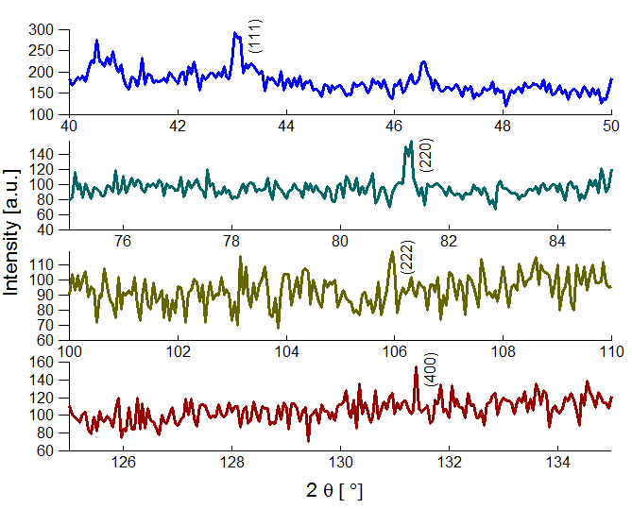
Figure 3. The X-ray pattern of Be plate irradiated more than 100 hours at different ranges

After irradiation the (222) diffraction peak of the cubic superlattice dramatically increases compared to the values of other considered peaks. Background of X-ray irradiated beryllium is decreased; the content of beryllium is by two orders of magnitude less than in pure beryllium. The structure of beryllium superlattice after irradiation is quantitatively increased and improved approaching monocrystalline state since the background on monocrystals is much The difference between the calculated and experimental values of the parameteris0.02 Å (or about 1%), which can be considered as a good match. Average measurement accuracy of diffractometer is 0.01%). The mechanism of the beryllium regeneration after annealing can be explained as follows: annealing at 1000˚C in argon environment leads to fragmentation of micro-crystallites of the polycrystalline sample to nano-crystalline state because of hybridization of Be atoms. In turn the fragmentation occurs as follows: at hybridization interatomic distance of Be-Be atoms drastically reduces and there appears significant strain between excitedandnon- excitedregions, and when the strain exceeds the interatomic interaction the crystal breaks in full or in part. Fragmentation continues while the energy of the external impact does not exceed the binding energy of nano-crystallite atoms. However nanocrystal sand clusters of atomsless than 2.199 Ǻ agglomerate to the optimal value of 2.199Ǻ because of sp-hybridization and formation of Be-Be bonding. Thus, the dielectric nanocrystallite with a certain number of atoms (the magic number) that behaves as a single atom of the periodic table is formed (jellium model) [13], [14]. Since shared electrons (electrons of loosened level) are located at the orbitals around nanocrystallite (superatom core) forming an "electronic cloud", each nanocrystal can be called superatom. Such superatom has a nucleus consisting of 56atoms of beryllium with the electrons concentrated on the surface. Around the nucleus there are electron orbitals with an even number of electrons ("electron cloud"), because of that a dipole-dipole interaction similar to the interaction between the atoms of inert gases occurs between superatoms resulting in crystallization and formation of F-lattice. But the process of hybridization does not proceed effectively at high temperatures (the annealing temperature) although structurally sensitive (222) reflection of F-lattice is increased (Fig. 4). However the effect is not obtained after irradiation. Apparently this is due to the fact that there reverse processes occur after annealing, i.e. particles less than superatom in size agglomerate as well as get destructed. Therefore we assume that durable annealing should lead to establishing of equilibrium. From the calculated data, all the peaks of the roentgenograms correspond to beryllium, whatever phase they were α- or β- are located further than 25 °, and we on the X-ray patterns observe peaks of 2θ from 10 ° to 20 °.
This process becomes much more active when Be is irradiated with X-rays at the room temperature. The mechanism of superatom formation during irradiation is somewhat different. Formation of superatom during irradiation occurs in the following sequence: electrons ejected by X-rays (photoelectric effect) leave the crystallite (dielectric)resulting in it being positively charged up to the point where the energy of the Coulomb repulsion exceeds the binding energy leading to significant mechanical stresses in the crystallite that break the crystal ("Coulomb explosion" [1]). Thus there occurs a process of radiation crushing up to nano-size. The process continues until stable nanocrystals that we call superatoms are formed. Apparently the formation of superatoms can occur in two ways:
a) Crushing makes the size of large quantity of nanocrystals smaller than the superatom R_{at} = 2.199Ǻ (atoms of which are excited).Further, these nanocrystals are closing in leading to their agglomeration and hybridization on binding levels which in turn leads to formation of covalent σ-bonding (Pauli Exclusion Principle);
b) the electronic structure of nanocrystals with dimensions equal to R_{at}, change at the expense of the inner electrons of the nanocrystallite leading to formation of covalent σ-bonding within the nanocrystallite, while free electrons (at the loosed level or in conduction band) migrate to the orbit around nanocrystallite (superatom core).
Both processes lead to the formation of nanocrystallites (superatoms): the "top-down" process arising from radiation crushing, and "bottom-up"process where smaller smaller clusters of atoms and nanocrystallites agglomerate.

Table 3 Density of the different phases of beryllium
Lattice type | a, Ǻ | c, Ǻ | ρ, g/cm³
Table value | 2.2860 | 3.584 | 1.848
FCC superlattice | 6.2205 | - | 3.538
Hexagonal superlattice | 5.0786 | 10.77 | 3.538
Nanocrystallite | - | - | 21.00
Superatom core (dimond lattice) | 1.5514 | - | 32.008

The next step was to determine the number of Be atoms in the superatom core, the superatom structure and density. The number of atoms of Be in the superatom core was calculated using the analitical and geometric (5th coordination sphere) methods. The calculatedvalues showedthat the superatom contains 56 atoms (ions) of Be. Since the structure and electronic structure of three Be phases are different, the densities are alsodifferent for each phase. The calculated values of the density of the samples are listed in Table 3. Comparative analysis of the data shows that the density of three phases of beryllium significantly differs. The most significant difference is observed between the density of (nanocrystallite) superatom and superatom core. This serves as an experimental confirmation of the formation of superatom with "electron cloud" and covalent σ-bonding of Be-Be.

CONCLUSIONS
As a result of the indexing diffract grams of annealed and irradiated beryllium besides characteristic lines of the metal, there are lines in the lower angles. These lines were called superlattice lines, because it was found that they belong to the unit cells with bigger parameters. The results of the calculations showed that the superstructure reflections can be represented as a hexagonal close packed and cubic close packed. Calculated parameters of the hexagonal unit cell are a = 5,0786Å, c = 10,77Å, and the unit cell parameter of F-cubic lattice a = 6,2205Å, thus the cubic cell fits into the hexagonal unit cell. It should be noted that the parameters of superlattices have more parameters than table parameters of beryllium. Calculations showed that the sites of the superlattice of beryllium superatom has a radius of 2,199 Å. The results of geometric (5-th coordination sphere) and analytical methods have shown that beryllium superatom consists of 56 atoms (ions) of Be.
Thus, the confirmation of superatom formation is crystallization of beryllium into superlattice with the lattice parameter of 6.2205 Ǻ. We can make a conclusion that our assumptions were correct. The results of this work lead us to believe that doping of various alloys with beryllium and consequent treatment with high temperature enables relatively easy formation of covalent bindings between the atoms of Be and alloys, which in turn increases strength, hardness, elasticity and corrosion resistance of the treated materials (alloys). Good reflectivity of neutrons can be explained byvery high density and magnetic moment of superatom.

ACKNOWLEDGMENTS
This work was supported by al-Farabi Kazakh National University, Institute of Experimental & Theoretical Physics by AP05130069 project “Development of nanotechnology for the synthesis of functional galvanic coatings for electrical equipment components.”

REFERENCES
- Yerokhin K. M., Kalashnikov N. P., Nesterikhin Yu. Ye., Ol'chak A. S. Kulonovskij vzryv shchelochnyh i perekhodnyh metallov pri chastichnom udalenii ehlektronov provodimosti. Dokl. Akad. Nauk, vol.436/ issue 4, pp 464-469, 2011.
- Mukul K., Mookerjee A., Bhattacharya A. Structure and stability of copper clusters: A tight-binding molecular dynamics study. Phys review. A 69, 043203, 2004.
- Poole Ch.P., Owens F.J. Introduction to nanotechnology. 336 p. 2003.
- Ved' M., Sakhnenko N., Nenastina T. et al. Electrodeposition and properties of binary and ternary cobalt alloys with molybdenum and tungsten // Appl. Surf. Sci., vol. 445, pp 298-307. 2018.
- Yu.A. Baykov, V.M. Kuznetsov. Fizika kondensirovannogo sostoyaniya. M.: Binom. Laboratoriya znaniy, 293 p. 2013.
- Pavlov P.V., Khokhlov A.F.. Fizika tverdogo tela. – M.: Lenand, 2015.– 496 p.
- Muradov, A., Mukashev, K. et al. Impact of silver metallization and electron irradiation on the mechanical deformation of polyimide films //Technical Physics, vol. 62 / issue 11, pp 1692-1697, 2017.
- Mussabek, G., Sagyndykov, A. et.al. Modern state of composite coatings formation problem // 17th Int.l Multidisc. Sc Geoconf. SGEM 2017. 17 (61), 2017, Pp 233-240. 130800Fan.
- Muradov, A., Mukashev, K. et al. Mathematical model of composite materials formation // 17th Int.l Multidisc. Sc Geoconf. SGEM 2017. 17 (61), 2017, Pp 201-208. 130800
- Ved' M., Sakhnenko N., Karakurkchi A., Yermolenko I. Appl. Surf. Sci., vol. 383, pp 346–352. 2016.
- Darisheva А., Kasimzhanov K. et al. Physicochemical Investigations of Scheelite Concentrate Decomposition // Euras. Chem.-Technol. J, № 17, р. 209–212, 2015.
- Ivanov V.K., Ipatov A.N. Ed. J.-P. Connerade. Singapore: World Sci., vol.141, 2006.
- Ved' M., Sakhnenko N., Koziar M. et al. Ternary cobalt-molybdenum-zirconium coatings for alternative energies //Appl. Surf. Sci., vol. 421. pp 68-76, 2017.
- Yar-Mukhamedova, G.Sh., Sakhnenko, N.D., Ved, M.V. Surface analysis of Fe-Co-Mo electrolytic coatings // IOP Conference Series: Materials Science and Engineering. 213 (1) 012019
- Sagyndykov, A.B., Kalkozova, Zh.K. et al. Fabrication of nanostructured silicon surface using selective chemical etching // Technical Physics, vol.62/ issue 11, pp 1675-1678, 2017.

