Al-Farabi Kazakh National University

G.Sh. Yar-Mukhamedova
K.Sh. Shunkeyev
N.N. Zhanturina

MECHANICS

Workbook

Almaty
Қазақ университеті
2017
UDS 67.017. (0.75)
ББК 30. 3 я 73
Я 71

Recommended for publication by the Academic Council
(protocol №4 dated by 01.04.2017)
And the decision of al-Farabi Kazakh National University
Editorial-Publishing Council
(protocol №4 dated by 01.04.2017)

Reviewers:
Academician of Kazakh National Academy of Sciences
Doctor of Physical and Mathematical Sciences, professor T.A. Kozhamkulov
Academician of Kazakh National Academy of Sciences
Doctor of Technical Sciences,
professor S.M. Kozhakhmetov
Academician of Kazakh National Academy of Sciences
Doctor of Physical and Mathematical Sciences, professor B.N.Mukashev

Mechanics / G.Sh.Yar-Mukhamedova, K.Sh. Shunkeyev, N.N. Zhanturina.- Almaty: Qazaq University, 2017.- 106 pp.

ISBN 978-601-04-1409-9

The content of the workbook corresponds to the curriculum (syllabus) and the teaching and methodological complex of the discipline "Mechanics", which is part of the compulsory component of the preparation of bachelors of the Physics and Technics Faculty.
There are main laws of mechanics in tutorial. It consist 7 parts, at the end of them are control questions, problems. The parts are kinematics, Dynamics of material point and translational motion of body, work and energy, Mechanics of solid state, Gravity. Elements of the field theory, Elements of Fluid Mechanics, elements of special relativity theory. The tutorial can be used by students of physical specialties.
The workbook is intended for students by specialties 5В060400 "Physics", 5В060500- "Nuclear Physics", 5B071000 "Material Science and Technology of New Materials", etc.

УДК 67.017. (0.75)
ББК 30. 3 я 73
 Yar-Mukhamedova G.Sh., Shunkeyev K.Sh., Zhanturina N.N., 2017
ISBN 978-601-04-1409-9 © Al-Farabi KazNU, 2017

CONTENS

Introduction……………………………………………………… |  | 5
Part 1. | Kinematics…………………………………………………… | 6
1 | Models in mechanics. Reference frames. Trajectory, the path length of the displacement vector……………………………......... | 6
2 | Velocity………………………………………………............... | 8
3 | Acceleration and its components…………………………… | 10
4 | Angular velocity and angular acceleration…………………… | 13
 | Control questions by the theme and problems……………. | 16
Part 2 | DYNAMICS OF MATERIAL POINT AND TRANSLATIONAL MOTION OF BODY…………………… | 18
5 | First Newtons law. Mass. Forse…………………………….. | 18
6 | Second Newtons law……………………………………………….. | 19
7 | Third Newtons law…………………………………………….. | 21
8 | Friction…………………………………………………………. | 21
9 | Conservation of momentum. Center of mass……………….. | 23
10 | Equation of motion of variable mass body…………………….. | 25
 | Control questions by the theme and problems…………………. | 27
Part 3 | WORK AND ENERGY…………………………………….. | 29
11 | Energy, Work, Power……………………………………… | 29
12 | Kinetic and potential energy…………………………… | 31
13 | The energy conversation law………………………………… | 34
14 | Graphical representation of the energy………………………. | 36
15 | The collision of absolutely elastic and nonelastic bodies… | 39
 | Control questions by the theme and problems………… | 43
Part 4 | Mechanics of solid state……………………… | 45
16 | Moment of inertia…………………………………… | 45
17 | Kinetic energy of rotation……………………………………....... | 46
18 | Moment of force. The equation of dynamics of rotational motion of solid body……………………………………….. | 48
19 | Momentum and the law of its conservation……………… | 50
20 | Free axys. Gyroscope………………………………………… | 53
21 | Deformations of solid body……………………………… | 57
 | Control questions by the theme and problems……….……… | 60
Part 5 | GRAVITY. ELEMENTS OF THE FIELD THEORY……….......... | 62
22 | Kepler's laws. Law of gravity………………………………….. | 62
23 | The force of gravity and weight. Weightlessness……………........ | 63
24 | Field of gravity and its strength…………………………………… | 64
25 | Work in the field of gravity. Potential of gravity field………... … | 65
26 | Escape velocities……………………………………………….. | 68
27 | Non-inertial frame of reference. Forces of inertia…………… | 69
 | Control questions by the theme and problems………………. | 74
Part 6 | Elements of Fluid Mechanics………………………. | 76
28 | Pressure in gas and liquids…………………………………… | 76
29 | The continuity equation……………………………… | 77
30 | Bernoulli equation and its consequences………………………. | 78
31 | Viscosity (internal friction). Laminar and turbulent flow of liquids……………………………………………………………….. | 83
32 | Methods of viscosity determining…………………………… | 85
33 | Motion in liquids and gases………………………… | 87
 | Control questions by the theme and problems…… | 89
Part 7 | elements of SPECIAL relativity theory…………… | 91
34 | Galileo transformations. Mechanical principle of relativity…....... | 91
35 | Postulates of special relativity theory………………………… | 92
36 | Lorentz transformations………………………………………… | 94
37 | Consequences from the Lorentz transformations………………… | 96
38 | Interval between events………………………………………...... | 100
39 | Main law of relativistic dynamics of a material point…… | 101
40 | The law of relationship of the mass and energy……………… | 102
 | Control questions by the theme and problems problems… | 105
 | References………………………………………………….. | 107

Introduction
The world around you, all that exists around us and finds us through the senses is a matter. An essential property of matter and form of its existence is the movement. Stir in the broadest sense of the word - it is all possible changes of matter - from the simple to the most complex moving processes of thinking.
Various forms of motion of matter being studied by various sciences, including physics. The subject of physics, for that matter, and any science, can be opened only when its detailed presentation. Post a strict definition of the object of physics is quite difficult because the boundaries between physics and a number of related disciplines conditional. At this stage of development can not be saved definition of physics just as the science of nature.
Akademik Ioffe (1880-1960, Russian physicist) defined physics as a science that studies the general properties of matter and the laws of motion and the field. Currently, it is generally accepted that all interaction is done through the fields, such as gravitational, electromagnetic, nuclear force fields. Golf, along with a substance is a form of matter existence. The inseparable connection between the field and the substance, as well as differences in their properties will be considered as the study of the course.
Physics - the science of the simplest and yet the most common forms of movement of matter and their mutual transformations. Studied physics forms of motion (mechanical, thermal, and others.) Are present in all higher and more complex forms of motion of matter (chemical, biological, etc.). Therefore, they being the most simple, are at the same time the most common forms of motion. The higher and more complex forms of motion of matter - the subject matter of other sciences (chemistry, biology, etc.).
Physics is closely related to the natural sciences. This close connection of physics with other branches of natural science, as noted by Academician Vavilov (1891-1955, Russian physicist and public figure), led to the fact that the physics of the deepest roots grown into astronomy, geology, chemistry, biology and other natural sciences. As a result a number of new related disciplines such as astrophysics, biophysics and others.
Physics is closely connected with the technique, and this relationship is two-way. Physics grew out of technology needs (development of the mechanics of the ancient Greeks, for instance, was caused by the demands of construction and military equipment of the time), and Technology, in turn, determines the direction of physical research (for example, at the time the task of creating the most efficient heat engines caused a rapid thermodynamics development). On the other hand, the development of physics depends on the technical level of production. Physics - the basis for the creation of new branches of technology (electronic engineering, nuclear engineering, etc..).
The rapid pace of development of physics, its growing ties with the technique point to an important role of physics course in technical colleges: a fundamental basis for the theoretical training of the engineer, without which it is impossible successful activity
Part 1

Kinematics

1. Models in mechanics. Reference frames. Trajectory, the path length of the displacement vector
Mechanics – the part of physics that studies the laws of mechanical motion and causes or alter the movement. Mechanical motion - a change of the position of a body with time in space.
Development of mechanics as a science begins with the III. BC. e., when an ancient Greek scientist Archimede (287-212 BC. e.) formulated the law of equilibrium of the lever and the laws of equilibrium of floating bodies. The basic laws of mechanics were installed by the Italian physicist and astronomer Galileo G. (1564-1642) and were finalized by the English scientist Isaac Newton (1643-1727).
Mechanics of Galileo-Newton is called classical mechanics. It examines the laws of motion of macroscopic bodies which velocities are small in comparison with the speed of light in vacuum. The laws of motion of macroscopic bodies at velocities comparable with the velocity of light are studied in relativistic mechanics, based on the special theory of relativity formulated by Albert Einstein (1879-1955). To describe the motion of microscopic bodies (individual atoms and elementary particles), the laws of classical mechanics do not apply - they are replaced by the laws of quantum mechanics.
In the first part of our course, we will study the mechanics of Galileo-Newton, consider the motion of macroscopic bodies at velosities much lower than the light speed. In classical mechanics generally accepted concept of time and space, developed by Newton and dominated by the natural sciences during the XVII-XIX centuries. Mechanics of Galileo-Newton considers space and time as objective forms of existence of matter, but in isolation from each other and from the movement of material bodies, which is corresponded to the level of knowledge at the time.
Mechanics is divided into three sections: 1) kinematics; 2) dynamics; 3) Static.
Kinematics studies the movement of bodies without considering the reasons that cause this movement.
Dynamics studies the laws of motion of bodies and the reasons that cause a movement or its change.
Static studies the laws of equilibrium of the system of bodies. If you know the laws of motion of bodies, some of them can be set the laws of equilibrium. Therefore, static laws apart from the laws of dynamics physics does not consider.
Mechanics describes the motion of bodies, depending on the conditions of specific tasks using various physical models. The simplest model is a material point - a body having mass, the size of which can be neglected in comparison with the distance on which it is considered. The concept of the material point - the abstract, but it facilitates the introduction of the solution of practical problems. For example, by studying the motion of planets in their orbits around the sun, you can take them as material points.
Arbitrary macroscopic body or system of bodies can be mentally divided into small interacting parts, each of which is considered as a material point. Then study the motion of an arbitrary system of bodies reduced to the study of a system.
Under the influence of bodies on each other's the body may be deformed, i.e. it can be changed its shape and size. Therefore, in the mechanics is introduced another model - absolutely solid body. Absolutely solid body is called the body, which under no circumstances can not be deformed and under all conditions, the distance between two points (or more precisely between two particles) of the body remains constant.
Any movement of a rigid body can be represented as a combination of translational and rotational movements. Translational motion - a movement in which every line is rigidly associated with a moving body, it remains parallel to its original position. The rotational movement - a movement in which all points of the body are moving in circles, the centers of which lie on the same straight line, called the axis of rotation.
The movement of bodies takes place in space and time. Therefore, it is necessary to know in order to describe the motion of a material point, the places where space, this point was, and at what times it was held a certain position.
Mass point position is determined with respect to any other arbitrarily selected body, called the reference body. Since it is bound reference system - a set of coordinate system, clock and the reference body.
In the general case the motion is determined by scalar equations

$x=x(t)$, $y=y(t)$, $z=z(t)$ or $r=r(t)$ (1.1)

Equations (1.1) are called the kinematic equations of motion of a material point.
The number of independent coordinates, completely defining the position of a point in space, are called the number of freedom degrees. If material point moves freely in space, then, as has been said, it has three freedom degrees, if it moves along a line, then it has one freedom degree.
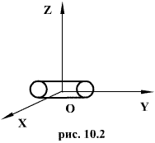
Figure 1. Freedom degrees of a material point

Eliminating the equations (1.1), we obtain the equation of the trajectory of motion of a material point. The trajectory of a material point is the line described this point in space. Depending on the shape of the motion the path may be straight or curved.
Let’s consider the motion of a point along an arbitrary trajectory (Fig. 2). The clock will start from the time when the point is in position A. The length of the portion of the trajectory AB is called the length of the path: Δs = Δs(t). Vector Δr = r – r₀, drawn from the initial position of the moving point in its position at a given time (the increment of the radius vector of a point in the reporting period of time), is called the displacement.

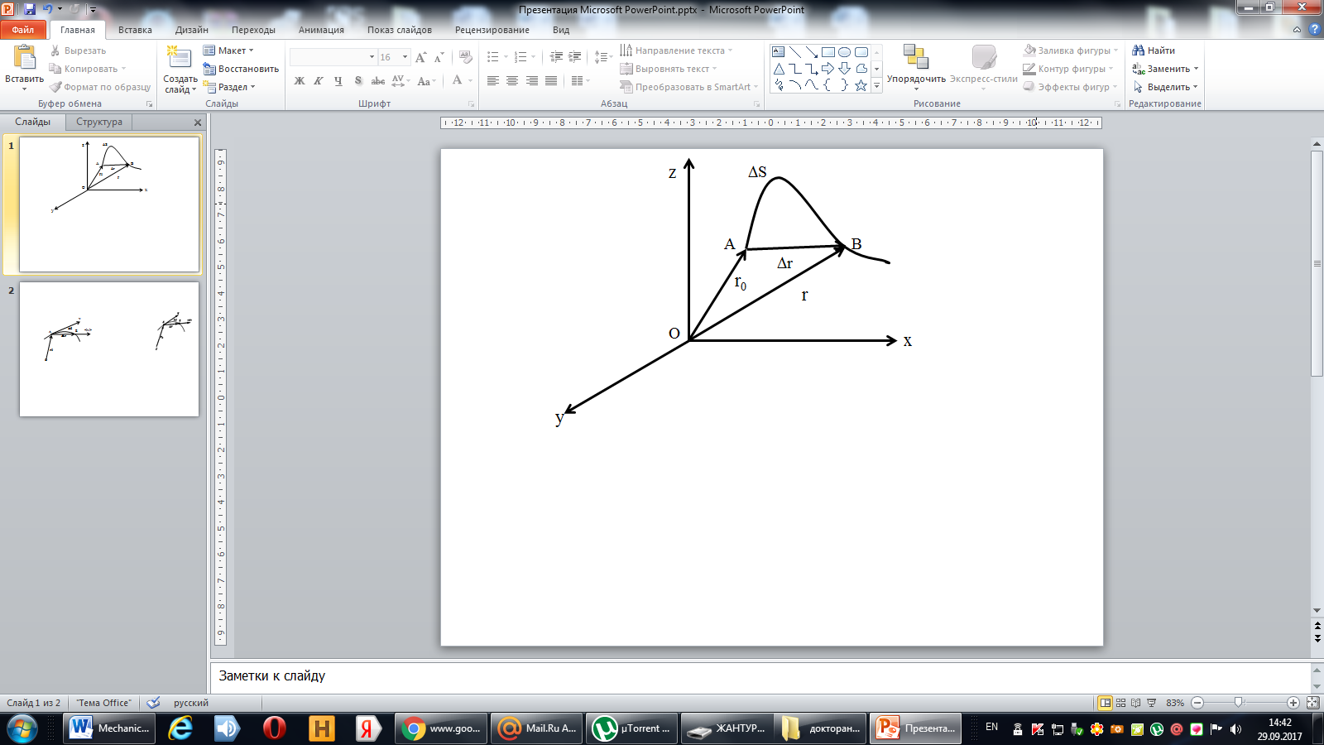

Figure 2. The motion of a point along an arbitrary trajectory

In linear motion the displacement vector coincides with the corresponding portion of the path and the module |Δr| is equal to the traveled distance Δs.

2. Velocity
Velocity is a vector quantity that refers to "the rate at which an object changes its position." Imagine a person moving rapidly - one step forward and one step back - always returning to the original starting position. While this might result in a frenzy of activity, it would result in a zero velocity. Because the person always returns to the original position, the motion would never result in a change in position. Since velocity is defined as the rate at which the position changes, this motion results in zero velocity. If a person in motion wishes to maximize their velocity, then that person must make every effort to maximize the amount that they are displaced from their original position. Every step must go into moving that person further from where he or she started. For certain, the person should never change directions and begin to return to the starting position.
Velocity is a vector quantity. As such, velocity is direction aware. When evaluating the velocity of an object, one must keep track of direction. It would not be enough to say that an object has a velocity of 55 m/h. One must include direction information in order to fully describe the velocity of the object. For instance, you must describe an object's velocity as being 55 m/h, east. This is one of the essential differences between speed and velocity. Speed is a scalar quantity and does not keep track of direction; velocity is a vector quantity and is direction aware.
Let the mass point moves along a curved path so that at time t the corresponding position vector r₀ (Fig. 3). For the small amount of time Δt point will pass a way Δs and receive elementary (infinitesimal) displacement Δr.

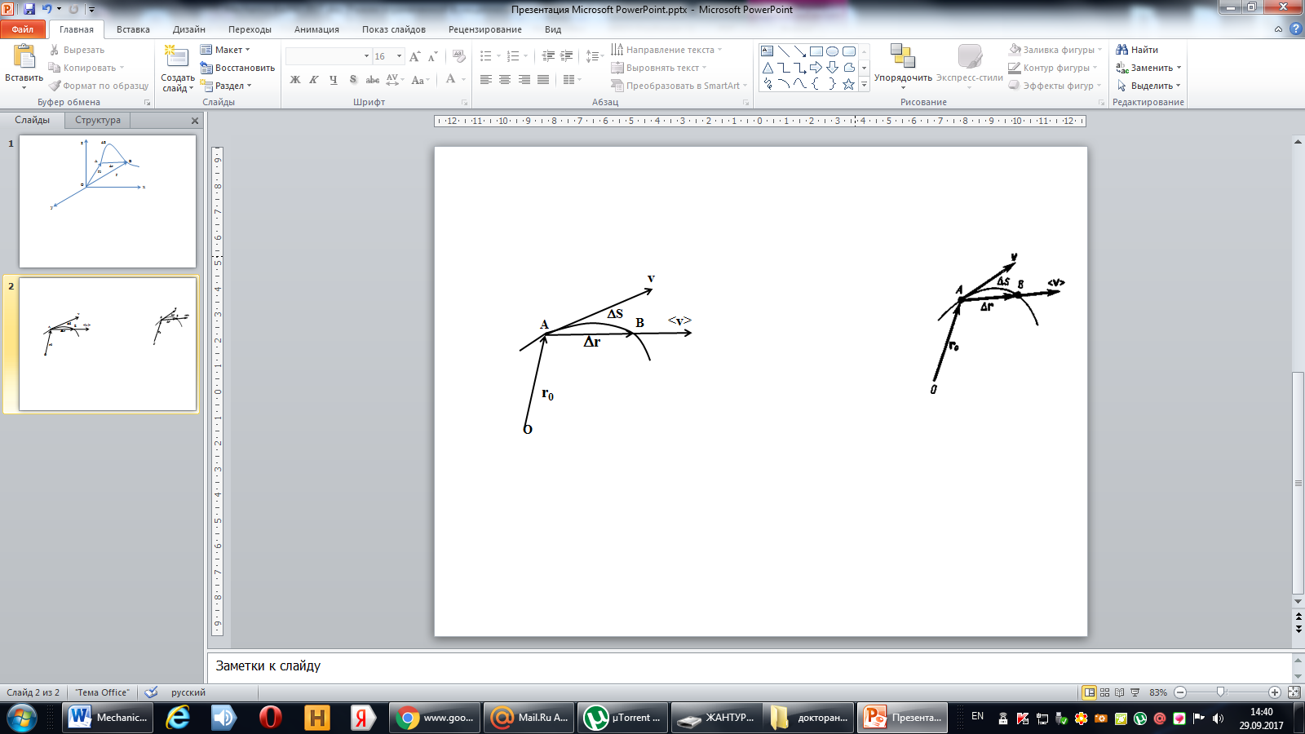

Figure 3. Displacement vector of the point

The vector average velocity <v> is the ratio of the increment Δr radius vector of the point to the time interval Δt:

$\left\langle v\right\rangle =\frac{Δr}{Δt}$. (2.1)

Average velocity vector coincides with the direction Δг. Average velocity decreases and indefinitely tends to a limiting value, which is called the instantaneous velocity v:

$v=\underset{Δr→0}{\text{lim}}\frac{Δr}{Δt}=\frac{\text{dr}}{\text{dt}}$. (2.2)

Instantaneous velocity v, therefore, is a vector quantity that is equal to the first derivative of the radius vector of a moving point in time. Since the secant coincides with the tangent, the velocity vector v is tangential to the path in the direction of motion (Fig. 3). With decreasing Δt path Δs more will approach |Δг|, so the instantaneous velocity module

Thus, the instantaneous rate is the first derivative module paths over
(2.2)

When nonuniform motion module instantaneous velocity varies with time. In this case, use a scalar <v> - an average rate of non-uniform motion:

From Fig. 3 <v> > |<r>||, since Δs >|Δг|, and only in the case of rectilinear motion

If the expression ds=vdt (. See (2.2)) integrated over time in the range from t до t+Δt, we find the length of the path traveled by the point in time Δt:

(2.3)

In the case of uniform motion in a numeric value the instantaneous velocity is constant; then the expression (2.3) takes the form

The length of the path traveled by a point in the time interval from t \ to fa, is given by the integral

3. Acceleration and its components
In the case of non-uniform motion is important to know how does the velocity change rapidly with time. Physical quantity that characterizes the rate of velocity change in magnitude and direction is called an acceleration.
Let’s consider the plane motion. i.e. the movement in which all sections of the trajectory points lie in the same plane. During the time Δt moving point has moved to the position B and the acquired velocity v is different from both the unit and the direction and equal v₁ = v + Δv. We transfer vector v₁ to the point А and find Δv (Fig. 4).
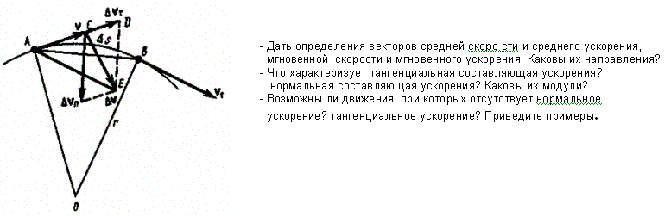
Figure 4. Plane motion

An average acceleration of the uniform motion in the interval from t to t+Δt is the vector quantity equal:
$\left\langle a\right\rangle =\frac{Δv}{Δt},$

The instantaneous acceleration of the material point at time t is the limit of the average acceleration:

$a=\underset{Δt→0}{\text{lim}}\left\langle a\right\rangle =\underset{Δt→0}{\text{lim}}\frac{Δv}{Δt}=\frac{\text{dv}}{\text{dt}}$

Thus, the acceleration is a vector equal to the first time derivative of velocity.
Let’s expand the the vector Δv into two components. To do this, from the point A (Fig. 4) in the direction of the velocity v postpone the vector $\vec{\text{AD}}$ with module equal v₁. Obviously, the vector equal $\vec{\text{CD}}$, equal Δv_{τ} determines the rate of velocity change over time Δt by module: Δv_{τ} = v₁ - v. The second component Δv_{n} of the vector Δv represents the change in velocity during Δt by direction.
The tangential component of the acceleration

$a_{τ}=\underset{Δt→0}{\text{lim}}\frac{{Δv}_{τ}}{Δt}=\underset{Δt→0}{\text{lim}}\frac{Δv}{Δt}=\frac{\text{dv}}{\text{dt}}$

i.e. is the first time derivative of the velocity, thereby determining the speed of the rate of velocity change by module.
Let’s find a second component of acceleration. Assume that the point B is close enough to the point A, so we can assume Δs the arc of a circle of radius r, which is little different from the chord AB. Then, from the similarity of triangles AOB and EAD should be${Δv}_{n}/\text{AB}=v_{1}/r$, but as AB=vΔt, the

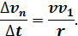

At limit Δt → 0 we obtain v₁ → v.
Because the v₁ = v, an angle EAD tends to zero, due to the triangle EAD is isoscele, the ADE angle between v and Δv_{n} tends to direct angle. Therefore, at Δt → 0 the vectors Δv_{n} and v are mutually perpendicular. The second component of the acceleration equal to

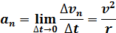

is called the normal component of acceleration and is perpendicular by the normal to trajectory to the center of curvature (it is also called the centripetal acceleration). The full acceleration of the body is the geometric sum of the tangential and normal components (Figure 5.):
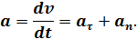
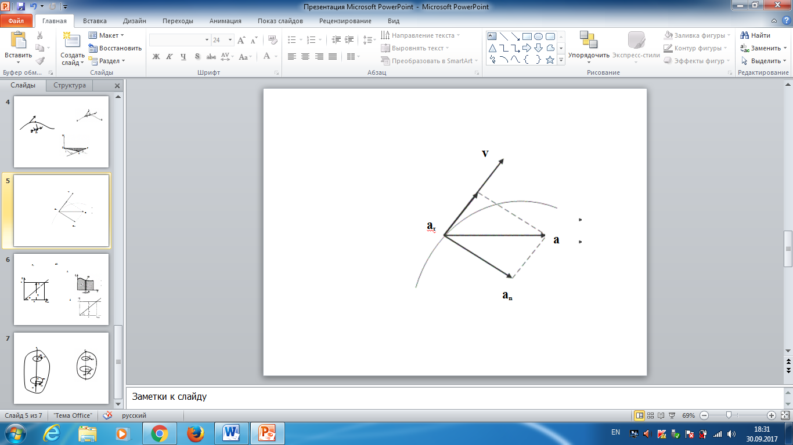

Figure 5. Components of acceleration

Thus, the tangential component of the acceleration characterizes the rate of velocity change by modulus (tangential to the path), and the normal component of acceleration – the rate of velocity change by direction (toward the center of curvature of the path).
Depending on the tangential and normal components of the acceleration the motion can be classified as follows:
- а_{τ} = 0, a_{n} = 0 — uniform motion;
- a_{τ} = a = const, a_{n} = 0 – nonuniform motion.
At such motion

$a_{τ}=a=\frac{Δv}{Δt}=\frac{v_{2}−v_{1}}{t_{2}−t_{1}}$

If at initial moment of the time t₁ = 0 and initial velosity v₁=v₀, then, take t₂=t and v₂ = v, we obtasin a=(v—v₀)/t, then

$$v=v_{0}+\text{at}$$

Integrating this equation in the range from zero to an arbitrary time t, we find that the length of the path traveled by a point, in the case of nonuniform motion

$s=\int_{0}^{t}{\text{vdt}=}\int_{0}^{t}{\left(v_{0}+\text{at}\right)\text{dt}=}v_{0}t+\frac{{\text{at}}^{2}}{2}$

- a_{τ} = f(t), a_{n} = 0 – linear motion with variable acceleration;
- a_{τ} = 0, a_{n} = const. At a_{τ} = 0 the velocity by module does not change, but changes in direction. From formula a_{n} =v²/r It follows that the radius of curvature should be a constant. Consequently, the rotational motion is uniform;
- a_{τ} = 0, a_{n} ≠ 0 — uniform curvilinear motion;
- a_{τ} = const, a_{n} ≠ 0 — curved uniformly accelerated motion;
- a_{τ} = f(t), a_{n} ≠ 0 — curvilinear motion with a variable acceleration.

4. Angular velocity and angular acceleration
Consider a rigid body that rotates around a fixed axis. Then the individual points of this body will describe a circles of different radii centers of which lie on the axis of rotation. Suppose a point moves along a circle of radius R (Fig. 6). Its position after a time Δt moves angle Δϕ. Elementary (infinitesimal) rotations can be regarded as vectors (or they are designated as $\vec{Δϕ}$ are $\vec{dϕ}$). The module of vector $\vec{Δϕ}$ is equal to the angle of rotation and its direction coincides with the direction of forward motion of the tip of the screw, which head rotates in the direction of the point on the circle, i.e. obeys the right-hand screw (see Fig. 6). Vectors, directions of which are associated with the direction of rotation are called pseudovectors or axial vectors. These vectors have no certain points of application: they can be deposited from any point of the axis of rotation.
Angular velocity is a vector quantity equal to the first derivative of the angle of rotation of the body by time:

$$ω=\underset{Δt→0}{\text{lim}}\frac{Δ\vec{ϕ}}{Δt}=\frac{d\vec{ϕ}}{\text{dt}}$$

The vector $\vec{ω}$ is directed along the rotation axis by right-handed screw rule, i.e. as vector $d\vec{ϕ}$(Fig. 7). The dimension of the angular velocity $\text{dim}ω=T^{−1}$and its unit - radians per second (rad/s).

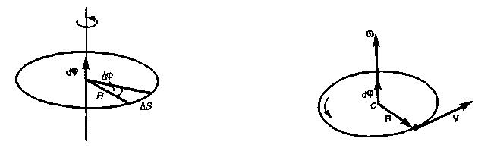
Figure 6 Figure 7

The linear velocity of a point (Fig. 6)

$$v=\underset{Δt→0}{\text{lim}}\frac{Δs}{Δt}=\underset{Δt→0}{\text{lim}}\frac{RΔϕ}{Δt}=R\underset{Δt→0}{\text{lim}}\frac{Δϕ}{Δt}=Rω$$

$$v=ωR$$

The formula for the linear velocity in vector form can be written as a vector product:

$$v=\left[\vec{ω}R\right]$$

If ω =const, then the rotation is uniform and can be characterized by a period of revolution T – the time at which the point makes one full rotation, i.e. rotates to an angle 2π. Since the time interval Δt = Т corresponds Δϕ = 2π, then ω = 2π/Т, where

$$T=\frac{2π}{ω}$$

The number of complete rotations made by the body when it moves uniformly by circle per unit of time is called the frequency:

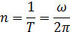

from this

The angular acceleration is a vector quantity equal to the first derivative of the angular velocity with respect by time:

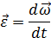

The tangential component of the acceleration

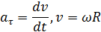
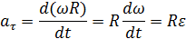

Normal acceleration

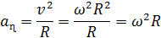

When the body rotates about a fixed axis angular acceleration vector is directed along the rotation axis at the direction of the elementary increment of angular velocity. At accelerated motion the vector $\vec{ε}$ has the same direction as vector $\vec{ω}$ (Figure 8), at decelerated motion – is opposite to it (Figure 9.)
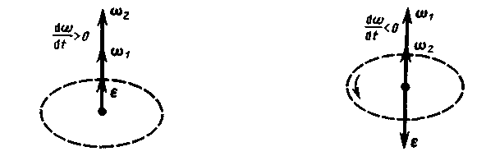

Figure 8 Figure 9

Thus, the connection between the linear (the path length s, the linear velocity v, tangential acceleration а_{τ}, normal acceleration а_{n} ) and the angular values (rotation angle ω, the angular velocity ω, angular acceleration ε) is expressed as follow formulas:

In the case of uniformly accelerated motion of point by circle (ε-const.)
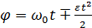

where ω₀ — initial angular velocity.

Control questions by the theme
- What is the material point?
- What is the difference between the displacement and path?
- Define the concepts of "mechanical motion", "body of reference" and "material point".
- The difference between the concepts "trajectory", "path" and "displacement".
- What is the forward motion of the body?
- What is the uniform rectilinear motion of a body (particle)?
- What does the speed of uniform motion show?
- What movement is called equally accelerated?
- What is acceleration and what does it show? The unit of acceleration.
- Draw graphs showing the dependence of velocity on time with uniform motion, uniformly accelerated motion with initial velocity and without it (there should be three graphs in total).
- What is the free fall of bodies? What is the acceleration of gravity g near the Earth's surface.
- The law of addition of velocities. An example of the law.
- The motion of a material point along a circle. Definitions of the period of revolution, rotation speed. Formulas for centripetal acceleration and velocity for a uniform motion of a point along a circle.

Problems
1.1. The dependence of the traversed path of the body from time is given by the equation s=A+Bt+Ct²+Dt ³(С=0,1 м/с², D=0,03 m/s³). Define: 1) time after the beginning of the motion, through which the acceleration of a body is equal 2 m/s²;
2) average acceleration <а> of body through time. [1) 10 s; 2) 1,1 m/s²]

1.2. Neglecting air resistance, determine the angle at which the body is thrown to the horizon, where the maximum lifting height of the body is equal to 1/4 of the range of its flight. [45°]

1.3. Wheel of radius R = 0,1m rotated so that the angular velocity dependence on time is given by the equation ω = 2At + 5Bt⁴ (А = 2 rad/s² и В = 1 rad/s⁵). Determine the total acceleration of the wheel rim points after t=1 s after the start of rotation and the number of revolutions made by the wheel during this time. [а=8,5 m/s²; N = 0,48]

1.4. Normal acceleration of the point moving by a circle of radius r = 4 m, is given by equation a_{n}=A+Bt+Ct² (A = 1 m/s², B = 6 m/s², С = 3 m/s²). Define: 1) tangential acceleration of a point; 2) the path traversed by the point after time t₁=5 s after the start of motion; 3) full acceleration for time t₂=1 s. [1) 6 m/s²; 2) 85 m; 3) 6,32 m/s²]

1.5. Wheel rotation frequency speed at uniformly decelerated motion in t = 1 min decreased from 300 to 180 minutes ⁻¹. Define: 1) angular acceleration of the wheel; 2) The number of complete rotations made by the wheel during this time. [1) 0,21 rad/s²; 2) 240]

1.6. Disc of radius R = 10 cm rotates around a fixed axis so that dependence of the angle of rotation of the disk radius on time is given by the equation ϕ=A+3t+Ct²+Dt³ (B = 1 rad/s, С = 1 rad/s², D = 1 rad/s³). Determine for the points on the rim of wheel at the end of 2nd second after the start of motion: 1) tangential acceleration %; 2) normal acceleration а_{n}; 3) full acceleration а. [1) 1,4 m/s²; 2) 28,9 m/s²; 3) 28,9 m/s²]

Part 2

Dynamics of material point

5. First Newtons law. Mass. Forse
Dynamics is the main part of mechanics, based on three Newton's Laws, formulated in 1687. Newton's Laws play a crucial role in the mechanics and are (like all the laws of physics) a generalization of the results of vast human experience. They are considered as a system of interrelated laws and subjected to experimental verification of every single law, and the whole system.
Newton's first law: An object in motion with a constant velocity will continue in motion unless acted upon by some net external force. A body at rest is just a special case of Newton’s first law with zero velocity. Newton’s first law is often called the law of inertia and is also used to describe inertial reference frames.
Mechanical motion is relative, and it depends on the nature of the reference system. Newton's first law does not apply in any frame of reference, and those systems with respect to which it is performed are called inertial frames. Inertial reference frame is a frame of reference with respect to which a material point, free from external influences, either at rest or at uniform motion by a straight line. Newton's first law asserts the existence of inertial reference systems.
Laws of Nature are essentially mathematical postulates that permit us to understand natural phenomena and make predictions concerning the time evolution or static relations between the coordinates associated with objects in nature that are consistent mathematical theorems of the postulates. These predictions can then be compared to experimental observation and, if they are consistent (uniformly successful) we increase our degree of belief in them. If they are inconsistent with observations, we decrease our degree of belief in them, and seek alternative or modified postulates that work better. The entire body of human scientific knowledge is the more or less successful outcome of this process. This body is not fixed – indeed it is constantly changing because it is an adaptive process, one that self-corrects whenever observation and prediction fail to correspond or when new evidence spurs insight (sometimes revolutionary insight!) Newton’s Laws built on top of the analytic geometry of Descartes (as the basis for at least the abstract spatial coordinates of things) are the dynamical principle that proved successful at predicting the outcome of many, many everyday experiences and experiments as well as cosmological observations in the late 1600’s and early 1700’s all the way up to the mid-19th century. When combined with associated empirical force laws they form the basis of the physics you will learn in this course.Body weight - a physical quantity, which is one of the main characteristics of matter that determines its inertia (inertial mass) and gravity (gravitational mass) properties. It can now be considered proven that the inertial and gravitational masses are equal to each other (with an accuracy of not less than 10 values).
To describe the effects mentioned in the first Newton's law, was introduced the concept of force. Under the action of body forces, or change the speed of motion, i.e. body acquire acceleration (dynamic display of power), or deformed, i.e. body change their shape and size (static display of forces). At any time, the power is characterized by a numerical value, direction in space and point of application. Thus, the force is a vector quantity, which is a measure of the mechanical effects on the body from other bodies or fields, in which the body becomes at-acceleration or changes its shape and size we can take that the inertial and gravitational masses are equal to each other ( with an accuracy not less than the value of 10).

6. Second Newtons law
Newton's second law - the fundamental law of dynamics of translational motion answers the question of how does change the mechanical motion of a material point under the influence of mechanical forces.
If we consider the effect of various forces on the same body, then the acceleration acquired by the body, is always directly proportional to the resultant of applied forces:

(2.1)

The action of the same force on the bodies with different masses their acceleration are different, namely

$a≈\frac{1}{m}$ (F= const) (2.2)

Using the expression (2.1) and (2.2) and taking into account that the force and acceleration are vector quantities, we can write

$a=k\frac{F}{m}$ (2.3)

Equation (2.3) expresses the second Newton's law: The net force applied to an object is directly proportional to its acceleration in an inertial reference frame. The constant of proportionality is called the mass of the object.
In the system SI proportionality coefficient k = 1. Then

$a=\frac{F}{m}$
$F=\text{ma}=m\frac{\text{dv}}{\text{dt}}$ (2.4)
Given that the mass of the material point (the body) in classical mechanics is a constant in the expression (6.4) it can be made under the sign of the derivative:

$F=\frac{d}{\text{dt}}\left(\text{mv}\right)$ (2.5)
Vector quantity

P = mv (2.6)

numerically equal to the product of the mass of a particle and its velocity and has direction of the velocity is called momentum (momentum) of the material point. Putting (2.6) into (2.5), we obtain

$F=\frac{\text{dp}}{\text{dt}}$ (2.7)

This expression - a more general formulation of Newton's second law: the rate of change of momentum of a material point is equal to the acting at it force. Expression (2.7) is called the equation of motion of a material point.
The unit of force in SI - newton (N): 1 N - force acting to the mass of 1 kg according to the acceleration of 1 m/s² in the direction of the force:

1 N= 1 kg*m/

Newton's second law is valid only in inertial reference systems. Newton's first law can be obtained from the second. Indeed, in the case of zero resultant force (in the absence of effects on the body from other bodies) the acceleration (consider (2.3)) is also zero. However, Newton's first law is regarded as a separate law (rather than as a consequence of the second law), since it asserts about the existence of inertial reference systems, which only satisfied the equation (2.7).
In mechanics of great importance is the principle of superposition: if on a material point act multiple forces, then each of these forces gives to a material point the acceleration according to Newton's second law, as if was not other forces. According to this principle, force and acceleration can be decomposed into components, the use of which leads to a significant simplification of solving problems. For example, in Fig. 10 acting force F = ma broken down into two components: the tangential force F (tangential to the trajectory) and normal F_{n} (directed along the normal to the center of curvature).

$$F_{τ}{\text{ma}}_{τ}=m\frac{\text{dv}}{\text{dt}}$$
$$F_{n}={\text{ma}}_{τ}=\frac{{\text{mv}}^{2}}{R}={mω}^{2}$$

Using expressions $a_{τ}=\frac{\text{dv}}{\text{dt}}$ , $a_{n}=v^{2}R$, and v = Rv, we can right:
$\begin{aligned}F_{τ}={\text{ma}}_{τ}=m\frac{\text{dv}}{\text{dt}}; \\ F_{n}={\text{ma}}_{n}={{\text{mv}}^{2}}/R={mω}^{2}R\end{aligned}$

If the material point is acted by some forces, according to the principle of force independence in Newton’s second law we mean resultant force.

7. Third Newtons law
The interaction between particles (bodies) is defined by Newton's third law: The force exerted by body 1 on body 2 is equal in magnitude and opposite in direction to the force that body 2 exerts on body 1. If the force on body 2 by body 1 is denoted by F21, then Newton’s third law is written as:

$F_{\text{12}}=−F_{\text{21}}$ (7.1)

where F₁₂ - the force acting on the first material point from the second; F₂₁ - the force acting on the second material point from the first. These forces are applied to different material points (bodies), always operate in pairs and are a forces of nature.
Newton's third law allows the transition from the dynamics of a separate material points to the dynamics of system of material points. This follows from the fact that the interaction of a system is lead to the pair of interaction forces between particles.

8. Friction
Discussing still forces, we were not interested in their origins. However, in mechanics we will consider the various forces: friction, elasticity, gravity.
From the experience we know that any body moving on a horizontal surface of the other body, in the absence of other forces slows down with time and eventually stops. This can be explained by the existence of the friction that prevents sliding bodies in contact with each other. The friction depends on the relative velocity of bodies. The friction forces can be of different nature, but as a result of their actions the mechanical energy is transformed into internal energy of bodies in contact.
There are external (dry) and internal (liquid or viscous) friction. External friction is called the friction that occurs in the plane of contact of two bodies in contact at their relative motion. If the bodies are motionless, we can talk about the friction of rest, if there is a relative motion of the bodies, then depending on the nature of their relative motion we can talk about sliding friction, rolling or spinning.
Internal friction is called the friction between the parts of the same body, such as between the various layers of liquid or gas, the speed of which changes from layer to layer. In contrast to the external friction there is no static friction. If the bodies slide relative to each other and separated by a layer of viscous liquid (lubricant), the friction occurs in the lubricant layer. In this case we speak about of a hydrodynamic friction (lubrication layer is thick enough) and boundary friction (lubricant layer thickness ≈0,1 microns or less).
Let us discuss some of the laws of the internal friction. This friction is due to the roughness of contacting surfaces; in the case of very smooth surfaces the friction is due to the forces of intermolecular attraction.
Let’s consider the body lying in the plane (Fig. 10), to which is attached a horizontal force F. The body will move only when the applied force F is greater than the friction f. French physicists G. Amontons (1663-1705) and S. Coulomb (1736-1806) empirically established the following law: the friction is proportional to the normal force with which one body acts on another:
$F_{\text{fr}}=\text{fN}$

where f- sliding friction coefficient, which depends on the properties of the contacting surfaces.
Let us find the value of the coefficient of friction. If the body is on an inclined plane with an inclination angle α (Fig. 12), it starts to move, when only the tangential component of gravity force is greater than the friction. Therefore, in the limiting case (start sliding body) F = F_{fr} or $P\text{sin}α_{0}=f=\text{fN}=\text{fP}\text{cos}α_{0}$, then

$f=\text{tg}α_{0}$
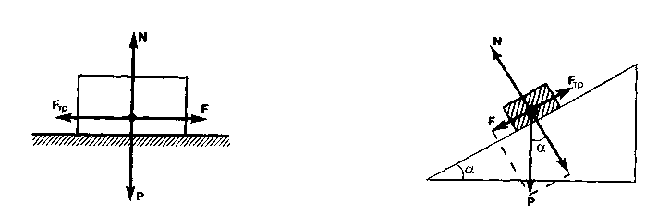
Figure 10 Figure 11

For smooth surfaces play a role the intermolecular attraction. The law of friction for them

$F_{\text{fr}}=f\left(N+{\text{Sp}}_{0}\right)$
where p₀ - the additional pressure caused by the forces of intermolecular attraction, which rapidly decrease with increasing the distance between the particles; S - the square of contact between the bodies; f - coefficients of friction.
Friction plays an important role in nature and technology. Due to friction move transport, the nail kept driven into the wall and so on.
In some cases, the friction forces have a deleterious effect and therefore they must be reduced. For this purpose, a lubricant is applied to the friction surfaces (friction force is reduced by about 10 times) to fill irregularities between the surfaces and is located as the thin layer so that the surface would no longer like to touch each other and slide against each other as separate liquid layers. Thus, the external friction of solids replaced with much lower internal friction of liquid.
A radical way to reduce the friction force is the replacement of sliding friction by rolling friction (ball and roller bearings and so on.). The strength of the rolling friction is determined according to the law, established by Coulomb:
$F_{\text{fr}}={\text{fN}}/r$ (8.1)

where r - radius of the rolling body; f - coefficient of rolling friction with the dimension dim f_{k} = L. From (8.1) it follows that the force of rolling friction is inversely proportional to the radius of the rolling body.

9. Conservation of momentum. Center of mass
To derive the law of conservation of momentum, let’s consider some definitions. The collection of material points, considered as a single entity, is called the mechanical system. The forces of interaction between the material points of the mechanical system are called internal. The forces with which act on the material points of the system the external body are called external. The mechanical system of bodies on which no external force is called a closed (or isolated). If we have a mechanical system consisting of many bodies, according to Newton's third law, the forces acting between the two bodies are equal and are opposite directed, i.e. geometric sum of the internal forces is zero.
Consider a mechanical system consisting of n bodies, mass and the velosity of which are m₁, m₂, ..., m_{n} and v₁, v₂, ..., v_{n}. Let F′₁, F′₂, ..., F′_{n} - resultant of internal forces acting on each of the bodies, and F₁, F₂, ..., F_{n} - resultant of external forces. Let’s write Newton's second law for each of the N bodies (mechanical system):

$$\frac{d}{\text{dt}}\left(m_{1}v_{1}\right)=F_{1}^{'}+F_{1}$$
$\frac{d}{\text{dt}}\left(m_{2}v_{2}\right)=F_{2}^{\}+F_{2}}$..
$$\frac{d}{\text{dt}}\left(m_{n}v_{n}\right)=F_{n}^{\}+F_{n}}$$

Adding these equations term by term, we obtain

$$\frac{d}{\text{dt}}\left(m_{1}v_{1}+m_{2}v_{2}+m_{3}v_{3}+\text{.}\text{.}\text{.}m_{n}v_{n}\right)=F_{1}^{\}+F_{2}^{\}+F_{3}^{\}+\text{.}\text{.}\text{.}+F_{n}^{\}+F_{1}+F_{2}+\text{.}\text{.}\text{.}F_{n}}}}}$$

But as the geometric sum of the internal forces of the mechanical system is equal zero by the third law of Newton,
$$\frac{d}{\text{dt}}\left(m_{1}v_{1}+m_{2}v_{2}+m_{3}v_{3}+\text{.}\text{.}\text{.}m_{n}v_{n}\right)=F_{1}+F_{2}+\text{.}\text{.}\text{.}F_{n},$$
or

$\frac{\text{dp}}{\text{dt}}=F_{1}+F_{2}+\text{.}\text{.}\text{.}F_{n},$ (9.1)

where $p=\sum_{i=1}^{n}{m_{i}v_{i}}$ — system momentum. Thus, the time derivative of the momentum of the mechanical system is the geometric sum of the external forces acting on the system.
In the absence of external forces (consider a closed system)

$\frac{\text{dp}}{\text{dt}}=\sum_{i=1}^{n}{\frac{d}{\text{dt}}}\left(m_{i}v_{i}\right)=0,$$p=\sum_{i=1}^{n}{m_{i}v_{i}}=\text{const},$

The last expression is the law of conservation of momentum: impulse of an isolated system is conserved, i.e., does not change over time.
The law of conservation of momentum is valid not only in classical physics, though he received as a consequence of Newton's laws. Experiments show that it holds for closed systems of microparticles (they obey the laws of quantum mechanics). This law is universal, i.e., the law of conservation of momentum - fundamental law of nature.
The law of conservation of momentum is a consequence of a certain symmetry properties of space - its homogeneity. The homogeneity of space is that the parallel displacement in the space of an isolated system of bodies as a whole, its physical properties and the laws of motion do not change, in other words, do not depend on the choice of the position of the origin of the inertial reference system.
Note that, according to (9.1), the momentum is maintained and to an open system if the geometric sum of all the external forces is zero.
In the mechanics of Galileo-Newton due to the independence of the masses on velocity the impulse of the system can be expressed through the speed of its center of mass. The center of mass (or center of mass) of a system of material points is called an imaginary point C, the position of which describes the distribution of the mass of the system. Its radius vector is

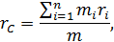

where m_{i} and r_{i} — mass and radius vector of i- material point; n — number of material points in the system; $m=\sum_{i=1}^{n}{m_{i}}$, — system’s mass. Velosity of mass center

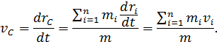

Taking into account that $p_{i}=m_{i}v_{i}$ the $\sum_{i=1}^{n}{m_{i}}$, we can right

, (9.2)

i. e. the momentum of the system is the product of a system’s mass and velocity of its center of mass.
Substituting (9.2) into (9.1), we obtain

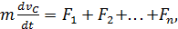 (9.3)

so center of mass moves as the point at which the mass of whole system is concentrated and on which the force is equal to the geometric sum of all external forces applied to the system. Expression (9.3) is a law of motion of the mass center.
In accordance with (9.2) from the law of conservation of momentum follows that the center of mass of a closed system moves uniformly or remains stationary.

10. Equation of motion of variable mass body
The motion of some bodies is accompanied by changes in their weight, for example, the mass of a rocket decreases as a result of the expiration of gases produced by the combustion of fuel, and so on.
We derive the equation of motion of variable mass body on the example of the rocket. If at time t the rocket’s mass is m, its speed v, then after the time dt its mass will decrease to dm, and the speed becomes equal to v + dv. Change in the momentum of the system in time dt

where u — velocity of expiration of gas relative to the missile. Then

If the system is subjected to external force, dp = Fdt, therefore

or

$m\frac{{\text{dv}}_{c}}{\text{dt}}=F−u\frac{\text{dm}}{\text{dt}}$ (10.1)

The second term on the right side of (10.1) is called the reaction force F_{p}. If it is the opposite of the direction, the rocket is accelerating, and if coincides with v, then rocket braked.
Thus, we have obtained the equation of motion of variable mass body
(10.2)

which was first displayed by Meshcherski (1859-1935).
The idea of using the reactive force to create aircrafts was voiced in 1881 by N.I. Kibalchich (1854-1881). Konstantin Tsiolkovsky (1857-1935) in 1903 published an article in which he proposed the theory of the rocket and the basis of the liquid jet engine theory. Therefore, he is considered as the founder of Russian cosmonautics.
Let’s apply the equation (10.1) to the motion of the rocket, which is not affected by any external forces. Putting F = 0, and assuming that the rate of emitted gases relatively constant (rocket moves in a straight line), we obtain

$m\frac{\text{dv}}{\text{dt}}=−u\frac{\text{dm}}{\text{dt}}$ ,

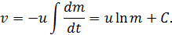

The value of the integration constant C is determined from the initial conditions.
If at the initial time the velocity of rocket is zero, and its launch weight is m₀ then C = ulnm₀. Consequently,
(10.3)

This ratio is called the Tsiolkovsky rocket equation. It shows that: 1) the larger the final mass of the rocket m, the greater should be the starting mass m₀; 2) the greater the velocity of the gases and the greater may be the final mass for this launch weight of the rocket.
Equations (10.2) and (10.3) are obtained for the non-relativistic motions, i. e. for the cases where the velocities v and u are small compared with the speed of light in a vacuum.

Control questions by the theme
- Newton's first law, a system for which he is just. principle of relativity of Galileo.
- Newton's second law.
- What is the density of matter. Unit of density.
- The third law of Newton.
- How many kinds of forces are distinguished in mechanics?
- Hooke's Law.
- The law of sliding friction. The frictional force of rest.
- What is body weight and weightlessness? What is the first cosmic speed?
- Formulate Newton's third law, explain it. What forces are called external, and which are internal? What is called the center of mass (the center of inertia) of the mechanical system? When considering the motion of a mechanical system it is sufficient to consider the motion of only its center of mass?
- What forces act on the load suspended on the thread? What is called body weight? In what case is the weight of a body numerically equal to the force of gravity?
- How many equations are needed to describe a mechanical system consisting of n bodies that are acted upon by both internal and external forces? How do these equations form? What is the sum of all internal forces acting on a system of bodies?
- Write down the law of conservation of momentum for two interacting bodies.

Problems
2.1. The body slides by an inclined plane with an inclination to the horizontal 30 °. Determine the velocity of the body at the end of the third second from the beginning of sliding, if the coefficient of friction is 0.15. [10.9 m / s]

2.2. The plane describes the loop of radius 80 m. What should be the lowest speed of the aircraft to the pilot's seat does not cut out at the top of the loop? [28 m / s]

2.3. The unit is mounted on top of the two inclined planes constituting with the the horizon angles 30 ° and 45 °. Weights of equal mass (m₁ = m₂ = 2 kg) are connected by thread, thrown through the block. Considering the thread and block weightless, taking friction coefficients f₁ = f₂ = f = 0.1 and neglecting the friction determine 1) the acceleration of weights, 2) tension of the thread. [1) 0.24 m/s²; 2) 12 H]

2.4. On the railway platform is mounted recoilless gun from which the shot along the track at an angle 45 ° to the horizon. The weight of platform with gun 20 tonns, projectile mass m = 10 kg, the coefficient of friction between the wheels and the rails of the platform f = 0,002. Determine the velocity of the projectile, if after the shot the platform shifted to the distance s=3 m. [$v_{0}=M\sqrt{2\text{fgs}\left(m\text{cos}∂\right)}=\text{970}$ m/s]

2.5. On the boat with mass m = 5 tonns is the water jet, eject 25 kg / s of water at a speed of u = 7 m/s relative to the boat backwards. Neglecting the resistanse to the boats movement, define: 1) the speed of the boat after 3 minutes after the beginning of the motion, 2) the maximum possible speed of the boat. [1) $v=u\left(1−\text{exp}\left(−μt/m\right)\right)$=4,15 м/с; 2) 7 m/s]

Part 3

Work and energy

11. Energy, Work , Power
Energy - an universal measure of different forms of motion and interaction. With different forms of motion of matter is binded various forms of energy: mechanical, thermal, electromagnetic, nuclear and so on. In one phenomena the matter motion form does not change (for example, hot body heats cold), in others - it goes into an another form (eg, as a result of friction mechanical motion is converted into heat). However, it is essential that in all cases the energy given up (in one form or another) by one body to another body, equal to the energy received by the latter body.
The change in mechanical motion of the body is caused by the forces acting on it by other bodies. To quantitatively characterize the process of energy exchange between the interacting bodies in mechanics introduced the concept of the work of force.
When the body moves rectilinearly and has a constant force F, which is at an angle а with a moving direction, then the work of this force is equal to the product of the projection of force F and the direction of movement, multiplied by the displacement of the point of force application
(11.1)

In general, the force can vary as by mod, and direction, so the formula (11.1) can not be used. If, however, consider the elementary displacement dr, then the force F can be assumed to be constant, and the movement of its point of application - straight. The elementary work of the force F on the displacement dr is called a scalar quantity

dA = Fdr = Fcosα ds = F₂ds,

where α — an angle between F and dr; ds=|dr| — elementary path; F_{s} — projection of vector F on dr (Fig. 12).

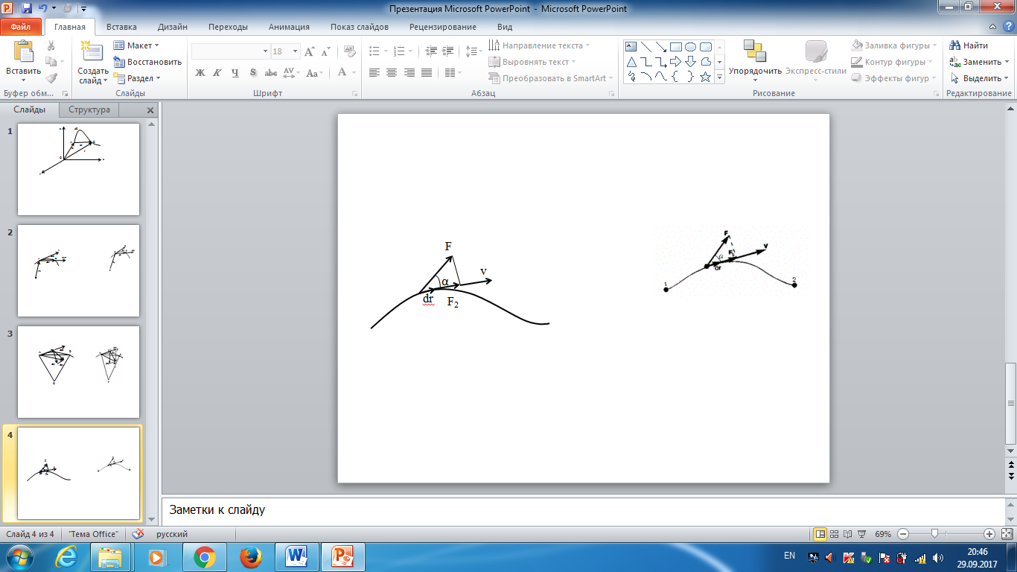
Figure 12
The force work in the area of the trajectory from point 1 to point 2 is equal to the algebraic sum of the elementary works on selected infinitesimal sections of the path. This amount is reduced to the integral
(11.2)

To calculate this integral it is necessary to know the dependence of the force F_{s} from the path along the trajectory 1-2. Let this dependence is shown graphically (Fig. 13), then the required work A is defined on the graph by the square of the shaded figure. If, for example, the body moves in a straight line, the force F = const and a = const, we obtain

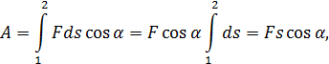
where s — distance traveled by body.

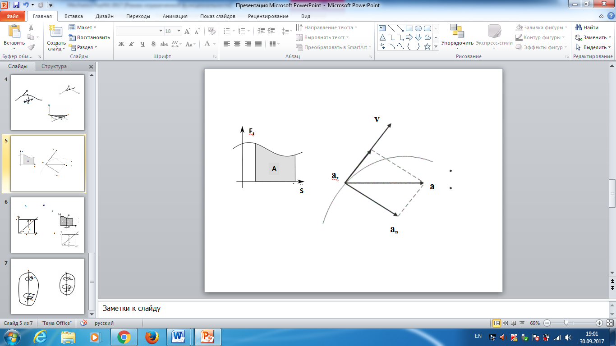
Figure 13. Calculation of the work by integration

From (11.1) it follows that if α < π/2 the force work is positive, and in this case, the F component is in the the same direction as the vector of velocity v (see. Fig. 13). If α > π/2, the force work is negative. If α = π/2 (the force is perpendicular to the displacement of) the force work is zero.
The unit of work is — Joule (J): 1 J —t he work done by the force on the path 1 m (1 J=1 N-m).
In order to characterize the rate of work doing, introduce the concept of power:

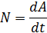

During the time dt the force F does the work Fdr, and power developed by this force at a given time
$N=\frac{\text{Fdr}}{\text{dt}}=\text{Fv}$ (11.3)

that is equal to the scalar product of the force vector to the velocity vector, with which moves the point of force application; N - the scalar quantity.
The unit of Power is watt (W): 1 W – the power, at which on time 1 second is done the work 1 J (1 W = 1 J/s).

12. Kinetic and potential energy
The kinetic energy of the mechanical system - the energy of the mechanical motion of the system.
The force F, acting on a body at rest, and causing its motion, does work, and the energy of a moving body is increased by the amount of expended work. Thus, the work dA of the force F on the path that the body passed during the ascending of the velocity from 0 to v, is to increase the kinetic energy of the body i. e.

Using Newton's second law F = ma and multiplying by displacement dr, we get

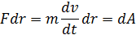

The $v=\frac{αr}{dt^{'}},$ then dA = mvdv = mvdv = dT, and

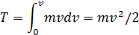

Thus, the body of mass m moving with velocity v, has a kinetic energy

(12.1)

Formula (12.1) shows that the kinetic energy depends only on the mass and velocity of the body. The kinetic energy of the system is a function of its state of motion.
From the derivation of (12.1) it was assumed that the motion is considered in an inertial frame of reference, since otherwise it would be impossible to use Newton's laws.
In different inertial reference systems moving relative to each other, the body speed, and consequently, its kinetic energy will vary. Thus, the kinetic energy depends on the choice of the reference system.
Potential energy - mechanical energy of a system of bodies, determined by their mutual disposition and the nature of the interaction forces between them.
Let the interaction of bodies is carried out by force fields (e.g., the field of elastic forces, the field of gravitational forces), characterized by the fact that the work done by the acting forces at body motion from one position to another, does not depend on a trajectory of this motion and itdepends only on initial and final positions. Such fields are called potential, and the forces acting in them - conserved. If the work done by the force depends on the path of the body from one point to another, such force is called dissipative; the example of it is friction.
The body in a potential force field has potential energy P. The work of conservative forces in elementary (infinitesimal) change of the configuration of the system is equal to the increment of potential energy, taken with a minus sign, as the work is done by the loss of potential energy:

(12.2)

The work dA work is expressed as a scalar product of the force F on the displacement dr and the expression (12.2) can be written as

(12.3)

Therefore, if the function P(r) is known, then from the formula (12.3) we can find the force F in magnitude and direction.
Potential energy can be determined on the basis of (12.3) as the

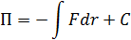

where C -constant of integration, i.e., the potential energy is defined with accuracy to some arbitrary constant. This, however, does not affect on the laws of physics, as they contain or the difference between the potential energies in the two positions of the body, or a derivative of P by coordinates. Therefore, the potential energy of the body in any particular situation is considered to be zero (the zero reference level is selected), and the energy of the body in other states is determined relative to the zero level. For the conservative forces

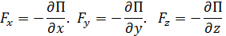

Or in vector form

(12.4)
where

$\text{gradП}=\frac{∂}{∂x}i+\frac{∂}{∂y}j+\frac{∂}{∂z}k$ (12.5)

(i, j, k - the unit vectors of the coordinate axes). The vector defined by the expression (12.5) is called the gradient of a scalar P. For it, along with the designation grad P is also applied ∇. ∇ («nabla") refers to the symbolic vector, called Hamilton operator or Nabla-operator.

$∇=\frac{∂}{∂x}i+\frac{∂}{∂y}j+\frac{∂}{∂z}k$ (12.6)

The particular form of the function P depends on the nature of the force field. For example, the potential energy of a body with mass m, raised to a height h above the Earth's surface, is equal to

P =mg (12.7)

where the height H is measured from the zero level for which P₀=0. Expression (12.7) follows directly from the fact that the potential energy is equal to the work of gravity force when the body dropped from a height h on the Earth's surface.
Since the reference point is chosen arbitrarily, then the potential energy can be negative (the kinetic energy is always positive!). If we take the potential energy of the body on the ground surface as zero, the potential energy of the body, located on the bottom of the shaft (depth h¹), P= —mgh'.
Let’s find the potential energy of elastically deformed body (spring). The strength of the elastic deformation is proportional to:

where F_{х elast} — the projection of the elastic force on x-axis; k - the coefficient of elasticity (a spring - stiffness) and the minus sign indicates that the force F_{х elast} is directed oppositely to deformation x.
According to Newton's third law, the deforming force is equal in modulus to elastic force and is oppositely directed to her, i. e.

The elementary work dA, done by the force F_{x elast} at it infinitely small deform ation dx is equal

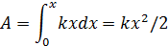
and is for the increase in potential energy of the spring. Thus, the potential energy of elastically deformed body
P=

The potential energy of the system is a function of the system state. It depends on the system configuration and its position in relation to external bodies.
The full mechanical energy of the system - the energy of mechanical motion and interaction:

E=T+P

- e. is the sum of kinetic and potential energies.

13. The energy conversation law
The law of energy conservation - the result of summarizing of many experimental data. The idea of this law belongs to Mikhail Lomonosov (1711-1765), set out the law of conservation of matter and motion, and quantitative formulation of the energy conservation law was given by the german doctor Yu Mayer (1814-1878) and the german naturalist G. Gelmgoltz (1821-1894).
Let’s consider the system of material points with masses m₁, m₂,…, m_{n}, move with velosities v₁, v₂,…, v_{n}. F′₁, F′₂, ..., F′_{n} — the resultant internal conservative forces acting on each of these points, and F₁, F₂, ..., F_{n} — the resultant of the external forces which will also be considered as conservative. In addition, we assume that also non conservative external forces act on material points; resultants of these forces acting on each of the material points is denoted f₁, f₂,…, f_{n}. At v << c mass of material points are constant and the equations of Newton's second law for these points as follows:

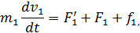
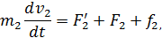………………………
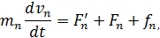

Driving under the influence of the forces, the systems points in time interval dt do displacements equal dr_{t}, dr₂, ..., dr_{n}. Let’s multiply each of the equations scalarly on corresponding displacement and, taking into account that dr_{i} = v_{i}dr, we obtain

