POTENTIAL USE OF CARBON ELECTRODE MATERIALS DERIVED FROM VEGETABLE BIOMASS FOR SUPERCAPACITORS

V. Pavlenko ¹, J. Jandosov^{2*}, F. Bѐguin³,
Z. Mansurov², P. Cleszyk⁴, et al.

¹ Kazakh National University, Institute of Combustion Problems, Almaty, 172 Bogenbai Batyr st., 050012, Kazakhstan
² Institute of Combustion Problems, Almaty, Kazakhstan, 172 Bogenbai Batyr st., 050012, Kazakhstan, *E-mail: Jandosovj@gmail.com
³ CRMD, CNRS-University, France; ICTE, Poznan University of Technology, Poland
⁴ Poznan University of Technology, Poland

*email address for the corresponding author

Introduction
Activated carbons are versatile materials used in a broad
range of applications. In the last decade, activated carbons gained a significant amount of interest as the electrodes of electric doublelayer capacitors, often called supercapacitors [12]. This is due to their high surface areas, possibility of tailoring their structure for particular application, good polarization, high chemical stability and favorable price [13, 14]. Vegetable raw materials, based on agriculture wastes are rapidly renewable source for active carbon production. Also it has essential porosity structure, low content of mineral compounds and they are environmental friendly products.

Experimental
Different activated carbons were produced from vegetable raw materials, e.g.: rice husk, apricot stones and walnut shells, by means of chemical activation using phosphoric acid. 70% H3PO4 (p =1.54 g/cm ) was admixed to appropriate amount of rice husk or 1-2 mm fraction of walnut shells and apricot stones to make НзРO₄/рrecursor
(wt/wt) impregnation ratio of up to 2:1. The mixtures were first precarbonized in an oven at 200 °C for 12 hours, and then activated in self-generated atmosphere at 500 °C for rice husk and apricot stones, and at various temperatures within range of 400-800 °C for walnut shells. In the case of rice husk, upon carbonization, an additional method of desilication with 0.5M NaOH solution was applied.
To analyze the textural characteristics of carbonized materials at low-temperature (77 ºK) nitrogen adsorption-desorption isotherms were recorded using «ASAP-2400» Analyzer (Micromeritics Instrument Corp., Norcross, GA, USA), upon preliminary training of the samples at 150 ºC & residual pressure of 0.001 mm Hg. The measurements for isotherms were conducted at 77 ºK within range of relative pressures from 0.005 to 0.991.
Analyses of mineral part of the sample were performed using X-ray fluorescent spectroscopy on VRA-30 analyzer with Cr-anode X-ray tube. Carbon and hydrogen contents were determined by use of elemental analyzer «VARIO ELEMENTAR III». The morphology of activated carbons was studied by scanning electron microscopy (SEM) using a QUANTA 3D 200i microscope (FEI, USA) with accelerating voltage of 30 kV.
For SEM imaging AC beads and crushed particles (to view internal structure) were mounted onto a sample holder and coated with 4 nm platinum using a Zeiss Sigma field emission gun SEM (Zeiss NTS) at an accelerating voltage of 5 kV.
The electrochemical investigations were conducted by using the VMP-3 «BioLogic». The obtained carbons were used for preparation of composite electrodes with addition of 10 % polyvinylidene fluoride binder (PVdF) and 5 % commercial carbon black. Two-electrode capacitors were assembled by using the Teflon Swagelok® system. Electrodes were prepared by pressing (appr. 100 kg/cm2) in the form of pellets (5–8 mg/pc) with a geometric surface area of appr. 0,785 cm2 per electrode. Electrochemical investigations were performed with 1M Li2SO4 aqueous solution. A cellulosic fibrous material played the role of the separator Electrochemical characterization of porous carbons in supercapacitor cell assemblies was fulfilled using the methods of cycling voltametry at voltage scan rates from 1 to 100mVs−1, galvanostatic cycling with potential limitation (50–25,000 mAg−1), and by potentio electrochemical impedance spectroscopy (0,1-100 Hz) using the «VMP-3» BioLogic.

Results and discussion
Phosphoric acid and zinc chloride are used for the activation of lignocellulosic materials that have not been carbonized previously; whereas metal compounds such as KOH are commonly used for the activation of coal precursors or chars [11]. From different literature sources [9, 11,] is known that the process of activation of lignocellulose materials with ortho-phosphoric acid includes two important stages during the process of activation. During the first stage between temperatures of 170–215◦C, the cellulosic material along with other components are degraded and a plastic mass is formed which transforms into dry powder. During this stage phosphoric acid loses half water molecule and converts into pyrophosphoric acid [10]. During the second stage, carbon particles covered with large amounts of pyrophosphoric acid are exposed to different temperatures.
The contents of carbon, hydrogen, nitrogen and oxygen for various samples are shown in the table # 1. It shown, that the activated walnut shell had the biggest carbon content.

Table # 1 Elemental analysis of carbon materials
Sample | C, % | H, % | N, % | O, %
CRH | 87,96 | 1,92 | 0,26 | 8,62
SGO 600 | 90,53 | no data | no data | 7,75
AS-P-500 | 88,5 ± 0,4 | 1,68 ± 0,03 | 0,11 ± 0,01 | ~ 8,6

Phosphoric acid appears to function both as an acid catalyst to promote bond cleavage reactions and the formation of crosslinks via processes such as cyclization, and condensation, and to combine with organic species to form phosphate and polyphosphate bridges that connect and crosslink biopolymer fragments [6].
For effective use as electrodes for supercapacitors, the selected materials should fulfill some requirements such as: 1) a high conductivity for assuring a high power density [1]; 2) an adequate pore size distribution consisting mainly of nanopores with an average pore size smaller than 1 nm enhancing capacitance either in organic or aqueous electrolytes [2, 3] 3) a large amount of surface functionalities that could undergo fast redox reactions in order to enhance the capacitance through pseudo-capacitive processes when working in aqueous electrolytes [4,5].
The SEM images of the carbonized and activated walnut shell displayed in figures #1, #2 demonstrate the porous internal structure in the macropore and micro- mesopore range of diameters respectively.

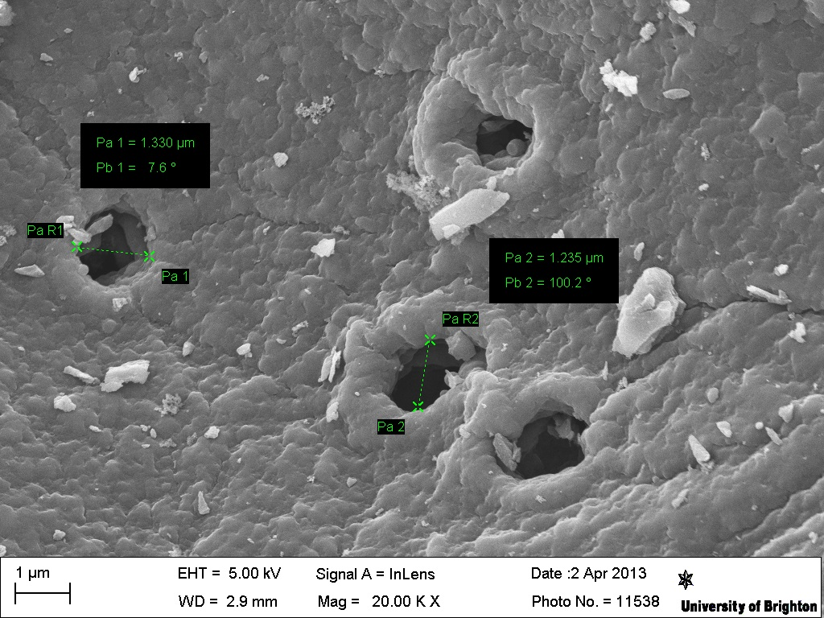
Fig. # 1 SEM image of KWS-P-500

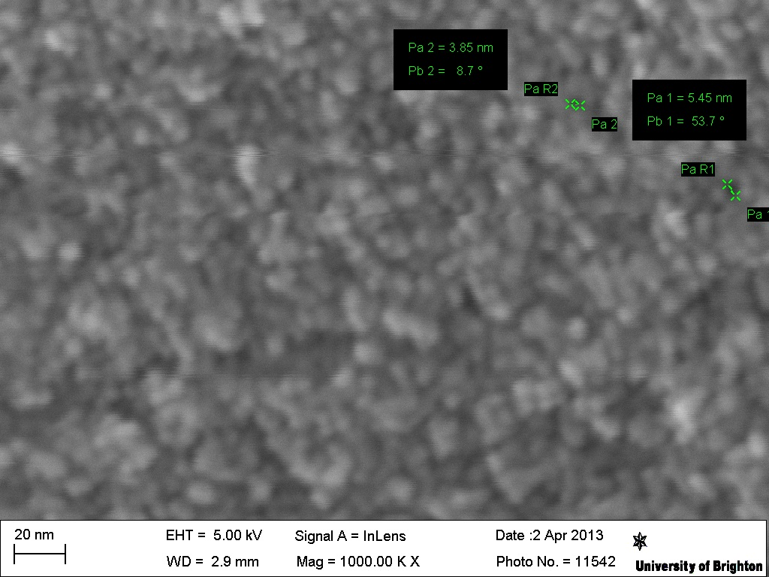
Fig. # 2 SEM image of KWS-P-500

By conducting the activation process of rice husk with concentrated phosphoric acid during two hours at 500ºC we obtained the micro- mesopore sample (Fig # 3).

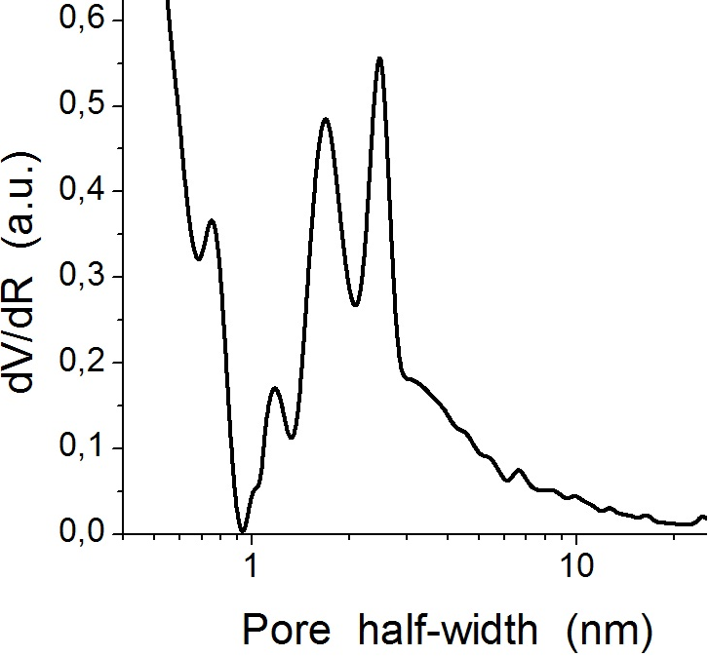
Fig # 3. Pore size distribution for CRH using QSDFT

The electrochemical properties of the carbon electrodes obtained from apricot stones (AS-P-500), rice husk (CRH) and walnut stones (KWS-P-500) have been investigated by using two-electrode cells. Fig.# 4 shows the cyclic voltammograms obtained for some carbonized and chemically activated materials in 1 mol L⁻¹ Li₂SO₄ media.
Fig. #4 Dependence of the specific capacitance at different potential limits

Fig. #5 shows the Nyquist plot for two-electrode capacitors that were assembled with three different carbonized and chemically activated vegetable raw materials in 1 mol L⁻¹ Li2SO4 aqueous electrolyte. From these different plant materials exactly rice husk has a better square shape of cyclic voltammograms and its characteristics may prove a good charge propagation in this material (Fig. #6).
Fig. #5 Nyquist plots for different carbon materials

As it can be seen from the Figure #5 the Warburg impedance region for activated apricot stones sample was associated to Faradaic reactions together with the kinetic leakage processes in the diffusion line, also it had very significant ohmic drop value of 0,3 volts (Fig. #8). These factors doubtless lead to definetely low general quality of the carbon, which was obtained through carbonization and activation of apricot stones sample despite it’s mild specific capacitance of 112 F*g-1 (current density 0,2 A*g-1, vertex potential 1V) in the media of 1 mol L⁻¹ Li2SO4 aqueous electrolyte.
Figure #6 Dependence of the specific capacitance vs different potential

The dependence of capacitance at low frequencies showed the maximum capacitance for activated rice husk (Fig. #7).
The dependence of capacitance at different current loads (Fig. #9) for a supercapacitor which was assembled with carbonized and activated with phosphoric acid walnut stones in 1 M*L⁻¹ Li₂SO₄ media showed the optimal electrochemical performance.
Fig. # 7 The capacitance at different frequencies

On the results of a series of experiments on carbonization and activation of different plant materials in inert atmosphere and at mild temperatures the walnut shell was selected as main precursor for the further testing under changed conditions. Namely we had chosen a one-step process (carbonization+activation) in carbon dioxide atmosphere at temperature range from 500 to 800 ºC, also it was some air oxygen getting to the reactor through a small holes.
Fig. #8 Galvanostatic characteristic of supercapacitor built from carbonized and activated apricot stones

Fig. #9 represents the capacitance (galvanostatic measurements data) at different current densities.
Fig. #9 Dependance of capacitance vs current density

In their works Jagtoyen and Derbyshire found out that treatment with phosphoric acid promotes an expansion of the lignocellulose structure over the temperature range 250-450 ºC corresponding directly to the development of porosity, especially for mesopores, which maximum volume development (0,55 cm3/g) evolved at 500 ºC [6]. Therefore with subsequent growth of temperature it would be expected the reduction in specific surface area and as a consequence - the decrease of the capacitance values. This statement is in good agreement with the data of specific surface area which was obtained by adsorption of argon molecules (table #2).

Table #2 Properties of carbonized and activated walnut stones
The name of sample | Temperature of carbonization + activation, ºC | Specific surface area (BET Ar-desorption), m²/g | Specific capacitance (calculated from GCPL-data), F*g-1
SGO 600 | 600 | 1380 | 135
SGO 700 | 700 | 1241 | 140
SGO 750 | 750 | 1152 | 150
SGO 800 | 800 | 1050 | 160

From the figure #10 it can be seen the increase of the specific capacitance for the sample «SGO 800» (appr. 160 F*g-1) it may be due to the influence of the pseudocapacitance. This fact can be associated with some irreversible reactions occurred on electrode surface leading to increased low reversible capacitance of this material.
Fig.10 Capacitance vs. Voltage for walnut stones activated at different temperatures

Conclusions
Different active carbons were obtained from vegetable wastes by carbonization and activation with phosphoric acid; they were characterized in terms of their morphology, structure and other physical and chemical properties.
Using these active carbons, the electrode materials were made; they were tested as electrodes for supercapacitor cells.
Electrochemical investigations of the assembled cells were conducted. Perspective of using these materials is shown.
The maximal capacitance was obtained for activated walnut shells of 160 F*g⁻¹ (in the media of 1M Li₂SO₄) which was synthesized at 800 ºC .

References
1. E.J. Ra, E. Raymundo-Pinero, Y.H. Lee, F. Béguin. High power supercapacitors using polyacrylonitrile-based carbon nanofiber paper. Carbon 47 (2009) 2984 –2992
2. E. Raymundo-Pinero, K. Kierzek, J. Machnikowski, F. Béguin. Relationship between the nanoporous texture of activated carbons and their capacitance properties in different electrolytes. Carbon 2006; 44:2498–507.
3. Chmiola J, Yushin G, Gogotsi Y, Portet C, Simon P, Taberna PL. Anomalous increase in carbon capacitance at pore sizes less than 1 nanometer. Science 2006; 313:1760–3.
4. Conway BE. Electrochemical supercapacitors – scientific fundamentals and technological applications. New York: Kluwer Academic/Plenum; 1999.
5. Frackowiak E., Béguin F. Carbon materials for the electrochemical storage of energy in capacitors. Carbon 2001; 39:937–50.
6. Marit Jagtoyen, Frank Derbyshire. Activated carbons from yellow poplar and white oak by H₃PO₄ activation. Carbon Vol. 36, No. 7-8, pp. 1085-1097, 1998
7. A.G. Pandolfo, A.F. Hollenkamp. Carbon properties and their role in supercapacitors. Journal of Power Sources 157 (2006) 11–27
8. B.E. Conway. Electrochemical Supercapacitors. Scientific Fundamentals and Technological Applications, Kluwer, New York, 1999.
9. C.Srinivasakannan, Mohamad Zailani Abu Bakar. Production of activated carbon from rubber wood sawdust. Biomass and Bioenergy 27 (2004) 89 – 96
10. Sax NJ, Lewis RJ. Hawley’s condensed chemical director. New York: Van Nostrand Reinhold; 1987.p.910.
11. W.C. Lim, C. Srinivasakannan, N. Balasubramanian. Activation of palm shells by phosphoric acid impregnation for high yielding activated carbon. Journal of Analytical and Applied Pyrolysis 88 (2010) 181–186
12. Mykola Seredych, Denisa Hulicova-Jurcakova. Surface functional groups of carbons and the effects of their
chemical character, density and accessibility to ions
on electrochemical performance. Carbon 46 (2008) 1475–1488
13. Pandolfo AG, Hollenkamp AF. Carbon properties and their role in supercapacitors. J Power Sources 2006;157:11–27.
14. Frackowiak E. Supercapacitors based on carbon materials and ionic liquids. J Brazil Chem Soc 2006;17:1074–82.

