Matlab simulations of the quantum computer algorithms with application to the time series analysis

A.S. Kussainov*, S.G. Kussainov**, A.T. Karimova*
* - Al-Farabi Kazakh National University, Almaty, Republic of Kazakhstan;
** - K.I. Satpaev Kazakh National Technical University, Almaty, Republic of Kazakhstan

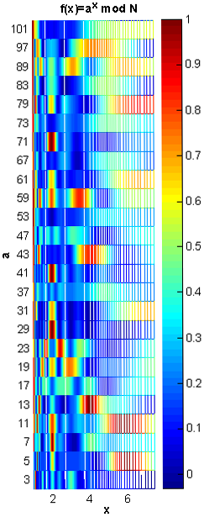
Introduction. Quite recently, Feynman [1,2] outlined the computational capabilities of a quantum system. He showed that a group of computational problems exists and it could be addressed, in terms of success in finding solution, only by means of a quantum computer. The properties of such machine, the existence of a quantum mechanical simulator (or emulator) of the Turing machine [3], and its practical effectiveness was shown by Deutsch [4]. We considered a few aspects of quantum computing in connection with the time series analysis and its numerical implementation. Shor’s integer factorization algorithm and Quantum Fourier Transform [5, 6] were selected for simulation due to their important practical values in spectral analysis, the easiness of implementation and its generic nature with respect to many other quantum algorithms.
Fig.1. f(x)=a^{x} mod N function used to confirm the continued fraction expansion implemented for the Shor’s quantum factoring algorithm. N=105
The quantum computing poses several immediate problems, such as simulating infinite, continuous time series by a finite state vector, or, assuming that we have complete basis hidden in the long sequence of data, we need to find this basis dimension and location satisfying our computational needs. After this, assuming that we have successfully divided long data sequence into snapshots of the basis vector, we should be able to connect individual parts by a unitary time evolution as required by the physics of quantum computations.
Big advantage is that the quantum computers are multipurpose from the very elementary level and up to the top. For example an application of the so called Hadamard gate is equivalent to the averaging on two bits (cat state) and keeping track of the so called Bell state is equivalent to the derivative approximated by a finite difference. At the top of this, Quantum Fourier Transform has its unique unifying applications in phase estimation, order-finding and hidden subgroup problem [7].
The limited available register size of a quantum computer may be an issue at the data postprocessing stage, but carry significant practical value if included into the data acquisition stage. These procedures should be necessarily considered with the accompanying decoherence issue for the big quantum systems and long evolution times.
Experimental data and analysis. The quantum Fourier transform (QFT) acts on a quantum state. The 2-qubit quantum Fourier transform (for example the one acting on the bases |00⟩, |01⟩, |10⟩, |11⟩ of a two spin system) will be described by its multiplication with the unitary matrix F of the following form
$$F=\frac{1}{2}\left(\begin{matrix}1 & 1 & 1 & 1 \\ 1 & ω & ω^{2} & ω^{3} \\ 1 & ω^{2} & 1 & ω^{2} \\ 1 & ω^{3} & ω^{2} & ω\end{matrix}\right)=\frac{1}{2}\left(\begin{matrix}1 & 1 & 1 & 1 \\ 1 & i & −1 & −i \\ 1 & −1 & 1 & −1 \\ 1 & −i & −1 & i\end{matrix}\right)$$ | (1)
here the phase factors ω=e^{πi/2}=i, ω²=e^{πi}=-1and etc.
In general, if we have number N qubits equals to some power n of 2 represented by an individual kets
$$|0⟩,\text{.}\text{.}\text{.},|2^{n}−1⟩$$ | (2)
they will constitute the computational basis for an n qubit quantum computer. If we to adopt the binary representation for integer number
$j=j_{1}j_{2}\text{.}\text{.}\text{.}j_{3}$or $j=j_{1}2^{n−1}+j_{2}2^{n−2}+\text{.}\text{.}\text{.}+j_{n}2^{0}$ | (3)
and for binary fraction
$0\text{.}j_{l}j_{l+1}\text{.}\text{.}\text{.}j_{m}$that is ${j_{1}}/2+{j_{l+1}}/4+\text{.}\text{.}\text{.}+{j_{m}}/{2^{m−l+1}}$ | (4)
any QFT may be written as the operator product, see [8]
$$|j_{1}j_{2},\text{.}\text{.}\text{.},j_{3}⟩→\frac{\left(|0⟩+e^{2πi0\text{.}j_{n}}|1⟩\right)\left(|0⟩+e^{2πi0\text{.}j_{n−1}j_{n}}|1⟩\right)⋯\left(|0⟩+e^{2πi0\text{.}j_{1}j_{2}⋯j_{n}}|1⟩\right)}{2^{\frac{n}{2}}}$$ | (5)
QFT is used within the Shor’s algorithm to find the period of the function f(x) imposed on the chosen quantum computational basis as probability amplitudes distribution. We can find the r, which is the function’s period or fundamental frequency we are looking for, according to the following formula describing the quantum measurement on the earlier prepared state
$${\left|N^{−1}\sum_{x:f(x)=f(x_{0})}{ω^{\text{xy}}}\right|}^{2}=N^{−2}{\left|\sum_{b}{ω^{(x_{0}+\text{rb})y}}\right|}^{2}=N^{−2}{\left|\sum_{b}{ω^{\text{bry}}}\right|}^{2}$$ | (6)
where b is how many times this repetition is observed in the data set, x and y are combinations of the frequencies and counts connecting the original space and Fourier transformed one.
This algorithm and many others required have been implemented by us in Matlab programming language (The MathWorks, Inc., Natick, Massachusetts, United States). It provides flexibility and a big variety of the preinstalled and user defined function for matrix computations. For our immediate purposes we have used functions vander, primes, factors, nextpow2m, modular arithmetic functions and others.
In Fig.1 we can see the control data which has been generated by continued fraction expansion subroutine used in Shor’s algorithm. Function’s maxima are indicated by the intense red color. The number used for factoring and this particular plot was N=105.
Below (see Fig.2) is a data sample acquired by a single channel of Tian-Shian high elevation mounting station [9] in a period between November 21st, 2012 and November 30th, 2012. We used this data for our further code testing.
The original raw data of the period of about five days are shown in Fig.2(a). Another set, derived from original by the moving average and baseline subtraction, is shown in Fig.2(b). The Fourier transform coefficients of these data are shown at the bottom of the figure, see Fig.2(c). The right hand side of the Fig.2, which is the subplots (d),(e) and (f) is used to estimate how fast the elementary properties of this particular times series such as mean, median and variance attained the stable level.
Our program was tested for factoring simple integer numbers on the order of several thousands, preparation of the quantum state and its transformation according to the quantum physics laws.
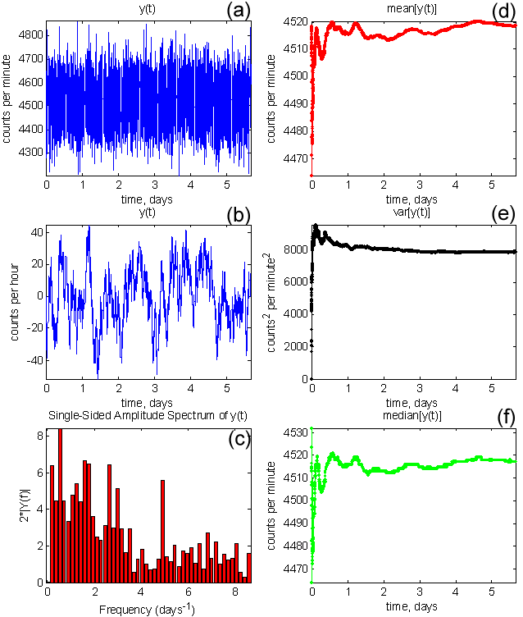
Conclusions. So far, the closest connection point between the quantum computing and time series analysis is its time delayed data availability matching the consecutive execution of the scheme described by Eq.(5). The elementary simulation of quantum algorithms is quite straightforward and was implemented by us in Matlab programming language for the further studies and software development. The studies of statistic and information aspects of quantum computing will be continued in the chosen direction.
Fig.2. From top to the bottom and from left to the right. a) Unfiltered five and a half days data from a single acquisition channel of 18NM64 neutron monitor (Y axis displays the neutron’s counts), c) original signal averaged and subtracted with the baseline, b) its Fourier transform coefficients’ absolute values, and (d),(e), and (f) are the mean, variance and median values of the raw data as a functions of available data points.

References

- R. Feynman. Simulating physics with computers. International Journal of Theoretical Physics, 21(6/7): pp.467–488, 1982.
- R. Feynman. Quantum mechanical computers. Foundations of Physics, 16: pp.507–531, 1986.
- A. M. Turing. On computable numbers, with an application to the Entscheidungsproblem. Proceedings of the London Mathematical Society, Series 2, 42: pp.230–265. Correction in 43, pp.544–546, 1937.
- D. Deutsch. Quantum computational networks. Proceedings of the Royal Society of London, A425: pp.73–90, 1989.
- P.W. Shor. Algorithms for quantum computation: Discrete logarithms and factoring. SFCS '94 Proceedings of the 35th Annual Symposium on Foundations of Computer Science. IEEE Computer Society Washington, DC, USA: pp. 124-134, 1994.
- http://math.nist.gov/quantum/zoo/
- M. Nielsen, I. Chuang. Quantum Computation and Quantum Information (Cambridge Series on Information and the Natural Sciences). Cambridge University Press: pp. 216-246, 2000.
- S. Parker and M. B. Plenio, Phys. Rev. Lett. 85, p.3049, 2000.
- http://cr29.izmiran.ru/vardbaccess/title.html

