Матер1али III МЪкнароднси науково-методичнси конференцп

Лшгвютична пщготовка студент.в нефшолопчних спец.альностей вищих навчальних заклад.в

у контекст! Болонського процесу та Загальноевропейських Рекомендацм з вивчення, викладання та оцжювання мов

»

4-5 жовтня 2012 року

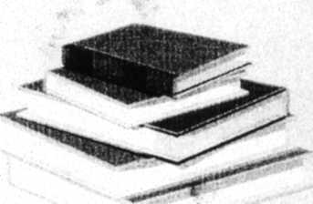

Одеса, Украина

Мппетерство освпн i науки, молод1 га спорту УкраТни Одеська национальна академи зв'язку (ОНАЗ) jm. О.С. Попова (Украша) МЬкнародна aconiauia вин) скнш-мв ОНАЗ (Украша) Поволзькпй дсржавний ушверситет телекомушкацШ та шформатики (PocU) Те.чжчний ушверситет Котике (Словаччина)

МАТЕ ПАЛ И

III МЬкмародно! науково-методичноГ конференцп

Лшгвктична пщготовка студентов нефшолопчних спещальностей вищих навчальних заклад!в

у контекст! Болоиського процесу та Загальноевропейських Рекомендации з винчения, викладання та оцпповання мов

4-5 жовтня 2012 року А ,\

Одеса, Укра'ша

Министерство образования и науки, молодежи и спорта Украины Одесская национальная академия связи (ОНАС) им. А.С. Попова (Украина) Международная ассоциация выпускников ОНАС (Украина) Поволжский государственный университет телекоммуникаций и информатики (Россия) Технический университет Ко шипе (Словакия)

МАТЕРИАЛЫ

ill Международной научно-методической конференции

Лингвистическая подготовка студентов нефилологических специальностей высших учебных заведений

в контексте Болонского процесса и Общеевропейских Рекомендаций по изучению, преподаванию и оцениванию языков

4-5 октября 2012 года

Одесса, Украина

Ministry of Education and Science, Youth and Sport of Ukraine Odessa National A.S. Popov Academy of Telecommunications (ONAT) (Ukraine) International Association of ONAT Graduates (Ukraine) Povolzhskiy State University of Telecommunications and Informatics (Russia) Technical University of KoSice (Slovakia)

PROCEEDINGS

of the HI International Scientific and Methodical Conference

Linguistic Training of Students of Universities of Non-philological Specialities

iu the Context of Bologna Process and Recommendations of the Common European Framework of Reference for Languages: Learning, Teaching and Assessment

October 4-5, 2012

Odessa, Ukraine

Матфкат Ш ЫЬЮыфодшЯ паукшю-меттшчис) коифярлнцД щЩшкящщт nuXviiiosKii cmyoetmm He<pimw.i4HUX сйвфнШОСНШЛ tiuufix т&иыыиа <ак!ии)№

_____ 4-5 ЖОвИПМ 2012 року ^_^

Gumarova Sh.B.,

Deputy Head of the Department of Foreign Languages.

Strautman L.E.,

Senior Teacher of the Department of Foreign Languages, w "Al-FarabiKazakh National University, Almafy.

Kazakhstan

PROJECT WORK IN THE TECHNICAL ENGLISH CLASSROOM

I

Project work has become an integral part of the course "English for Professional ■ Purposes" at the faculty of physics. Al-Farabi Kazakh National University. The paper shows the benefits that the students of different levels can get from participation and collaboration in a project.

Introduction

Project work has become an integral part of the course "English for Professional Purposes" at the faculty of physics. Al-Farabi Kazakh National University. A limited choice of ESP textbooks (more precisely, English for physicists) makes it necessary to search for more efficient mediods rn teaching technical English. Our experience of practical work has shown that project work is one of the most successful mediods. The formulation of the definition of project work as a content-based instruction is in die streamline of the process of teaching English for professional purposes. This forms the base for close interconnection between teaching professional English and Project Work.

In our practice we have used different types of projects even at the time when this approach was not widely discussed. The specificity of work with technical texts makes к necessary to develop different types of tasks related to practical realization of the themes of the texts as the available textbooks, both published in Russia (as we work in the Russian-language groupsl, Kazakhstan (which are mainly based on the textbooks published in Russia) and textbooks on technical English published by British publishing houses mainly contain one-type exercises, which do not arise students' interest. This situation forced us to develop different types of additional activities, most of winch can be classified as project work Our projects differ in die structure of their organization, the number of students involved in projects, techniques used tin information collection and ways of information "reporting"

Characteristics of the project work

According to Diana L Fried-Booth (2002) Project work is a source of inspiring ideas from a variety of contexts, clearly presented, within a framework diat responds to important issues in modern ELT pedagogical practice from a humanistic perspective

The format of the project work depends on a variety of factors including curriculum objectives, levels of students' proficiency student interests, time constraints and availability of materials. According to the classification of Fredrica L. Stoller projects are classified as structured, unstructured and semi-structured. In our work with different groups we mainly used semi-structured projects, i.e projects defined and organized in part by the teacher and in part by the students.

The students are mainly interested in the real-world projects, as an example of such project we describe m details the project "Do We Need Nuclear Power Plants'", which uicludes a wide variety of techniques.

Projects can differ in techniques of data collection and sources of in formation It I expressed in the project types: Research projects, text projects which require working with the: texts, correspondence projects which require communication with individuals, survey project which entail creating a survey instrument, then collecting and analyzing data from "informants' encounter projects which include face-lo-tace contact with speakers outside the classroom. Projects may also differ in the way the information is "reported". Production projects invoivt creation of bulletin board displays, videos, radio programs, poster sessions, etc. Per/or mam projects include stage debates, theatrical performances, oral presentations, or fashion shows Organizational projects include formation of a club, conversation table, or conversation program.

Steps of the project work

Project work, whetirer it is integrated into a content-based thematic unit or introduced as a special sequence of activities in a more traditional classroom, requires multiple stages ol development to succeed

A project is a large task (macro-task) composed of smaller steps (micro-tasks). Each step has its own task and can be expanded or reduced. Every project should have a pre-planned beginning and an end. A project moves through three stages: Beginning in the classroom moving out into the world, and reluming to the classroom.

Project work bridges the gap between the theoiy and the practice, as there's a deep gap between the language the students are taught and the language they in tact require.

Advantages of the project work

1. In project work, the students become responsible for their own learning They selecl and devise die project, with the teacher acting as "coordinator" and "facilitator" or "'consultant'".
2. Students are highly motivated as they are away from routine. They are eager to show their distinction through a serious follow up.

3Through project work students can express diemselves easily, since their work require social interaction dirough interviews, questionnaires, etc

1. According to language, much of the language learning operates through tasks devised by die teacher Students are offered an opportunity of using the language skills already acquired in a situation which is new. challenging and real
2. Project work improves the capacity for work as students have an enormous enthusiasm for work.

When choosing the dieme for the project it is advisable to stmt with a process of  
brainstonuing. This process can be drawn as a diagram which shows the first draft for the whole  
project. ■ ,

Forming Groups: After choosing and outlining the project, the forming of groups comes next to put things into action. The teacher establishes groups which are balanced in temis ot skills, asking into consideration, each student's interest. Anodier way of grouping is done in a random way using grouping techniques (guessing numbers, selecting card from a pack, matchiiijt pictures, etc.

We will consider the steps of the project in the framework of the concrete project "Do wc  
need nuclear power plants?" ji

The theme of the project is an actual "real-world" theme, and it really inspired the students to take pan in it At the stage of gathering information the students interviewed diftereni groups of "informants": professors of our university, students of the faculties of physics, chemistry', law and journalism, and dieir friends in the Internet The interviews were recorded on

Л famepiam III Л ИжпарпОтЯ науюмо-MtmodUHHol конференции numbers, selecting card from a pack, matchiiijt pictures, etc.

We will consider the steps of the project in the framework of the concrete project "Do wc  
need nuclear power plants?" ji

The theme of the project is an actual "real-world" theme, and it really inspired the students to take pan in it At the stage of gathering information the students interviewed diftereni groups of "informants": professors of our university, students of the faculties of physics, chemistry', law and journalism, and dieir friends in the Internet The interviews were recorded on

Л famepiam III Л ИжпарпОтЯ науюмо-MtmodUHHol конференци

4-5 жочтпя 2012 рОК¥

the video, analyzed and presented at the "reporting" stage of the project The "reporting" stage included demonstration ofvideo materials, oral presentations, demonstration of charts and tables

PROJECT: Do we need nuclear power plants? The project included the following stages:

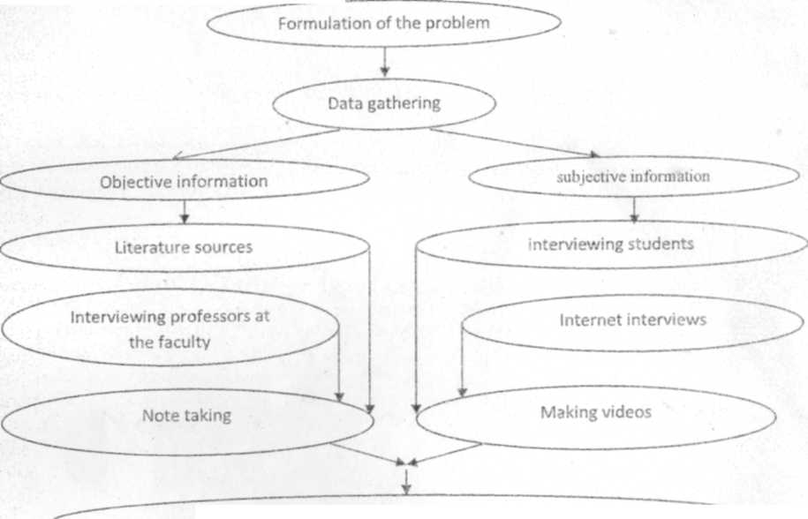

Compilation and analysis of information with the teacher

Working at language problems (simplifications)

Preparation of reports

A sequence of steps in die project "Do we need nuclear power plants?"

1. The problem was discussed with the students. We decided to interview the students and members of the teachuig staff (if possible) of the other faculties, interview people of other age groups, interview Internet friends. The students discussed the problem with enthusiasm.
2. The students interviewed the students of the faculty of technical physics, faculty of law, philology, journalism and some other faculties. More than 15 interviews were recorded on the video camera; the best of them were selected and demonstrated at the presentation The students also interviewed their Internet friends; some of the answers are included in the report Some examples of answers in the Internet-interviews:

i'he question Do we need nuclear power9 kirill. 21. a psychologist Yes. because people need energy. Sergei. 22. a manager

No. scientists do not know what to do with wastes Stas, 21. an architect

No. diey are harm till for the atmosphere Temir. 21, а Mill student

Yes. as coal gives a lot of pollution, reserves of oil and gas are limited, bio fuel will not save us. wind stations and solar cells have very low efficiency, many years will pass till dial time when people VI know how to use diermonuclear energy Kazakhstan has huge reserves of uranium Ersin, 11, a driver

No. it is harm (ill for the environment Enazar. 25, uitcniauonal relations

No. because of safety of people Nuclear energy and war arc closely eoiuiccted

1. The students analyzed die information and made conclusions For example thev found on that die students of humanitarian faculties wore all against nuclear power, even not knowing what it в Thus, one of die conclusions of the project was to educate people in diis field
2. The teacher widi die students woikcd at the language of compiled data, clarified ant simplified some not understandable sentences.
3. The students from groups 206 and 304 presented reports on nuclear power plants, die. advantages and disadvantages. It is an important problem now as aller die accident at Fukushhna Nuclei Power Plant the number of people voting against nuclear power increased The students of our faculti showed pluses and minuses of nuclear power The students themselves found a story about Hiroshim and 'he cranes which became the symbol of stmggle agauist nuclear weapons. They made a conclusia aboiu iCi-lth protection when using nuclear power and die necessity of its use The students of our faculti saw diat main' students at odier faculties know iiodung about nuclear power plants, some of diem an afraid of the word nuclear power", even
4. future journalist, so the students of our faculty can inform otho students of our university about die considered problem

Conclusion

Project-based learning allows teachers to develop tasks simulating real-world problems. .Student see die interdisciplinary nature of die tasks, they can use different strategies and approaches, whicb develops dicir cntical flunking and ability to solve problems in die re;il world

Students of different levels can benefit from the participation and collaboration in the project, Students involved in die project development gain valuable experience in setting goals Working at ttu project die students acquire problem-solving. cooperation, communication and self-evaluation skills li enables them to tbcus on their learning process and to see Uicir progress Students enjov learning who learning has sense Project work provides diem with an opportunity to choose how aiid what they Icam 4vhat increases dieir motivation in the process of learning

Literature:

1. L Fried-Booth. D 2002 Project work New York: Oxford University Pfess
2. Shcppard. К , and F. Stoller 1995 Guidelines for the integration of student projects in ESP classrooms English Teaching Fonun. 33,2. pp 10-15.

TEACHING TECHNICAL ENGLISH IN NEW EDUCATIONAL ENVIRONMENT

Gitmarova Sh.B..

Deputy Head of the Department of Foreign Languages,

Strautman L.E.

Senior Teacher of the Department of Foreign Languages, Al-Farabi Kazakh National University. Almaty,

Kazakhstan

TEACHING TECHNICAL ENGLISH IN NEW EDUCATIONAL ENVIRONMENT

The new educational environment recpiires development of new approaches to teaching technical English. To be competitive in this field it is necessary to include into work with specialized texts not only reading, translation and learning words, but also interactive activities, animations and diagrams arising more active students' participation in classroom activities

Introduction

The new educational environment requires development of new approaches to teaching technical English In order to maintain students' interest to studies it is necessary to introduce new types of activities. To be competitive in this field it is necessary to include into work with specialized texts not only reading, translation and learning words, but also interactive activities, animations and diagrams arising more active students' participation m classroom activities.

Implementation of new technology must become a reality not only in teaching natural sciences but also in teaching English In one of the presentations Donna Brinton presented a time scale of usage of new technologies in teaching English. The scale started in the 1960s and went forward to our days. In the 1960s the scope of available instruments included blackboard & chalk and a manual typewriter, the era of the 1970s included whiteboards, electric typewriters, overhead projectors, the era of the 1990s already had desktop computers, Xerox copiers, audio/video cassettes and learning centers, PowerPoint, digital photos, the 2000s brought laptop computers, LCD projectors, the Internet, online instructions, websites, etc.

The scale presents the technologies existing in the field of English teaching. This situation brings up the problem of availability of such interactive material. However strange it may seem but textbooks on technical English are either not available or irrelevant. Why is relevance so important? Why. nowadays, having so many textbooks it is difficult to find a textbook that will suit your needs? To begin with, it should be noted that the situation

in teaching Technical English is different from the situation in teaching General or Business English. For teaching General English different multi-level text-books have been developed The task of the teacher is to determine the level of the students and to provide them with the text-books of the corresponding level.

Current situation in teaching technical English

The situation in teaching technical English is not so simple. The limited number of horn's forces us to search for the most suitable material and new strategies which would improve the efficiency of its usage. The key factor is the response to the demands of the new educational environment when more and more EnglLsh-speakmg scientists reading lectures on physics in English come to the University and new disciplines in English are included in die curriculum

It should be noted that now the students are more interested in the subject of their study than in general English. Even the texts about film stars do not arouse such interest as the texts on phvsics. The students are focused on their future needs which include listening to Enghsh- speaking reporters and reading scientific articles, journals, catalogues, books on subject mattei and uistruction manuals in English The students are especially motivated by lectures on special subjects in English They not only motivate them to leam English but also enrich thei vocabulary.

According to our needs analysis reading comprehension is the skill that requires special  
attention and priority in our lesson planning. Reading comprehension implies both general and  
specific information, though inference and prediction are also involved in this skill but *b*comprehension we may also mean that die student is capable of recognizing die stnicture of th«  
text, guessing the meaning of unknown words from the context, re-expressing die content of the  
text, re-writing the text, summarizing it, either in a written or oral way. However, not all these  
activities can be found in the textbooks used tor the students of the Faculty of Technical Physics  
For example, the most widely used textbooks in the Russian-language groups are IK. Berlin;  
"English for the Second-Year Students of Natural Faculties7' and I.D. Lepeshova "English for  
Senior Students of Physics Faculty^The texts in the textbooks enable us to solve the above  
stated problems, they are useful for enriching technical vocabulary but the exercises are rather  
boring and do not motivate the students. Fkre we give some examples of the tasks for some o(  
the exercises "State the function of Gerunds and Gerundial Complexes proceeded b)  
prepositions", "Translate die sentences paying attention to the Objective + Infinitive and the  
Nominative + Infinitive constructions". We also have textbooks published by Cambridat  
University Press "Professional English in Use" and "Science" from Macmillan Vocabulary  
Practice Series, which provides opportunities to practice vocabulary using interactive activities,  
animations and diagrams Usage of interactive activities does not leave indifferent even the most  
passive and weakest students, so we have developed some interactive exercises for out  
materials. •

One of the approaches arising students' interest is usage of the methods called in one of the papers "reading-to-do-skills", which means to give instructions to some practical applications. Such examples can be found in the textbook "Professional English in Use Engineering" published by Cambridge University Press. For example, it explains the use of Pythagoras's theorem in practice in plain English.

A quick geometry lesson. Measure a length of timber for one of the sides adjacent to the right angle. It is 3 feet long. Square that number - 3 multiplied by 3 equals 9. Do the same with the other side adjacent to the right angle. Work out the square of the number. Then calculate tin square root of the sum of two numbers.

Even the weakest students do not remain indifferent to such exercises. The other problem is the problem of vocabulary learning. Which vocabulary type should the ESP teacher leach?

In the research related to vocabulary learning P. Nation stated. "It is wise to direct vocabulary leaning to more specialized areas

when a learner has mastered *2000-3000* words of general usefulness in English" (Nation P., *2001.* 187).

Learners who will do academic study in English must focus on academic vocabulary known as "general useful scientific vocabulary" or "semirtechnical vocabulary" because they need to exhibit wide range of academic skills like reading'research papers in their own Geld, listening to lecturers, discussing and presenting their own methods and results. Therefore semi-technical vocabulary should be given priority by ESP teachers as this'-vocabulary is*used in everyday lite but has a

frequent occurrence in academic descriptions and discussions (Dudley-Evans &Johns, Developments in English for specific purposes, R98, 87).

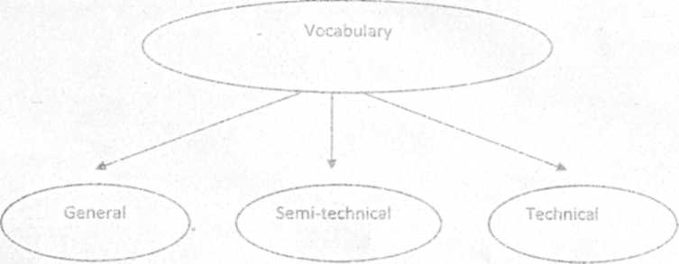

Let us consider a passage from the text taken from the book on solid state **physics,** ГО tinker CI Oxide layers deposited from organic solutions Physics of thin films):

Adhesion strength was evalujted by tensile adhesion '.est by using a testing machine at a cross-head speed of 0.5 mimnnn Before measurements the specimens were filled with acrylic resin in a vacuum dryer and cured at 150" for 1 h to prevent adhesive penetration After removing the protruded acrylic resin, the specimens were fixed with tensile jigs using epoxy adhesives and then cured at 150° for 2 h. "the tensile strength of the epoxy adhesive was cnlv *0-?QMpa

The teachers, adherents of authentic texts, may applaud It is an authentic text, but it can hardly be useful for students. What does the above example give us? In terms of relevancv or irrelevancy the text is irrelevant for bachelor students.

A new generation of textbooks, for example. V A. Raclovel "English for Technical Universities". Moscow, 2010, El. Kurashvili "English for Physicists", Astrel Publishing House. 2004 suggest more varied exercises but do not give mteractive activities which stimulate students' participation in the learning process.

Development of computer-based tasks

In special subjects (mechanics, molecular, atomic physics, etc) the students are given various interactive lasks. they are allowed to simulate various processes, in the course of nuclear physics they are even allowed to simulate the operation of a nuclear power plant, therefore our text books do not meet their expectations and reduce their motivation. Therefore tc maintain students' interest it is necessary to introduce new types of activities. The tasks presented below provide a feedback between the teacher and the student, they are placed in the Intranet as tasks tor homework and means of interim control. The computer program for the tasks was specially developed by a programmer V V D'yachkov. it enables the students to fulfill some tasks with answer key. whereas the tasks without answer key are used as means of control

Practical examples

i. Match the two parts

|  |  |
| --- | --- |
| Kinetic energy | Energy that results in an increase m temperature |
|  |  |
| Thermal enerav | The form of energy that can be heard |
| Sound enerav | Potential energy stored in a detbnncd material |
| Chemical energy | Mechanical energy in the form of movement |
| Light energy- | Energy stored wtthm the liquids or solids m a ballcrv |
| Strain energy | The forms of energy that shines and can he seen |

(The exercise is fulfilled hy drugging the right-hand parts of the sentences to righ places )

2. Drug the words from the box into the table to make groups of verbs with similar

meanings _____

amend circulate redesign revise supersede  
approve issue re line sign off

|  |  |  |  |
| --- | --- | --- | --- |
| I | 2 | - 3 | 4 |
| Change | Send out | Accept | replace |
| Improve | distribute | agree |  |

3. Fill in the blanks with the appropriate words from the list given below

1. The ... of matter and the size of the universe arc not known yet.
2. Uranium and thorium are. in the course of time. ... into certain kinds (isotopes) of lead.
3. The amount of uranium ... . that of lead .. gradually.
4. Nitrogen and oxygen are a mixture ... 99% of the atmosphere.

5 ... all the carbon and oxygen m the organic compouuds of both plants and animal! conies from carbon dioxide (C02) ... from die surrounding water or from the air by green plants.

1. Coral animals growing on ... of the ocean floor eventually piled high enough to read the surface of the water
2. Ocean drifts and are caused mainly by the prevailing winds of the earth

8 Air has not much ... .

1. The atmosphere becomes progressively thinner with increasing ... . It и approximaiely 8 miles above the surface ofthe earth.
2. In to the layers of ions, in the ionosphere there are layers of electrons that provid reflecting layers lor radio-waves

11 In terms of electron content, the lowest layers the least number of electrons.  
12. Silicon dioxide or quarts is the major ... of granite

13 Dark surface ofthe earth, such as rock and soil, are good of haat 14. Life might exist somewhere in the universe but it might not have to the level о thinking beings

a), b) currents, c) comprising d) decreases, e) elevations, f) possess, gf^Jbsorbers. h altitudes, l) evolved, jf amount, k) increases. I) eventually, m) extends, n> absorbed, o) weight, p addition, q) converted

When there are several components in an electric circuit, they can oe connected in series or in parallel.

a all the components in the circuit are connected together in one loop and there is only one route through

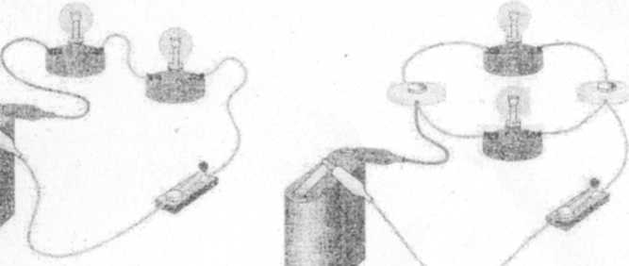

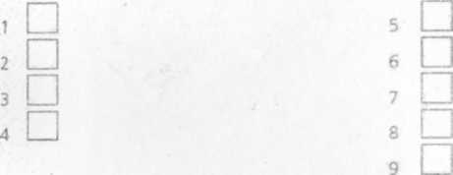

Series circuit Parallel circuit

which the current can travel, b Also a defective or disconnected component ir. one part of a parallel circuit wili not stop the flow of current

to the remaining branches in the circuit с If one of the components should become defective or disconnected, no electric current .vili fiow through

the circuit, d In a parallel circuit, e In a series circuit,

f The current need not be the same in each of the branches, g The same current will flow through each part ot the circuit

h there is more tnan one route through which current can travel around and back to the battery, i Therefore the current spiits up' to supply each branch of the circuit with electric current.

Conclusion

Teaching of special subjects in English requires development of new approaches to teaching technical English To be competitive in this field it is necessary to include into work with specialized texts not only reading, translation and memorizing words, but also interactive activities, animations and diagrams arising more active students' participation in classroom activities