study of the influence of liquid fuels spray angle on the fuel combustion at high pressure
Askarova A., Bolegenova S., Berezovskaya I., Ospanova Sh.
Al-Farabi Kazakh National University, Physical-technical faculty.
Kazakhstan
Abstract
The problems of combustion are widely studied now by the scientists. Increasing level of ecological pollution of the environment, reserve depletion of hydrocarbon fuel and economic growth of many countries causing increase of demand for energy - all these factors gave rise to the problem of finding of more economic and ecological way of fuel combustion [1]. The purpose of this work is to study the influence of liquid fuel spray angle on the fuel combustion by means of numerical simulation on the basis of the solution of differential equations of turbulent reacting flow. This study is based on the stochastic mathematical model.

Keywords: liquid fuel, stochastic model, spray angle, pressure.

The combustion of liquid fuels has a number of specific features caused the chemical reaction in a dynamic and thermal interaction of reagents, intensive mass transfer in phase transformations, as well as the dependence of the process parameters of the thermodynamic state of the system and its structural characteristics.
As the study of combustion is not impossible without detailed study, that comes to the fore the problem of the fundamental study of consistent patterns of heat and mass transfer processes on different fuels burning.
Numerical study of liquid fuels combustion is a challenge of the thermal physics, as it requires a large number of related accounting processes and phenomena. Therefore, the computational experiment is becoming an increasingly important element of the study of combustion processes and design of various devices that use the combustion process. It's safe to say that its role will increase in the future. Therefore, in the thermal physics methods of computational fluid dynamics is spreading increasingly, since it is possible to optimize the experiment based on its virtual prototype.
Up to date it becomes increasingly clear that the problems arising in aero-and hydrodynamics in the numerical solution of the Navier-Stokes equations, are unlikely to be resolved. Due to the increasing use of numerical studies in solving scientific and technical problems it is important to ensure the greatest possible scientific and practical «harvest». This is possible only with the deep penetration of mathematical modeling in a particular subject area. Solution of the spray and combustion of liquid fuels by means of numerical modeling using differential equations that describe the turbulent flow in the presence of chemical reactions and are presented by the basic equations (1-7): continuity, motion, internal energy, k-ε turbulence model, as well as initial and boundary conditions.
Continuity equation for component m:
$\frac{∂ρ_{m}}{∂t}+\vec{∇}(ρ_{m}\vec{u})=\vec{∇}\left[ρD\vec{∇}\left(\frac{ρ_{m}}{ρ}\right)\right]+{\overset{˙}{ρ}}_{m}^{c}+{\overset{˙}{ρ}}^{s}δ_{m1},$ (1)
where D – diffusion coefficient, ρ_{m} – mass density of the liquid phase, ρ – total mass density, ${\overset{˙}{ρ}}_{m}^{c}$– chemical source term, – source term due to the injection, u– fluid velocity.
The continuity equation for the liquid is:
$\frac{∂ρ}{∂t}+\vec{∇}(ρ\vec{u})={\overset{˙}{ρ}}^{s}$. (2)
Momentum equation:
$\frac{∂(ρ\vec{u})}{∂t}+\vec{∇}(ρ\vec{u}\vec{u})=−\frac{1}{a^{2}}\vec{∇}{\text{p-A}}_{0}\vec{∇}(23ρk)+\vec{∇}\vec{σ}+{\vec{F}}^{s}+ρ\vec{g},$ (3)
where р – fluid pressure, α - nondimensional quantity, A0 is 0 for laminar flow and 1 – in turbulence. The viscous tension tensor is:

$σ=μ\left[\vec{∇}\vec{u}+(\vec{∇}\vec{u})^{T}\right]+λ\vec{∇}\vec{u}\vec{I}\text{.}$ (4)

Here μ - dynamic viscosity of the fluid, - viscosity factor, g – gravity acceleration and I - specific internal energy.
Energy equation:
$\frac{∂(ρ\vec{I})}{∂t}+\vec{∇}(ρ\vec{u}\vec{I})=−ρ\vec{∇}\vec{u}+(1−A_{0})\vec{σ}\vec{∇}\vec{u}−\vec{∇}\vec{J}+A_{0}\text{ρε}+{\overset{˙}{Q}}^{c}+{\overset{˙}{Q}}^{s}$, (5)
where ${\overset{˙}{Q}}^{c}$– source term due to the heat in a chemical reaction and ${\overset{˙}{Q}}^{s}$– heat, which brings the injected fuel. Heat flux vector J is composed of electrical and transfer enthalpy.
Equations of k-е turbulence model:
$\frac{∂ρk}{∂t}+\vec{∇}⋅(ρ\vec{u}k)=−\frac{2}{3}ρk\vec{∇}⋅\vec{u}+σ⋅∇\vec{u}+\vec{∇}⋅\left[\left(\left(\frac{μ}{{\text{Pr}}_{k}}\right)\vec{∇}k\right)\right]−\text{ρε}+{\overset{˙}{W}}^{s},$ (6)
$\begin{aligned}\frac{∂\text{ρε}}{∂t}+\vec{∇}⋅(ρ\vec{u}ε)=−(\frac{2}{3}c_{ε1}−c_{ε2})\text{ρε \{}\vec{∇}⋅\vec{u}+\vec{∇}⋅\left[\left(\left(\frac{μ}{{\text{Pr}}_{ε}}\right)\vec{∇}ε\right)\right]+\end{aligned}+\frac{ε}{k}\left[c_{ε1}\vec{σ}\vec{∇}\vec{u}−c_{ε2}\text{ρε}+c_{s}{\overset{˙}{W}}^{s}\right]\begin{matrix}\text{.} & \end{matrix}$ (7)
The constants $c_{ε1},c_{ε2},c_{S}{\text{,Pr}}_{k}{\text{,Pr}}_{ε}$ are determined from the experimental data [1].
In the main section of the jet development evaporation and mixing processes of atomized fuel is flowing more intensive. The lateral surface as the distance from the spray nozzle increases with little changing aperture angle of the jet. The lateral surface is reducing when fuel jet are injected into the engine cylinder with a small angle, thereby the amount of vaporized fuel are reducing for ignition delay period. Changing the angle of dispersion fuel jet allows intensification «spin» that the air charge, resulting in a positive impact on fuel efficiency [2].
Usually of the working mixture of fuel and oxidizer at high pressure is used diesel engine. At high pressure fuel is ignited by the temperature of the mixture. As a consequence, the characteristic feature of diesel engines is the lack of fuel ignition. The main characteristic of the diesel fuel is the cetane number. It describes the percentage of cetane in a mixture of reference fuel. Dodecane C₁₂H₂₆ is used as a component of diesel fuel.
The basic chemical property of saturated hydrocarbons is the reaction of combustion. In general, the equation for the combustion of any hydrocarbon C_{x}H_{y}, can be written as follows: C_{x}H_{y} + (x + 0,25y)O₂ → xCO₂ + 0,5yH₂O.
In this paper we have used two types of liquid fuels: octane (C₈H₁₈) and dodecane (C₁₂H₂₆).
The chemical reactions for the two types of fuels are as follows:
2С₈Н₁₈ + 50О₂ = 16СО₂ + 18Н₂О, 2С₁₂Н₂₆ + 37О₂ = 24СО₂ + 26Н₂О (8)
This study is based on the stochastic mathematical model (described in [3]). The spray angle α is surveyed from 2° до 14° at the optimal values ​​of pressure (P) and mass (m), as defined in [4]. For octane P is 100 bar and m is 6 mg and for dodecane P=80 bar and m=7 mg. Liquid fuel is sprayed through a nozzle that located in the center of the base cylindrical chamber where the height is 15 cm and the radius is 2 cm. Injected fuel into the combustion chamber rapid evaporates and burns in the gas phase. The temperature of liquid fuel is 298 K and T of the air is 800 K. The spray time of liquid fuel is 1,4 ms. Number of control cells are 600. Temperature of the combustion chamber walls is 353 К. Area of ​​the injector nozzle is 2·10⁻⁴ cm².
The results of numerical experiments on the effect of liquid fuel spray angle on the temperature distribution in the combustion chamber, the formation of carbon dioxide and fuel presents in Figures 1-3.
Analysis of Fig. 1 shows that the temperature in the combustion chamber for both fuels increases monotonically with changing angle of spray from 2⁰ to 10⁰. The maximum temperature in the combustion chamber is 1964 K for octane and 1991 K for dodecane reached at α =10⁰. With further increase in α, for octane temperature change is not observed, and for dodecane is a slight decrease in temperature.

Т, К | 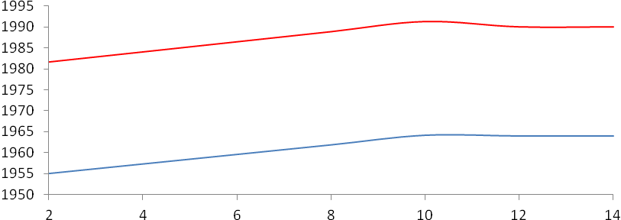
 | α, degree
Figure 1 - Change of maximum temperature in the burner chamber depending on the spray angle α
(blue line – octane at Р=100 bar, red line – dodecane at Р=80 bar)

In Fig. 2 shows the dependence of CO₂ concentration on the value of the spray angle. Figure 2 shows for changing spray octane angle from 2⁰ to 10⁰ the carbon dioxide concentration is produced a small amount, notably concentration values are from 0,1007 g/g to 0,1008 g/g. The concentration value for dodecane make from 0,1019 g/g to 0,1022 g/g. Further increasing α hardly changes the values ​​of CO₂ in the combustion chamber for both fuels.

СО₂, g/g | 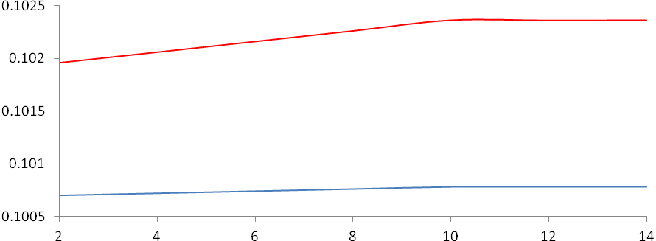
 | α, degree
Figure 2 - Distribution of the concentration of CO₂ in the combustion chamber depending on the spray angle α (blue line -
octane at P = 100 bar, the red line - dodecane at P = 80 bar)

For both fuels, a small amount of carbon dioxide (Fig. 2) is allocated at the maximum temperature in the combustion chamber (Fig. 1), which can be used for a better organization of the process of liquid fuels combustion.
As the curves show in the Fig. 3 with increasing spray angle of 2⁰ to 10⁰ the concentration of both fuels is reduced. Withvalues of more than 10⁰ the concentration of fuel practically does not change, which is consistent with the previous result, shown in the Fig. 2. For octane observed almost linear dependence of the concentration of fuel in the combustion chamber and the concentration derived from the burning of carbon dioxide from fuel spray angle.
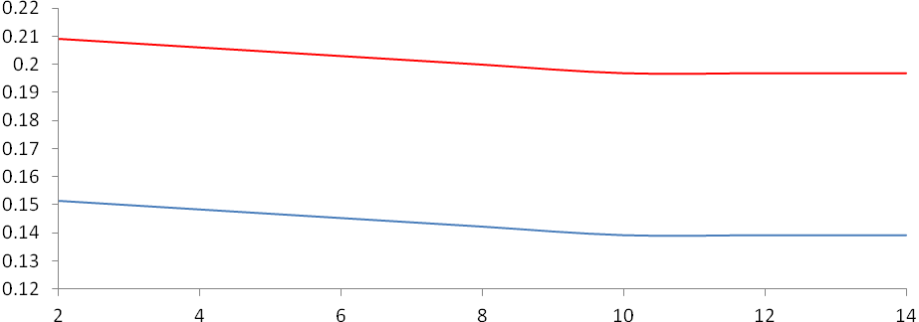
Fuel, g/g
α, degree
Figure 3 - Distribution of the fuel concentration depending on the spray angle α (blue line - octane at Р=100 bar, red line - dodecane at Р=80 bar)

In the given problem, the optimal value of the pressure in the combustion chamber and the mass of fuel for better organization of combustion of octane and dodecane spray applied to the angle is shown, that the most efficient combustion process takes two fuels to an angle of spray 10⁰. In this case, the temperature in the combustion chamber heated to a maximum values of 1964 K for octane and 1991 K for dodecane. Fuels burned without residue. The carbon dioxide concentration was insignificant and didn’t exceed the maximum permissible concentration of harmful substances.

List of references:
[1] Amsden A.A., O'Rourke P.J., Butler T.D. KIVA-II: A computer program for chemically reactive flows with sprays. - Los Alamos, 1989. - 160 р.
[2] Vitman l.A., Kacnel'son B.D., Paleev I.I. pod red. Kutateladze S.S. Raspylivanie zhidkosti forsunkami. M.: Gosudarstvennoe jenergeticheskoe izdatel'stvo, 1962. 265 s.
[3] Gorokhovski M., Chtab-Desporter A., Voloshina I., Askarova A. Stochastic simulation of the spray formation assisted by a high pressure // Proceed. of 6th Internat. Symposium on Multiphase Flow, Heat mass transfer and energy conversion. - Xi’an, 2009. - P. 254 - 261.
[4] Askarova, A.S., Bolegenova S.A., Ryspayeva M.Zh., Berezovskaya I.E., Maksimov V.Y. Chislennoe modelirovanie Vliyanie massy vpryska oktana i dodekana na process goreniya v kamere shoraniya pri visokih davleniyah // Materiali VII Mezhdunarodnoy nauchno-prakticheskoy konferencii «Obrazovanie, nauka, innovacii – vklad molodih issledovateley». – Kemerovo, 2012. - S. 758 – 761.

