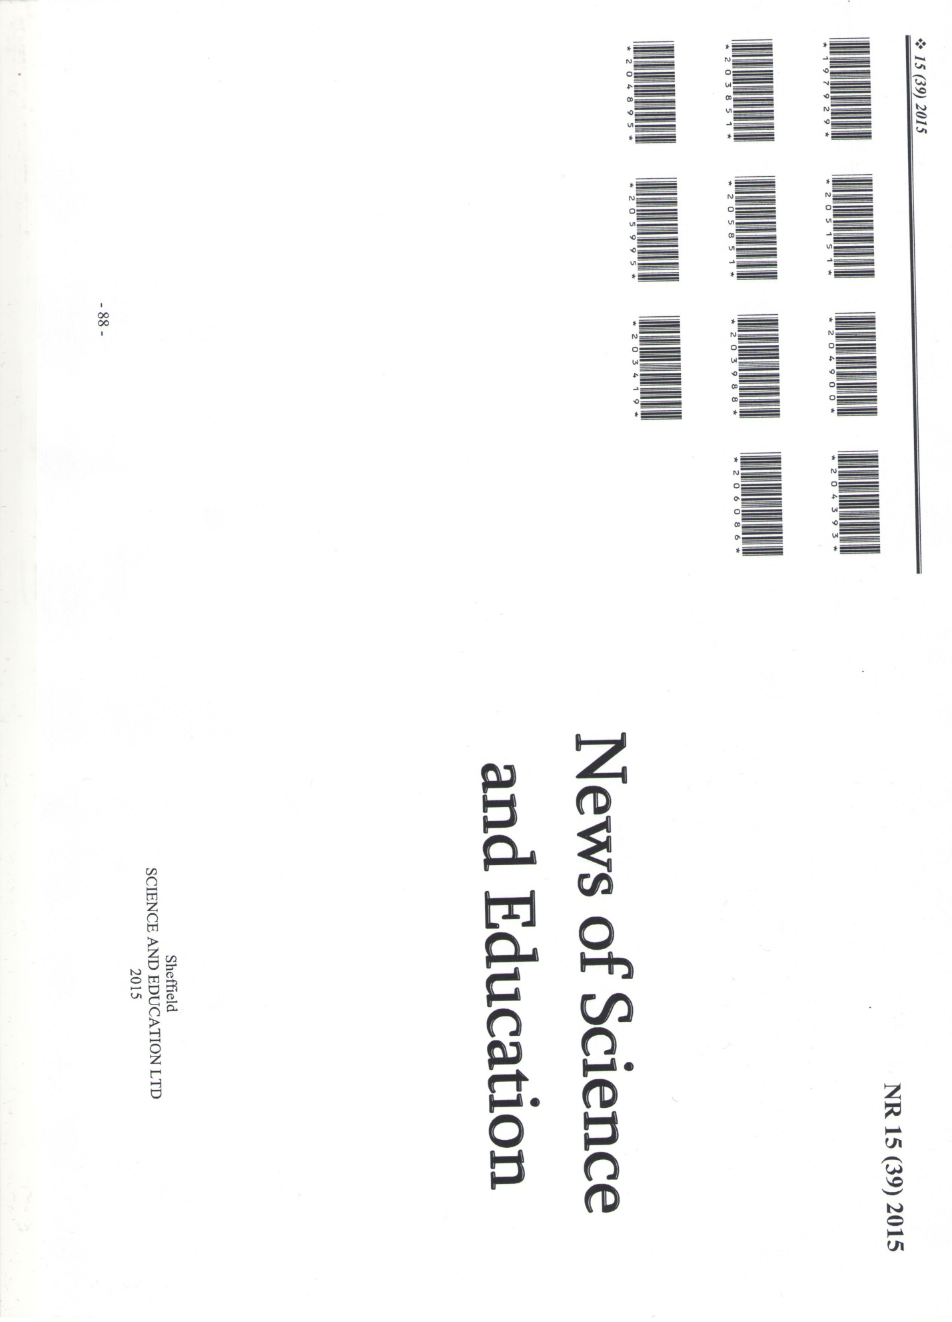
Sadenova A., Torokhtii L. Assessment of the communicative competence of foreign students in the result of testing // News of Science and Education. England, NR 15 (39) 2015. Р. 14-18.

