THE NEUTRON MONITOR TIME SERIES STATISTICS ANALYSIS AND APPLICATIONS

A.S. Kussainov¹, N.E. Pya², M.T. Aitkulov¹, M.B. Urazov¹
¹Physics and Technology Department, al-Farabi Kazakh National University, Almaty, Republic of Kazakhstan,
²Department of Mathematical Sciences, University of Bath, Bath, United Kingdom

Introduction. Multiple studies have being done on the possible connection between seismic or/and atmospheric events with neutron counting rate (further referred as NCR) registered with the surface and underground neutron monitors located at Tien-Shan high-elevation mountain station (3340 m above sea level) [1, 2]. Neutron monitors and detectors facilities around the world have being addressing the same connection with unconvincing results [3-6]. The known loose and complex relationships between variables in the earth sciences, their complex geographical and frequency distribution demand the proper treatment by the time series statistical methods of analysis [7-10].

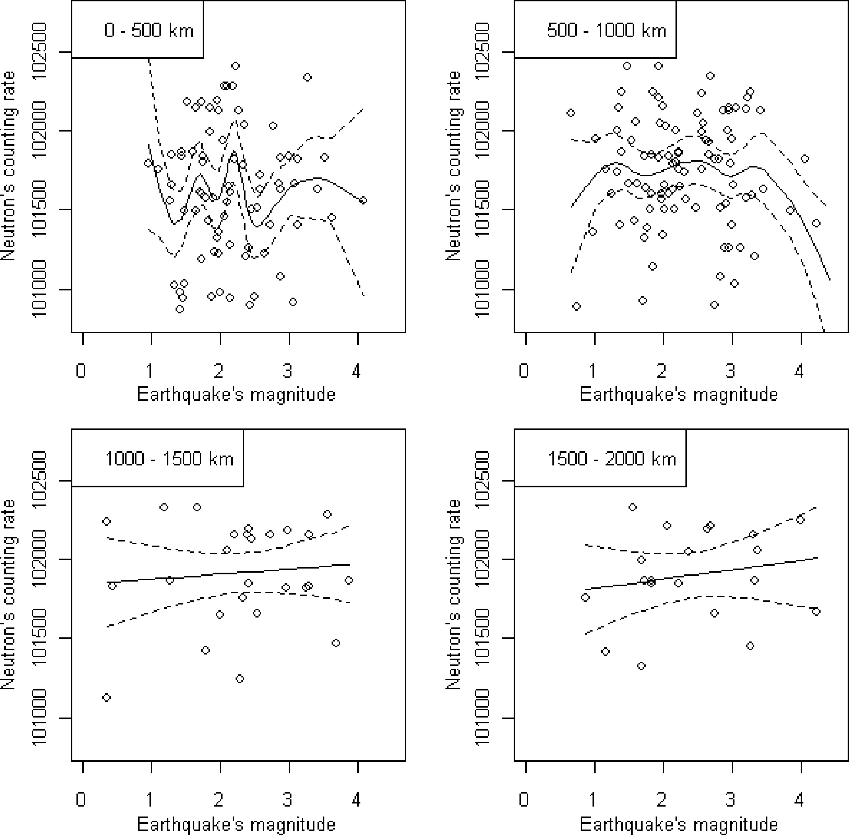
Fig.1. NCR vs. em dependence plotted for 4 data sets. From top to bottom and from left to the right, the earthquakes are registered within 0 to 500 km, 500 to 1000 km, 1000 to 1500 km and 1500 to 2000 km. Two σ confidence interval is marked by the dotted lines on each plot.
We have considered several methods for time series analysis applied to the neutron monitor counting rate and earthquake data set to find a possible correlation between the neutron counting rate at Tien-Shan mountain station and simultaneously registered earthquakes in 2000 km range from the target city of Almaty, Kazakhstan. This correlation has a complex form defined by the spatially and temporally ordered set of events and used to estimate the probability of an earthquake based on the readings of the station’s detectors located 50 km up in the mountains around the city. We also tested few other methods for nonlinear data analysis and processing results for the further development.
Experimental results The two time series chosen for analysis are represented by the neutron monitor data through the single month of September 2007 and by corresponding set of seismic events registered in the same month and available from the National Nuclear Center of the Republic of Kazakhstan [12]. The NCR data were acquired with a 1-minute temporal resolution by the neutron monitors at Tien-Shan Mountain Station (3340 m above sea level) and could be found for download and analysis at [17].
The following single smooth generalized regression model was considered.
$\text{log}\left(μ_{t}\right)=f\left({\text{em}}_{t}\right),{}^{}t=1,\text{.}\text{.}\text{.},n\text{.}$ | (1)
where f(em_{t}) is a smooth unknown function of the earthquake magnitude em_{t} at time E(NCR_{t})=μ_{t} and NCR_{t} follows Poisson distribution with mean exp(f(em_{t})). Low index t stands for the time dependence.
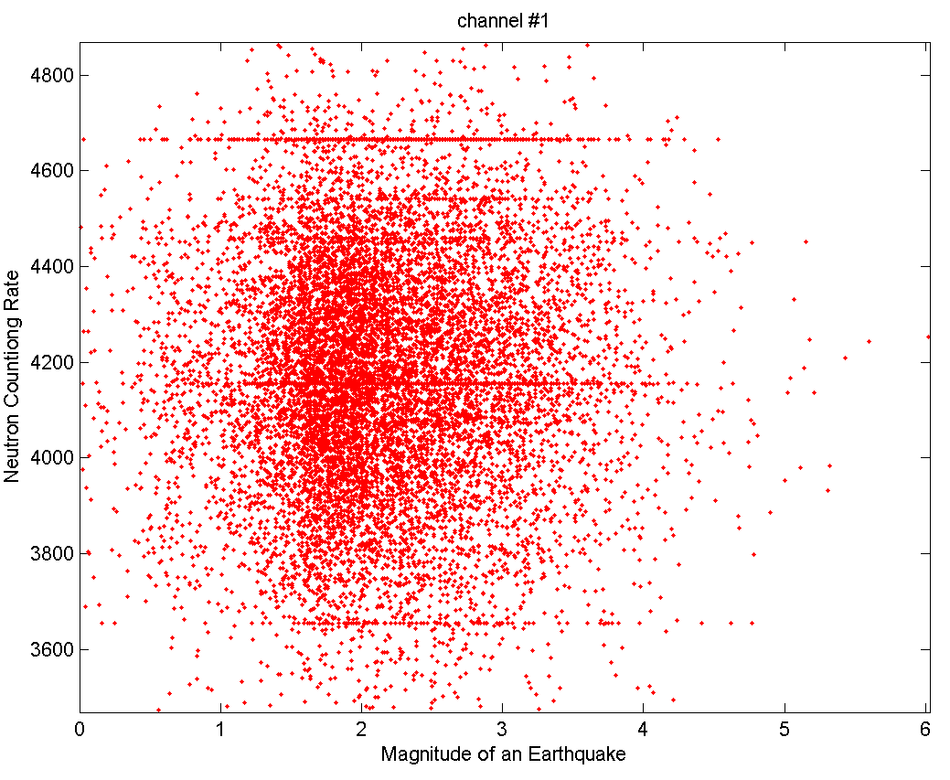

Fig.2. NCR vs. em scatterplot for year 2009. NCR values with no corresponding seismic events have being omitted. Linear artifacts (horizontal lines) where NCR stays the same for a long period of time are easily observed.

Different approaches to fitting such a model have been developed. Here we used the penalized regression smoothing spline approach [12]. The smooth function f(em_{t}) was represented by penalized cubic regression splines with the basis dimension 10. Smoothing parameter was selected by minimizing the unbiased risk estimator [13]. For implementation of this approach R package mgcv has been used. R is a free programming language and environment standard for practical statistical analysis.
Four subsets of data have been analyzed. Each subset is selected to be within the certain distance range from the city of Almaty. That is within 0 to 500 km, 500 to 1000 km, 1000 to 1500 km and from 1500 to 2000 km. The distance between the registered earthquake and Almaty city has been calculated along the great-circle connecting these two points using the haversine formula. Fig. 1 shows the estimated fitted curves for all four data sets.
All regression curves plotted are found to be characterized by a low (α=0.1) or none statistical significance. Diurnal and lower frequency variations in data have being kept and served for the purpose of additional data quality analysis. These variations are hidden in the density of scatterplot changing along the Y axis. The transient difference between the upper left plot (range from 0 to 500 km) and the bottom right one (range from 1500 to 2000 km) is mainly caused by the structure of our data favoring the events happening within the Kazakhstan Republic, close to Almaty city [14].

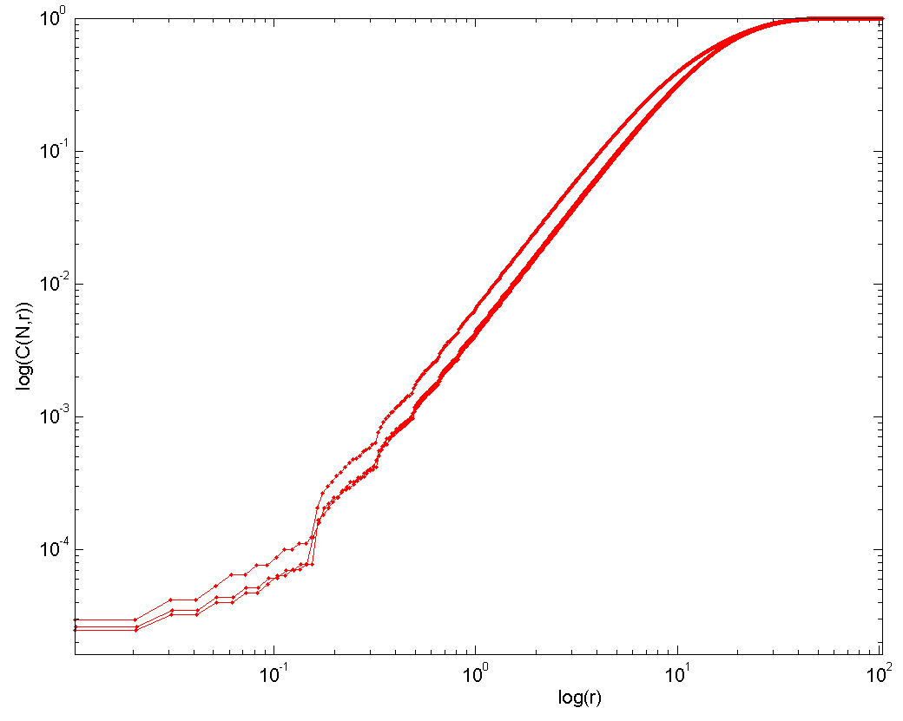
Fig.3. log-log plot for C(N,r) vs. r correlation integral obtained from the year 2009 for three separate channels of neutron detectors. Earthquakes data stays the same.

Additionally the newer set of data both from neutron monitor and earthquake databases covering the whole year of 2009 have being analyzed for the purpose of finding the standard Grassberger-Procaccia correlation dimension of a strange attractor. Grassberger-Procaccia suggested the following correlation integral to compute
$\begin{aligned}\sum_{1≤i≤j≤N}{}i,j\end{aligned}$ | (2)
where H stands for Heaviside step function. The pair of points x_{i} and x_{j} to be taken from the space of normalized neutron counting rate vs. earthquake magnitudes which are happened to be registered at the same time, see Fig.2. As suggested in [15], the dimension ν of a strange attractor could be found from a log-log plot of C(N,r) function versus r according to the following equation
$C(N,r)≈(r/R)^{ν}$ | (3)
These results are plotted on Fig.3. We intended to use these data later for acquisition channel quality assessment, to find possible correlation with geophysical data (earthquakes etc.) and to develop chaotic modeling and simulation methods in nuclear physics with an emphasis on teaching these methods for students
Conclusions As we can see if the comparatively reach data statistics is available (like for the data points in 0 to 500 km range) the certain conclusions could be made about possible correlation between earthquakes and NCR. Despite the luck of desired prediction power this correlation contains potentially rich information on seismic events distribution throughout Republic and their coupling to the ionosphere phenomena. Consideration of the data covering a greater time period available from both Kazakhstan National Data Center and Tien-Shan neutron detector station allows us to employ the advance methods of studying fractal and chaotic properties of our NCR vs. em earthquake magnitude data with promising results.

References

- A.H. Argynova, A.A. Loctionov, V.V. Oskomov, T.H. Sadykov, “Search for the short time variations in wavelet spectrum of neutron counting rate correlating with the processes of upcoming earthquakes build up”, “Contemporary space technologies”, Almaty, October 7-9, 2008, pp.108-110.
- N.M. Duisekeyeva, A.S. Kussainov, V.V. Oskomov, “The earthquake precursors in wavelet transform of the data form the neutron monitor at Tien-Shan high elevation research station”. Vestnik (Physics Edition), v.2 (37), 2011. Al-Farabi Kazakh National University. Almaty, Kazakhstan.
- M.A.Despotashvili, N.G.Khazaradze, N.A.Nachkebia, L.Kh.Shatashvili, D.I.Sikharulidze. Anomalous solar-diurnal variation of Cosmic Ray Neutron and Hard components intensity, cosmic phenomena and the problem of Earthquakes. Proceedings of the 26th International Cosmic Ray Conference. August 17-25, 1999. Salt Lake City, Utah, USA,Vol.7, pp. 440-443.
- V. F. Ostapenko, V. A. Krasnoperov. Analysis of natural neutron flux in a seismically active zone, Natural Hazards and Earth System Sciences, 2003, Vol:3, Issue:6, pp. 777-780.
- B. M. Kuzhevskij, O. Yu. Nechaev, E. A. Sigaeva, V. A. Zakharov. Neutron flux variations near the Earth's crust. A possible tectonic activity detection. Natural Hazards and Earth System Science, 2003, Volume 3, Issue 6, pp. 637-645.
- N.N. Volodichev, O.Y. Nechayev, Y.A. Sigayeva, V.P. Antonova, S,V. Kryukova, A.P. Chubenko, A.L. Shepetov. Registration of the thermal neutron flow from the secondary cosmic rays near the Earth surface during gravitational or seismic waves propagation. 31-st Conference on Cosmic Rays, Moscow, MSU, 2010, GEO_18, pp. 1-4.
- Goltz C. ”Fractal and Chaotic Properties of Earthquakes”, 1998), pp. 128-133.
- B. M. Kuzhevskij, O. Yu. Nechaev, E. A. Sigaeva, V. A. Zakharov. Neutron flux variations near the Earth's crust. A possible tectonic activity detection. Natural Hazards and Earth System Science, 2003, Volume 3, Issue 6, pp. 637-645.
- R.G. Harrison, D.B. Stephenson. “Empirical evidence for a nonlinear effect of galactic cosmic rays on clouds”, Proc. R. Soc. A 8 April 2006 vol. 462 no. 2068, pp. 1221-1233.
- Statistics of Earth Science Data : Their Distribution in Time, Space and Orientation Borradaile, Graham J. , 2003, 351 p.
- N.N. Mikhailova, I.L. Aristova. Reference events database for the needs of seismology. Vestnik NNC RK, 2005, 2 (22), pp. 62 - 72.
- S.N. Wood. Generalized additive models. An introduction with R. Chapman & Hall, 2006, 391 p.
- P. Craven and G. Wahba. Smoothing noisy data with spline functions. Numerische Mathematik, 1979, 31, pp. 377 - 403.
- A.S. Kussainov, N.E. Pya. The neutron monitor time series statistics analysis and earthquakes prediction. Vestnik KazNU/ Physics Series , 3(38) 2011, pp. 53-58.
- P. Grassberger, I. Procaccia. Characterization of Strange Attractors. Phys. Rev. Lett. 50, 346–349 (1983).

