www.peterlang.com/dokument/1143232#

Learning Disabilities and Mental Health
von Evelin Witruk (Band-Herausgeber:in)Shally Novita (Band-Herausgeber:in)
Sammelband 206 Seiten
Science, Society & Culture
Reihe: Beiträge zur Pädagogischen und Rehabilitationspsychologie. Studies in Educational and Rehabilitation Psychology, Band 9

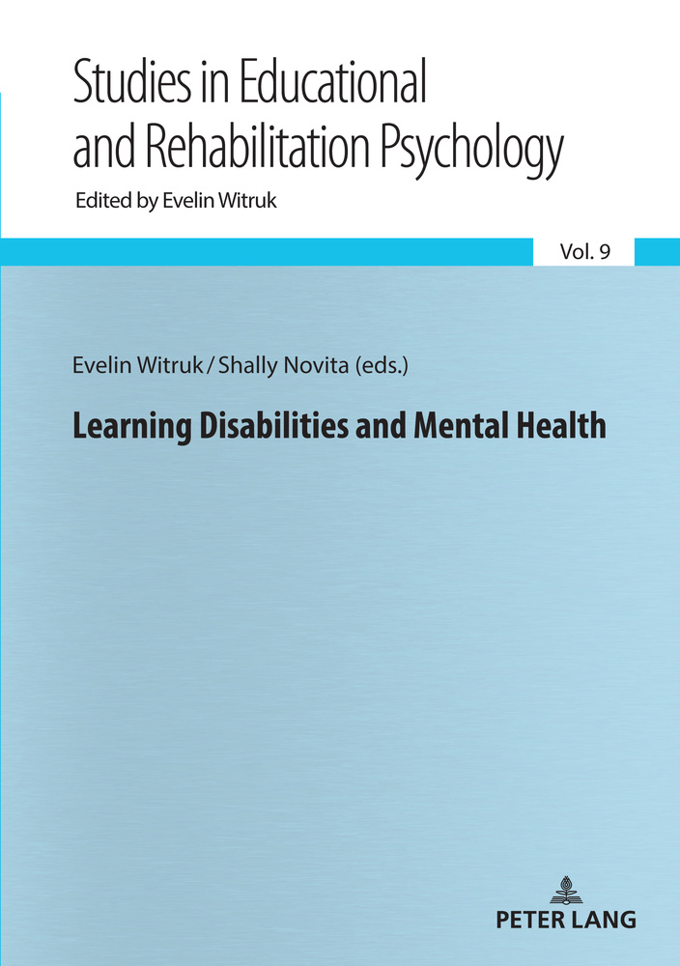

eBook für 49,95 € (netto: 46,68 €)
Sofort herunterladen. Inkl. MwSt.
Format: PDF, ePUB und MOBI – für alle Geräte
Paperback für 49,95 € (netto: 46,68 €)
Versand in ca. 10 Werktagen national, internationaler Versand möglich
In den Warenkorb

Zusammenfassung
The main topics of the book are learning disabilities, trauma, resilience and coping with stress, and violence, peace building and disaster management. The authors of the book articles are from Indonesia, South Korea, Sri Lanka, Iran, Ethiopia, Morrocco, Portugal and Germany. The interdisciplinary character of this book is represented in contributions of scientists from different areas of Psychology, Special Education and Sociology.

Leseprobe

Inhaltsverzeichnis
- Cover
- Title
- Copyright
- About the editors
- About the book
- This eBook can be cited
- Contents
- List of Contributors
- Preface
- Chapter 1 Learning Disabilities
- The ABC...s of Learning Disabilities in Iran: A Review of Studies on Attitudes, Barriers, Challenges and Differences (Mahnaz Akhavan Tafti, Jamal Abedi & Mansoor Ali Hameedy)
- Mindset in Adults with Intellectual Disabilities (Adelinda Araújo Candeias)
- My Child has Dyslexia, Therefore I Expect Less: Parents’ Educational Expectations for Their Children with Dyslexia (Shally Novita)
- Functioning of Cognitive Domain of Dyslexic Students: A Multiple Case Study in Sri Lanka (Enoka Randeniya)
- Children with Difficulties to Learn Mathematics: A Psychological Perspective (Edgar Galindo)
- Chapter 2 Trauma, Resilience and Coping with Stress
- Psychological Sense of Community and Self-identity among North Korean Refugees Living in South Korea: Overcoming the Trauma of the Migration Experience and Not Being Accepted by the Host Society (Miae Yoo)
- Analytical on Moral Distress: An Inevitable Challenge for Trauma Nurses (Mohammadjavad Hosseinabadi-Farahani & Mojtaba Jafari)
- Stress bei Autofahrern im beruflichen Kontex (Udo Kranich)
- Umgang mit Stress bei Bankangestellten am Arbeitsplatz (Ouafa Raziq)
- Psychological Research on Stress in Kazakhstan – Past, Present, and Future (Konrad Reschke, Alena Garber, Sveta Berdibayeva, Anar Bikadamova, Sandugash Duanayeva, Nina Gusseinova & Gulzat Sarbassova)
- Belastungsreduktion in Zeiten des Wandels – Einführung in die Theorie des Biozentrischen Gesundheitsmanagements (BGM) (Marcus Stueck)
- Chapter 3 Violence, Peace Building and Disaster Management
- Psychological Distress and Quality of Life among Cancer Patients in Ethiopia (Yemataw Wondie & Andreas Hinz)
- Making the Invisible Visible: An Exploration into the Risk and Protective Factors of Psychological Intimate Partner Violence against Women (Gunendra R.K. Dissanayake)
- Peace Building and Rehabilitation of War-affected Children through Education: The Sri Lankan Experience (Kumari Thoradeniya)
- Psychology and Social Work: Psychology behind Helping People in Different Social Contexts (Asanka Bulathwatta)
- Painting Therapy: Healing Emotional Trauma (Samudra Senarath)
- Konzeption eines Fragebogens zur Bestimmung der Güte des Biozentrischen Agierens (Marcus Stueck)
- Lack of Psychological Intervention in Disaster Management: International Experiences (Juliet Roudini, Hamidreza Khankeh & Evelin Witruk)
- Series index

←8 | 9→

List of Contributors
Jamal Abedi
University of California, Davis, United States of America
Mahnaz Akhavan Tafti
Alzahra University, Iran
Mansoor Ali Hameedy
Alzahra University, Iran
Sveta Berdibayeva
Al Farabi University Almaty, Kazakhstan
Anar Bikadamova
Al Farabi University Almaty, Kazakhstan
Asanka Bulathwatta
University of Peradeniya, Sri Lanka
Adelinda Araújo Candeias
University of Evora, Portugal
Gunendra R.K. Dissanayake
University of Peradeniya, Sri Lanka
Sandugash Duanayeva
Al Farabi University Almaty, Kazakhstan
Edgar Galindo
University of Evora and Comprehensive Health Research Center, Portugal
Alena Garber
Klinik Reinhardshöhe, Bad Wildungen, Germany
Nina Gusseinova
Center of Active Longevity Almaty, Kazakhstan←9 | 10→
Andreas Hinz
University of Leipzig, Germany
Mohammadjavad Hosseinabadi-Farahani
University of Social Welfare and Rehabilitation Sciences, Iran
Mojtaba Jafari
Bam University of Medical Sciences, Iran
Hamidreza Khankeh
University of Social Welfare and Rehabilitation Science, Iran and Karolinska Institute, Sweden
Udo Kranich
DEKRA Automobil GmbH, Leipzig, Germany
Shally Novita
Leibniz Institute for Educational Trajectories, Germany and Padjadjaran University, Indonesia
Enoka Randeniya
University of Colombo, Sri Lanka
Ouafa Raziq
Universität Hussein II, Casablanca, Marokko
Konrad Reschke
University of Leipzig, Germany
Juliet Roudini
University of Leipzig, Germany
Gulzat Sarbassova
Al Farabi University Almaty, Kazakhstan
Samudra Senarath
University of Colombo, Sri Lanka
Marcus Stueck
DPFA-Academia of Work Health and International Research Academy BIONET, Germany←10 | 11→
Kumari Thoradeniya
University of Peradeniya, Sri Lanka
Evelin Witruk
University of Leipzig, Germany
Yemataw Wondie
University of Gondar, Ethiopia
Miae Yoo
Friedrich-Schiller-University Jena, Germany
←12 | 13→

Preface
This book serves as the 9th volume in the series of “Contributions in Educational and Rehabilitation Psychology”. It contains selected contributions from the International Conference “Dyslexia and Traumatic Experiences” organized by the team members of the Department of Educational and Rehabilitation Psychology of the Institute of Psychology at the University of Leipzig. The conference took place at 6th and 7th December 2019 at the University of Leipzig, Germany. The participants came from China, Ethiopia, Germany, Indonesia, Iran, Morocco, Poland, Portugal, South Korea, and Sri Lanka. One participant from Sri Lanka who conducted research on traumatic experiences was sponsored by the Research Academy of the University of Leipzig.
The book integrates the aspects of learning disabilities, trauma, resilience and coping with stress as well as violence, peace building and disaster management. It brings together selected articles as examples.
The book is structured in three chapters, in which the following topics are integrated:
Chapter 1 is focusing on Learning Disabilities and integrated articles from Iran, Germany, Sri Lanka and Portugal. The article of Mahnaz Akhavan Tafti from the Alzahra University in Teheran explained the basic elements of learning disabilities. The article written by Adelinda Candejas from the University of Evora in Portugal described the problems of intellectual disordered adults. Evidence about the relationship between dyslexia and parents’ educational expectations was presented in the paper authored by Shally Novita from the Leibniz Institute for Educational Trajectories, Germany. Furthermore, using multiple study cases, Enoka Randeniya from the University of Colombo wrote about the functioning of cognitive domain in dyslexic children in Sri Lanka. At the end of this chapter, Edgar Galindo from the University of Evora in Portugal gave an overview about applying Behavioral Skills Training to help children with learning difficulties to learn mathematics.
Chapter 2 is related to Trauma, Resilience, and Coping with Stress and integrated articles from Germany, Iran, Kazakhstan, Morocco, and South Korea. It starts with the article about trauma and resilience written by Miae Yoo from the Friedrich-Schiller-University Jena. She outlined a very interesting research about refugees of North Korea in South Korea, their migration experiences and the problems of not being welcomed and accepted by the host society. With similar focus on trauma and resilience, Mohammadjavad Hosseinabadi-Farahani from ←13 | 14→the University of Social Welfare and Rehabilitation Science Teheran in Iran examined moral distress of nurses in traumatic situations. Furthermore, Udo Kranich from the DEKRA automobile GmbH Leipzig in Germany wrote about the stress experiences of car drivers. In accordance, Ouafa Raziq from the University of Casablanca in Morocco also examined the stress factors in working places that related to burn-out. She investigated employees in banks regarding their feelings and their approaches in processing work-related stress situations. Having a more general topic, Konrad Reschke from University of Leipzig, Germany and colleagues from Kazakhstan delivered an overview about the history and development of stress research in Kazakhstan. The second chapter is concluded with a paper that provides practical recommendations written by Marcus Stueck from the DPFA-Academia of Work Health, Germany. He suggested the implementation of bio-centric health management in the stress analyses.
Chapter 3 describes a relatively general portrait about Violence, Peace Building and Disaster Management. Disasters are affected in the micro level by individual factors like illness or violent significant others. In the macro level, disasters are influenced by natural and man-made disaster. In this chapter, readers could find papers from Ethiopia, Germany, Iran, and Sri Lanka. Explaining the disasters affected by the individual factors, Yematow Wondie from the University of Gondar in Ethiopia reported the life situation of cancer patient in Ethiopia. Gunendra R. K. Dissanayake from Sri Lanka also investigated disasters affected by individual factors by examining correlates of intimate partner violence against ever-married women in Sri Lanka and comparing these results with those from other studies. Taking the perspectives of peace building, W. M. Sachitra Mangalika Kumari Thoradeniya from Sri Lanka showed a way of peace building and reconciliation of war affected children through education and focused on the Sri Lankan experience. Furthermore, topics related to disaster management started with a paper written by Asanka Bulathwatta from Sri Lanka. He demonstrated the importance of social work in facilitating the positive growth. In addition, Juliet Roudini from Iran / Germany explained the relevancy of psychological intervention in the disaster management. In accordance to chapter 2, chapter 3 also concluded with a paper about practical implementations of specific intervention method. In this respect, Samudra Senarath from University of Colombo in Sri Lanka gave an overview about painting therapy as a frequently implemented method for trauma healing. The last paper in this chapter is from Marcus Stueck from DPFA-Academia of Work Health, Germany and he gave an impression of a questionnaire for measurement of the quality of bio-centric actions.
←14 | 15→
All of the articles are work reports from many researchers across the countries that are integrated in the presentations on the international conference in December 2019 at the University of Leipzig.
Evelin Witruk & Shally Novita

Details
Seiten 206
ISBN (PDF) 9783631859216
ISBN (ePUB) 9783631859223
ISBN (Paperback) 9783631859209
Sprache Englisch
Erscheinungsdatum 2021 (November)
Schlagworte DyslexiaDyscalculiaTraumaCoping with stressViolenceDisaster management
Erschienen Berlin, Bern, Bruxelles, New York, Oxford, Warszawa, Wien, 2021. 206 pp., 5 fig. b/w, 22 tables.

Biographische Angaben
Evelin Witruk (Band-Herausgeber:in)Shally Novita (Band-Herausgeber:in)
Evelin Witruk is a full professor of Educational and Rehabilitation Psychology at the University of Leipzig. Shally Novita was a team member in the department of Educational and Rehabilitation Psychology at the University of Leipzig, later at the Leibniz Institute for Education in Bamberg, and now at the Padjadjaran University, Sumedang in Indonesia.

